Supplementary materials
Experimental methods
Inactivation Assay
The plaque assay was performed to investigate whether Gel-FeS NPs exhibit direct inactivation for PRRSV. Briefly, we first used different contents of PRRSV (MOI = 1, 0.1, 0.01, 0.001, 0.0001) for pre-experiments, a suitable concentration of PRRSV was selected for plaque assay to explore the effect of Gel-FeS NPs on the inactivation of PRRSV [1]. PRRSV (MOI = 0.001) was incubated with different concentrations (0, 85.0, 170.0, 255.0, 340.0 µg/mL) of Gel-FeS NPs for 1 h at 37 °С. Separately, the 6-well plates were pre-chilled at 4 °С for 30 min when cells reach 100% confluence. Then the pretreated PRRSV was added to the 6-well plates. After incubation at 4 °С for 2 h, the cells were covered with overlay medium and performed with corresponding plaque assay.
Adsorption Assay
The MARC-145 cells cultured in 6-well plates were pre-chilled at 4 °С for 30 min and then incubated with the PRRSV (MOI = 0.001) and different concentrations (0, 85.0, 170.0, 255.0, 340.0 µg/mL) of Gel-FeS NPs at 4 °С for 2 h, the cells were washed three times with pre-cooling DMEM the cells were covered with overlay medium and performed with corresponding plaque assay [2].
Invasion Assay
The MARC-145 cells cultured in 6-well plates were pre-chilled at 4 °С for 30 min, then infected with PRRSV (MOI = 0.001) at 4 °С for 2h. and subsequently washed three times with pre-cooling DMEM. The virus-containing medium was replaced by fresh medium containing different concentrations (0, 85.0, 170.0, 255.0, 340.0 µg/mL) of Gel-FeS NPs. After incubation at 37 °С for 3 h, the supernatant was discarded, then the cells were covered with overlay medium and performed with corresponding plaque assay [3].
Replication Assay
The MARC-145 cells in 24-well plates were infected with PRRSV (MOI = 1.0) at 37 °С for 1 h, then the supernatant was substituted with DMEM (containing 2% FBS) and the cells were cultured for additional 6 h. After removing the supernatant, DMEM with different concentrations (0, 85.0, 170.0, 255.0, 340.0 µg/mL) of Gel-FeS NPs were added to 24-well plates. After incubation for another 7, 8, 9 and 10 h, the total RNA of infected cells was extract by TRIzol reagent following the manufacturer’s instruction. TAKARA Reverse Transcription Kit was used to reverse transcribe RNA to cDNA according to the manufacturer’s instructions, the primer (5′UF: GACGTATAGGTGTTGGCTC) was used for the reverse transcription. the PCR assay was performed using primers (F: GCATTTGTATTGTCAGGAGC, R: AGCAGTGCAACTCCGGAAG). The abundance of PRRSV negative-sense RNA was quantified by RT-qPCR assay [4].
Release Assay
The MARC-145 cells were infected with PRRSV (MOI = 1.0) at 37 °С for 1 h, then the supernatant was discarded and the cells were cultured in DMEM (containing 2% FBS) at 37 °С for another 18 h. After washing with DMEM for three times, fresh DMEM with different concentrations (0, 85.0, 170.0, 255.0, 340.0 µg/mL) of Gel-FeS NPs were added to 24-well plates and incubation for 15, 30, 45 and 60 min, the supernatant PRRSV samples were collected, replenish with fresh DMEM, the cell lysate was collected by freeze and thaw for three times. Finally, a responding plaque assay was performed to determine the virus content of the samples [5].

Supplementary Figure S1
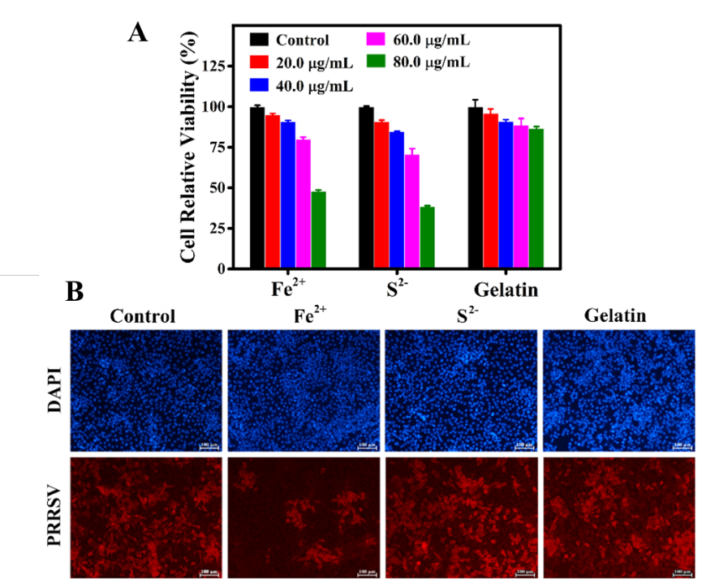

Fig. S1. Cytotoxicity and antiviral activity of ferrous ion. (A) Cytotoxicity of different concentration Fe²⁺, S²⁻ and gelatin (0-80 µg/mL) on MARC-145 cells by MTT assay. (B) Immunofluorescence images of PRRSV-infected MARC-145 cells treated with Fe²⁺, S²⁻ and gelatin as the same concentrations (40.0 µg/mL). Scale bar = 100 µm.

Supplementary Figure S2
Fig. S2 Effect of Gel-FeS NPs on PRRSV-induced ROS production as evaluated by DCFH-DA.

References
1. Du T, Liang JG, Dong N, Lu J, Fu YY, Fang LR, et al. Glutathione-Capped Ag₂S Nanoclusters Inhibit Coronavirus Proliferation through Blockage of Viral RNA Synthesis and Budding. ACS Appl Mater Interfaces. 2018;10(5):4369-4378.
2. Zhu ZB, Guo Y, Yu P, Wang XY, Zhang XX, Dong WJ, et al. Chlorine dioxide inhibits the replication of porcine reproductive and respiratory syndrome virus by blocking viral attachment. Infect Genet Evol. 2019;67:78-87.
3. Feng JP, Bai XL, Cui TT, Zhou H, Chen Y, Xie JX, et al. In Vitro Antiviral Activity of Germacrone Against Porcine Reproductive and Respiratory Syndrome Virus. Curr Microbiol. 2016;73(3):317-323.
4. Duan EZ, Wang D, Fang LR, Ma J, Luo JY, Chen HC, et al., Suppression of porcine reproductive and respiratory syndrome virus proliferation by glycyrrhizin. Antiviral Res. 2015;120:122-5.
5. Wang RN, Yu Y, Kong WL, Li CF, Kang YF, Wang GQ, et al. Molecular cloning of porcine 2',5'-oligoadenylate synthetase-like protein and its role in porcine reproductive and respiratory syndrome virus infection. Microb Pathog. 2018;125:281-289.

