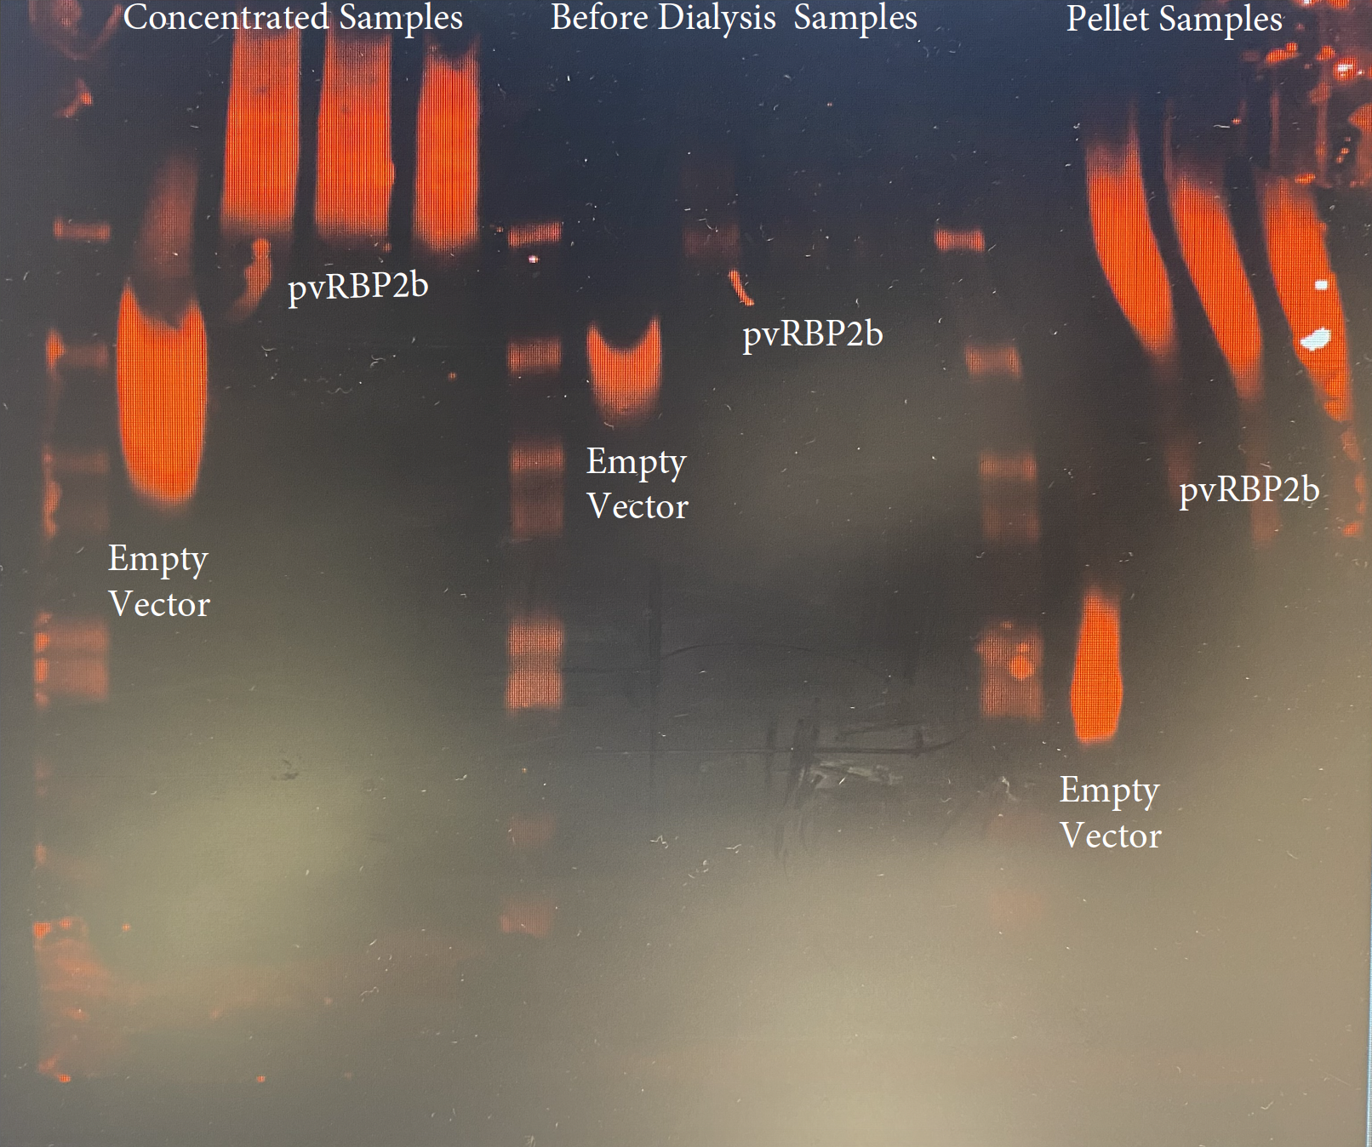
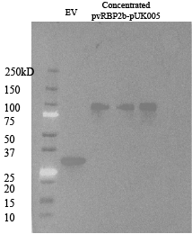

Supplementary Figure S1. Western Blots of PvRBP2b Recombinant Protein. 400ug pUK006-pvRBP2b vector transfected into a total of 1200mL mammalian culture (HEK293T-E6 cells) divided into 3 flasks and purified RBP2b protein (dialyzed -> concentrated -> frozen at -80C) stored in HEPES buffered saline w/ Ca2+ and Mg2+ Plus 10% glycerol. CD4(OX68) and goat anti-mouse IgG, HRP used at 1:1000 in PBST w/ 1% milk. Expected band size is ~108kD. However, the fluorescent bands appear larger than expected because the buffer lacked SDS. Samples were re-run with SDS added and showed the correct size on the correct blot.

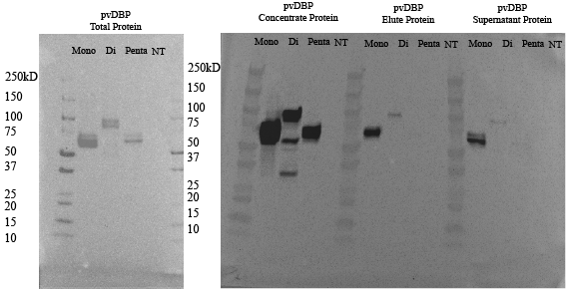
Supplementary Figure S2. Western Blots of PvDBP-II Recombinant Protein. Sub-cloned pvDBP-II protein into pUK004, pUK005, and pUK006 vectors, maxi-prepped, transfected into 100 mL mammalian culture (HEK293T-E6 cells), harvested protein, purified and concentrated CD4(OX68) and goat anti-mouse IgG, HRP used at 1:1000 in PBST w/ 5% milk. Coomassie blue gel showed impurities, and the amount was not quantified.

Supplementary Figure S3. A) Blood chemistry. a) Blood Urea Nitrogen, b) Creatinine, c) ALT, d) Albumin. B) Hematology. a) Hematocrit, b) Hemoglobin, c) Platelets, d) Weight. Data are presented as box-and-whisker plots, with the center line indicating the median, the box representing the interquartile range (IQR), and the whiskers denoting the minimum and maximum values. Individual groups include PvDBP, PvRBP2b, PvDBP/PvRBP2b, and Al(OH)₃ control animals monitored over time following challenge. The dashed line indicates the day of the challenge using the heterologous P. vivax AMRU-1 strain.

