Microbial Signatures in Ancient Desert Environments: MISS from the Mesoproterozoic Mangabeira Formation, Brazil - Supplementary Information

Amanda de Souza Carvalho Feitosa, Manoela Bettarel Bállico, Ezequiel Galvão de Souza, Claiton Marlon dos Santos Scherer, Flavia Callefo, Vanessa Balbinot, Gustavo Kube Tatsch, Elder Yokoyama, Amanda Moreira Leite, Adriano Domingos dos Reis, Sebastião Willian da Silva, Alexandre Silva Santos, Alysson Martins de Almeida Silva, Rodrigo Nunes de Souza

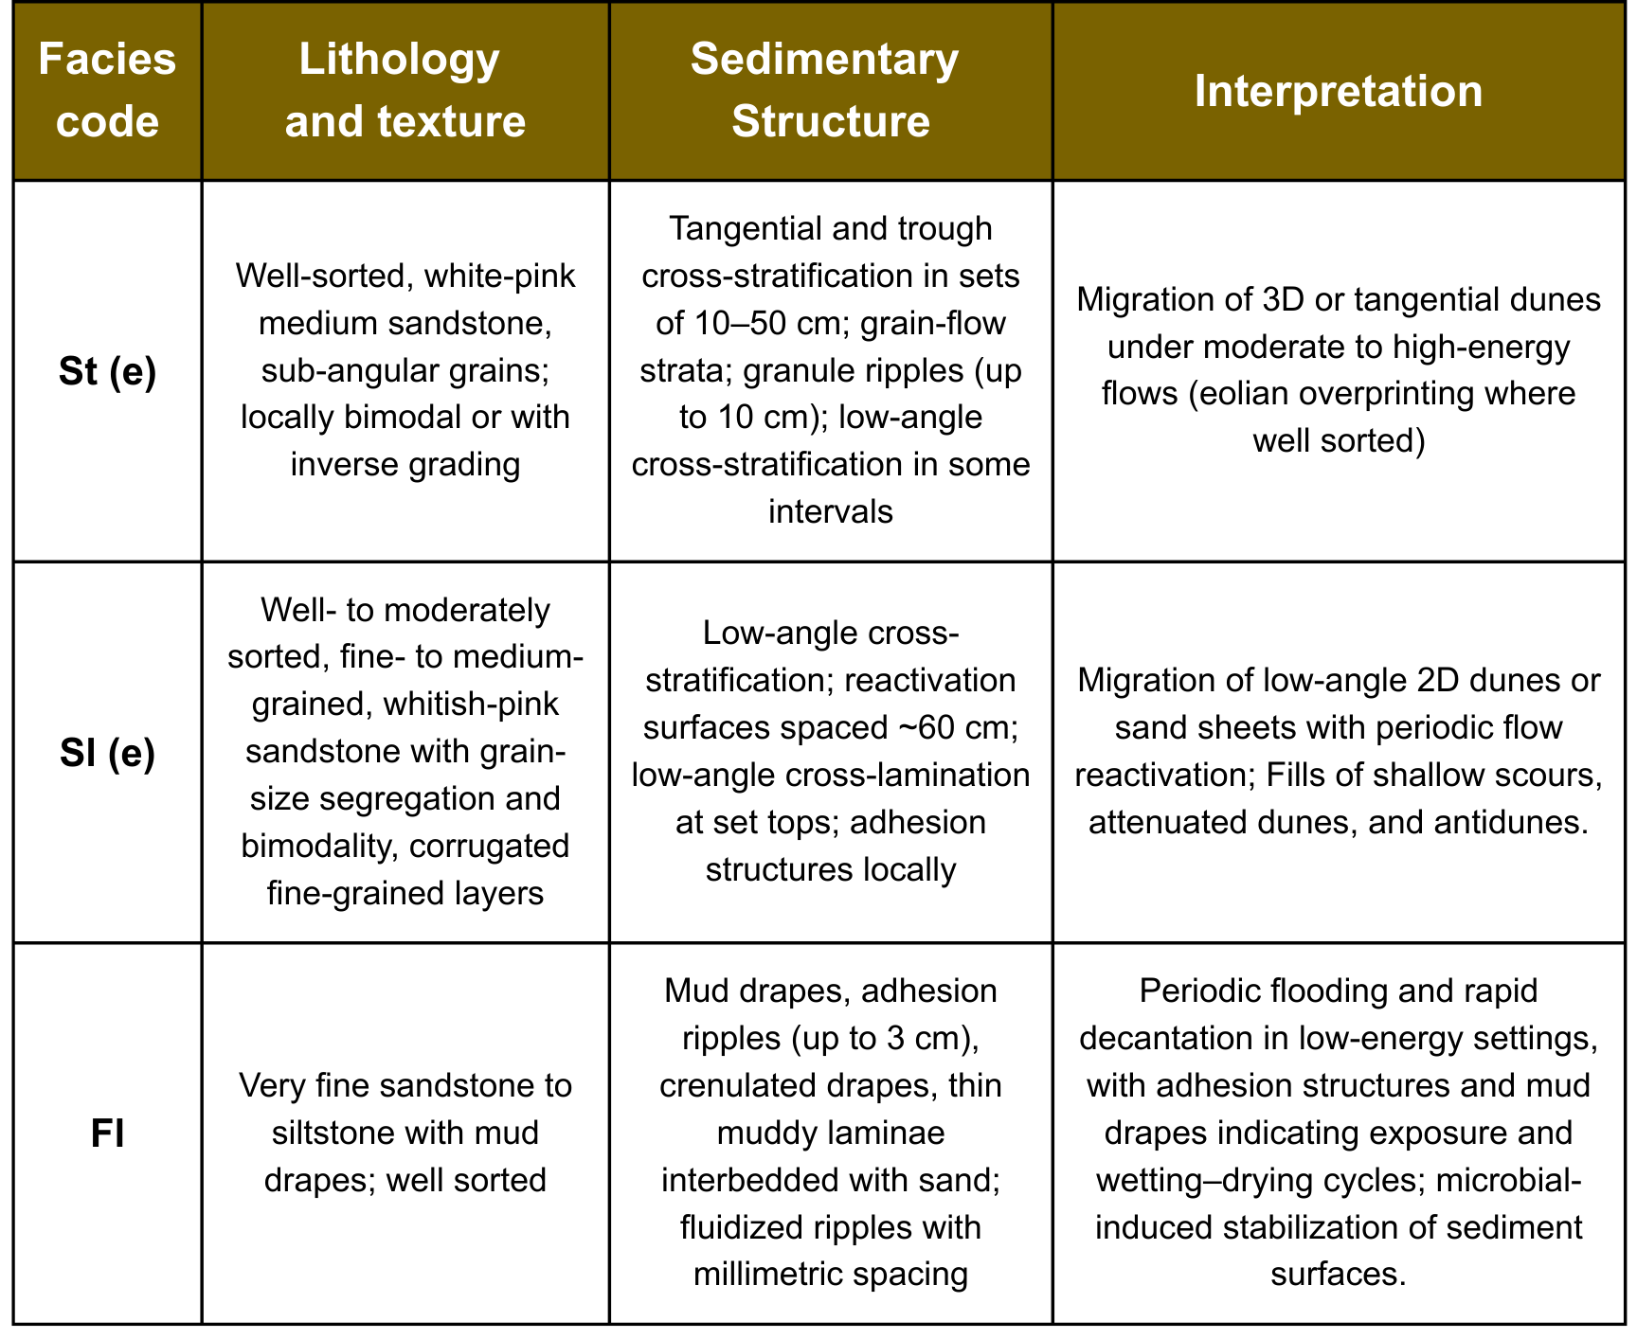
Supplementary Figure S1: Summary of the main sedimentary facies, presenting their lithological and textural attributes, key sedimentary structures, and brief interpretations based strictly on observed features.

.
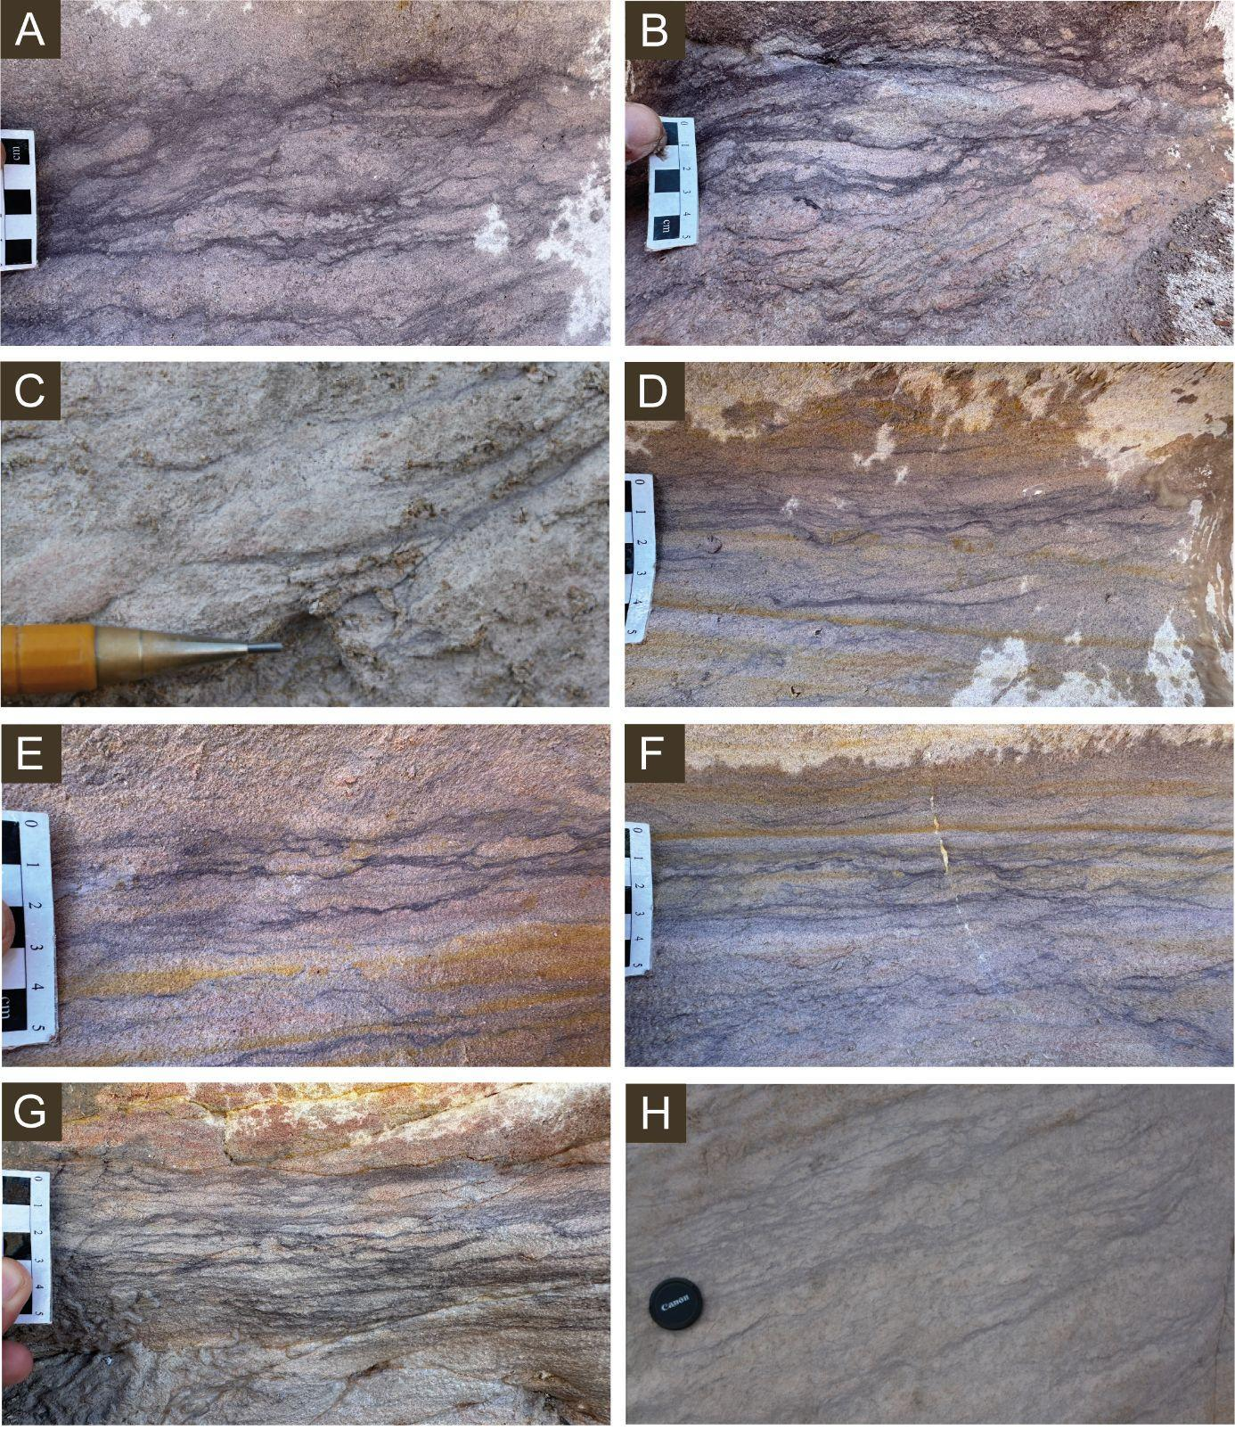
Supplementary Figure S2: Different morphologies of mud drapes were identified: (A) disoriented, (B) mixed with coarse sand, (C) concave, (D) wavy, (E) with dispersive tails, (F) bifurcated and crenulated, (H) in sub-horizontal layers, and (G) rough and diffuse.

Petrology
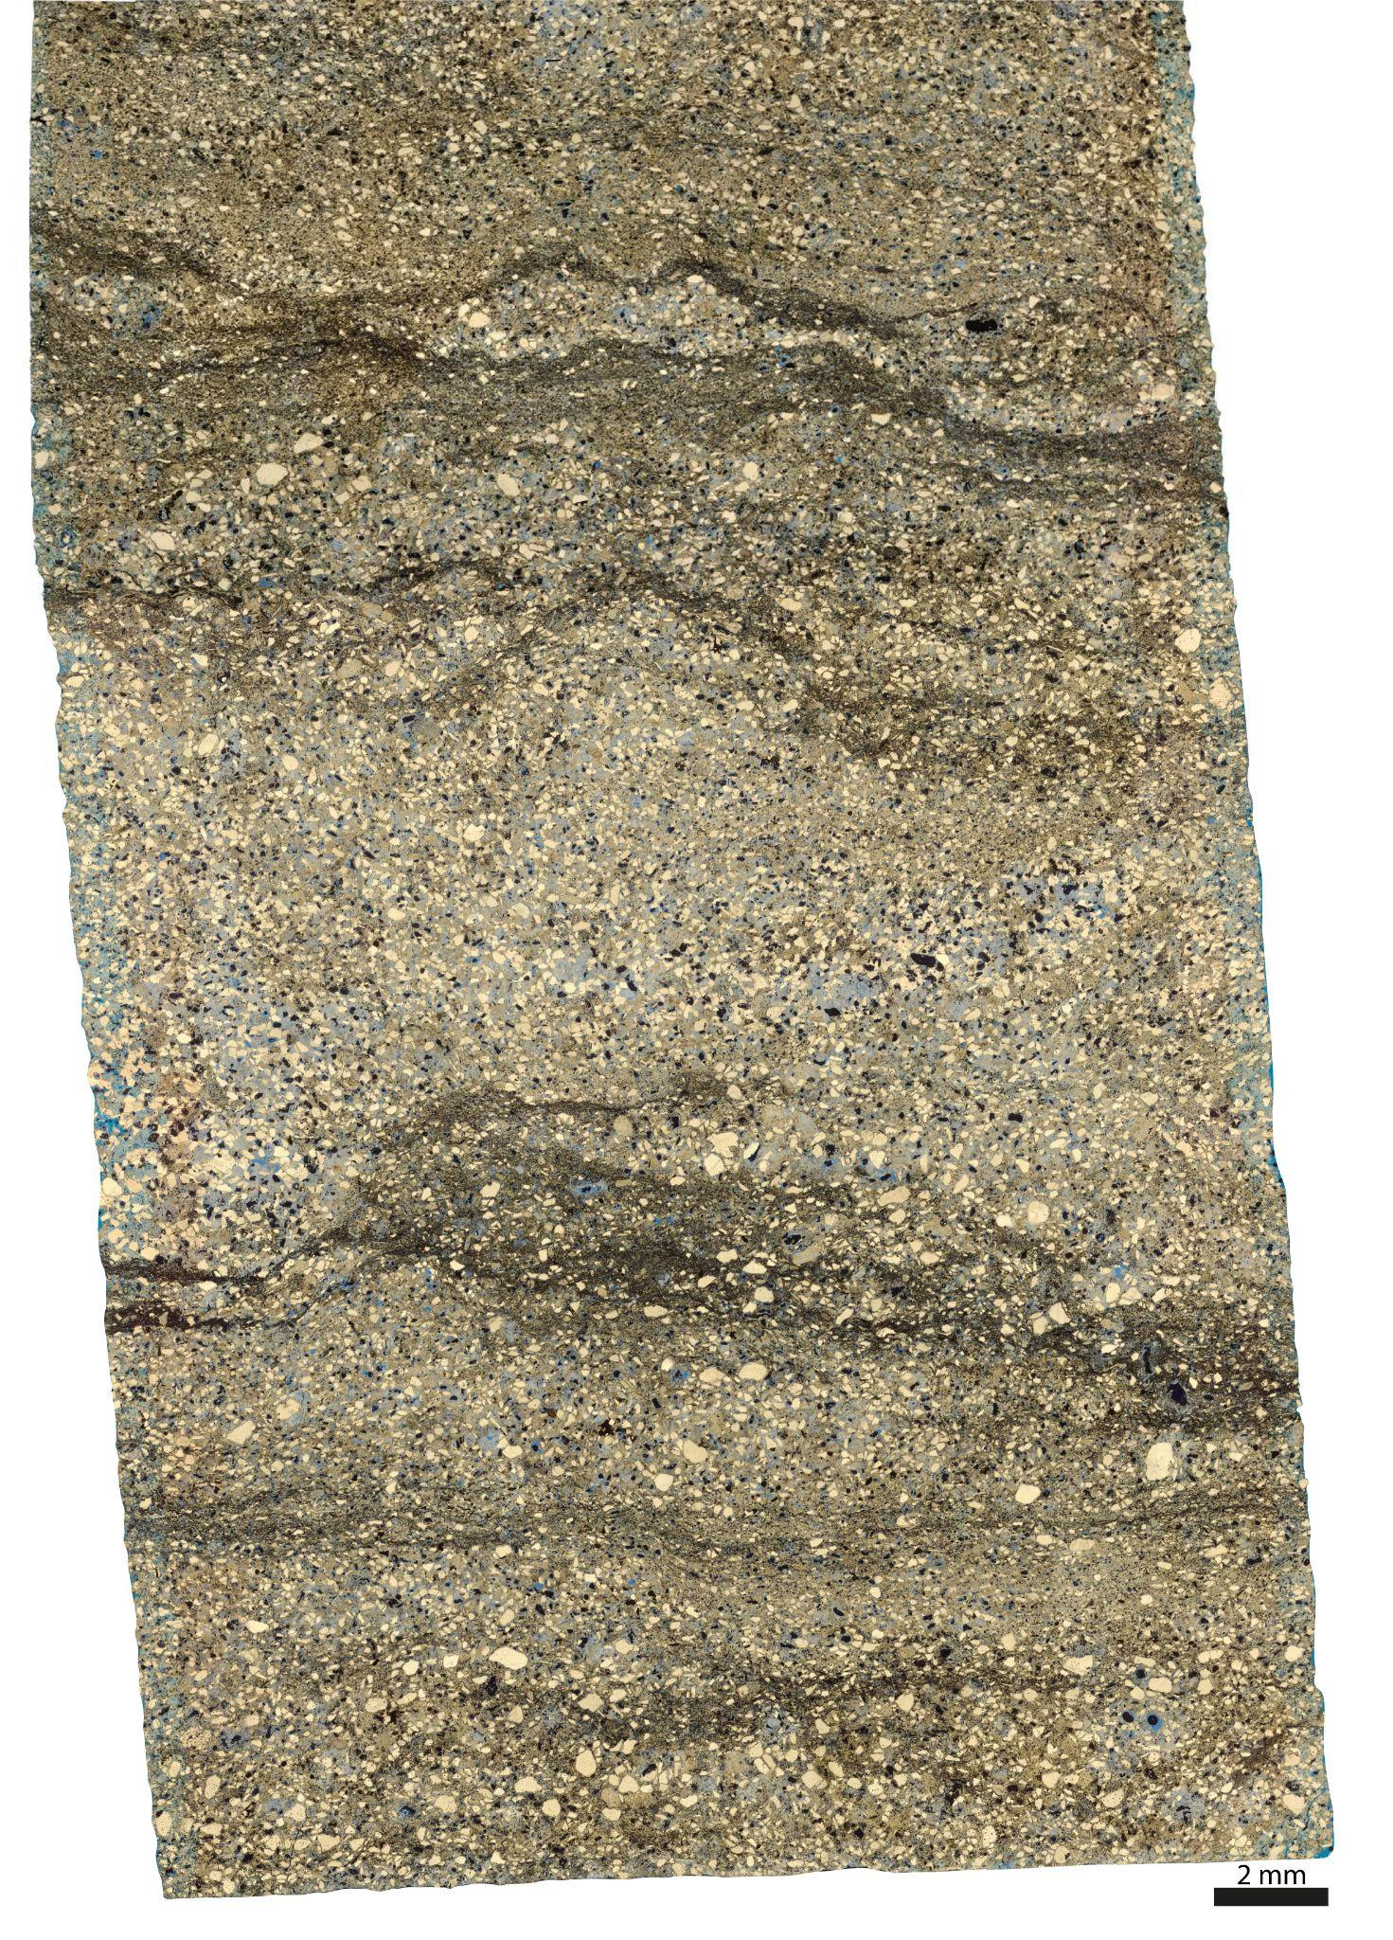
Supplementary figure S3: Mosaic of petrographic thin section MAG-01 highlighting microbial mats with corrugated features, either continuous or discontinuous, showing different levels of biofilm development.

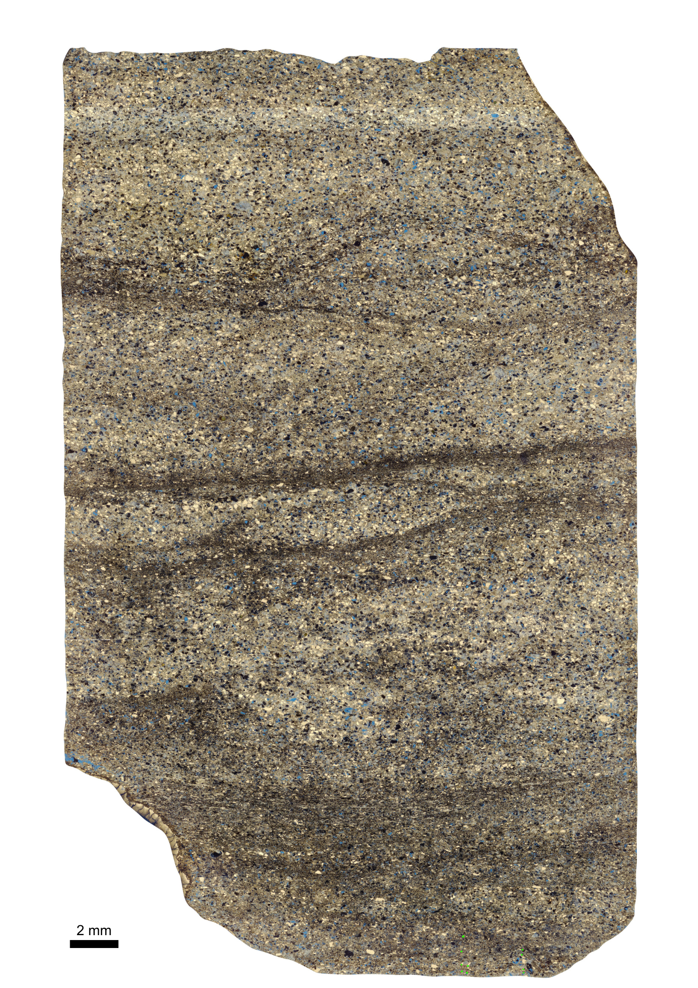
Supplementary figure S4: Mosaic of petrographic thin section MAG-02 highlighting microbial mats with corrugated features, either continuous or discontinuous, showing different levels of biofilm development.
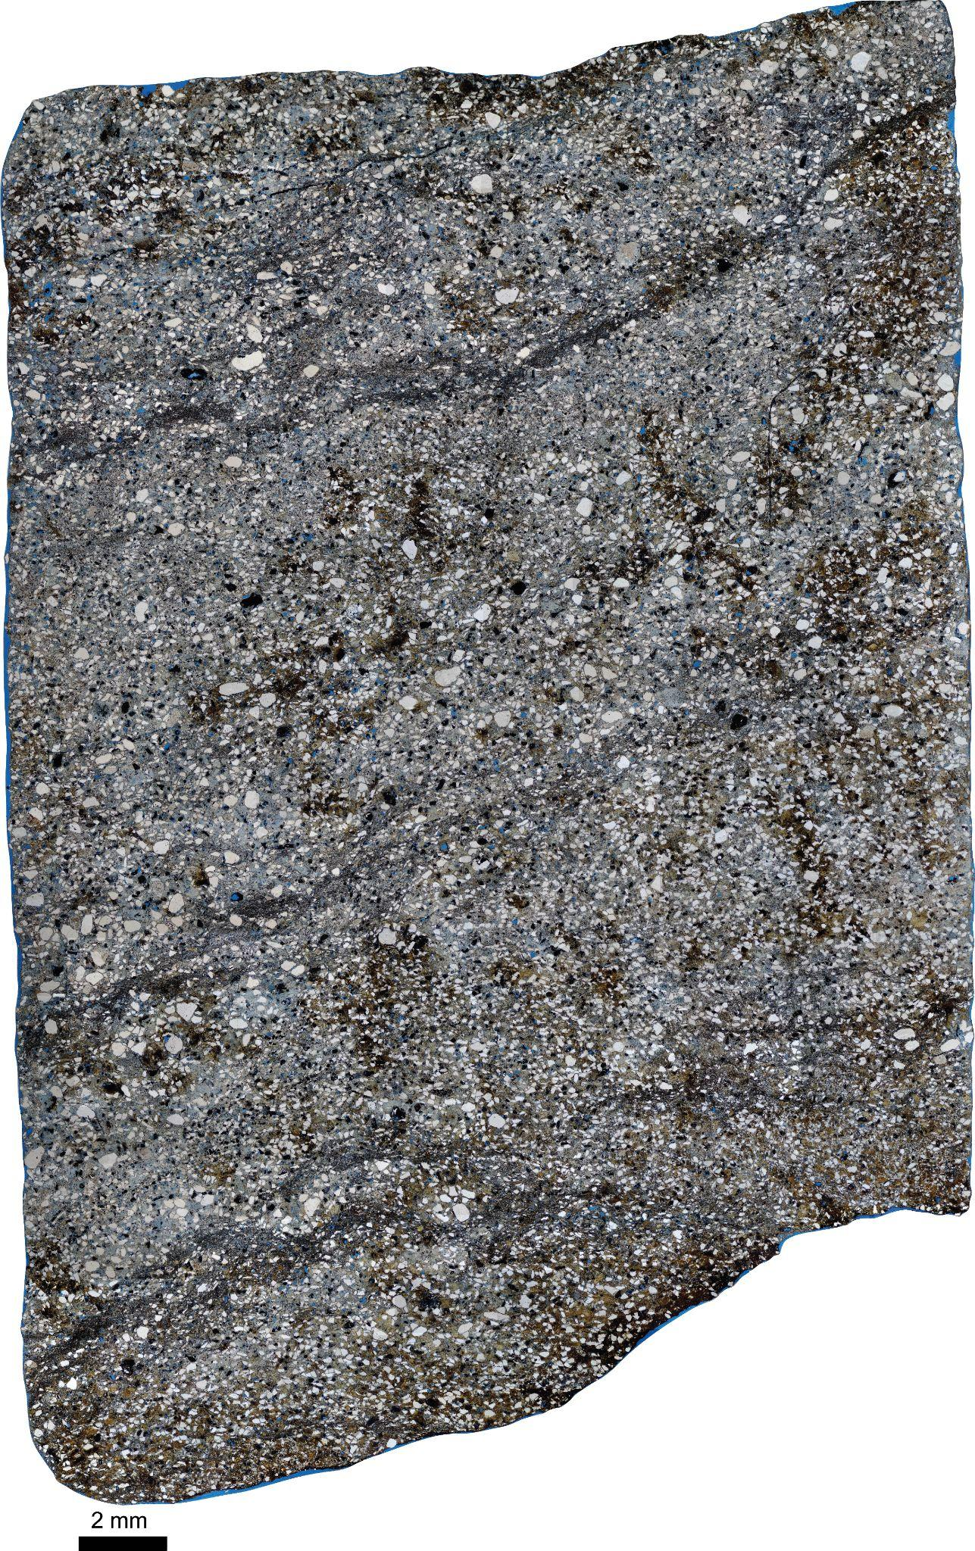
Supplementary figure S5: Mosaic of petrographic thin section MAG-03 highlighting microbial mats with corrugated features, either continuous or discontinuous, showing different levels of biofilm development.

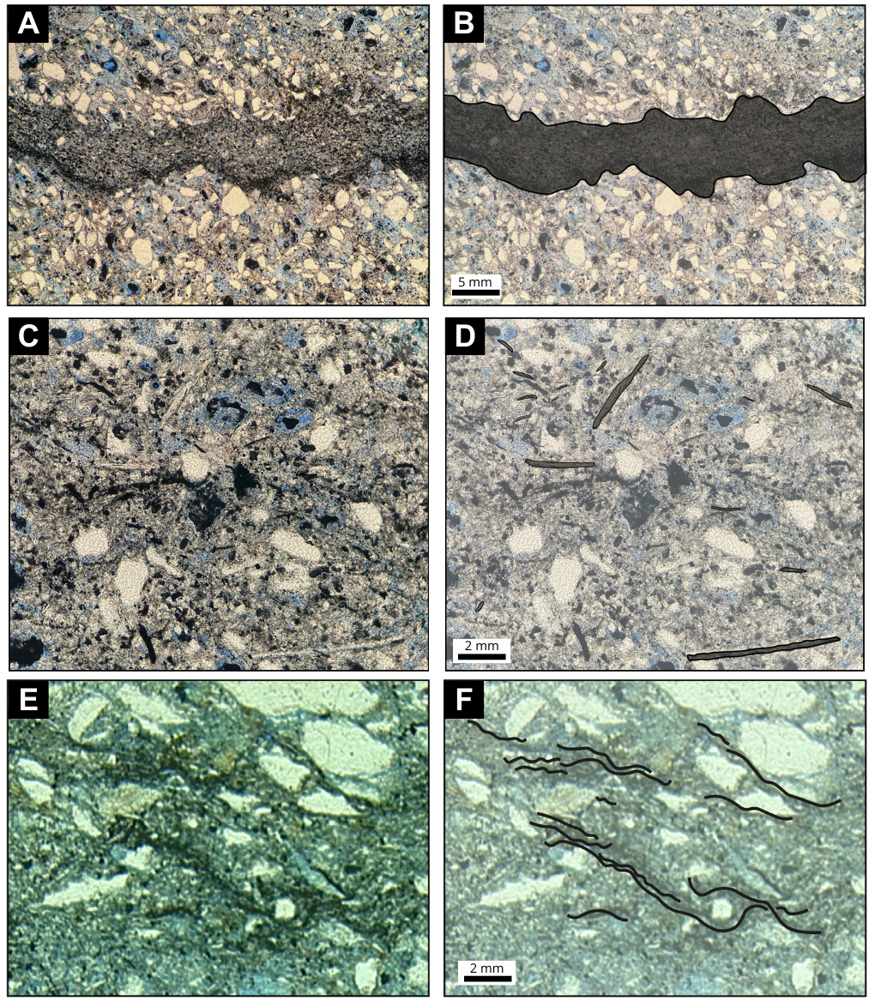
Supplementary Figure S6: The following MISS from the Mangabeira Formation were identified under optical microscopy: (A) Surfaces displaying shallow depressions, (B) Interpretation, (C) Disoriented micas, (D) Interpretation. (E) Fragmented microbial mats with frayed edges, (F) Interpretation

Confocal fluorescence microscopy
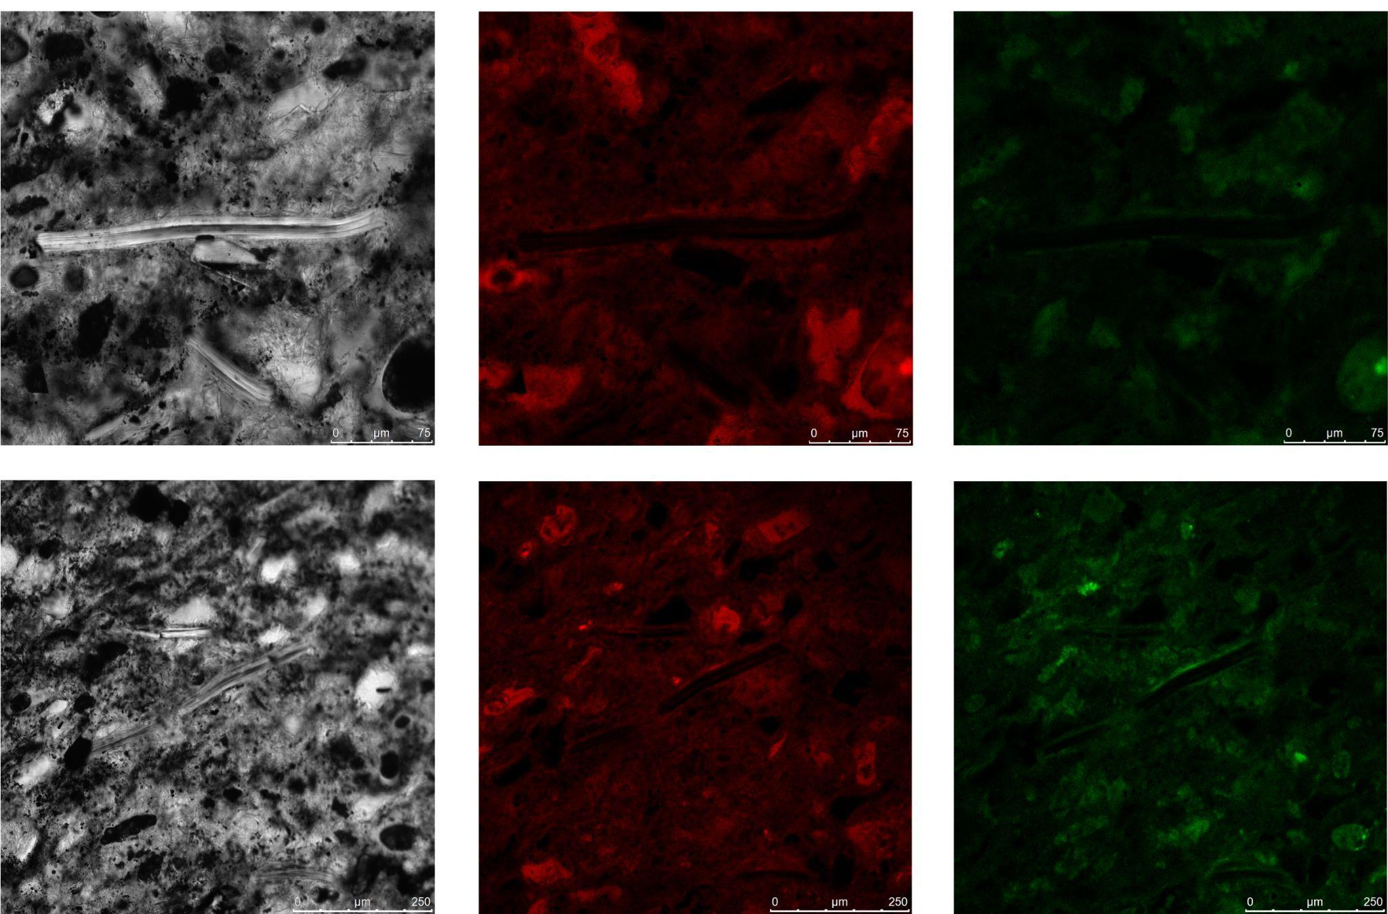
Supplementary Figure S7: (A) Identification of the dense phase in computed microtomography images. (B) Interpretations of domains showing a higher predominance of Fe₂O₃. This analysis is based on samples MGB-01.

Micro-computed tomography
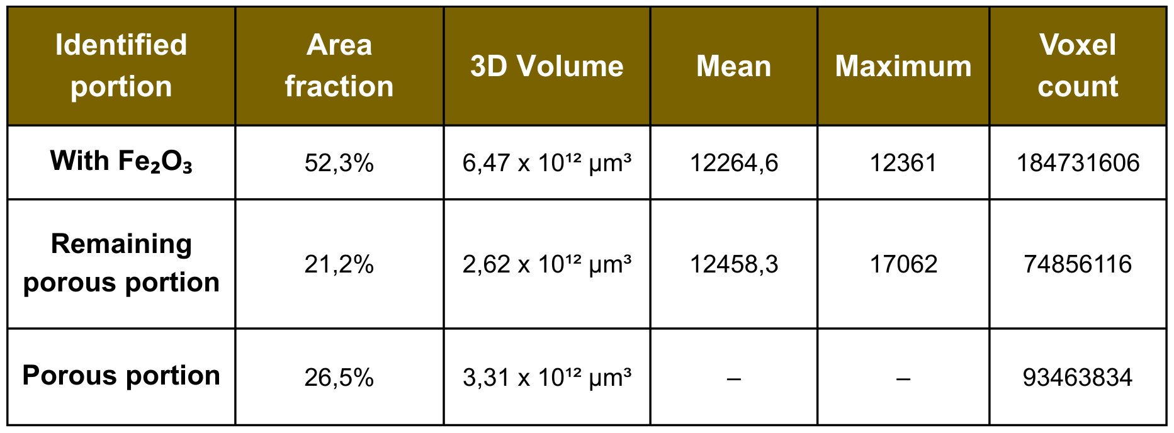
Supplementary Table S8: Quantitative results of the micro-computed tomography of sample MGB-01.

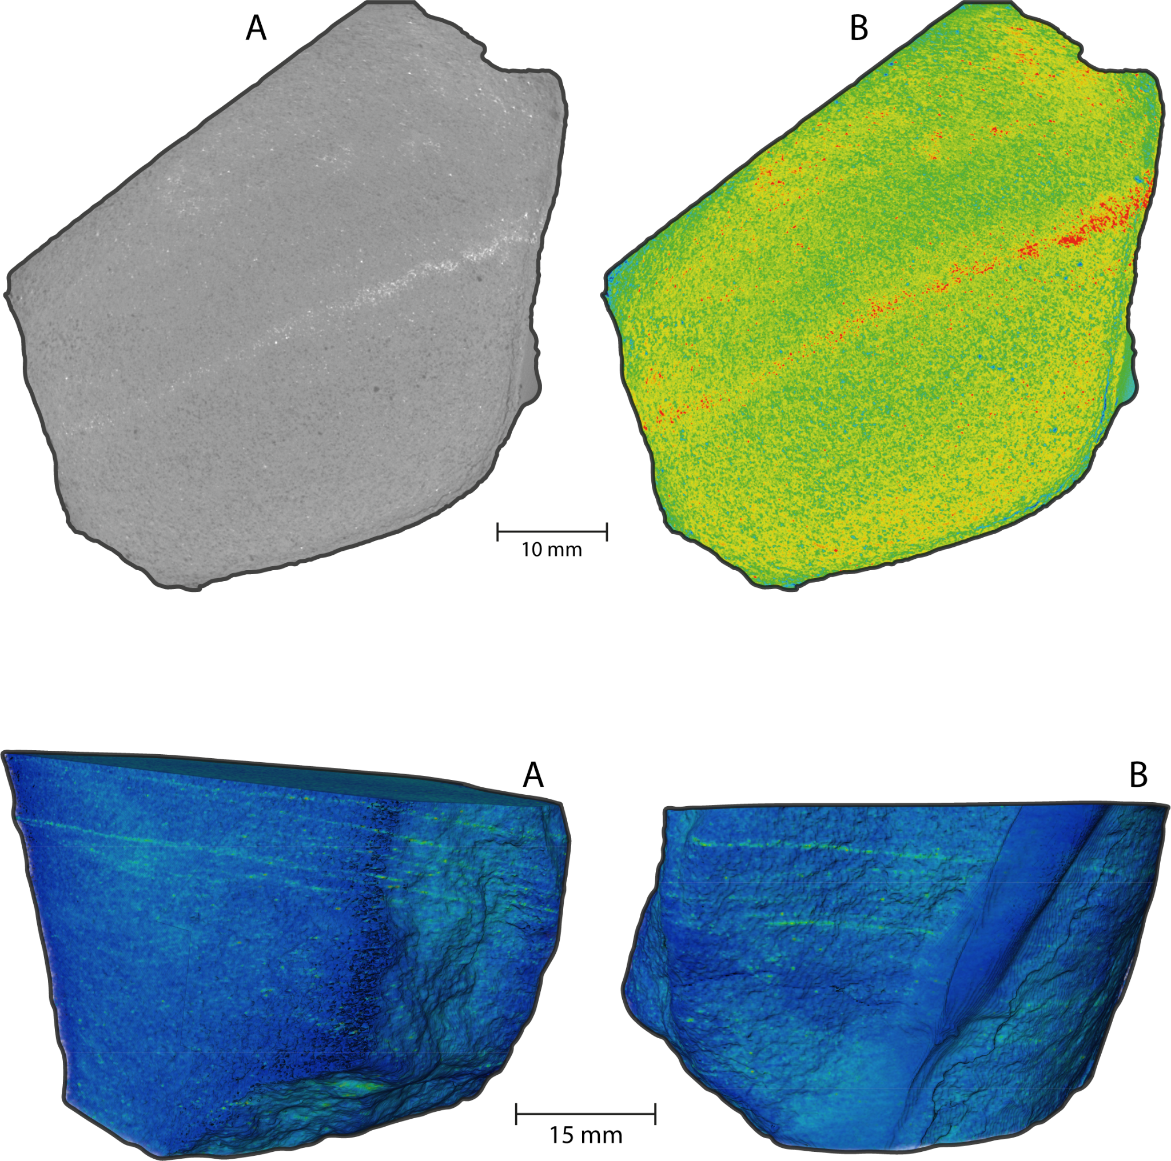
Supplementary Figure S9: Orthoslices obtained from different planes of computed microtomography of sample MGB-01. (A) Fe₂O₃-rich portions highlighted in white, indicating higher density. (B) Sample after application of a color filter to enhance visualization of the Fe₂O₃-rich portion, highlighted in red.

Supplementary Figure S10: Rendered orthoslices highlighting portions with higher Fe₂O₃ concentration in green.

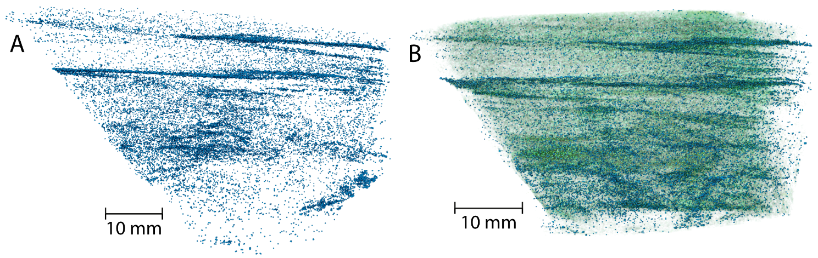
Supplementary Figure S11: Portion showing only the isolated Fe₂O₃ phase.
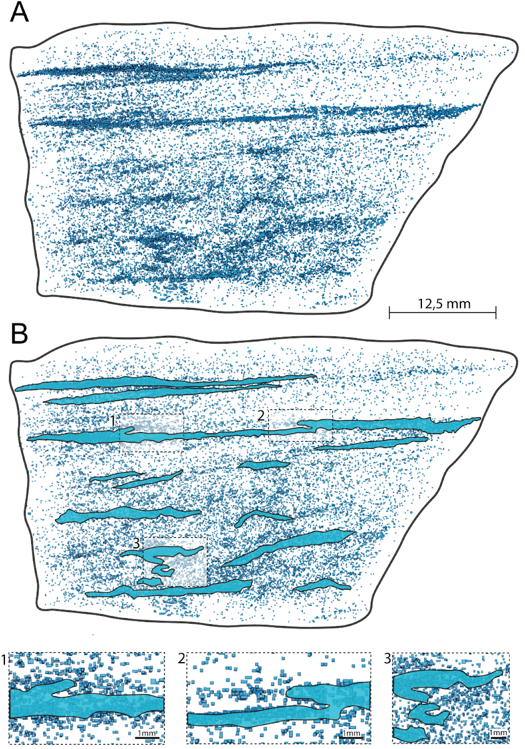
Supplementary Figure S12: Microbial mats illustrated at a three-dimensional scale through a volume isolating only the Fe₂O₃-rich phase, indicating higher density consistent with bacterial activity. Insets 1, 2, and 3 highlight roll-up mat structures.

