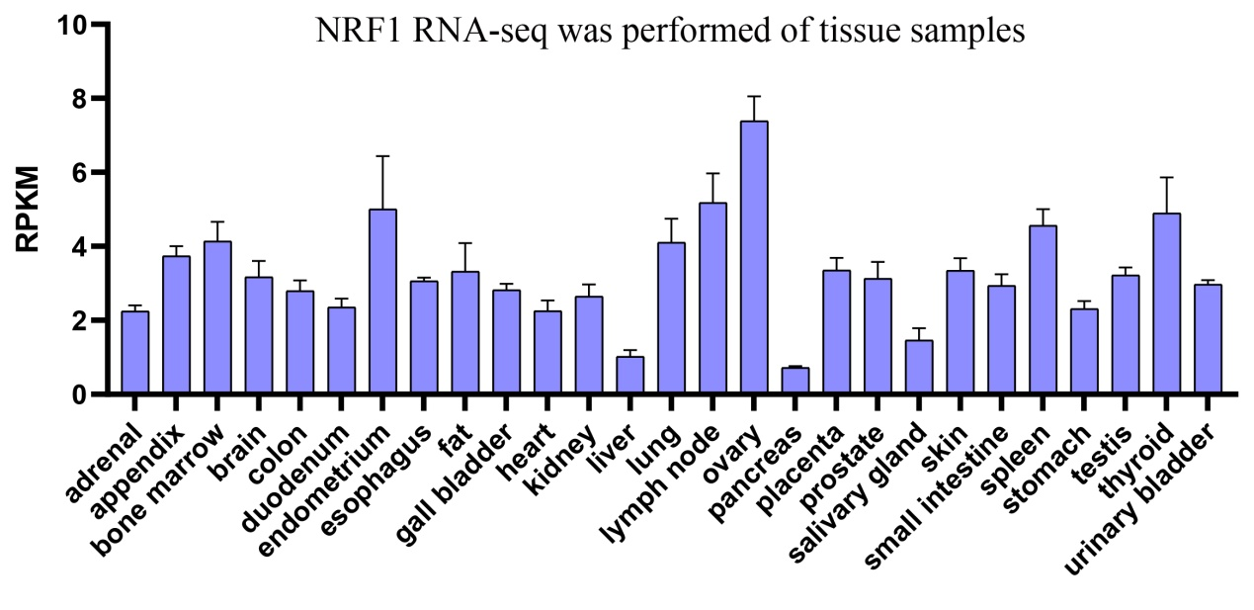

Fig S1. Expression level of NRF1RNA-seq in normal tissues obtained from HPA database.

