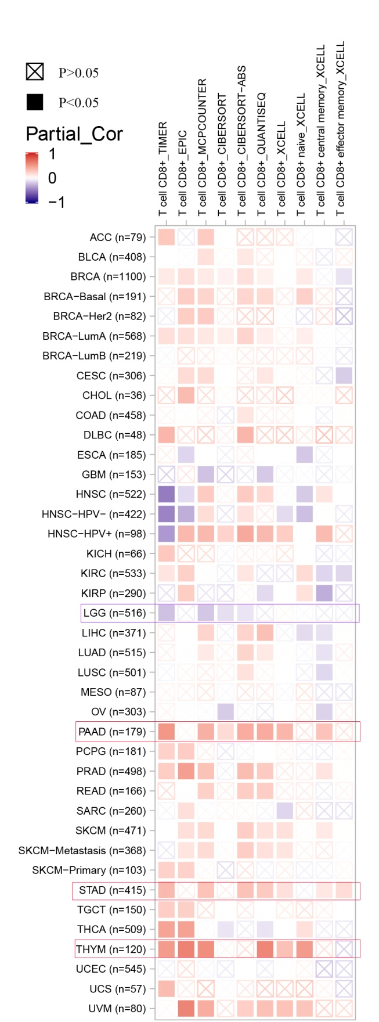
Figure S2. Correlation analysis between NRF1 expression and immune infiltration of CD8+ cell was get by TIMER2 . Different algorithms were used to explore the potential correlation between the expression level of the NRF1 gene and the infiltration level of CD8+ cell across all types of cancer in TCGA.

