Supplementary Information
- Supplementary Table S1. Geochemical analysis of cobalt-decorated areas (EDXRF).
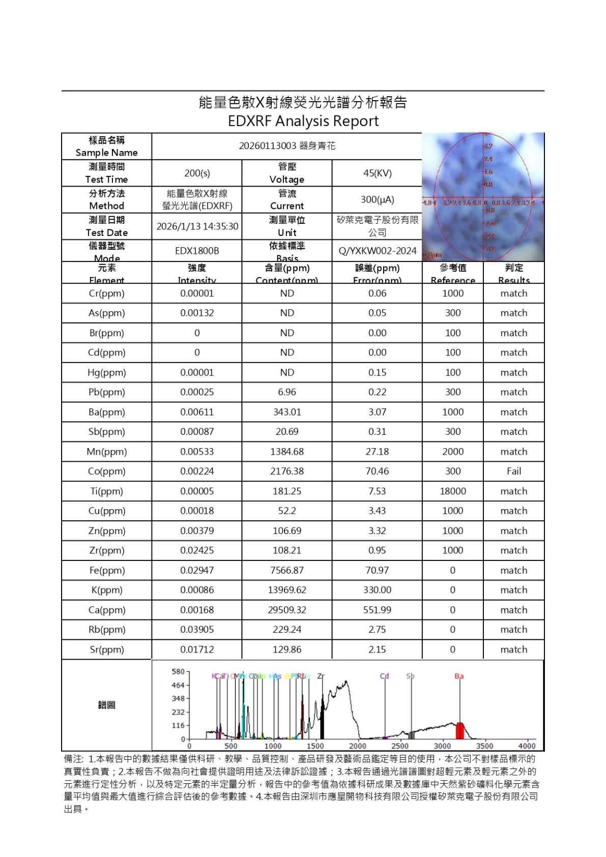
- Supplementary Table S2. Geochemical analysis of the ceramic body at the foot ring (EDXRF).
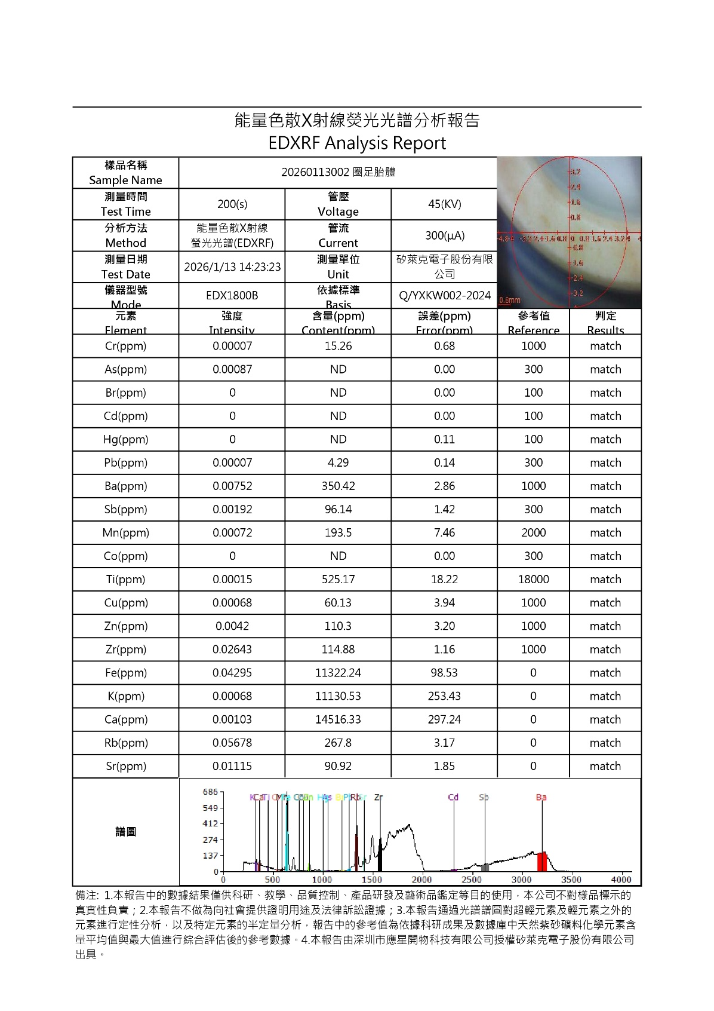

- Supplementary Table S3. Geochemical analysis of the base white glaze (EDXRF).
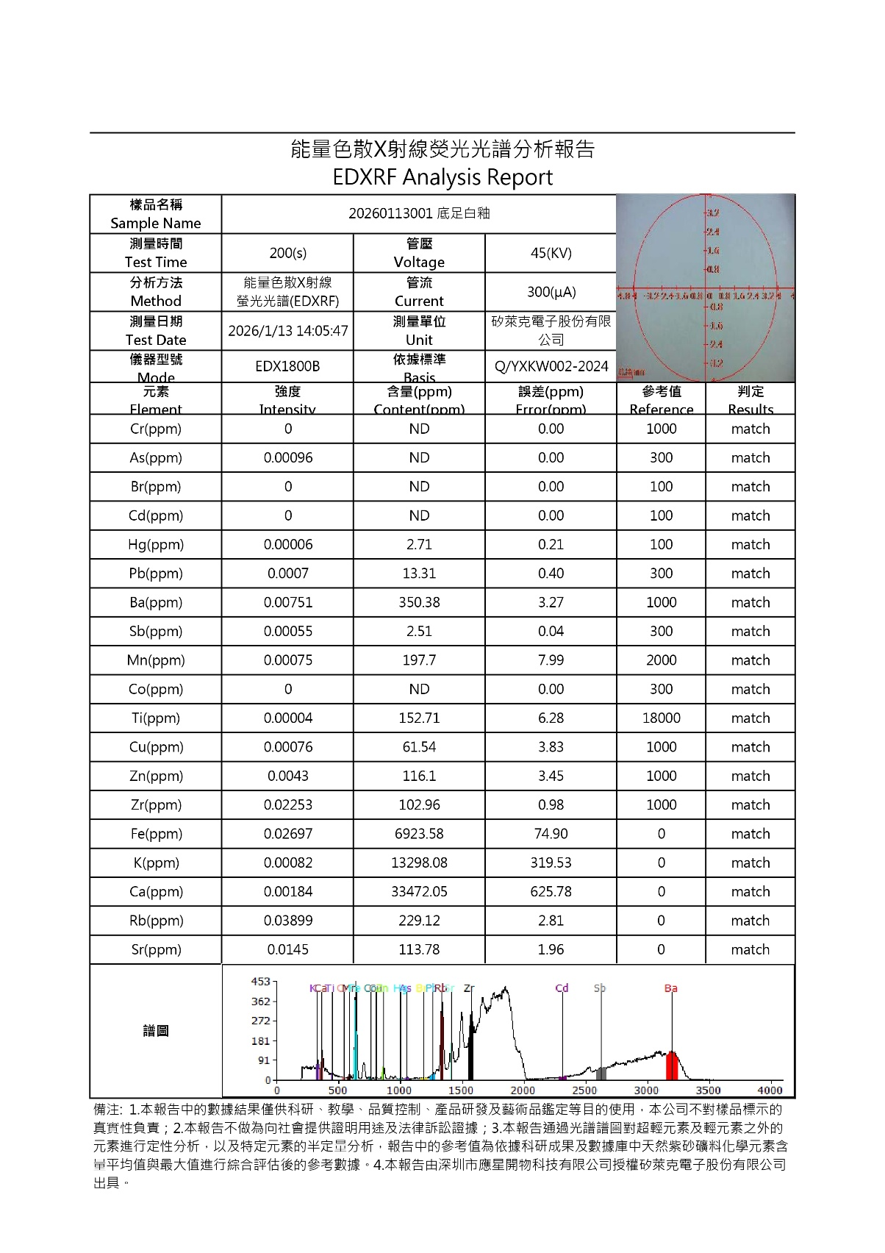

- Supplementary Table S4. Calculation of Geometric Spillover Correction for Rb/Sr Ratio
Region | Area (%) | Rb (ppm) | Sr (ppm) | Rb/Sr Ratio
Measured Composite (Foot Ring) | - | 267.80 | 90.92 | 2.95
Interior of the foot ring (S3) | 19.0 | 229.12 | 113.78 | 2.01
Exterior of the foot ring (S1) | 18.0 | 229.24 | 129.86 | 1.77
Corrected Body (S2) | 63.0 | 290.48 | 72.90 | 3.98

- Supplementary Fig. S1: Transmitted-light appearance of the ceramic body.
Transmitted-light photomicrograph of the Ya-shou-bei, with illumination introduced from below through the vessel base. The ceramic body transmits a uniform warm amber-yellow tonality, consistent with a fine-grained, well-levigated porcelain body of low impurity content. The even distribution of transmitted light across the vessel wall indicates homogeneous body thickness and uniform raw material processing, characteristic of high-quality Jingdezhen porcelain stone-based bodies. Underglaze cobalt-decorated zones are visible as darker silhouettes, reflecting consistent pigment application depth without evidence of bleed-through or anomalous accumulation. The wall thickness increases gradually from rim to belly, consistent with the intentional weight distribution of the ya-shou-bei form. No localized opacity, pin holing, or glaze discontinuity is observed. These transmitted-light characteristics are qualitatively consistent with the refined body preparation associated with early Ming imperial kiln production at Jingdezhen.
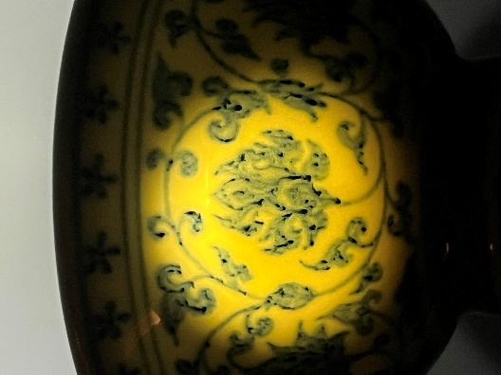

- Supplementary Fig. S2. Sub-glaze bubble distribution and boundary softening in the cobalt-decorated glaze layer.
High-magnification photomicrograph of the cobalt-decorated glaze layer, showing a multimodal distribution of sub-glaze bubbles of varying diameter within the glaze matrix. Large, isolated bubbles coexist with densely packed medium-to-small bubbles concentrated at the margins of high-density cobalt zones, and a fine dispersion of micro-bubbles throughout the glaze body. This heterogeneous bubble size distribution is consistent with extended high-temperature maturation under wood-fired kiln conditions, reflecting differential gas evolution at varying depths and temperatures within the glaze layer during prolonged firing.
Two to three localized subsidence zones are visible as circular depressions of deep cobalt coloration, corresponding to high-concentration pigment accumulation areas. Elevated bubble density at the margins of these zones indicates localized pigment–glaze interaction and viscous flow during firing. The transitions between high- and low-concentration cobalt zones exhibit gradual tonal gradients rather than sharp boundaries, indicative of lateral diffusion and vertical infiltration of cobalt ions into the surrounding glaze matrix during high-temperature maturation. These features are collectively consistent with natural high-temperature firing processes and are not attributable to post-production intervention.
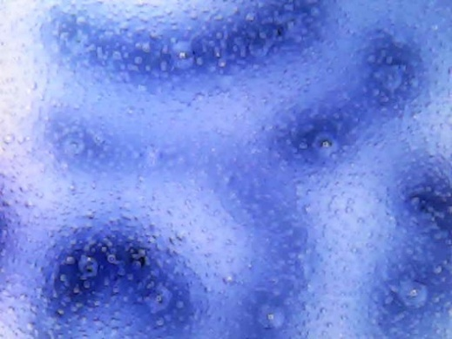

- Supplementary Fig. S3. Feather-like Fe–Mn crystallites and pigment–glaze interaction features in the cobalt-decorated zone.
High-magnification photomicrograph of the cobalt-decorated glaze layer, revealing feather-like (lanceolate) Fe–Mn crystallites at the periphery of a high-density iron–manganese precipitation zone (dark region, centre-left). The crystallites exhibit characteristic bilateral symmetry with a pronounced central axis and laterally radiating branches, consistent with directional solidification of iron-rich phases during high-temperature firing. Metallic specular reflections from crystal surfaces indicate partial exposure at the glaze–air interface. The surrounding glaze matrix contains densely distributed sub-glaze bubbles of varying diameter, indicative of extended maturation under high-temperature wood-fired kiln conditions. Localized glaze subsidence is observed at the margins of the precipitation zone, resulting from pigment–glaze interdiffusion and viscous flow during prolonged firing. These features are characteristic of authentic Sumaliqing-type imported cobalt pigments fired under reducing kiln atmospheres at temperatures exceeding 1250°C.
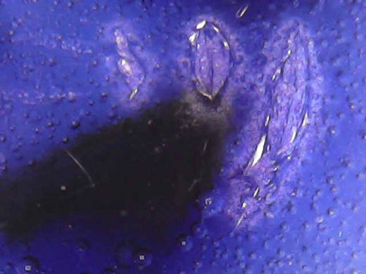

- Supplementary Fig. S4. Macroscopic views of the Ya-shou-bei examined in this study.
(a) Overall exterior view. The vessel displays a characteristic ya-shou-bei (press-hand cup) profile with an everted rim, globular belly, and short foot ring, mounted on a wooden stand for display. The exterior surface bears dense scrolling lotus (lianhua) decoration in cobalt blue underglaze, with a register of five-petalled floral diaper motifs encircling the rim. The blue-and-white decoration exhibits the deep, saturated cobalt tonality with localized areas of darker concentration characteristic of high-iron, low-manganese imported cobalt pigment. The glaze surface presents a clear, lustrous finish consistent with high-fired reduction-atmosphere firing.
(b) Interior view. The interior presents a plain white glazed surface with two fine cobalt blue line borders near the rim. The central medallion depicts two lions at play with a brocade ball (shuangshi gunxiuqiu), enclosed within a circle border. At the center of the composition, a circular cartouche bears a four-character reign mark inscribed in seal script (zhuanshu). The overall interior glaze is even and luminous, with concentric throwing marks visible across the bowl wall, indicative of fine wheel-thrown construction.
(c) Base view. The foot ring (quanzu) is unglazed on its contact surface, exposing the fired ceramic body, which shows the characteristic iron-rich reddish-brown coloration (huoshi hong, fire-stone red) consistent with natural oxidation of iron-bearing raw materials at the foot margin during kiln firing. The interior of the foot ring floor is covered with a pale blue-white glaze. The exterior wall below the foot ring continues the scrolling floral decoration. No reign mark is present on the base, consistent with the Yongle-period practice of incorporating the mark within the interior decorative programme rather than on the exterior base.
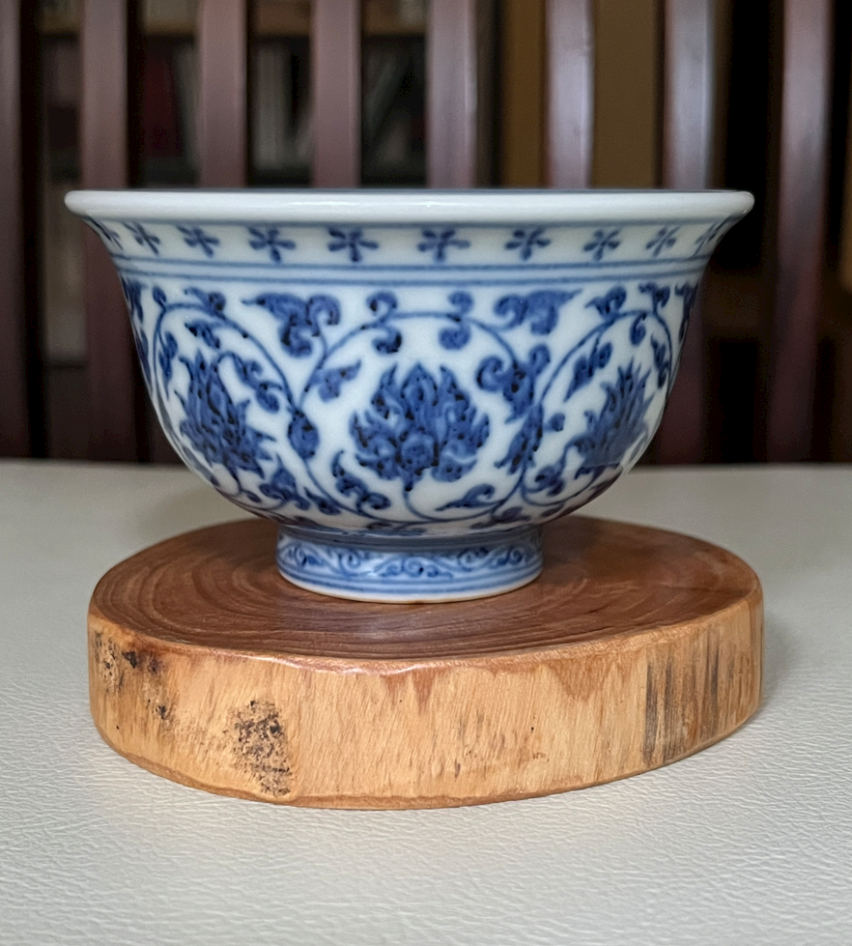 | 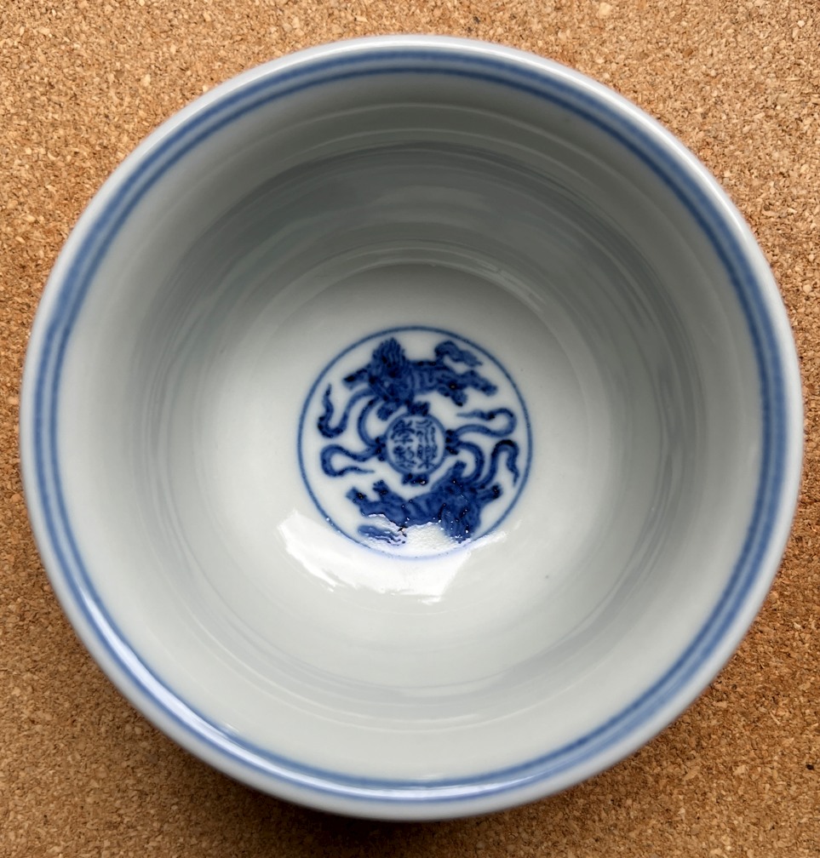 | 