Table 2 Molecular docking results of 5 main active ingredients and 10 core targets
Target | PDB ID | Target Structure | Active Ingredients | Affinity  (kJ·mol⁻¹) | Best-docked complex
HSP90AA1 | 3O0I | 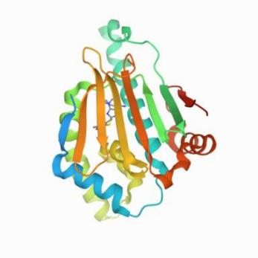 | quercetin | -5.6 | 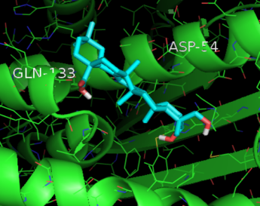
HSP90AA1 | 3O0I |  | kaempferol | -5.4
HSP90AA1 | 3O0I |  | formononetin | -5.1
HSP90AA1 | 3O0I |  | isorhamnetin | -5.4
HSP90AA1 | 3O0I |  | hederagenin | -5.9
NCOA2 | 5EHJ | 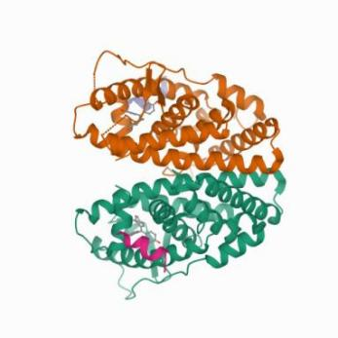 | quercetin | -5.5 | 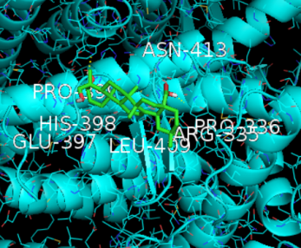
NCOA2 | 5EHJ |  | kaempferol | -5.3
NCOA2 | 5EHJ |  | formononetin | -4.5
NCOA2 | 5EHJ |  | isorhamnetin | -5.2
NCOA2 | 5EHJ |  | hederagenin | -5.7
PPARG | 6TSG | 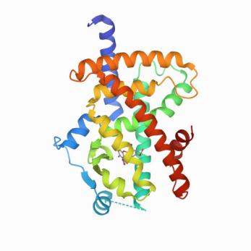 | quercetin | -7.9 | 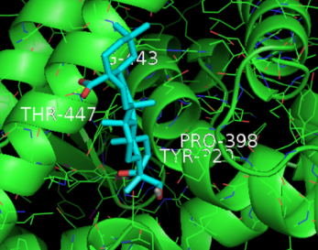
PPARG | 6TSG |  | kaempferol | -7.3
PPARG | 6TSG |  | formononetin | -6.7
PPARG | 6TSG |  | isorhamnetin | -7.3
PPARG | 6TSG |  | hederagenin | -8.2
PRKACA | 6ZN0 | 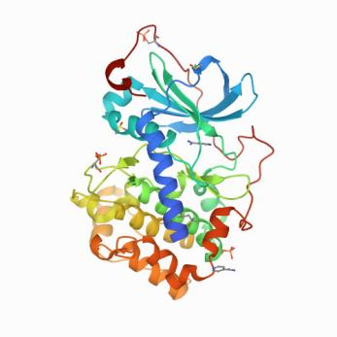 | quercetin | -7.4 | 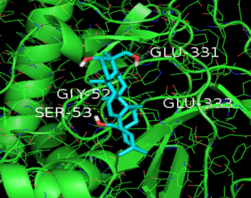
PRKACA | 6ZN0 |  | kaempferol | -7.1
PRKACA | 6ZN0 |  | formononetin | -6.4
PRKACA | 6ZN0 |  | isorhamnetin | -7.6
PRKACA | 6ZN0 |  | hederagenin | -7.9
NOS2 | 1NOS | 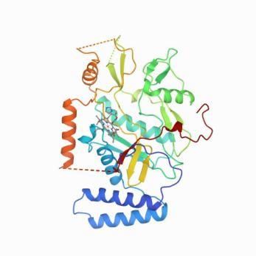 | quercetin | -7.4 | 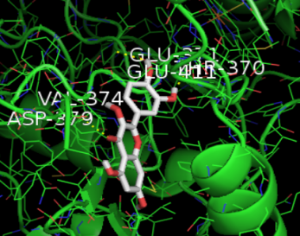
NOS2 | 1NOS |  | kaempferol | -6.9
NOS2 | 1NOS |  | formononetin | -6.5
NOS2 | 1NOS |  | isorhamnetin | -6.9
NOS2 | 1NOS |  | hederagenin | -6.8
PDE3A | 7LRE | 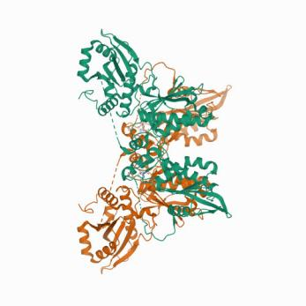 | quercetin | -8.3 | 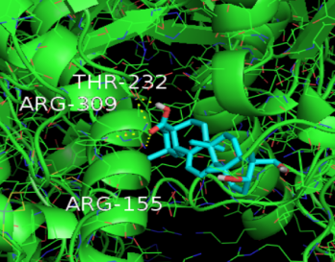
PDE3A | 7LRE |  | kaempferol | -8.4
PDE3A | 7LRE |  | formononetin | -7.5
PDE3A | 7LRE |  | isorhamnetin | -8.4
PDE3A | 7LRE |  | hederagenin | -8.9
PTGS1 | 1EBV | 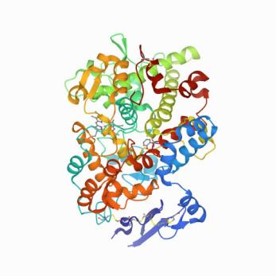 | quercetin | -9.7 | 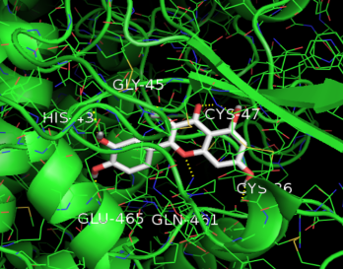
PTGS1 | 1EBV |  | kaempferol | -9.6
PTGS1 | 1EBV |  | formononetin | -9.3
PTGS1 | 1EBV |  | isorhamnetin | -9.5
PTGS1 | 1EBV |  | hederagenin | -8.2
PTGS2 | 4RUT | 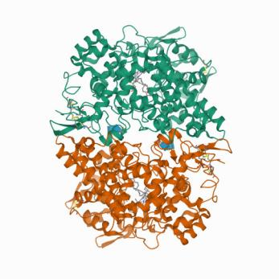 | quercetin | -7.9 | 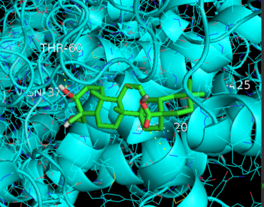
PTGS2 | 4RUT |  | kaempferol | -7.7
PTGS2 | 4RUT |  | formononetin | -7.7
PTGS2 | 4RUT |  | isorhamnetin | -7.8
PTGS2 | 4RUT |  | hederagenin | -8.8
ADRB2 | 3NY9 | 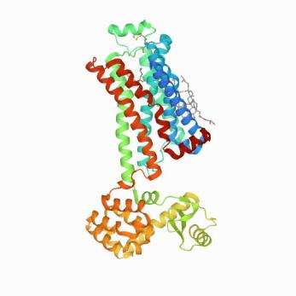 | quercetin | -7.8 | 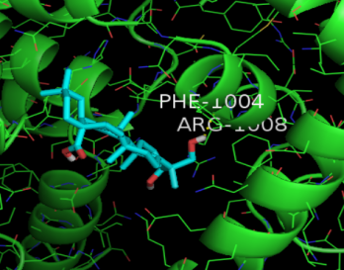
ADRB2 | 3NY9 |  | kaempferol | -7.8
ADRB2 | 3NY9 |  | formononetin | -8.1
ADRB2 | 3NY9 |  | isorhamnetin | -7.8
ADRB2 | 3NY9 |  | hederagenin | -8.5
ESR1 | 6KN5 | 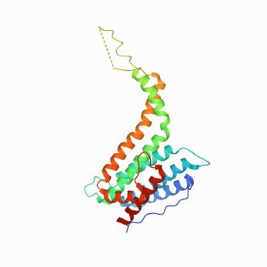 | quercetin | -6.6 | 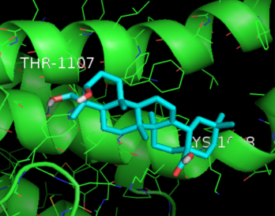
ESR1 | 6KN5 |  | kaempferol | -6.7
ESR1 | 6KN5 |  | formononetin | -7.0
ESR1 | 6KN5 |  | isorhamnetin | -6.6
ESR1 | 6KN5 |  | hederagenin | -7.1

