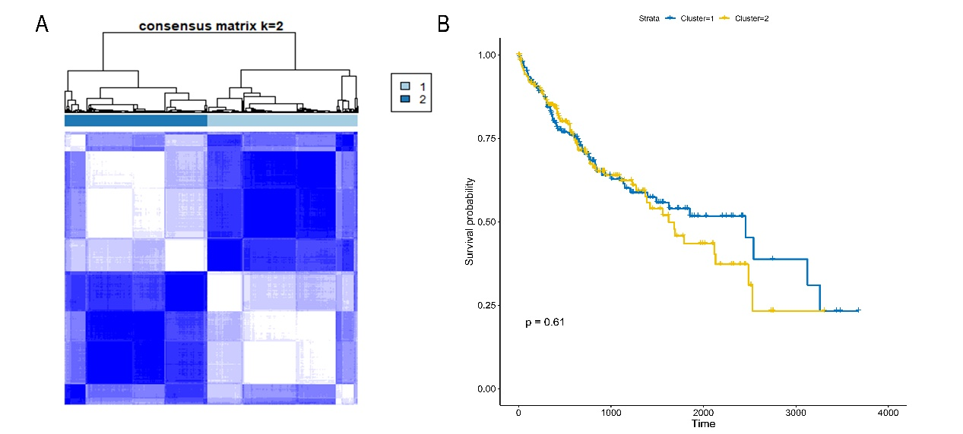
CC analysis to explore patient differences
In total, 367 HCC patients were grouped into two clusters according to the consensus clustering matrix (k = 2) (a). KM curves for the two clusters found no significant differences between the two clusters (b).

