Supplementary Table 1 Details of ATRT cell lines
Molecular details
Cell line | Culture type | Group | Location | SMARCB1 status
CHLA-05-ATRT | Suspension | SHH | Supratentorial | HMZ Del x6
CHLA-02-ATRT | Suspension | SHH | Infratentorial | HMZ Del x1-9
CHLA-04-ATRT | Suspension | SHH | Supratentorial | HMZp.Gln257X
CHLA-06-ATRT | Suspension | TYR/MYC | Infratentorial | HMZ Del x6
BT12 | Adherent | TYR/MYC | Infratentorial | HMZp.Met27Argfs*28
BT16 | Adherent | TYR/MYC | Infratentorial | HMZp.Arg60Glufs*10
HMZ Del: homozygous deletion; x: exon; X: stop codon; HMZp: homozygous point mutation; fs: frameshift (Adapted from Torchia et al., 2016²²).

Clinical details

Cell line | Age (Months) | Gender | Derivation | Originally from
CHLA-05-ATRT | 34.0 | Male | Isolated from the resected brain tumor at the time of diagnosis | Children’s Hospital Los Angeles; USA
CHLA-02-ATRT | 20.4 | Male | Isolated from the resected brain tumor at the time of diagnosis | Children’s Hospital Los Angeles; USA
CHLA-04-ATRT | 20.0 | Male | Isolated from the brain tumor at the time of autopsy | Children’s Hospital Los Angeles; USA
CHLA-06-ATRT | 3.0 | Female | Unknown | Children’s Hospital Los Angeles; USA
BT12 | 24.0 | Female | Isolated from the resected brain tumor at the time of diagnosis | Children's Hospital of Philadelphia; USA
BT16 | 1.5 | Male | Unknown | Children's Hospital of Philadelphia; USA
Cell lines clinical details retrieved from https://www.cellosaurus.org/ and https://www.atcc.org/

Supplementary Table 2 KOs Genomic validation results summary
Cell line | Gene targeted | Exon targeted | Indel type | Indel percentage | Total efficiency
BT12 | CD44 | Exon 3 | -3bp deletion | 93.1% | 97%
BT12 | MIF | Exon 1 | +1bp insertion | 66% | 96.1%
BT12 | MIF | Exon 1 | -7bp deletion | 32.1% | 96.1%
BT12 | PDGFB | Exon 2 | +1bp insertion | 95.2% | 96.1%
BT12 | PDGFRB | Exon 4 | +1bp insertion | 3.4% | 93.9%
BT12 | PDGFRB | Exon 4 | +3bp insertion | 47% | 93.9%
BT12 | PDGFRB | Exon 4 | -3bp deletion | 1.9% | 93.9%
BT12 | PDGFRB | Exon 4 | -4bp deletion | 41.8% | 93.9%
BT12 | PDGFB (in PDGFRB/PDGFB DKO) | Exon 2 | -9bp deletion | 60.4% | 74.7%
BT12 | PDGFRB (in PDGFRB/PDGFB DKO) | Exon 4 | +1bp insertion | 17.4% | 96.5%
BT12 | PDGFRB (in PDGFRB/PDGFB DKO) | Exon 4 | -1bp deletion | 73.2% | 96.5%
BT12 | PDGFRB (in PDGFRB/PDGFB DKO) | Exon 4 | -3bp deletion | 1.3% | 96.5%
BT12 | PDGFRB (in PDGFRB/MIF DKO) | Exon 4 | +1bp insertion | 25.5% | 60.7%
BT12 | PDGFRB (in PDGFRB/MIF DKO) | Exon 4 | -1bp insertion | 21.2% | 60.7%
BT12 | MIF (in PDGFRB/MIF DKO) | Exon 1 | +3bp insertion | 3.8% | 94.3%
BT12 | MIF (in PDGFRB/MIF DKO) | Exon 1 | -1bp deletion | 85.3% | 94.3%
BT16 | CD44 | Exon 3 | -2bp deletion | 37.7% | 78%
BT16 | CD44 | Exon 3 | -3bp deletion | 6.1% | 78%
BT16 | CD44 | Exon 3 | -4bp deletion | 24% | 78%
BT16 | MIF | Exon 1 | +2bp insertion | 79.1% | 93.3%
BT16 | MIF | Exon 1 | +1bp insertion | 14.2% | 93.3%
BT16 | PDGFB | Exon 2 | -9bp deletion | 42.5% | 54%
BT16 | PDGFB | Exon 2 | +1bp insertion | 4.3% | 54%
BT16 | PDGFC | Exon 4 | +1bp insertion | 94.1% | 96.7%
BT16 | PDGFRB | Exon 4 | -2bp deletion | 45.9% | 82.5%
BT16 | PDGFRB | Exon 4 | -1bp deletion | 27.4% | 82.5%
BT16 | PDGFB (in PDGFRB/PDGFB DKO) | Exon 2 | -8bp deletion | 79% | 84.8%
BT16 | PDGFRB (in PDGFRB/PDGFB DKO) | Exon 4 | -7bp deletion | 1.4% | 72.2%
BT16 | PDGFRB (in PDGFRB/PDGFB DKO) | Exon 4 | -4bp deletion | 1.4% | 72.2%
BT16 | PDGFRB (in PDGFRB/PDGFB DKO) | Exon 4 | +1bp insertion | 66.4% | 72.2%
BT16 | PDGFRB (in PDGFRB/MIF DKO) | Exon 4 | +1bp insertion | 74.5% | 75.8%
BT16 | MIF (in PDGFRB/MIF DKO) | Exon 1 | -10bp deletion | 94.4% | 95.3%
b
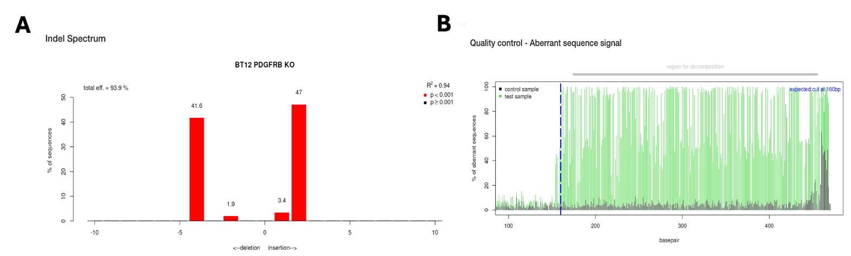
a
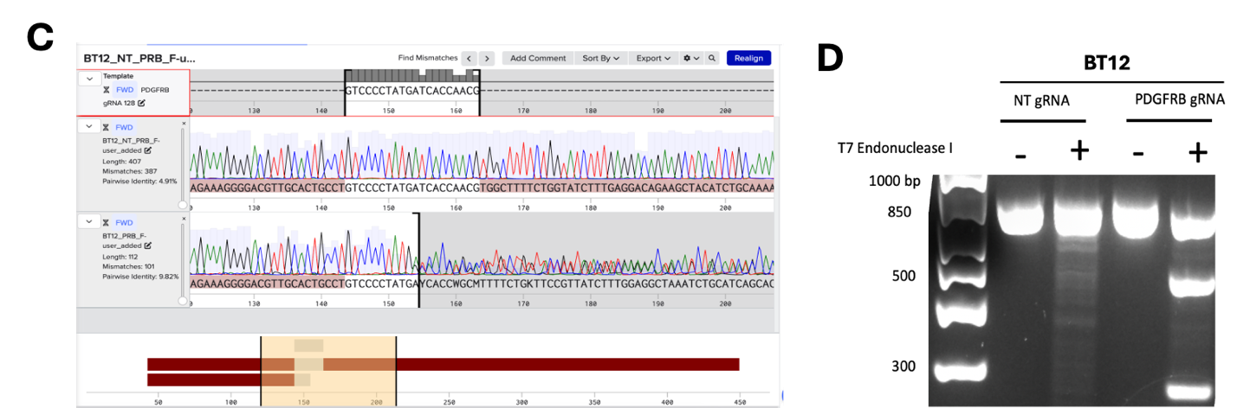
d
c

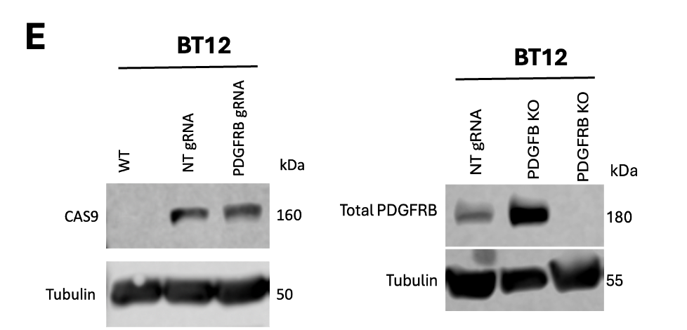
f
e
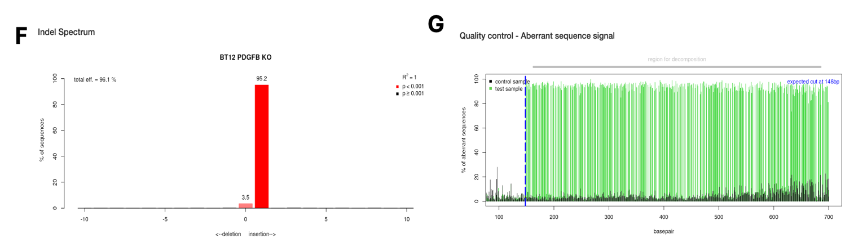
g
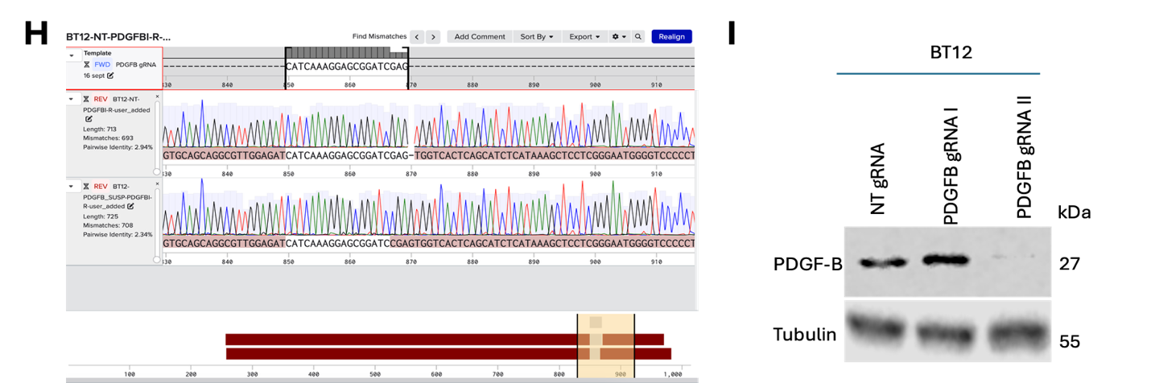
i
k
h
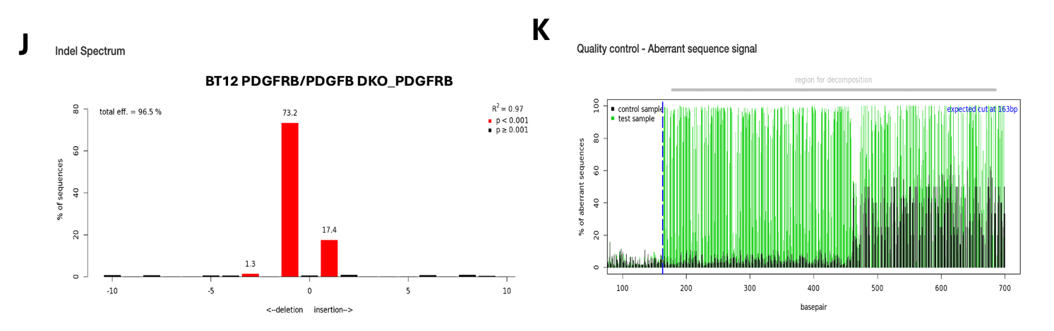
l
m
j
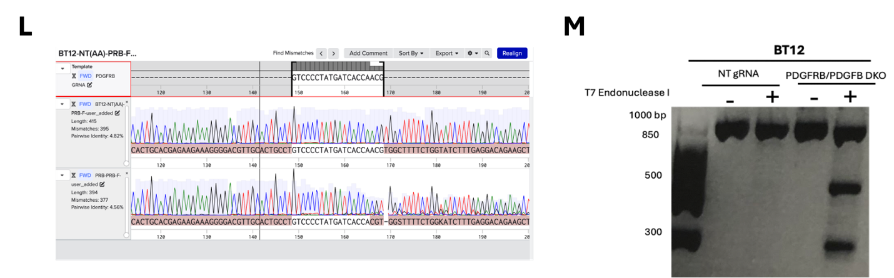

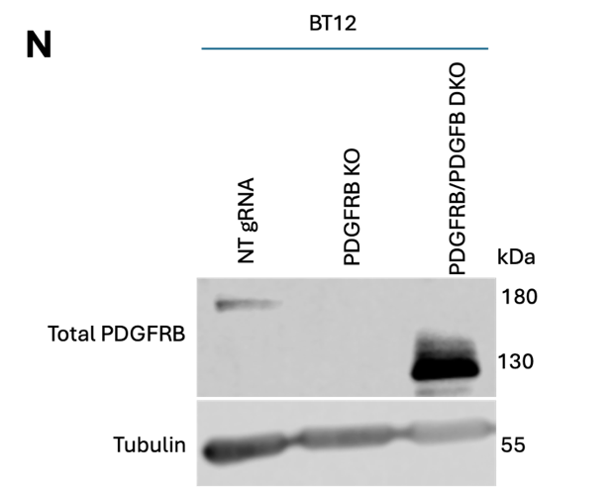
p
n
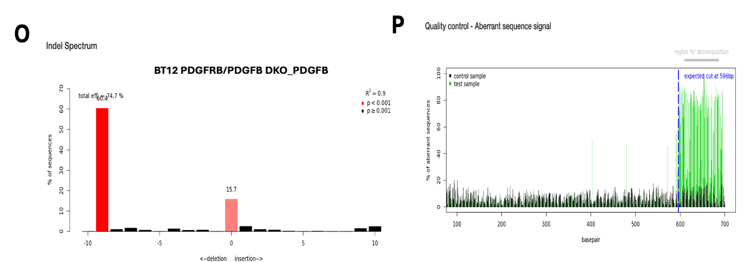
r
o
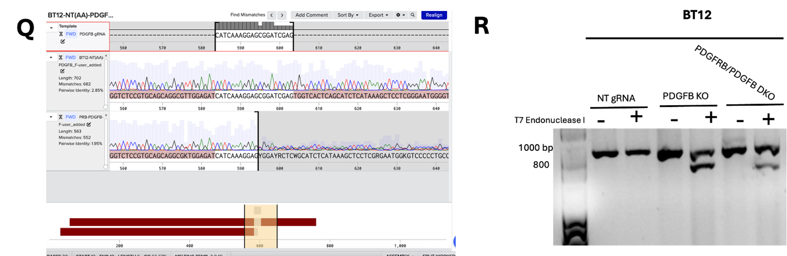
q
Supplementary Fig. 1. Validation of BT12 PDGFB KO, PDGFRB KO, and PDGFRB/PDGFB DKO
- a. Tracking of Indels by Decomposition (TIDE) analysis of BT12 PDGFRB KO relative to BT12 NT gRNA. Analysis was conducted using TIDE web tool https://tide.nki.nl/
- b. Corresponding TIDE analysis quality control. Analysis was conducted using TIDE web tool https://tide.nki.nl/
- c. Sanger sequences alignment of PDGFRB gRNA, BT12 NT gRNA, and BT12 PDGFRB KO. Alignment was conducted using Benchling web tool https://www.benchling.com/
- d. T7 Endonuclease I assay results of BT12 NT gRNA and BT12 PDGFRB KO. PCR products were amplified using primers flanking the PDGFRB gRNA site. +/- indicate presence and absence of T7 Endonuclease I, respectively. BT12 PDGFRB KO PCR produced treated with T7 Endonuclease I displays three fragments, indicative of indels presence.
- e. Left: Western blot validation of the expression of Cas9 protein in BT12 NT gRNA and BT12 PDGFRB KO. BT12 wild-type (WT) cells were used as a negative control for Cas9 expression. Right: Western blot validation of the loss of PDGFRB protein expression in BT12 PDGFRB KO cells.
- f-h. TIDE analysis and Sanger sequences alignment of BT12 PDGFB KO relative to BT12 NT gRNA.
- i. Western blot validation of the loss of PDGFB protein expression in BT12 PDGFB KO cells. Two different gRNAs were optimized; gRNA I-transfected cells maintained PDGFB protein expression. gRNA II was selected for downstream experiments.
- j-l. Genomic validation of PDGFRB KO in BT12 PDGFRB/PDGFB DKO cells.
- n. Western blot analysis of PDGFRB expression in BT12 PDGFRB/PDGFB DKO. BT12 PDGFRB KO showed loss of PDGFRB protein expression. BT12 PDGFRB/PDGFB DKO expressed a smaller band detected around 130 kDa.
- o-q. Genomic validation of PDGFB KO in BT12 PDGFRB/PDGFB DKO cells.
- r. T7 Endonuclease I assay showing cleavage of PDGFB PCR product from BT12 PDGFB KO and BT12 PDGFRB/PDGFB DKO, indicative of presence of indels.
a
a
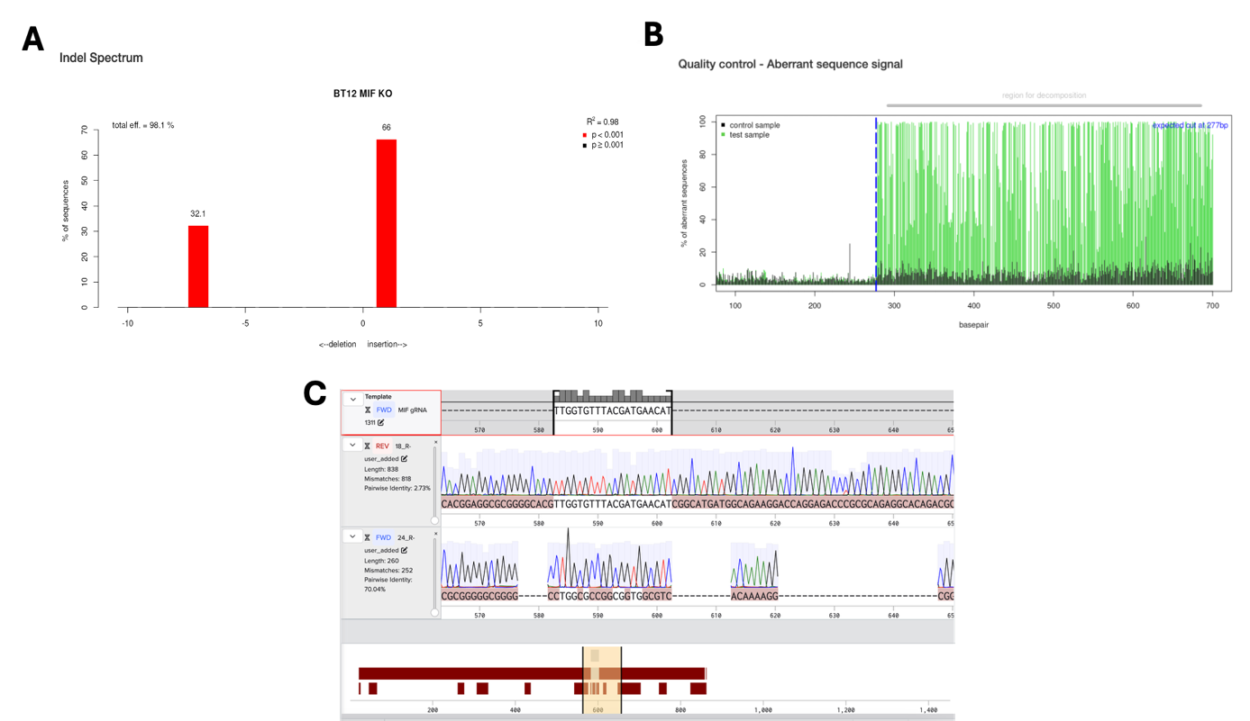
c
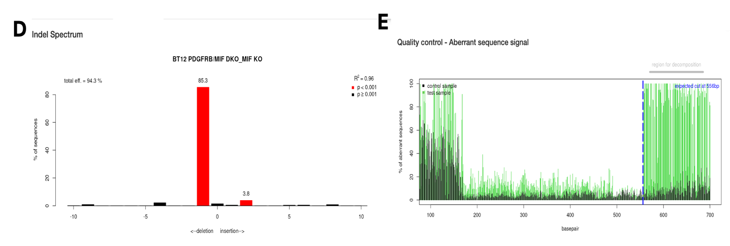
g
e
d
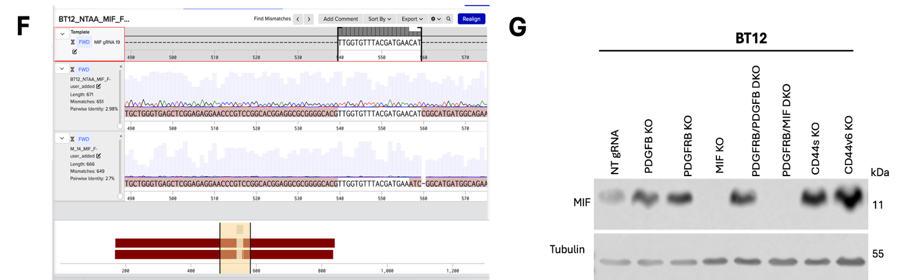
i
f
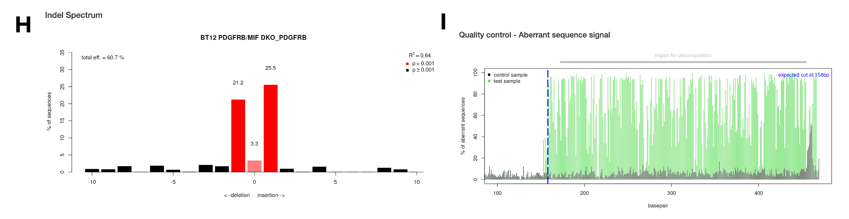
h
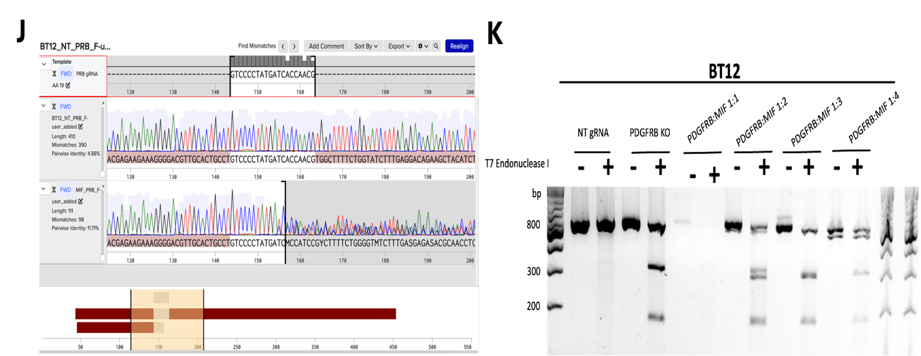
k
j
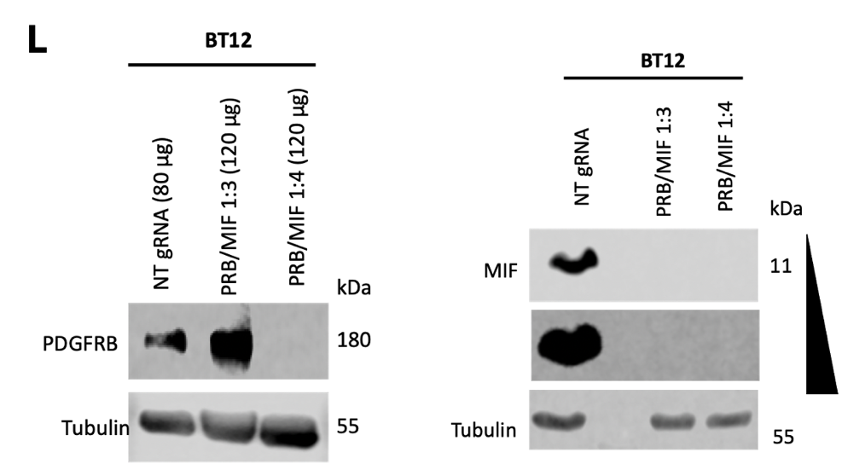
n
m
l
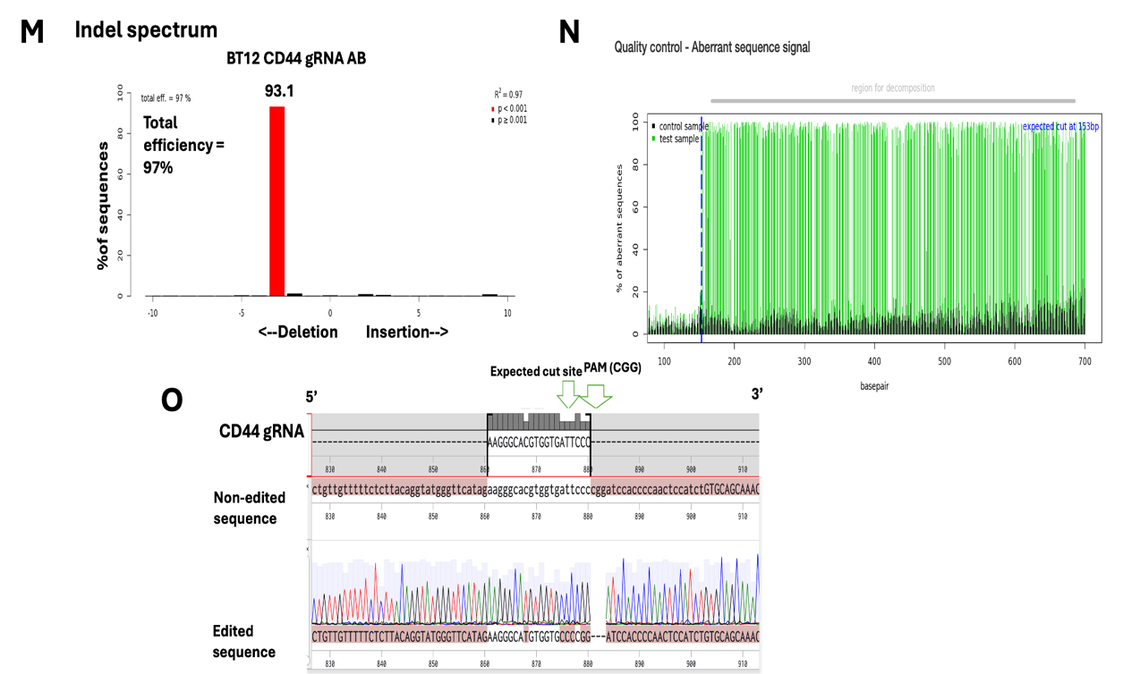
o
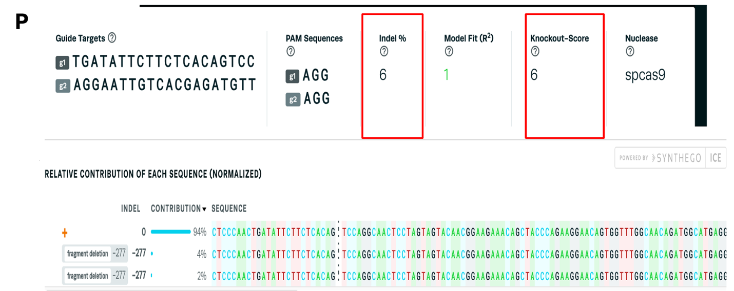
p
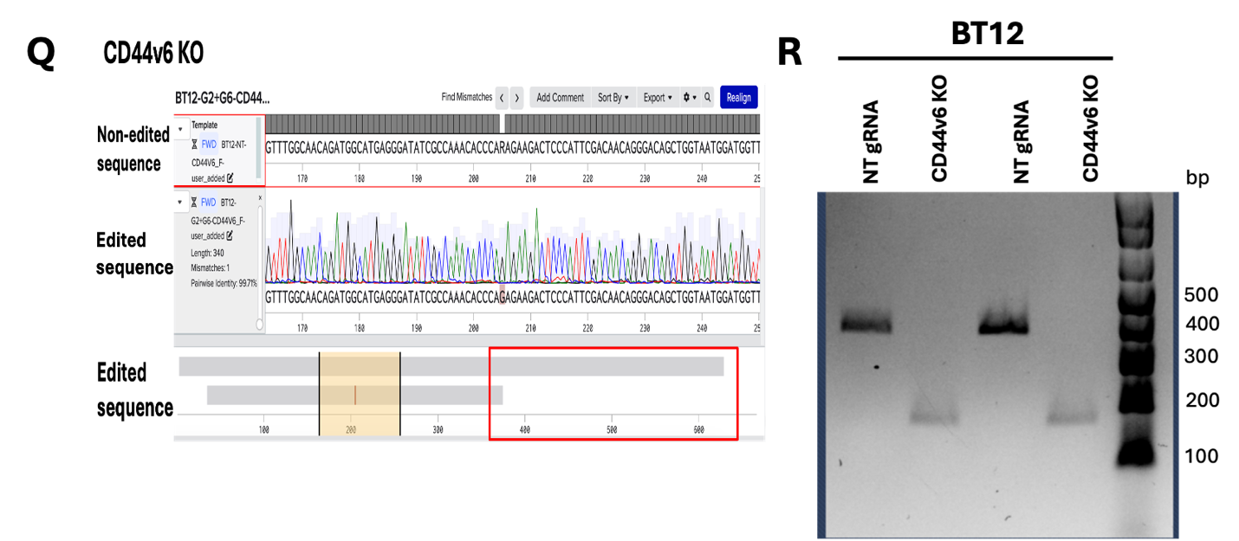
r
q
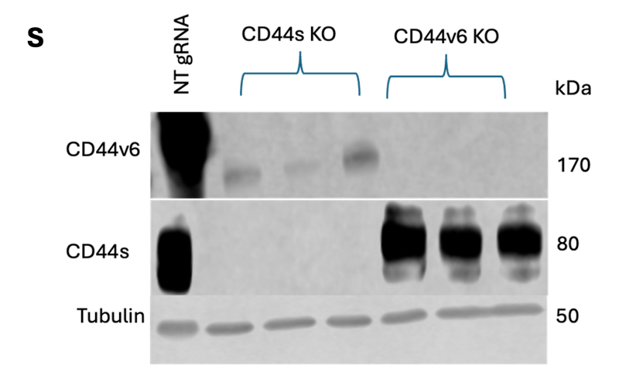
s
Supplementary Fig. 2. Validation of BT12 MIF KO, PDGFRB/MIF DKO, CD44s KO, and CD44v6 KO
- a-c. Genomic validation of BT12 MIF KO
- d-f. Genomic validation of MIF KO in BT12 PDGFRB/MIF DKO
- g. Western blot validation of loss of MIF protein in BT12 MIF KO and BT12 PDGFRB/MIF DKO
- h-j. Genomic validation of PDGFRB KO in BT12 PDGFRB/MIF DKO
- k. T7 Endonuclease I assay validation of PDGFRB KO in BT12 PDGFRB/MIF DKO. PDGFRB KO was included as a positive control; PDGFRB/MIF 1:1, 1:2, 1:3, and 1:4 represent different conditions for DKO optimization, PDGFRB gRNA:MIF gRNA ratio. PDGFRB/MIF DKO 1:4 was selected for subsequent experiments.
- l. Western blot validation of PDGFRB and MIF protein loss in BT12 PDGFRB/MIF DKO. BT12 PDGFRB/MIF DKO 1:4 was selected for subsequent experiments based on the dual loss of PDGFRB and MIF expression.
- m-o. Genomic validation of BT12 CD44s KO.
- p-q. Genomic validation of BT12 CD44v6 KO. Interference of CRISPR edits (ICE) analysis of Sanger sequences was achieved using Synthego ICE analysis tool (ice.synthego.com). The analysis shows ~277 bp fragment deletion, corresponding approximately to the region around CD44 exon 11 (or variable exon 6), as described by Lobo, et al¹⁴⁶.
- r. PCR product analysis of BT12 NT gRNA and BT12 CD44v6 KO, using primers flanking the region including intron v5, exon v6, and intron v6, as described by Lobo et al¹⁴⁶. Two biological replicates were used. BT12 CD44v6 product is smaller relative to that of BT12 NT gRNA, consistent with the fragment deletion.
- s. Western blot validation of CD44s loss in BT12 CD44s KO, and CD44v6 loss in BT12 CD44v6 KO. Three biological replicates of CD44s KO and CD44v6 KO were used, grouped under a brace. BT12 CD44s KO shows loss of CD44s and a decrease in CD44v6. BT12 CD44v6 KO shows loss of CD44v6 and no change in CD44s.
b
a
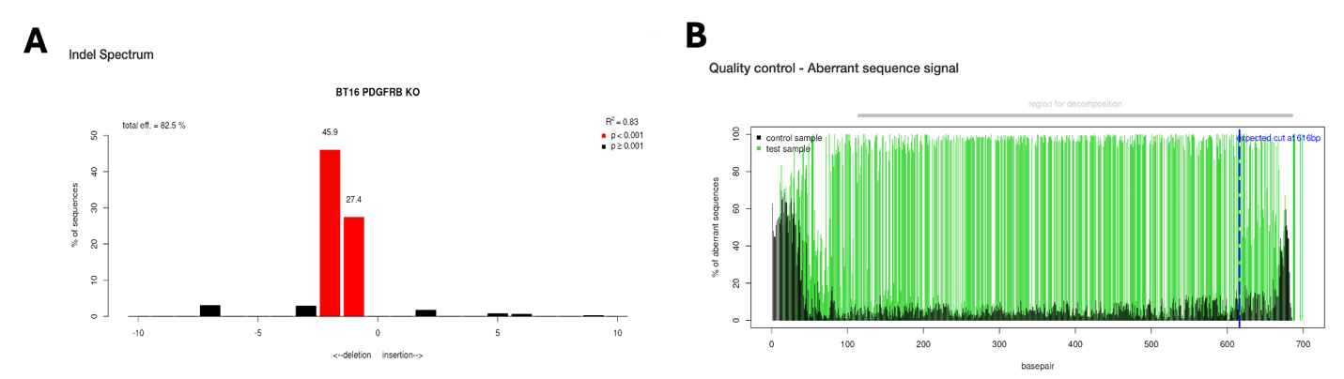
d
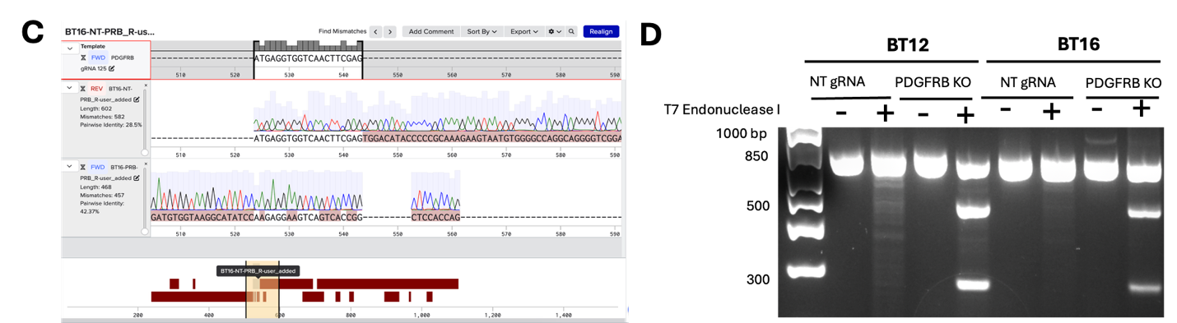
c
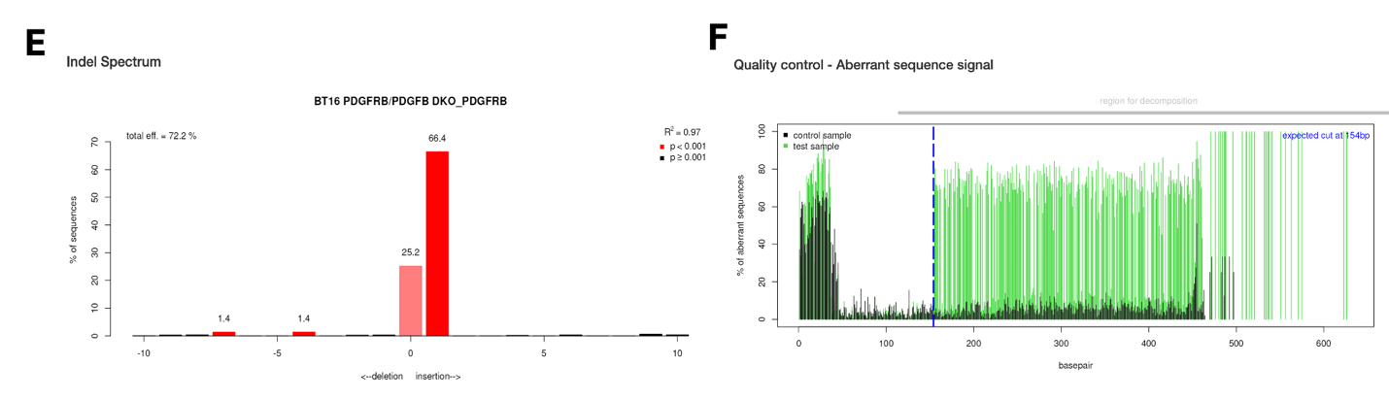
h
g
f
e
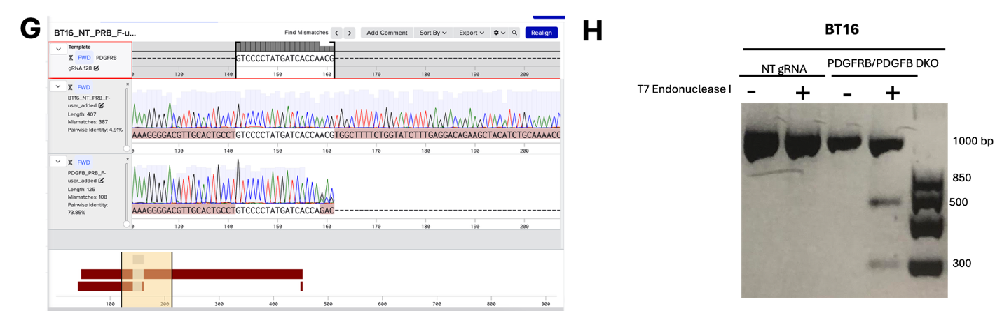
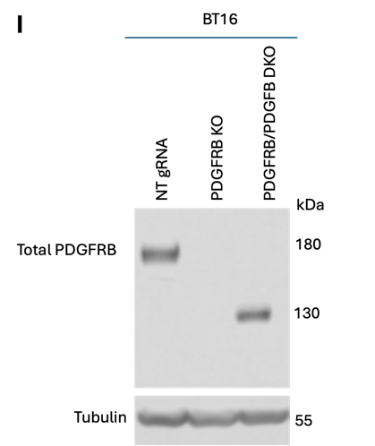
j
i
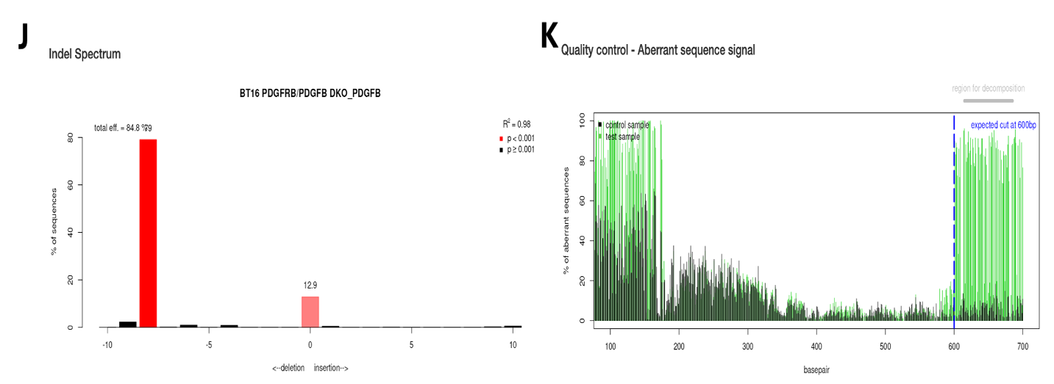
k
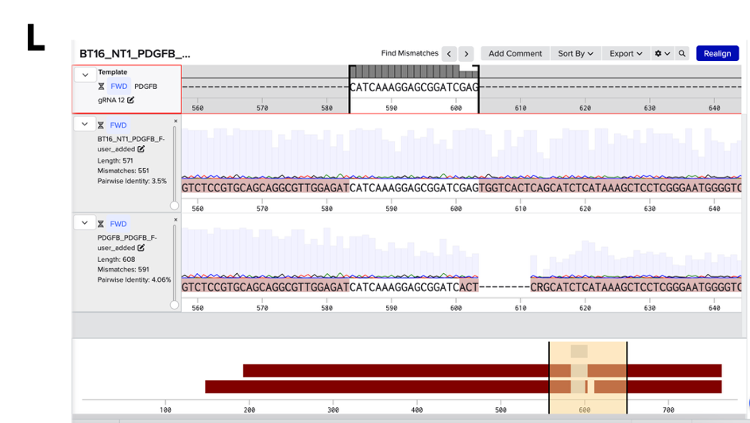
n
m
l
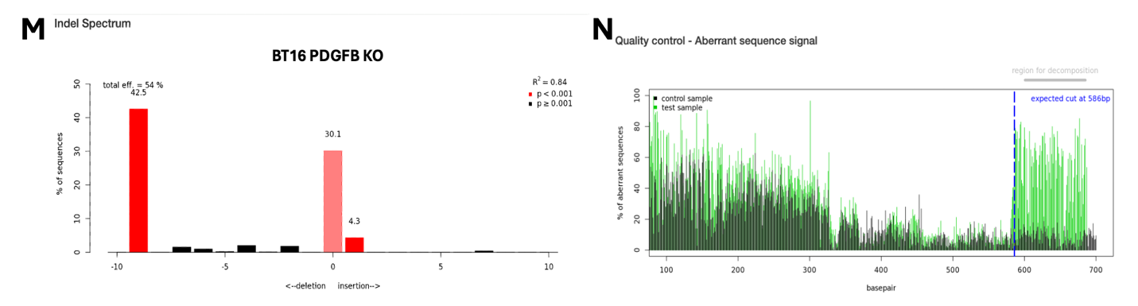
p
o
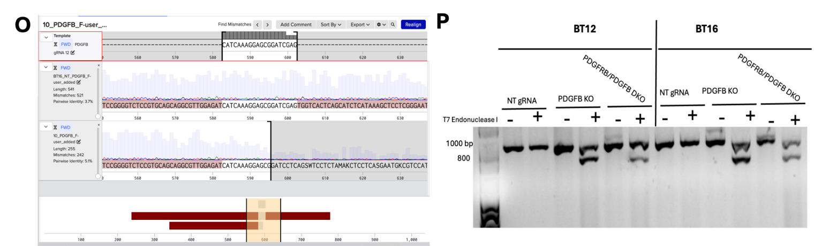
r
q
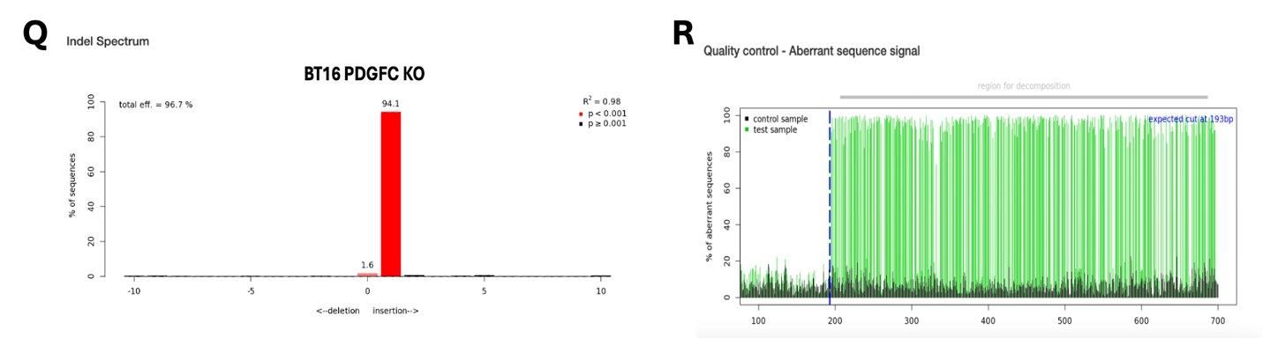
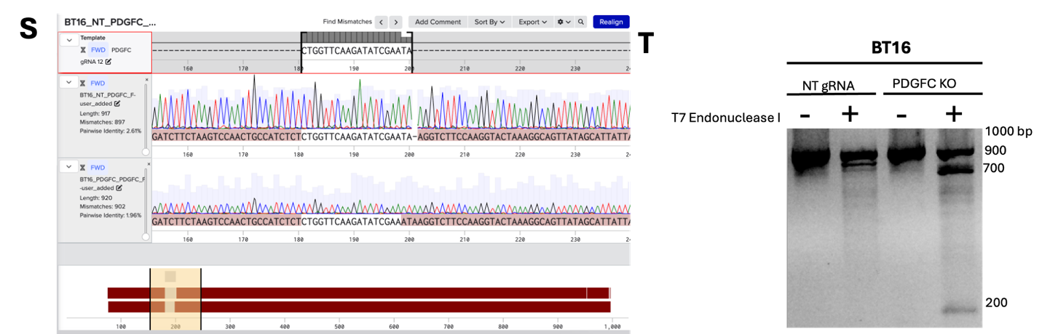
t
s
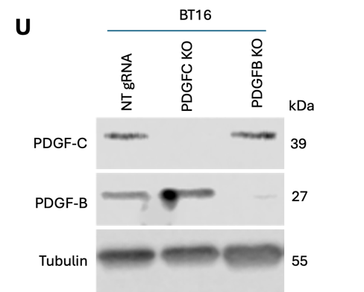
u
Supplementary Fig. 3. Validation of BT16 PDGFB KO, PDGFC KO, PDGFRB KO, and PDGFRB/PDGFB DKO
- a. Tracking of Indels by Decomposition (TIDE) analysis of BT16 PDGFRB KO relative to BT16 NT gRNA. Analysis was conducted using TIDE web tool https://tide.nki.nl/
- b. Corresponding TIDE analysis quality control. Analysis was conducted using TIDE web tool https://tide.nki.nl/
- c. Sanger sequences alignment of PDGFRB gRNA, BT16 NT gRNA, and BT16 PDGFRB KO. Alignment was conducted using Benchling web tool https://www.benchling.com/
- d. T7 Endonuclease I assay results of BT16 NT gRNA and BT16 PDGFRB KO. PCR products were amplified using primers flanking the PDGFRB gRNA site. +/- indicate presence and absence of T7 Endonuclease I, respectively. BT16 PDGFRB KO PCR produced treated with T7 Endonuclease I displays three fragments, indicative of indels presence.
- e-h. Genomic validation of PDGFRB KO in BT16 PDGFRB/PDGFB DKO.
- i. Western blot analysis of PDGFRB expression in BT16 PDGFRB KO and BT16 PDGFRB/PDGFB DKO. BT16 PDGFRB KO showed loss of PDGFRB protein expression. BT16 PDGFRB/PDGFB DKO showed a smaller band detected around 130kDa, similar to that observed in BT12 PDGFRB/PDGFB DKO.
- j-l. Genomic validation of PDGFB KO in BT16 PDGFRB/PDGFB DKO.
- m-o. genomic validation of PDGFB KO in BT16 PDGFB KO.
- p. T7 Endonuclease I assay showing cleavage of PDGFB PCR product from BT16 PDGFB KO and BT16 PDGFRB/PDGFB DKO, indicative of presence of indels.
- q-t. Genomic validation of PDGFC KO in BT16 PDGFC KO.
- u. Western blot analysis showing loss of PDGFB and PDGFC protein expression in BT16 PDGFB KO and BT16 PDGFC KO, respectively.

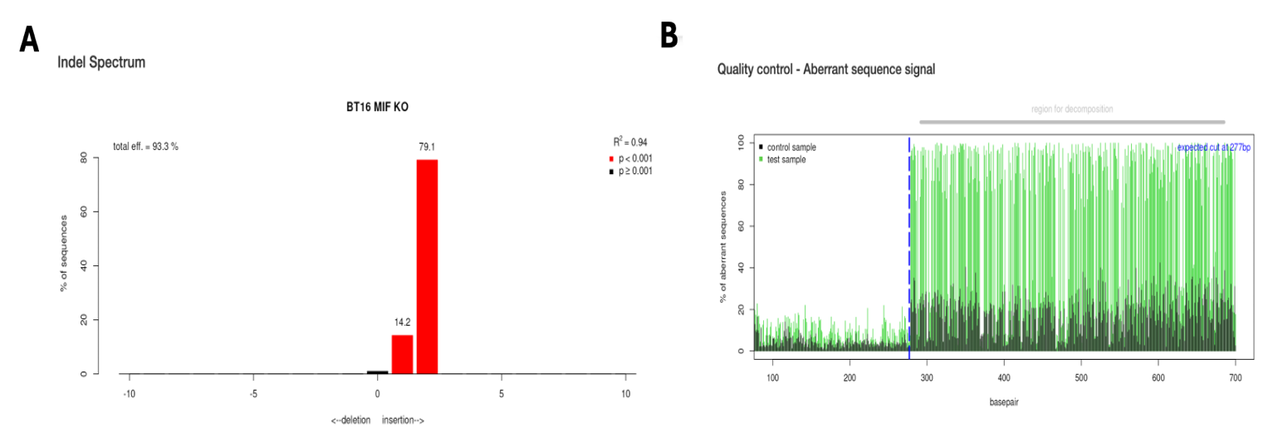
c
b
a
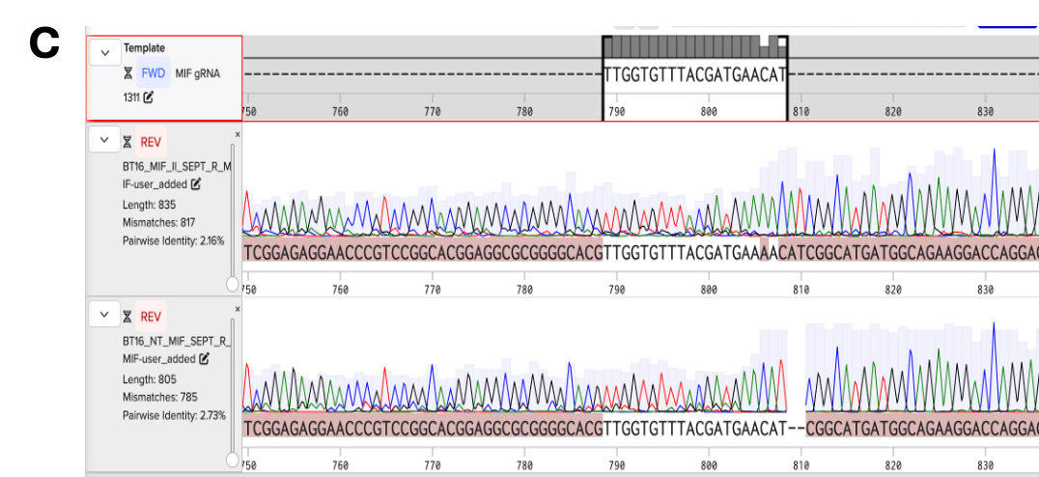
e
d
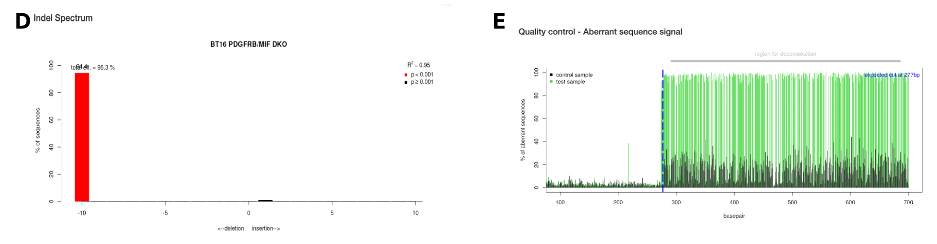
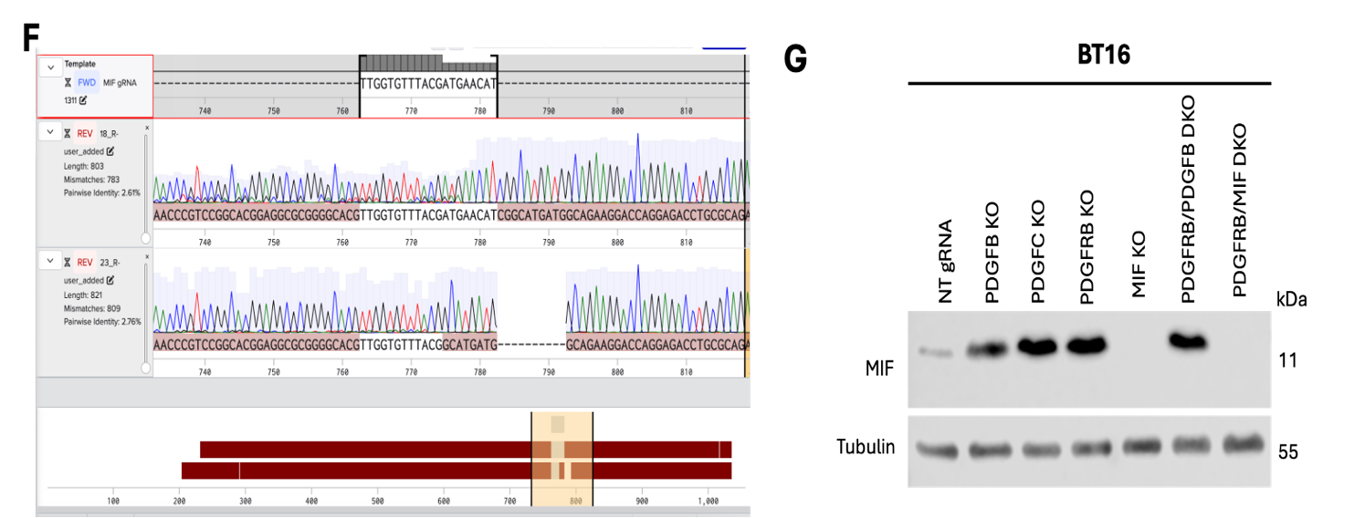
i
h
g
f
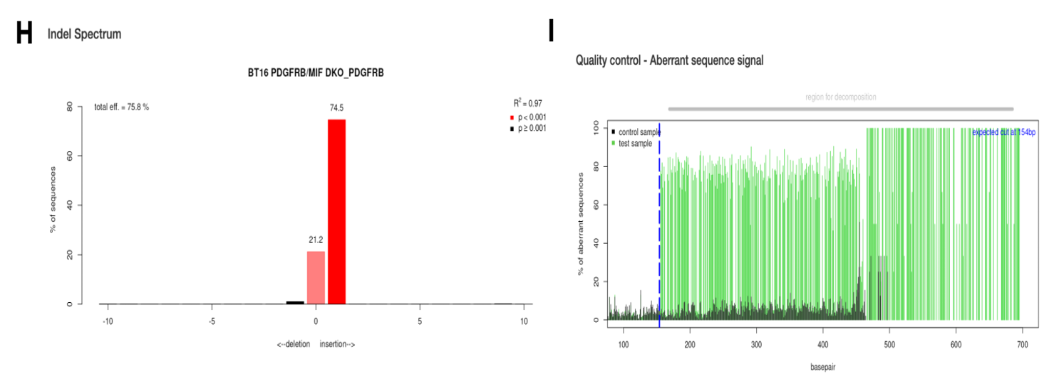
k
j
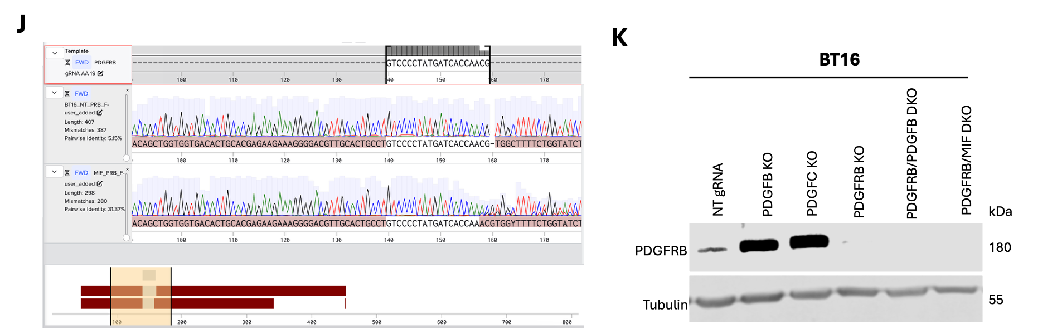
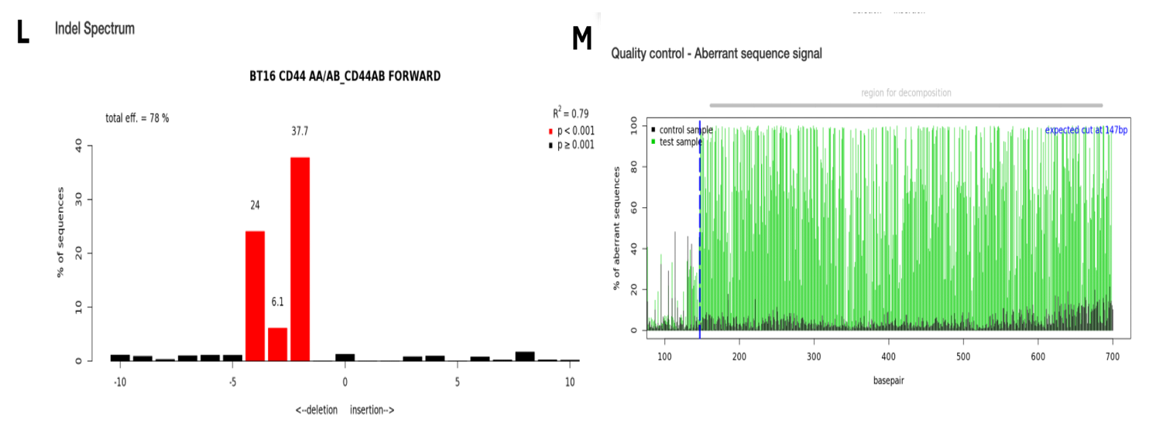
n
m
l
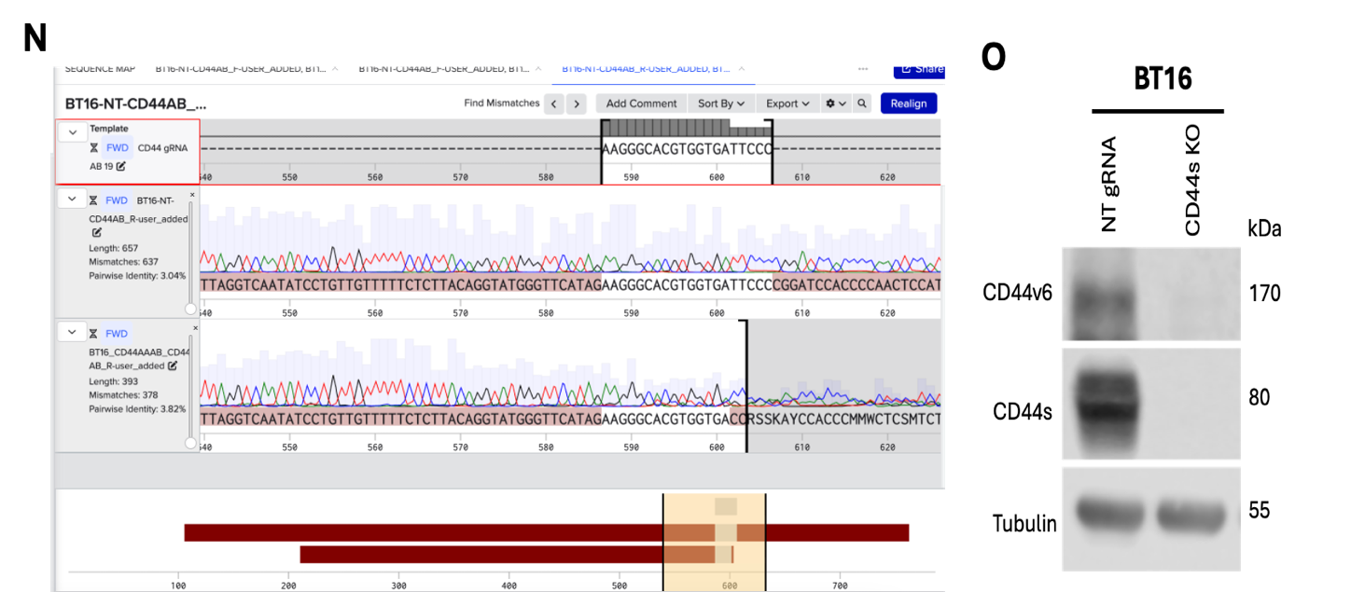
q
o
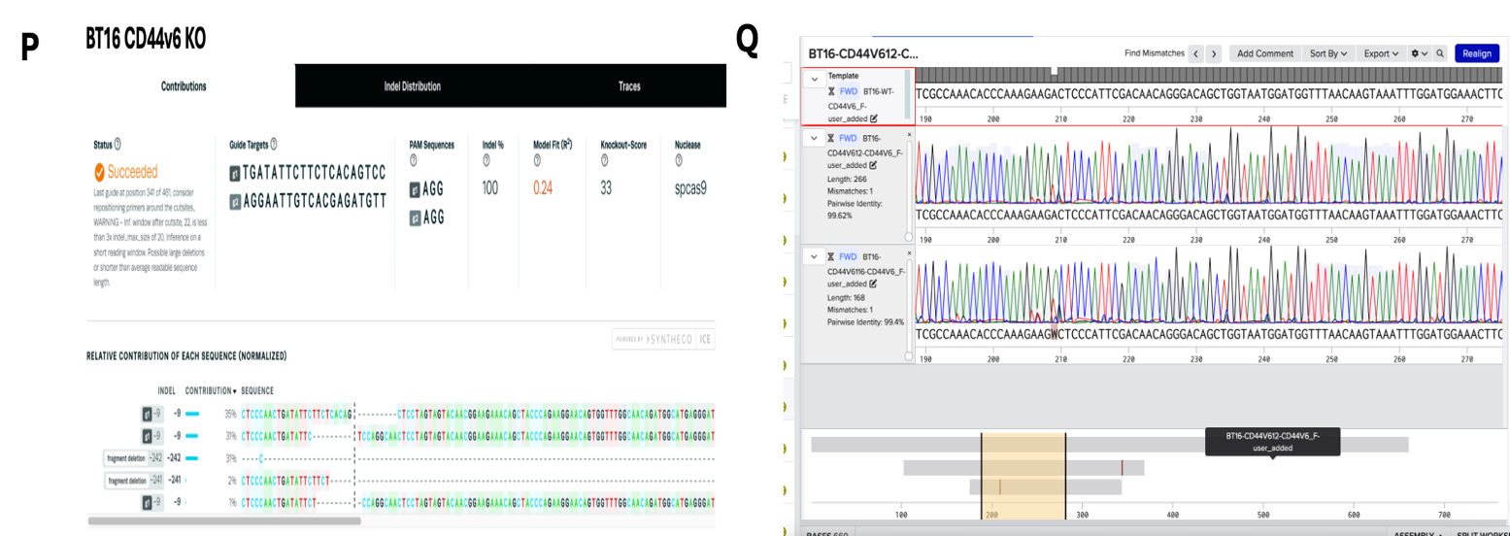
p
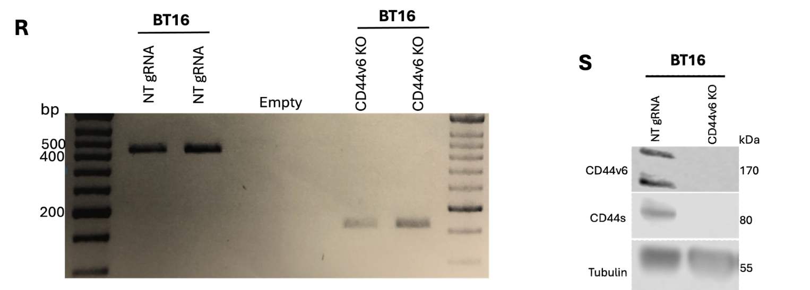
s
r
Supplementary Fig. 4. Validation of BT16 MIF KO, PDGFRB/MIF DKO, CD44s KO, and CD44v6 KO
- a-c. Genomic validation of BT16 MIF KO.
- d-f. Genomic validation of MIF KO in BT16 PDGFRB/MID DKO.
- g. Western blot validation of MIF protein loss in BT16 MIF KO and BT16 PDGFRB/MIF DKO.
- h-j. Genomic validation of PDGFRB KO in BT12 PDGFRB/MIF DKO.
- k. Western blot validation of PDGFRB protein loss in BT12 PDGFRB/MIF DKO.
- l-n. Genomic validation of BT16 CD44s KO.
- o. Western blot validation of CD44s protein loss in BT16 CD44s KO.
- p. Interference of CRISPR edits (ICE) analysis of Sanger sequences of BT16 CD44v6 KO relative to NT gRNA, using Synthego ICE analysis tool (ice.synthego.com). The analysis shows ~241 bp fragment deletion, corresponding approximately to the region around CD44 exon 11 (or variable exon 6), as described by Lobo et al.⁸⁹
- q. Sanger sequences alignment of BT16 NT gRNA and two BT16 CD44v6 KO samples, showing about ~250 bp shorter sequences in BT16 CD44v6 KOs.
- r. PCR product analysis of BT16 NT gRNA and BT16 CD44v6 KO, using primers flanking the region including intron v5, exon v6, and intron v6, as described by Lobo et al.⁸⁹ Two biological replicates were used. BT16 CD44v6 product is smaller relative to that of BT16 NT gRNA, consistent with the fragment deletion.
- s. Western blot validation of CD44v6 protein loss in BT16 CD44v6 KO. Interestingly, BT16 CD44v6 KO showed a loss of CD44s protein, despite no change in CD44 mRNA levels (Figure 4.2I)

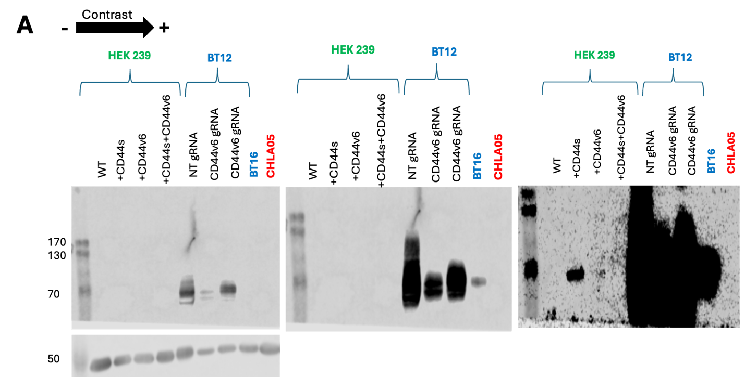
a
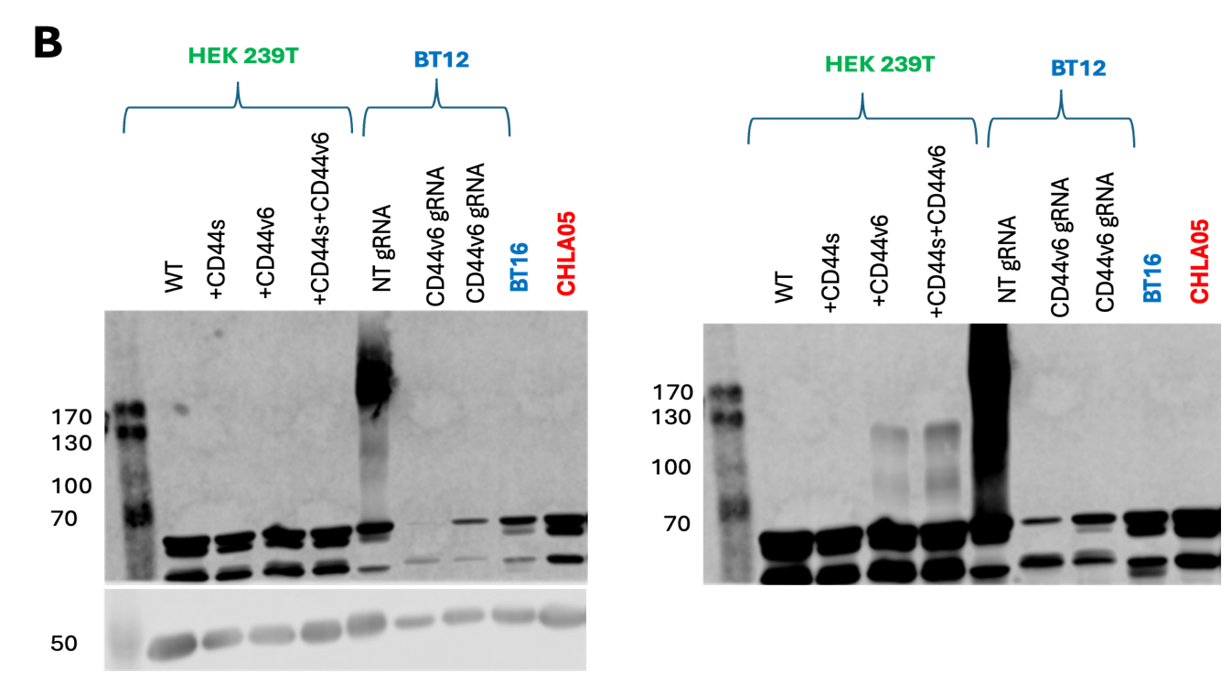
b
Supplementary Fig. 5. CD44 isoform-specific detection validation
CD44s (a) and CD44v6 (b) expression in HEK239T, BT12, BT16, and CHLA05 cells. The images from left to right represent an increasing contrast. HEK293T cells were transfected with CD44s expression plasmid (pPGK-T7/2-CD44s; Addgene Plasmid #137812), CD44v6 expression plasmid (pPGK-T7/2-CD44v6; Addgene Plasmid #137816), or a combination of both, as described by Mielgo et al.¹⁴⁷ BT12 NT gRNA was included as a positive control for CD44s and CD44v6 expression, BT12 CD44s KO was included as a negative control for CD44s expression, and BT12 CD44v6 KO was included as a negative control for CD44v6 expression. BT16 was included as a control for low CD44v6 expression. CHLA05 was included as a negative control for CD44s and CD44v6 expression. CD44 antibody (CST #37259) detects CD44s only in CD44s+ HEK293T cells, without cross-reacting with CD44v6 expressed by CD44v6+ HEK293T cells. Conversely, CD44v6 antibody (Invitrogen #33-6700) detects CD44v6 without cross-reacting with CD44s. Interestingly, HEK293T transfected with both pPGK-T7/2-CD44s and pPGK-T7/2-CD44v6, expressed only CD44v6, which could be due varying transfection efficiency. CD44v6 band size was lower in CDD4v6+ HEK293T cells relative to BT12 cells, which could be due to difference in CD44v6 glycosylation.
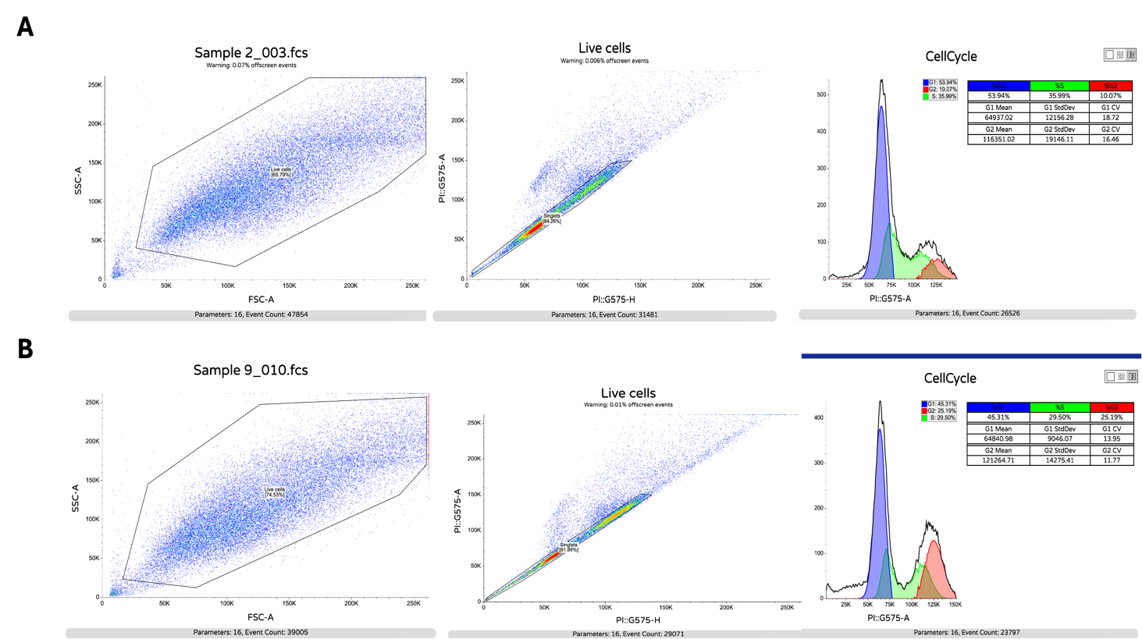
b
a
Supplementary Fig. 6. Representative gating strategy for cell cycle analysis
a. BT12 NT gRNA control cells and b. CD44v6 KO cells. Cells were gated to exclude debris based on forward scatter (FSC-A) and side scatter (SSC-A) (left panels). Singlets were discriminated from doublets using PI pulse height (PI-H) and pulse area (PI-A) (middle panels). Cell cycle distribution was determined from PI intensity histograms of singlet populations, with gates defining G1 (blue), S (green), and G2/M (red) phases (right panels).

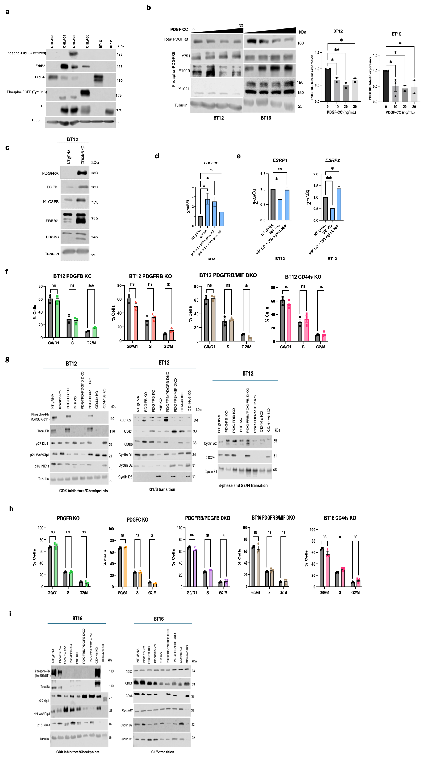

Supplementary Fig. 7.
- a. Expression of EGFR, phospho-EGFR, ErbB3, phospho-ErbB3, and ErbB4 (by western blot) in ATRT cell lines.
- b. The effects of PDGF-CC stimulation (0, 10, 20, and 30 ng/mL for 5 minutes) on PDGFRB and phospho-PDGFRB protein expression in BT12, and BT16 cells (right). Densitometry quantification of total PDGFRB (left). (n=2; Error bars represent ± SEM; One-way ANOVA; *p< 0.05, **p < 0.01, ***p < 0.001, ****p < 0.0001).
- c. Effects of BT12 CD44s KO and CD44v6 KO on PDGFRA, EGFR, M-CSFR, ERBB2, and ERBB3 by western blot (n=2; Error bars represent ± SEM; One-way ANOVA; *p< 0.05, **p < 0.01, ***p < 0.001, ****p < 0.0001).
- d. PDGFRB mRNA expression by qRT-PCR under MIF stimulation (200 ng/mL and 400 ng/mL for 24 hours) (n=2; Error bars represent ± SEM; One-way ANOVA; *p< 0.05, **p < 0.01, ***p < 0.001, ****p < 0.0001).
- e. ESPR1 and ESRP2 mRNA expression by qRT-PCR in MIF KO without and with MIF stimulation.
- f, h. Cell cycle distribution in PDGFB KO, PDGFC KO, PDGFRB KO, PDGFRB/PDGFB DKO, and CD44s KO relative to NT gRNA BT12 (E) and BT16 (I) measured by PI staining by flow cytometry. Cell cycle data represent mean ± SEM of 3 independent biological replicates performed in technical singlets (3 data points per condition) (One-way ANOVA with Dunnett’s post-hoc test).
- g, i. Cell cycle markers protein expression in BT12 (F) and BT16 (J) NT gRNA, PDGFB KO, PDGFRB KO, MIF KO, PDGFRB/PDGFB DKO, PDGFRB/MIF DKO, CD44s KO, and CD44v6 KO by western blot. Markers were grouped by cell cycle phase/transition.

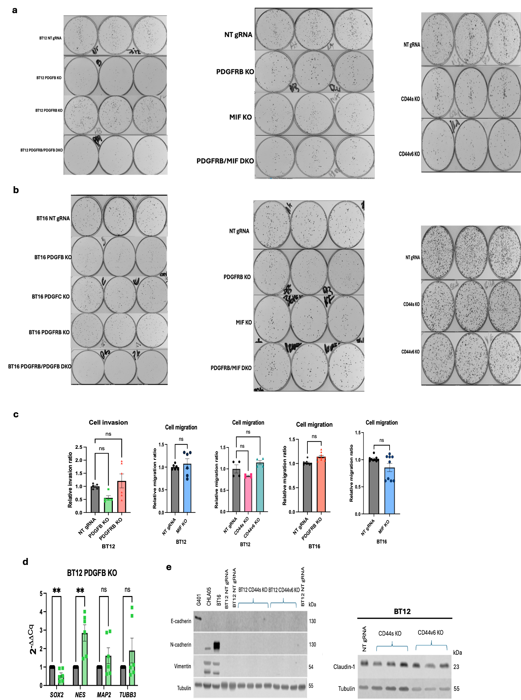
Supplementary Figure 8.
- a, b. Colony count in PDGFB KO, PDGFC KO, PDGFRB KO, PDGFRB/PDGFB DKO, MIF KO, PDGFRB/MIF DKO, CD44s KO, and CD44v6 KO relative to NT gRNA. Colony formation data represent mean ± SEM of 3 independent biological replicates performed in technical triplicates (minimum 9 data points per condition). The images represent one of the replicates (One-way ANOVA with Dunnett’s post-hoc test).
- c. Cell invasion/migration in PDGFB KO, PDGFRB KO, MIF KO, CD44s KO, and CD44v6 KO relative to NT gRNA measured by Matrigel/FluroBlok assay (Em/Ex 494/517 nm). Cell invasion and migration data represent mean ± SEM of 3 independent biological replicates performed in technical duplicates (6 data points per condition; except for BT12 CD44 KOs migration assay: 2 biological replicates and 4 data points) (One-way ANOVA with Dunnett’s post-hoc test; Two-tailed Student’s t-test).
- d. Neural stemness (SOX2 and NES) and differentiation marker (TUBB3 and MAP2) expression in PDGFB KO relative to NT gRNA BT12 by qRT-PCR. (n=3; Error bars represent ± SEM; Two-tailed Student’s t-test; *p< 0.05, **p < 0.01, ***p < 0.001, ****p < 0.0001).
- e. EMT marker expression in BT12 CD44s KO and CD44v6 KO relative to NT gRNA by western blot. BT16 was included as a positive control for N-cadherin expression (N-cadherin high); CHLA05 as a control for low N-cadherin expression; G401, a kidney MRT cell line, as a positive control for E-cadherin expression. Three independent biological replicates were used from BT12 CD44s KO and CD44v6 KO, corresponding to the three lanes grouped under the same brace.

