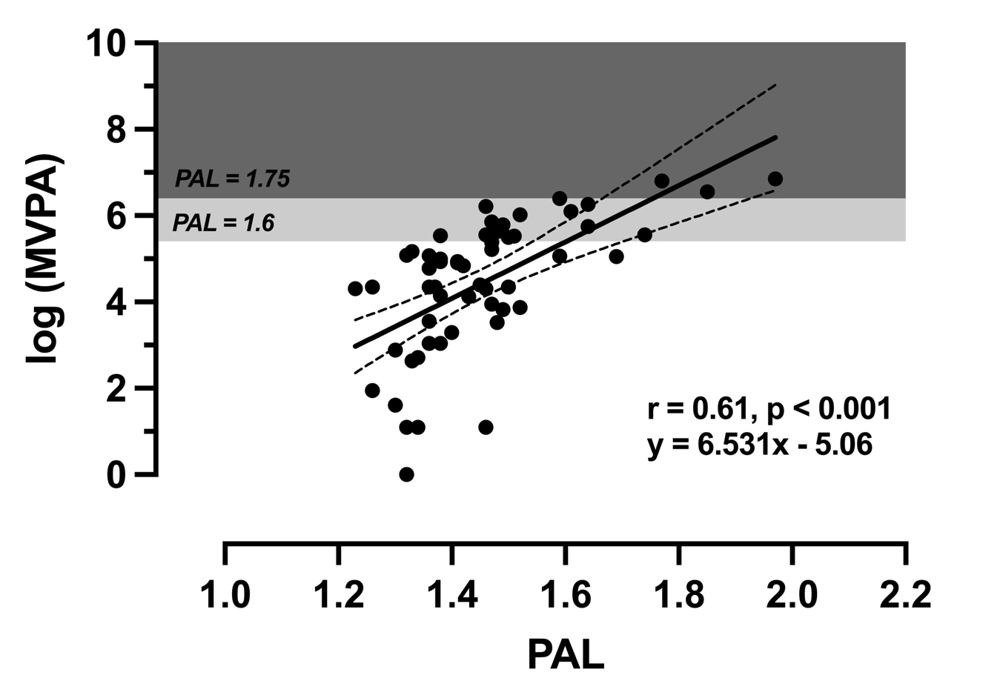
Supplementary Figure 1. The relationship between physical activity level (PAL) as a standardised measure of physical activity energy expenditure (TDEE/RMR) and the natural logarithm of time engaged in moderate-to-vigorous intensity physical activity in wheelchair users with paraplegia (n = 60). The regression line with 95% confidence intervals, correlation magnitude and prediction equation are included. The light grey and dark grey shaded areas depict PAL values of 1.6 and 1.75, respectively, as set out by FAO/WHO/UNU. Predicted values were back-transformed to minutes per week for interpretation, indicating that a PAL of 1.75 corresponded to 584 minutes per week of moderate-to-vigorous intensity physical activity (95% confidence intervals: 276 to 1235 minutes per week).

