Supplementary material for:

Changes in temperature, rainfall and snow cover during the breeding season of Arctic-breeding birds

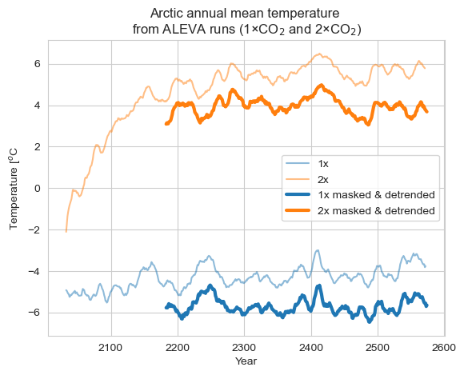

Supplementary figure 1: Arctic annual mean near-surface air temperature from two 550-year EC-Earth3 equilibrium simulations with fixed CO₂ forcing: present-day (1×, 420 ppm; blue) and doubled (2×, 840 ppm; orange). Light lines show the raw, unmasked 550-year runs (60–90°N, non-detrended), while dark lines show the masked and linearly detrended 400-year segments used for analysis after discarding the initial 150-year spin-up. All values are annual means, with a 10-year rolling mean applied for visualization clarity only (all calculations are based on unsmoothed annual data). The raw series illustrate the full adjustment and model drift, whereas the masked & detrended series represent the equilibrated climates used in this study: -5.7 °C (raw data: –4.2 °C) under 1×CO₂ and 3.9 °C (raw data: +5.5 °C) under 2×CO₂. These equilibrated states provide the contrasting baselines for our extreme-event analyses, allowing us to assess how a ~10 °C shift in mean Arctic climate alters rainfall extremes, snow cover, and the productive period critical for migratory birds.

The equilibrium experiments confirm that the magnitude of warming under doubled CO₂ is broadly consistent with transient CMIP6 projections. After spin-up, the 1× and 2× EC-Earth3 runs stabilize at mean Arctic temperatures of –4.2 °C and +5.5 °C, respectively, representing a ~10 °C difference between present-day and doubled-CO₂ climates (Supplementary Figure 1). This contrast is comparable in scale to the ~8.6 °C late-century (2081–2100) Arctic warming projected under SSP5-8.5 relative to 1995–2014 (Figure 3d). While the equilibrium design differs from the transient scenarios—providing end-member states rather than socio-economic trajectories—the similarity in magnitude indicates that our 1× vs 2× framework is directly relevant for drawing ecological conclusions. The long equilibrated runs further allow us to isolate variability and characterize extremes with greater statistical confidence, offering complementary insight into how a strongly warmed Arctic may reshape rainfall, snow cover, and the productive period critical to migratory birds.

Supplementary table 1: Arctic study regions with their bounding coordinates (longitude and latitude ranges).

Area | Lon min | Lon max | Lat min | Lat max
Arctic | -180 | 180 | 60 | 90
Norway | 0 | 45 | 57 | 71
Svalbard | 2 | 35 | 75 | 81
Nova Zembla | 45 | 57 | 57 | 79
Taimyr | 80 | 136 | 60 | 83
East Siberia | 137 | -169 | 60 | 77
Alaska | -88 | -140 | 58 | 77
Canada | -139 | -60 | 58 | 83
Greenland | -70 | -10 | 67 | 83
Iceland | -28 | -10 | 62 | 67

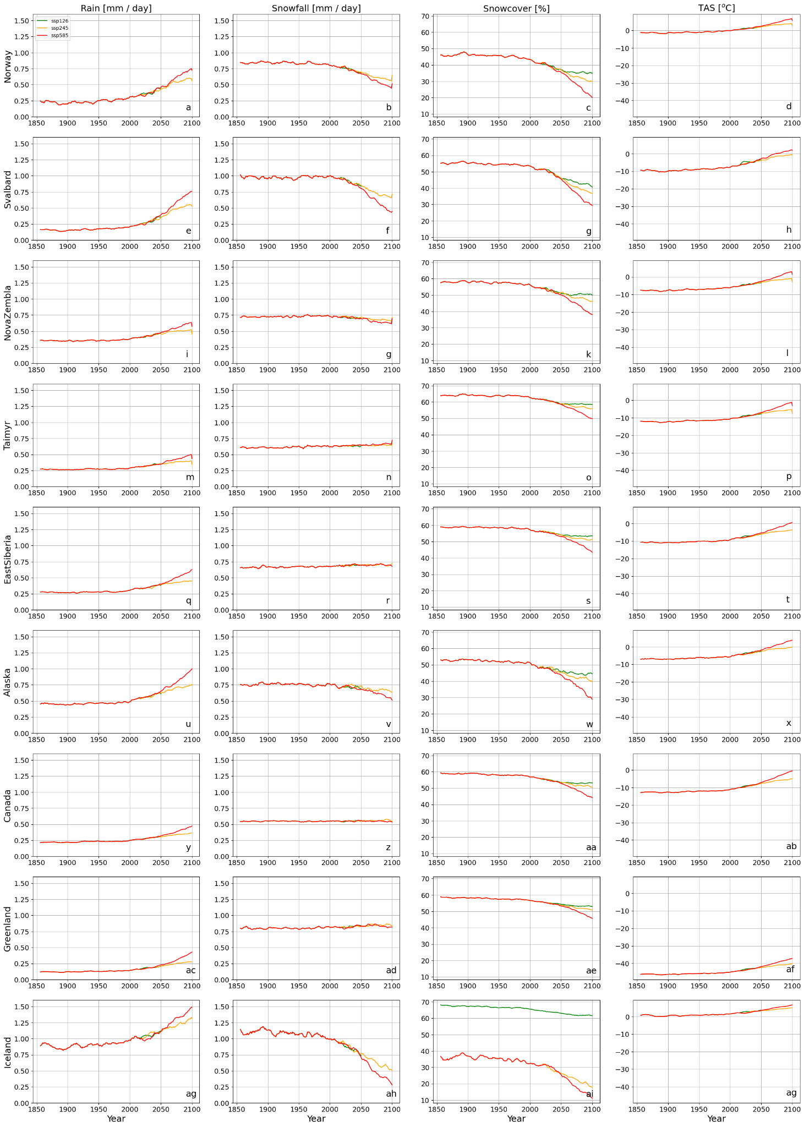

Supplementary figure 2: Long-term climate trends (1850–2100) from CMIP6 models for nine Arctic regions. Panels show annual mean a) rainfall (mm water equivalent per year), b) snowfall (mm w.e. per year), c) snow cover fraction (%), and d) near-surface air temperature (°C). Each row corresponds to a different region (Norway, Svalbard, Nova Zembla, Taimyr, East Siberia, Alaska, Canada, Greenland, Iceland). Simulations are shown for SSP1-2.6 (green), SSP2-4.5 (orange), and SSP5-8.5 (red). While all regions exhibit warming and snow cover decline, the balance between rainfall and snowfall varies substantially, reflecting strong spatial contrasts.
Supplementary Figure X shows long-term climate trends (1850–2100) for nine Arctic regions based on CMIP6 simulations under SSP1-2.6, SSP2-4.5, and SSP5-8.5. Panels display annual mean rainfall, snowfall, snow cover fraction, and near-surface air temperature. The results highlight consistent warming and snow cover decline across all regions, but with strong spatial contrasts: maritime regions (e.g. Iceland, Greenland, Svalbard, Norway) show an earlier shift toward rain-dominated precipitation and rapid snow loss, while continental interiors (e.g. Taimyr, East Siberia, Canada) remain cold enough for snowfall to persist much longer.

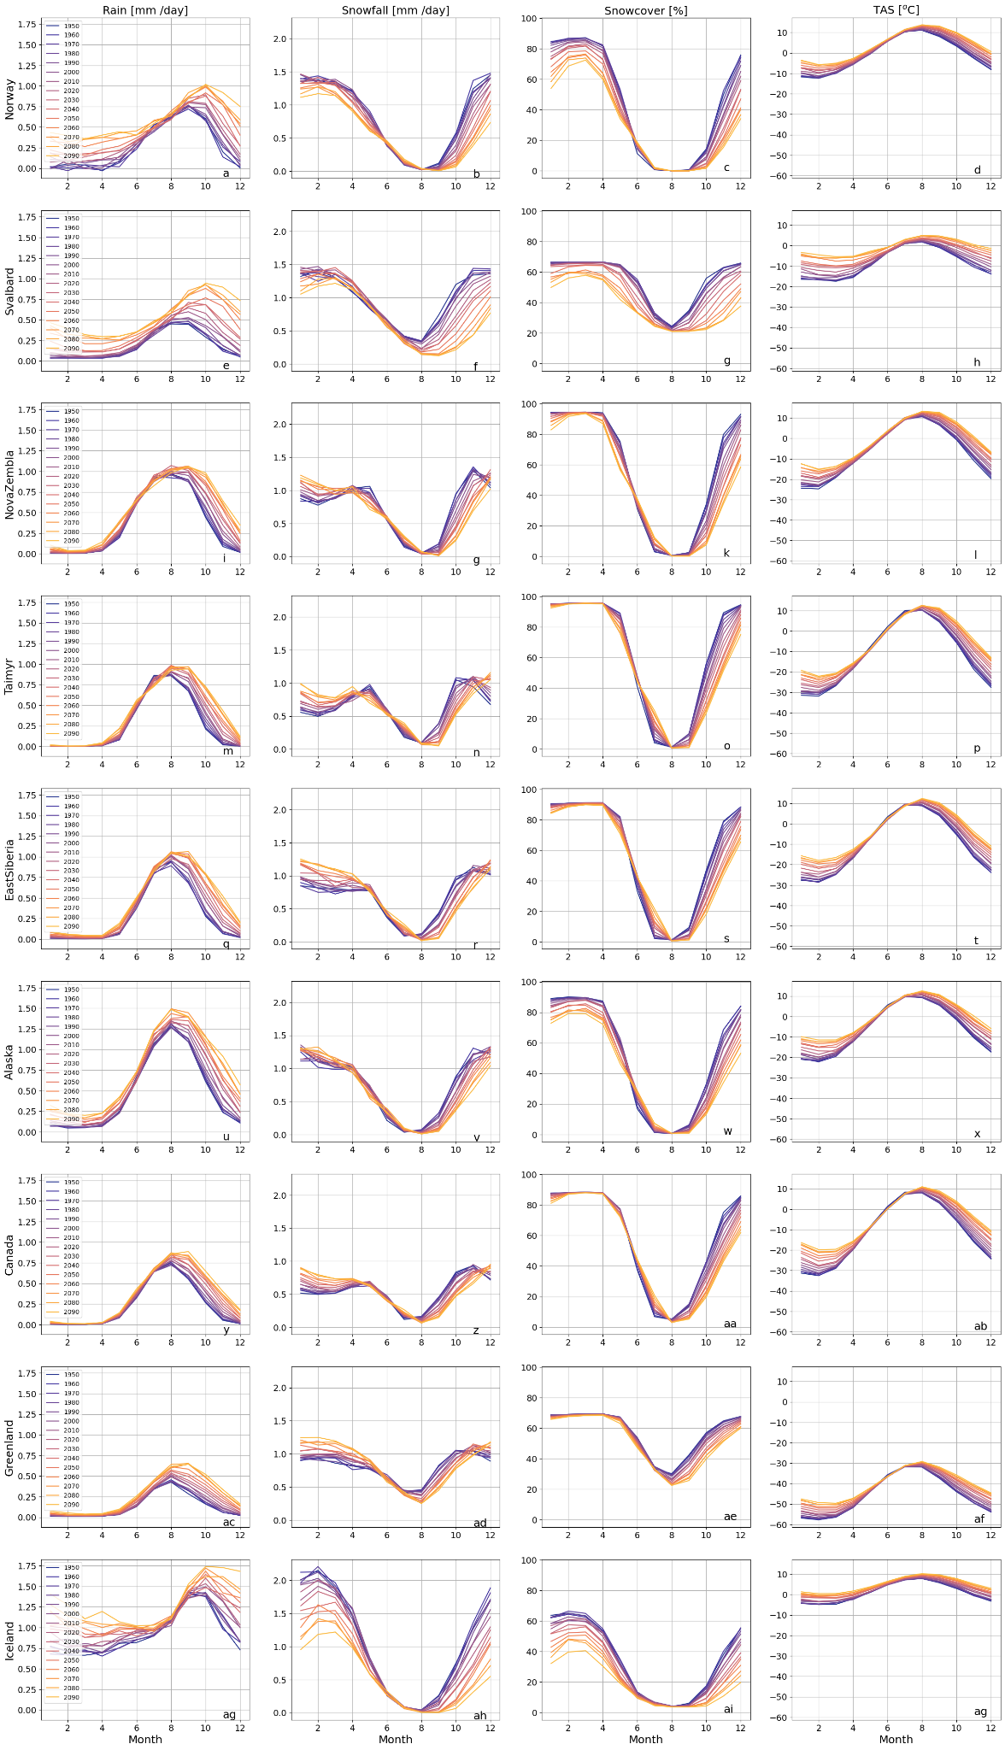

Supplementary figure 3: Monthly climatology of the CMIP6 ensemble mean for SSP5-8.5, shown per decade from 1950 to 2090 (line colour from dark blue to yellow), for nine Arctic regions. Panels show a) rainfall (mm/day), b) snowfall (mm/day), c) snow cover fraction (%), and d) 2 m air temperature (°C). Each line represents the multi-model mean monthly values for a given decade. Regional patterns highlight long-term warming and a seasonal shift from snow to rain, occurring earlier in maritime regions while persisting longer in continental interiors.

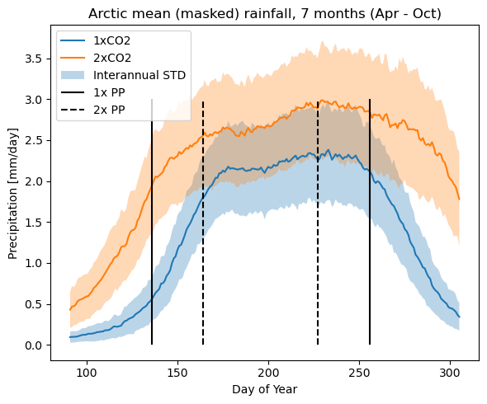

Supplementary figure 4: Arctic mean rainfall (mm/day) for the snow-free season (April–October) under 1×CO₂ (blue) and 2×CO₂ (orange) steady-state simulations. Shaded areas show the interannual standard deviation. Vertical black lines mark the start and end of the productive period (PP) under 1×CO₂ (solid) and 2×CO₂ (dashed). Data are masked using the three-step procedure described in the Methods. Rainfall increases across the entire PP under 2×CO₂, remaining elevated into autumn.

Arctic mean rainfall increases substantially under 2×CO₂ compared to 1×CO₂, with higher values throughout the productive period (PP) and greater variability across years (Figure X). The seasonal cycle peaks in mid-summer, but rainfall remains elevated well into autumn, coinciding with the delayed snow return under 2×CO₂. As a result, the lengthened PP is also characterized by wetter conditions, increasing the likelihood that breeding birds encounter more frequent and intense rainfall during the critical nesting and fledging stages.

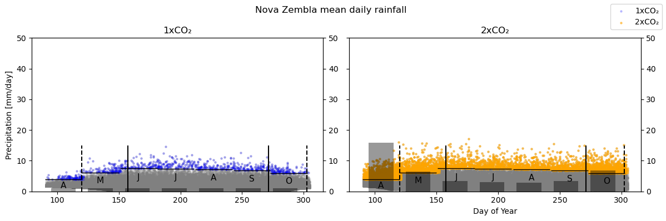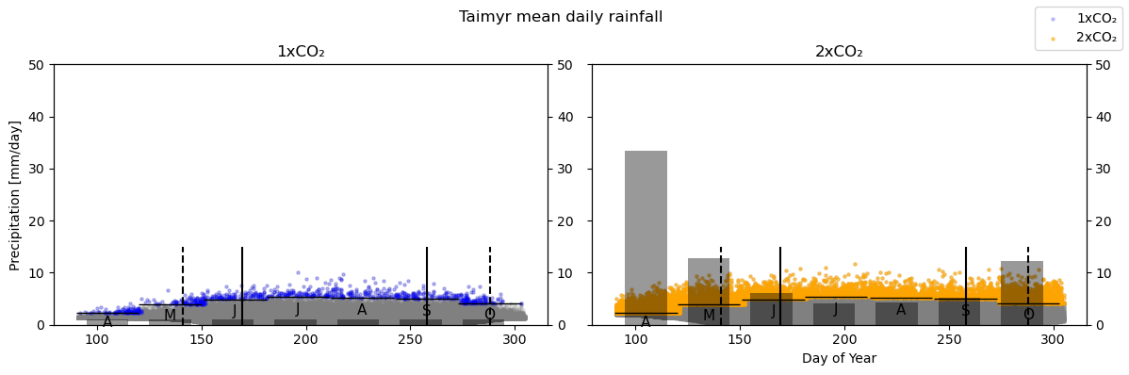

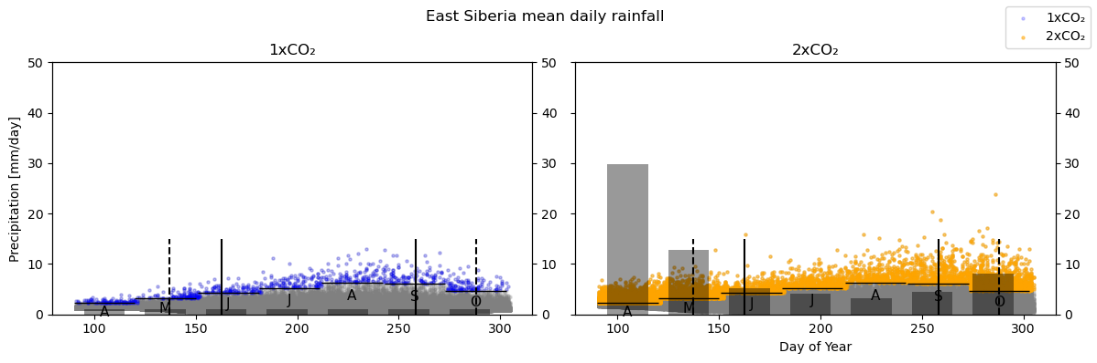
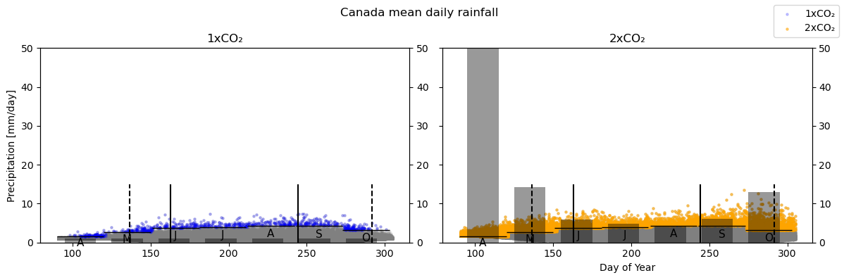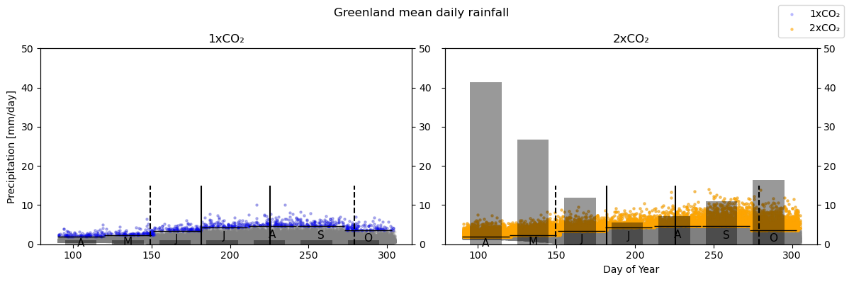

Supplementary figure 5: Regional daily rainfall distributions (mm/day) and extreme-event statistics under 1×CO₂ (≈ 410 ppm; left) and 2×CO₂ (≈ 840 ppm; right) steady-state simulations. Results are shown for nine Arctic regions, each based on 400-year time slices. Grey dots show all daily values; coloured dots (blue/orange) mark days exceeding the monthly 99th percentile from the 1× baseline. Vertical black lines indicate the PP. Grey bars (right axis) show the proportion of days above threshold. Under 2×CO₂, extremes increase in all regions, though the seasonal timing and intensity vary.
While all regions exhibit an increase in the number of days exceeding present-day extreme thresholds, the patterns differ: maritime regions (e.g. Svalbard, Norway, Iceland) show widespread “spillover” of extremes into April, May, and October, whereas continental interiors (e.g. Taimyr, East Siberia, Canada) display a stronger amplification of extremes during June, with more limited seasonal spillover. Greenland 1 stands out as an outlier with a particularly pronounced rise in extreme-event frequency. These results highlight that the timing and intensity of rainfall extremes vary substantially across Arctic regions, underscoring the need to account for regional differences when assessing ecological risks.

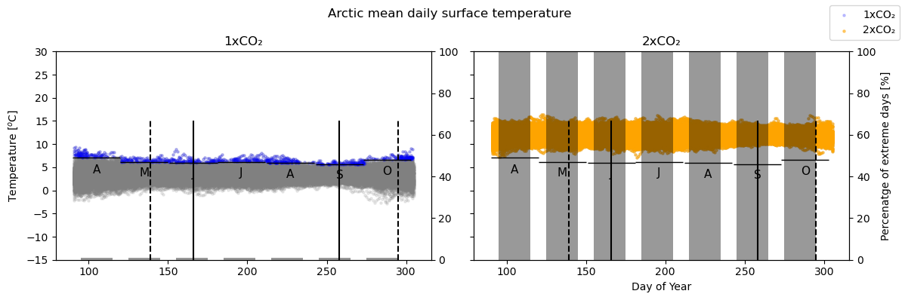

Supplementary figure 6: Arctic mean daily surface temperature under 1×CO₂ (left) and 2×CO₂ (right). Grey dots show all daily values; blue/orange indicate daily means. Vertical black lines mark the PP, with dashed lines showing the alternate scenario for comparison. Shaded grey bands highlight months. 2×CO₂ conditions produce warming across all months, with spring crossing freezing earlier and autumn later, lengthening the snow-free season.
Warming is evident across all months, with particularly strong increases in spring and autumn. Under 2×CO₂, temperatures rise above freezing earlier in spring and remain above freezing later into autumn, extending the potential snow-free season. These changes align with shifts in the productive period (PP), suggesting that birds may encounter a longer breeding window but under warmer and wetter conditions.

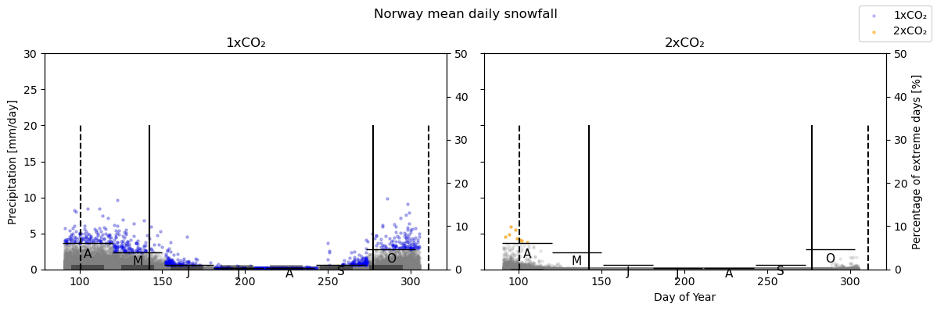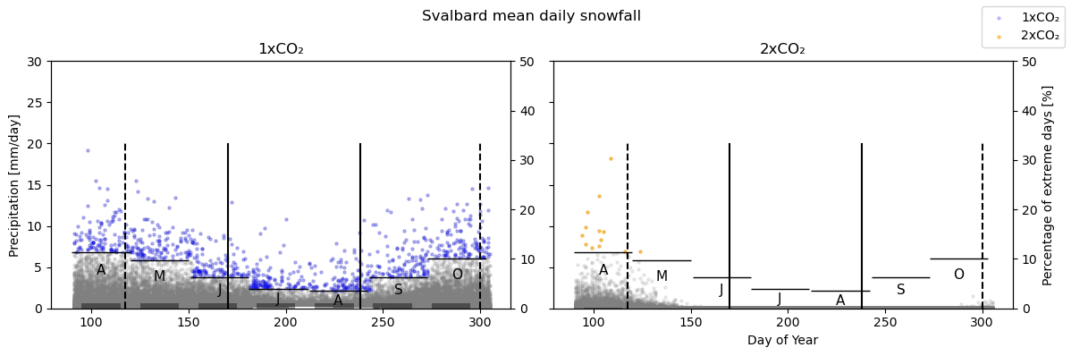
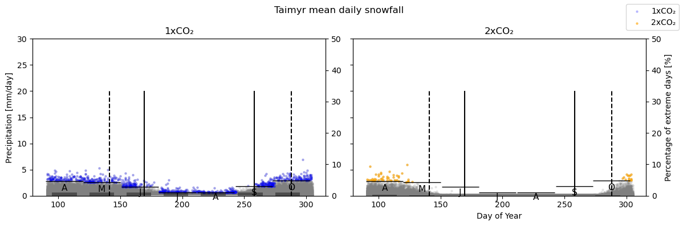
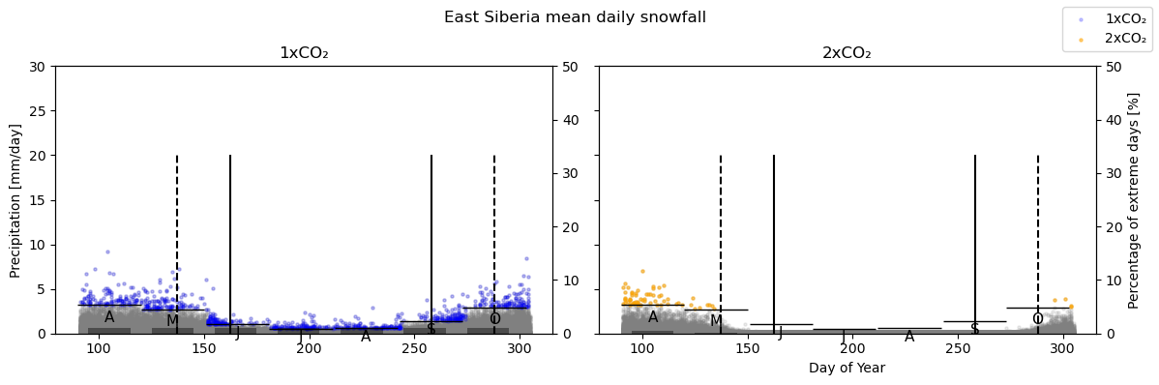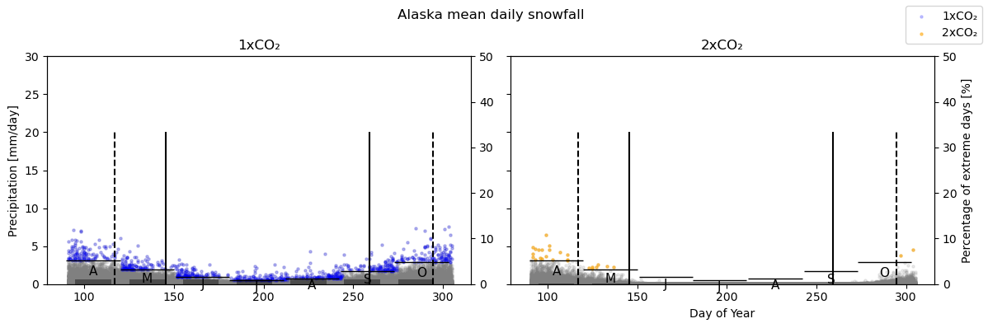
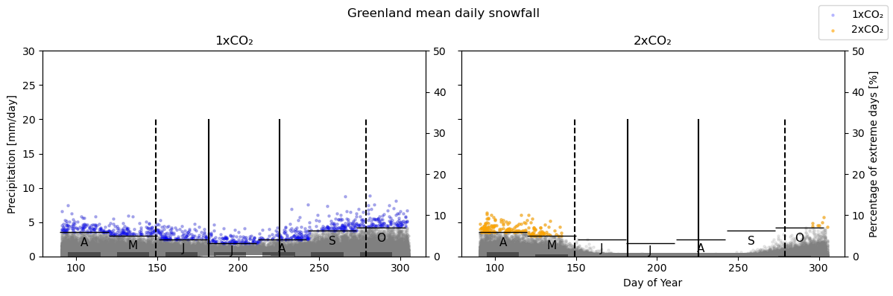
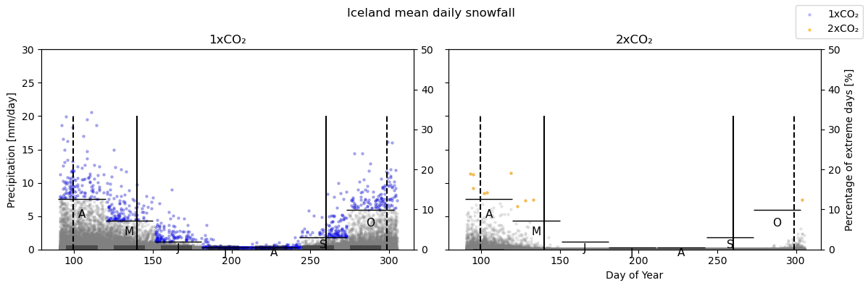

Supplementary figure 7: Regional daily snowfall distributions and extreme-event statistics under 1×CO₂ (left) and 2×CO₂ (right). Results are shown for nine Arctic regions, each based on 400-year simulations. Grey dots show all daily values; coloured dots mark extreme snowfall days (monthly 99th percentile from the 1× baseline). Grey bars show the proportion of days above threshold. Extreme snowfall events decline under 2×CO₂, nearly disappearing in maritime regions and decreasing substantially elsewhere.
Compared to rainfall, extremes in snowfall show a pronounced decline under 2×CO₂, particularly during the productive period when temperatures increasingly cross above freezing. In maritime regions (e.g. Norway, Iceland, Svalbard), extreme snowfall events nearly disappear, while in continental interiors (e.g. Taimyr, East Siberia, Canada) they remain more common but still decrease in frequency. These results highlight that under warmer conditions, extreme precipitation events during the productive period increasingly occur as rainfall rather than snowfall.

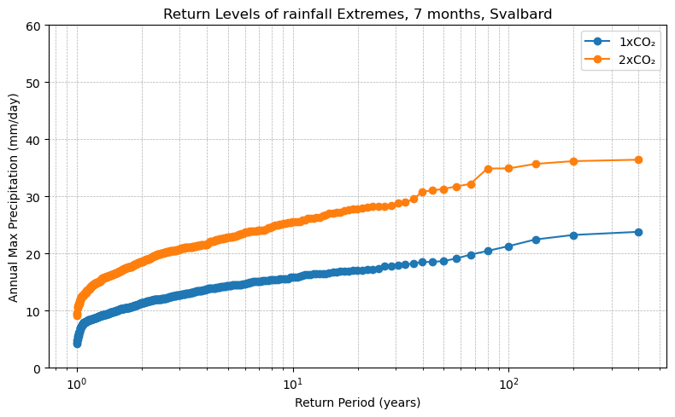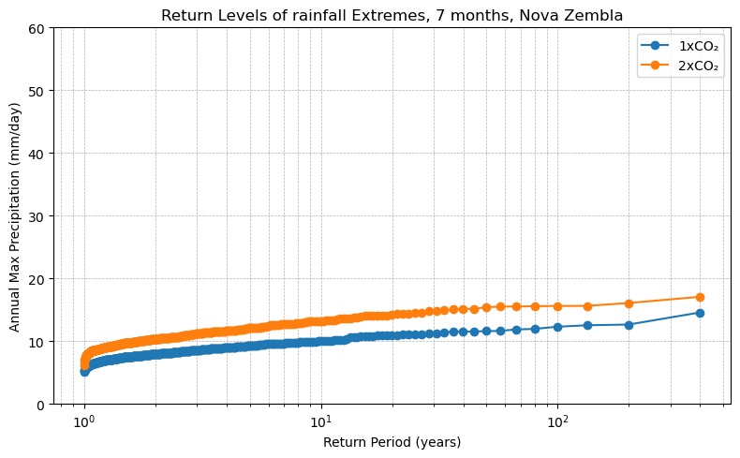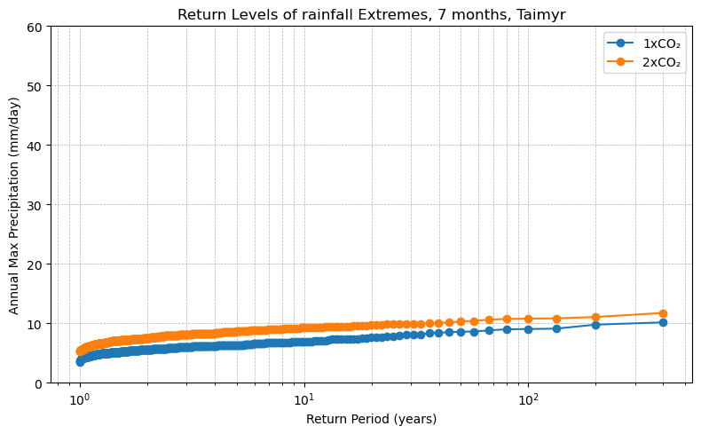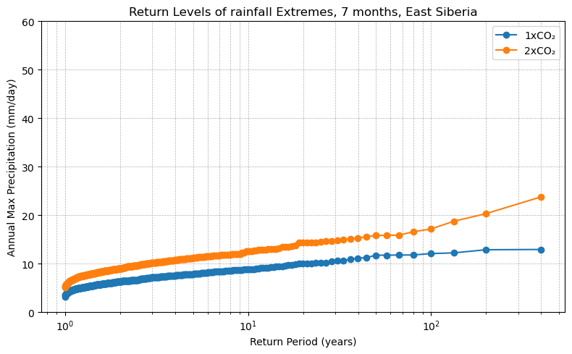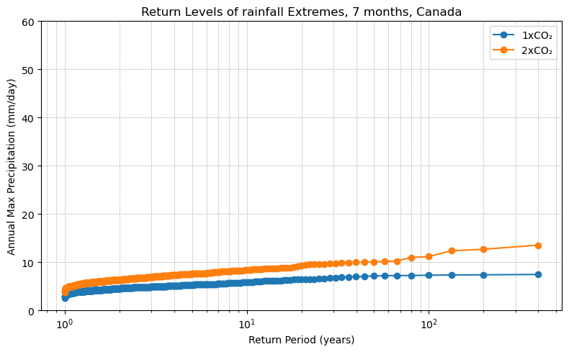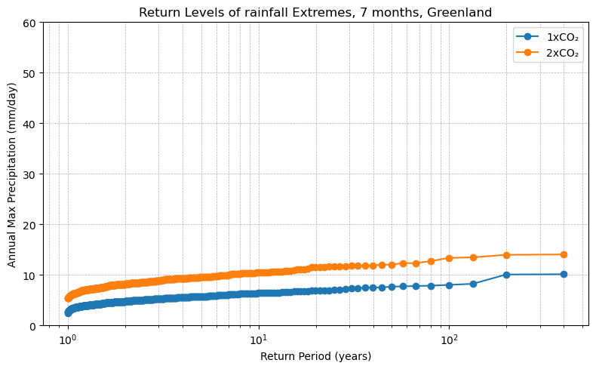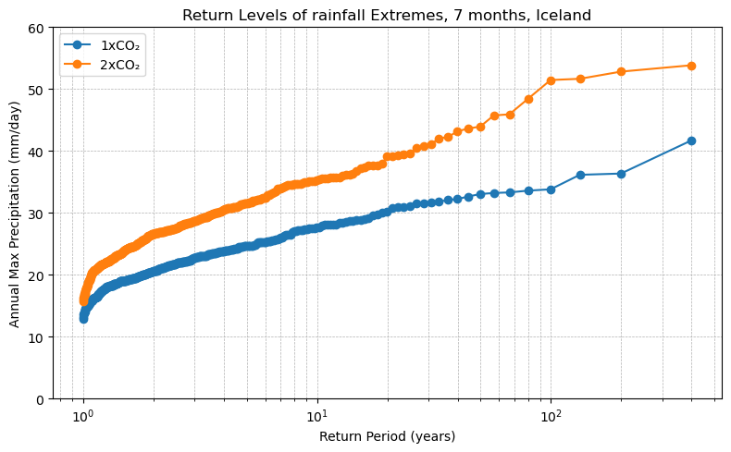

Supplementary figure 8: Regional return levels of daily rainfall extremes under 1×CO₂ (blue) and 2×CO₂ (orange) steady-state simulations. Results are based on 400-year time slices and calculated empirically from annual maximum daily precipitation (mm/day) during April–October. Return levels are consistently higher under 2×CO₂, but the degree of intensification differs between regions.
Across all regions, 2×CO₂ conditions produce higher return levels, indicating more intense rainfall extremes. The magnitude of change differs regionally: maritime regions (e.g. Norway, Svalbard, Iceland) show smaller proportional increases but still experience a marked rise in recurrence frequency, while continental regions (e.g. Taimyr, East Siberia, Canada) exhibit stronger amplification of extreme-event magnitudes. Greenland 1 and Greenland 2 stand out as outliers, with exceptionally large increases in rainfall intensity relative to the 1× baseline. These results confirm that intensification of extremes is robust across the Arctic, but the degree of change varies considerably between regions.

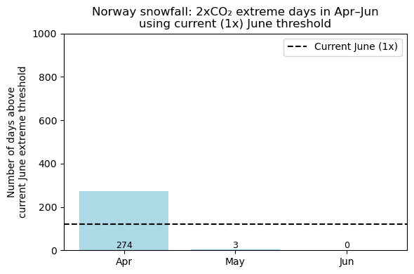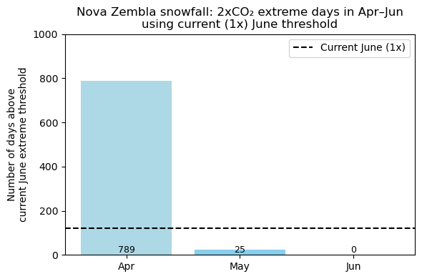
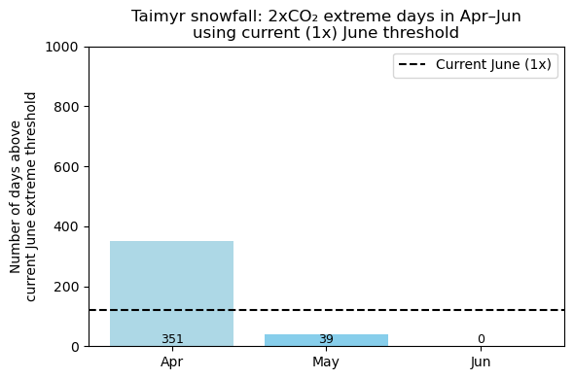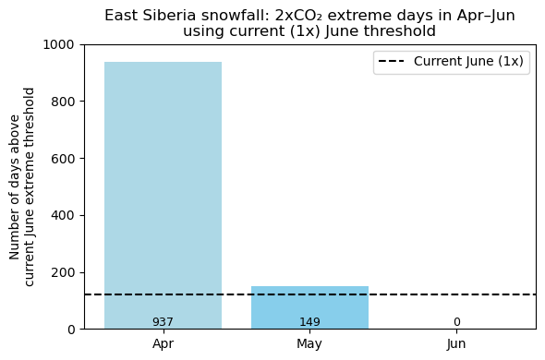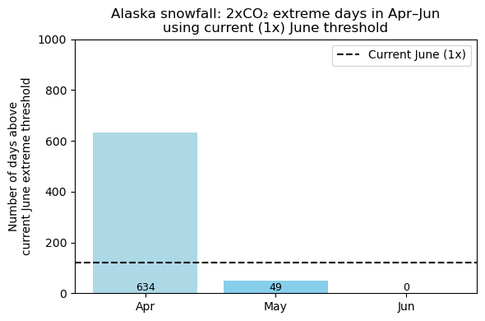
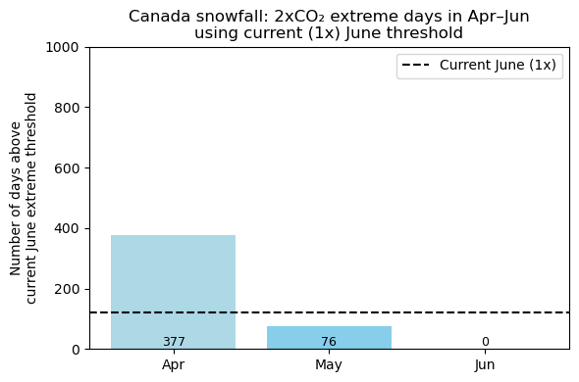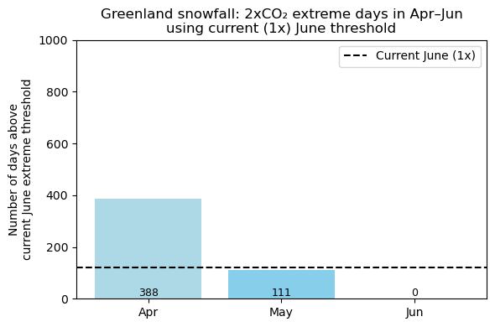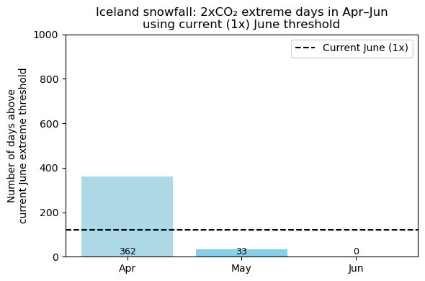

Supplementary figure 9: Number of days exceeding the present-day (1×CO₂) June extreme snowfall threshold under 2×CO₂ conditions, shown for April–June across nine Arctic regions. Bars indicate monthly counts over 400-year simulations; the dashed line marks the present-day June baseline. Extreme snowfall events decrease sharply under warming, with few exceedances after May.

In contrast to rainfall extremes (Supplementary Figure 7), extreme snowfall events decrease sharply, with most regions showing only a handful of exceedances by May and almost none by June. This highlights an important ecological trade-off: if migratory birds attempt to arrive earlier to avoid heightened rainfall extremes, they may instead face rare but intense late-season snow events that could bury nests or delay access to feeding grounds. Moreover, these changes interact with shifts in the snowmelt date, which ultimately determines when nesting habitat becomes available. Taken together, the timing of rainfall extremes, snowfall extremes, and snowmelt must all be considered to assess how feasible earlier arrival strategies will be for Arctic-breeding birds.

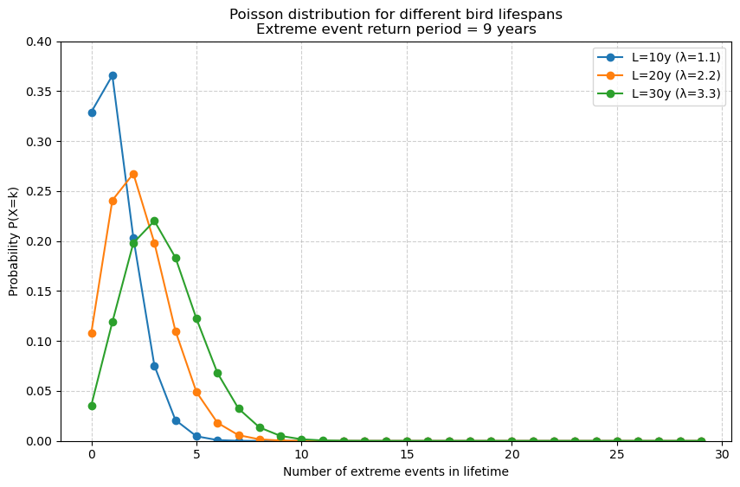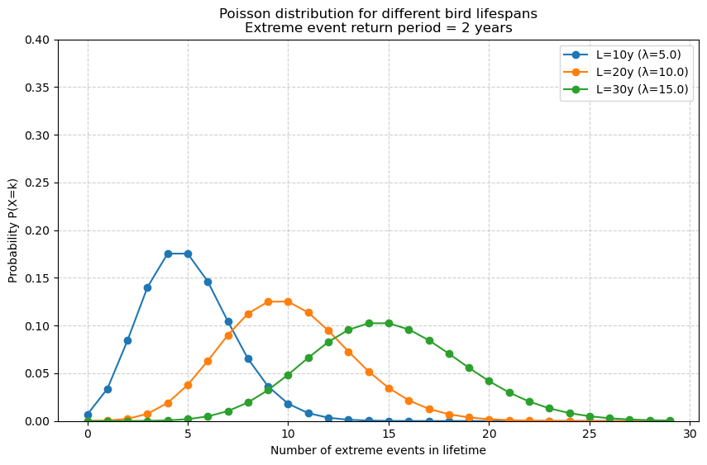

Supplementary figure 10: Probability distributions of the number of extreme rainfall events experienced over a bird’s lifetime, modeled with a Poisson distribution. Left: lifespans of 10, 20, and 30 years with a return period of 9 years (λ ≈ 1.1, 2.2, 3.3). Right: lifespans of 10, 20, and 30 years with a return period of 2 years (λ = 5, 10, 15). Longer lifespans or shorter return periods increase both the expected number of events and the spread of the distribution.

Birds are likely to experience multiple extreme rainfall events within their lifetimes, with the number depending strongly on both lifespan and the frequency of events. For long-lived species, even relatively rare extremes (e.g. return period of 9 years) accumulate to a high probability of occurrence, while shorter return periods expose individuals to numerous events. This highlights that extreme weather is not an exceptional risk but a recurring feature within the lifetime of many birds.
The number of extreme rainfall events expected over a bird’s lifetime follows a Poisson distribution with mean λ = L/RP, where L is lifespan and RP is the return period of the event. For a return period of 9 years, λ increases from 1.1 to 3.3 as lifespan extends from 10 to 30 years, shifting the mode of the distribution accordingly. For more frequent extremes (RP = 2 years), the distribution broadens and peaks at higher values (λ = 5–15), reflecting the cumulative nature of event risk across an individual’s life .

