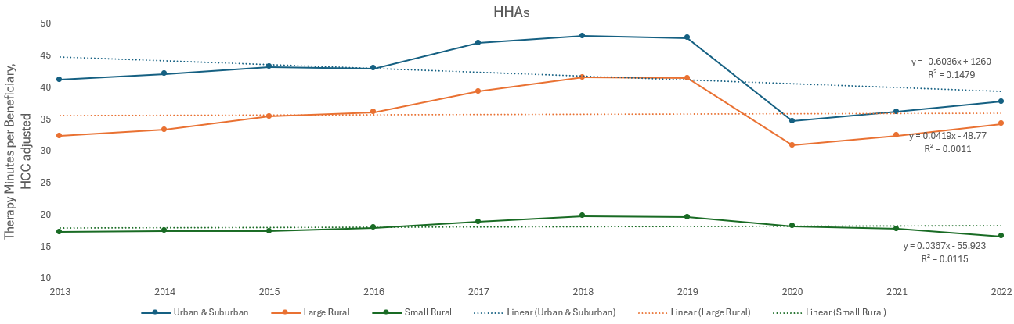
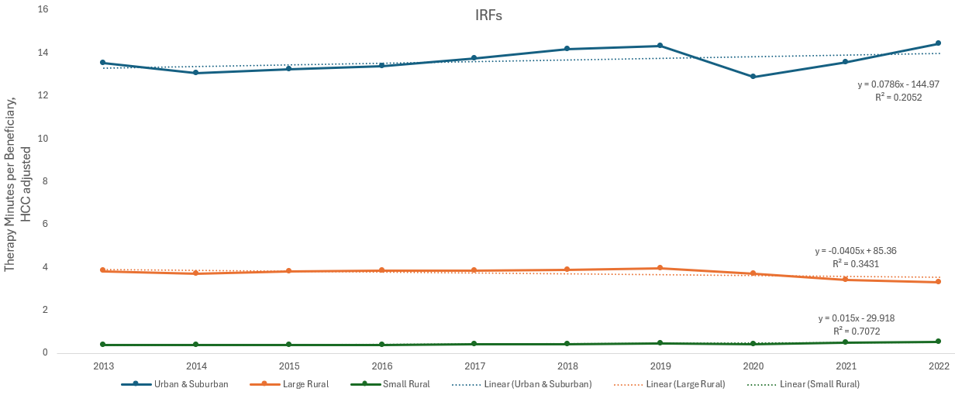
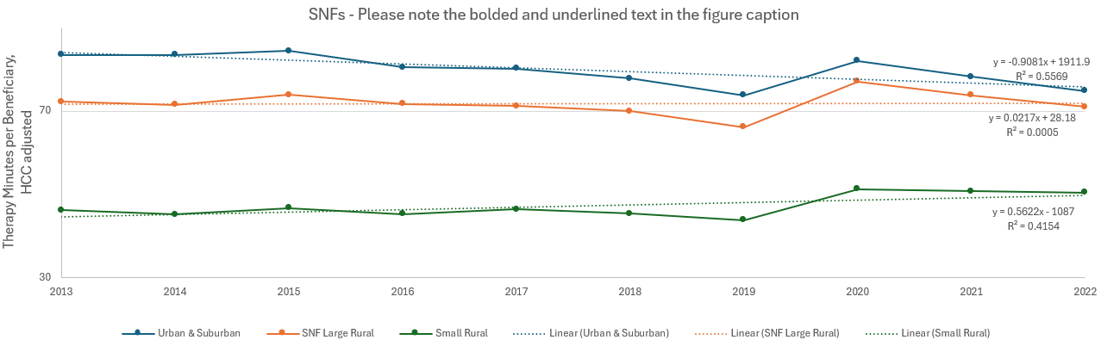
Supplementary Figure 1: Time series of the nationwide therapy utilization rate: minutes per fee-for-service Medicare beneficiary, HCC-adjusted (2013-2022), for each provider type, stratified by urban-rural categories, and with the linear regression trendline, equation, and R² values for each category.
Note: For SNFs, the increase in documented therapy minutes from 2019 to 2020 onwards, across rural and urban areas, reflects changes in the documentation requirements and should not be understood as an increase in the therapy minutes delivered; research suggests a decline in the actual therapy minutes. See for example: Prusynski RA, Leland NE, Frogner BK, et al. Therapy Staffing in Skilled Nursing Facilities Declined after Implementation of the Patient-Driven Payment Model. J Am Med Dir Assoc 2021;22(10):2201-06. Here the data is shown merely for the purpose of the comparison of the relative differences over time between the rural (especially small rural) and urban & suburban areas.
Legend: SNFs: Skilled Nursing Facilities; HHAs: Home Health Agencies; IRFs: Inpatient Rehabilitation Facilities. HCC: Hierarchical Condition Category.

