Supplementary information
Immunogenomic intertumor heterogeneity across primary and metastatic sites in a patient with lung adenocarcinoma
Chen et al.

Supplementary Figure 1
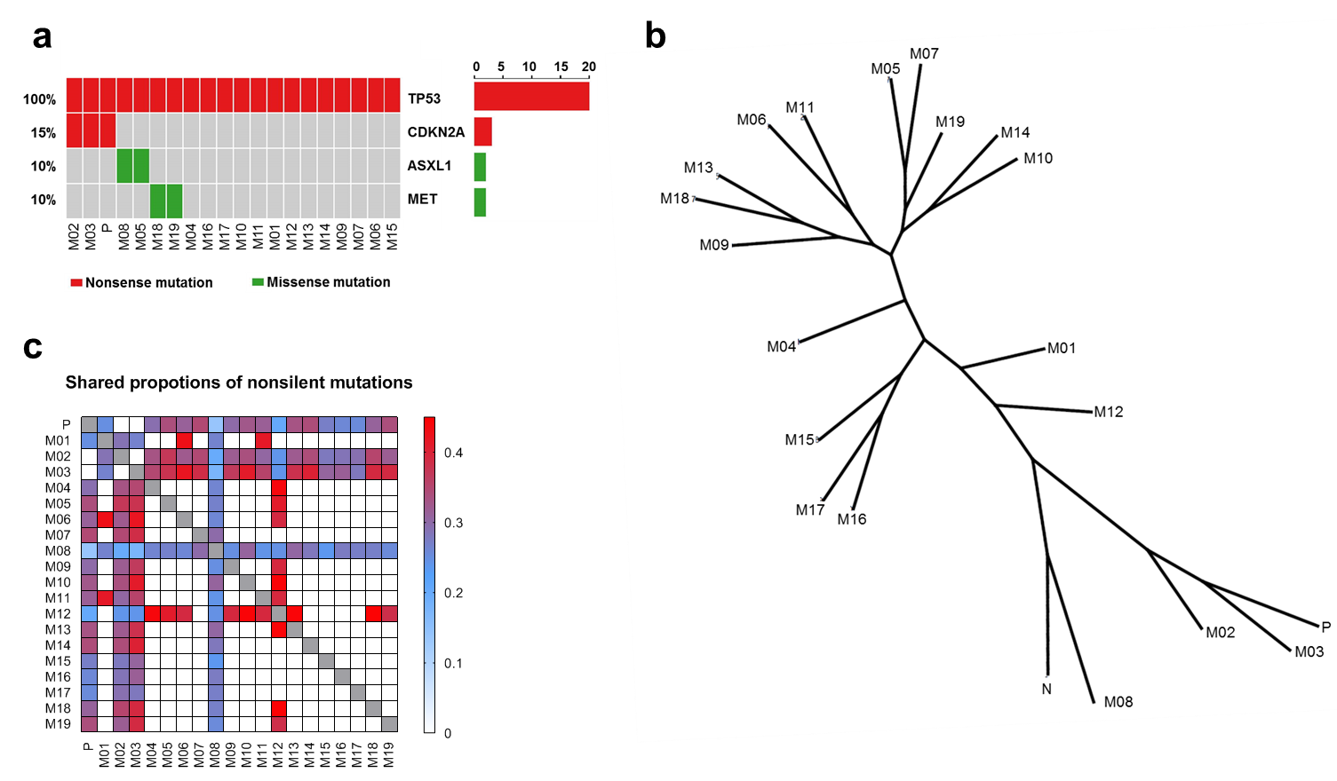
Supplementary Figure 1. Distinct mutational profiles are seen across primary tumor and synchronous metastases. a) Oncomap of 20 tumors in the patient with known cancer gene mutations; b) Phylogenetic trees were generated from all SNVs by using the Wagner parsimony method in “phangorn” package. Trunk and branch lengths are proportional to the numbers of mutations acquired on the corresponding trunk or branch; c) Share proportions of nonsilent mutations quantified by Jaccard index (JI).

Supplementary Figure 2
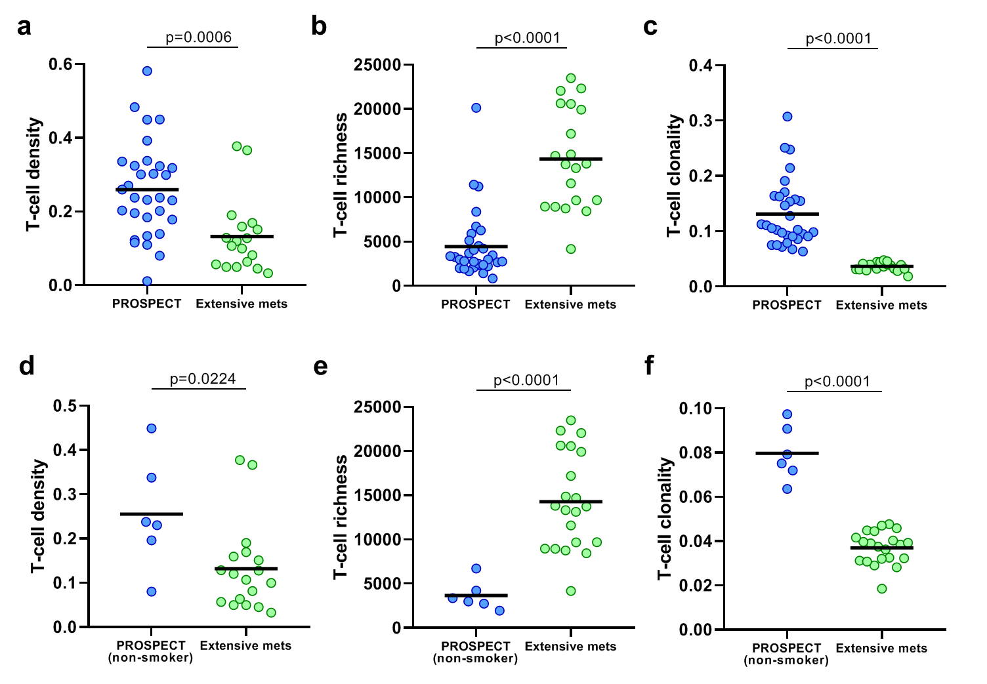
Supplementary Figure 2. Distinct T cell repertoire metrics between tumors from patients in localized non-small cell lung cancer (NSCLC, PROSPECT cohort) and our patient. Comparisons of T-cell a) density, b) richness and c) clonality.

Supplementary Figure 3
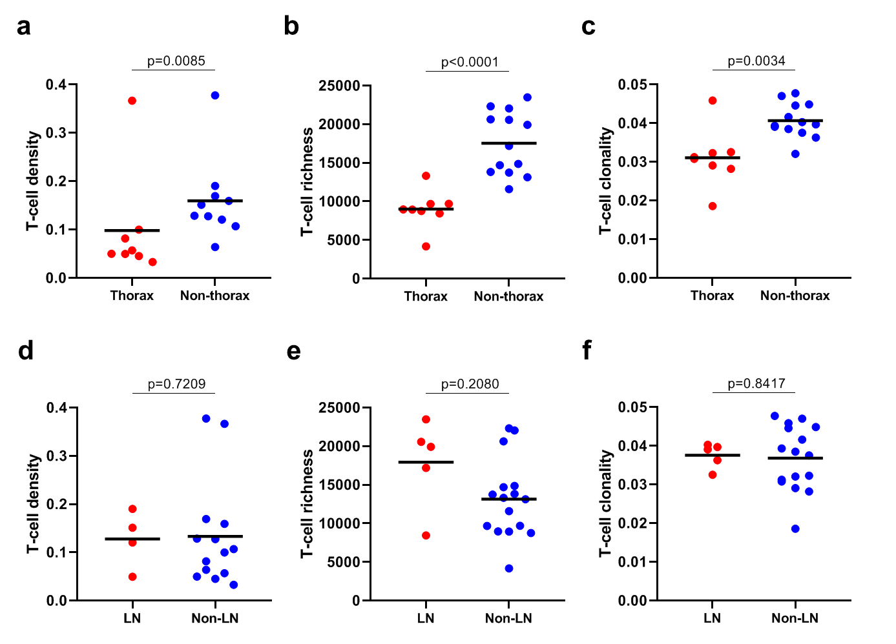
Supplementary Figure 3. Distinct T cell repertoire metrics between thoracic and non-thoracic tumors but no differences in relation to lymph node involvement. T-cell a) density, b) richness and c) clonality comparisons between thoracic and non-thoracic tumors. T-cell d) density, e) richness and f) clonality comparison between lymph node and non-lymph node tumors.

Supplementary Figure 4
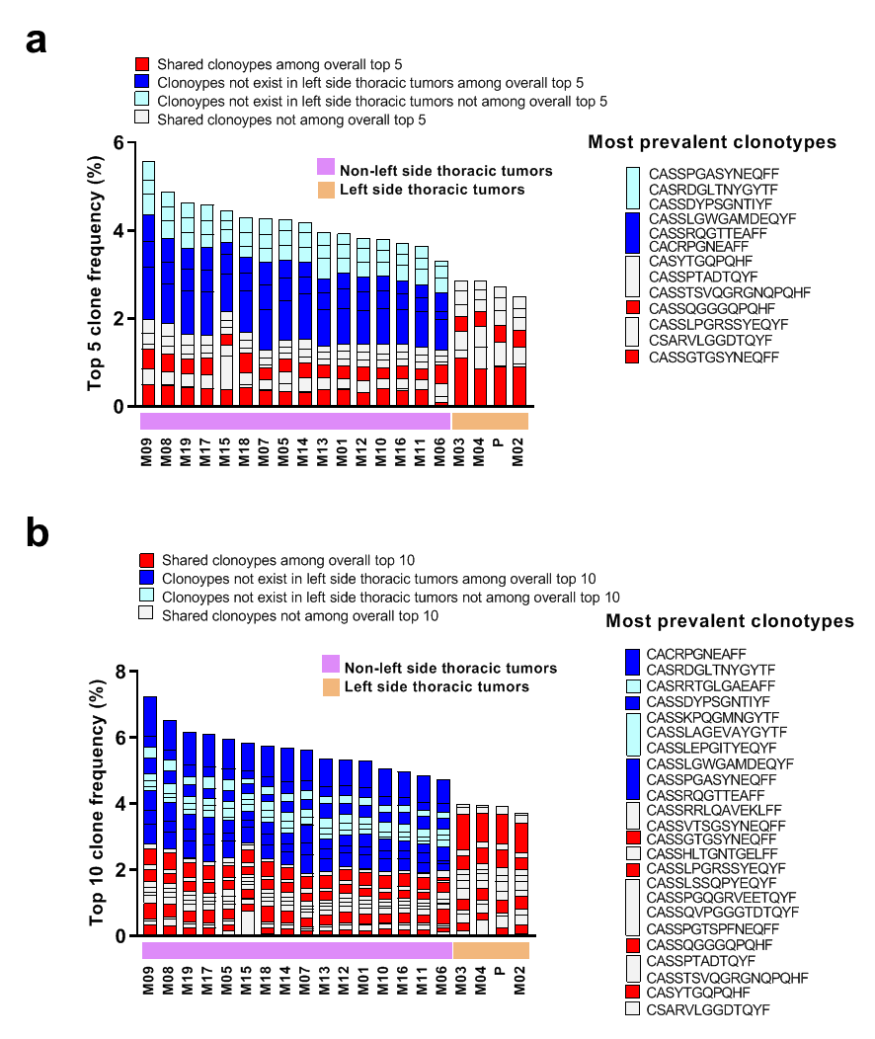
Supplementary Figure 4. Distinct antigenic profiles are associated with left-side thoracic tumors. a) Top 5 and b) top 10 T cell clonotype distribution landscapes among the 20 tumors.

Supplementary Figure 5
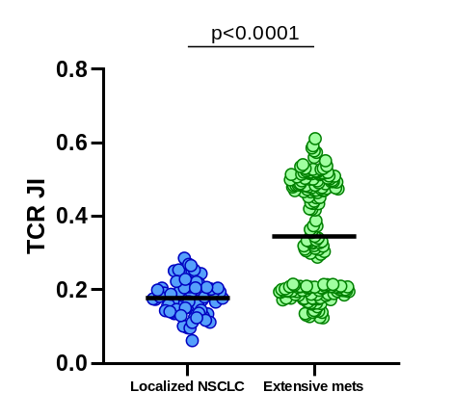
Supplementary Figure 5. A higher TCR Jaccard index (JI) in our patient compared to a previously published multi-region localized non-small cell lung cancer (NSCLC)

Supplementary Figure 6
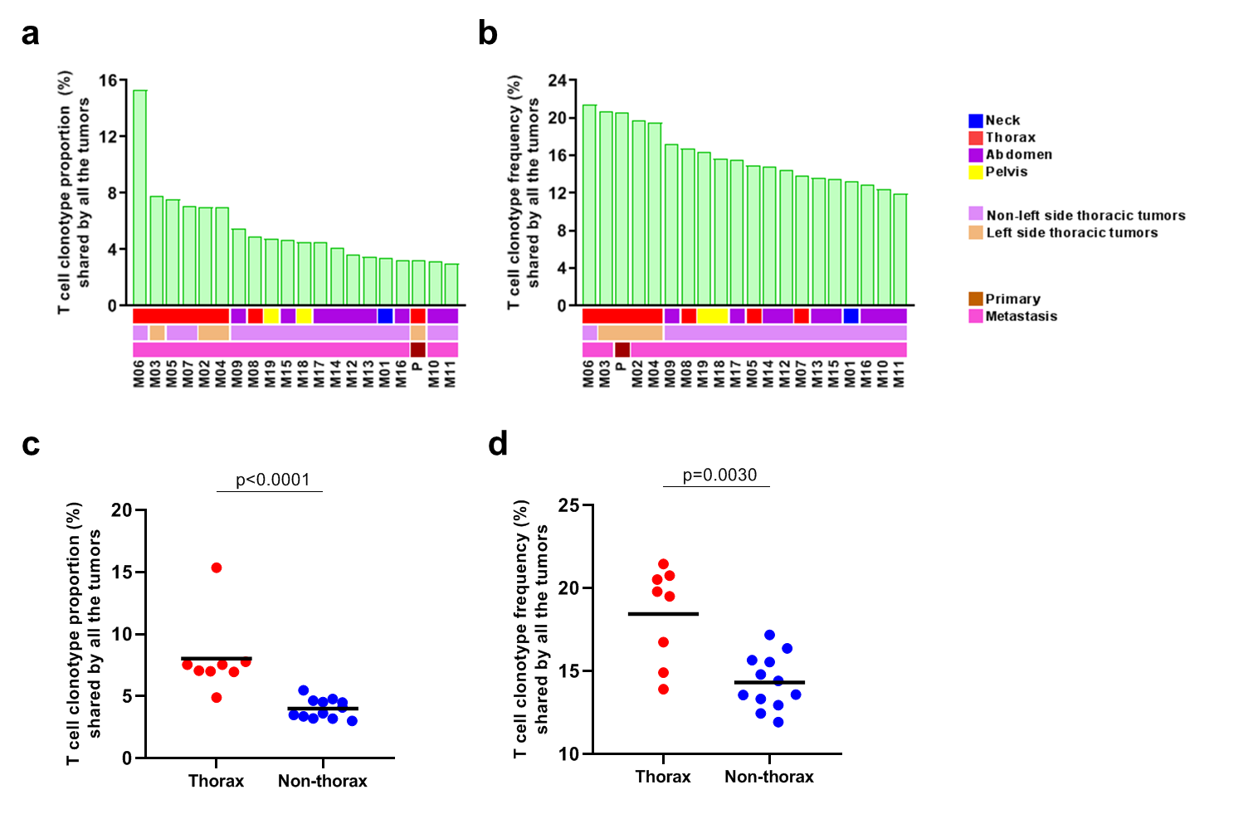
Supplementary Figure 6. Characterization of shared T cell clonotype proportions and percentages by all 20 tumors. Shared T-cell clonotype a) proportion and b) frequency of all 20 tumors. Comparison of shared T-cell clonotype c) proportion and d) percentage by all the tumors in thoracic and non-thoracic tumor.

Supplementary Figure 7
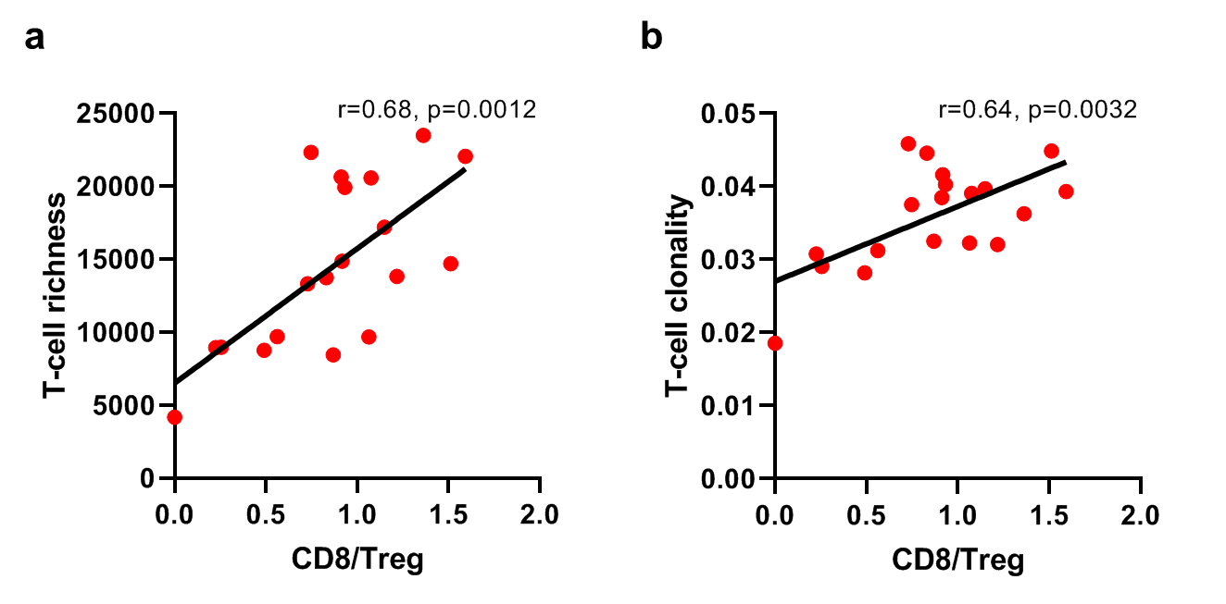
Supplementary Figure 7. Positive correlations of CD8 to Treg ratio with TCR metrics. Associations of ratio of CD8 to Treg with T-cell a) richness and b) clonality.

Supplementary table S1. Sample information
Sample ID | Location | System | Described organ
M01 | Neck | Endocrine | Thyroid gland
P | Thorax | Respiratory | Left lung
M02 | Thorax | Respiratory | Left pleural cavity
M03 | Thorax | Lymphatic | Left hilar lymph node
M04 | Thorax | Respiratory | Left parietal pleura
M05 | Thorax | Cardiovascular | Heart
M06 | Thorax | Respiratory | Right lung
M07 | Thorax | Respiratory | Right pleural cavity
M08 | Thorax | Lymphatic | 12th thoracic vertebrate
M09 | Abdomen | Digestive | GI tract
M10 | Abdomen | Digestive | Liver
M11 | Abdomen | Lymphatic | Hepatobiliary lymph node
M12 | Abdomen | Lymphatic | Omental lymph node
M13 | Abdomen | Lymphatic | Omental lymph node
M14 | Abdomen | Lymphatic | Retroperitoneal lymph node
M15 | Abdomen | Endocrine | Left adrenal gland
M16 | Abdomen | GU | Right kidney
M17 | Abdomen | GU | Right kidney
M18 | Pelvis | GU | Left ovary
M19 | Pelvis | GU | Right ovary

Supplementary Data. TCR rearrangements

