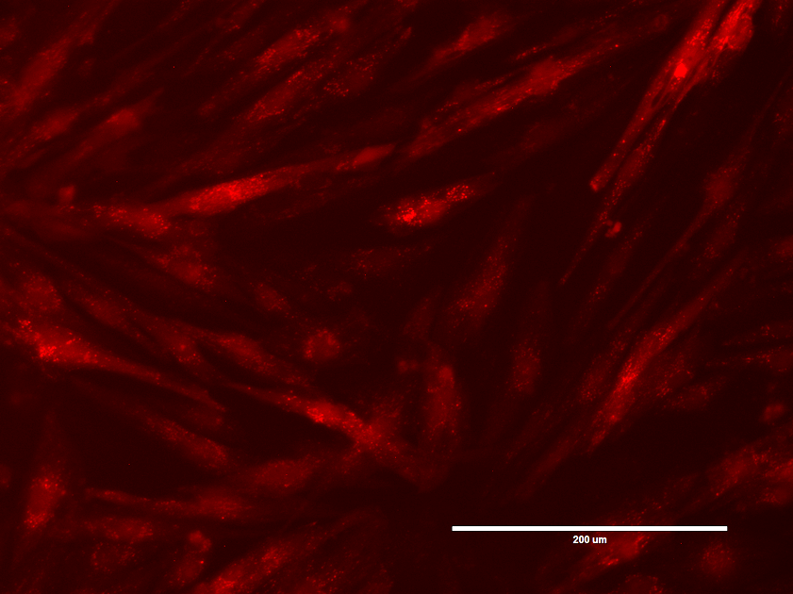

Supplementary Figure S1. Expression of mCherry in hPD-MSCs following adenoviral transduction with Ad-PMN.


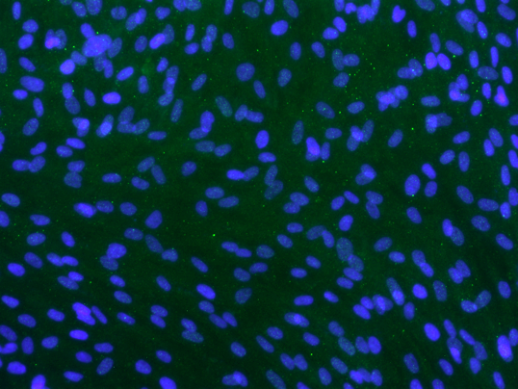
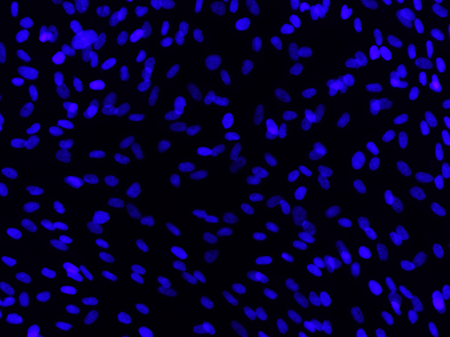
DAPI
MaFA
DAPI + MaFA

+MaFA
DAPI
MaFA
DAPI + MaFA

+MaFA
A
B

Supplementary Figure S2. Immunofluorescence staining for MafA expression in hPD-MSCs following Ad-PMN transduction.
Representative immunofluorescence images showing MafA expression in hPD-MSCs. (A) Non-transduced control cells. (B) hPD-MSCs transduced with Ad-PMN displaying increased MafA expression. Nuclei were counterstained with DAPI.

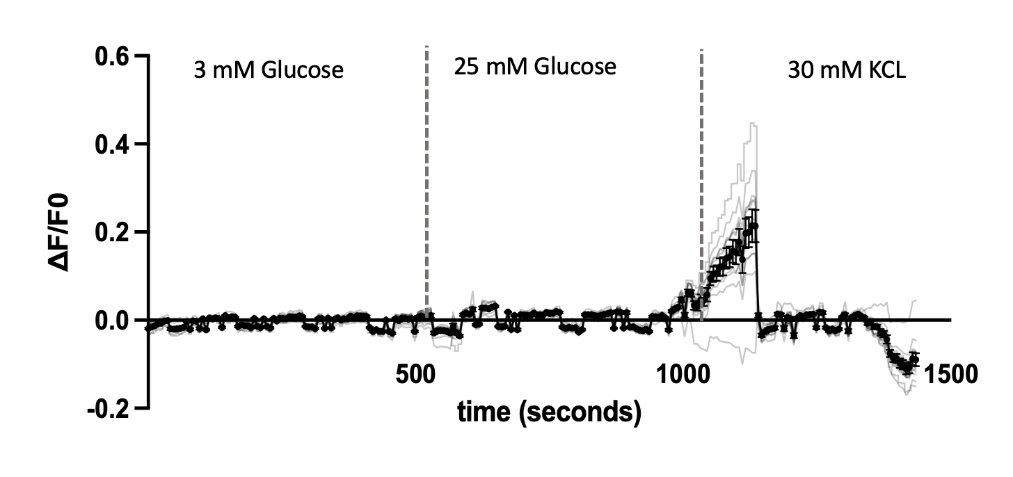

Supplementary Figure S3. Intracellular calcium dynamics in undifferentiated hPD-MSCs measured using Fluo-4 AM.
Changes in intracellular calcium levels were monitored using the calcium-sensitive fluorescent dye Fluo-4 AM in hPD-MSCs cultured in differentiation medium NPM without transcription factors. Cells were sequentially stimulated with low glucose (3 mM), high glucose (25 mM), and KCl (30 mM) to evaluate glucose responsiveness and membrane depolarization-induced calcium influx.

