SUPPLEMENTAL INFORMATION

TITLE: Sex differences in DNA methylation in autism spectrum disorder: an epigenome-wide association study

Authors: Natalia Cullell, PhD¹*; Amaia Hervas, MD,PhD²; Alexandre Serra-Llovich, MsC¹; Aida Álvarez, MD²; Valentin Bote, MD²; Cristina Gallego, PhD³; Enric Duran-Tauleria, MD⁴; María J. Arranz, PhD¹*

Supplemental Figures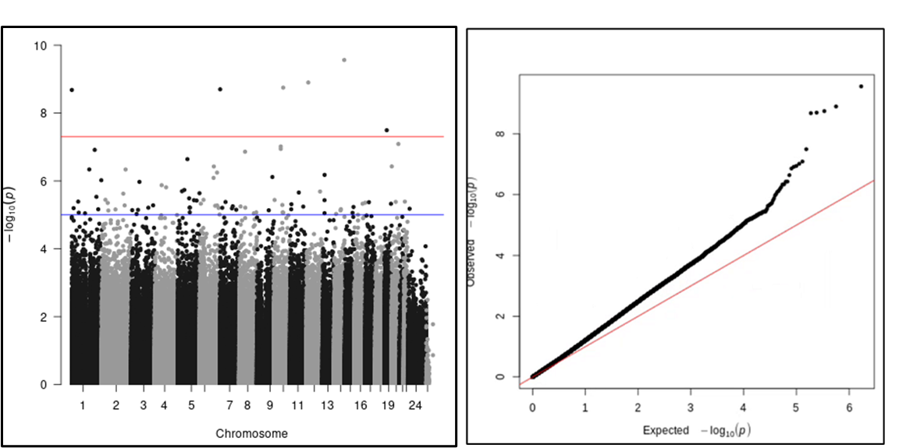Figure S1: Manhattan and QQ-plot from the Analysis 1. Representation of the EWAS results from the analysis 1 (both sexes analysed together). The red line represents the threshold for the EWAS significant CpG-sites. The blue line shows the threshold for nominal associations (p-value < 10e-5).

Figure S2: Gene-set enrichment analysis (GSEA) results from Analysis 1.
The GSEA results from analysis 1 are represented in the bar plot.

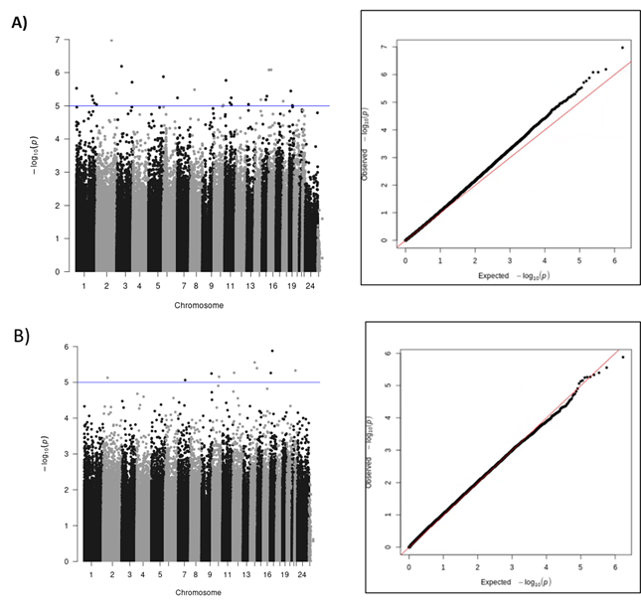
Figure S3: Manhattan and QQ-plot from the Analysis 2. Representation of the EWAS results in A) males and B) females. The blue line shows the threshold for nominal associations (p-value < 10e-5).

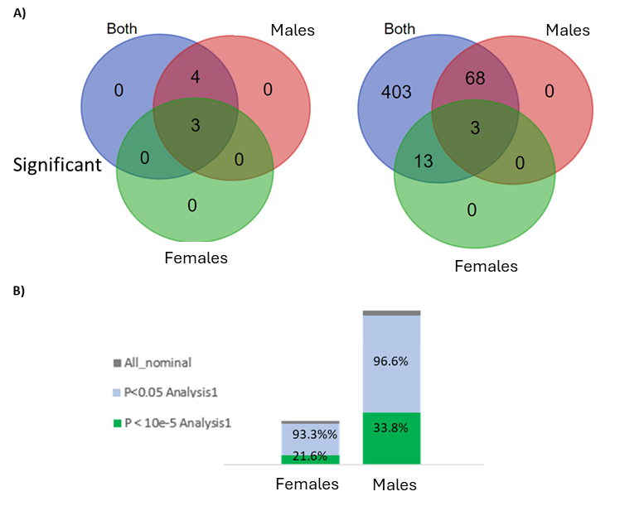
Figure S4: Comparison of sex-specific CpG-sites in ASD with CpG-sites associated with ASD in both sexes. A) Left plot shows the number of significant CpG-sites (p-value < 9.4e-8) from the analysis 1 that were nominally associated (p-value < 10e-5) with ASD in the stratified sex analysis. The right plot shows the number of nominally associated CpG-sites (p-value < 10e-5) from the analysis 1 that were nominally associated with ASD in the sex stratified analysis. B) Percentage of CpG-sites with a nominal p-value in the sex-stratified analysis with a p-value < 0.05 in the analysis 1 (blue) or a p-value < 10e-5 (green).

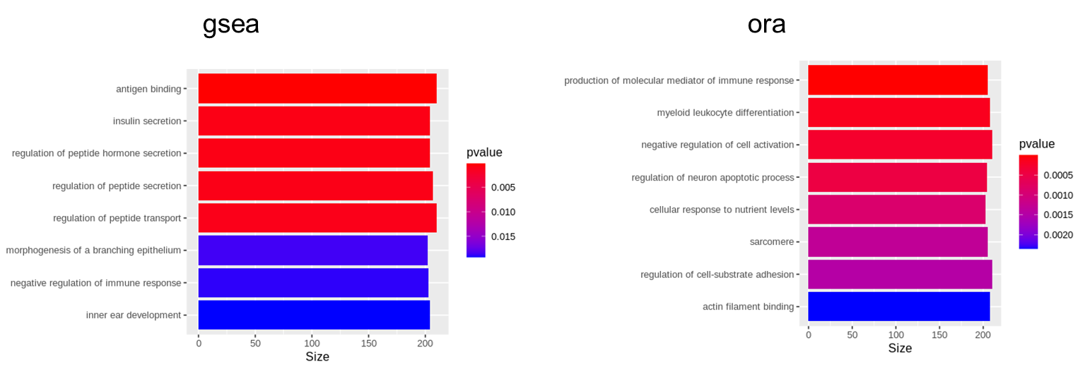
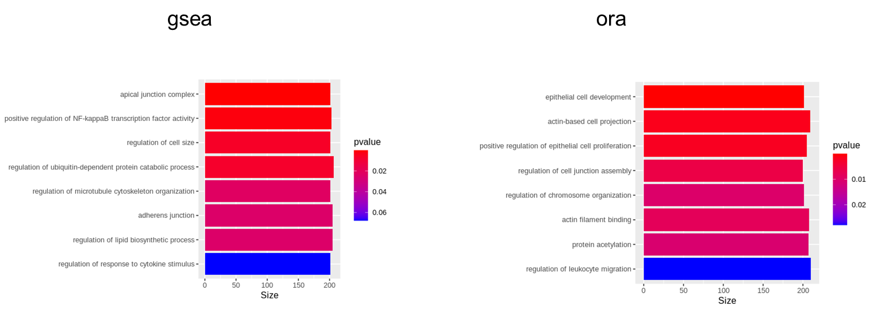

A)
B)

Figure S5: GSEA results from the Analysis 2. The GSEA results from the nominal genes in the analysis 2 are presented for males (A) and females (B).

Supplemental Tables

Table S1: Top results from Analysis 1 for CpG-sites in ASD genes
CpG | CHR | MAPINFO | t-value | P-value | Gene
cg11212237 | 6 | 116358814 | 5,19 | 8,13E-07 | FRK
cg01186321 | 4 | 93760188 | 5,04 | 1,54E-06 | GRID2
cg08432318 | 3 | 183882883 | 4,76 | 5,24E-06 | DVL3
cg11578891 | 8 | 140930124 | 4,64 | 8,44E-06 | TRAPPC9
cg10091135 | 16 | 83520096 | 4,58 | 1,11E-05 | CDH13
cg11797904 | 5 | 11903492 | -4,50 | 1,49E-05 | CTNND2
cg20036874 | 9 | 140812046 | 4,49 | 1,55E-05 | CACNA1B
cg09695403 | 22 | 18920114 | 4,35 | 2,76E-05 | PRODH
cg04353302 | 15 | 57667969 | 4,33 | 2,96E-05 | CGNL1
cg15343917 | 11 | 114052116 | 4,31 | 3,17E-05 | ZBTB16

Top results 10 more significant CpG-sites from the Analysis1 located in genes previously associated with ASD in Sfari and AutismKB2.0

Table S2: Top results from Analysis 2 (in females) for CpG-sites in ASD genes
CpG | CHR | MAPINFO | t-value | P-value | Gene
cg04353302 | 15 | 57667969 | 4,31 | 6,45E-05 | CGNL1
cg24954689 | 11 | 85310591 | 4,21 | 9,10E-05 | DLG2
cg25708850 | X | 80065793 | -4,19 | 9,94E-05 | BRWD3
cg04647039 | X | 31285105 | -4,12 | 1,25E-04 | DMD
cg16259985 | 5 | 9467915 | 4,10 | 1,33E-04 | SEMA5A
cg03569068 | 20 | 10286857 | 4,08 | 1,40E-04 | SNAP25
cg20822028 | 15 | 61038077 | 4,06 | 1,54E-04 | RORA
cg26398555 | X | 67458704 | 4,04 | 1,60E-04 | OPHN1
cg06619047 | 16 | 8772199 | 4,00 | 1,86E-04 | ABAT
cg01425168 | 7 | 70153200 | 3,94 | 2,22E-04 | AUTS2

Top results 10 more significant CpG-sites from the Analysis 2 (in females) located in genes previously associated with ASD in Sfari and AutismKB2.0

Table S3: Top results from Analysis 2 (in males) for CpG-sites in ASD genes
CpG | CHR | MAPINFO | t-value | P-value | Gene
cg08432318 | 3 | 183882883 | 4,76 | 1,09E-05 | DVL3
cg23788123 | 11 | 846403 | 4,58 | 2,10E-05 | TSPAN4
cg20036874 | 9 | 140812046 | 4,55 | 2,35E-05 | CACNA1B
cg11752586 | 2 | 149632599 | 4,50 | 2,74E-05 | KIF5C
cg00044210 | 7 | 154390803 | 4,37 | 4,46E-05 | DPP6
cg17980119 | 2 | 219472607 | 4,23 | 7,22E-05 | PLCD4
cg15847198 | 11 | 106889318 | -4,19 | 8,29E-05 | GUCY1A2
cg12927833 | 7 | 621876 | 4,15 | 9,70E-05 | PRKAR1B
cg15194167 | 13 | 102632310 | -4,07 | 1,24E-04 | FGF14
cg05326150 | 20 | 44896796 | 4,05 | 1,34E-04 | CDH22

Top results 10 more significant CpG-sites from the Analysis 2 (in males) located in genes previously associated with ASD in Sfari and AutismKB2.0

Table S4: DNA methylation clock results
 | Assoc. ASD (Males) |  |  | Assoc. ASD (Females) |  |  | Assoc. Sex (controls) |  |  | Assoc. Sex (ASD) |  |  | IQ
 | Std. Error | t value | P_value | Std. Error | t value | P_value | Std. Error | t value | P_value | Std. Error | t value | P_value | Std. Error | t value | P_value
Levine | 1,565 | -1,30 | 1,98E-01 | 1,536 | 0,14 | 8,90E-01 | 1,746 | 0,53 | 5,96E-01 | 1,308 | -1,01 | 3,17E-01 | 0,049 | -2,17 | 3,88E-02
ageAcc1.Levine | 1,074 | -1,60 | 1,14E-01 | 1,210 | 0,48 | 6,32E-01 | 1,395 | 0,87 | 3,88E-01 | 0,925 | -1,18 | 2,42E-01 | 0,045 | -0,65 | 5,24E-01
ageAcc2.Levine | 1,007 | -1,63 | 1,07E-01 | 1,241 | 0,66 | 5,13E-01 | 1,374 | 0,93 | 3,55E-01 | 0,907 | -1,30 | 1,97E-01 | 0,046 | -0,25 | 8,08E-01
ageAcc3.Levine | 0,952 | -1,23 | 2,23E-01 | 1,219 | 0,85 | 3,97E-01 | 1,350 | 0,96 | 3,42E-01 | 0,862 | -1,06 | 2,92E-01 | 0,043 | -0,45 | 6,60E-01
TL | 0,038 | 0,51 | 6,14E-01 | 0,038 | 1,21 | 2,31E-01 | 0,043 | -1,30 | 2,02E-01 | 0,032 | -2,59 | 1,11E-02 | 0,001 | 1,28 | 2,09E-01
ageAcc1.TL | 0,784 | 0,42 | 6,73E-01 | 1,019 | 1,01 | 3,15E-01 | 0,855 | 0,26 | 7,93E-01 | 0,829 | -0,57 | 5,68E-01 | 0,029 | 2,63 | 1,40E-02
ageAcc2.TL | 0,030 | 0,38 | 7,05E-01 | 0,034 | 1,36 | 1,78E-01 | 0,037 | -1,71 | 9,32E-02 | 0,027 | -3,62 | 5,03E-04 | 0,001 | 0,15 | 8,85E-01
ageAcc3.TL | 0,026 | 0,24 | 8,13E-01 | 0,035 | 0,79 | 4,33E-01 | 0,038 | -1,54 | 1,30E-01 | 0,025 | -3,22 | 1,83E-03 | 0,001 | 0,15 | 8,84E-01

Results for the association of the biological clocks with ASD (Assoc. ASD) in males and in females, for the association of the biological clocks with the sex (Assoc. Sex) in controls and ASD patients and for the association of the biological clocks with the IQ.
AgeAcc: Age acceleration 1; AgeAcc: Age acceleration 2, AgeAcc: Age acceleration 3.

