SUPPLEMENTARY DOCUMENT 1 to:
Cropping practices modulate tree-driven benefits of temperate agroforestry on soil organic carbon, nutrient availability and enzyme activities
Aloïs Fournier^{1*}, Pietro Barbieri¹, Mark R. Bakker¹, Nicolas Fanin¹, Sterenn Le Guennic^{1,2},
Marie Charru¹, Lionel Jordan-Meille¹
¹INRAE, Bordeaux Sciences Agro, ISPA, F-33140 Villenave d’Ornon, France
²Research Institute of Organic Agriculture (FiBL France), 26400 Eurre, France
Contact: Aloïs Fournier, alois.fournier@mailo.com

Table of contents

S1. Supplementary document to section Material and Methods 2
S1.1. Climatic conditions 2
S1.2. Detailed information on soil characteristics and richness 2
S1.3. Detailed information on tree strips arrangement and management 3
S1.4. Detailed information on agricultural practices indicators 4
S1.5. Cropping systems classification 6
S1.6. Example of the procedure to delimitate the study area 7
References 7

List of Figures
Figure S1.1 Temperature and rainfall at the Saint-Laurent-de-la-Prée reference station. 2
Figure S1.2 Cropping system classification.. 6
Figure S1.3 Example of the procedure applied to delimit the study area on each agroforestry site. 7
List of Tables
Table S1.1 Soil characteristics across the 15 sites. 2
Table S1.2 Spatial arrangement and management of trees and understorey vegetation strips (UVS) across sites. 3
Table S1.3 Description of selected agricultural practices intensity indicators 4
Table S1.4 Soil cover duration for annual crops and standard seeding and harvest dates assumed. 5
Table S1.5 Description of tillage categories used for STIR calculations 6

Supplementary document to section Material and Methods

Climatic conditions
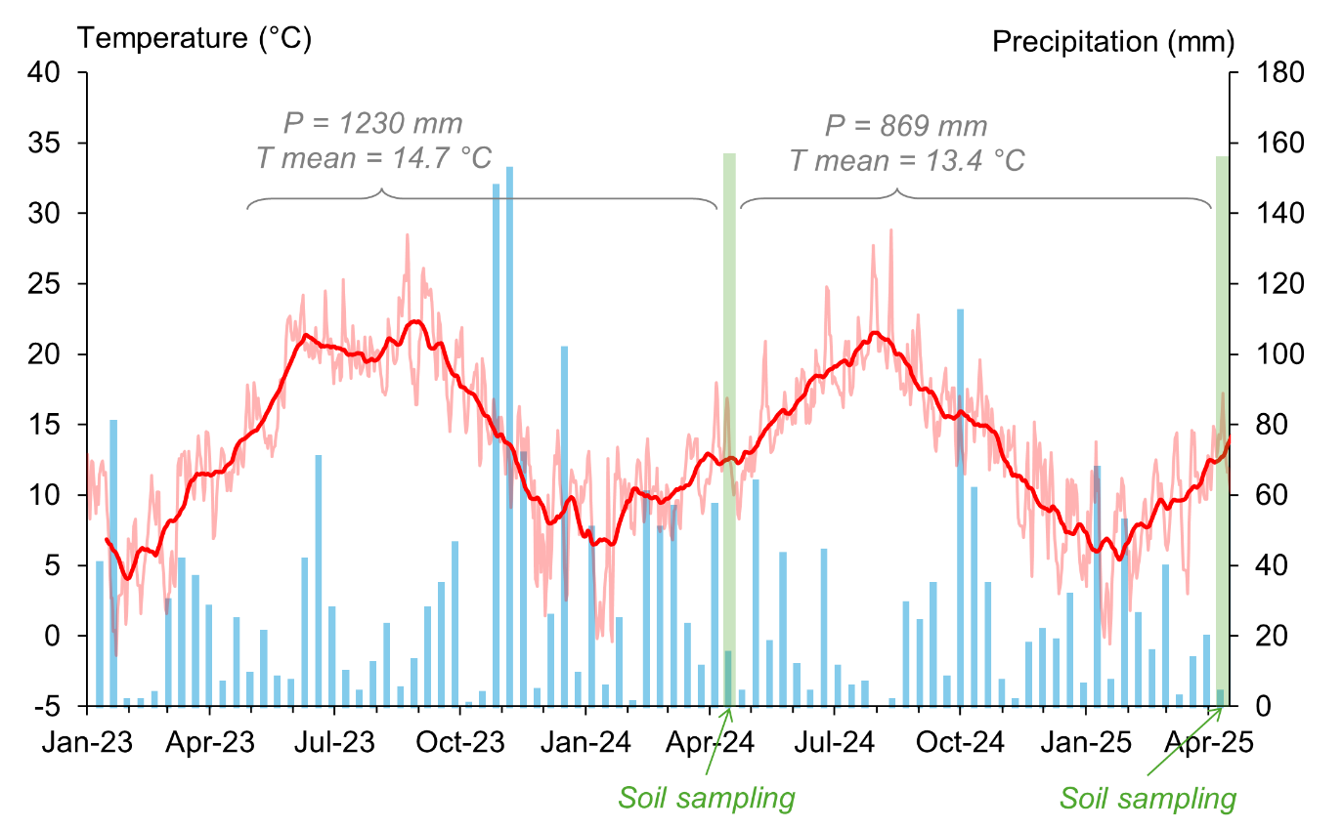
Figure S1.1 Temperature and rainfall at the Saint-Laurent-de-la-Prée reference station. Daily (light red) and 30-day smoothed (dark red) temperatures are shown alongside 10-day cumulative rainfall (blue bars). Green bars indicate soil sampling periods.

Detailed information on soil characteristics and richness
Table S1.1 Soil characteristics across the 15 alley-cropping sites. Soil texture, CaCO3 concentration and cationic exchange capacity (CEC) were measured on composite soil sample (0-20 cm) at the site scale. pH values were the mean values at FAR position (see 2.2).
SAF sites | WRB soil type | Soil depth (cm) | Clay / Silt / Sand (%) | pH in water | CaCO₃ (%) | CEC (ppm) | Coarse  elements (%)
P14 | luvic cambisol | 100 | 26 / 54 / 20 | 6.0 | 0 | 11 | 5
P17 | luvic cambisol | 130 | 19 / 71 / 10 | 6.7 | 0 | 7 | 20
P17b | luvic cambisol | 130 | 19 / 71 / 10 | 6.3 | 0 | 0 | 20
P9 | calcaric cambisol | 40 | 36 / 49 / 15 | 8.3 | 55 | 13 | 50
P25 | calcaric cambisol | 80 | 48 / 39 / 13 | 8.3 | 22 | 29 | 40
P13 | luvic cambisol | 150 | 28 / 60 / 12 | 6.4 | 1 | 11 | 5
P6 | calcaric cambisol | 90 | 48 / 35 / 17 | 8.3 | 36 | 27 | 40
P7 | calcaric cambisol | 90 | 32 / 44 / 24 | 8.3 | 53 | 19 | 40
P15 | luvic cambisol | 70 | 22 / 60 / 18 | 6.8 | 0 | 8 | 10
P8 | calcaric cambisol | 40 | 33 / 57 / 10 | 8.2 | 1 | 20 | 50
P11 | calcaric cambisol | 30 | 38 / 47 / 15 | 8.3 | 46 | 14 | 50
P12 | calcaric cambisol | 30 | 49 / 41 / 10 | 8.3 | 39 | 19 | 50
P22 | calcaric cambisol | 50 | 35 / 43 / 22 | 8.2 | 28 | 19 | 50
P32 | calcaric cambisol | 30 | 11 / 12 / 77 | 7.9 | 10 | 6 | 40
P33 | calcaric cambisol | 70 | 15 / 15 / 70 | 8.2 | 5 | 10 | 40

Detailed information on tree strips arrangement and management
Table S1.2 Spatial arrangement and management of trees and understorey vegetation strips (UVS) across 15 agroforestry sites. Management frequency: regular (annual/biennial), periodic (< once every 3 years), or never (since planting). UVS origin: sown or spontaneous (spont.).
SAF sites | Planting year | Alley / UVS width (m) | Tree density (nb.tree ha⁻¹) | UVS origin | UVS  management | Tree  pruning | Pruning wood  management
P14 | 2013 | 25 / 2 | 33 | sown | regular | regular | shredded, spread
P17 | 2012 | 25 / 2 | 56 | sown | regular | regular | left on site
P17b | 2012 | 25 / 2 | 56 | sown | regular | regular | left on site
P9 | 2011 | 26 / 1 | 56 | spont. | regular | regular | shredded, spread
P25 | 2009 | 34 / 4 | 370 | sown | never | regular | exported
P13 | 2008 | 25 / 2 | 34 | sown | periodic | regular | left on site
P6 | 2007 | 24 / 3 | 62 | sown | periodic | never | left on site
P7 | 2008 | 25 / 2 | 64 | sown | periodic | periodic | shredded, spread
P15 | 2010 | 24 / 3 | 37 | sown | never | regular | shredded, spread
P8 | 2008 | 24 / 3 | 41 | sown | periodic | periodic | left on site
P11 | 2014 | 25 / 2 | 38 | sown | periodic | never | /
P12 | 2014 | 25 / 2 | 38 | sown | periodic | never | /
P22 | 2007 | 25 / 2 | 62 | spont. | never | periodic | left on site
P32 | 2009 | 24 / 3 | 53 | sown | never | regular | left on site
P33 | 2011 | 24 / 3 | 53 | sown | never | regular | left on site

Detailed information on agricultural practices indicators
A set of 10 indicators characterising the agricultural practices on each AF site was derived based on interviews with farmers (Table S3). These indicators were selected because they represent agricultural practices that distinguish between different cropping systems (Büchi et al. 2019). The details of how the indicator values were determined are set out below.
Table S1.3 Description of selected agricultural practices intensity indicators
Abbreviation |  | Description
Crop rotation
nbLeg | # / 5y | Number of leguminous crops in the crop rotation
nbWint | # / 5y | Number of winter crops (sown before march) in the crop rotation as winter crops impacts tree-roots development (Germon et al. 2016; O’Connor et al. 2023)
cropDiv | # / 5y | Number of different crop species in the crop rotation
sCover | # / 12m | Estimated indicator of soil cover by crops (including cover crops) over the rotation (detailed description at section S1.4.1)
Productivity
export | T ha⁻1 yr⁻¹ | Annual dry biomass exportations (including any exported crop residues).
Soil disturbance
STIR |  | Soil Tillage Intensity Rating (detailed description at section S1.4.2)
Fertilization
N.inputs | kgN ha⁻¹ yr⁻¹ | Averaged annual N inputs through fertilization (organic or mineral)
P.inputs | kgP ha⁻¹ yr⁻¹ | Averaged annual P inputs through fertilization (organic or mineral)
C.inputs | kgC ha⁻¹ yr⁻¹ | Averaged annual C inputs through organic fertilization
Crop protection
pestTreat | # / 5y | Averaged annual treatment frequence index (= sum of the ratios of applied treatment dose over recommended dose)

Soil cover index (sCover)
For each site, information on the crop succession (including cover crops) was collected. We assume that harvested crops were seeded and harvest at standard dates (real dates not collected). We assume that cover crops were seeded 3 weeks after the previous harvest and destroy 1 week before the next seeding (1 month without soil cover). Finally, a percentage of soil cover was calculated by summing all the durations and dividing by the duration of the rotation.

Table S1.4 Soil cover duration for annual crops and standard seeding and harvest dates assumed.
Soil cover duration | Crops | Seeding date | Harvest date
5 months | spring barley | 01/02 | 30/06
5 months | lentils | 01/03 | 31/07
5 months | millet | 01/05 | 30/09
6 months | sunflower, maize, sorghum, buckwheat | 01/04 | 30/09
8 months | winter barley, faba bean | 15/10 | 15/06
9 months | winter wheat, oat, triticale, winter pea,  einkorn wheat, mixed grain | 15/10 | 15/07
10 months | oil flax | 01/11 | 31/08
10 months | rapeseed | 15/09 | 15/07

Rotation complexity indicator
To summarise the information from the various rotation indicators into a single indicator, we computed a composite indicator termed 'rotation', inspired by Büchi et al. (2019). This was done by adding the normalised values of the primary indicators and dividing by the number of indicators.
$$rotation=nbLeg+nbWint+cropDiv+sCover$$
The ‘rotation’ indicator reflects the complexity of the crop rotation. The higher the indicator, the greater the variety of crops in the rotation—including a significant proportion of legumes and winter cereals—and the greater the soil cover (provided by main crops or cover crops).

Soil Tillage Intensity Rating
The Soil Tillage Intensity Rating (STIR) is an indicator of the intensity of soil disturbance caused by all forms of tillage (ploughing, harrowing, mechanical weeding, …) (USDA 2012). A tillage intensity score is attributed to each type of tillage implement or operation according to four factors: 1. operating speed (km h⁻¹), 2. tillage type (from 0.15 to 1), 3. tillage depth (cm), 4. proportion of surface area disturbed (from 0 to 1). Tillage type adjusts the STIR score according to the type of mechanical disturbance to the soil (e.g. soil inversion = 1, mixing = 0.7). The score for any operation is then calculated according to the following formula:
$${STIR}_{i}\text{ = }\left(0.3107×{speed}_{i}\right)×\left(3.25×{tillage type}_{i}\right)×\left(0.3937×{depth}_{i}\right)×{surface}_{i}$$
During interviews with farmers, we collected information on the machinery used for tillage, ploughing or mechanical weeding, as well as the number of operations each year. These operations were classified into six categories inspired by the classification of soil operations proposed by Labreuche et al. (2014). We assigned standard characteristics to each category based on the values from the FIBL (progress-sol.ch/stir), in order to calculate STIR scores (Table S1.5). The sum of all operation scores was computed at the rotation scale and divided by the number of years to determine the average soil disturbance intensity per year at each site.

Table S1.5 Description of tillage categories used for STIR calculations
Tillage classes | Description | Speed km h⁻¹ | Tillage type | Depth cm | Surface area disturbed | STIR score
Class 4 | Ploughs (soil inversion) | 8 | 1 | 20 | 1 | 64
Class 3 | Mixing tillage (with some inversion): disc harrows, spring tooth harrows, cultivators, etc. | 10 | 0.8 | 12 | 1 | 38
Class 2 | Shallow soil harrowing tools: tine  harrows, shallow power harrows, etc. | 10 | 0.7 | 8 | 1 | 22
Class 2b | Subsoilers/deep cultivators: deep but  localised tools | 8 | 0.7 | 35 | 0.3 | 23
Class 1 | Very shallow tools: tine harrows | 12 | 0.7 | 4 | 1 | 13
Class 0 | Seed drills | 10 | 0.7 | 4 | 0.3 | 3

Cropping systems classification
(A)  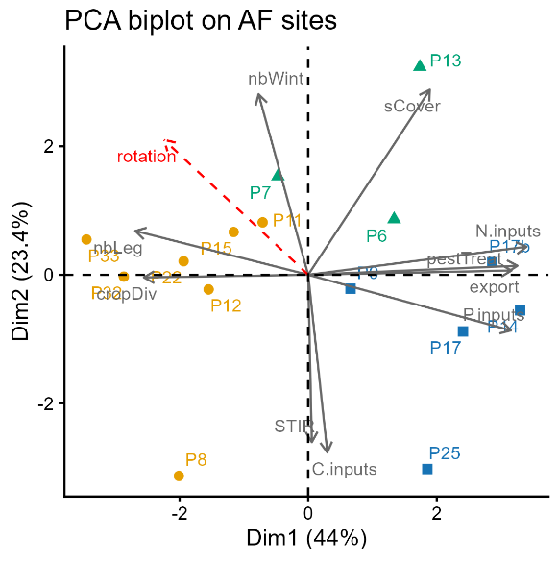 | (B)  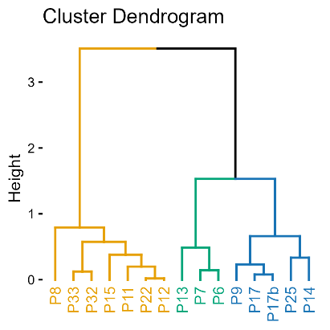
Figure S1.2 Cropping system classification. (A) PCA biplot of agricultural practice indicators. Active variables are grey arrows; the rotation composite indicator is a supplementary variable (dotted red arrow). (B) Cluster dendrogram grouping sites into three cropping systems: organic agriculture (OA, orange), soil conservation agriculture (CA, green), and conventional agriculture (Conv, blue).

Example of the procedure to delimitate the study area
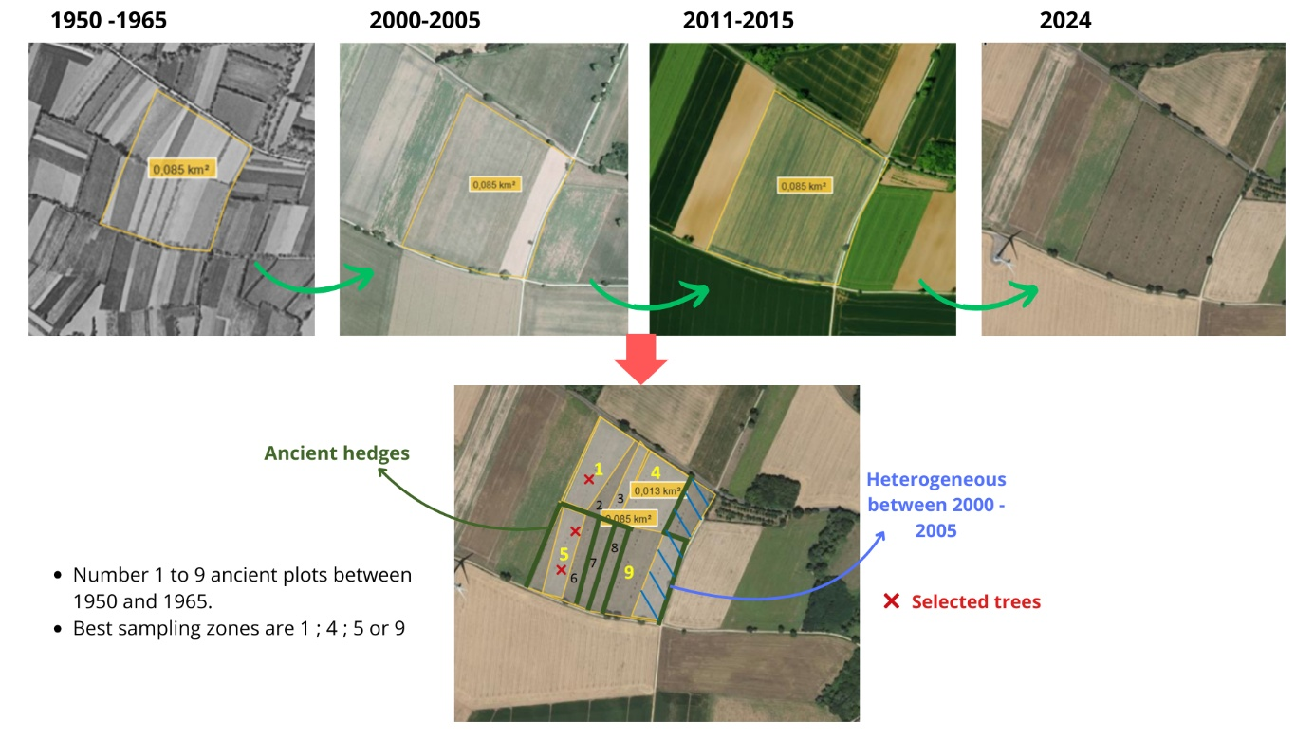
Figure S1.3 Example of the procedure applied to delimit the study area on each agroforestry site.

References
Büchi L, Georges F, Walder F, et al (2019) Potential of indicators to unveil the hidden side of cropping system classification: Differences and similarities in cropping practices between conventional, no-till and organic systems. European Journal of Agronomy 109:125920. https://doi.org/10.1016/j.eja.2019.125920
Germon A, Cardinael R, Prieto I, et al (2016) Unexpected phenology and lifespan of shallow and deep fine roots of walnut trees grown in a silvoarable Mediterranean agroforestry system. Plant Soil 401:409–426. https://doi.org/10.1007/s11104-015-2753-5
Labreuche J, Laurent F, Roger-Estrade J (2014) Faut-il travailler le sol ?: Acquis et innovations pour une agriculture durable. Editions Quae
O’Connor C, Zeller B, Choma C, et al (2023) Trees in temperate alley-cropping systems develop deep fine roots 5 years after plantation: What are the consequences on soil resources? Agriculture, Ecosystems & Environment 345:108339. https://doi.org/10.1016/j.agee.2022.108339
USDA (2012) Revised Universal Soil Loss Equation Version 2 (RUSLE2). U.S. Department of Agriculture, Natural resources Conservation Service

