SUPPLEMENTARY DOCUMENT 2 to:
Cropping practices modulate tree-driven benefits of temperate agroforestry on soil organic carbon, nutrient availability and enzyme activities
Aloïs Fournier^{1*}, Pietro Barbieri¹, Mark R. Bakker¹, Nicolas Fanin¹, Sterenn Le Guennic^{1,2},
Marie Charru¹, Lionel Jordan-Meille¹
¹INRAE, Bordeaux Sciences Agro, ISPA, F-33140 Villenave d’Ornon, France
²Research Institute of Organic Agriculture (FiBL France), 26400 Eurre, France
Contact: Aloïs Fournier, alois.fournier@mailo.com

Table of contents

S2. Supplementary document to section Results and Discussion 2
S2.1. Change in soil nutrients and enzymes across SAF sites 2
S2.2. Simplified mass-balance model for litterfall incorporation and comparison with fertilizers and harvested biomass flows 3
S2.3. Changes in pH, nutrients and enzymes across the 15 sites 4
S2.4. Assessment of OM stabilization by the soil fine fraction 7
References for supplementary document 2 7

List of Tables
Table S2.1 Changes in soil nutrients and enzyme quantities near trees across the 15 SAF sites. 2
Table S2.2 Simplified mass-balance model for litterfall. 3
Table S2.3 Nutrient inputs and outputs across cropping systems. 3
List of Figures
Figure S2.1 Mean differences in soil pH in water across SAF sites 4
Figure S2.2 Mean differences in total nitrogen and C:N ratio across SAF sites 4
Figure S2.3 Mean differences in exchangeable potassium magnesium across SAF sites 5
Figure S2.4 Mean differences in enzymes activities across SAF sites 6
Figure S2.5. C saturation across SAF sites as defined by Hassink (1997) 7

Supplementary document to section Results and Discussion

Change in soil nutrients and enzymes across SAF sites
Table S2.1 Changes in soil nutrients and enzyme quantities near trees across the 15 SAF sites. NEAR–FAR differences were estimated using site as a fixed effect, with significance assessed via the Dunnett’s test. Cropping systems: Conv (conventional), CA (soil conservation), OA (organic). Soil type: luvic/calcaric cambisol. Variables: SOC (soil organic carbon), NT (total nitrogen), C:N (ratio), P (Olsen available phosphorus), K (exchangeable potassium), Mg (exchangeable magnesium), EnzTot (Cenz+Nenz+Penz), C/N/Penz (C-/N-/P-related enzymes quantities). Symbols and colours: “++”/“+” significant/marginal positive change (blue/light blue); “--”/“-” significant/marginal negative change (orange/light orange). Significant change: P < 0.05. Marginal significant change: P < 0.10 for nutrients, P < 0.15 for enzymes.
Cropping system | Soil type | Site | SOC | NT | C:N | P | K | Mg | EnzTot | Cenz | Nenz | Penz
Conv | luvic | P14 |  |  |  |  |  |  |  | ++ | +
Conv | luvic | P17 |  |  | ++ | - | + |  |  | - | --
Conv | luvic | P17b |  |  | ++ | + |  | - | ++ |  |  | ++
Conv | calcaric | P9 | ++ | ++ |  |  |  | + |  | + |  | +
Conv | calcaric | P25 |  | ++ |  |  |  | ++
CA | luvic | P13 | + |  |  | ++ |  |  |  | + | +
CA | calcaric | P6 | ++ |  |  | ++ |  |  |  | -- |  | +
CA | calcaric | P7 | ++ | ++ |  | ++ |  |  |  | --
OA | luvic | P15 |  |  | -- | - |  | -- |  | ++ | ++ | -
OA | calcaric | P8 |  |  |  |  |  | ++ | ++ | + | ++ | +
OA | calcaric | P11 |  |  |  |  |  |  |  | + |  | -
OA | calcaric | P12 |  |  |  | ++ |  |  |  |  | + | ++
OA | calcaric | P22 | ++ | ++ |  | ++ |  | ++ |  |  | ++
OA | calcaric | P32 |  |  |  |  |  |  |  |  |  | --
OA | calcaric | P33 | - |  |  |  |  |  |  |  |  | --

Simplified mass-balance model for litterfall incorporation and comparison with fertilizers and harvested biomass flows
Table S2.2. Simplified mass-balance model for litterfall. We used the Hénin and Dupuis (1945) model to estimate the humification of litterfall after its incorporation into the soil, with applying a humification coefficient of 0.32 for C (Cardinael et al. 2018) and an incorporation coefficient of 0.40 for P (Raguet et al. 2025). We modelled a walnut tree with a linear DBH growth that reached 16.6 cm 14 years after planting. We assumed that the additional fresh OM inputs into the soil through litterfall were homogeneous within a 4 m radius circle around the tree trunk. Walnut litterfall characteristics from Cardinael et al. (2018) were used for C and N content, and global deciduous characteristics from Kang et al. (2010) for P content.
 | Biomass |  | Elements
 | DM | units | C | N | P | units
Litterfall production
Nutrients content | – |  | 449 | 9.2 | 0.9 | g kg⁻¹
Annual biomass (at 14 yr.) | 9.3 | kg tree⁻¹ yr⁻¹ | 4.2 k | 85 | 8 | g tree⁻¹ yr⁻¹
Cumulated biomass | 77 | kg tree⁻¹ | 34 k | 706 | 69 | g tree⁻¹
Homogeneous litterfall repartition
within a 4m radius circle
Annual inputs | 185 | g m⁻² yr⁻¹ | 83 | 1.7 | 0.17 | g m⁻² yr⁻¹
Cumulated inputs | 1532 | g m⁻² | 688 | 14 | 1.4 | g m⁻²
Litterfall incorporation into the soil
Humif. / incorp. coefficient | – |  | 0.32 | 1.00 | 0.40 | g g⁻¹
Annual humified inputs | – |  | 27 | 1.7 | – | g m⁻² yr⁻¹
Cumulated humified inputs | – |  | 220 | 14 | – | g m⁻²
Annual inorganic P inputs | – |  | – | – | 0.10 | g m⁻² yr⁻¹
Cumulated inorganic P inputs | – |  | – | – | 0.83 | g m⁻²

Table S2.3 Nutrient inputs and outputs across cropping systems. Fertilizers inputs and harvested biomass were estimated through interviews with farmers (Method 2.1.4). Nutrient outputs were computed based on soft wheat concentration.
 | Mass / Biomass |  | Elements
 | DM | units | C | N | P | units
Organic agriculture (OA)
Harvest outputs | 179 | g m⁻² | 75 | 2.8 | 0.8 | g m⁻² yr⁻¹
Fertilizers inputs | – |  | 18 | 3.3 | 1.7 | g m⁻² yr⁻¹
Conventional agriculture (Conv)
Harvest outputs | 510 | g m⁻² | 214 | 8.1 | 2.1 | g m⁻² yr⁻¹
Fertilizers inputs | – |  | 0 | 13.3 | 4.0 | g m⁻² yr⁻¹
Conservation agriculture (CA)
Harvest outputs | 348 | g m⁻² | 146 | 5.5 | 1.4 | g m⁻² yr⁻¹
Fertilizers inputs | – |  | 0 | 12.5 | 3.0 | g m⁻² yr⁻¹

Changes in pH, nutrients and enzymes across the 15 sites
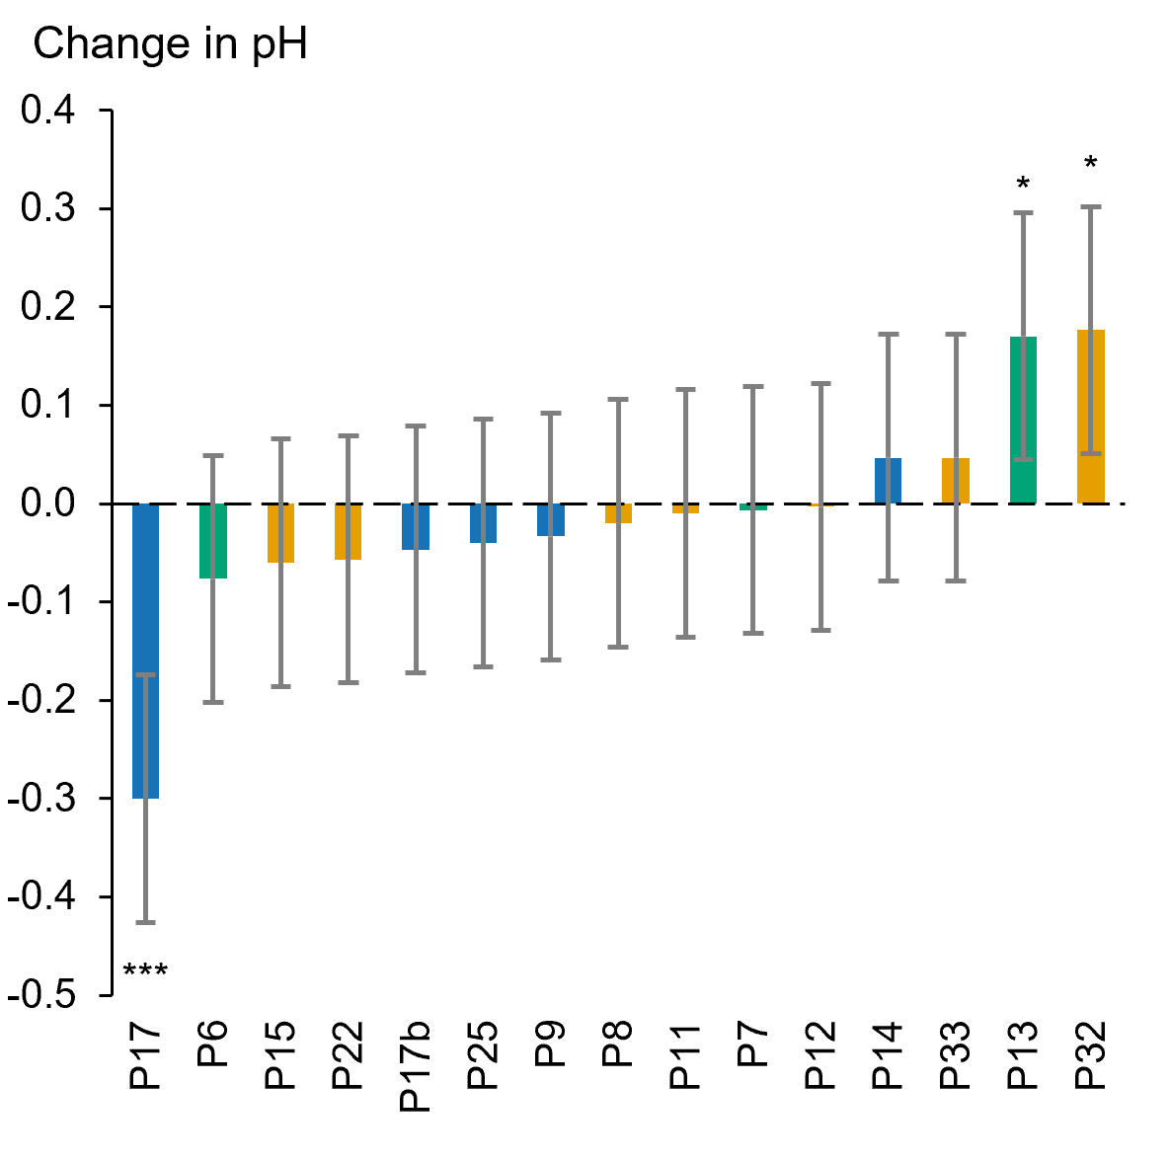
Figure S2.1 Mean differences in soil pH in water between NEAR and FAR positions across SAF sites (Step 2 in method). Colors denote cropping systems: blue (conventional), orange (organic), and green (soil conservation). Error bars show 95% confidence intervals (Dunnett’s test). Significance: • P < 0.10, * P < 0.05, ** P < 0.01, *** P < 0.001.

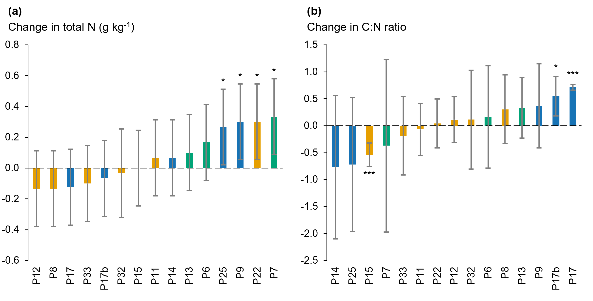
Figure S2.2 Mean differences in (a) total nitrogen and (b) C:N ratio between NEAR and FAR positions across SAF sites (Step 2 in method). Colors denote cropping systems: blue (conventional), orange (organic), and green (soil conservation). Error bars show 95% confidence intervals (Dunnett’s test). Significance: • P < 0.10, * P < 0.05, ** P < 0.01, *** P < 0.001.

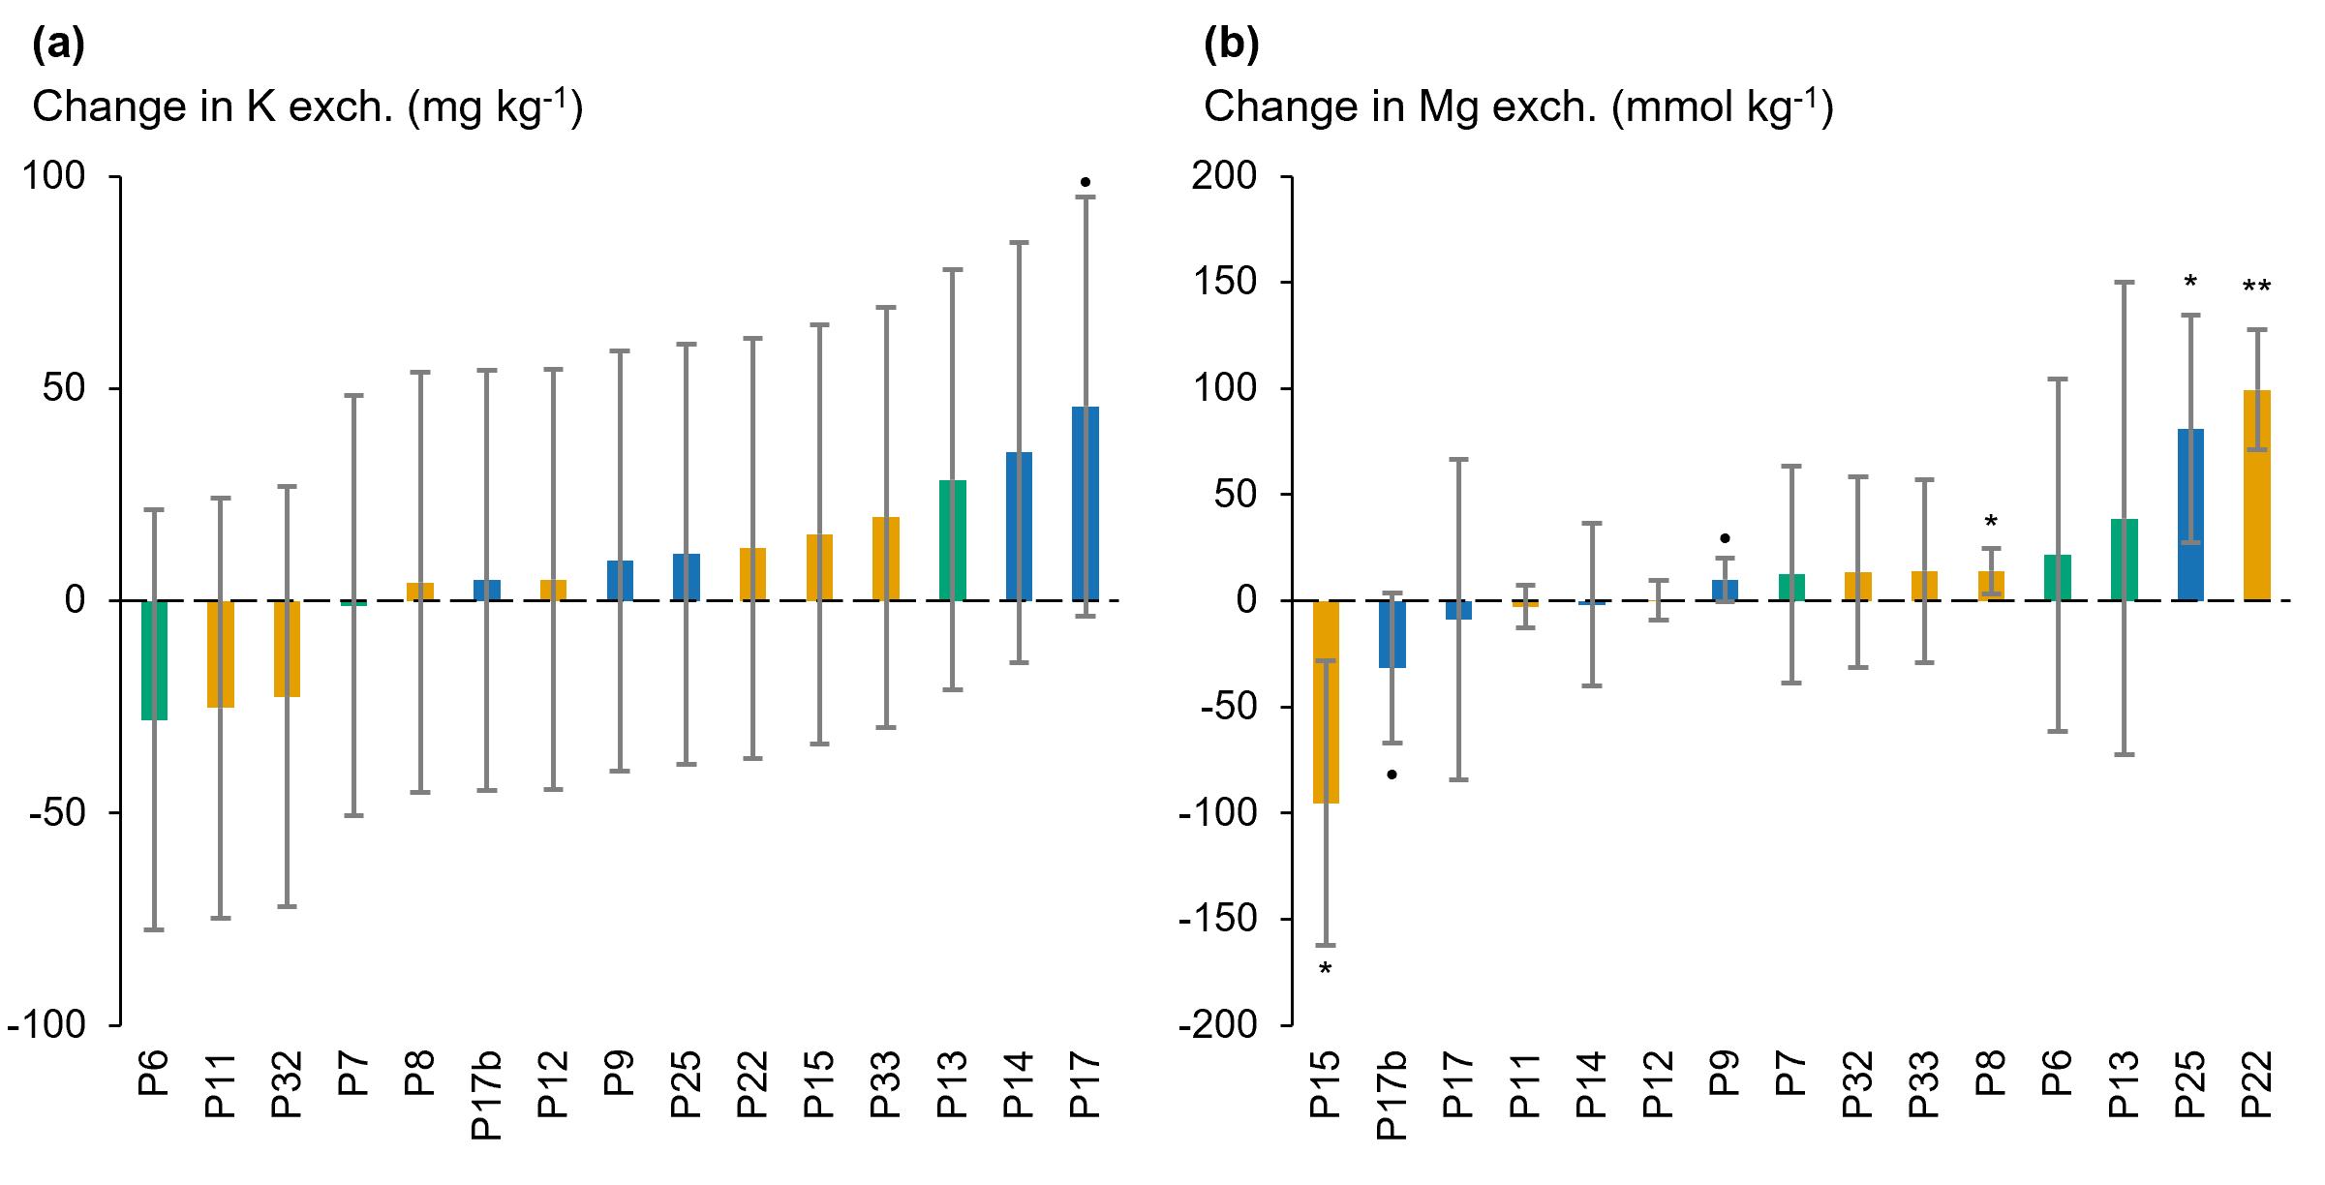
Figure S2.3 Mean differences in (a) exchangeable potassium (K) and (b) exchangeable magnesium (Mg) between NEAR and FAR positions across SAF sites (Step 2 in method). Colors denote cropping systems: blue (conventional), orange (organic), and green (soil conservation). Error bars show 95% confidence intervals (Dunnett’s test). Significance: • P < 0.10, * P < 0.05, ** P < 0.01, *** P < 0.001.

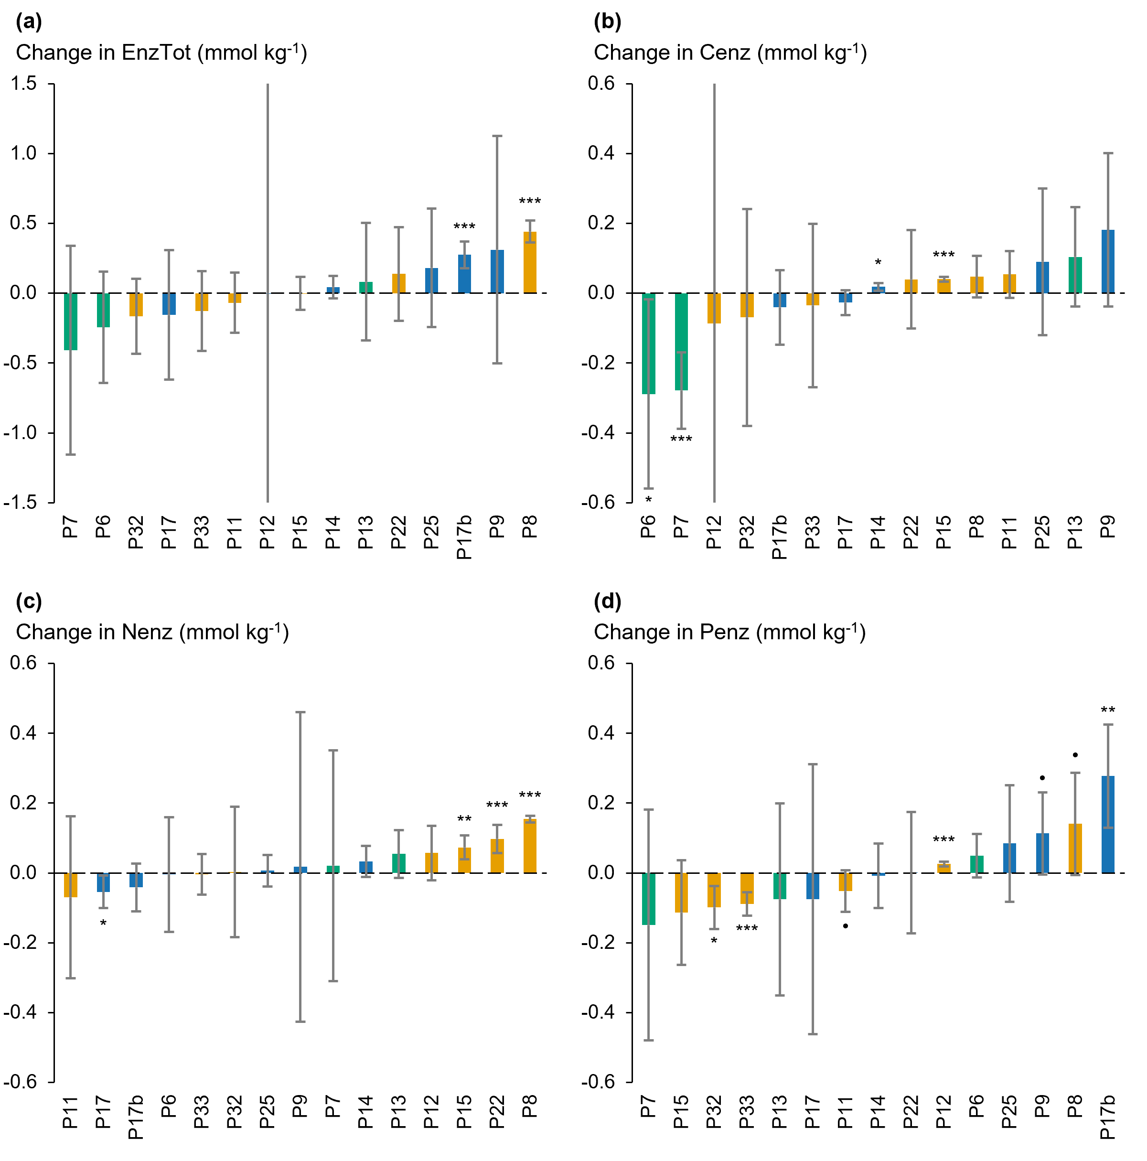
Figure S2.4 Mean differences in enzymes activities between NEAR and FAR positions across SAF sites (Step 2 in method): (a) total enzymatic activity, (b) C-related enzymes activities, (c) N-related enzymes activities, (d) P-related enzymes activities. Colors denote cropping systems: blue (conventional), orange (organic), and green (soil conservation). Error bars show 95% confidence intervals (Dunnett’s test). Significance: • P < 0.10, * P < 0.05, ** P < 0.01, *** P < 0.001.

Assessment of OM stabilization by the soil fine fraction
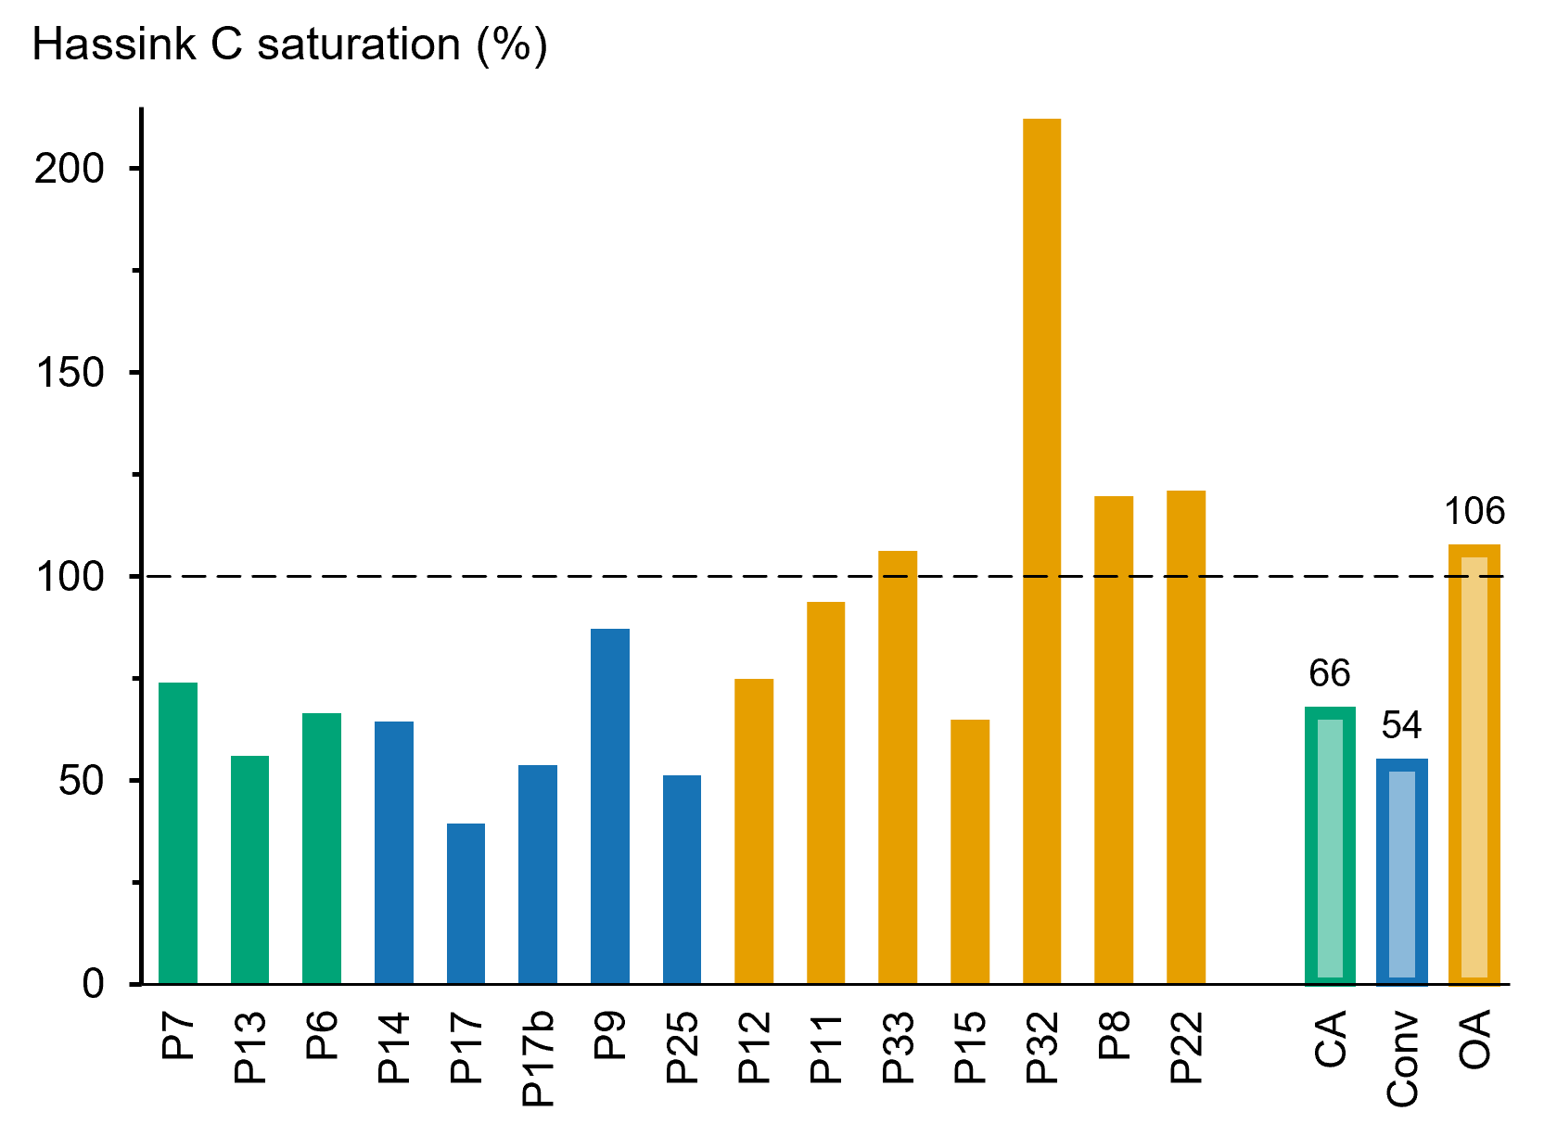
Figure S2.5. C saturation across SAF sites as defined by (Hassink 1997): saturation percentage is the ratio of observed SOC to the theoretical potential (Csat) of the soil to stabilize OM by association with the soil fine fraction (<20 μm). The C stabilization potential is estimated using Hassink formulae (Angers et al. 2011): Csat = 4.09 + 0.37 × (Clay + Fine Silt). Colors denote cropping systems: Conv (conventional), OA (organic), and CA (soil conservation). Median values across cropping systems are indicated on the right side of the graph.

References
Angers DA, Arrouays D, Saby NPA, Walter C (2011) Estimating and mapping the carbon saturation deficit of French agricultural topsoils. Soil Use and Management 27:448–452. https://doi.org/10.1111/j.1475-2743.2011.00366.x
Cardinael R, Guenet B, Chevallier T, et al (2018) High organic inputs explain shallow and deep SOC storage in a long-term agroforestry system - combining experimental and modeling approaches. Biogeosciences 15:297–317. https://doi.org/10.5194/bg-15-297-2018
Hassink J (1997) The capacity of soils to preserve organic C and N by their association with clay and silt particles. Plant and Soil 191:77–87. https://doi.org/10.1023/A:1004213929699
Hénin S, Dupuis M (1945) Essai de bilan de la matière organique du sol. Annales agronomiques 17–29
Kang H, Xin Z, Berg B, et al (2010) Global pattern of leaf litter nitrogen and phosphorus in woody plants. Ann For Sci 67:811–811. https://doi.org/10.1051/forest/2010047
Raguet P, Houot S, Montenach D, et al (2025) Soil organic phosphorus mineralisation rate in cropped fields receiving various P sources. Nutr Cycl Agroecosyst 130:69–89. https://doi.org/10.1007/s10705-024-10377-2

