APPENDIX
A1. Effect of Election Windows
Our paper builds on the baseline expectation that donations positively correlate with firm profits. We put this expectation to test and conducted several supplementary analyses with variations of our primary independent variable, donations, to ensure the robustness of the study. First, we split the overall sample into different election windows in Table A1. An election window refers to the time between the two central/federal elections held in the country. We had four election windows in our sample, i.e., 2007-2009, 2010-2014, 2015-2019, and 2020-2021. In Model 1, we estimated the average profitability in a window using donations received in the prior window to check for the persistence of donation effects. We found that donations produced a positive significant effect (β = 0.01, p <0.05). Secondly, we observed in our data that corporate political donations were pronounced around the election year. Therefore, we combined all the donations received in the election year, the year before, and one year after, as an alternative independent variable in Model 2. The findings remained consistent (β = 0.03, p <0.001) and provided additional support for the positive effect of donations on firm profitability. In Model 3, we used donations and profitability in the same window as independent and dependent variables respectively to find a positive significant effect of donations (β = 0.04, p <0.001). Since donations significantly affect firm's profitability in these robustness models, the baseline correlation may not be fortuitous but may demonstrate a meaningful association.

Table A1: Effect of Political Donations on Firm Performance
DV: Average Profitability | Last Window Donation | Election Year +/- One Year Donation | General Election Term Window Donation
DV: Average Profitability | Model 1 | Model 2 | Model 3
DV: Average Profitability | β /se | β /se | β /se
CR Income | 23.67* | 23.40* | 18.33
 | (9.69) | (10.06) | (9.48)
B G Affiliate | 0.50** | 0.49** | 0.59***
 | (0.16) | (0.15) | (0.14)
Firm Age | 0.01*** | 0.01*** | 0.02***
 | (0.00) | (0.00) | (0.00)
ROE | 0.02 | 0.02 | 0.01
 | (0.02) | (0.02) | (0.02)
Asset to Sales Ratio | 0.01 | 0.00 | -0.02
 | (0.06) | (0.06) | (0.05)
Public | 1.48*** | 1.48*** | 1.54***
 | (0.15) | (0.15) | (0.13)
One Party Loyalty (National) | -0.96*** | -0.83*** | -0.79***
 | (0.21) | (0.21) | (0.19)
One Party Loyalty (State) | 0.34 | 0.28 | 0.33
 | (0.27) | (0.27) | (0.25)
National-State Gov. Coalition | 0.02 | -0.01 | 0.11
 | (0.07) | (0.07) | (0.07)
Manufacturing Sector | 0.70*** | 0.68*** | 0.58***
 | (0.14) | (0.14) | (0.12)
Donation | 0.01* | 0.03*** | 0.04***
 | (0.00) | (0.00) | (0.00)
Rivals | -0.00 | -0.00 | -0.00
 | (0.00) | (0.00) | (0.00)
Constant | 2.01*** | 1.94*** | 1.12***
 | (0.26) | (0.26) | (0.26)
Year fixed effect | Yes | Yes | Yes
N | 3460 | 3460 | 4514
R² | 0.26 | 0.29 | 0.29
Wald Chi² | 1007.63 | 1321.58 | 1319.72
Note: Robust standard errors in parentheses; * p < 0.05, ** p < 0.01, *** p < 0.001
A2. Variation of Dependent Variable
We performed further analyses to strengthen the reliability of our study using return on assets (RoA) as the DV. Results are reported in Table A2. Model 1 replicated the main Model 4 of Table 5 in the paper using RoA as the DV. The results were in agreement of Model 4 result showing positive effect of donations on RoA and a negative moderating role played by industry rivals (H1).
We also tested the effect of donations on RoA using election windows, similar to Model 1 of Table A1, and found similar results, reported in Model 2 of Table A2. Average donations in the prior window produced a positive significant effect on RoA and rivals moderated this relationship negatively (H1). Additionally, we employed one more measure of donations using the tenure of political alliances in the country. The two major alliances in our sample were UPA (2007-2013) and NDA (2014-2021). Using the average donations in these year windows as the independent variable, we estimated the effect on RoA. The results are reported in Model 3, which are consistent with our hypotheses.

Table A2: Robustness Test Using ROA and Alternative Measures of Political Donation
DV: Return on Asset (ROA) |  | Window Donations | Tenure of Political Alliance
DV: Return on Asset (ROA) | Model 1 | Model 2 | Model 3
DV: Return on Asset (ROA) | β /se | β /se | β /se
CR Income | -1.53 | -8.22 | -10.90
 | (42.13) | (25.56) | (25.38)
B G Affiliate | 0.26 | 0.17 | -0.41
 | (0.71) | (0.54) | (0.52)
Firm Age | 0.00 | -0.00 | 0.01
 | (0.01) | (0.01) | (0.01)
ROE _{t-1} | 0.35* | -0.04 | 0.11
 | (0.15) | (0.05) | (0.07)
Asset to Sales Ratio | -1.61*** | -1.32*** | -1.65***
 | (0.29) | (0.27) | (0.22)
Public | -0.71 | -0.64 | -0.18
 | (0.66) | (0.61) | (0.51)
One Party Loyalty (National) | -1.85** | -1.52* | -1.39*
 | (0.72) | (0.64) | (0.62)
One Party Loyalty (State) | 0.91 | -3.30* | -3.34*
 | (1.04) | (1.48) | (1.46)
National-State Gov. Coalition | -0.10 | 0.19 | 0.30
 | (0.40) | (0.36) | (0.26)
Manufacturing Sector | -0.87 | -0.59 | -1.25*
 | (0.74) | (0.71) | (0.59)
Donation | 0.64*** | 0.74*** | 0.79***
 | (0.17) | (0.17) | (0.19)
Rivals | 0.04* | 0.03 | 0.05*
 | (0.02) | (0.02) | (0.02)
Donation * Rivals | -4×10^{-3**} | -4×10^{-3**} | -0.01***
 | (0.00) | (0.00) | (0.00)
Constant | 4.19 | 3.97 | 4.56
 | (6.35) | (2.85) | (2.83)
Year fixed effect | Yes | Yes | Yes
N | 1371 | 4109 | 6173
R² | 0.10 | 0.08 | 0.08
Wald Chi² | 131.97 | 147.16 | 176.51
Note: Robust standard errors in parentheses; * p < 0.05, ** p < 0.01, *** p < 0.001

A3. Sub-Sample Analyses for Donation Amounts and Political Realignment
In Table A3, we conducted sub-sample analyses to understand the effects of realigning political associations. Model 1 and Model 3 in Table A3 used the sample of firms donating at or below their industry average. Both models showed significant profitability gains (β = 0.30 p<0.05; β = 0.39 p<0.05) when those firms realigned their political association, providing additional support to H3. These tests thus provided further evidence of profitability gains when firms adopted a transactional approach to donations by realigning political associations and donating lower.
Model 2 used firms donating above their industry average. Although donation amounts improved profitability in this model, realigning did not produce a significant effect in Model 2, as expected. We note that firms with a relational approach may need a combination of CPAs in addition to donating. That is, only donating higher amounts than the industry average may not be sufficient as these firms may need to go beyond donations, in order to establish deeper engagements with political actors. This result provides additional support to our arguments on the limited potential of donations.

Table A3: Sub-sample analyses for Realigning Political Association
Variables | DV: NPAT |  | DV: Firm NPAT – Avg. Ind. NPAT
Variables | Model 1  (Donations at or below Ind. Avg.) | Model 2  (Donations above Ind. Avg.) | Model 3  (Donations at or below Ind. Avg.)
Donation _{t-1} | 0.14*** | 0.28*** | 0.14***
 | (0.03) | (0.08) | (0.03)
Political Association Realignment | 0.30* | -0.05 | 0.39*
 | (0.15) | (0.18) | (0.16)
CR Income | 9.88 | 14.01 | -25.43***
 | (7.11) | (13.38) | (7.65)
B G Affiliate | 0.92*** | 0.45 | 0.73***
 | (0.18) | (0.30) | (0.18)
Firm Age | 0.01** | 0.01 | 0.01*
 | (0.00) | (0.01) | (0.00)
ROE _{t-1} | 0.00 | 0.58 | 0.01
 | (0.01) | (0.30) | (0.01)
Asset to Sales Ratio | 0.01 | -0.06 | -0.10
 | (0.07) | (0.10) | (0.06)
Public | 0.72*** | 0.67* | 0.80***
 | (0.17) | (0.28) | (0.17)
National-State Gov. Coalition | 0.12 | 0.16 | 0.13
 | (0.10) | (0.15) | (0.10)
Manufacturing Sector | 0.15 | 0.43 | -0.68***
 | (0.16) | (0.29) | (0.16)
Constant | 2.83*** | -0.01 | -2.50***
 | (0.64) | (1.26) | (0.71)
Year fixed effect | Yes | Yes | Yes
N | 823 | 352 | 791
R² | 0.2621 | 0.3309 | 0.2202
Wald Chi² | 266.90 |  | 248.46
(Robust standard errors); † p < 0.10, * p < 0.05, ** p < 0.01, *** p < 0.001

A4. Instrumental variable analysis I
Despite using time lags and robust standard errors, there may concerns of endogeneity for the variable of corporate political donations. In the main paper, we tested for self-selection bias using the IMR technique and a categorical variable capturing firm’s decision to donate. Here, we now consider the continuous variable of donation amounts and explore an instrumental variable approach to allay concerns of its endogeneity.
Prior research, including that on CPA, used industry averages as valid instruments (Ferrell, Liang, & Renneboog, 2016; Shi, Connelly & Sanders, 2016; Su & Tsang, 2015; Sutton, Devine, Lamont, & Holmes, 2021). Following this practice, we used the lagged average donation amounts in an industry as an IV, using various number of year lags. We expected that past average industry donations may be correlated with the amount a firm donates (relevance), but may not directly predict an individual firm’s contemporary profitability (exclusion). Further, with the additional time lags, these past industry average donations may not be correlated with contemporary variables which are omitted and captured in the error term of the profit equation (exogeneity). The results using a 2SLS setup with this IV are reported in Models 1 and 2 in Table A4. Model 1 supported our expectation that donations positively relate to profitability (β=1.00, p<0.001). Similarly, Model 2 reinforced the result of negative moderation by industry rivals (β=-0.01, p<0.05). The magnitude of the interaction coefficient was comparable to the main Model 4, although both donations and rivals produced larger effects in the IV models.

Table A4: Instrumental variable of average industry donations
Variables  DV: NPAT | Model 1 | Model 2
 | β /se | β /se
CR Income | 7.98 | 10.38
 | (8.94) | (13.67)
B G Affiliate | -0.56 | 0.23
 | (0.36) | (0.53)
Firm Age | 0.01 | 0.01**
 | (0.00) | (0.01)
ROE | 0.02 | -0.01
 | (0.02) | (0.02)
Asset to Sales Ratio | -0.19* | -0.03
 | (0.09) | (0.08)
Public | 0.81*** | 0.71***
 | (0.18) | (0.18)
One Party Loyalty (National) | 0.50 | -0.34
 | (0.39) | (0.61)
One Party Loyalty (State) | -0.04 | -0.06
 | (0.33) | (0.52)
National-State Gov. Coalition | 0.46** | 0.30*
 | (0.15) | (0.15)
Manufacturing Sector | 1.04 | 0.35
 | (0.39) | (0.28)
Donation | 1.00*** | 1.15*
 | (0.24) | (0.56)
Rivals | -0.01*** | 0.16*
 | (0.00) | (0.07)
Donation*Rivals |  | -0.01*
 |  | (0.00)
Constant | -8.35* | -11.69
 | (3.35) | (8.60)
Year Fixed Effect | Yes | No
N | 1185 | 1185
R² | 0.28 | 0.22
Wald Chi² | 385.51 | 219.86
Note: Robust standard errors in parentheses; † p < 0.10, * p < 0.05, ** p < 0.01, *** p < 0.001

A5. Instrumental variable analysis II
We created a variable to capture corruption in the state as a potential instrumental variable for donation amounts. Corruption may encourage firms to donate to political parties making it a relevant instrument. Past levels of corruption may not be correlated with contemporary error term satisfying its exogeneity. Finally, past corruption may not directly impact firm profits except through firm’s engagement in donations satisfying the exclusion criterion.
To formulate the corruption measure for Indian states, we used the number of registered corruption cases per 100,000 people. The corruption index is the ratio of registered corruption cases per 100,000 people in state $i$ at time $t$ to the number in the base year. However, past studies indicate that such a measure does not accurately represent the true level of corruption due to under-reporting, as many cases go unreported due to fear of harassment or inefficiencies in the judicial system. Thus, the actual incidences of corruption are often lower than the official data, such as cases registered under the Prevention of Corruption Act 1988.
To address this issue, we adopted the approach used by Chaudhuri et al. (2015) and Shaurav & Rath (2023), employing a stochastic production frontier model (Aigner, Lovell, & Schmidt, 1977), to adjust for under-reporting. The relationship is represented by the equation:
$${logy}_{it}​=​{l{ogy}_{it}}^{*}-u_{it}$$
Where: ${logy}_{it}$ is the observed number of registered corruption cases. ${l{ogy}_{it}}^{*}$ is the true number of corruption cases. $u_{it}$ is the under-reporting (reporting error), representing inefficiency in the stochastic frontier model. Following Chaudhuri et al. (2015) and Shaurav & Rath (2023), we estimated this inefficiency (i.e., $u_{it}$ ) as follows:
$$u_{it}​=​f(x_{it}​,t,β)+v_{it}$$
Where: $x_{it}$represents socio-economic factors influencing corruption reporting (e.g., literacy rate, economic development, governance quality). $v_{it}$is the random error term.
We then added the predicted under-reporting to the registered corruption cases to find the Adjusted Corruption Index. This was used in our study to represent the actual level of corruption in the state as an IV. The results of the IV model are reported in Table A5. The results of Model 1 supported our baseline expectation that donations positively associate with higher profitability (β=0.62, p<0.05). Similarly, Model 2 provided further support for the main hypothesis by indicating a negative moderating effect of industry rivals (β=-0.01, p<0.01).

Table A5: Instrumental variable of corruption Index
Variables  DV: NPAT | Model 1 | Model 2
 | β /se | β /se
Donation | 0.62* | 0.52***
 | (0.31) | (0.15)
Rivals | -0.01* | 0.07**
 | (0.01) | (0.27)
CR Income | 9.49 | 13.13**
 | (8.52) | (7.84)
B G Affiliate | 0.04 | -0.61**
 | (0.43) | (0.24)
Firm Age | 0.01 | 0.01***
 | (0.01) | (0.01)
ROE | 0.01 | 0.01
 | (0.02) | (0.01)
Asset to Sales Ratio | -0.04 | -0.09
 | (0.07) | (0.07)
Public | 0.72*** | 0.79***
 | (0.15) | (0.16)
One Party Loyalty (National) | 0.03 | -0.55*
 | (0.47) | (0.27)
One Party Loyalty (State) | -0.30 | -0.36
 | (0.28) | (0.30)
National-State Gov. Coalition | 0.35*** | 0.18*
 | (0.12) | (0.90)
Manufacturing Sector | 0.68** | 0.12**
 | (0.27) | (0.18)
Donation*Rivals |  | -0.01**
 |  | (0.01)
Constant | -8.76 | -2.14
 | (6.23) | (2.28)
Year Fixed Effect | Yes | No
N | 1161 | 1136
R² | 0.35 | 0.31
Wald Chi² | 459.68 | 342.66
Note: Robust standard errors in parentheses; † p < 0.10, * p < 0.05, ** p < 0.01, *** p < 0.001

A6. Data Preparation Process
Section 29 of the Representation of the People's Act (RPA), 1951, allows political parties in India to accept voluntary contributions from Individuals and companies, other than government companies and those from foreign sources. Section 29 (C) of RPA mandates the political parties to file an audited account statement (financial contribution report) of contributions above Rs 20,000 to the Election Commission of India (ECI), latest by 30th October every year; failing to do that leads to severe penalties and denial of tax reliefs from the Income Tax Act, 1961. The Elections Commission of India (ECI) is an autonomous entity that works independently of the government. Indian Constitution article 324 gives power to the ECI to regulate, administer, control, and direct the elections of the two parliamentary houses, the state legislature, as well as the president and the vice-president of the country.
Section 13A of Income Tax Act, 1961 provides 100% tax exemptions to the political parties if they maintain and file the audited account statements, record the details of donors, and avoid anonyms cash donations of more than Rs. 2000. Section 182 of the Companies Act, 2013 authorise the companies to donate to the political parties through cheques, demand draft or direct transfer. However, donations made through direct transfer require the company to submit a formal declaration letter to the political parties and must disclose the amount in the company's profit and loss account. The contributions made by companies and Individuals are fully deductible (100% tax exemption) under Section 80GGB of the Income Tax Act, 1961.
For our study, we created a novel, hand-collected database of firms' donations to political parties using these annual audited contribution reports submitted to the ECI. We collated the annual audited account statements of political parties available on the ECI website (https://www.eci.gov.in/contribution-reports) from 2007-2021 to generate a master dataset. Additionally, we extracted political contribution data from the ADR website (https://www.myneta.info/party/). ADR is a non-governmental organization that improves governance and democracy by making relevant data available. Previous studies have used ECI and ADR data for measuring corporate political activity in India (Awasthi, Yayavaram, George, & Sastry, 2025; Chahal & Ahmad, 2022). We web-scraped the data from these two public sources. The financial contribution statements of political parties contain details such as the name of the contributing Individual/company, complete address of the contributing person/company, contribution amount, mode of contribution, PAN number, and the name & address of the issuing bank.
To ensure the reliability and accuracy of the data, we refined and processed it through multiple steps. First, we categorize the contributions into individual and company contributions by manually reviewing each entry in the list. This is a lengthy and time-consuming process, as the total number of donors can reach as high as 8,000 (approximately) in a single financial year for a single political party. We reviewed all the financial contribution reports of the political parties in India and categorized the contributions into personal and company contributions. In the next step, we separated the firms into public and private by searching for the phrases "Limited", "Private Limited", "Ltd.", Pvt. Ltd.", and similar phrases that are commonly used in a company's nomenclature. To obtain accurate company names from this unstructured data, we searched for the names of the firms in other sources, including the Ministry of Corporate Affairs database and news agencies such as Moneycontrol, Financial Times, and Bloomberg. As a parallel activity, we generated a list of all the Indian firms from the Prowess database (CMIE Prowess).
We identified a list of companies that are present in both the financial contribution list of political parties and the Prowess database, resulting in our final sample of firms providing political contributions to political parties from 2007 to 2021. Our sample selection process involves all public and private Indian companies that provide financial assistance to political parties, resulting in a total of 1166 unique firms across 31 different sectors. The entire process is illustrated in the figure below.
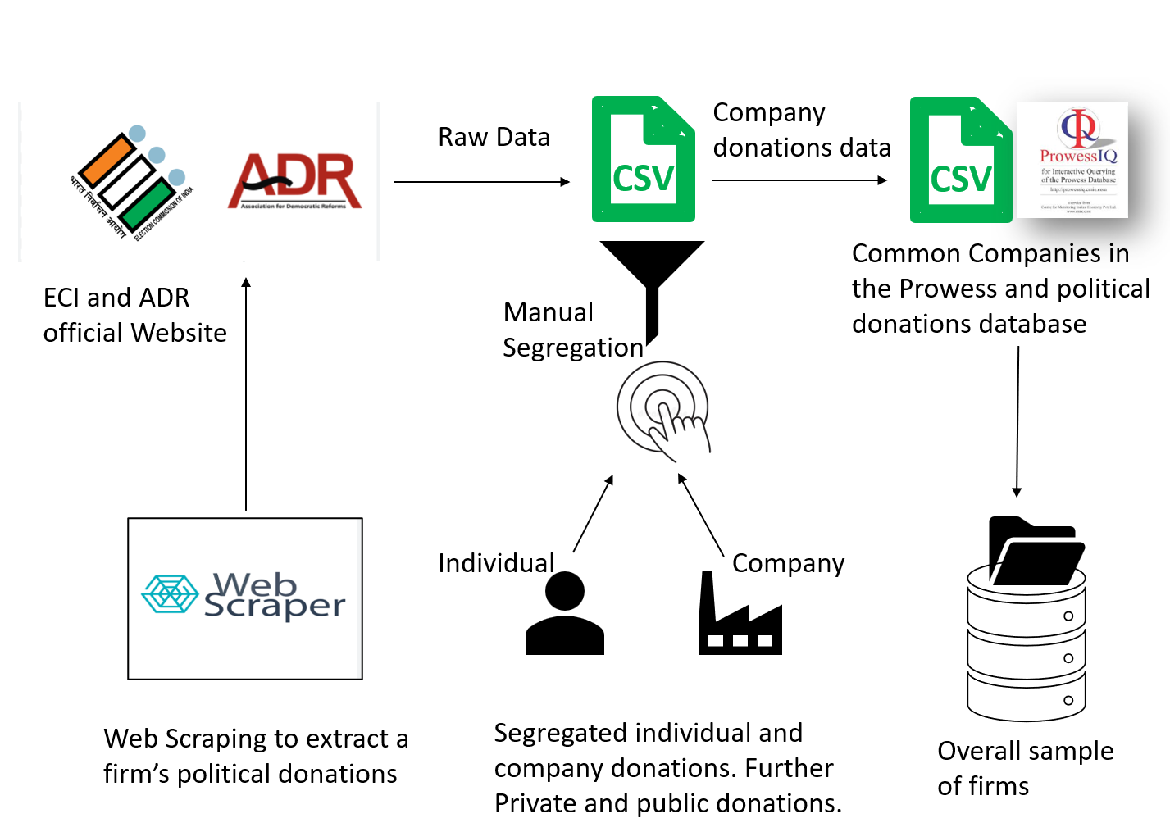
Figure-A6 Data Preparation Process

References
Aigner, D., Lovell, C. K., & Schmidt, P. (1977). Formulation and estimation of stochastic frontier production function models. Journal of econometrics, 6(1), 21-37.
Awasthi, K., Yayavaram, S., George, R., & Sastry, T. (2025). Political connections and profit persistence in India. Asia Pacific Journal of Management, 42(2).
Chahal, R. J. K., & Ahmad, W. (2022). Political connections, investment inefficiency, and the Indian banking crisis. The Quarterly Review of Economics and Finance, 85, 16-30.
Chaudhuri, K., Chowdhury, P., & Kumbhakar, S. C. (2015). Crime in India: specification and estimation of violent crime index. Journal of Productivity Analysis, 43(1), 13-28.
Ferrell, A., Liang, H., & Renneboog, L. (2016). Socially responsible firms. Journal of Financial Economics, 122(3), 585–606.
Shaurav, K., & Rath, B. N. (2023). Measurement and determinants of corruption across Indian states. Journal of Economic Studies, 50(7), 1526-1548.
Shi, W., Connelly, B. L., & Sanders, W. G. (2016). Buying bad behavior: Tournament incentives and securities class action lawsuits. Strategic Management Journal, 37(7), 1354-1378.
Su, W., & Tsang, E. W. K. (2015). Product diversification and financial performance: The moderating role of secondary stakeholders. Academy of Management Journal, 58(4), 1128–1148.
Sutton, T., Devine, R. A., Lamont, B. T., & Holmes, R. M. (2021). Resource dependence, uncertainty, and the allocation of corporate political activity across multiple jurisdictions. Academy of Management Journal, 64(1), 38–62.

