Supplementary material

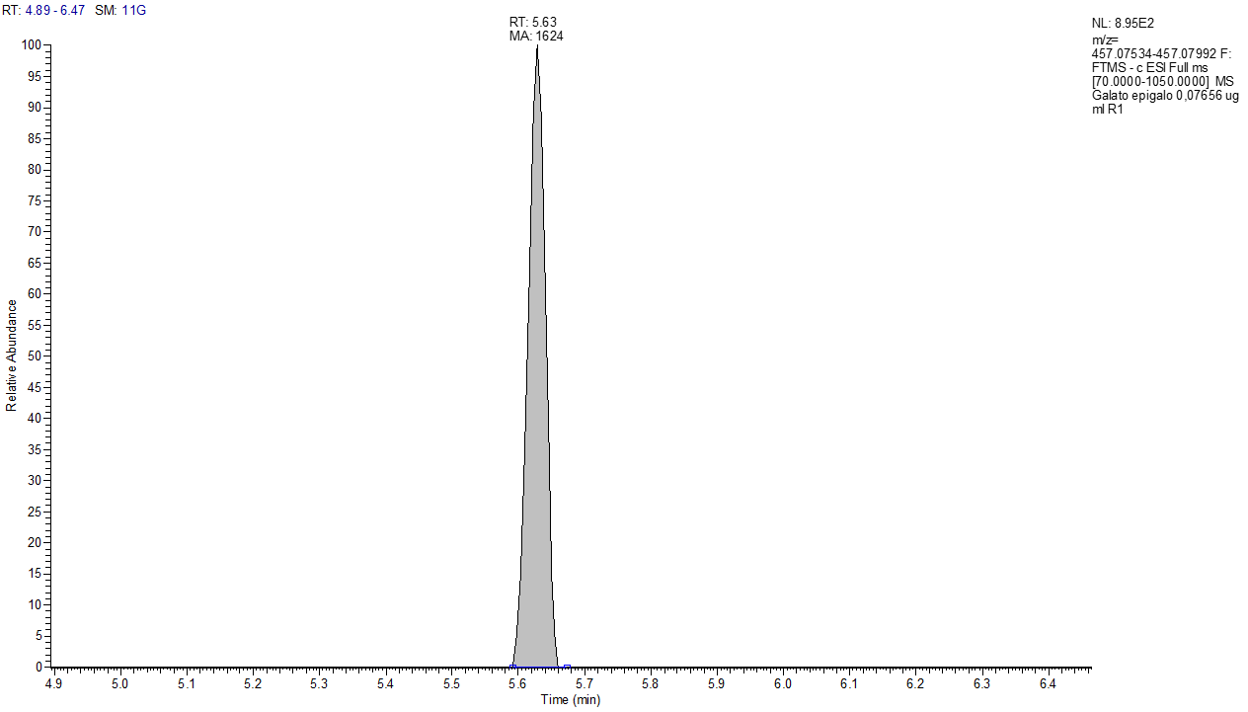
Figure S1: Extracted ion chromatogram of EGCG at 0.08 µg/mL.

Table S1: Results from calibration curve.

