Supplementary data
Supplementary Table 1. Test of parallelism (equality of slopes) for five lepidoteran species treated with three B. thuringiensis preparations. Slope: estimated slope of the Probit regression line of log(dose) versus mortality ± standard error (SE). P: probability value associated with the chi-square (χ²) test for equality of slopes (parallelism test). Same slope: pairwise test of equality of slopes between Delfin® and LipF. P > 0.05 indicates no significant deviation from parallelism (i.e., slopes are considered statistically similar), whereas P < 0.05 indicates significant differences among slopes.

Species | Treatments | Slope | Same slope^{b}
S. frugiperda | Lip F | 1.8±0.2 | Yes. χ²= 1.0, df=1, P = 0.32
 | Delfin® | 2.2±0.3
S. exigua | Lip F | 1.2±0.2 | Yes. χ²= 3.6, df=1, P = 0.06
 | Delfin® | 1.8±0.3
P. absoluta | Lip F | 3.1±0.5 | Yes. χ²= 0.1, df=1, P = 0.84
 | Delfin® | 3.3±0.5
G. molesta | Lip F | 1.4±0.2 | No. χ²= 4.3, df=1, P = 0.04
 | Delfin® | 1.0±0.1
O. nubilalis | Lip F | 1.3±0.2 | Yes. χ²= 0.5, df=1, P = 0.47
 | Delfin® | 1.4±0.2
Supplementary Figure1 Uncropped gel of SDS-PAGE for Lip-U and Lip-F

Supplementary Figure 2 BSA profile for SDS-PAGE. M: Molecular weight, DE: Delfin, BL,BS: Positive control of another Bt strain, LF:Lip-F formualtion, LU: Lip-U material.
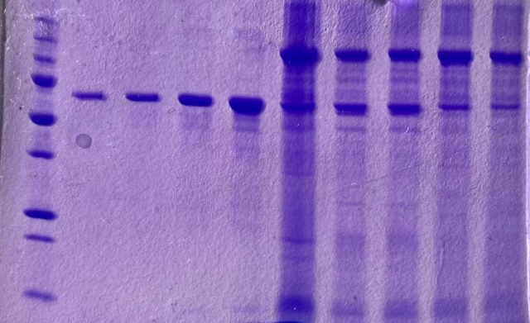
BSA
M 0,05 0,1 0,2 0,4 DE BL BS LF LU

Supplementary Figure 3 SDS-PAGE gel picture of Lip-F and Lip-U after sunlight (SL) exposure . Three replicates of each treatment

