Supplementary Materials

Optimization of Running Parameters to Maintain peak Ground Reaction Forces in Simulated Lunar and Martian Gravity
Marcello Grassi¹, Jonas Böcker², Timo Frett², David Green^{3,4,5}, Marcin Mider⁶, Tobias Weber^{3,7,8}, Martin Daumer^{1,6,9}, Jörn Rittweger^{2,†}
Affiliations:
¹ TUM School of Computation, Information and Technology, Munich, Germany
² Institute of Aerospace Medicine, German Aerospace Center, Cologne, Germany
³ European Space Agency, European Astronauts Center, Spaceship and Facilities Team, Cologne, Germany
⁴ Centre of Human and Applied Physiological Sciences (CHAPS), King’s College London, London, United Kingdom
⁵ Institute for Risk and Disaster Reduction (IRDR), University College London, London, United Kingdom
⁶ Trium Analysis Online GmbH, Munich Germany
⁷ KBR GmbH, Cologne, Germany
⁸ Aerospace Medicine & Rehabilitation Laboratory, Department of Sport, Exercise & Rehabilitation, Northumbria University, Newcastle upon Tyne, UK
⁹ SLCMSR e.V. - The Human Motion Institute, Munich, Germany
† Deceased on 21st April 2025
Corresponding author: Marcello Grassi (marcello.grassi@tum.de)

Table S1
Gravity Level | Walking Speed (m/s) | Running Speed (m/s)
0.16g | 0.89 ± 0.02 | 1.49 ± 0.04
0.27g | 1 ± 0.02 | 1.67 ± 0.05
0.38g | 1.09 ± 0.03 | 1.79 ± 0.07
0.7g | 1.34 ± 0.03 | 2.18 ± 0.16
1.0g | 1.57 ± 0.04 | 2.62 ± 0.08
Table S1: Prescribed walking and running speeds by gravity level (mean ± SD across participants). The same speeds were used on both the AlterG and VTF treadmill systems. Walking and running speeds were set at 75% and 125% of each participant's individual walk-run transition speed, respectively.

Table S2
 | Post-Hoc comparison |  |  | Cohen’s d
Contrast | Estimate | SE | p-value (adjusted) | Effect size [95% CI] | Magnitude
Peak GRF (BW)
1.0g - 0.7g | 0.510 | 0.008 | < 0.001 | 3.49 [3.32:3.67] | large
1.0g - 0.38g | 1.095 | 0.008 | < 0.001 | 7.5 [7.23:7.77] | large
1.0g - 0.27g | 1.274 | 0.009 | < 0.001 | 8.72 [8.42:9.03] | large
1.0g - 0.16g | 1.343 | 0.009 | < 0.001 | 9.2 [8.88:9.52] | large
GCT (ms)
1.0g - 0.7g | 8.067 | 2.499 | 0.011 | 0.18 [0.05:0.31] | small
1.0g - 0.38g | -19.794 | 2.584 | < 0.001 | -0.44 [-0.58:-0.31] | small
1.0g - 0.27g | -48.196 | 2.655 | < 0.001 | -1.08 [-1.22:-0.93] | large
1.0g - 0.16g | -69.467 | 2.684 | < 0.001 | -1.55 [-1.7:-1.4] | large
Cadence (spm)
1.0g - 0.7g | 10.943 | 0.788 | < 0.001 | 0.78 [0.64:0.91] | medium
1.0g - 0.38g | 26.583 | 0.815 | < 0.001 | 1.88 [1.74:2.03] | large
1.0g - 0.27g | 39.320 | 0.837 | < 0.001 | 2.79 [2.62:2.95] | large
1.0g - 0.16g | 43.427 | 0.846 | < 0.001 | 3.08 [2.91:3.25] | large
Step Length (m)
1.0g - 0.7g | 0.103 | 0.004 | < 0.001 | 1.35 [1.22:1.48] | large
1.0g - 0.38g | 0.180 | 0.004 | < 0.001 | 2.36 [2.21:2.51] | large
1.0g - 0.27g | 0.161 | 0.005 | < 0.001 | 2.12 [1.97:2.27] | large
1.0g - 0.16g | 0.217 | 0.005 | < 0.001 | 2.85 [2.69:3.01] | large
Table S2: Pairwise comparisons of running gait parameters at each gravity level versus the 1.0g reference, for the AlterG treadmill only (the VTF did not include a 1.0g condition). Estimate = estimated mean difference from post-hoc contrasts; SE = standard error; p-values adjusted using Tukey correction for multiple comparisons. Cohen's d is reported with 95% confidence intervals (CI). Effect size magnitudes were classified as small: |d | < 0.5, medium 0.5 ≤ |d| < 0.8 and large: |d| ≥ 0.8.

Table S3
 | Post-Hoc comparison |  |  | Cohen’s d
Contrast  AlterG - VTF | Estimate | SE | p-value (adjusted) | Effect size [95% CI] | Magnitude
Peak GRF (BW)
0.7g | 0.229 | 0.008 | < 0.001 | 1.74 [1.59:1.89] | large
0.38g | 0.151 | 0.009 | < 0.001 | 1.14 [0.99:1.3] | large
0.27g | 0.204 | 0.009 | < 0.001 | 1.55 [1.38:1.71] | large
0.16g | 0.349 | 0.009 | < 0.001 | 2.65 [2.47:2.83] | large
GCT (ms)
0.7g | -46.942 | 2.872 | < 0.001 | -0.99 [-1.14:-0.85] | large
0.38g | -63.939 | 3.062 | < 0.001 | -1.35 [-1.51:-1.19] | large
0.27g | -54.037 | 3.187 | < 0.001 | -1.14 [-1.3:-0.98] | large
0.16g | -39.457 | 3.287 | < 0.001 | -0.83 [-1:-0.67] | large
Cadence (spm)
0.7g | 9.865 | 0.866 | < 0.001 | 0.69 [0.55:0.84] | medium
0.38g | 15.572 | 0.921 | < 0.001 | 1.09 [0.94:1.25] | large
0.27g | 10.534 | 0.959 | < 0.001 | 0.74 [0.58:0.9] | medium
0.16g | 14.857 | 0.989 | < 0.001 | 1.04 [0.88:1.21] | large
Step Length (m)
0.7g | -0.055 | 0.005 | < 0.001 | -0.63 [-0.77:-0.49] | medium
0.38g | -0.095 | 0.006 | < 0.001 | -1.1 [-1.25:-0.95] | large
0.27g | -0.070 | 0.006 | < 0.001 | -0.81 [-0.97:-0.66] | large
0.16g | -0.107 | 0.006 | < 0.001 | -1.24 [-1.4:-1.08] | large
Table S3: Pairwise comparisons of running gait parameters between treadmill systems (AlterG – VTF) at each of the shared gravity levels (0.16g, 0.27g, 0.38g, 0.7g). Positive estimates indicate higher values on the AlterG. Estimate = estimated mean difference; SE = standard error; p-values adjusted using Tukey correction for multiple comparisons. Cohen's d is reported with 95% confidence intervals (CI). Effect size magnitudes were classified as small: |d | < 0.5, medium 0.5 ≤ |d| < 0.8 and large: |d| ≥ 0.8.

Table S4
Model | # Parameters | Adjusted R² | MAE (N) | RMSE (N) | Stability (CV %)
M9 | 22 | 0.842 ± 0.008 | 125.8 ± 3.1 | 176.5 ± 6.4 | 2.4
M4 | 9 | 0.830 ± 0.010 | 130.1 ± 4.6 | 185.1 ± 7.3 | 3.5
M8 | 10 | 0.826 ± 0.010 | 131.8 ± 4.4 | 187.2 ± 7.3 | 3.3
M3 | 11 | 0.823 ± 0.009 | 134.3 ± 4.3 | 188.4 ± 7.0 | 3.2
M5 | 7 | 0.813 ± 0.010 | 136.9 ± 4.5 | 194.2 ± 7.5 | 3.3
M6 | 9 | 0.812 ± 0.009 | 137.0 ± 3.8 | 194.3 ± 6.5 | 2.8
M2 | 8 | 0.812 ± 0.010 | 137.7 ± 4.4 | 194.4 ± 7.3 | 3.2
M7 | 8 | 0.812 ± 0.010 | 137.7 ± 4.4 | 194.4 ± 7.3 | 3.2
M1 | 7 | 0.807 ± 0.009 | 139.6 ± 4.1 | 197.3 ± 7.0 | 2.9
M10 | 6 | 0.801 ± 0.010 | 139.7 ± 4.4 | 200.4 ± 8.0 | 3.2
Table S4: Cross-validated performance of ten candidate GRF prediction models using 5-time repeated 5-fold cross-validation, evaluated on the training set. Models ranked by adjusted R². Values are mean ± SD across folds. MAE = mean absolute error; RMSE = root mean square error. Stability is the coefficient of variation of MAE. The selected model (M4) is shown in bold.

Table S5
 |  | % relative to 1g
Gravity (g) | Total Solutions | >95% | 85-95% | 75-85% | <75%
0.16 | 294618 | 80.7 | 15.9 | 2.3 | 1.1
0.27 | 296209 | 84.6 | 13.6 | 1.1 | 0.7
0.38 | 296602 | 90.2 | 8.4 | 0.9 | 0.5
0.70 | 299154 | 93.0 | 6.5 | 0.5 | 0.1
Table S5: Distribution of NSGA-II optimisation solutions across GRF restoration bands, by gravity level. Values represent the percentage of all evaluated solutions at each gravity level falling within each band. Restoration is defined relative to each subject's 1g peak GRF reference. Total solutions = total number of solutions evaluated per gravity level, pooled across subjects and treadmill systems.

Figure S1
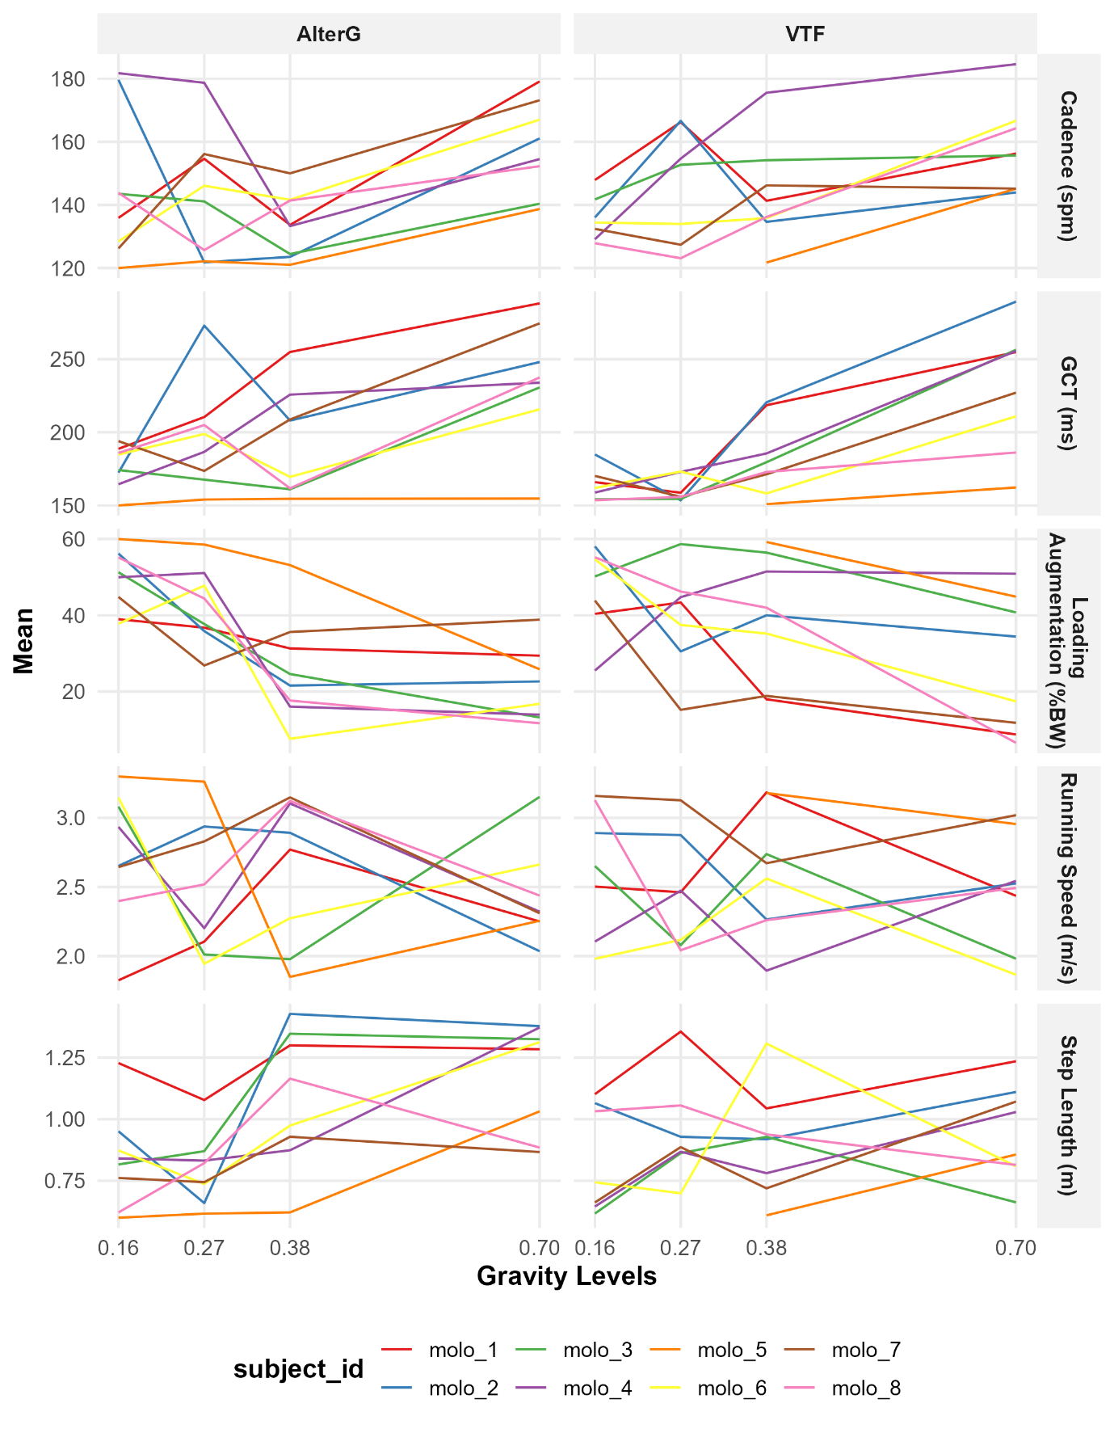
Figure S1: Subject-level mean optimised running parameters across gravity levels, derived from NSGA-II solutions achieving >95% of each subject's 1g peak GRF. Each line represents one participant. Panels show cadence, ground contact time (GCT), loading augmentation (% body weight), running speed, and step length, faceted by treadmill system. For pooled group-level results, see Figure 4.

Walking Biomechanics Across Gravity Levels
All biomechanical parameters showed systematic changes with simulated gravity level during walking (Table S6; Figure S2). Mixed-effects model results are reported in Table S7, with pairwise comparisons and effect sizes in Table S9.
Peak ground reaction forces demonstrated the strongest gravity dependence among all walking parameters. On the AlterG, peak GRF increased from 0.43 ± 0.1 BW at 0.16g to 1.37 ± 0.13 BW at 1.0g. The VTF showed a comparable relationship, with peak GRF ranging from 0.28 ± 0.07 BW at 0.16g to 0.94 ± 0.12 BW at the maximum tested level of 0.70g. Post-hoc comparisons confirmed significant differences between all gravity levels on both systems (all p < 0.001), with uniformly large effect sizes (d > 4.4; Table S9).
Ground contact time decreased with increasing gravity on the AlterG (p < 0.001), declining from 768.6 ± 109 ms at 0.16g to 611.9 ± 48 ms at 1.0g. However, this relationship was not statistically significant on the VTF (p = 0.087), suggesting that the body-weight support mechanism may influence stance phase duration differently than the lower-body positive pressure system.
Cadence and step length both increased significantly with gravity on both treadmill systems (all p < 0.001; Table S7). Pairwise effect sizes were predominantly large, ranging from d = 0.67 to d = 3.6 across parameters and gravity level comparisons (Table S9).

Treadmill System Comparison
Combined linear mixed-effects models fitted on the four shared gravity levels revealed a more complex pattern of treadmill differences during walking than during running (Table S8; Table S10).
For peak GRF, the direction of the treadmill difference reversed across gravity levels. At 0.16g, the AlterG produced higher peak forces than the VTF (Δ = 0.117 BW, d = 1.35, p < 0.001), whereas at 0.70g, the VTF yielded slightly higher forces (Δ = −0.021 BW, d = −0.25, p < 0.001). At 0.38g, the two systems were effectively equivalent (Δ = −0.006 BW, p = 0.307). This crossover was captured by the significant gravity × treadmill interaction (β = 0.201 ± 0.016, p < 0.001), indicating that the relationship between gravity and peak GRF during walking differed between the two systems.
GCT differences between treadmills also varied across gravity levels, with a significant interaction (β = 108.540 ± 10.827, p < 0.001). At 0.70g, 0.38g, and 0.27g, GCT was shorter on the AlterG than on the VTF (d = −0.75 to −0.43), consistent with the results observed for running bouts. However, at 0.16g, this relationship reversed: GCT was 43.3 ms longer on the AlterG (d = 0.71, p < 0.001).
Cadence was higher on the AlterG at all shared gravity levels (p < 0.001), with medium to large effect sizes (d = 0.67–0.95). Unlike peak GRF and GCT, the gravity × treadmill interaction for cadence was not significant (p = 0.619), indicating that the between-system offset in cadence remained approximately constant across gravity levels during walking.
Step length was consistently longer on the VTF than on the AlterG (p < 0.001), with medium to large effect sizes (d = −0.72 to −1.04). The interaction term was not significant (p = 0.434), suggesting that this difference was stable across gravity levels.

Table S6
Gravity Levels | Peak GRF (BW) | Cadence (spm) | GCT (ms) | Step Length (m)
AlterG
0.16 g | 0.43 ± 0.1 | 97.9 ± 13.4 | 768.6 ± 109 | 0.56 ± 0.08
0.27 g | 0.48 ± 0.12 | 102.8 ± 12.4 | 739.4 ± 53.9 | 0.59 ± 0.07
0.38 g | 0.58 ± 0.15 | 108.5 ± 10.7 | 704.8 ± 56.9 | 0.61 ± 0.06
0.70 g | 0.95 ± 0.11 | 120.8 ± 9.1 | 639.9 ± 43.9 | 0.67 ± 0.05
1.0 g | 1.37 ± 0.13 | 127.1 ± 10.7 | 611.9 ± 48 | 0.75 ± 0.05
VTF
0.16 g | 0.28 ± 0.07 | 91.6 ± 14.4 | 719.2 ± 96.5 | 0.6 ± 0.09
0.27 g | 0.41 ± 0.08 | 97.5 ± 12.9 | 757.1 ± 67 | 0.63 ± 0.07
0.38 g | 0.56 ± 0.07 | 103 ± 12.4 | 733.7 ± 72.4 | 0.64 ± 0.07
0.70 g | 0.94 ± 0.12 | 112.7 ± 12.7 | 678.4 ± 67.5 | 0.72 ± 0.07
Table S6: Mean ± SD of walking gait parameters by gravity level and treadmill system (AlterG and VTF). Abbreviations: GRF = ground reaction force; BW = body weight; spm = steps per minute; GCT = ground contact time; ms = milliseconds, m = meters.

Figure S2
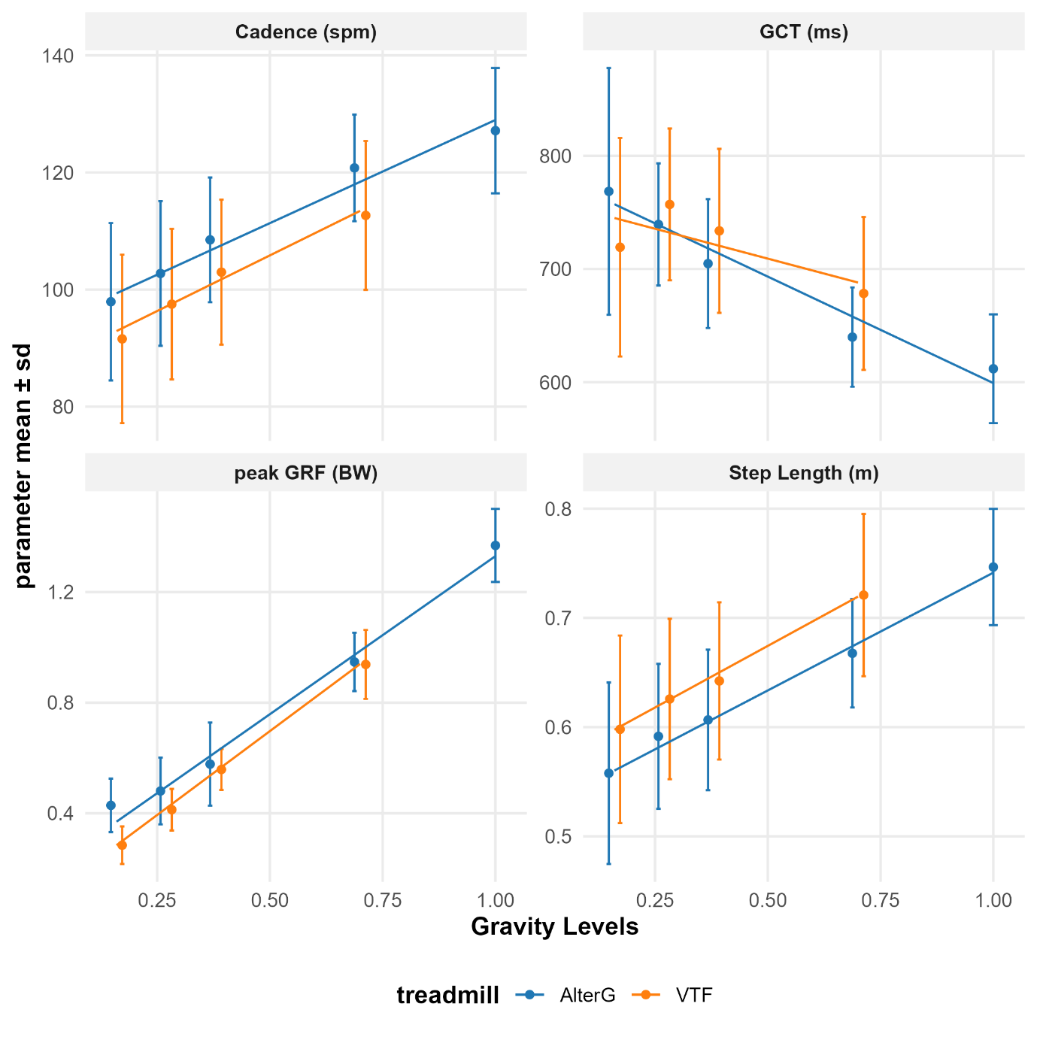
Figure S2: Mean ± SD of walking gait parameters across gravity levels for the AlterG (blue) and VTF (orange) treadmill systems. Panels show cadence, ground contact time (GCT), peak ground reaction force (peak GRF), and step length. Error bars represent ± 1 SD. Solid lines indicate linear regression fits for each treadmill system.

Table S7
Parameter | Gravity Effect (β) | t-value | p-value | R² | n
AlterG
Peak GRF (BW) | 1.146 ± 0.033 | 34.30 | < 0.001 | 0.875 | 2187
GCT (ms) | -188.920 ± 24.824 | -7.61 | < 0.001 | 0.430 | 2187
Cadence (spm) | 35.517 ± 3.683 | 9.64 | < 0.001 | 0.474 | 2187
Step Length (m) | 0.212 ± 0.022 | 9.50 | < 0.001 | 0.504 | 2187
VTF
Peak GRF (BW) | 1.218 ± 0.040 | 30.50 | < 0.001 | 0.877 | 1355
GCT (ms) | -102.363 ± 50.034 | -2.05 | 0.087 | 0.064 | 1355
Cadence (spm) | 37.903 ± 3.877 | 9.78 | < 0.001 | 0.243 | 1355
Step Length (m) | 0.224 ± 0.028 | 7.96 | < 0.001 | 0.248 | 1355
Table S7: Mixed-effects model results for gravity effects on walking gait parameters, stratified by treadmill system. Abbreviations: β = unstandardized regression coefficient (change per 1g increase) ± standard error; R² = semi-partial R²; n = total number of step events.

Table S8
Statistics | Peak GRF (BW) | GCT (ms) | Cadence (spm) | Step Length (m)
Treadmill Effect (β) | 0.093 ± 0.010 | 84.069 ± 6.918 | -8.449 ± 1.155 | 0.055 ± 0.007
Treadmill t-value | 9.14 | 12.15 | -7.32 | 8.19
Treadmill p-value | < 0.001 | < 0.001 | < 0.001 | < 0.001
Interaction Effect (β) | 0.201 ± 0.016 | 108.540 ± 10.827 | -0.897 ± 1.807 | 0.008 ± 0.010
Interaction t-value | 12.60 | 10.03 | -0.50 | 0.78
Interaction p-value | < 0.001 | < 0.001 | 0.619 | 0.434
n | 3042 | 3042 | 3042 | 3042
Table S8: Combined linear mixed-effects model results for treadmill system comparison during walking. Abbreviations: β = unstandardized regression coefficient ± standard error; n = total number of step events.

Table S9
 | Post-Hoc comparison |  |  | Cohen’s d
Contrast | Estimate | SE | p-value (adjusted) | Effect size [95% CI] | Magnitude
Peak GRF (BW)
1.0g - 0.7g | 0.422 | 0.006 | < 0.001 | 4.48 [4.26:4.7] | large
1.0g - 0.38g | 0.789 | 0.006 | < 0.001 | 8.36 [8.03:8.7] | large
1.0g - 0.27g | 0.887 | 0.006 | < 0.001 | 9.4 [9.03:9.77] | large
1.0g - 0.16g | 0.937 | 0.006 | < 0.001 | 9.93 [9.54:10.32] | large
GCT (ms)
1.0g - 0.7g | -27.575 | 3.386 | < 0.001 | -0.52 [-0.67:-0.37] | medium
1.0g - 0.38g | -93.879 | 3.497 | < 0.001 | -1.77 [-1.94:-1.61] | large
1.0g - 0.27g | -127.301 | 3.546 | < 0.001 | -2.4 [-2.58:-2.23] | large
1.0g - 0.16g | -158.099 | 3.603 | < 0.001 | -2.99 [-3.18:-2.79] | large
Cadence (spm)
1.0g - 0.7g | 6.315 | 0.606 | < 0.001 | 0.67 [0.52:0.82] | medium
1.0g - 0.38g | 18.851 | 0.625 | < 0.001 | 1.99 [1.82:2.16] | large
1.0g - 0.27g | 24.530 | 0.634 | < 0.001 | 2.59 [2.41:2.77] | large
1.0g - 0.16g | 29.479 | 0.644 | < 0.001 | 3.11 [2.92:3.31] | large
Step Length (m)
1.0g - 0.7g | 0.079 | 0.003 | < 0.001 | 1.52 [1.36:1.68] | large
1.0g - 0.38g | 0.138 | 0.003 | < 0.001 | 2.66 [2.48:2.84] | large
1.0g - 0.27g | 0.154 | 0.003 | < 0.001 | 2.97 [2.78:3.15] | large
1.0g - 0.16g | 0.187 | 0.004 | < 0.001 | 3.6 [3.39:3.8] | large
Table S9: Pairwise comparisons of walking gait parameters at each gravity level versus the 1.0g reference, for the AlterG treadmill only (the VTF did not include a 1.0g condition). Estimate = estimated mean difference from post-hoc contrasts; SE = standard error; p-values adjusted using Tukey correction for multiple comparisons. Cohen's d is reported with 95% confidence intervals (CI). Effect size magnitudes were classified as small: |d | < 0.5, medium 0.5 ≤ |d| < 0.8 and large: |d| ≥ 0.8.

Table S10
 | Post-Hoc comparison |  |  | Cohen’s d
Contrast  AlterG - VTF | Estimate | SE | p-value (adjusted) | Effect size [95% CI] | Magnitude
Peak GRF (BW)
0.7g | -0.021 | 0.006 | < 0.001 | -0.25 [-0.41:-0.08] | small
0.38g | -0.006 | 0.006 | 0.307 | -0.07 [-0.25:0.1] | small
0.27g | 0.040 | 0.007 | < 0.001 | 0.47 [0.29:0.64] | small
0.16g | 0.117 | 0.007 | < 0.001 | 1.35 [1.17:1.54] | large
GCT (ms)
0.7g | -45.716 | 4.214 | < 0.001 | -0.75 [-0.91:-0.59] | medium
0.38g | -35.373 | 4.442 | < 0.001 | -0.58 [-0.75:-0.41] | medium
0.27g | -26.440 | 4.593 | < 0.001 | -0.43 [-0.61:-0.26] | small
0.16g | 43.322 | 4.741 | < 0.001 | 0.71 [0.53:0.89] | medium
Cadence (spm)
0.7g | 9.726 | 0.709 | < 0.001 | 0.95 [0.78:1.11] | large
0.38g | 6.900 | 0.747 | < 0.001 | 0.67 [0.5:0.84] | medium
0.27g | 6.945 | 0.772 | < 0.001 | 0.68 [0.5:0.85] | medium
0.16g | 7.900 | 0.797 | < 0.001 | 0.77 [0.59:0.95] | medium
Step Length (m)
0.7g | -0.062 | 0.004 | < 0.001 | -1.04 [-1.2:-0.87] | large
0.38g | -0.043 | 0.004 | < 0.001 | -0.72 [-0.89:-0.55] | medium
0.27g | -0.044 | 0.005 | < 0.001 | -0.72 [-0.9:-0.55] | medium
0.16g | -0.049 | 0.005 | < 0.001 | -0.81 [-1:-0.63] | large
Table S10: Pairwise comparisons of walking gait parameters between treadmill systems (AlterG – VTF) at each of the shared gravity levels (0.16g, 0.27g, 0.38g, 0.7g). Positive estimates indicate higher values on the AlterG. Estimate = estimated mean difference; SE = standard error; p-values adjusted using Tukey correction for multiple comparisons. Cohen's d is reported with 95% confidence intervals (CI). Effect size magnitudes were classified as small: |d | < 0.5, medium 0.5 ≤ |d| < 0.8 and large: |d| ≥ 0.8.

