SPSS Analysis Output

Descriptive Statistics
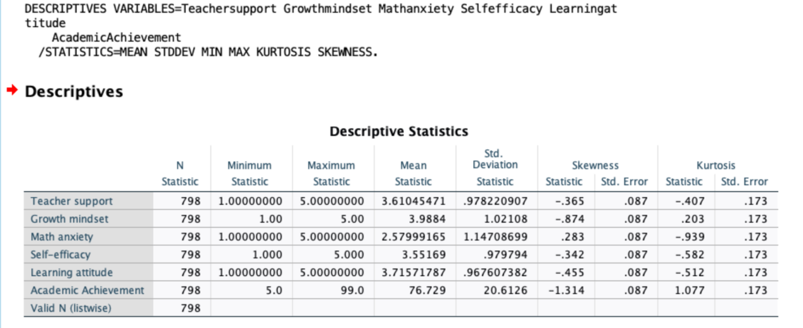

Bivariate Correlation Analysis
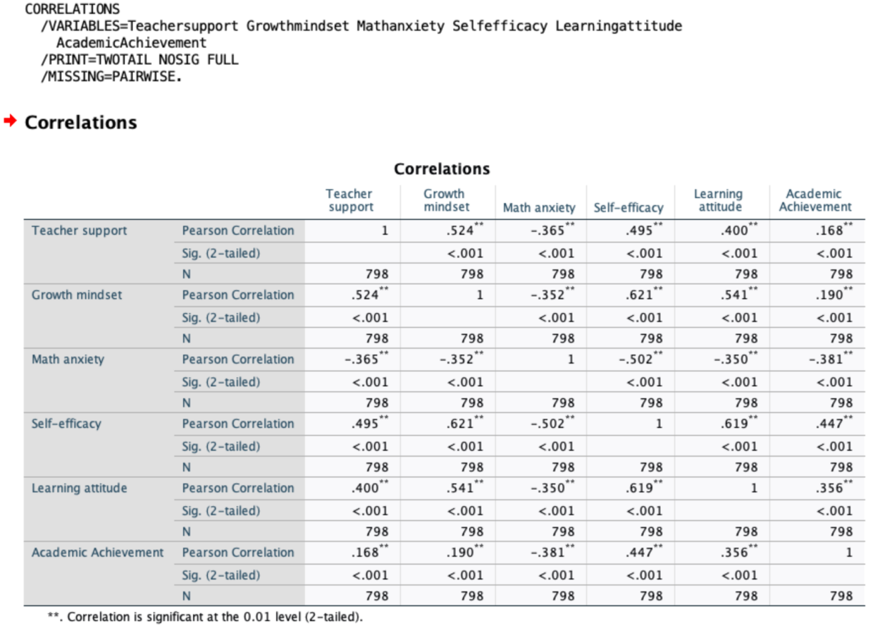

Group Difference Tests

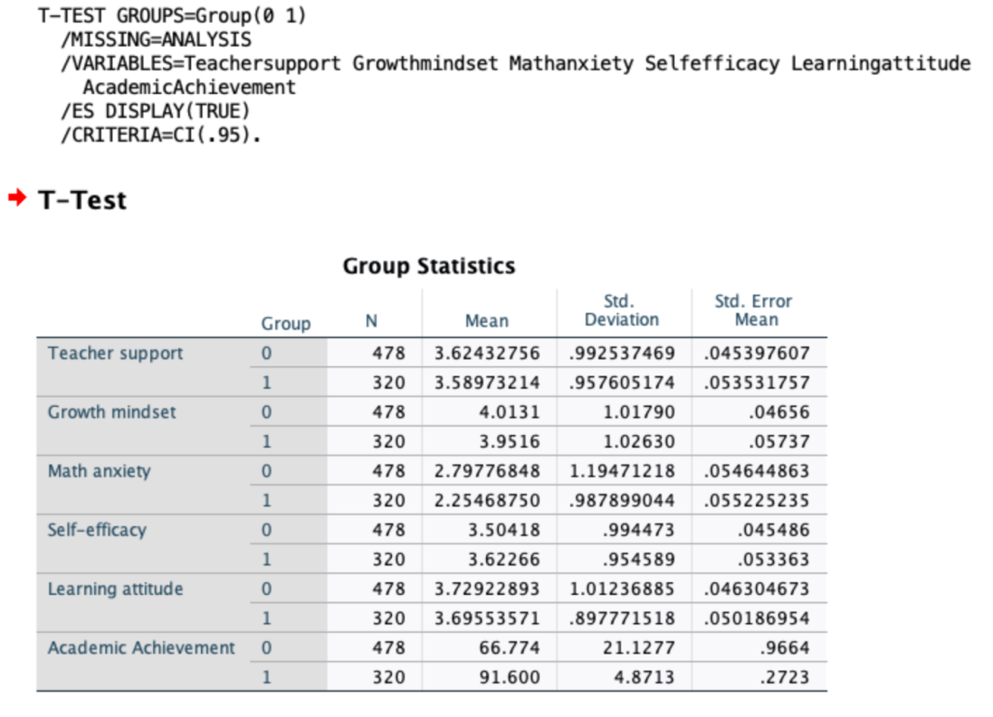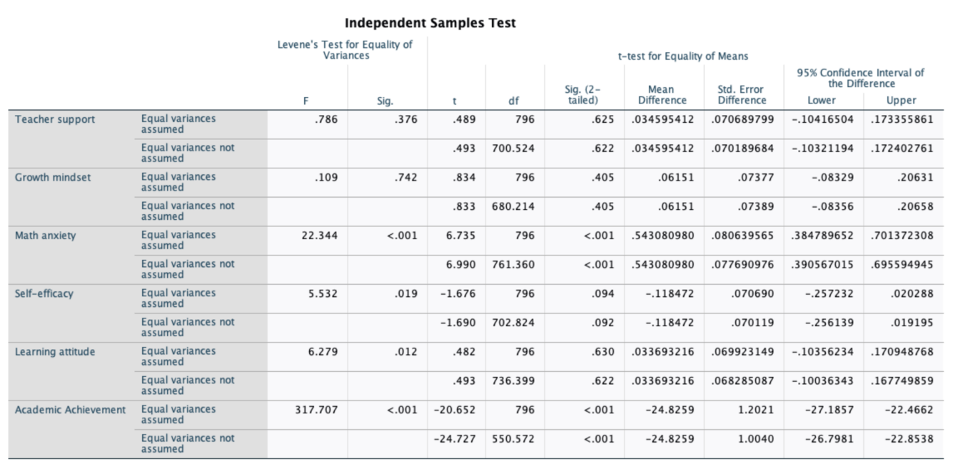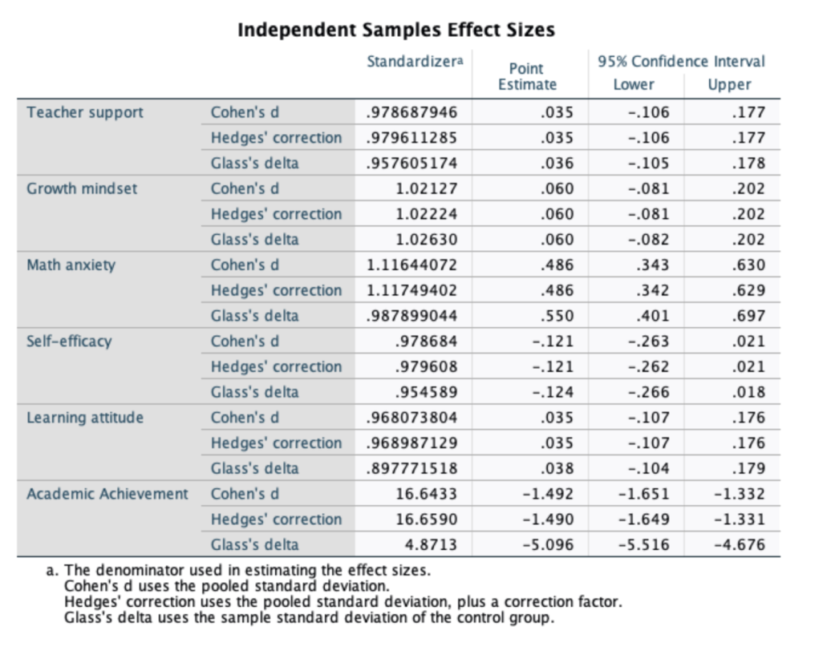

Confirmatory Factor Analysis (CFA) & Output

Overall Six-Factor Confirmatory Factor Analysis
mplus
TITLE: Confirmatory Factor Analysis (Six-Factor Model) - Reliability and Validity Test;
DATA: FILE IS data.dat; ! Your data file (identical to the multi-group analysis)
VARIABLE:
NAMES = TS1-TS8 GM1-GM4 MAn1-MAn6 SE1-SE8 LA1-LA7 SC group;
USEVARIABLES = TS1-TS8 GM1-GM4 MAn1-MAn6 SE1-SE8 LA1-LA7; ! Use only scale items, exclude SC and group
ANALYSIS:
ESTIMATOR = MLR; ! Robust Maximum Likelihood estimator (preferred for non-normal data)
PROCESSORS = 4; ! Enable multi-threading for faster computation (adjust based on your CPU)
MODEL:
! Define measurement model (factor loadings labeled p1-p33, fully consistent with measurement invariance tests)
TS BY TS1 (p1) TS2 (p2) TS3 (p3) TS4 (p4) TS5 (p5) TS6 (p6) TS7 (p7) TS8 (p8);
GM BY GM1 (p9) GM2 (p10) GM3 (p11) GM4 (p12);
MAn BY MAn1 (p13) MAn2 (p14) MAn3 (p15) MAn4 (p16) MAn5 (p17) MAn6 (p18);
SE BY SE1 (p19) SE2 (p20) SE3 (p21) SE4 (p22) SE5 (p23) SE6 (p24) SE7 (p25) SE8 (p26);
LA BY LA1 (p27) LA2 (p28) LA3 (p29) LA4 (p30) LA5 (p31) LA6 (p32) LA7 (p33);
! Define error variances (labeled e1-e33 for CR and AVE calculation)
TS1 (e1); TS2 (e2); TS3 (e3); TS4 (e4); TS5 (e5); TS6 (e6); TS7 (e7); TS8 (e8);
GM1 (e9); GM2 (e10); GM3 (e11); GM4 (e12);
MAn1 (e13); MAn2 (e14); MAn3 (e15); MAn4 (e16); MAn5 (e17); MAn6 (e18);
SE1 (e19); SE2 (e20); SE3 (e21); SE4 (e22); SE5 (e23); SE6 (e24); SE7 (e25); SE8 (e26);
LA1 (e27); LA2 (e28); LA3 (e29); LA4 (e30); LA5 (e31); LA6 (e32); LA7 (e33);
! Automatically calculate Composite Reliability (CR) and Average Variance Extracted (AVE)
MODEL CONSTRAINT:
NEW(CR_TS AVE_TS CR_GM AVE_GM CR_MAn AVE_MAn CR_SE AVE_SE CR_LA AVE_LA);
! Teacher Support (TS): 8 items
CR_TS = (p1+p2+p3+p4+p5+p6+p7+p8)**2 / ((p1+p2+p3+p4+p5+p6+p7+p8)**2 + e1+e2+e3+e4+e5+e6+e7+e8);
AVE_TS = (p1**2+p2**2+p3**2+p4**2+p5**2+p6**2+p7**2+p8**2) / (p1**2+p2**2+p3**2+p4**2+p5**2+p6**2+p7**2+p8**2 + e1+e2+e3+e4+e5+e6+e7+e8);
! Growth Mindset (GM): 4 items
CR_GM = (p9+p10+p11+p12)**2 / ((p9+p10+p11+p12)**2 + e9+e10+e11+e12);
AVE_GM = (p9**2+p10**2+p11**2+p12**2) / (p9**2+p10**2+p11**2+p12**2 + e9+e10+e11+e12);
! Math Anxiety (MAn): 6 items
CR_MAn = (p13+p14+p15+p16+p17+p18)**2 / ((p13+p14+p15+p16+p17+p18)**2 + e13+e14+e15+e16+e17+e18);
AVE_MAn = (p13**2+p14**2+p15**2+p16**2+p17**2+p18**2) / (p13**2+p14**2+p15**2+p16**2+p17**2+p18**2 + e13+e14+e15+e16+e17+e18);
! Self-Efficacy (SE): 8 items
CR_SE = (p19+p20+p21+p22+p23+p24+p25+p26)**2 / ((p19+p20+p21+p22+p23+p24+p25+p26)**2 + e19+e20+e21+e22+e23+e24+e25+e26);
AVE_SE = (p19**2+p20**2+p21**2+p22**2+p23**2+p24**2+p25**2+p26**2) / (p19**2+p20**2+p21**2+p22**2+p23**2+p24**2+p25**2+p26**2 + e19+e20+e21+e22+e23+e24+e25+e26);
! Learning Attitude (LA): 7 items
CR_LA = (p27+p28+p29+p30+p31+p32+p33)**2 / ((p27+p28+p29+p30+p31+p32+p33)**2 + e27+e28+e29+e30+e31+e32+e33);
AVE_LA = (p27**2+p28**2+p29**2+p30**2+p31**2+p32**2+p33**2) / (p27**2+p28**2+p29**2+p30**2+p31**2+p32**2+p33**2 + e27+e28+e29+e30+e31+e32+e33);
OUTPUT:
TECH1 TECH4 STANDARDIZED CINTERVAL MODINDICES(3.84);
! Output: parameter estimates, standardized results, 95% confidence intervals, modification indices (only show values > 3.84, p < 0.05)

Single-Factor Confirmatory Factor Analysis (Individual Scale Testing)
mplus
TITLE: Single-Factor CFA - Teacher Support (TS);
DATA: FILE IS data.dat;
VARIABLE:
NAMES = TS1-TS8 GM1-GM4 MAn1-MAn6 SE1-SE8 LA1-LA7 SC group;
USEVARIABLES = TS1-TS8; ! Use only items from this scale
ANALYSIS: ESTIMATOR = MLR;
MODEL:
TS BY TS1-TS8;
OUTPUT:
STANDARDIZED CINTERVAL MODINDICES;

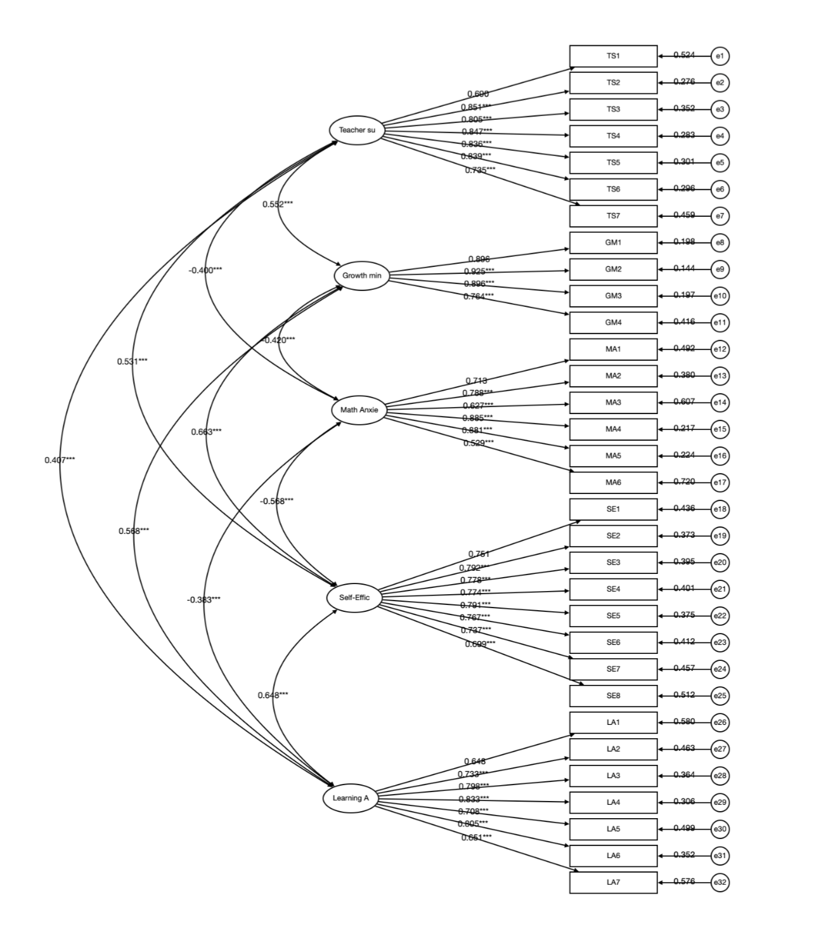

Mplus Syntax for Multi-Group Analysis

Measurement Invariance Testing (Multi-Group Confirmatory Factor Analysis)
mplus
TITLE: Multi-Group CFA Measurement Invariance Testing (Configural, Metric, Scalar);
DATA: FILE IS data.dat; ! Data file
VARIABLE:
NAMES = TS1-TS8 GM1-GM4 MAn1-MAn6 SE1-SE8 LA1-LA7 SC group;
USEVARIABLES = TS1-TS8 GM1-GM4 MAn1-MAn6 SE1-SE8 LA1-LA7 SC;
GROUPING = group (1=Competitive 2=Regular); ! Grouping variable (1=Competitive students, 2=Regular students)
ANALYSIS:
ESTIMATOR = MLR; ! Use MLR for Satorra-Bentler correction
MODEL:
! Configural invariance model: freely estimate factor loadings across groups
TS BY TS1-TS8;
GM BY GM1-GM4;
MAn BY MAn1-MAn6;
SE BY SE1-SE8;
LA BY LA1-LA7;
MODEL group2:
TS BY TS1-TS8;
GM BY GM1-GM4;
MAn BY MAn1-MAn6;
SE BY SE1-SE8;
LA BY LA1-LA7;
OUTPUT:
MODINDICES; ! Optional: Examine model fit indices and modification indices

Metric Invariance Testing: Constrain Factor Loadings to Be Equal Across Groups
mplus
TITLE: Multi-Group CFA - Metric Invariance;
DATA: FILE IS data.dat;
VARIABLE:
NAMES = TS1-TS8 GM1-GM4 MAn1-MAn6 SE1-SE8 LA1-LA7 SC group;
USEVARIABLES = TS1-TS8 GM1-GM4 MAn1-MAn6 SE1-SE8 LA1-LA7 SC;
GROUPING = group (1=Competitive 2=Regular);
ANALYSIS: ESTIMATOR = MLR;
MODEL:
! Factor loadings for Group 1 (Competitive students), labeled p1–p33
TS BY TS1 (p1) TS2 (p2) TS3 (p3) TS4 (p4) TS5 (p5) TS6 (p6) TS7 (p7) TS8 (p8);
GM BY GM1 (p9) GM2 (p10) GM3 (p11) GM4 (p12);
MAn BY MAn1 (p13) MAn2 (p14) MAn3 (p15) MAn4 (p16) MAn5 (p17) MAn6 (p18);
SE BY SE1 (p19) SE2 (p20) SE3 (p21) SE4 (p22) SE5 (p23) SE6 (p24) SE7 (p25) SE8 (p26);
LA BY LA1 (p27) LA2 (p28) LA3 (p29) LA4 (p30) LA5 (p31) LA6 (p32) LA7 (p33);
MODEL group2:
! Factor loadings for Group 2 (Regular students), use identical labels to enforce equality constraints
TS BY TS1 (p1) TS2 (p2) TS3 (p3) TS4 (p4) TS5 (p5) TS6 (p6) TS7 (p7) TS8 (p8);
GM BY GM1 (p9) GM2 (p10) GM3 (p11) GM4 (p12);
MAn BY MAn1 (p13) MAn2 (p14) MAn3 (p15) MAn4 (p16) MAn5 (p17) MAn6 (p18);
SE BY SE1 (p19) SE2 (p20) SE3 (p21) SE4 (p22) SE5 (p23) SE6 (p24) SE7 (p25) SE8 (p26);
LA BY LA1 (p27) LA2 (p28) LA3 (p29) LA4 (p30) LA5 (p31) LA6 (p32) LA7 (p33);
OUTPUT:
TECH1 TECH4 STANDARDIZED; ! Examine factor loadings and model fit indices

Scalar Invariance Testing: Further Constrain Intercepts to Be Equal (Building on Metric Invariance)
mplus
TITLE: Multi-Group CFA - Scalar Invariance;
DATA: FILE IS data.dat;
VARIABLE:
NAMES = TS1-TS8 GM1-GM4 MAn1-MAn6 SE1-SE8 LA1-LA7 SC group;
USEVARIABLES = TS1-TS8 GM1-GM4 MAn1-MAn6 SE1-SE8 LA1-LA7 SC;
GROUPING = group (1=Competitive 2=Regular);
ANALYSIS: ESTIMATOR = MLR;
MODEL:
! Factor loadings (same as metric invariance model)
TS BY TS1 (p1) TS2 (p2) TS3 (p3) TS4 (p4) TS5 (p5) TS6 (p6) TS7 (p7) TS8 (p8);
GM BY GM1 (p9) GM2 (p10) GM3 (p11) GM4 (p12);
MAn BY MAn1 (p13) MAn2 (p14) MAn3 (p15) MAn4 (p16) MAn5 (p17) MAn6 (p18);
SE BY SE1 (p19) SE2 (p20) SE3 (p21) SE4 (p22) SE5 (p23) SE6 (p24) SE7 (p25) SE8 (p26);
LA BY LA1 (p27) LA2 (p28) LA3 (p29) LA4 (p30) LA5 (p31) LA6 (p32) LA7 (p33);
! Constrain intercepts of observed variables to be equal across groups, labeled i1–i33
[TS1] (i1); [TS2] (i2); [TS3] (i3); [TS4] (i4);
[TS5] (i5); [TS6] (i6); [TS7] (i7); [TS8] (i8);
[GM1] (i9); [GM2] (i10);[GM3] (i11);[GM4] (i12);
[MAn1] (i13);[MAn2] (i14);[MAn3] (i15);[MAn4] (i16);[MAn5] (i17);[MAn6] (i18);
[SE1] (i19);[SE2] (i20);[SE3] (i21);[SE4] (i22);
[SE5] (i23);[SE6] (i24);[SE7] (i25);[SE8] (i26);
[LA1] (i27);[LA2] (i28);[LA3] (i29);[LA4] (i30);
[LA5] (i31);[LA6] (i32);[LA7] (i33);
MODEL group2:
! Factor loadings and intercepts for Group 2, use identical labels
TS BY TS1 (p1) TS2 (p2) TS3 (p3) TS4 (p4) TS5 (p5) TS6 (p6) TS7 (p7) TS8 (p8);
GM BY GM1 (p9) GM2 (p10) GM3 (p11) GM4 (p12);
MAn BY MAn1 (p13) MAn2 (p14) MAn3 (p15) MAn4 (p16) MAn5 (p17) MAn6 (p18);
SE BY SE1 (p19) SE2 (p20) SE3 (p21) SE4 (p22) SE5 (p23) SE6 (p24) SE7 (p25) SE8 (p26);
LA BY LA1 (p27) LA2 (p28) LA3 (p29) LA4 (p30) LA5 (p31) LA6 (p32) LA7 (p33);
[TS1] (i1); [TS2] (i2); [TS3] (i3); [TS4] (i4);
[TS5] (i5); [TS6] (i6); [TS7] (i7); [TS8] (i8);
[GM1] (i9); [GM2] (i10);[GM3] (i11);[GM4] (i12);
[MAn1] (i13);[MAn2] (i14);[MAn3] (i15);[MAn4] (i16);[MAn5] (i17);[MAn6] (i18);
[SE1] (i19);[SE2] (i20);[SE3] (i21);[SE4] (i22);
[SE5] (i23);[SE6] (i24);[SE7] (i25);[SE8] (i26);
[LA1] (i27);[LA2] (i28);[LA3] (i29);[LA4] (i30);
[LA5] (i31);[LA6] (i32);[LA7] (i33);
OUTPUT:
TECH1 TECH4 STANDARDIZED CINTERVAL;
! Output intercepts, factor loadings, and fit differences including ΔCFI

Multi-Group Structural Equation Modeling and Path Coefficient Difference Testing
mplus
!-----------------------------
TITLE: Multi-Group Structural Equation Model and Path Coefficient Difference Testing;
DATA: FILE IS data.dat;
VARIABLE:
NAMES = TS1-TS8 GM1-GM4 MAn1-MAn6 SE1-SE8 LA1-LA7 SC group;
USEVARIABLES = TS1-TS8 GM1-GM4 MAn1-MAn6 SE1-SE8 LA1-LA7 SC;
GROUPING = group (1=Competitive 2=Regular);
ANALYSIS:
ESTIMATOR = MLR;
MODEL:
! Specify structural equation model with all explicit paths, freely estimated across groups initially
TS BY TS1-TS8;
GM BY GM1-GM4;
MAn BY MAn1-MAn6;
SE BY SE1-SE8;
LA BY LA1-LA7;
! Structural relationships
GM ON TS (a1); ! Teacher Support -> Growth Mindset
LA ON GM (b1); ! Growth Mindset -> Learning Attitude
MAn ON GM (b2); ! Growth Mindset -> Math Anxiety
SE ON GM (b3); ! Growth Mindset -> Self-Efficacy
SC ON LA (c1) MAn (c2) SE (c3) GM (c4);
! Learning Attitude, Math Anxiety, Self-Efficacy, Growth Mindset -> Math Achievement
MODEL group2:
TS BY TS1-TS8;
GM BY GM1-GM4;
MAn BY MAn1-MAn6;
SE BY SE1-SE8;
LA BY LA1-LA7;
GM ON TS (a4);
LA ON GM (b4);
MAn ON GM (b5);
SE ON GM (b6);
SC ON LA (c5) MAn (c6) SE (c7) GM (c8);
OUTPUT:
STANDARDIZED TECH1;

Introduce Path Equality Constraints and Perform Difference Testing (Wald Test)
mplus
TITLE: Path Coefficient Equality Constraint Difference Testing;
DATA: FILE IS data.dat;
VARIABLE:
NAMES = TS1-TS8 GM1-GM4 MAn1-MAn6 SE1-SE8 LA1-LA7 SC group;
USEVARIABLES = TS1-TS8 GM1-GM4 MAn1-MAn6 SE1-SE8 LA1-LA7 SC;
GROUPING = group (1=Competitive 2=Regular);
ANALYSIS: ESTIMATOR = MLR;
MODEL:
TS BY TS1-TS8;
GM BY GM1-GM4;
MAn BY MAn1-MAn6;
SE BY SE1-SE8;
LA BY LA1-LA7;
! Constrain paths to be equal (test differences one by one as needed)
GM ON TS (a);
LA ON GM (b);
MAn ON GM (d);
SE ON GM (e);
SC ON LA (f) MAn (g) SE (h) GM (c);
MODEL group2:
TS BY TS1-TS8;
GM BY GM1-GM4;
MAn BY MAn1-MAn6;
SE BY SE1-SE8;
LA BY LA1-LA7;
GM ON TS (a);
LA ON GM (b);
MAn ON GM (d);
SE ON GM (e);
SC ON LA (f) MAn (g) SE (h) GM (c);
MODEL TEST:
! Test differences in path coefficients between the two groups
0 = a - a; ! TS->GM (no change, typically zero difference)
0 = b - b; ! GM->LA
0 = d - d; ! GM->MAn
0 = e - e; ! GM->SE
0 = f - f; ! LA->SC
0 = g - g; ! MAn->SC
0 = h - h; ! SE->SC
0 = c - c; ! GM->SC
OUTPUT:
SAMPSTAT;

Bootstrap Mediation Effect Testing and Cross-Group Effect Difference Testing
mplus
TITLE: Bootstrap Mediation Effects and Cross-Group Effect Difference Testing;
DATA: FILE IS data.dat;
VARIABLE:
NAMES = TS1-TS8 GM1-GM4 MAn1-MAn6 SE1-SE8 LA1-LA7 SC group;
USEVARIABLES = TS1-TS8 GM1-GM4 MAn1-MAn6 SE1-SE8 LA1-LA7 SC;
GROUPING = group (1=Competitive 2=Regular);
ANALYSIS:
ESTIMATOR = MLR;
BOOTSTRAP = 5000; ! Number of bootstrap resamples
MODEL:
! Measurement model (consistent with previous models)
TS BY TS1-TS8;
GM BY GM1-GM4;
MAn BY MAn1-MAn6;
SE BY SE1-SE8;
LA BY LA1-LA7;
! Structural paths (estimated separately for each group)
MODEL group1:
GM ON TS (a1);
LA ON GM (b1);
MAn ON GM (b2);
SE ON GM (b3);
SC ON LA (c1) MAn (c2) SE (c3) GM (c4);
MODEL group2:
GM ON TS (a4);
LA ON GM (b4);
MAn ON GM (b5);
SE ON GM (b6);
SC ON LA (c5) MAn (c6) SE (c7) GM (c8);
MODEL INDIRECT:
! Define indirect effect paths: independent variable -> mediator(s) -> outcome
GM IND LA SC; ! GM -> LA -> SC
GM IND MAn SC; ! GM -> MAn -> SC
GM IND SE SC; ! GM -> SE -> SC
TS IND GM LA SC; ! TS -> GM -> LA -> SC
TS IND GM MAn SC; ! TS -> GM -> MAn -> SC
TS IND GM SE SC; ! TS -> GM -> SE -> SC
MODEL CONSTRAINT:
NEW(GM_LA1 GM_MAn1 GM_SE1 TS_GM_LA1 TS_GM_MAn1 TS_GM_SE1
GM_LA2 GM_MAn2 GM_SE2 TS_GM_LA2 TS_GM_MAn2 TS_GM_SE2
diff_GM_LA diff_GM_MAn diff_GM_SE diff_TS_GM_LA diff_TS_GM_MAn diff_TS_GM_SE);
! Calculate mediation path effects (Group 1 and Group 2)
GM_LA1 = b1 * c1; ! Group 1: GM->LA->SC
GM_MAn1 = b2 * c2; ! Group 1: GM->MAn->SC
GM_SE1 = b3 * c3; ! Group 1: GM->SE->SC
TS_GM_LA1 = a1 * b1 * c1; ! Group 1: TS->GM->LA->SC
TS_GM_MAn1 = a1 * b2 * c2; ! Group 1: TS->GM->MAn->SC
TS_GM_SE1 = a1 * b3 * c3; ! Group 1: TS->GM->SE->SC
GM_LA2 = b4 * c5; ! Group 2: GM->LA->SC
GM_MAn2 = b5 * c6; ! Group 2: GM->MAn->SC
GM_SE2 = b6 * c7; ! Group 2: GM->SE->SC
TS_GM_LA2 = a4 * b4 * c5; ! Group 2: TS->GM->LA->SC
TS_GM_MAn2 = a4 * b5 * c6; ! Group 2: TS->GM->MAn->SC
TS_GM_SE2 = a4 * b6 * c7; ! Group 2: TS->GM->SE->SC
! Calculate effect differences between the two groups
diff_GM_LA = GM_LA1 - GM_LA2;
diff_GM_MAn = GM_MAn1 - GM_MAn2;
diff_GM_SE = GM_SE1 - GM_SE2;
diff_TS_GM_LA = TS_GM_LA1 - TS_GM_LA2;
diff_TS_GM_MAn= TS_GM_MAn1 - TS_GM_MAn2;
diff_TS_GM_SE = TS_GM_SE1 - TS_GM_SE2;
OUTPUT:
CINTERVAL(BCBOOTSTRAP) STANDARDIZED;
! Output bias-corrected bootstrap confidence intervals and standardized effects

