Supporting Information
Supporting Information for: Origin of Reduced Coercive Field in ScAlN: Synergy of Structural Softening and Dynamic Atomic Correlations

¹Ryotaro Sahashi, ¹Po-Yen Chen, and ^{1,2}Teruyasu Mizoguchi
¹Department of Materials Engineering, The University of Tokyo, Tokyo, Japan
²Institute of Industrial Science, The University of Tokyo, Tokyo, Japan

This Supporting Information provides detailed validation results of the machine-learning force-field (MLFF) and Born effective charge models, as well as representative structural configurations and supplementary visualization of the electric-field-driven molecular dynamics (MD) simulations.

S1. Construction and Benchmarking of Machine-Learning Force Field and Polarization Models
To investigate the ferroelectric switching behavior of ScAlN at the atomic scale, we fine-tuned a MACE model that describes the potential energy surface (PES) by learning total energies and interatomic forces, together with an equivar_eval model for predicting BECs.

S1.1. Accuracy of the MACE Force Field
For training the MACE model, we used a publicly available dataset reported in Ref. ¹, which consists of 1664 supercell structures (256 atoms each) of Sc_{x}Al_{1-x}N calculated using the PBE exchange–correlation functional. The dataset covers four Sc compositions: x = 0, 0.125, 0.25, and 0.375.
To rigorously evaluate the generalization performance of the model, the dataset was randomly divided into a training set (1332 structures) and a test set (332 structures), and the predictive accuracy was assessed exclusively on the test data that were not included in training.
Figure S1 shows the correlation between DFT reference values and predictions obtained from the MACE model for the test dataset.

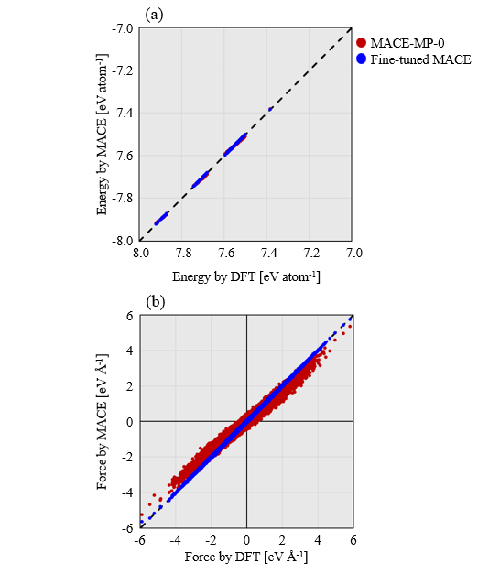
Figure S1. Correlation between DFT-calculated values and MACE model predictions for the test dataset. (a) Total energy (meV atom⁻¹) and (b) atomic forces (meV Å⁻¹). Red symbols correspond to predictions obtained using the pre-trained MACE model before fine-tuning, while blue symbols represent predictions from the fine-tuned MACE model developed in this study. Results are compared using the same test dataset in both panels.
As shown in Figure S1(a), which presents the accuracy of total energy predictions, the mean absolute error (MAE) of the pre-trained model (MACE-MP-0-large) was 2.76 meV atom⁻¹. After fine-tuning, the MAE was dramatically reduced to 0.22 meV atom⁻¹.
Similarly, for atomic force predictions shown in Figure S1(b), the MAE improved substantially from 120.4 meV Å⁻¹ before fine-tuning to 6.4 meV Å⁻¹ after fine-tuning. Notably, the pre-trained model tends to produce an overly smoothed representation of the potential energy surface, leading to reduced force gradients. Such behavior can artificially soften atomic responses in MD simulations. The fine-tuned model successfully alleviates this limitation, restoring physically meaningful force magnitudes and local gradients that are essential for reliable electric-field-driven MD simulations.
The simultaneous and high-accuracy reproduction of both energies and forces indicates that the constructed model successfully learned the complex PES of ScAlN, which is essential for reliably describing ferroelectric switching dynamics.
To objectively position the performance of the present model, we further conducted a quantitative comparison with other widely used pre-trained general-purpose MLFFs. In addition to MACE-MP-0², the following models were considered: SevenNet-0,³ GRACE-1L-OMAT,⁴ ORB v3,⁵ and eSEN-30M-OAM.⁶ A summary of the prediction accuracies obtained with these models is presented in Table S1.
As evident from Table S1, while general-purpose models exhibit reasonable zero-shot performance, their accuracy is insufficient to achieve the sub-meV precision required to describe subtle structural changes and energy barriers associated with ferroelectric behavior. In contrast, the fine-tuned model developed in this study outperforms these state-of-the-art general-purpose models in terms of both energy and force prediction accuracy, confirming its suitability for high-fidelity MD simulations of ferroelectric switching in ScAlN.

Table S1. Comparison of energy and force prediction accuracy among different MLFF models. The fine-tuned MACE model developed in this study achieves sub-meV accuracy, outperforming universal MLFFs.
MLFF Model | Energy MAE / meV atom⁻¹ | Force MAE / meV Å⁻¹
Fine-tuned MACE | 0.22 | 6.42
MACE-MP-0 | 2.76 | 120.40
SevenNet-0 | 3.63 | 75.41
GRACE-1L-OMAT | 45.52 | 82.04
ORB v3 | 14.35 | 22.77
eSEN-30M-OAM | 1.12 | 14.62

S1.2. Reproducibility of Structural Parameters
The reproducibility of crystal structures, which is directly linked to ferroelectric properties, was also carefully examined.
In wurtzite-type ferroelectrics, the c/a ratio is a key structural parameter that governs both the spontaneous polarization and the height of the switching barrier. Therefore, accurately capturing its composition dependence is critically important.⁷
We evaluated the reproducibility of the lattice parameters—namely, the a-axis length, the c-axis length, and the resulting c/a ratio—as summarized in Figure S2(a).
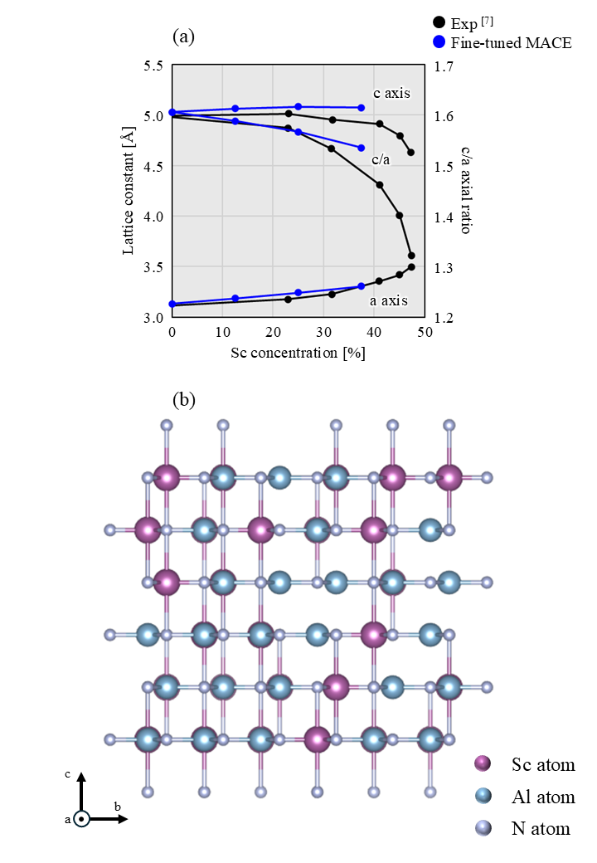
Figure S2. (a) Composition dependence of crystal structural parameters as a function of Sc concentration. Lattice constants a and c are shown with reference to the left vertical axis, while the c/a ratio is shown with reference to the right vertical axis within a single plot. Blue symbols represent results calculated using the fine-tuned MACE model, and black symbols indicate experimental values taken from Ref. ¹². (b) Schematic illustration of the reference structure used for polarization evaluation in this study. The nitrogen (N) atoms are positioned coplanar with the cations (Al/Sc), forming a centrosymmetric non-polar configuration that serves as the zero-polarization reference state. Atomic displacements at each MD step are evaluated relative to this reference structure and combined with BECs to compute the electric polarization.
The fine-tuned model successfully reproduced the experimentally established trend that the c/a ratio decreases with increasing Sc concentration. Quantitative agreement with experimental values was obtained across the entire composition range from x = 0 to x = 0.375.
Because the c/a ratio plays a decisive role in determining spontaneous polarization and switching barriers in wurtzite ferroelectrics, this high level of structural accuracy provides a solid foundation for the reliability of the MD simulations discussed in subsequent sections.

S1.3. Accuracy of the Born Effective Charge Model
To describe the electric-field response, we employed the equivar_eval model (architecture: BM1) for predicting BECs.
The same structural dataset used for training the MACE model (Train: 1332, Test: 332) was adopted. However, since reference BEC values were not included in the publicly available dataset, BECs were independently computed in this study using density functional perturbation theory (DFPT).
Figure S3 shows the prediction accuracy of BECs for each atomic species (Sc, Al, and N). When the initial BM1 model prior to fine-tuning was used, large mean absolute errors (MAEs) were observed for all atomic species (Sc: 2.744 e, Al: 2.322 e, N: 3.033 e). This poor performance is attributed to the absence of wurtzite-type structures in the training data of the initial model.
In contrast, after fine-tuning using the ScAlN-specific dataset, the MAEs were dramatically reduced to 0.020 e for Sc, 0.011 e for Al, and 0.014 e for N. The fine-tuned model thus achieved highly accurate reproduction of DFPT-calculated BEC values.
These results confirm that the electric-field-induced driving forces acting on individual atoms are described with first principles-level accuracy, which is essential for reliable electric-field-driven MD simulations.

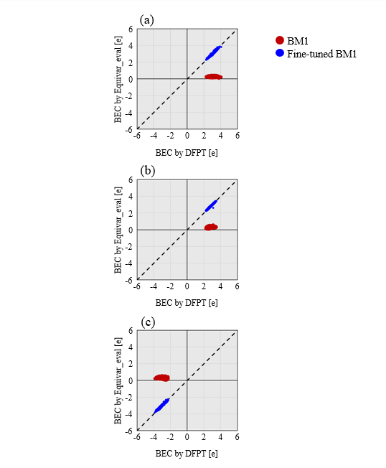
Figure S3. Prediction accuracy of BECs. Comparisons between DFPT-calculated values and equivar_eval model predictions for (a) Sc, (b) Al, and (c) N atoms. Red symbols correspond to predictions from the BM1 model before fine-tuning, while blue symbols represent predictions obtained after fine-tuning.
S2. Validation of Simulation Setup
We quantitatively evaluated how simulation parameters affect ferroelectric properties and selected optimal conditions accordingly. The following validation tests were conducted using a representative composition, Sc 25% (Sc_{0.25}Al_{0.75}N).

S2.1. Reference Structure for Polarization Evaluation
Polarization was evaluated relative to a centrosymmetric nonpolar reference configuration, illustrated in Figure S2(b). In this structure, nitrogen atoms lie coplanar with the cations (Al/Sc), forming an inversion-symmetric configuration corresponding to zero macroscopic polarization. Atomic displacements at each MD step were measured relative to this reference structure and combined with BECs to compute polarization.
The use of a well-defined centrosymmetric reference is essential to avoid artificial polarization offsets and ensures consistent evaluation of switching behavior across different compositions.

S2.2. Interaction Range: Short-Range vs Long-Range Model
To examine the effect of the interaction cutoff range, we compared the default “Short Range” MACE model with a long-range interaction model based on a locally extended scheme (LES), referred to as the “Long Range” model.⁸ These tests were performed using a 2880-atom supercell.
The resulting P–E hysteresis loops obtained using both models are shown in Figure S4(a). The two curves almost completely overlap, indicating that the interaction cutoff treatment does not significantly influence the ferroelectric switching behavior.
Quantitatively, coercive field (E_{c}) and remanent polarization (P_{r}) obtained using the default Short Range model were 8.82 MV cm⁻¹ and 107 μC cm⁻², respectively. These values are in excellent agreement with those obtained using the Long Range model, namely 9.44 MV cm⁻¹ for E_{c} and 106 μC cm⁻² for P_{r}, with only negligible differences.
Based on these results, we adopted the default Short Range model in this study, as it provides an optimal balance between computational efficiency and accuracy.

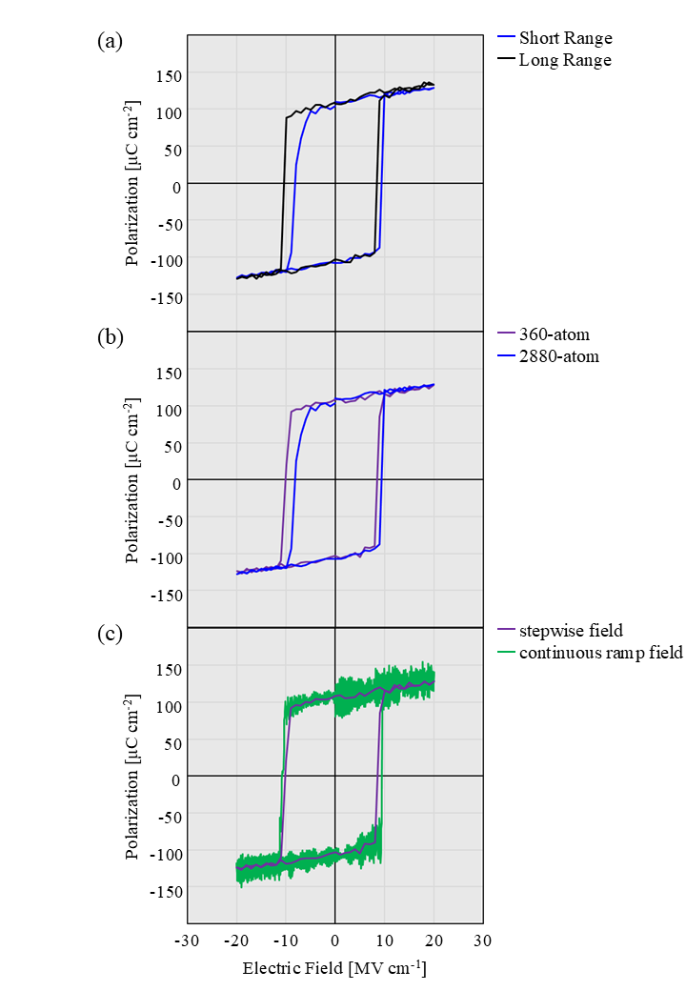
Figure S4. (a) Comparison of interaction range effects. P–E hysteresis loops obtained for a 2880-atom supercell. Blue curves correspond to the default Short Range model, and black curves correspond to the LES-type Long Range model. (b) Comparison of supercell size dependence. P–E hysteresis loops obtained using a 360-atom supercell (purple) and a 2880-atom supercell (blue). (c) Comparison of P–E hysteresis loops obtained using different electric-field application schemes. Results obtained using the stepwise field application are shown in purple, while those obtained using the continuous ramp field application are shown in green.
S2.3. Validation of the supercell size
Next, to assess the impact of finite-size effects, we compared simulations performed using a standard 360-atom supercell and a larger 2880-atom supercell (Figure S4(b)).
A comparison of the calculated ferroelectric properties shows that the 360-atom system yields E_{c} = 9.33 MV cm⁻¹ and P_{r} = 106 μC cm⁻², whereas the corresponding values for the 2880-atom system are E_{c} = 8.82 MV cm⁻¹ and P_{r} = 107 μC cm⁻². The close agreement between these values indicates that finite-size effects are sufficiently converged even for the 360-atom supercell. Therefore, we conclude that the 360-atom system is large enough to represent bulk ferroelectric properties, and this supercell size was adopted for all subsequent analyses.
It should be noted that, in the above validation tests, the ferroelectric properties were evaluated under quasi-static conditions by varying the applied electric field stepwise in increments of 1 MV cm⁻¹. In contrast, the switching dynamics analyses presented in the following sections employed a continuous electric-field ramp in order to track atomic motions continuously. Under the stepwise protocol, the E_{c} and P_{r} were E_{c} = 9.33 MV cm⁻¹ and P_{r} = 106 μC cm⁻², respectively, whereas under the continuous ramp protocol they were E_{c} = 10.12 MV cm⁻¹ and P_{r} = 107 μC cm⁻².
These results are also evident from the P–E hysteresis loops shown in Figure S4(c), which demonstrate that the overall loop shape and the key ferroelectric parameters remain essentially unchanged despite the different electric-field application schemes. This confirms that the choice of electric-field protocol does not significantly affect the primary ferroelectric properties. Although the specific electric-field application methods differ, the underlying MD framework is identical; therefore, the absence of significant differences in the ferroelectric characteristics is consistent with expectations.
The real-time atomic evolution during electric-field-driven switching under the continuous ramp protocol is shown in Movie S1, illustrating the simulation framework adopted in this study.
Taken together, these validations confirm that the present simulation setup — including reference structure definition, interaction cutoff choice, supercell size, and electric-field sweep protocol — provides a quantitatively reliable and converged description of ferroelectric switching in ScAlN.

Movie S1. Real-time atomic evolution during electric-field-driven polarization switching of Sc_{0.25}Al_{0.75}N obtained from MLFF–based MD simulations under a continuous electric-field ramp (0.05 kV cm⁻¹ fs⁻¹). The movie illustrates the large-scale simulation framework employed in this study.
S2.4. Dynamic response and sweep-rate dependence
The electric-field sweep rate is a critical parameter in ferroelectric switching simulations because the E_{c} is not an intrinsic constant but a time-dependent observable determined under finite switching time conditions. Experimentally, the E_{c} of ScAlN increases systematically with measurement frequency, reflecting the exponential time dependence of domain nucleation and growth described by Merz’s law.⁹ According to this relationship, the characteristic switching time decreases exponentially with increasing electric field. Consequently, when the available switching time becomes shorter at higher frequencies (or faster sweep rates), a larger electric field is required to complete polarization reversal within the given timescale. This strong rate dependence is particularly pronounced in ScAlN due to its unusually high activation field. Reproducing this experimentally observed behavior in simulations therefore serves as a stringent benchmark for validating not only the accuracy of the interatomic forces and BECs, but also the physical fidelity of the electric-field-driven MD protocol itself.
Using the constructed models, we analyzed polarization switching behavior under three different electric-field sweep rates. Figure S5 summarizes the sweep-rate-dependent switching characteristics. Figure S5(a) shows the P–E hysteresis loops obtained at each sweep rate.
As a general trend, increasing the electric-field sweep rate leads to a wider hysteresis loop, indicating that a higher electric field is required to induce polarization reversal under faster field variations.
The E_{c} extracted from each hysteresis loop is plotted as a function of the electric-field sweep rate in Figure 1(b), where the horizontal axis is shown on a logarithmic scale.

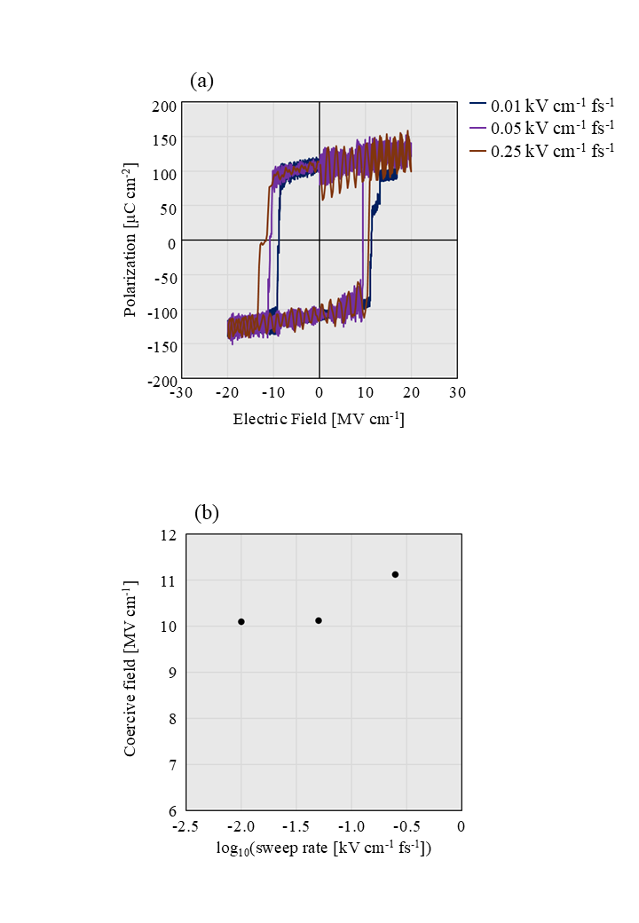
Figure S5. Dependence on electric-field sweep rate. (a) P–E hysteresis loops obtained at sweep rates of 0.01 kV cm⁻¹ fs⁻¹ (navy), 0.05 kV cm⁻¹ fs⁻¹ (purple), and 0.25 kV cm⁻¹ fs⁻¹ (brown). (b) E_{c} as a function of sweep rate. The horizontal axis is shown on a logarithmic scale.
Although the applied electric-field frequency is significantly higher than the Hz–kHz range typically used in experimental P–E measurements, this choice is dictated by the intrinsic time-scale limitations of MD simulations. In MD, the time step is restricted to the order of femtoseconds in order to resolve the fastest atomic vibrations. As a consequence, the accessible simulation time is typically limited to nanoseconds, which leads to an intrinsic “timescale gap” between atomistic simulations and macroscopic experiments¹⁰. Therefore, reproducing experimental Hz–kHz frequencies within a fully atomistic MD framework is computationally infeasible and conceptually unnecessary.
At the highest sweep rate of 0.25 kV cm⁻¹ fs⁻¹, a relatively large E_{c} = 11.13 MV cm⁻¹ was obtained. In contrast, when the sweep rate was reduced to 0.05 kV cm⁻¹ fs⁻¹ and further to 0.01 kV cm⁻¹ fs⁻¹, the E_{c} decreased to E_{c} = 10.12 MV cm⁻¹ and E_{c} = 10.09 MV cm⁻¹, respectively. The difference between these two lower sweep rates is as small as approximately 0.03 MV cm⁻¹.
These results suggest two important points. First, the present simulation framework successfully reproduces the characteristic dynamic rate dependence of ferroelectric switching, in which polarization reversal is delayed under rapidly varying electric fields.¹¹ Second, at a sweep rate of 0.05 kV cm⁻¹ fs⁻¹, the E_{c} has already converged to a value close to the quasi-static limit, and further reduction of the sweep rate does not lead to any significant change in the results.
Therefore, considering the balance between computational cost and accuracy, we identified 0.05 kV cm⁻¹ fs⁻¹ as the optimal electric-field sweep rate. This value provides sufficient convergence while retaining physical fidelity, and it was adopted for all subsequent analyses.

References
1. Dong, H. et al. Thermal transport in disordered wurtzite ScAlN alloys using machine learning interatomic potentials. Mater. Today Commun. 39, 109213 (2024).
2. Batatia, I. et al. A foundation model for atomistic materials chemistry. arXiv:2401.00096, (2025).
3. Park, Y., Kim, J., Hwang, S. & Han, S. Scalable Parallel Algorithm for Graph Neural Network Interatomic Potentials in Molecular Dynamics Simulations. J. Chem. Theory Comput. 20, 4857–4868 (2024).
4. Lysogorskiy, Y., Bochkarev, A. & Drautz, R. Graph atomic cluster expansion for foundational machine learning interatomic potentials. arXiv:2508.17936, (2025).
5. Rhodes, B. et al. Orb-v3: atomistic simulation at scale. arXiv:2504.06231, (2025).
6. Fu, X. et al. Learning Smooth and Expressive Interatomic Potentials for Physical Property Prediction. arXiv:2502.12147, (2025).
7. Yazawa, K., Mangum, J. S., Gorai, P., Brennecka, G. L. & Zakutayev, A. Local chemical origin of ferroelectric behavior in wurtzite nitrides. J. Mater. Chem. C Mater. 10, 17557–17566 (2022).
8. Ji, Y., Liang, J. & Xu, Z. Machine-Learning Interatomic Potentials for Long-Range Systems. Phys. Rev. Lett. 135, 178001 (2025).
9. Merz, W. J. Switching Time in Ferroelectric BaTiO3 and Its Dependence on Crystal Thickness. J. Appl. Phys. 27, 938–943 (1956).
10. Leimkuhler, B., Margul, D. T. & Tuckerman, M. E. Stochastic, resonance-free multiple time-step algorithm for molecular dynamics with very large time steps. Mol. Phys. 111, 3579–3594 (2013).
11. Lu, H. et al. Domain Dynamics and Resistive Switching in Ferroelectric Al _{1–x} Sc _{x} N Thin Film Capacitors. Adv. Funct. Mater. 34, (2024).
12. Akiyama, M. et al. Enhancement of Piezoelectric Response in Scandium Aluminum Nitride Alloy Thin Films Prepared by Dual Reactive Cosputtering. Advanced Materials 21, 593–596 (2009).

