Supplementary Methods
I．Approach to identify ARDS patients
To identify ARDS patients in the CDIC cohort, we first extracted all cases of acute respiratory failure requiring mechanical ventilation. Experienced intensivists and radiologists then reviewed each patient’s medical history, radiographs (lung CT or chest X-ray), blood gases, and PEEP levels to confirm ARDS based on the Berlin definition. In cases of diagnostic disagreement, the final decision was made by a senior intensivist.

II．Data Collection
Respiratory variables included respiratory rate, tidal volume, minute ventilation, positive end–expiratory pressure (PEEP), peak pressure (Ppeak) and Plateau pressure (Pplat) were obtained. For patients who received ventilation in a volume–controlled assist mode, driving pressure (ΔP) was calculated as Pplat minus PEEP, if not specified, Ppeak was considered equal to Pplat in pressure-regulated modes other than pressure support ventilation. Mechanical power (MP) was calculated as [ 0·098*respiratory rate*tidal volume*(Ppeak–(0·5*ΔP))]. Ventilatory ratio is defined as [minute ventilation * arterial PCO2/ [predicted body weight (PBW) * 100 * 37.5], PBW was calculated as equal to [50 + 0.91 (centimeters of height – 152.4)] in males, and [45.5 + 0.91 (centimeters of height – 152.4)] in females.
Hemodynamic variables (heart rate, systolic blood pressure, diastolic blood pressure, use of vasopressor and lactate level), markers of organ dysfunction and injury (platelets, creatinine, bilirubin and PaO2/FiO2 ratio) and other variables (temperature, hemoglobin, sodium, glucose, bicarbonate, and pH) were also collected.
Longitudinal data were collected from Day 1 until death, ICU discharge, liberation from mechanical ventilation, or Day 7 in the ICU, whichever came first. We defined ΔP > 40 cmH₂O, respiratory rates >60 breaths/min, and tidal volumes >20 mL/kg PBW as outliers, as these physiologically improbable values were assumed to be erroneous. Outliers were transformed into missing values and imputed using the Multiple Imputations by Chained Equations (MICE) method.
Outcomes were 28-day mortality, ICU mortality, hospital mortality, and extrapulmonary organ dysfunction. Organ dysfunction was defined as a SOFA score ≥1 for any organ system. Daily SOFA scores were calculated using the most abnormal values for each organ. New-onset organ dysfunction was defined as a ≥1-point increase in organ-specific SOFA score within 7 days among patients without that organ dysfunction at baseline. For cardiovascular dysfunction, further assessment is conducted using the Vasoactive-Inotropic Score (VIS) to evaluate cardiovascular function. Considering the high proportion of ARDS patients receiving sedative analgesics, the Glasgow Coma Scale (GCS) score may not accurately reflect neurological function, so neurological dysfunction is not calculated.

III．Data preprocessing
Before performing LPA, we first assessed the distributions and missingness of candidate variables. We assumed the data were “missing at random” and applied multiple imputation by chained equations (MICE) to generate missing values based on observed patient data. A total of five imputed datasets (n = 5) were created using weighted predictive mean matching. The imputation was performed in R Studio using the ‘mice’ package (https://cran.r-project.org/web/packages/mice). And stand[Monti, 2003 #32]ardized transformation was used for the dataset.

Supplementary Tables
Supplemental Table 1: Characteristics of Cohort and Clinical Trial
 | Derivation Cohort | Validation Cohort
 | CDIC | ALVEOLI
No. of patients | 769 | 549
Enrollment period | 2014-2022 | 1999-2002
Inclusion criteria | Patients with ARDS and received invasive mechanical ventilation. (Berlin definition) | Patients with ARDS and received invasive mechanical ventilation.  (AECC definition)
Outcomes | 28-day mortality, ventilator-free days,  ICU mortality, hospital mortality,  and extrapulmonary organ dysfunction. | 28-day mortality, ventilator-free days and extrapulmonary organ dysfunction.

Supplemental Table 2: Clinical variables for phenotyping in different datasets
 | CDIC | ALVEOLI
Minute ventilation | √ | √
Driving pressure | √ | √
Mechanical power | √ | √
Ventilatory ratio | √ | √
PaO₂/FiO₂ ratio | √ | √
PaCO₂ | √ | √
pH | √ | √
Compliance | √ | √
PEEP= positive end-expiratory pressure; PaO2=partial pressure of oxygen; FiO2=fraction of inspired oxygen.

Supplemental Table 3: Clinical characteristics of ARDS patients in CDIC at the start of mechanical ventilation
 | All  (n=769) | Alive at Day 28  (n=513) | Dead at Day 28  (n=256) | P-value
Age (years) | 65.0 (52-76) | 65.0 (50-75) | 69.0 (56-78) | <0.001
BMI，kg/m² | 23.7 (21.2-26.1) | 24.0 (21.6-26.1) | 23.4 (20.8-25.0) | 0.045
Male (gender), n (%) | 549 (71.4) | 372 (72.5) | 177 (69.1) | 0.352
ARDS Primary risk factor, n (%) |  |  |  | 0.004
Pneumonia | 476 (61.8) | 301 (58.6) | 175(68.3)
Sepsis | 125 (16.3) | 84 (16.4) | 41 (16.0)
Aspiration | 79(10.2) | 54(10.5) | 25(9.7)
Trauma | 56 (7.3) | 46 (9.0) | 10 (3.9)
Other | 33 (4.3) | 28 (5.5) | 5 (2.0)
Comorbidities, n (%)
Hypertension | 334 (43.4) | 206 (40.2) | 128 (50.0) | 0.011
Diabetes，n (%) | 161 (20.9) | 99 (19.3) | 62 (24.2) | 0.132
Chronic heart failure | 87 (11.3) | 46 (9.0) | 41 (16.0) | 0.005
Coronary heart disease | 105 (13.7) | 54 (10.5) | 51 (19.9) | 0.001
Chronic renal diseases | 76 (9.9) | 40 (7.8) | 36 (14.1) | 0.007
COPD | 44 (5.7) | 28 (5.5) | 16 (6.2) | 0.742
Vital signs
Temperature (℃) | 38.0 (37.3-38.6) | 38.0 (37.3-38.6) | 37.9 (37.3-38.6) | 0.856
Respiratory rate (breaths min−1 ) | 28 (24-32) | 27 (24-31) | 30 (26-34) | <0.001
Heart rate (beats min−1 ) | 121 (108-137) | 118 (105-131) | 127 (114-143) | <0.001
MAP (mmHg) | 71 (64-78) | 72(65-79) | 68 (62-75) | <0.001
Laboratory data
White blood cell count (10⁹/L) | 11.4 (7.7-15.9) | 11.5 (8.2-15.7) | 11.0 (7.2-16.4) | 0.261
Hemoglobin (g/L) | 102.0 (85.0-117.0) | 103 .0(87.0-117.9) | 97.8 (84.3-115.3) | 0.05
Platelet count (10⁹/L) | 136.0 (80.0-201.5) | 143 (90.1-204.0) | 118 (64.8-195.0) | 0.007
BUN (mg/dl) | 9.9 (7.0-16.3) | 9.4 (6.6-15.2) | 11.7 (7.7-19.1) | <0.001
Creatinine (umol/L) | 107.0 (75.0-181.0) | 101.0 (73.0-163.0) | 119.0 (80.0-213.0) | 0.001
TBIL (umol/L) | 15.5 (9.9-26.5) | 15.9 (10.1-26.1) | 14.8 (9.3-28.2) | 0.625
CRP (mg/L) | 132.0 (70.4-207.0) | 126.0 (62.5-208.7) | 144 (84.0-197.5) | 0.095
Procalcitonin (ng/L) | 3.63 (0.98.-10.41) | 3.08 (0.939.93) | 4.66 (1.18-10.78) | 0.082
pH | 7.38 (7.33-7.42) | 7.39 (7.35-7.42) | 7.36 (7.30-7.40) | <0.001
PaO₂ (mm Hg) | 89.6 (78.9-103.8) | 90.9 (80.9-104.7) | 86.2 (76.0-101.8) | 0.015
PaCO₂ (mm Hg) | 36.4 (32. 5-40.7) | 36.6 (31.9-43.6) | 36.5 (32.4-41.4) | 0.313
Bicarbonate (mmol/L) | 22.1 (19.7-24.3) | 20.6 (18.3-23.3) | 21.8 (19.2-24.1) | <0.001
PaO₂/FiO₂ ratio (mm Hg) | 154.0 (111.7-201.8) | 162.0(120.3-207.4) | 137.0 (92.8-181.4) | <0.001
Lactate，mmol/L | 1.78 (1.304-2.63) | 1.66 (1.27-2.29) | 2.13 (1.46-3.54) | <0.001
Parameters of mechanical ventilation
Tidal volume (ml/kg PBW) | 6.7 (6.0-7.4) | 6.7 (6.1-7.4) | 6.5 (5.8-7.3) | 0.063
Minute ventilation (L/min) | 7.8 (6.8-8.9) | 7.7 (6.8-8.8) | 8.2 (6.8-9.3) | 0.007
Driving pressure (cmH₂O) | 11.5 (9.9-13.6) | 11.3 (9.8-13.2) | 11.8 (9.9-14.7) | 0.014
Compliance (ml/cmH₂O) | 37.9 (29.4-46.8) | 38.6 (30.4-46.6) | 35.0 (28.1-46.8) | 0.027
Mechanical power (J/min) | 11.5 (9.3-14.2) | 11.0 (9.1-13.0) | 12.8 (10.2-15.9) | <0.001
Ventilatory ratio | 1.42 (1.18-1.78) | 1.38 (1.16-1.69) | 1.53 (1.25-1.98) | <0.001
APACHE II score | 23.0±8.4 | 22.0±8.5 | 24.6±8.2 | 0.057
SOFA score | 8.0(6.0-11.0) | 8.0 (6.0-10.0) | 10.0 (7.0-12.0) | 0.235
ARDS= acute respiratory distress syndrome; BMI= Body mass index; PaO₂=partial pressure of oxygen; PaCO₂=partial pressure of Carbon Dioxide; FiO₂=fraction of inspired oxygen; MAP=mean arterial blood pressure; BUN= Blood urea nitrogen; TBIL: Total Bilirubin; CRP: C-Reactive Protein; PBW=Predicted body weight; SOFA= Sequential organ failure assessment; APACHE= Acute Physiology and Chronic Health Evaluation II.

Supplemental Table 4: Clinical characteristics and outcomes of respiratory phenotypes in ALVEOLI
 | Class1  (n=276) | Class 2  (n=61) | Class 3  (n=212) | P-value
Age (years) | 52.5 (39-67) | 47.0 (39-60) | 49.0 (37-63) | 0.437
BMI，kg/m² | 26.1 (22.2-30.0) | 25.3 (22.8-30.3) | 25.9 (22.0-30.7) | 0.806
Male (gender), n (%) | 146 (52.9%) | 32 (52.5%) | 124 (58.5%) | 0.428
ARDS Primary risk factor, n (%) |  |  |  | 0.128
Pneumonia | 101 (36.6%) | 29 (47.5%) | 91 (42.9%)
Sepsis (non-pulmonary) | 52 (18.8%) | 17 (27.9%) | 51 (24.1%)
Aspiration | 48 (17.4%) | 7 (11.5%) | 29 (13.7%)
Trauma | 28 (10.1%) | 3 (4.9%) | 14 (6.6%)
Other | 47 (17.0%) | 5 (8.2%) | 27 (12.7%)
Vital signs
Temperature (℃) | 38.4 (± 0.9) | 38.5 (± 1.1) | 38.5 (±0.9) | 0.58
Respiratory rate (breaths min⁻¹) | 28.0 (22-35) | 38.0 (34-42) | 35.0 (28-40) | <0.001
Heart rate (beats min⁻¹ ) | 121 (103-135) | 141 (120-156) | 126 (109-140.5) | <0.001
MAP (mm Hg) | 62.0 (55-70) | 58.0 (51-63) | 60.0 (54-66) | 0.006
Laboratory data
White blood cell count (10⁹/L) | 12.9 (9.0-18.3) | 13.4 (6.7-18.9) | 12.8 (8.7-17.8) | 0.935
Platelet count (10⁹/L) | 152 (88-236) | 152 (72.8-219.3) | 154 (78.5-243.5) | 0.903
BUN (mg/dl) | 20.0 (12-35) | 25.0 (16-38) | 22.0 (14-41) | 0.13
Creatinine (mg/dL) | 1.0 (0.8-1.7) | 1.3 (0.9-2.3) | 1.1 (0.8-2.0) | 0.257
TBIL (mg/dL) | 0.8 (0.5-1.3) | 0.8 (0.4-1.5) | 0.9 (0.5-1.8) | 0.825
pH | 7.42 (7.37-7.455) | 7.25 (7.18-7.34) | 7.37 (7.3-7.42) | <0.001
PaO₂(mm Hg) | 79.0 (67-100) | 80.0 (65-96.75) | 74.0 (64-89.5) | 0.263
PaCO₂ (mm Hg) | 38.0 (33-42) | 44.5 (38-55) | 39.0 (34.5-44) | <0.001
PaO₂/FiO₂ ratio (mm Hg) | 138 (104.1-190) | 119 (91.6-170.6) | 137 (99.3-175.9) | 0.301
Parameters of mechanical ventilation in the first 24 h
Tidal volume (ml/kg PBW) | 7.0 (6.0-8.0) | 6.8 (5.9-7.9) | 6.7 (6.0-7.9) | 0.067
Minute ventilation (L/min) | 9.6 (8.0-11) | 16.7 (15.2-19.6) | 13.9 (12-15.2) | <0.001
Driving pressure (cmH₂O) | 14.0 (11-17) | 18.0 (16-26) | 14.0 (12-19) | <0.001
Compliance (ml/cmH20) | 31.4 (25.6-41.7) | 22.2 (16.5-29.3) | 29.4 (22.9-36.9) | <0.001
Mechanical power (J/min) | 21.2 (16.4-25.5) | 50.0 (39.5-50.0) | 35.6 (29.4-44.7) | <0.001
Ventilatory ratio | 1.44 (1.25-1.67) | 3.06 (2.73-3.44) | 2.15 (1.91-2.44) | <0.001
Outcomes
Mortality at day 28, n (%) | 38 (13.8%) | 27 (44.3%) | 60 (28.3%) | <0.001
Ventilator-free days | 22.0 (14-24) | 0 (0-17) | 15.5 (0-21.25) | <0.001
Cardiovascular dysfunction | 166 (60.1%) | 46 (75.4%) | 146 (68.9%) | 0.029
Use of Vasopressors, n (%) | 68 (24.6%) | 32 (52.5%) | 88 (41.5%) | <0.001
Kidney dysfunction | 73 (26.4%) | 23 (37.7%) | 72 (34.0%) | 0.086
Liver dysfunction | 38 (13.8%) | 8 (13.1%) | 43 (20.3%) | 0.134
Hematologic dysfunction | 116 (42.0%) | 29 (47.5%) | 109 (51.4%) | 0.119
ARDS= acute respiratory distress syndrome; BMI= Body mass index; PaO₂=partial pressure of oxygen; PaCO₂=partial pressure of Carbon Dioxide; FiO₂=fraction of inspired oxygen; MAP=mean arterial blood pressure; BUN= Blood urea nitrogen; TBIL: Total Bilirubin; CRP: C-Reactive Protein; PBW=Predicted body weight; SOFA= Sequential organ failure assessment; APACHE= Acute Physiology and Chronic Health Evaluation II.

Supplemental Table 5: Adjusted Cox regression of 28-day mortality by phenotypes on Day 1
 |  | Hazard ratio | 95% CI
The derivation cohort | Class 2 (vs 1) | 3.11 | 1.75-5.55
The derivation cohort | Class3 (vs 1) | 1.39 | 0.86–2.25
The validation cohort | Class 2 (vs 1) | 2.59 | 1.56-4.29
The validation cohort | Class 3 (vs 1) | 1.42 | 0.94-2.15
Cox regression were used to evaluate 28-day mortality across phenotypes, adjusting for baseline SOFA score, age, sex, and body mass index (BMI); CI: Confidence interval.

Supplemental Table 6: Heterogeneity of treatment effect to PEEP strategy within phenotypes in the validation cohort ALVEOLI
 | Class 1  (n = 276) |  | Class 2  (n = 61) |  | Class 3  (n = 212)
 | High PEEP  (n=130) | Low PEEP  (n=146) | High PEEP  (n=30) | Low PEEP  (n=31) | High PEEP  (n=116) | Low PEEP  (n=96)
60-d mortality, n (%) | 22 (16.9) | 16 (10.9) | 14 (46.6) | 13 (41.9) | 28 (24.1) | 32 (33.3)
Interaction  between phenotypes  and PEEP strategy | reference |  | 0.70 (0.26-1.88)  p=0.476 |  | 0.43 (0.19-0.97)  p=0.041
Interaction  between phenotypes  and PEEP strategy | - |  | reference |  | 0.61 (0.25-1.52)  p=0.287
PEEP: positive end-expiratory pressure, HR: hazard ratio, CI: Confidence interval

Supplementary Figures
Supplemental Figure 1 Patients selection on the CDIC cohort
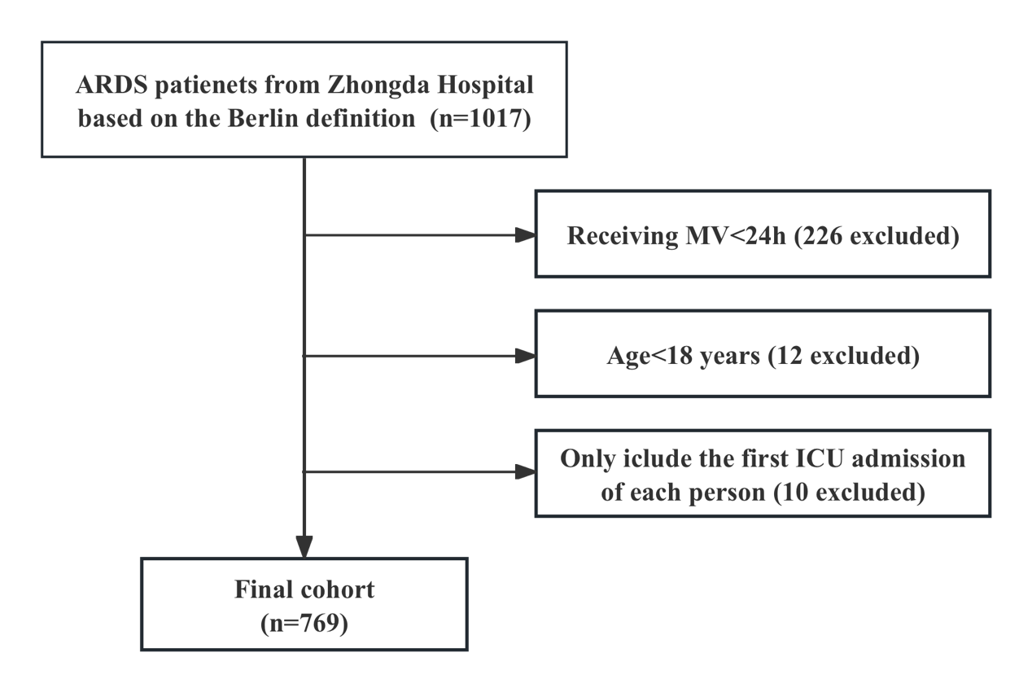

Supplemental Figure 2 Consensus k-means clustering for phenotyping in the CDIC cohort
A. Consensus matrix heatmap for k = 3 clusters. B. Consensus cumulative distribution function (CDF) plot for k = 2 to k = 6. The consensus CDF curves showed a marked improvement in cluster separation from k=2 to k=3, with only marginal changes observed for higher k values, supporting the selection of three clusters. C. Relative change in the area under the CDF curve as k increases. The relative increase in the area under the CDF curve peaked at k=3 and plateaued thereafter, indicating minimal gain in clustering stability with further increases in k. D. Cluster consensus plot representing pairwise consensus values within each cluster.

Supplemental Figure 3 Derivation of respiratory phenotypes for ARDS in CDIC including only the patients without chronic lung disease

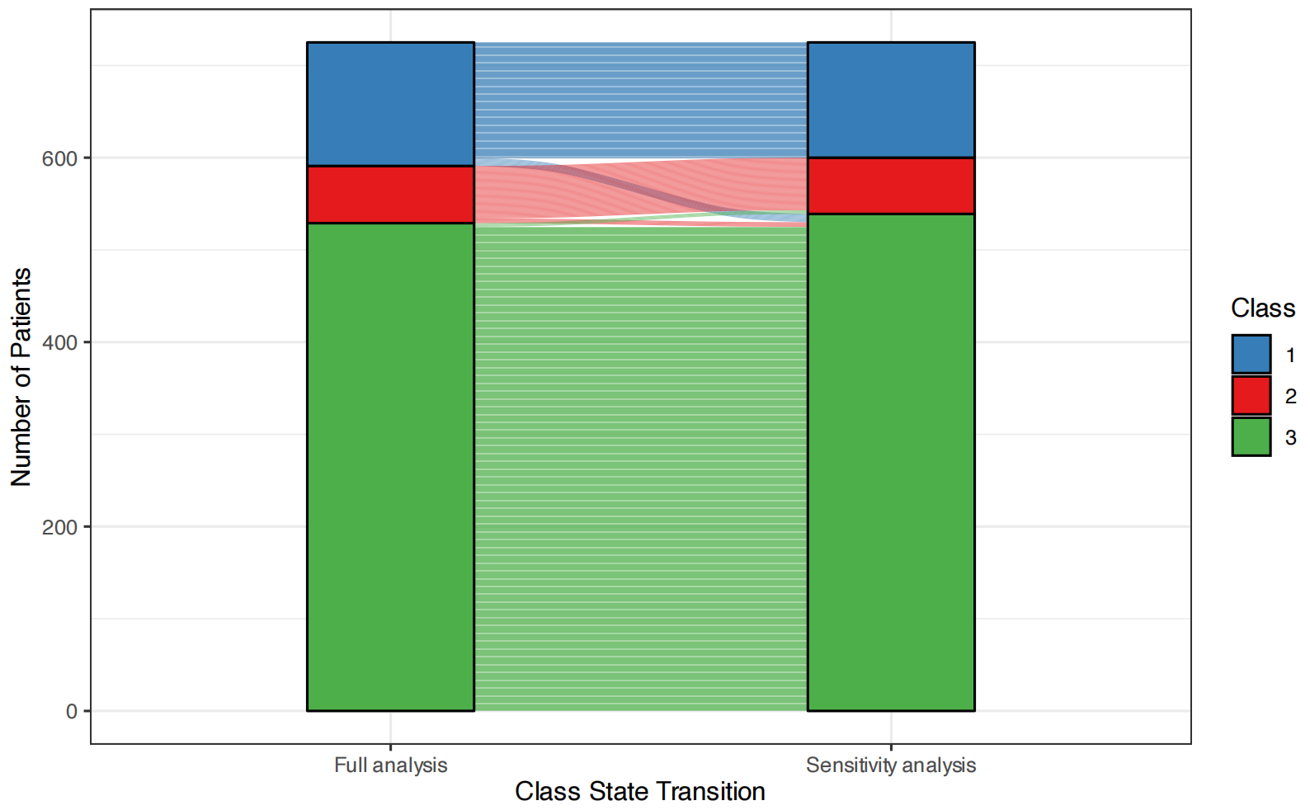

Supplemental Figure 4 The expression levels of inflammatory markers in different respiratory phenotypes of ARDS
Panels A-B show the expression levels of interleukin-6 (A) and high-sensitivity C-reactive protein (B) in different respiratory phenotypes.
ARDS: Acute Respiratory Distress Syndrome; IL-6: Interleukin-6; HsCRP: High-sensitivity C-reactive protein.

Supplemental Figure 5 Comparison of dynamic changes of driving pressure, ventilatory ratio and mechanical power between respiratory phenotypes

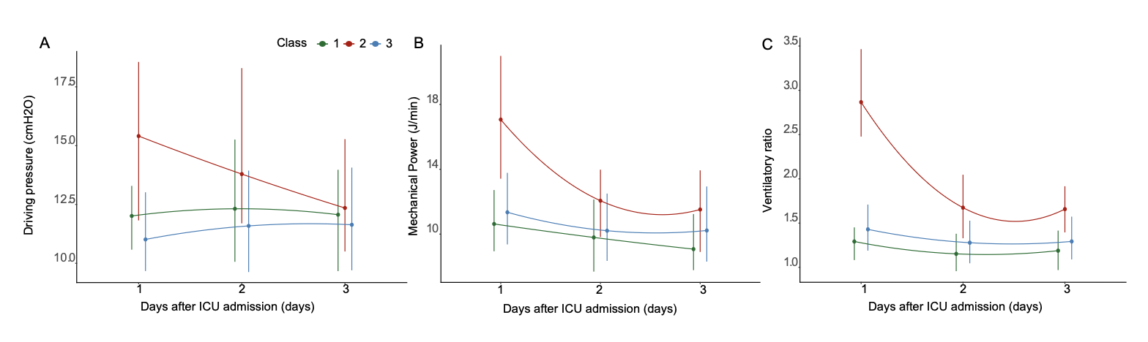
Supplemental Figure 6 Standardized mean differences between respiratory phenotypes in ALVEOLI cohort

Supplemental Figure 7 ARDS state transition over days 1 and 3 (A) and clinical outcomes by transition status (B) in CDIC
A. ARDS state transition over days 1 and 3

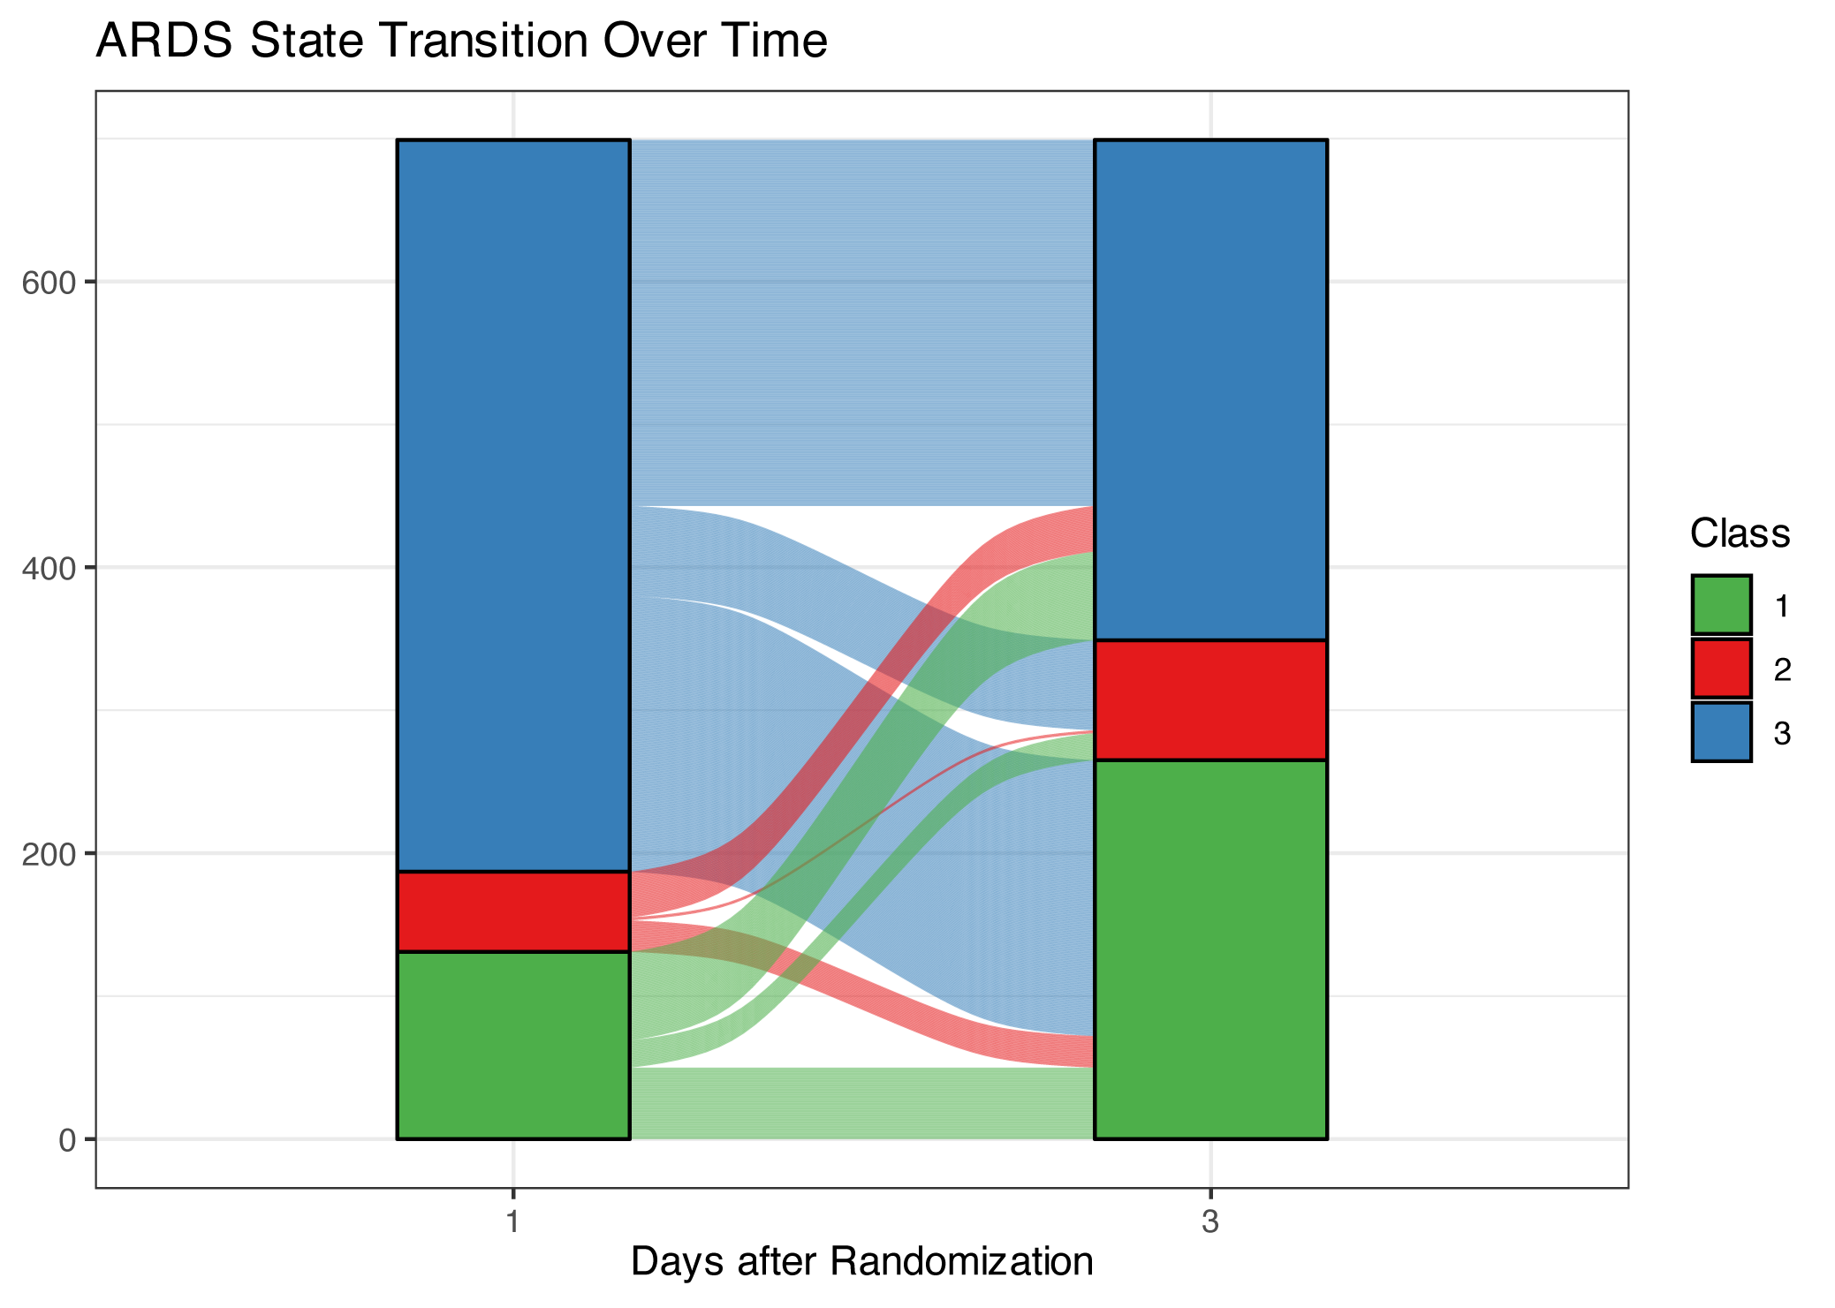
B. Clinical outcomes by transition status

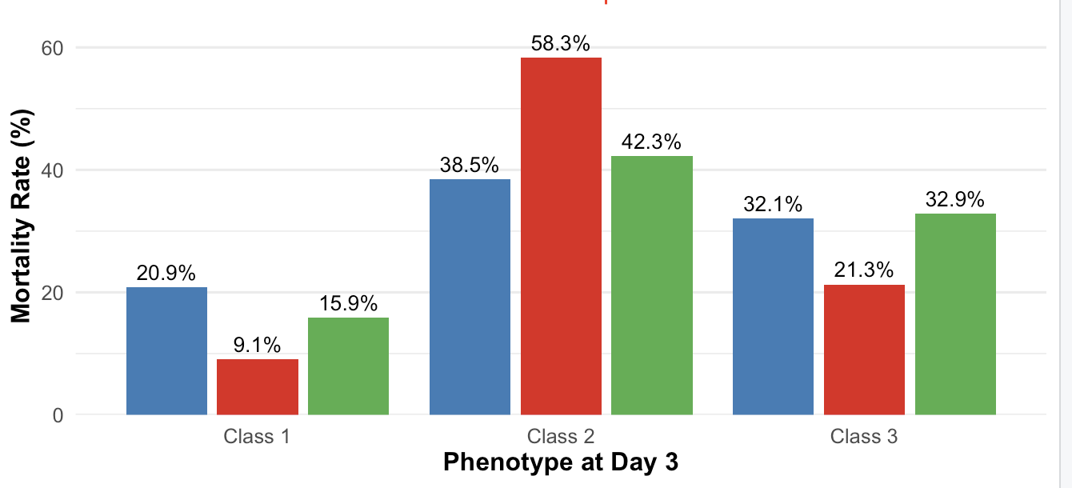

Supplemental Figure 8 ARDS state transition over days 1 and 3 (A) and clinical outcomes by transition status (B) in ALVEOLI
A. ARDS state transition over days 1 and 3

B. Clinical outcomes by transition status

