SUPPLEMENTARY STUDIES
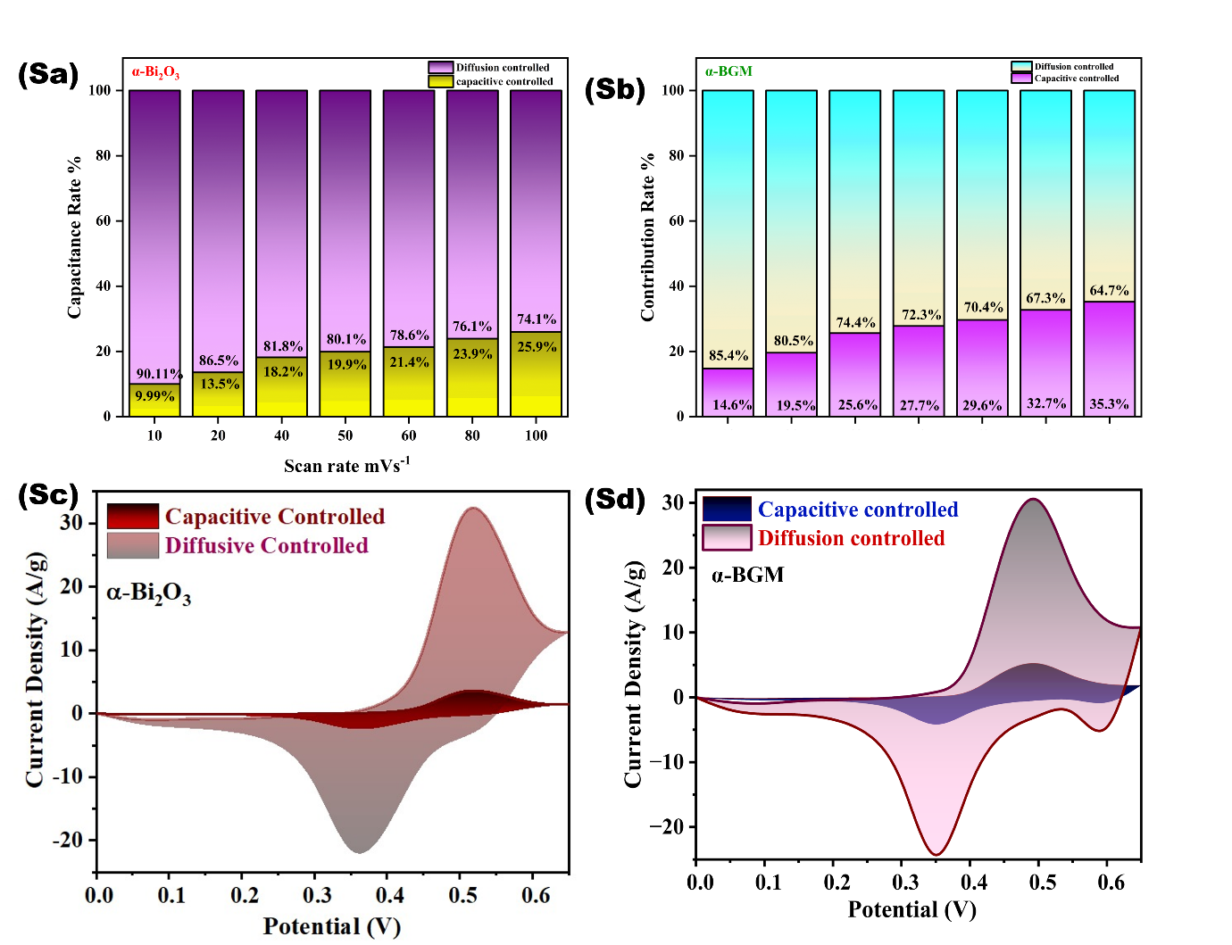
Figure 1: (Sa) and (Sb) Diffusion and capacitive behaviour for the α-BGM and α-Bi₂O₃
(Sc) and (Sd) Dunn plot

