Authors Information
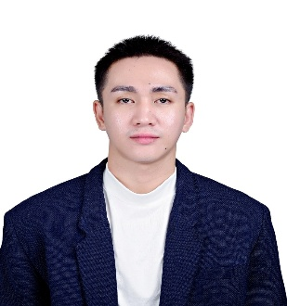

Mark Winston C. Ladrillo
Email: markladwins@gmail.com

Mr. Mark Winston C. Ladrillo is an expert in food product development, quality assurance, and food safety compliance. He holds a Master’s degree in Food Science and Technology from the Visayas State University and currently serves as an MS Graduate Fellow under the Career Incentive Program (CIP) of the Department of Science and Technology-Science Education Institute (DOST-SEI) deployed at DOST Davao Region and assigned to the Food Processing Innovation Center (FPIC) – Davao Inc. He plays a key role in research and development (R&D) and technical support services on product consultation and food safety.

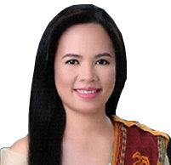

Lynette C, Cimafranca
Email: lynette.cimafranca@vsu.edu.ph

Ms. Lynette C. Cimafranca, PhD, is a member of the Teaching Graduate Faculty and an active Research Adviser. She earned her Doctorate in Food Science, establishing a robust academic and research foundation in the discipline. Dr. Cimafranca’s research agenda focuses on the intersections of Food Nutrition, Fermentation, Baking Science, and the development of Functional Foods. As a graduate educator and mentor, she guides advanced academic research aimed at driving innovation in food composition, microbial processing, and nutritional quality.

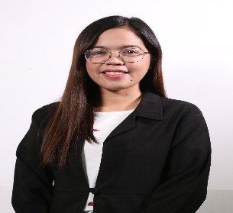

Inish Chris P. Mesias
Email: inishchris.mesias@vsu.edu.ph

Ms, Inish Chris P. Mesias, MS is a member of the teaching graduate faculty and an active research adviser. She holds a Master of Science in Food Technology, with a core specialization in Food Science. Her research portfolio focuses on food chemistry and food analysis, with particular emphasis on the characterization and application of food flavors, pigments, and other food additives.

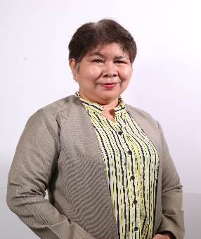

Lijueraj J. Cuadra
Email:lijueraj.cuadra@vsu.edu.ph

Ms. Lijueraj J. Cuadra, Ph.D. is a member of the teaching faculty and serves as a research adviser, bringing extensive expertise to the fields of agricultural extension and development. She holds a Doctor of Philosophy in Agricultural Extension, and her academic and research interests focus on optimizing extension modalities, community-led agricultural development, and rural innovation systems. As an educator and mentor, Dr. Cuadra actively guides undergraduate and postgraduate research, contributing to the advancement of sustainable agricultural practices and evidence-based policy in agricultural education.

