Characterization of Selected Lactic Acid Bacteria from Tapay: A Starter for Maguindanao Ethnic Delicacy in Cotabato City, Philippines

Mark Winston C. Ladrillo¹, Lynette C. Cimafranca¹,
Inish Chris P Mesias¹, and Lijueraj J. Cuadra²
¹Department of Food Science and Technology, Faculty of Agriculture and Food Science, Visayas State University, Baybay City, Leyte, Philippines.
²Department of Agriculture Education and Extension, Faculty of Agriculture and Food Science, Visayas State University, Baybay City, Leyte, Philippines.
Corresponding Author: Mark Winston C. Ladrillo
Corresponding Author Email: markladwins@gmail.com

Images (Supplementary Files)
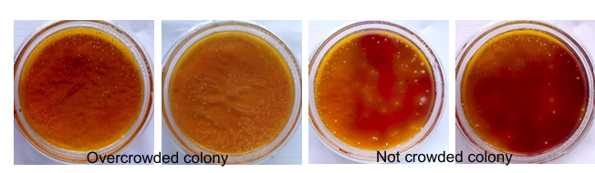

Figure 1: Mother culture of isolated LAB
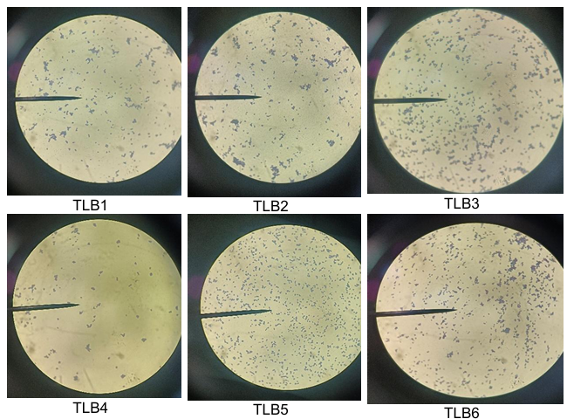

Figure 2: Gram-staining of isolated LAB

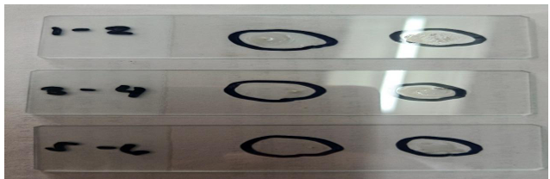

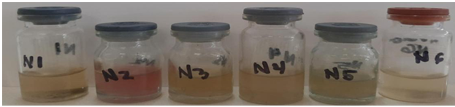
Figure 3: Catalase test result of isolated LAB

Figure 4: Nitrate reduction result of isolated LAB

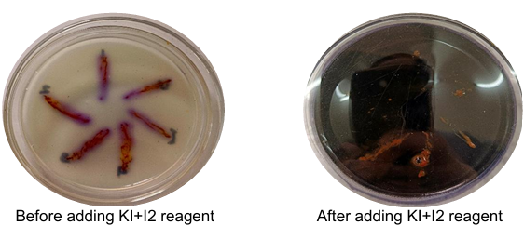

Figure 5: Starch hydrolysis results of isolated LAB

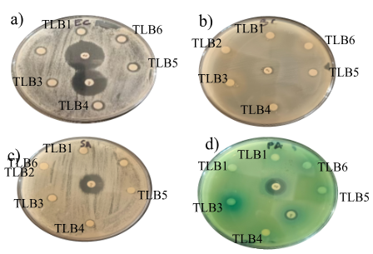

Figure 6. Potential antibacterial activity of isolated LAB a) Petri image of E. coli Biotech 1634 b) Petri image of B. cereus Biotech 1509 c) Petri image of S. aureus ATCC 25923 d) Petri image of P. aeruginosa Biotech 1335

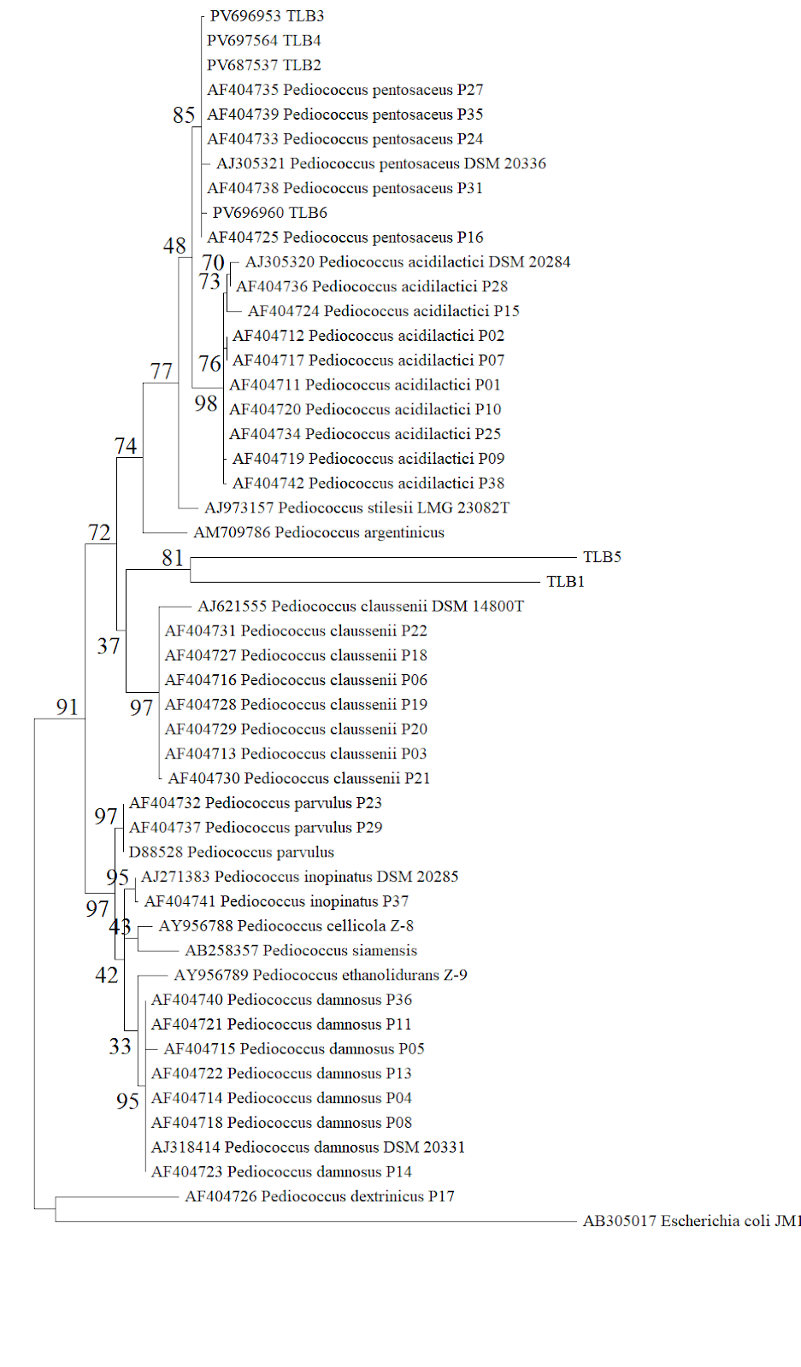

Figure 7. Maximum-likelihood phylogenetic tree based on 16S rRNA gene sequences of test strains and related type species. Escherichia coli JM109 was used as an out-group. Bootstrap values based on 1000 replications are listed as percentages at branching points. The accession numbers are given with the species. The scale bar represented 0.5% divergence

Table 1 . Antimicrobial activity of isolated LAB against pathogenic bacteria
