Various Expressions over novel k-µ/Inverse Gamma LOS Shadowed Fading
Shilpi Gadiª, Member, IEEE, S Pratap Singh^{b}, Member, GISFI, Member, IEEE, Sanjay Kumar^{c}, Member, GISFI, Ghanshyam Singh^{d} , Sr. Member, IEEE, Anurag Singh Baghel^{e}, Sr. Member, IEEE.
^{a, e}School of ICT, Gautam Buddha University, Greater Noida, India.
^{b,d}Department of Electronics and Comm. Engineering, G.C.E.T, Greater Noida, India.
^{c}Department of ECE, Birla Institute of Technology, Mesra, Ranchi, India.

e-mail:shilpig74@gmail.com,
e-mail:drsprataps@gmail.com,
e-mail:skumar@bitmesra.ac.in
e-mail:drghanshyam singh@gmail.com,
e-mail:anuragsbaghel@yahoo.com

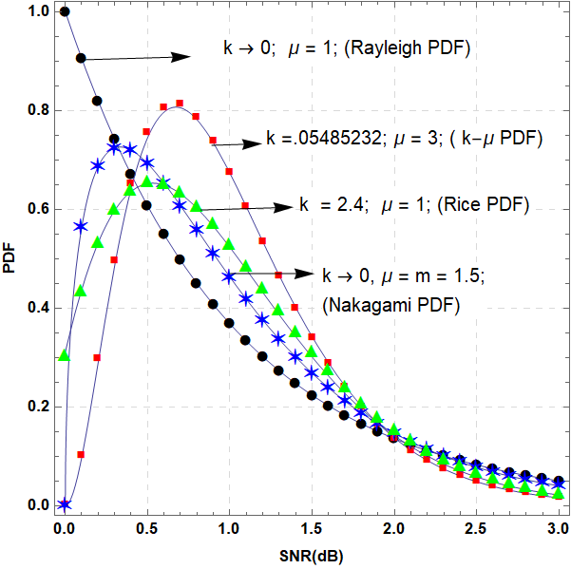

Fig. 1: PDFs of the proposed inverse Gamma LOS Shadowed k-μ fading model (continuous-lines) for the special cases: k-µ (squares), Nakagami-m (asterisks), Rice (triangles) and Rayleigh (circles) fading under light shadowing. The corresponding values of the, β are taken from Table-II ($\overline{γ}$ =1).

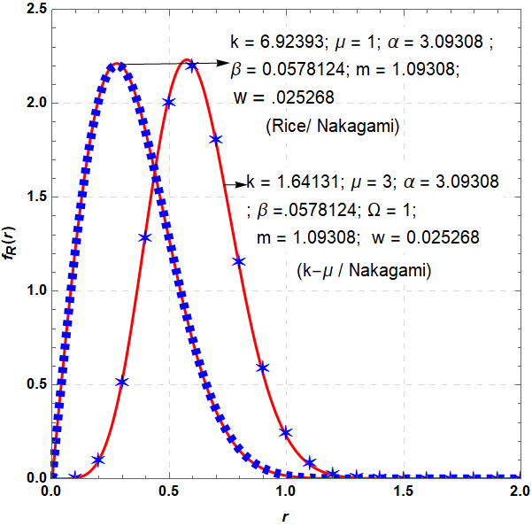

Fig. 2: PDFs of the proposed inverse Gamma LOS shadowed k-μ fading model (continuous lines) for
the approximation of the [7] (thick dashed), [4] (five-point star) under heavy shadowing. The corres-ponding values of (α, β) and (m, w) are taken from Table-II and Table-III respectively.

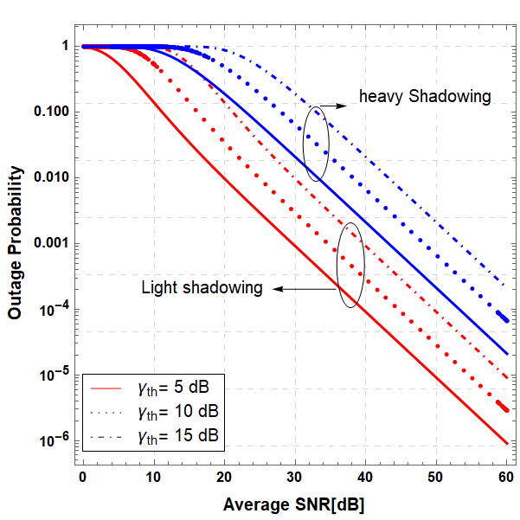
Fig. 3: Outage probability against $\overline{γ}$ for different threshold SNR under light $\left(α=77.11;β=85.9\right)$and heavyshadowing $(α=3.09308;β =0\text{.0578129)}\text{.}$

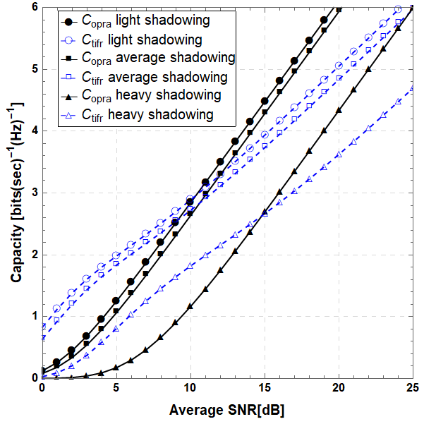
Fig. 4(a): Comparison of C_{opra} and C_{tifr} against $\overline{γ}$ under light environment $(α=77.11; β=85.9)$.

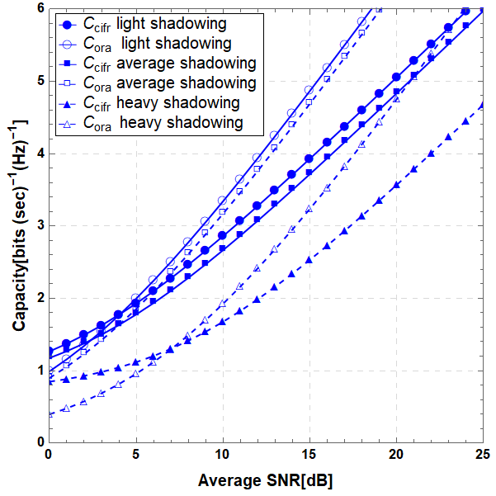
Fig. 4(b): Comparison of C_{ora} and C_{cifr} against $\overline{γ}$ under moderate environment $(α=40.0809;β=35.2898)$.

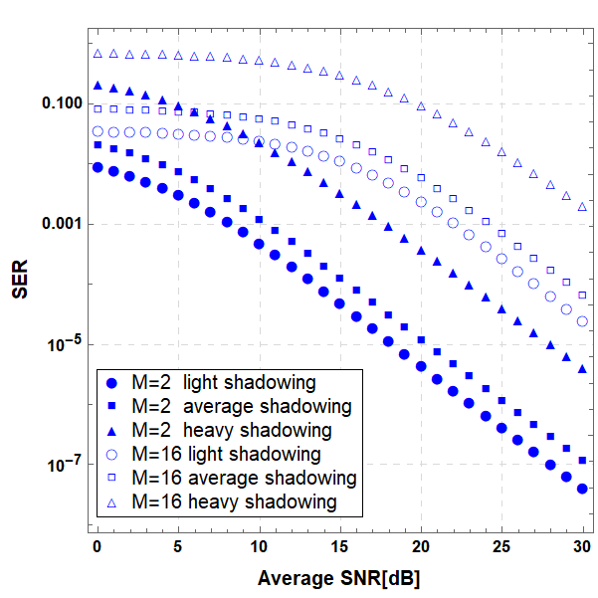
Fig. 5(a): The response of SNR (dB) on error probability with shadowing of the environment for M-QAM (M = 2, 16) modulation scheme

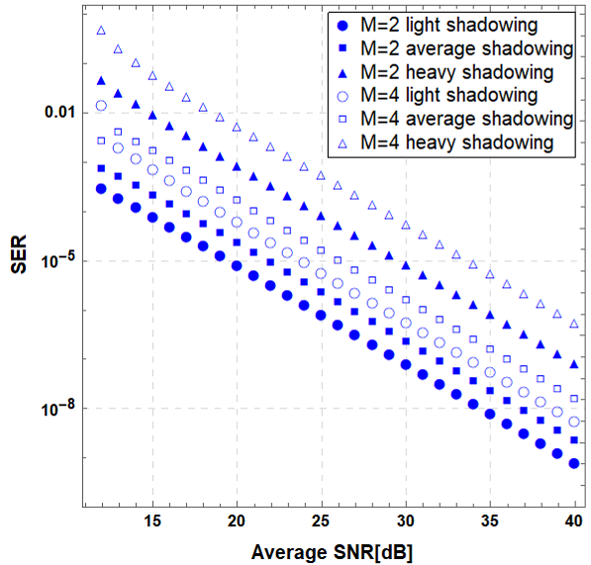

Fig. 5(b): The response of SNR (dB) on error probability with shadowing of the environment for MPSK (M = 2, 4) modulation scheme.

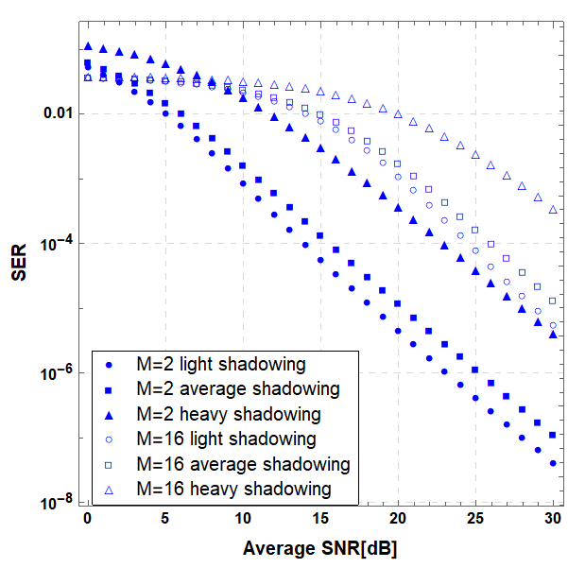
Fig. 5(c): The response of SNR (dB) on error probability with shadowing of the environment for M- AM (M = 2, 16) modulation schemes.

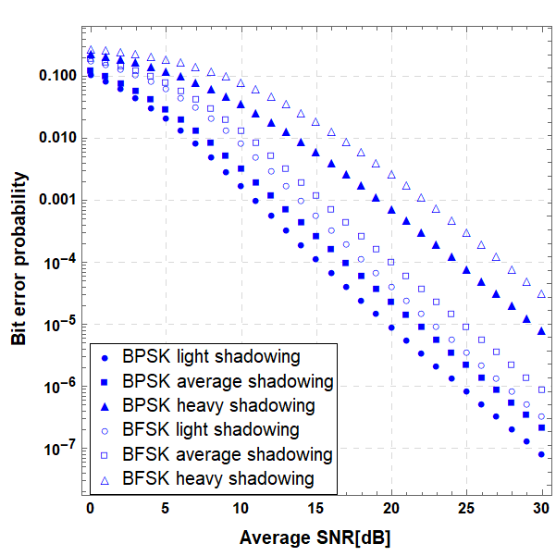
Fig. 6(a): The response of SNR (dB) on bit error-probability with shadowing of the environment for BPSK (s = 1) and BFSK (s = 0.5) modulation schemes.

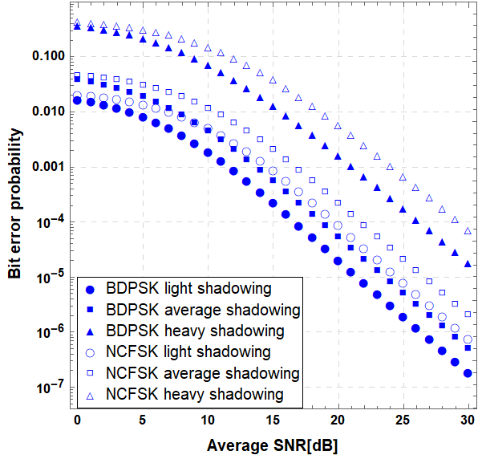
Fig. 6(b): The response of SNR (dB) on bit error-probability with shadowing of the environment for BDPSK (s = 1) and NCFSK (s = 0.5) modulation schemes.

