Fine-scale population structure and contrasting connectivity in remnant populations of the alpine tree frog
Alexander S. Wendt^{1*}, Lee Berger¹, Lee F. Skerratt¹, Laura A. Brannelly¹
¹Melbourne Veterinary School, Faculty of Science, The University of Melbourne, Werribee, Victoria, Australia, 3030
*Corresponding email: a.wendt@unimelb.edu.au

Online Resource 1
This supplementary file provides additional methodological detail and results referenced in the main paper.

Supplementary Methods

Sequencing
DArTseq combines the traditional DArT complexity reduction approach with next-generation sequencing (NGS) technology to identify single nucleotide polymorphisms (SNPs) and presence/absence variations (PAVs) across the genome (Jaccoud et al. 2001; Sansaloni et al. 2011; Kilian et al. 2012; Cruz et al. 2013). Rather than sequencing the entire genome, DArTseq uses restriction enzymes to generate a reduced representation enriched for low-copy genomic regions while minimizing highly repetitive DNA. This method involves the digestion of genomic DNA using a combination of PstL and Sphl restriction enzymes, custom proprietary bar-coded adapters, PCR amplification, and sequencing using Illumina HiSeq2500. The generated sequences are analyzed using proprietary DArT analytical pipelines to filter out low-quality markers and ensure high reproducibility, as described by Georges et al. (2018).

Population genetic differentiation

LDNe assumptions and parameterization
Rather than applying a global MAF filter prior to analysis, we used the call rate-filtered dataset and allowed LDNe (Waples and Do 2008) to implement its own MAF filtering separately within each population. We assumed random mating (mating = "random") and set the critical allele frequency threshold to 0.05, allowing LDNe to exclude low-frequency alleles that can bias N_{e} estimates. This approach ensures that allele frequency thresholds are applied in a population-specific manner.

TESS parameterization
Within TESS (Caye et al. 2016), for the Victoria sampling groups, we evaluated K = 1-6, and for the New South Wales sampling groups, K = 1-8. To reduce sensitivity to local optima, three independent runs were performed for each K. Each run was conducted using an admixture model with 20,000 burn-in and 50,000 MCMC iterations. The model with the lowest deviance information criterion (DIC) was selected as the best-supported run within each K, and the optimal K was identified from the lowest cross-validation (CV) score.

Landscape Resistance NSW

Raster derivation and preprocessing
TPI was calculated as the difference between the elevation of each cell and the mean elevation of its surrounding neighborhood. We used TPI to represent the relative topographic position of each cell in relation to its surroundings and incorporated it into the resistance surface model to capture landscape heterogeneity.
The DEA Land Cover (C3) raster follows the FAO Land Cover Classification System (LCCS) Level 3 taxonomy (Tissott and Mueller 2022). We reclassified land cover classes into multiple candidate resistance values based on plausible biological assumptions and generated a grid of reclassification combinations to explore parameter uncertainty.
Both the hydrology shapefile and road network, we buffered each by 30 m, we rasterized the buffered layer and overlaid it on the resistance surface. For the hydrology raster, we created a binary raster where a value of 1 represented a cell with a hydrological feature and a value of 10 represented non-hydrology cells. For the road network, we created a binary raster where a value of 10 represented road cells and a value of 1 represented non-road cells.
We also buffered the extent of all rasters by 3500 m beyond the population location boundaries to ensure that all potential dispersal routes were captured. This step enabled us to account for possible movement outside the immediate population areas.
The rasters were resampled to a 30 m resolution using the resample function from the raster package. For all environmental layers, we exported the rasters as ASCII files to facilitate their use in the optimization process. We used the writeRaster function from the raster package to export these rasters in ASCII format, ensuring compatibility with the ResistanceGA package (Peterman 2018).

Optimization settings and benchmarking
We set the transition function to 1/mean(x) to reflect the assumption that gene flow is inversely related to resistance values, specified 8 directional movement steps, and set longlat = FALSE to match the projected coordinate system of the rasters.
For model selection, we used the AIC method (method = "AIC") to evaluate the best-fitting model based on the balance of goodness of fit and model complexity. Continuous and categorical surfaces were capped at 500 levels (max.cont = 500, max.cat = 500), and a fixed random seed (seed = 555) ensured reproducibility. The optimization was run using 8 parallel threads.
To establish a baseline for evaluating the explanatory power of resistance surfaces, ResistanceGA automatically includes two fundamental models: a null model, where genetic distances are not explained by spatial structure, and a distance-only model based on Euclidean distances between sampling locations.
The Euclidean distance model tests for isolation by distance (IBD), representing the expectation that genetic differentiation increases with geographic distance alone. For each resistance surface optimization, ResistanceGA fits these baseline models alongside the candidate environmental surfaces using pairwise genetic differentiation (F_{ST}) as the response variable. The null and Euclidean models are evaluated using the same optimization framework, allowing direct comparisons based on Akaike Information Criterion (AIC) and marginal R². By comparing each resistance surface model to the null and Euclidean models, we assessed whether landscape features provided a better explanation of genetic structure than geographic distance alone, thereby quantifying the strength of isolation by resistance (IBR) relative to IBD and no spatial structure.

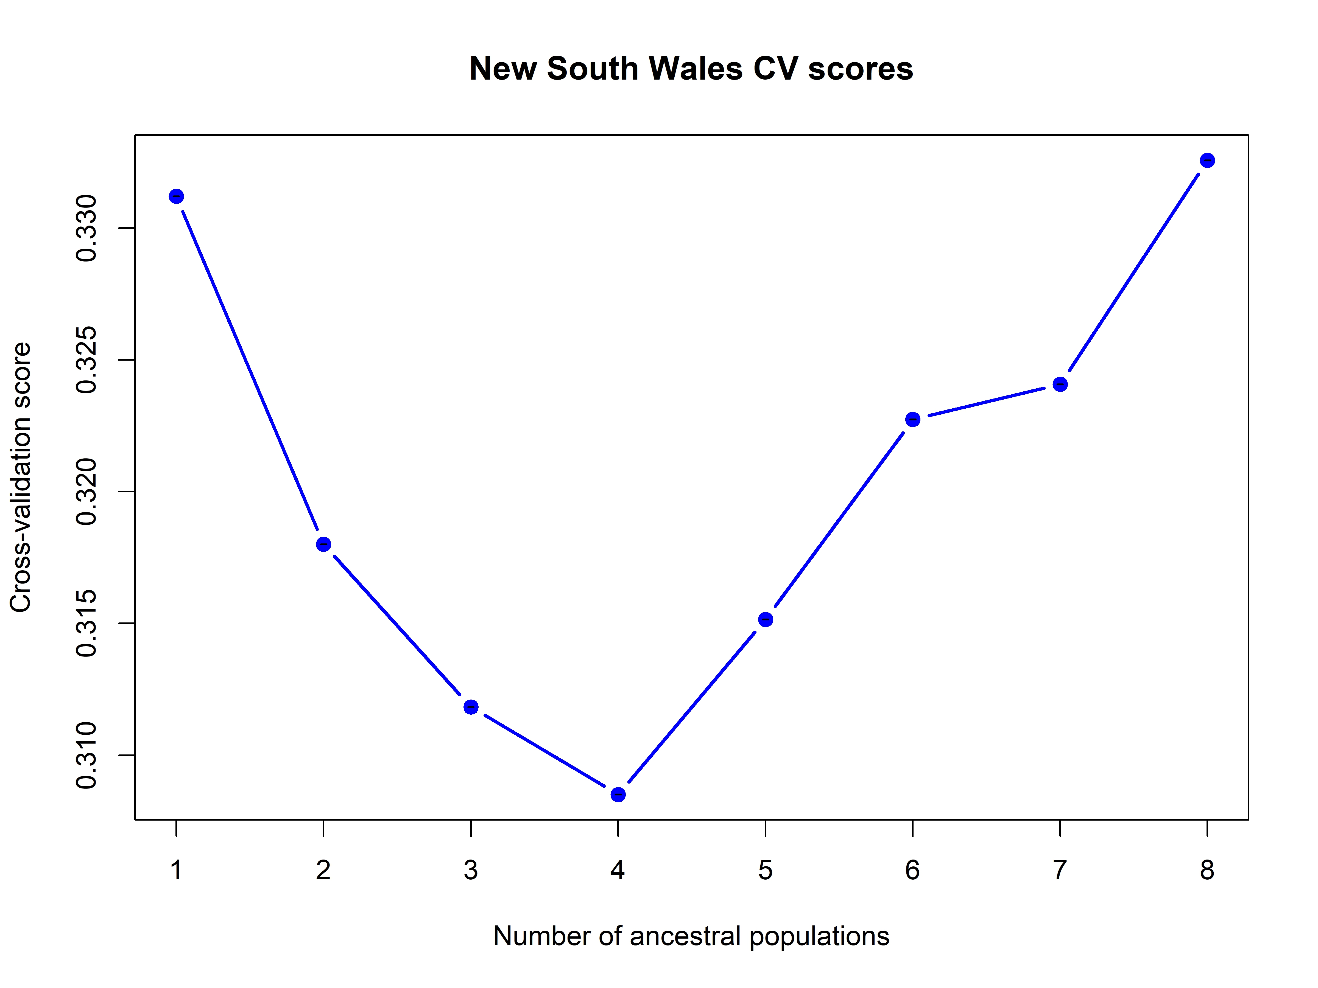
Supplementary Results
Cross-validation scores for the New South Wales dataset were lowest at K = 4, indicating that this model had the strongest support among the tested values. Scores declined from K = 1 to K = 4 and then increased steadily from K = 5 to K = 8, suggesting that additional ancestral populations beyond K = 4 did not improve model fit. These results support K = 4 as the most likely number of ancestral populations for the New South Wales dataset.
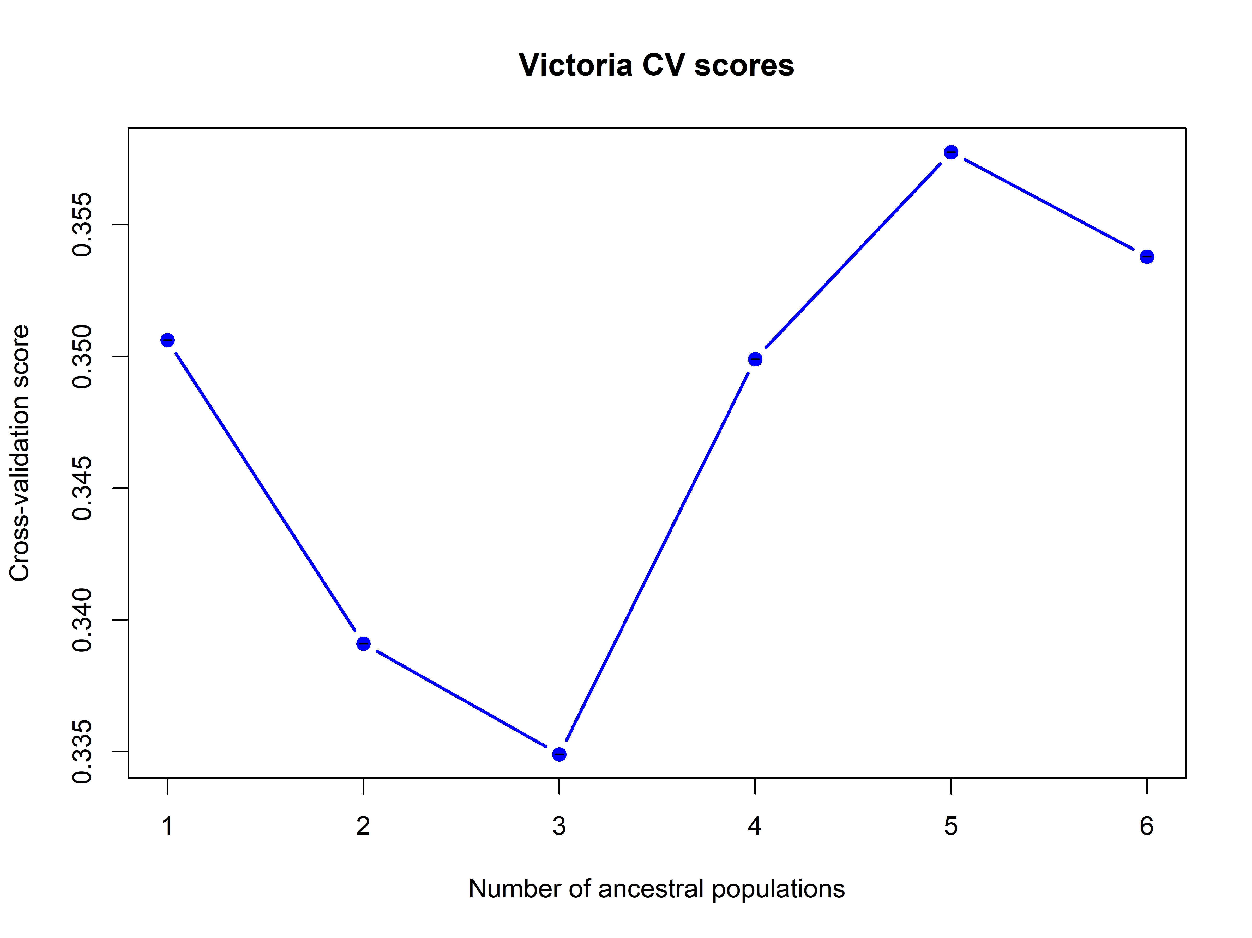

Cross-validation scores for the Victoria dataset were lowest at K = 3, indicating strongest support for this model. Scores declined from K = 1 to K = 3, then increased at higher K values, suggesting that additional ancestral populations beyond K = 3 did not improve model fit. These results support K = 3 as the most likely number of ancestral populations for the Victoria dataset.

References
Caye K, Deist TM, Martins H, et al (2016) TESS3: Fast inference of spatial population structure and genome scans for selection. Mol Ecol Resour 16:540–548. https://doi.org/10.1111/1755-0998.12471
Cruz VM V., Kilian A, Dierig DA (2013) Development of DArT Marker Platforms and Genetic Diversity Assessment of the U.S. Collection of the New Oilseed Crop Lesquerella and Related Species. PLoS One 8:e64062. https://doi.org/10.1371/journal.pone.0064062
Georges A, Gruber B, Pauly GB, et al (2018) Genomewide SNP markers breathe new life into phylogeography and species delimitation for the problematic short-necked turtles (Chelidae: Emydura) of eastern Australia. Mol Ecol 27:5195–5213. https://doi.org/10.1111/mec.14925
Jaccoud D, Peng K, Feinstein D, Kilian A (2001) Diversity arrays: a solid state technology for sequence information independent genotyping. Nucleic Acids Res 29:e25. https://doi.org/10.1093/nar/29.4.e25
Kilian A, Wenzl P, Huttner E, et al (2012) Diversity arrays technology: A generic genome profiling technology on open platforms. Methods in Molecular Biology 888:67–89. https://doi.org/10.1007/978-1-61779-870-2_5
Peterman WE (2018) ResistanceGA: An R package for the optimization of resistance surfaces using genetic algorithms. Methods Ecol Evol 9:1638–1647. https://doi.org/10.1111/2041-210X.12984
Sansaloni C, Petroli C, Jaccoud D, et al (2011) Diversity Arrays Technology (DArT) and next-generation sequencing combined: genome-wide, high throughput, highly informative genotyping for molecular breeding of Eucalyptus. BMC Proc 5:(Suppl 7). https://doi.org/10.1186/1753-6561-5-s7-p54
Tissott B, Mueller N (2022) DEA Land Cover 25m. In: Geoscience Australia. https://dx.doi.org/10.26186/146090
Waples RS, Do C (2008) LDNE: A program for estimating effective population size from data on linkage disequilibrium. Mol Ecol Resour 8:753–756. https://doi.org/10.1111/j.1755-0998.2007.02061.x

