Supplementary figure 1. STROBE diagram.
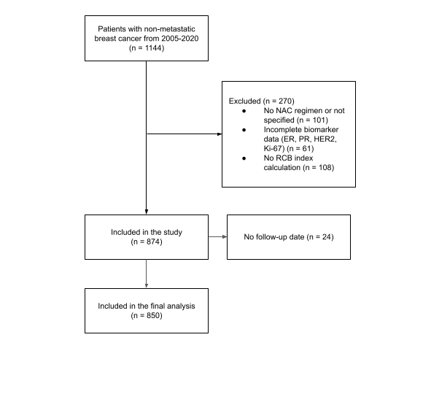

Supplementary table 1. Eight-year DFS and OS by Classification System in Luminal Disease. Hazard ratios estimated using Cox regression with Firth's penalized likelihood.
 |  | Disease-Free Survival |  |  | Overall Survival
Staging System | Category | 8-Year DFS | HR (95% CI) | P-value | 8-Year OS | HR (95% CI) | P-value
Clinical Stage (cTNM) | IA-IIA | 73.3% | 1.00 (Reference) | - | 91.0% | 1.00 (Reference) | -
Clinical Stage (cTNM) | IIB | 77.9% | 0.74 (0.38 - 1.42) | 0.363 | 86.1% | 1.19 (0.45 - 3.18) | 0.721
Clinical Stage (cTNM) | IIIA | 69.2% | 1.00 (0.56 - 1.81) | 0.994 | 75.8% | 1.99 (0.81 - 4.92) | 0.100
Clinical Stage (cTNM) | IIIB | 54.4% | 1.64 (0.91 - 2.94) | 0.080 | 58.1% | 3.99 (1.64 - 9.70) | < 0.001
Clinical Stage (cTNM) | IIIC | 52.8% | 2.17 (0.99 - 4.74) | 0.056 | 65.9% | 3.61 (1.19 - 10.99) | 0.022
Pathologic Prognostic Stage | 0 | 79.3% | 1.00 (Reference) | - | 85.9% | 1.00 (Reference) | -
Pathologic Prognostic Stage | I A-I B | 74.0% | 1.40 (0.74 - 2.67) | 0.303 | 79.6% | 1.67 (0.80 - 3.53) | 0.176
Pathologic Prognostic Stage | II A | 69.2% | 1.56 (0.94 - 2.58) | 0.080 | 70.2% | 2.18 (1.22 - 3.92) | 0.006
Pathologic Prognostic Stage | II B | 64.7% | 2.48 (1.32 - 4.65) | 0.006 | 72.6% | 2.60 (1.23 - 5.47) | 0.014
Pathologic Prognostic Stage | III A | 60.3% | 2.32 (1.35 - 3.98) | 0.002 | 75.2% | 2.17 (1.11 - 4.25) | 0.023
Pathologic Prognostic Stage | III B-III C | 29.9% | 6.29 (3.67 - 10.78) | < 0.001 | 47.5% | 6.19 (3.23 - 11.87) | < 0.001
Residual Cancer Burden | pCR | 79.3% | 1.00 (Reference) | - | 85.9% | 1.00 (Reference) | -
Residual Cancer Burden | RCB-I | 66.5% | 1.74 (0.95 - 3.20) | 0.077 | 71.3% | 2.13 (1.06 - 4.28) | 0.036
Residual Cancer Burden | RCB-II | 64.8% | 2.01 (1.26 - 3.19) | 0.002 | 70.7% | 2.37 (1.36 - 4.13) | 0.001
Residual Cancer Burden | RCB-III | 57.0% | 2.65 (1.62 - 4.35) | < 0.001 | 69.9% | 2.79 (1.53 - 5.07) | < 0.001
Neo-Bioscore | 0-1 | 77.8% | 1.00 (Reference) | - | 90.7% | 1.00 (Reference) | -
Neo-Bioscore | 2 | 78.2% | 0.94 (0.40 - 2.19) | 0.877 | 84.2% | 1.52 (0.46 - 4.95) | 0.467
Neo-Bioscore | 3 | 73.8% | 1.09 (0.50 - 2.38) | 0.828 | 82.0% | 1.57 (0.51 - 4.84) | 0.394
Neo-Bioscore | 4 | 61.8% | 1.79 (0.82 - 3.90) | 0.111 | 66.8% | 3.12 (1.03 - 9.46) | 0.017
Neo-Bioscore | 5 | 39.5% | 4.19 (1.86 - 9.41) | < 0.001 | 42.7% | 7.99 (2.59 - 24.66)
Neo-Bioscore | 6+ | 0.0% | 11.78 (4.46 - 31.10) | < 0.001 | 42.3% | 13.99 (3.74 - 52.27) | < 0.001

Supplementary table 2. Eight-year DFS and OS by Classification System in HER2-enriched disease. Hazard ratios estimated using Cox regression with Firth's penalized likelihood.
 |  | Disease-Free Survival |  |  | Overall Survival
Staging System | Category | 8-Year DFS | HR (95% CI) | P-value | 8-Year OS | HR (95% CI) | P-value
Clinical Stage (cTNM) | IA | 100.0% | 1.00 (Reference) | - | 100.0% | 1.00 (Reference) | -
Clinical Stage (cTNM) | IIA | 47.6% | 1.52 (0.07 - 35.30) | 0.771 | 47.6% | 1.36 (0.06 - 32.00) | 0.834
Clinical Stage (cTNM) | IIB | 94.7% | 0.19 (0.01 - 5.72) |  | 89.5% | 0.30 (0.01 - 7.56)
Clinical Stage (cTNM) | IIIA | 55.5% | 1.05 (0.05 - 21.29) |  | 65.1% | 0.87 (0.04 - 18.05) | 0.926
Clinical Stage (cTNM) | IIIB | 25.2% | 3.81 (0.19 - 78.29) | 0.259 | 35.7% | 2.32 (0.11 - 50.04) | 0.518
Clinical Stage (cTNM) | IIIC | 27.8% | 4.27 (0.18 - 101.22) | 0.265 | 27.8% | 3.55 (0.15 - 85.18) | 0.338
Pathologic Prognostic Stage | 0 | 85.4% | 1.00 (Reference) | - | 92.7% | 1.00 (Reference) | -
Pathologic Prognostic Stage | I A-I B | 66.7% | 2.90 (0.73 - 11.45) | 0.136 | 55.6% | 6.63 (1.51 - 29.17) | 0.010
Pathologic Prognostic Stage | II A | 21.7% | 5.39 (1.87 - 15.49) | 0.001 | 32.8% | 8.37 (2.24 - 31.29) | < 0.001
Pathologic Prognostic Stage | II B | 100.0% | 25.94 (0.83 - 813.74) | 0.137 | 0.0% | 122.81 (11.92 - 1265.63) | 0.001
Pathologic Prognostic Stage | III A | 0.0% | 13.96 (4.50 - 43.27) | < 0.001 | 14.3% | 21.25 (5.31 - 85.06) | < 0.001
Pathologic Prognostic Stage | III B-III C | 0.0% | 17.34 (2.49 - 120.81) | 0.021 | 0.0% | 32.44 (3.98 - 264.68) | 0.009
Residual Cancer Burden | pCR | 85.4% | 1.00 (Reference) | - | 92.7% | 1.00 (Reference) | -
Residual Cancer Burden | RCB-I | 66.7% | 1.94 (0.43 - 8.83) | 0.398 | 57.1% | 5.03 (1.07 - 23.54) | 0.042
Residual Cancer Burden | RCB-II | 0.0% | 6.97 (2.56 - 18.94) | < 0.001 | 33.1% | 9.78 (2.79 - 34.29) | < 0.001
Residual Cancer Burden | RCB-III | 0.0% | 26.47 (7.19 - 97.42) | < 0.001 | 0.0% | 57.09 (12.90 - 252.65) | < 0.001
Neo-Bioscore | 0-1 | 50.0% | 1.00 (Reference) | - | 50.0% | 1.00 (Reference) | -
Neo-Bioscore | 2 | 95.2% | 0.08 (0.01 - 0.63) | 0.014 | 95.2% | 0.08 (0.01 - 0.65) | 0.015
Neo-Bioscore | 3 | 53.6% | 0.51 (0.12 - 2.16) | 0.372 | 61.0% | 0.45 (0.10 - 1.96) | 0.301
Neo-Bioscore | 4 | 38.5% | 0.89 (0.19 - 4.09) | 0.873 | 65.0% | 0.59 (0.12 - 3.01)
Neo-Bioscore | 5 | 12.9% | 2.38 (0.53 - 10.67) |  | 12.9% | 2.35 (0.52 - 10.67)

Supplementary table 3. Eight-year DFS and OS by Classification System in triple negative disease. Hazard ratios estimated using Cox regression with Firth's penalized likelihood.
 |  | Disease-Free Survival |  |  | Overall Survival
Staging System | Category | 8-Year DFS | HR (95% CI) | P-value | 8-Year OS | HR (95% CI) | P-value
Clinical Stage (cTNM) | IA-IIA | 93.3% | 1.00 (Reference) | - | 86.7% | 1.00 (Reference) | -
Clinical Stage (cTNM) | IIB | 78.3% | 2.37 (0.41 - 13.77) | 0.279 | 84.1% | 1.13 (0.26 - 4.88) | 0.870
Clinical Stage (cTNM) | IIIA | 59.7% | 5.26 (0.97 - 28.70) | 0.012 | 61.5% | 2.97 (0.77 - 11.44) | 0.064
Clinical Stage (cTNM) | IIIB | 47.4% | 7.19 (1.31 - 39.32) | 0.002 | 51.0% | 4.16 (1.08 - 16.03) | 0.012
Clinical Stage (cTNM) | IIIC | 22.2% | 7.73 (1.22 - 49.02) | 0.012 | 33.3% | 4.27 (0.88 - 20.85) | 0.059
Pathologic Prognostic Stage | 0 | 85.2% | 1.00 (Reference) | - | 85.5% | 1.00 (Reference) | -
Pathologic Prognostic Stage | I A-I B | 60.7% | 3.53 (1.36 - 9.13) | 0.009 | 65.1% | 3.16 (1.19 - 8.41) | 0.021
Pathologic Prognostic Stage | II A | 65.0% | 2.32 (0.90 - 6.01) | 0.076 | 66.2% | 2.47 (0.97 - 6.26) | 0.051
Pathologic Prognostic Stage | II B | 42.9% | 6.14 (1.90 - 19.90) | 0.006 | 42.9% | 6.29 (1.94 - 20.41) | 0.006
Pathologic Prognostic Stage | III A | 33.3% | 8.72 (3.27 - 23.28) | < 0.001 | 33.3% | 8.73 (3.26 - 23.36) | < 0.001
Pathologic Prognostic Stage | III B-III C | 11.6% | 14.12 (6.00 - 33.25) | < 0.001 | 30.7% | 12.76 (5.23 - 31.10) | < 0.001
Residual Cancer Burden | pCR | 85.2% | 1.00 (Reference) | - | 85.5% | 1.00 (Reference) | -
Residual Cancer Burden | RCB-I | 58.5% | 2.64 (0.89 - 7.89) | 0.091 | 52.8% | 3.69 (1.35 - 10.04) | 0.013
Residual Cancer Burden | RCB-II | 62.8% | 3.41 (1.49 - 7.80) | 0.002 | 65.6% | 3.15 (1.37 - 7.27) | 0.004
Residual Cancer Burden | RCB-III | 20.5% | 10.73 (4.81 - 23.96) | < 0.001 | 33.1% | 9.02 (3.95 - 20.61) | < 0.001
Neo-Bioscore | 2 | 100.0% | 1.00 (Reference) | - | 100.0% | 1.00 (Reference) | -
Neo-Bioscore | 3 | 85.6% | 1.20 (0.05 - 26.73) | 0.906 | 93.3% | 0.69 (0.03 - 18.34)
Neo-Bioscore | 4 | 83.6% | 1.24 (0.07 - 22.74) |  | 80.6% | 1.42 (0.08 - 25.87)
Neo-Bioscore | 5 | 52.1% | 4.28 (0.24 - 74.97) |  | 58.4% | 3.60 (0.20 - 63.47) | 0.265
Neo-Bioscore | 6+ | 24.7% | 8.68 (0.49 - 153.75) |  | 30.1% | 8.34 (0.47 - 148.63)

Supplementary figure 2. Alluvial plot showing the change in distribution between post-neoadjuvant prognostic models.

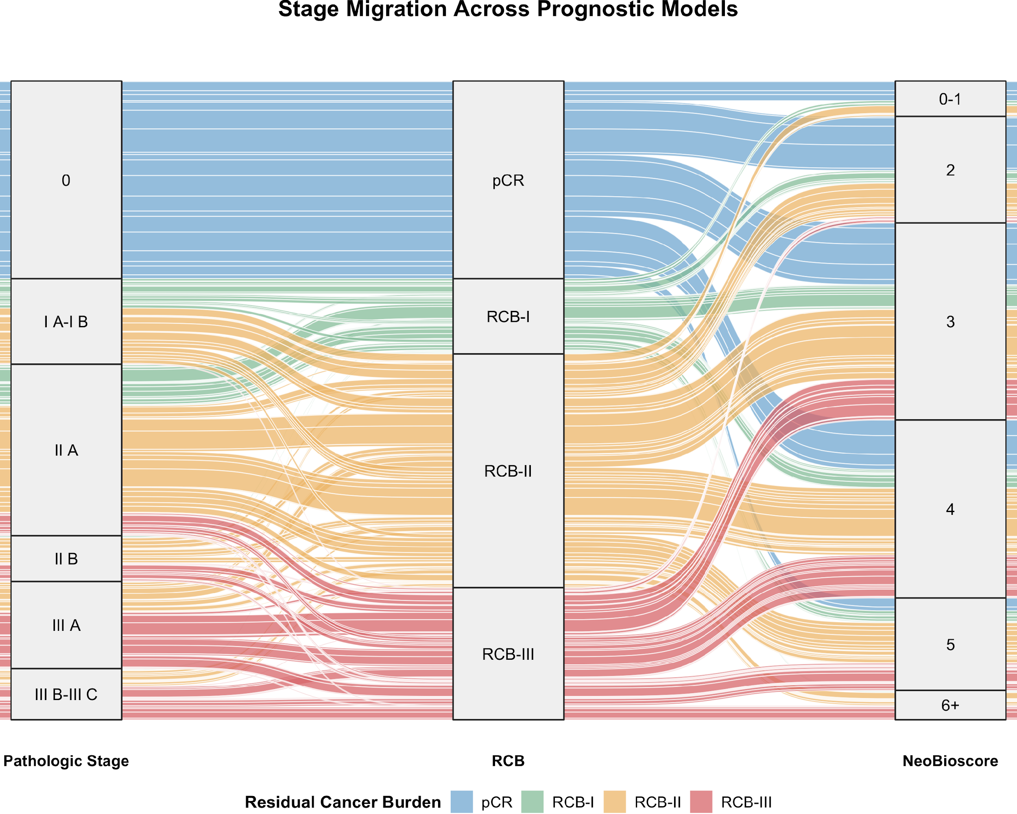

Supplementary figure 3. Calibration plot for the estimation of 8-year DFS, all models.

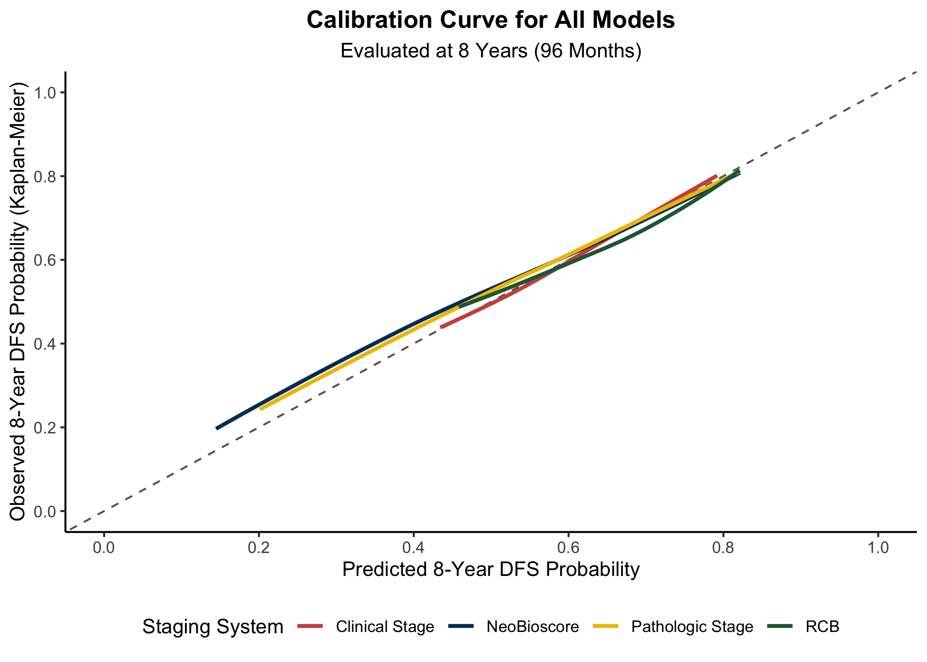

Supplementary table 4. Comparative prognostic accuracy and reclassification improvement of staging systems for OS at 5 and 8 years, overall.

 | 5-Year Performance |  |  | 8-Year Performance
Staging System | AUC | Brier Score | IDI (%) | AUC | Brier Score | IDI (%)
Clinical | 0.637 | 0.149 | Ref. | 0.682 | 0.131 | Ref.
NeoBioscore | 0.722 | 0.135 | 8.37 | 0.699 | 0.120 | 6.46
Pathologic | 0.687 | 0.143 | 2.98 | 0.666 | 0.130 | 0.88
RCB | 0.651 | 0.150 | -0.88 | 0.630 | 0.138 | -3.34
Abbreviations: AUC, Area Under the Curve; IDI, Integrated Discrimination Improvement; RCB, Residual Cancer Burden. Clinical stage served as the reference baseline model for IDI calculations (Ref.).

Supplementary table 5. Comparative prognostic accuracy and reclassification improvement of staging systems for DFS at 5 and 8 years, luminal disease.
 | 5-Year Performance |  |  | 8-Year Performance
Staging System | AUC | Brier Score | IDI (%) | AUC | Brier Score | IDI (%)
Clinical | 0.574 | 0.147 | Ref. | 0.623 | 0.211 | Ref.
NeoBioscore | 0.689 | 0.134 | 6.76 | 0.659 | 0.198 | 6.58
Pathologic | 0.704 | 0.134 | 5.52 | 0.634 | 0.206 | 3.75
RCB | 0.628 | 0.144 | 0.34 | 0.569 | 0.215 | -1.51
Abbreviations: AUC, Area Under the Curve; IDI, Integrated Discrimination Improvement; RCB, Residual Cancer Burden. Clinical stage served as the reference baseline model for IDI calculations (Ref.).

Supplementary table 6. Comparative prognostic accuracy and reclassification improvement of staging systems for OS at 5 and 8 years, luminal disease.

 | 5-Year Performance |  |  | 8-Year Performance
Staging System | AUC | Brier Score | IDI (%) | AUC | Brier Score | IDI (%)
Clinical | 0.631 | 0.123 | Ref. | 0.679 | 0.129 | Ref.
NeoBioscore | 0.692 | 0.116 | 5.24 | 0.699 | 0.120 | 5.38
Pathologic | 0.672 | 0.120 | 1.03 | 0.623 | 0.132 | -1.88
RCB | 0.615 | 0.125 | -2.07 | 0.568 | 0.139 | -5.04
Abbreviations: AUC, Area Under the Curve; IDI, Integrated Discrimination Improvement; RCB, Residual Cancer Burden. Clinical stage served as the reference baseline model for IDI calculations (Ref.).

Supplementary table 7. Comparative prognostic accuracy and reclassification improvement of staging systems for DFS at 5 and 8 years, HER2-enriched disease.
 | 5-Year Performance |  |  | 8-Year Performance
Staging System | AUC | Brier Score | IDI (%) | AUC | Brier Score | IDI (%)
Clinical | 0.763 | 0.148 | Ref. | 0.733 | 0.176 | Ref.
NeoBioscore | 0.748 | 0.150 | 2.73 | 0.762 | 0.170 | 3.79
Pathologic | 0.745 | 0.172 | 1.41 | 0.804 | 0.135 | 10.57
RCB | 0.776 | 0.149 | 6.39 | 0.874 | 0.110 | 17.06
Abbreviations: AUC, Area Under the Curve; IDI, Integrated Discrimination Improvement; RCB, Residual Cancer Burden. Clinical stage served as the reference baseline model for IDI calculations (Ref.).

Supplementary table 8. Comparative prognostic accuracy and reclassification improvement of staging systems for OS at 5 and 8 years, HER2-enriched disease.
 | 5-Year Performance |  |  | 8-Year Performance
Staging System | AUC | Brier Score | IDI (%) | AUC | Brier Score | IDI (%)
Clinical | 0.709 | 0.176 | Ref. | 0.685 | 0.130 | Ref.
NeoBioscore | 0.740 | 0.158 | 8.74 | 0.744 | 0.118 | 8.57
Pathologic | 0.819 | 0.152 | 13.74 | 0.830 | 0.104 | 18.46
RCB | 0.851 | 0.139 | 20.35 | 0.881 | 0.102 | 23.78
Abbreviations: AUC, Area Under the Curve; IDI, Integrated Discrimination Improvement; RCB, Residual Cancer Burden. Clinical stage served as the reference baseline model for IDI calculations (Ref.).

Supplementary table 9. Comparative prognostic accuracy and reclassification improvement of staging systems for DFS at 5 and 8 years, triple negative disease.
 | 5-Year Performance |  |  | 8-Year Performance
Staging System | AUC | Brier Score | IDI (%) | AUC | Brier Score | IDI (%)
Clinical | 0.661 | 0.193 | Ref. | 0.694 | 0.208 | Ref.
NeoBioscore | 0.739 | 0.177 | 8.81 | 0.750 | 0.185 | 9.26
Pathologic | 0.775 | 0.155 | 17.34 | 0.750 | 0.177 | 14.72
RCB | 0.757 | 0.160 | 13.83 | 0.758 | 0.184 | 11.15
Abbreviations: AUC, Area Under the Curve; IDI, Integrated Discrimination Improvement; RCB, Residual Cancer Burden. Clinical stage served as the reference baseline model for IDI calculations (Ref.).

Supplementary table 10. Comparative prognostic accuracy and reclassification improvement of staging systems for OS at 5 and 8 years, triple-negative disease.
 | 5-Year Performance |  |  | 8-Year Performance
Staging System | AUC | Brier Score | IDI (%) | AUC | Brier Score | IDI (%)
Clinical | 0.659 | 0.199 | Ref. | 0.691 | 0.130 | Ref.
NeoBioscore | 0.732 | 0.178 | 11.22 | 0.741 | 0.114 | 10.68
Pathologic | 0.759 | 0.165 | 15.69 | 0.745 | 0.116 | 13.08
RCB | 0.733 | 0.180 | 8.06 | 0.733 | 0.126 | 5.62
Abbreviations: AUC, Area Under the Curve; IDI, Integrated Discrimination Improvement; RCB, Residual Cancer Burden. Clinical stage served as the reference baseline model for IDI calculations (Ref.).

