Supplemental Figures

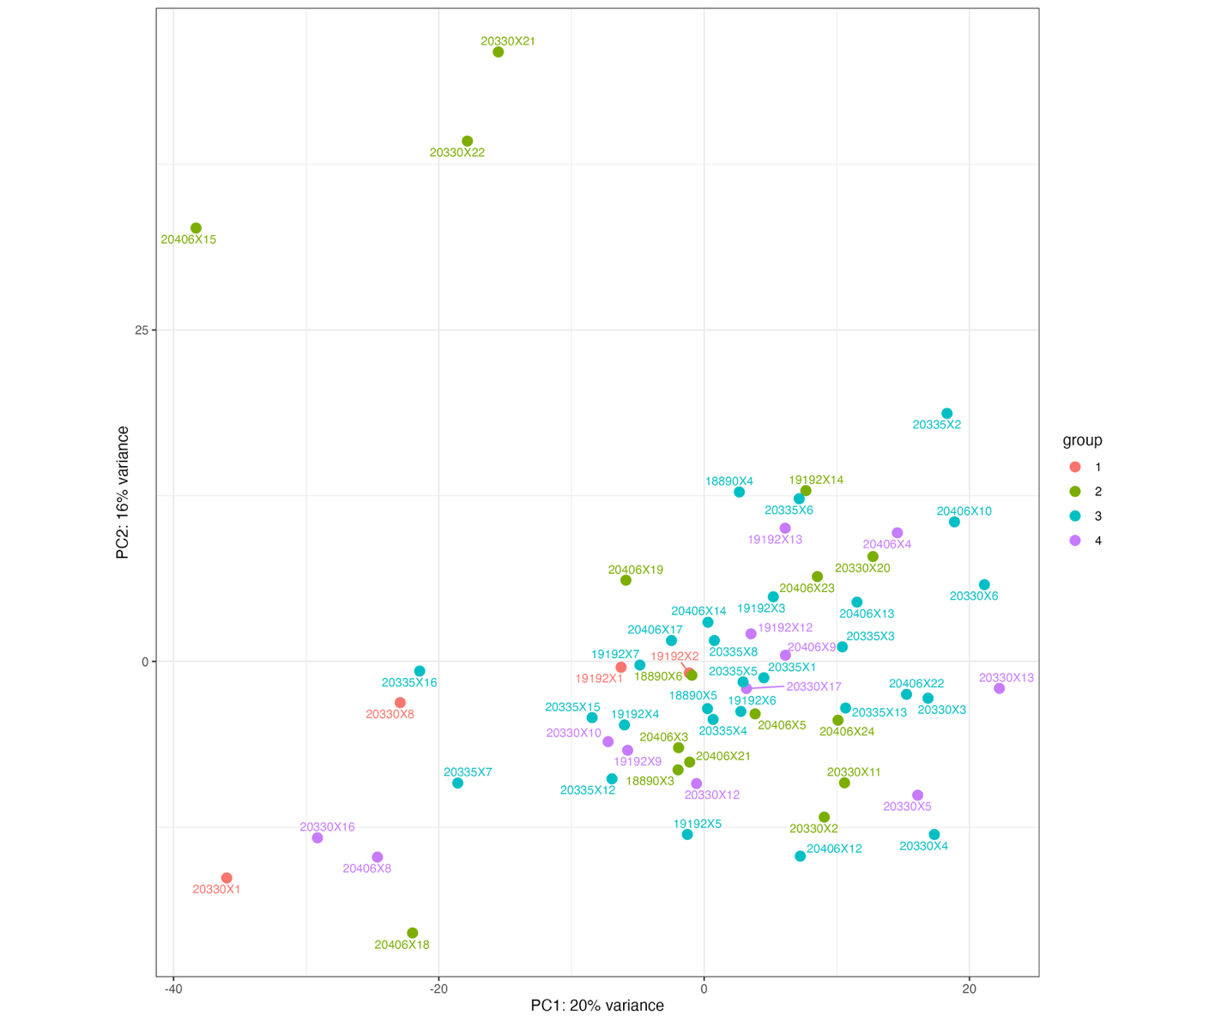
Supplemental Figure 1. Principal Component Analysis (PCA) plot for quality control.

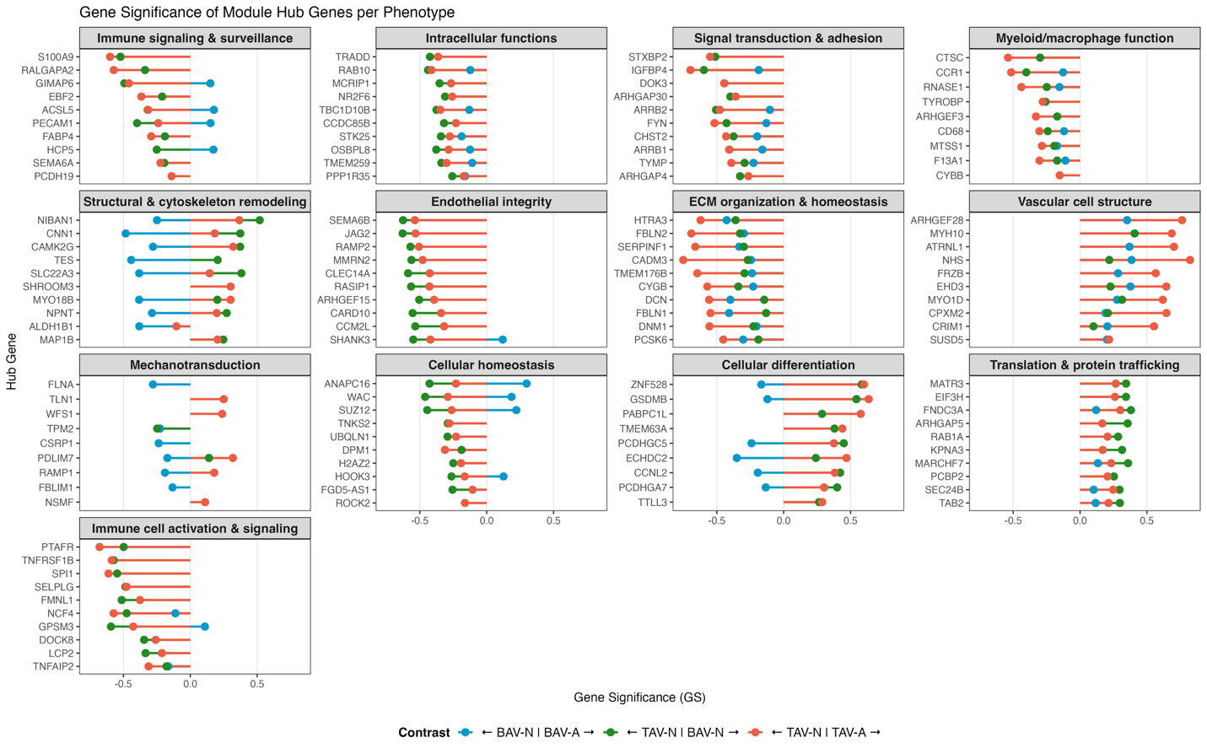
Supplemental Figure 2. Gene significance (GS) representing the correlation between gene expression and phenotype for top GS hub genes per all modules per phenotype comparison BAV-A vs BAV-N (blue), BAV-N vs TAV-N (green), and TAV-A vs TAV-N (orange); negative GS represents the gene is associated with the latter phenotype, positive GS represents the gene is associated with the former phenotype, and GS = 0 means no association between gene and either phenotype; magnitude of GS represents strength of gene association with phenotype.

