Title: Impact of Socioeconomic Status on Early Gastric Cancer Outcomes and Treatment Disparity: A SEER analysis
Journal: Journal of Gastrointestinal Cancer
Authors: Rinrada Worapongpaiboon MD ¹, Sonmoon Mohapatra, MD ², Kasenee Tiankanon, MD^{1,3}, Saowanee Ngamruengphong, MD ¹
Affiliations:
¹Division of Gastroenterology and Hepatology, Johns Hopkins Medicine, Baltimore, Maryland, USA
²Department of Gastroenterology and Hepatology, Sai Institute of Gastroenterology and Liver Sciences, Bhubaneswar, Odisha, India
³Division of Gastroenterology, Department of Medicine, King Chulalongkorn Memorial Hospital and Chulalongkorn University, Bangkok, Thailand

Corresponding author:
Saowanee Ngamruengphong, MD
Gastroenterology and Hepatology, Johns Hopkins University, Baltimore, United States
4940 Eastern Avenue, A Building, 5th Floor. A-501 Baltimore, MD 21224
Email: sngamru1@jhmi.edu
Phone: 410-550-0796

Supplementary Table 1 Demographics, Socioeconomics, Tumor Characteristics, by Treatment Modality of the T1aN0M0 gastric adenocarcinoma patients

 | Overall | Endoscopy | Surgery | No Treatment | P Value
Overall (n) | 3792 | 495 | 3034 | 263
Age at diagnosis (years), mean (SD) | 70.5 (11.0) | 72.1 (10.6) | 69.7 (11.0) | 75.7 (10.1) | <0.001
Male sex, n (%) | 2437 (64.3%) | 330 (66.7%) | 1938 (63.9%) | 169 (64.3%) | 0.034
Races, n (%) |  |  |  |  | <.001
White | 2482 (65.5%) | 384 (77.6%) | 1906 (62.8%) | 192 (73.0%)
Black | 405 (10.7%) | 37 (7.5%) | 328 (10.8%) | 40 (15.2%)
Asian/Pacific Islander | 891 (23.5%) | 74 (14.9%) | 786 (25.9%) | 31 (11.8%)
American Indian/ Alaskan Native | 14 (0.4%) | 0 (0.0%) | 14 (0.5%) | 0 (0.0%)
Year of Diagnosis, n (%) |  |  |  |  | <.001
2004-2007 | 987 (26.0%) | 51 (10.3%) | 876 (28.9%) | 60 (22.8%)
2008-2011 | 1132 (29.9%) | 82 (16.6%) | 966 (31.8%) | 84 (31.9%)
2012-2015 | 1278 (33.7%) | 211 (42.6%) | 955 (31.5%) | 112 (42.6%)
2016-2021 | 395 (10.4%) | 151 (30.5%) | 237 (7.8%) | 7 (2.7%)
US region, n (%) |  |  |  |  | 0.007
East | 1476 (38.9%) | 211 (42.6%) | 1140 (37.6%) | 125 (47.5%)
West | 2109 (55.6%) | 252 (50.9%) | 1735 (57.2%) | 122 (46.4%)
North | 82 (2.2%) | 12 (2.4%) | 65 (2.1%) | 5 (1.9%)
South | 125 (3.3%) | 20 (4.0%) | 94 (3.1%) | 11 (4.2%)
Median household income (USD), mean (SD) | 88855 (22964) | 89484 (23192) | 89128 (22755) | 84510 (24528) | 0.011
At least bachelor’s degree (%), mean (SD) | 27.3 (9.4) | 29.4 (11.0) | 27.1 (9.0) | 25.8 (9.1) | <.001
<150% poverty line (%), mean (SD) | 21.4 (8.1) | 20.0 (8.0) | 21.6 (8.0) | 22.2 (8.6) | <.001
Current unemployment (%), mean (SD) | 6.4 (2.0) | 6.0 (1.9) | 6.5 (2.0) | 6.4 (2.2) | <.001
Tumor size (mm), mean (SD) | 21.1 (16.7) | 12.7 (11.7) | 21.6 (16.5) | 30.7 (19.5) | <0.001
Tumor grade, n (%) |  |  |  |  | <.001
Well-differentiated; grade I | 671 (17.7%) | 90 (18.2%) | 558 (18.4%) | 23 (8.7%)
Moderately differentiated; grade II | 1672 (44.1%) | 252 (50.9%) | 1308 (43.1%) | 112 (42.6%)
Poorly differentiated; grade III | 1290 (34.0%) | 128 (25.9%) | 1041 (34.3%) | 121 (46.0%)
Undifferentiated; anaplastic; grade IV | 159 (4.2%) | 25 (5.1%) | 127 (4.2%) | 7 (2.7%)
Received Radiation, n (%) | 199 (5.2%) | 40 (8.1%) | 86 (2.8%) | 73 (27.8%) | 0.007
Received Chemotherapy, n (%) | 300 (7.9%) | 28 (5.7%) | 185 (6.1%) | 87 (33.1%) | <.001
NOTE. Data are presented as means (SD) or n (%). T, tertile. No treatment= No surgical or endoscopic treatment.

Supplementary Table 2 Demographics, Socioeconomics, Tumor Characteristics, and Treatment by Region of the T1aN0M0 gastric adenocarcinoma patients

Characteristic | Overall | East | West | North | South | P value
Overall (n) | 3792 | 1476 | 2109 | 82 | 125
Age at diagnosis, y (mean, SD) | 70.5 (11.0) | 69.9 (11.1) | 71.0 (10.8) | 68.3 (11.1) | 69.3 (13.2) | 0.003
Male sex, n (%) | 1355 (35.7%) | 539 (36.5%) | 749 (35.5%) | 20 (24.4%) | 47 (37.6%) | 0.155
Race, n (%) |  |  |  |  |  | <.001
White | 2482 (65.5%) | 1087 (73.6%) | 1201 (56.9%) | 78 (95.1%) | 116 (92.8%)
Black | 405 (10.7%) | 294 (19.9%) | 107 (5.1%) | 2 (2.4%) | 2 (1.6%)
Asian/Pacific Islander | 891 (23.5%) | 95 (6.4%) | 791 (37.5%) | 2 (2.4%) | 3 (2.4%)
American Indian/ Alaskan Native | 14 (0.4%) | 0 (0.0%) | 10 (0.5%) | 0 (0.0%) | 4 (3.2%)
Median household income, (USD), mean (SD) | 88854.5 (22964) | 81152 (22739) | 95969 (21018) | 69815 (7850) | 72255 (18352) | <.001
At least bachelor’s degree (%), mean (SD) | 27.3 (9.4) | 26.7 (10.6) | 28.0 (8.4) | 21.7 (7.9) | 26.1 (7.8) | <.001
<150% poverty line (%), mean (SD) | 21.4 (8.1) | 19.4 (9.1) | 22.8 (6.9) | 17.5 (3.4) | 23.8 (9.7) | <.001
County unemployment (%), mean (SD) | 6.4 (2.0) | 5.9 (2.0) | 6.9 (2.0) | 4.3 (1.0) | 6.1 (2.5) | <.001
Tumor size, mm, mean (SD) | 21.1 (16.7) | 21.7 (17.1) | 20.8 (16.5) | 19.4 (13.2) | 20.3 (15.3) | 0.264
Tumor grade, n (%) |  |  |  |  |  | 0.008
Well-differentiated | 671 (17.7%) | 272 (18.4%) | 364 (17.3%) | 7 (8.5%) | 28 (22.4%)
Moderately differentiated | 1672 (44.1%) | 688 (46.6%) | 892 (42.3%) | 42 (51.2%) | 50 (40.0%)
Poorly differentiated | 1290 (34.0%) | 466 (31.6%) | 757 (35.9%) | 29 (35.4%) | 38 (30.4%)
Undifferentiated / anaplastic | 159 (4.2%) | 50 (3.4%) | 96 (4.6%) | 4 (4.9%) | 9 (7.2%)
Procedure type, n (%) |  |  |  |  |  | 0.002
Endoscopy, n (%) | 495 (13.1%) | 211 (14.3%) | 252 (11.9%) | 12 (14.6%) | 20 (16.0%) | 0.144
Surgery, n (%) | 3034 (80.0%) | 1140 (77.2%) | 1735 (82.3%) | 65 (79.3%) | 94 (75.2%) | 0.0013
No treatment, n (%) | 263 (6.9%) | 125 (8.5%) | 122 (5.8%) | 5 (6.1%) | 11 (8.8%) | 0.015
Received RT, n (%) | 199 (5.2%) | 94 (6.4%) | 87 (4.1%) | 10 (12.2%) | 8 (6.4%) | <.001
Received chemotherapy, n (%) | 300 (7.9%) | 143 (9.7%) | 131 (6.2%) | 13 (15.9%) | 13 (10.4%) | <.001
NOTE. Data are presented as means (SD) or n (%). No treatment= No surgery and endoscopy.

Supplementary Table 3 Overall Survival, Cancer and Non-cancer Specific Mortality by Treatment Modality (Comparison in pair) of the T1aN0M0 gastric adenocarcinoma patients

 | Overall | Endoscopy, n (%) | Surgery, n (%) | P value
Overall (n) | 3481 | 488 | 2993
2-year overall survival | 3256 (93.5%) | 464 (95.1%) | 2792 (93.3%) | 0.992
5- year overall survival | 3047 (87.5%) | 438 (89.8%) | 2609 (87.2%) | 0.217
2-year cancer-specific mortality | 222 (6.4%) | 23 (4.7%) | 199 (6.6%) | 0.147
5-year cancer-specific mortality | 424 (12.2%) | 48 (9.8%) | 376 (12.6%) | 0.095
2-year noncancer mortality | 3 (0.1%) | 1 (0.2%) | 2 (0.1%) | 0.908
5-year noncancer mortality | 10 (0.3%) | 2 (0.4%) | 8 (0.3%) | 0.952

 | Overall | Endoscopy, n (%) | No treatment, n (%) | P value
Overall (n) | 722 | 488 | 234
2-year overall survival | 587 (81.3%) | 464 (95.1%) | 123 (52.6%) | <0.001
5- year overall survival | 531 (73.5%) | 438 (89.8%) | 93 (39.7%) | <0.001
2-year cancer-specific mortality | 133 (18.4%) | 23 (4.7%) | 110 (47%) | <0.001
5-year cancer-specific mortality | 186 (25.8%) | 48 (9.8%) | 138 (%) | <0.001
2-year noncancer mortality | 2 (0.3%) | 1 (0.2%) | 1 (0.4%) | 1
5-year noncancer mortality | 5 (0.7%) | 2 (0.4%) | 3 (1.3%) | 0.396

 | Overall | Surgery, n (%) | No treatment, n (%) | P value
Overall (n) | 3227 | 2993 | 234
2-year overall survival | 2915 (90.3%) | 2792 (93.3%) | 123 (52.6%) | <0.001
5- year overall survival | 2702 (83.7%) | 2609 (87.2%) | 93 (39.7%) | <0.001
2-year cancer-specific mortality | 309 (9.6%) | 199 (6.6%) | 110 (47%) | <0.001
5-year cancer-specific mortality | 514 (16%) | 376 (12.6%) | 138 (%) | <0.001
2-year noncancer mortality | 3 (0.1%) | 2 (0.1%) | 1 (0.4%) | 0.539
5-year noncancer mortality | 11 (0.3%) | 8 (0.3%) | 3 (1.3%) | 0.0515

Supplementary Table 4 Overall Survival, Cancer and Non-cancer Specific Mortality at 2- and 5-year by region of the T1aN0M0 gastric adenocarcinoma patients

 | Overall, n (%) | East, n (%) | West, n (%) | North, n (%) | South, n (%) | P value
Overall (n) | 3715 | 1442 | 2071 | 81 | 121
2-year overall survival | 3379 (91%) | 1073 (74.4%) | 1665 (80.4%) | 60 (74.1%) | 90 (74.4%) | <0.001
5-year overall survival | 3140 (84.5%) | 783 (54.3%) | 1265 (61.1%) | 47 (58.0%) | 58 (47.9%) | <0.001
2-year cancer-specific mortality | 332 (8.9%) | 153 (10.6%) | 161 (7.8%) | 5 (6.2%) | 13 (10.7%) | 0.022
5-year cancer-specific mortality | 562 (15.1%) | 233 (16.2%) | 301 (14.5%) | 9 (11.1%) | 19 (15.7%) | 0.422
2-year noncancer mortality | 4 (0.1%) | 0 (0.0%) | 3 (0.1%) | 0 (0.0%) | 1 (0.8%) | 0.052
5-year noncancer mortality | 13 (0.3%) | 3 (0.2%) | 9 (0.4%) | 0 (0.0%) | 1 (0.8%) | 0.507
NOTE. Data are presented as %

Supplementary Figure 1 Surveillance, Epidemiology, and End Results geographic regions. Registry data were divided geographically into 4 geographic regions: West (blue), South (orange), East (green), North (purple) of the T1aN0M0 gastric adenocarcinoma patients
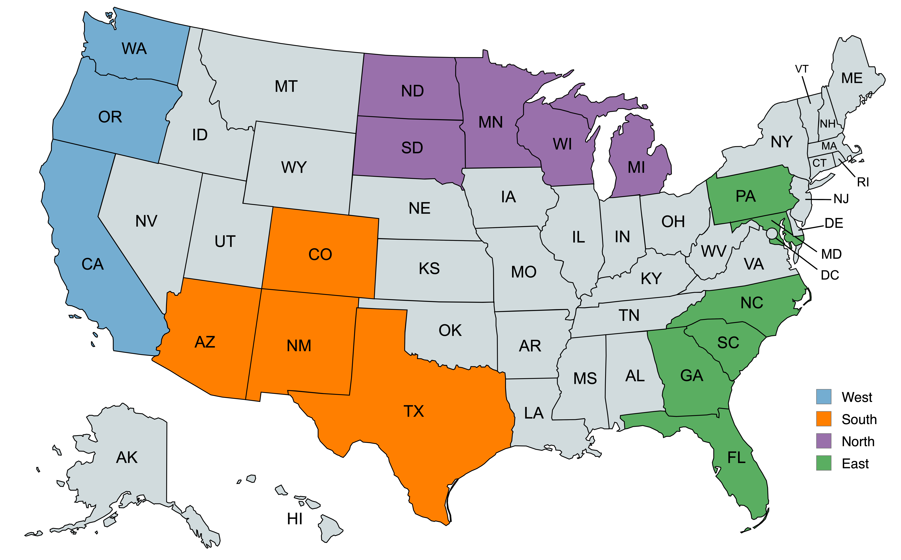

Supplementary Figure 2 Forest plot for hazard ratio and 95% CI for selected variables from multivariable regression of the T1aN0M0 gastric adenocarcinoma patients. Reference variables used to calculate the hazard ratios are available in Table 4.
