Metabolomic signatures of the steroid biosynthesis driving sex differences in clinical asthma subtypes
Authors: Gbenga Dairo^{1,2}, Rinku Sharma³, Rachel S. Kelly³, Kevin Mendez³, Michael J McGeachie³, Scott T. Weiss³, Jessica Lasky-Su^{3#}, Priyadarshini Kachroo^{2#}

¹Institute of Quantitative Biomedicine, Rutgers-The State University of New Jersey, New Brunswick, United States
²Department of Health Informatics, Rutgers School of Health Professions, Rutgers-The State University of New Jersey, Newark, United States
³Channing Division of Network Medicine, Department of Medicine, Brigham and Women’s Hospital and Harvard Medical School, Boston, Massachusetts, United States

Pre-and Post-Puberty Classification
The pubertal stage was approximated using age-based cutoffs informed by developmental literature (Cleveland Clinic, 2024). For females, prepuberty was defined as age <7 years and postpuberty as age >10 years at randomization; ages 8–9.99 years were excluded to minimize misclassification during the transitional phase. For males, corresponding cutoffs were <8 years (prepuberty) and >12 years (postpuberty), with ages 9–11 years excluded. These thresholds were selected to maximize the likelihood that participants would remain within the same pubertal category across the 4-year follow-up period. Although this approach was highly stable among males, a small proportion of females who were classified as prepubertal at randomization reached peak pubertal age by Year 4. Notwithstanding, we retained subjects in their randomization-defined stratum to preserve randomization-based classification and avoid post hoc selection bias. This strategy is conservative and may reduce statistical power in certain strata, but ensures consistent stratification anchored to baseline characteristics.

Supplementary Table 1: Characteristics by treatment status for all sex–puberty strata.
Group | Variable | Overall | No ICS | ICS
Male Pre-Puberty (Baseline) | N | 139 | 115 | 24
Male Pre-Puberty (Baseline) | Age, mean ± SD (years) | 6.6 ± 0.8 | 6.6 ± 0.8 | 6.5 ± 0.8
Male Pre-Puberty (Baseline) | BMI, mean ± SD (kg/m²) | 16.7 ± 2.3 | 16.5 ± 2.3 | 17.3 ± 2.2
Male Pre-Puberty (Baseline) | Sex, n (%) | Male: 139 (100.0%) | Male: 115 (100.0%) | Male: 24 (100.0%)
Male Pre-Puberty (Baseline) | Race/Ethnicity, n (%) | African American: 14 (10.1%); Hispanic: 12 (8.6%); Other: 11 (7.9%); White: 102 (73.4%) | African American: 12 (10.4%); Hispanic: 9 (7.8%); Other: 7 (6.1%); White: 87 (75.7%) | African American: 2 (8.3%); Hispanic: 3 (12.5%); Other: 4 (16.7%); White: 15 (62.5%)
Male Pre-Puberty (Year 4) | N | 141 | 117 | 24
Male Pre-Puberty (Year 4) | Age, mean ± SD (years) | 6.6 ± 0.8 | 6.6 ± 0.8 | 6.6 ± 0.8
Male Pre-Puberty (Year 4) | BMI, mean ± SD (kg/m²) | 19.4 ± 3.8 | 19.3 ± 3.8 | 20.3 ± 3.7
Male Pre-Puberty (Year 4) | Sex, n (%) | Male: 141 (100.0%) | Male: 117 (100.0%) | Male: 24 (100.0%)
Male Pre-Puberty (Year 4) | Race/Ethnicity, n (%) | African American: 14 (9.9%); Hispanic: 12 (8.5%); Other: 10 (7.1%); White: 105 (74.5%) | African American: 12 (10.3%); Hispanic: 9 (7.7%); Other: 7 (6.0%); White: 89 (76.1%) | African American: 2 (8.3%); Hispanic: 3 (12.5%); Other: 3 (12.5%); White: 16 (66.7%)
Male Post-Puberty (Baseline) | N | 41 | 33 | 8
Male Post-Puberty (Baseline) | Age, mean ± SD (years) | 12.6 ± 0.3 | 12.6 ± 0.3 | 12.4 ± 0.4
Male Post-Puberty (Baseline) | BMI, mean ± SD (kg/m²) | 20.6 ± 3.4 | 20.0 ± 3.2 | 23.0 ± 3.3
Male Post-Puberty (Baseline) | Sex, n (%) | Male: 41 (100.0%) | Male: 33 (100.0%) | Male: 8 (100.0%)
Male Post-Puberty (Baseline) | Race/Ethnicity, n (%) | African American: 5 (12.2%); Hispanic: 9 (22.0%); Other: 4 (9.8%); White: 23 (56.1%) | African American: 4 (12.1%); Hispanic: 4 (12.1%); Other: 3 (9.1%); White: 22 (66.7%) | African American: 1 (12.5%); Hispanic: 5 (62.5%); Other: 1 (12.5%); White: 1 (12.5%)
Male Post-Puberty (Year 4) | N | 41 | 33 | 8
Male Post-Puberty (Year 4) | Age, mean ± SD (years) | 12.6 ± 0.3 | 12.6 ± 0.3 | 12.5 ± 0.4
Male Post-Puberty (Year 4) | BMI, mean ± SD (kg/m²) | 22.6 ± 3.3 | 22.2 ± 3.1 | 24.4 ± 3.5
Male Post-Puberty (Year 4) | Sex, n (%) | Male: 41 (100.0%) | Male: 33 (100.0%) | Male: 8 (100.0%)
Male Post-Puberty (Year 4) | Race/Ethnicity, n (%) | African American: 4 (9.8%); Hispanic: 9 (22.0%); Other: 4 (9.8%); White: 24 (58.5%) | African American: 3 (9.1%); Hispanic: 4 (12.1%); Other: 4 (12.1%); White: 22 (66.7%) | African American: 1 (12.5%); Hispanic: 5 (62.5%); White: 2 (25.0%)
Female Pre-Puberty (Baseline) | N | 52 | 46 | 6
Female Pre-Puberty (Baseline) | Age, mean ± SD (years) | 6.1 ± 0.5 | 6.1 ± 0.5 | 6.3 ± 0.6
Female Pre-Puberty (Baseline) | BMI, mean ± SD (kg/m²) | 16.5 ± 2.5 | 16.5 ± 2.6 | 16.9 ± 0.9
Female Pre-Puberty (Baseline) | Sex, n (%) | Female: 52 (100.0%) | Female: 46 (100.0%) | Female: 6 (100.0%)
Female Pre-Puberty (Baseline) | Race/Ethnicity, n (%) | African American: 10 (19.2%); Hispanic: 1 (1.9%); Other: 3 (5.8%); White: 38 (73.1%) | African American: 9 (19.6%); Hispanic: 1 (2.2%); Other: 3 (6.5%); White: 33 (71.7%) | African American: 1 (16.7%); White: 5 (83.3%)
Female Pre-Puberty (Year 4) | N | 52 | 46 | 6
Female Pre-Puberty (Year 4) | Age, mean ± SD (years) | 6.1 ± 0.5 | 6.1 ± 0.5 | 6.3 ± 0.6
Female Pre-Puberty (Year 4) | BMI, mean ± SD (kg/m²) | 19.3 ± 3.5 | 19.2 ± 3.7 | 20.2 ± 2.1
Female Pre-Puberty (Year 4) | Sex, n (%) | Female: 52 (100.0%) | Female: 46 (100.0%) | Female: 6 (100.0%)
Female Pre-Puberty (Year 4) | Race/Ethnicity, n (%) | African American: 10 (19.2%); Hispanic: 1 (1.9%); Other: 3 (5.8%); White: 38 (73.1%) | African American: 9 (19.6%); Hispanic: 1 (2.2%); Other: 3 (6.5%); White: 33 (71.7%) | African American: 1 (16.7%); White: 5 (83.3%)
Female Post-Puberty (Baseline) | N | 82 | 63 | 19
Female Post-Puberty (Baseline) | Age, mean ± SD (years) | 11.3 ± 0.8 | 11.2 ± 0.8 | 11.4 ± 0.8
Female Post-Puberty (Baseline) | BMI, mean ± SD (kg/m²) | 20.3 ± 4.7 | 20.2 ± 4.7 | 20.5 ± 4.7
Female Post-Puberty (Baseline) | Sex, n (%) | Female: 82 (100.0%) | Female: 63 (100.0%) | Female: 19 (100.0%)
Female Post-Puberty (Baseline) | Race/Ethnicity, n (%) | African American: 14 (17.1%); Hispanic: 8 (9.8%); Other: 8 (9.8%); White: 52 (63.4%) | African American: 9 (14.3%); Hispanic: 6 (9.5%); Other: 6 (9.5%); White: 42 (66.7%) | African American: 5 (26.3%); Hispanic: 2 (10.5%); Other: 2 (10.5%); White: 10 (52.6%)
Female Post-Puberty (Year 4) | N | 85 | 66 | 19
Female Post-Puberty (Year 4) | Age, mean ± SD (years) | 11.3 ± 0.8 | 11.2 ± 0.8 | 11.4 ± 0.8
Female Post-Puberty (Year 4) | BMI, mean ± SD (kg/m²) | 24.2 ± 5.7 | 24.2 ± 5.7 | 24.0 ± 5.7
Female Post-Puberty (Year 4) | Sex, n (%) | Female: 85 (100.0%) | Female: 66 (100.0%) | Female: 19 (100.0%)
Female Post-Puberty (Year 4) | Race/Ethnicity, n (%) | African American: 15 (17.6%); Hispanic: 9 (10.6%); Other: 7 (8.2%); White: 54 (63.5%) | African American: 10 (15.2%); Hispanic: 6 (9.1%); Other: 6 (9.1%); White: 44 (66.7%) | African American: 5 (26.3%); Hispanic: 3 (15.8%); Other: 1 (5.3%); White: 10 (52.6%)

Sex | Metabolite | beta | SE | t | pvalue
Males | deoxycortisol | 0.089323841 | 0.133243402 | 0.67038097 | 0.503007705
Males | alphahydroxyprogesterone | 0.217505574 | 0.167065952 | 1.30191443 | 0.193706266
Males | hydroxycorticosterone | 0.001515643 | 0.133405243 | 0.0113612 | 0.990941021
Males | aldosterone | -0.017630896 | 0.280507217 | -0.0628536 | 0.949914936
Males | androstenedione | -0.060625096 | 0.16836914 | -0.3600725 | 0.718985858
Males | corticosterone | 0.07333506 | 0.11454582 | 0.64022467 | 0.522398677
Males | cortisol | 0.013808361 | 0.116964589 | 0.11805591 | 0.906083517
Males | cortisone | 0.135404883 | 0.101098554 | 1.3393355 | 0.181233564
Males | deoxycorticosterone | 0.244036135 | 0.106248509 | 2.29684292 | 0.022151543
Males | dehydroepiandrosteronesulfate | 0.052187524 | 0.043279304 | 1.20583095 | 0.228606306
Males | estradiol | 0.16880066 | 0.41079913 | 0.41090803 | 0.681363365
Males | estrone | 0.352631303 | 0.233394068 | 1.51088374 | 0.13161965
Males | estronesulfate | -0.326773019 | 0.282547901 | -1.1565225 | 0.248168224
Males | pregnenolonesulfate | 0.124506209 | 0.084115688 | 1.48017822 | 0.139624845
Males | progesterone | 0.301563564 | 0.144619682 | 2.085218 | 0.03769267
Males | testosterone | -0.172543318 | 0.242660137 | -0.7110493 | 0.47747441
Females | deoxycortisol | -0.035232263 | 0.125344131 | -0.2810843 | 0.778876419
Females | alphahydroxyprogesterone | 0.048871506 | 0.216390345 | 0.22584883 | 0.821502061
Females | hydroxycorticosterone | -0.041533981 | 0.166128828 | -0.2500107 | 0.80278278
Females | aldosterone | -0.141425282 | 0.301044372 | -0.4697822 | 0.638916902
Females | androstenedione | 0.126399618 | 0.166162983 | 0.76069661 | 0.447549476
Females | corticosterone | -0.083563661 | 0.132218153 | -0.6320135 | 0.527950991
Females | cortisol | 0.026870797 | 0.118421425 | 0.22690824 | 0.820679056
Females | cortisone | 0.213009484 | 0.107662635 | 1.97849036 | 0.048962347
Females | deoxycorticosterone | 0.06293653 | 0.126246379 | 0.49852147 | 0.618551381
Females | dehydroepiandrosteronesulfate | -0.054517436 | 0.087901272 | -0.6202121 | 0.535678574
Females | estradiol | -0.046326181 | 0.287055032 | -0.1613843 | 0.871920026
Females | estrone | -0.181018081 | 0.255609224 | -0.7081829 | 0.479486204
Females | estronesulfate | -0.314719132 | 0.295454355 | -1.0652039 | 0.287803208
Females | pregnenolonesulfate | -0.241176904 | 0.120678059 | -1.9985149 | 0.046735201
Females | progesterone | 0.213767412 | 0.764346698 | 0.27967336 | 0.779957532
Females | testosterone | 0.009567604 | 0.218269242 | 0.04383395 | 0.965071475
Supplementary Table 2: Results from testing the homogeneity of slopes assumption for ANCOVA models, stratified by sex. The interaction term (ICS x baseline metabolite) tests whether the baseline-endpoint relationship differs between treatment groups. Significant interactions (p < 0.05, bolded) indicate heterogenous slopes, violating the standard ANCOVA assumption. Non-significant interactions indicate homogenous slopes satisfying ANCOVA assumption.

Supplementary Figure 1. Longitudinal associations between ICS exposure and circulating steroid metabolites in children with asthma. (A–B) Results from the combined cohort analysis. (A) Main effect (i.e., effect at preintervention) of ICS exposure on circulating steroid metabolite levels estimated from a linear mixed model with metabolite at preintervention adjusted for. (B) Interaction effect between ICS use and time (baseline to Year 4), representing differential metabolite trajectories between ICS users and non-users, adjusted for baseline metabolite levels. (C-D) Sex-stratified analyses showing the corresponding effects in males and females. (C) Main effect of ICS exposure. (D) ICS × time interaction representing differential longitudinal changes. ** indicates p < 0.05; * indicates p < 0.10.

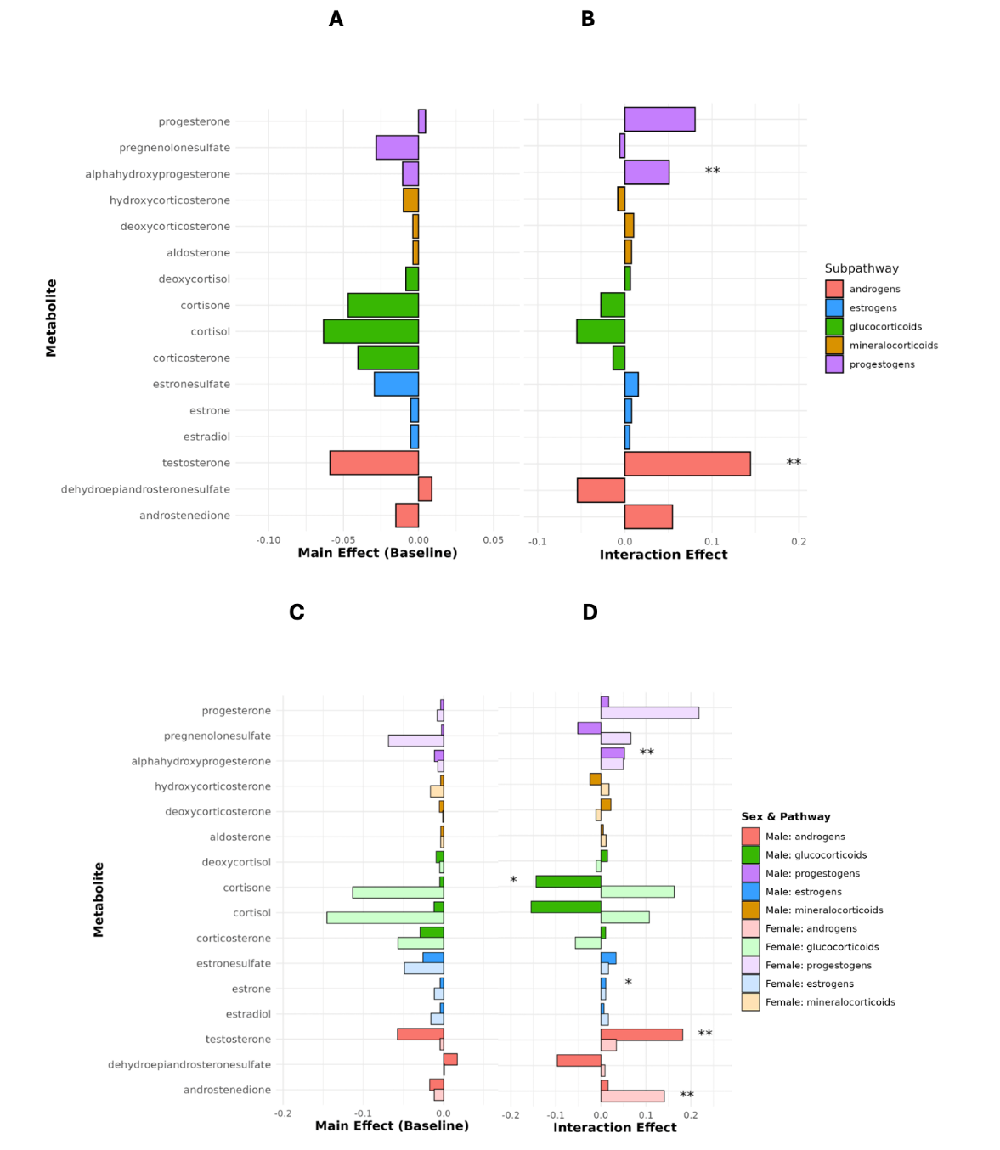

Supplementary Figure 2. Longitudinal and endpoint associations between ICS exposure and circulating steroid metabolites in males with asthma. (A&B) Mixed model results at pre-puberty without adjusting for baseline metabolite. (C&D) Mixed model results at pre-puberty, adjusted for baseline metabolite. Main effect (i.e., effect at baseline) represents the effect of ICS exposure on circulating steroid metabolite levels. Interaction effect (baseline to Year 4) represents differential metabolite trajectories between ICS users and non-users. (E) Endpoint associations at Year 4 estimated using ANCOVA models. ** indicates p < 0.05; * indicates p < 0.10.

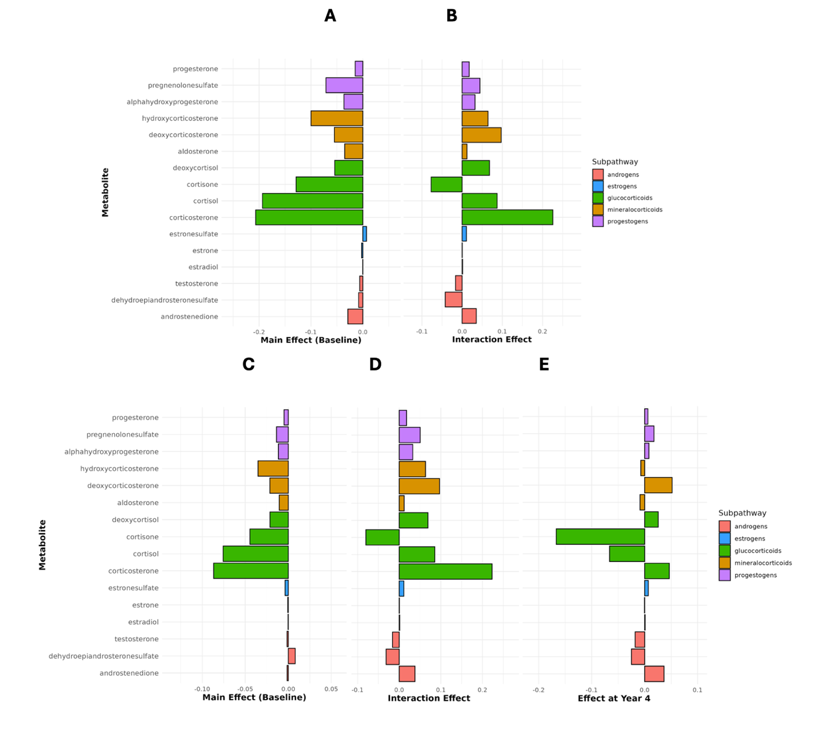

Supplementary Figure 3. Longitudinal and endpoint associations between ICS exposure and circulating steroid metabolites in females with asthma. (A&B) Mixed model results at post-puberty without adjusting for baseline metabolite. (C&D) Mixed model results at post-puberty, adjusted for baseline metabolite. Main effect (i.e., effect at baseline) represents the effect of ICS exposure on circulating steroid metabolite levels. Interaction effect (baseline to Year 4) represents differential metabolite trajectories between ICS users and non-users. (E) Endpoint associations at Year 4 estimated using ANCOVA models. ** indicates p < 0.05; * indicates p < 0.10.
