Supplementary Figure 1 – Response statistics for psychometric items

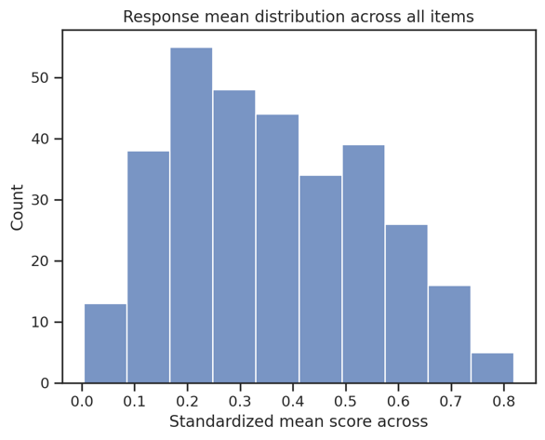
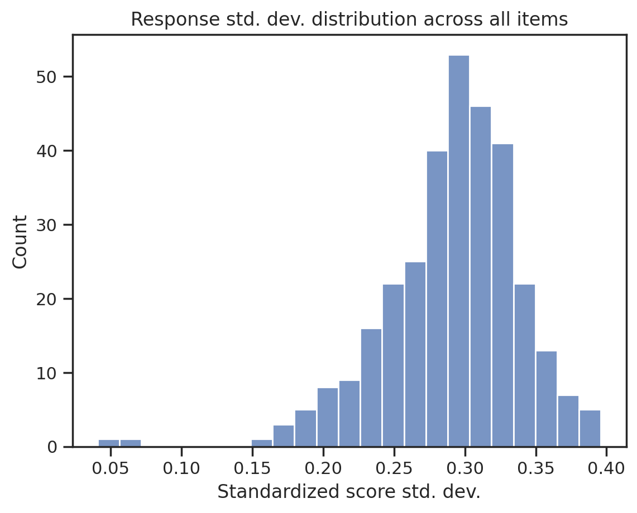
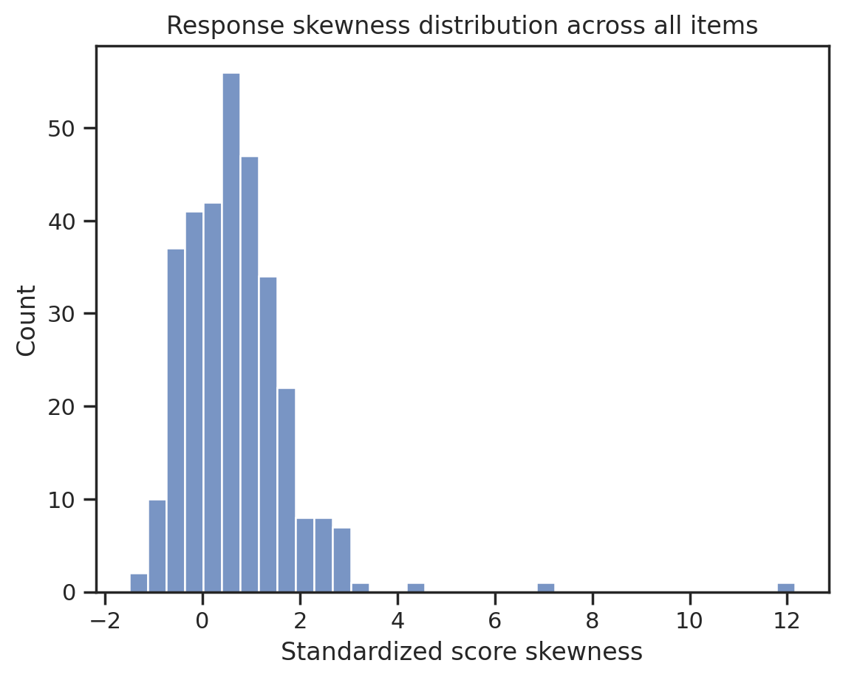
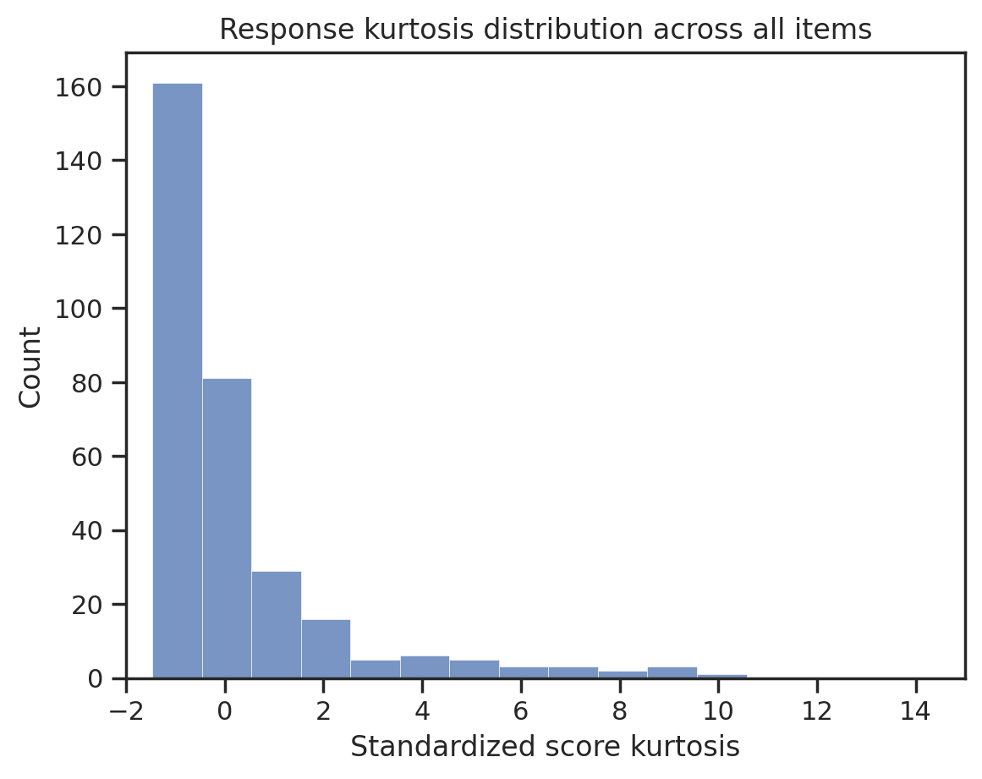
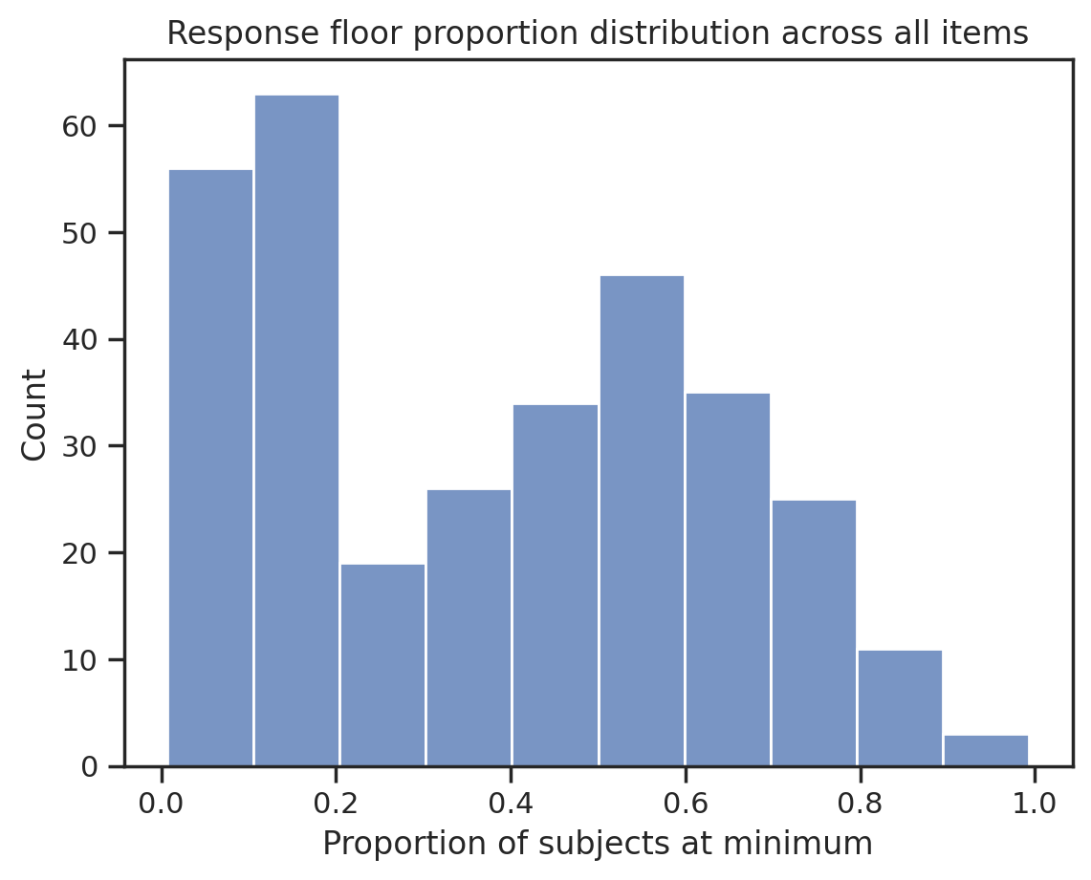
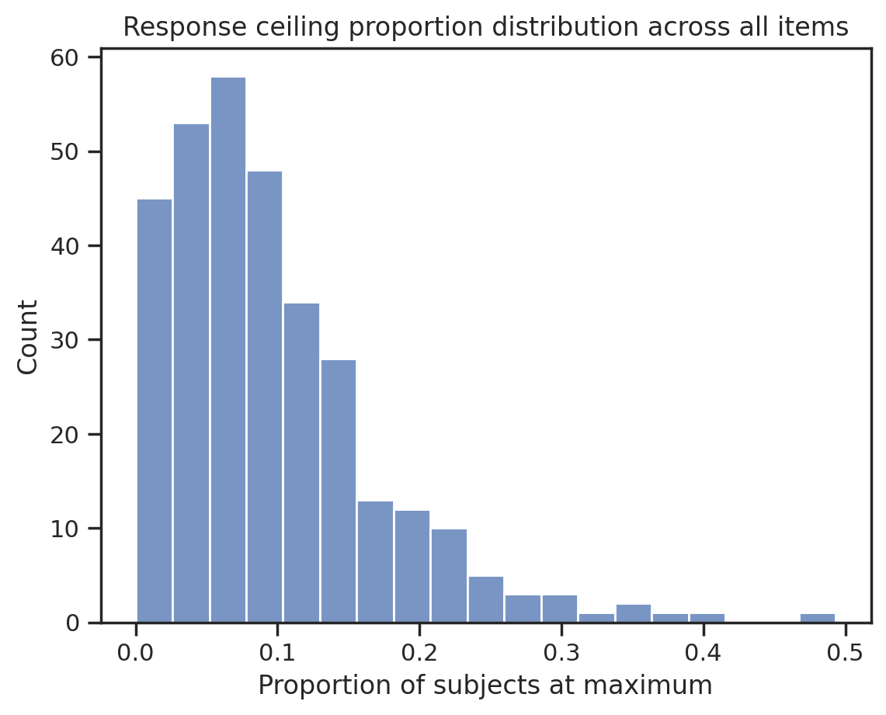
Supplementary Figure 1 — Standardized response metrics across all psychometric items (318 total). a) Response means. b) Response standard deviation. c) Response skewness. d) Response kurtosis (scale truncated for visualization, see Supplementary Table 3). e) Proportion of participants responding at minimum. f) Proportion of participants responding at maximum.
a)
b)
c)
d)
e)
f)

Supplementary Figure 2 – Functional connectivity predictive power not driven by item response variation using either whole-brain or functional networks

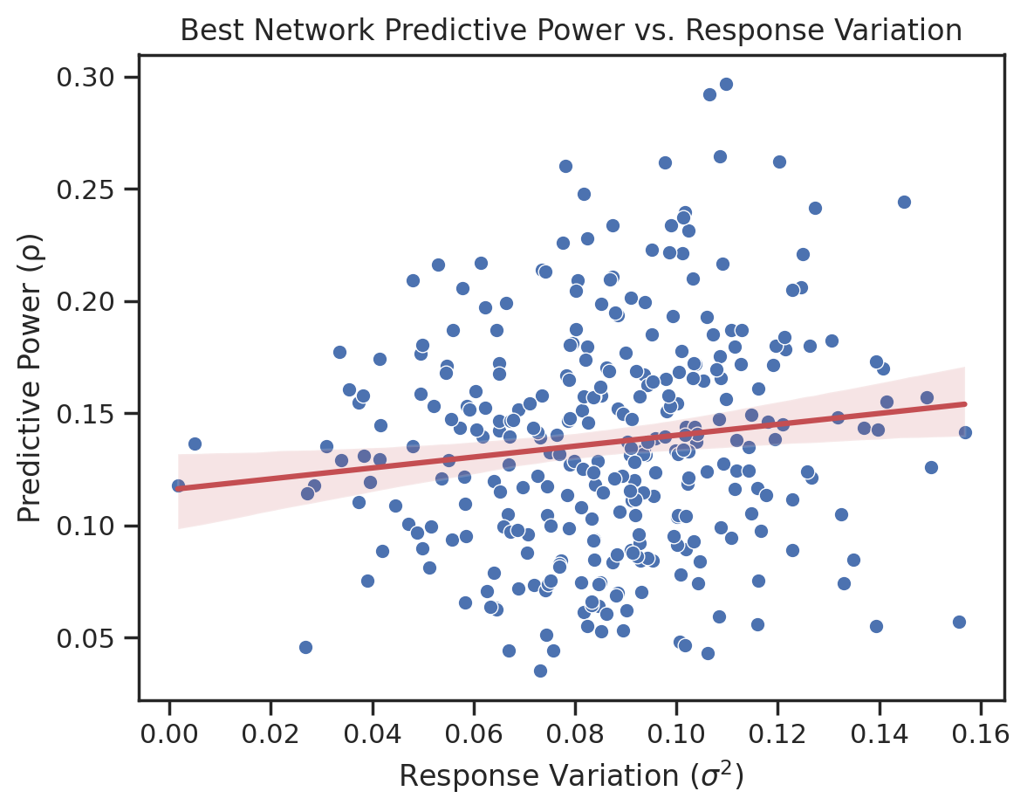
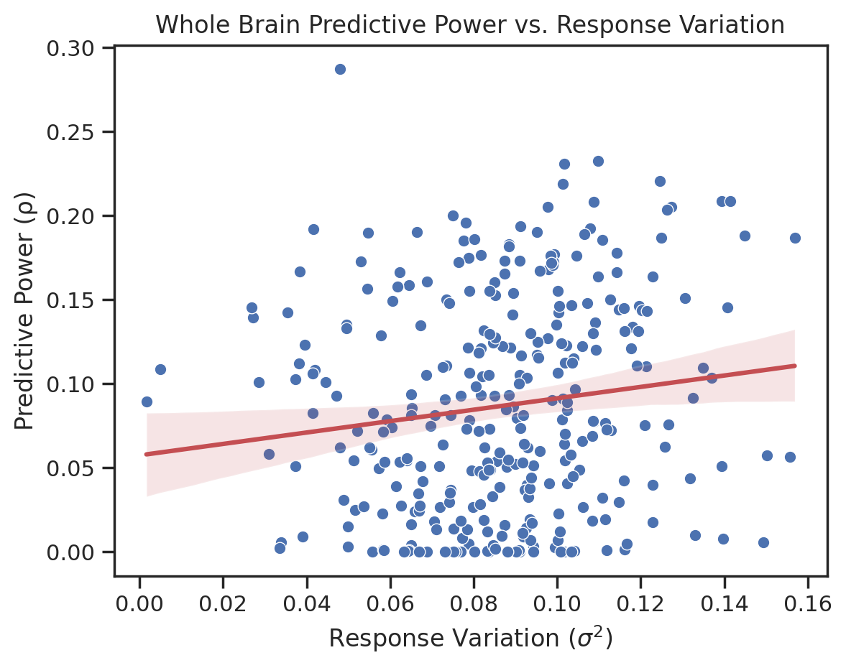
r² = 0.02
r² = 0.02
b)
a)
Supplementary Figure 2 — Correlation of psychometric item response variation with kernel ridge regression (KRR) predictive power. a) Best-network predictive power as a function of score variation for each item. b) Whole-brain predictive power as a function of score variation for each item. Correlation strength reported as the coefficient of determination (r²).

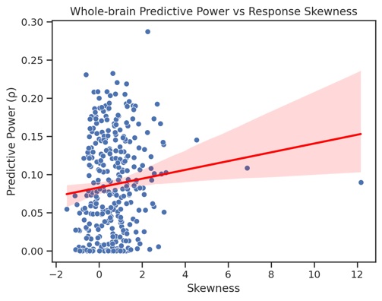
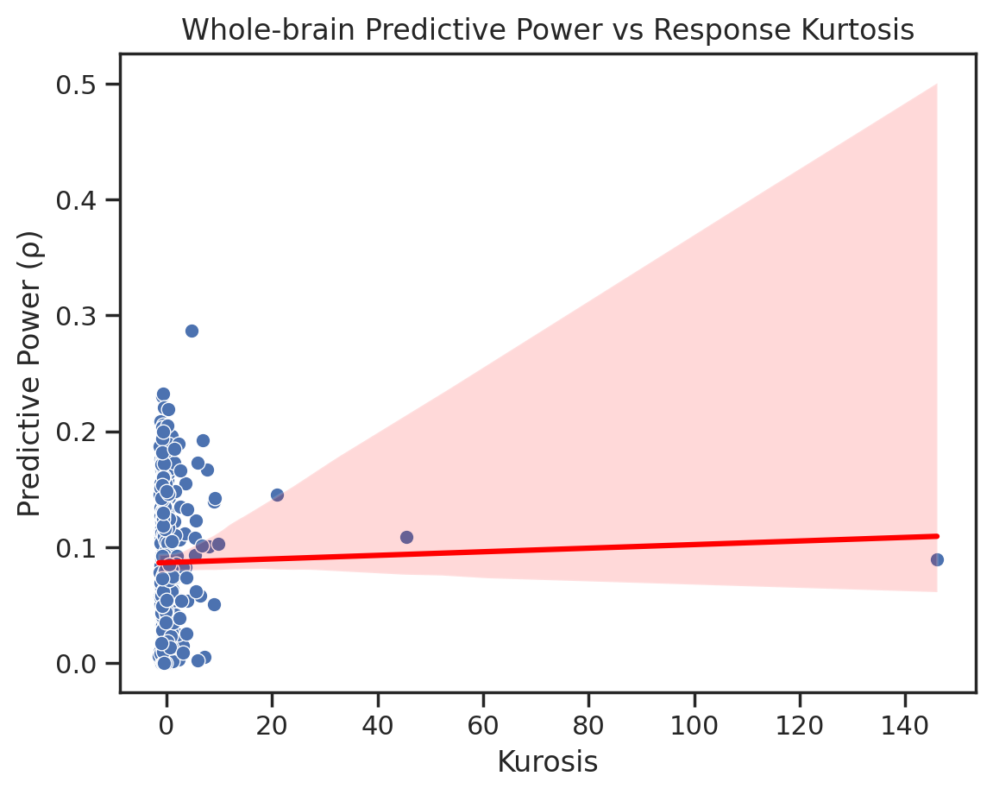
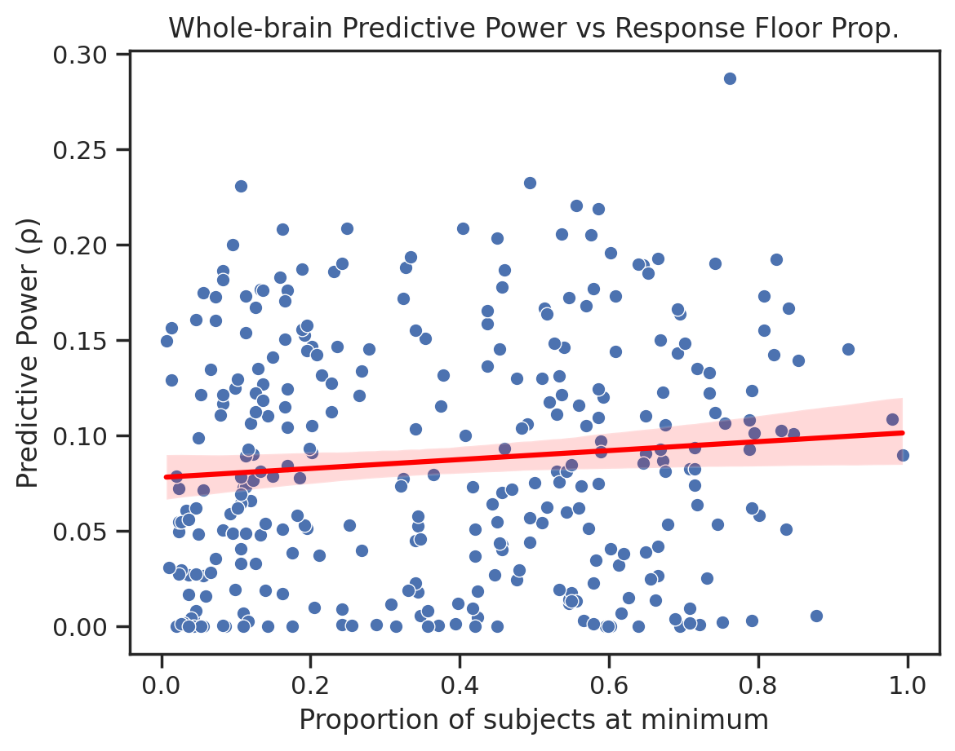
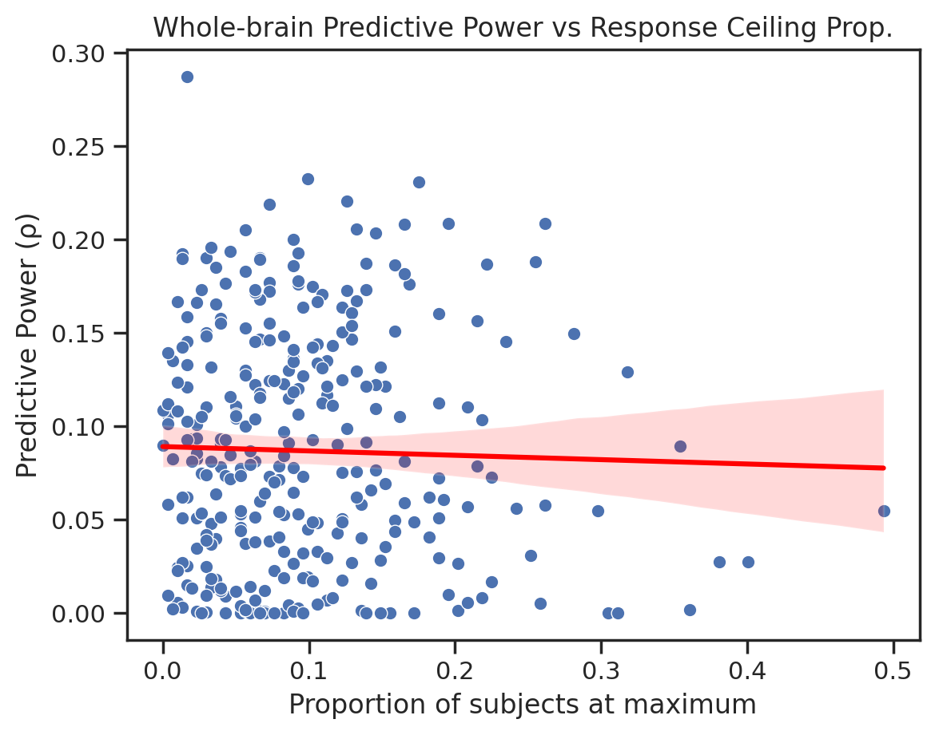
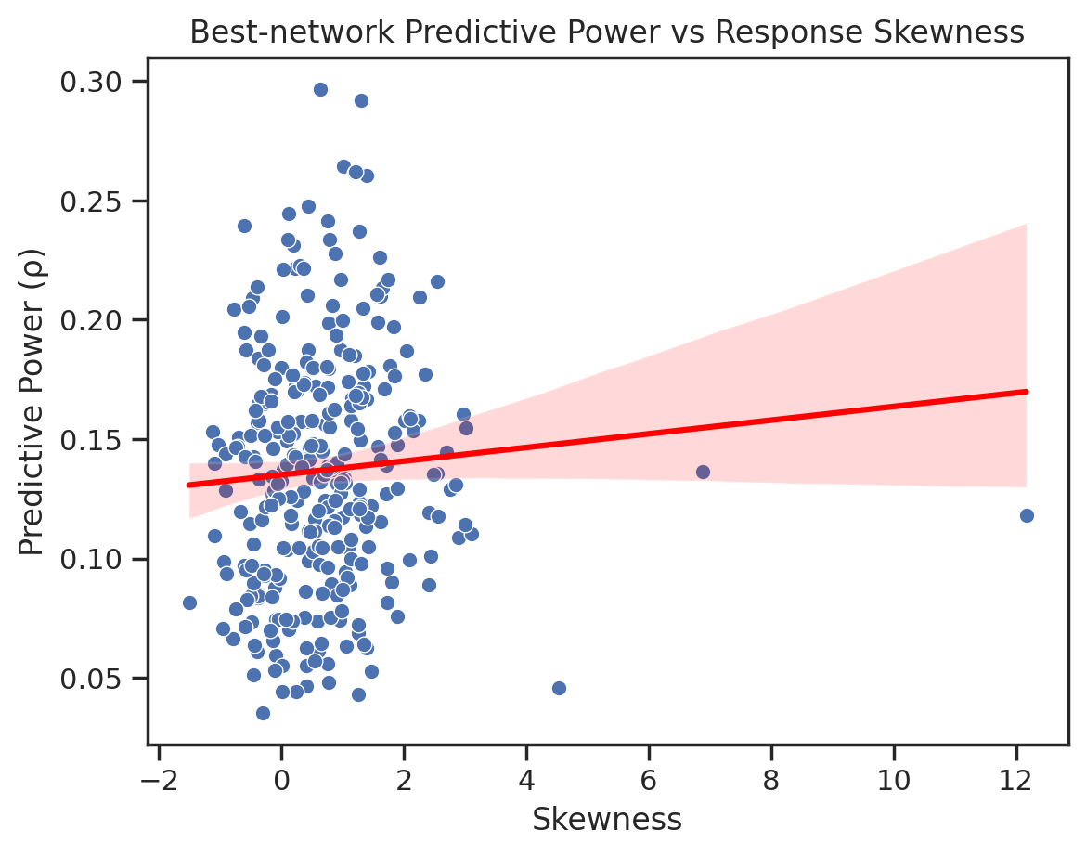
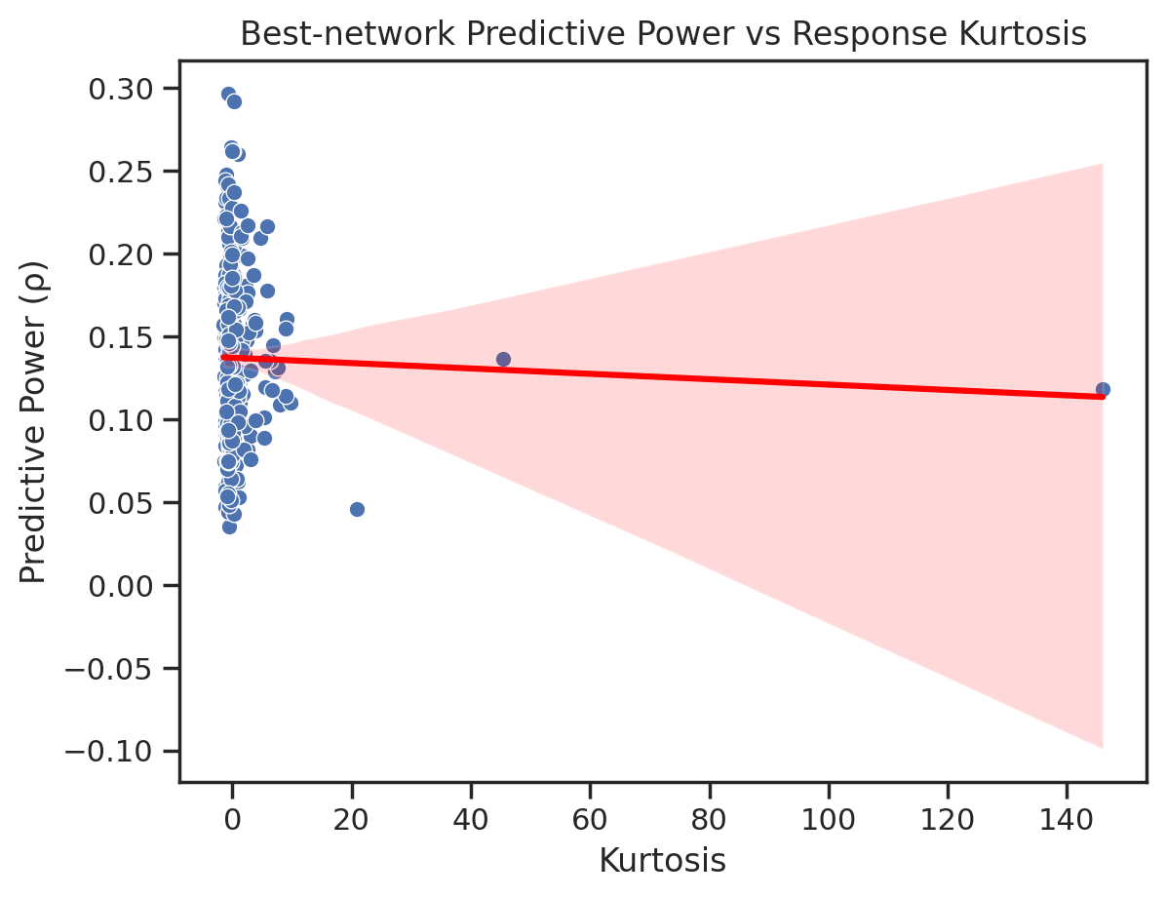
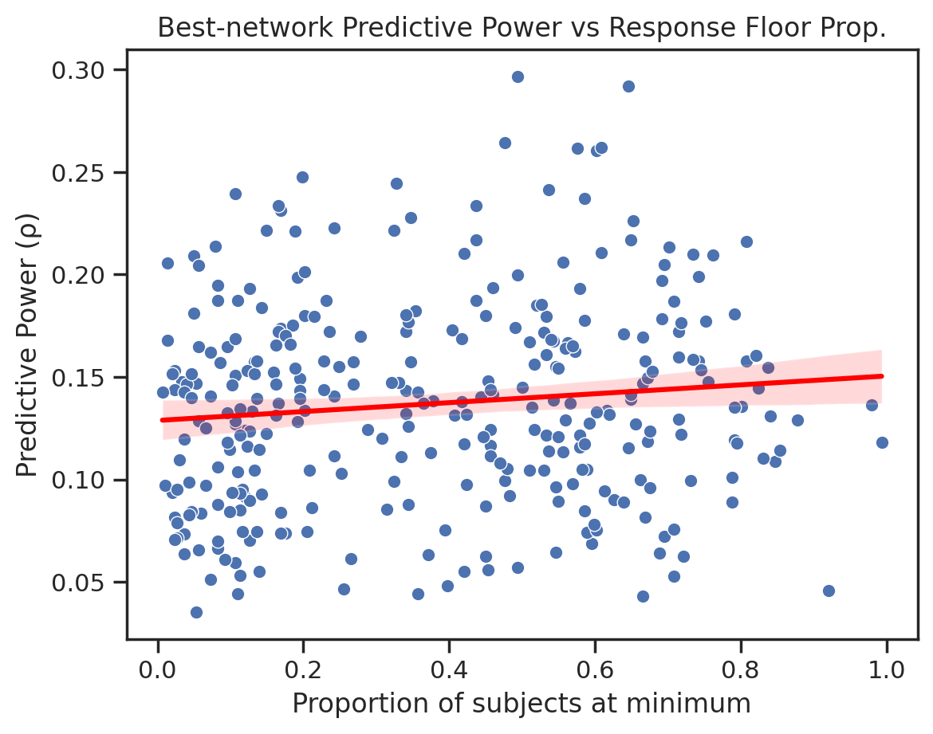
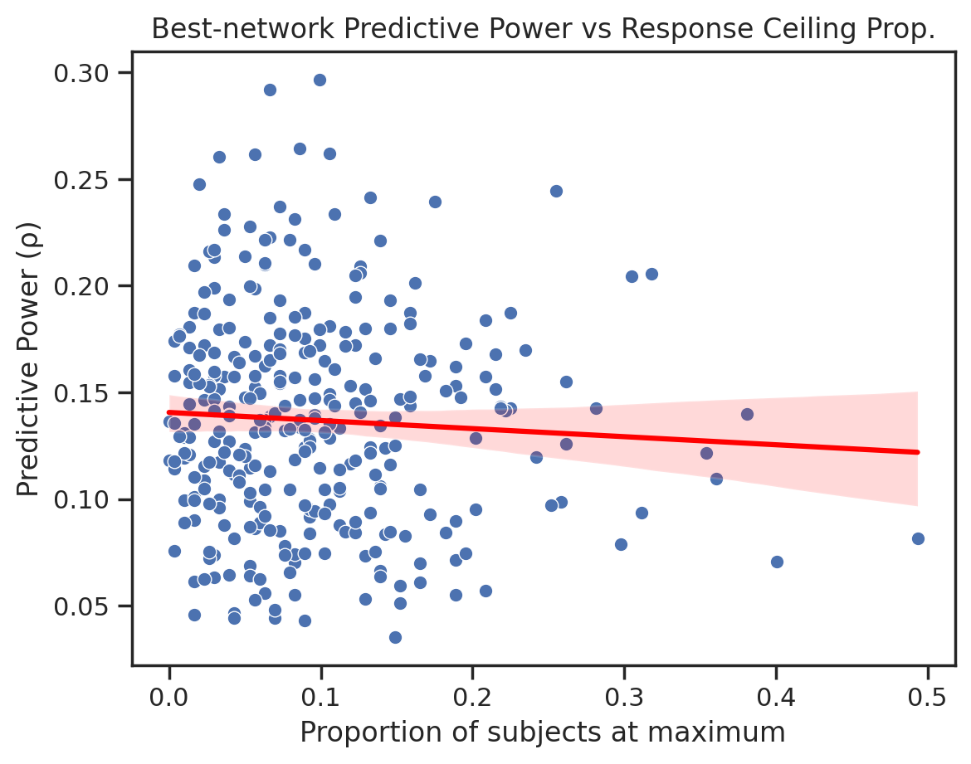
Supplementary Figure 3 – Functional connectivity predictive power not driven by item response statistics using either whole-brain or functional networks
a)
b)
c)
d)
r² < 0.01
r² < 0.01
r² < 0.01
r² < 0.01
r² < 0.01
r² < 0.01
r² < 0.01
r² = 0.03

Supplementary Figure 3 — Kernel Ridge Regression (KRR) predictive power relationships with psychometric item response statistics for whole-brain and best-network predictions. a) Response skewness versus whole-brain and best-network predictive power for each item. b) Response kurtosis versus predictive power. c) Proportion of participants responding at minimum (floor) value versus predictive power. d) Proportion of participants responding at maximum (ceiling) value versus predictive power.

Supplementary Figure 4 – Prediction of symptom-based composite scales improve with more predictable items but not item multicollinearity
a)
b)
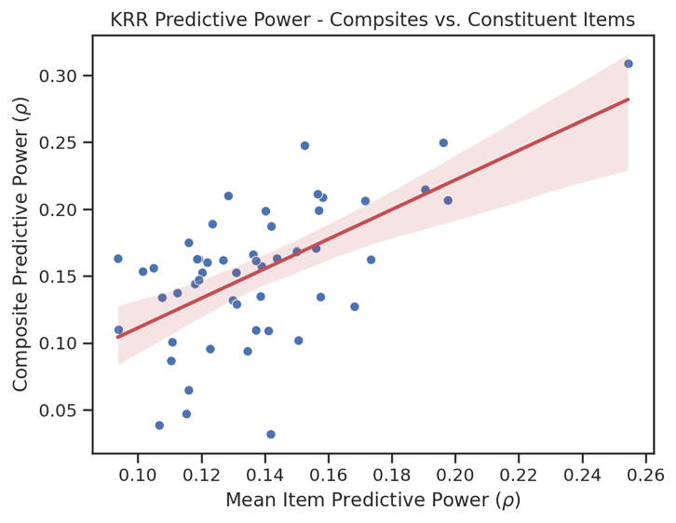
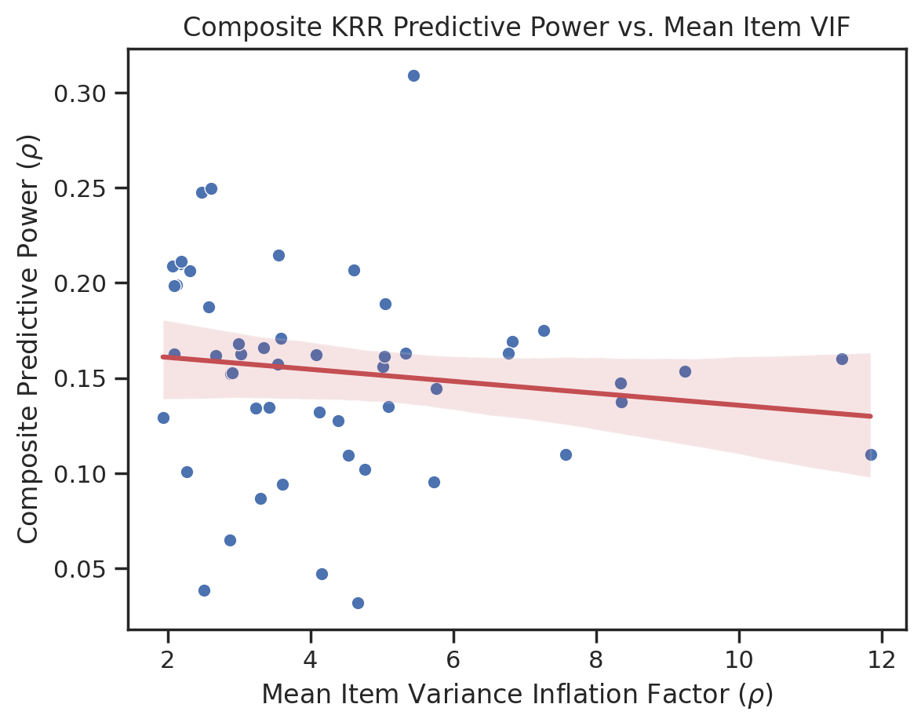
r² = 0.38
r² = 0.19

Supplementary Figure 4 — Relationship of symptom-based composite prediction power (best-network) with constituent items statistics. Coefficient of determination reported (r²). a) Power to predict symptom composite scores (best-network) as a function of the mean power to predict across constituent items. b) Best-network power to predict composite scores as a function of constituent item multicollinearity (mean variance inflation factor).

Supplementary Figure 5 – Predictive power curves of whole-brain and functional network connectivity across all items

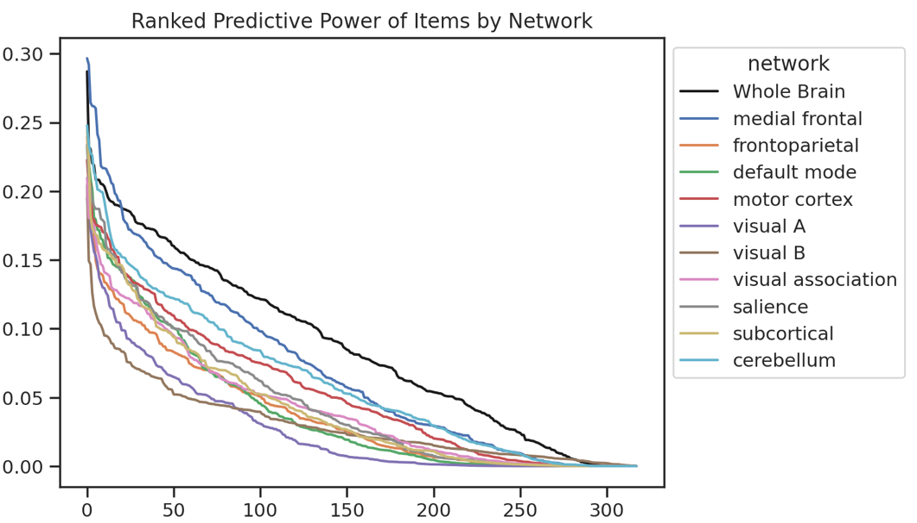
Item Rank
KRR predictive power (ρ)

Supplementary Figure 5 — Kernel ridge regression (KRR) predictive power rank curves for whole-brain and functional network connectivity. Item rank represents the order of items from highest to lowest predictive power on a per-network basis.

Supplementary Figure 6 – Ranking of psychometric item predictive power is unique to different functional networks

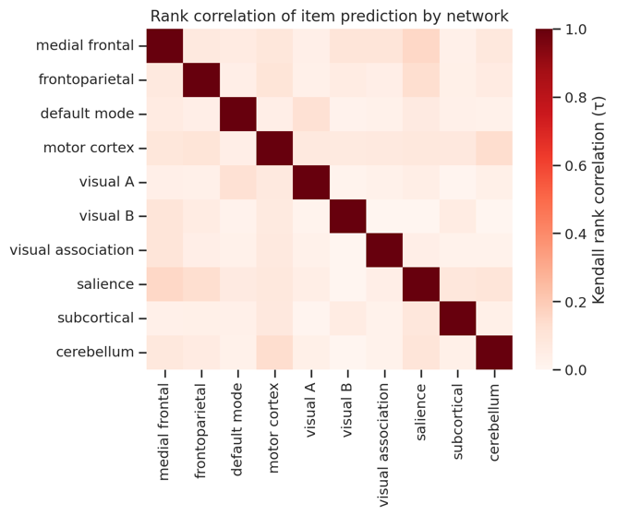
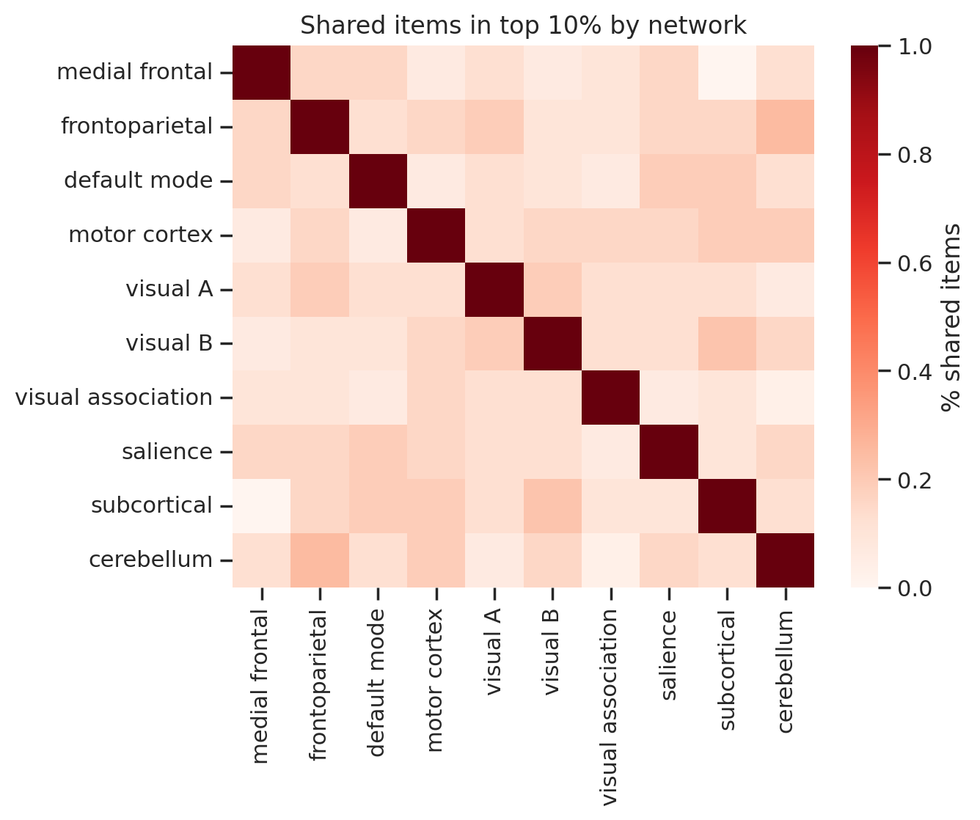
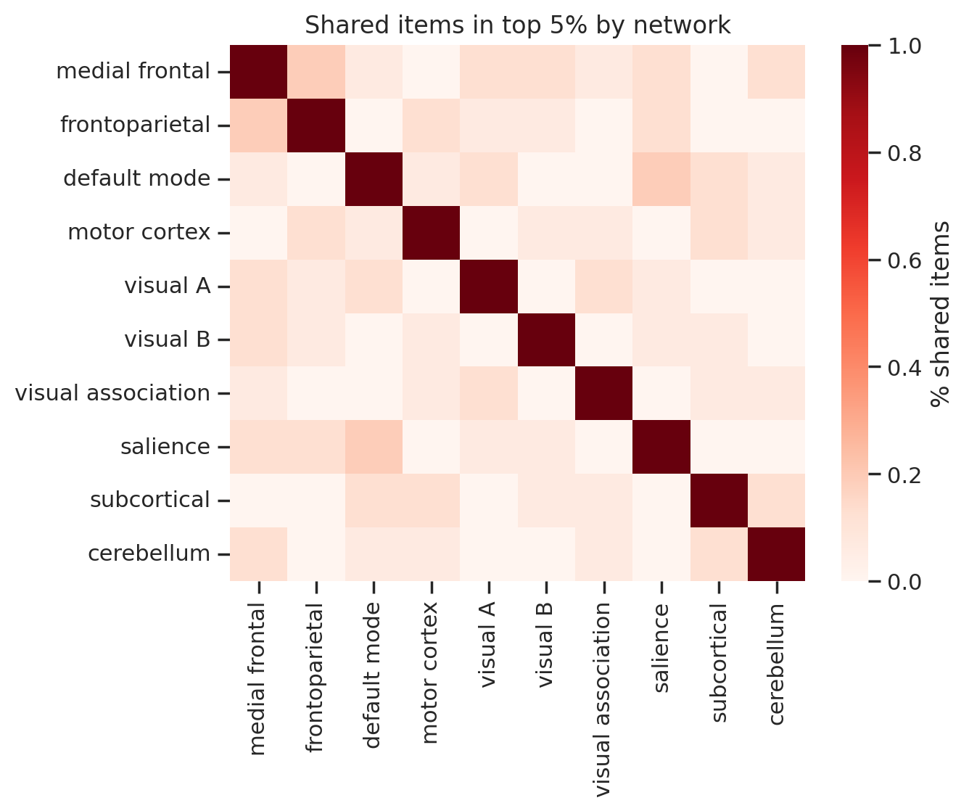
a)
b)
c)
Supplementary Figure 6 — Rank similarity of psychometric item kernel ridge regression (KRR) predictive power across functional networks. a) Pairwise comparison of Kendall’s rank correlation of ranked item predictive power by each functional network. b) Percent of items shared between networks in top 5% highest ranking items by predictive power. c) Percent of items shared between networks in top 10% highest ranking items by predictive power.

Supplementary Figure 7 – Predictive power of functional networks on composites constructed from top-ranked items does not improve with item multicollinearity
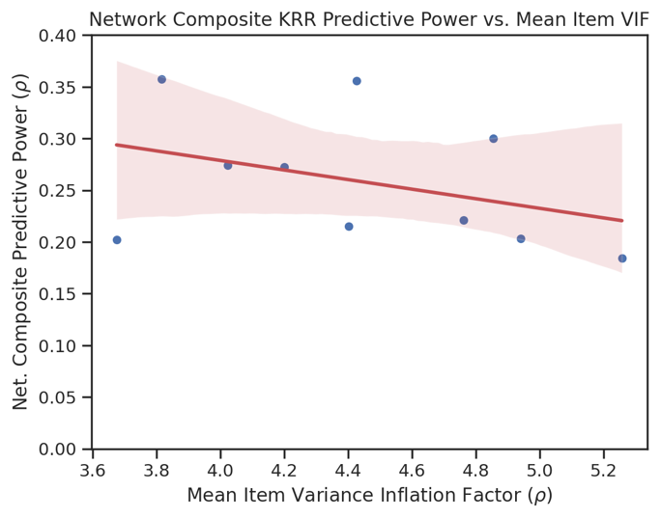
r² = 0.14

Supplementary Figure 7 — Kernel ridge regression (KRR) predictive power of functional networks to predict network-based composites (aggregated top 10 ranked items) as a function of item multicollinearity (mean variance inflation factor). Correlation strength reported as the coefficient of determination (r²).

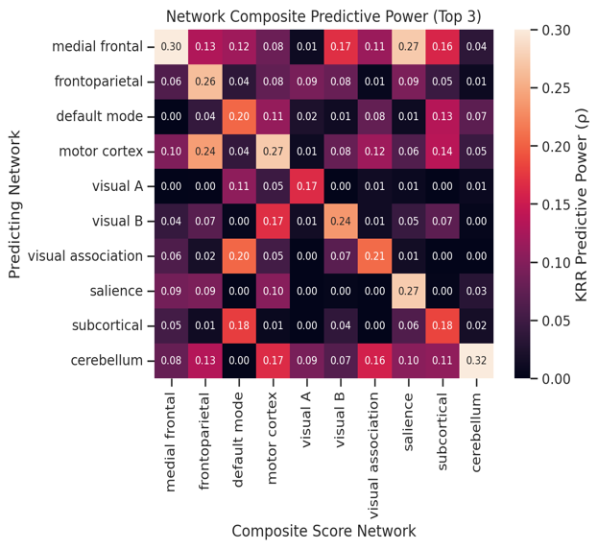
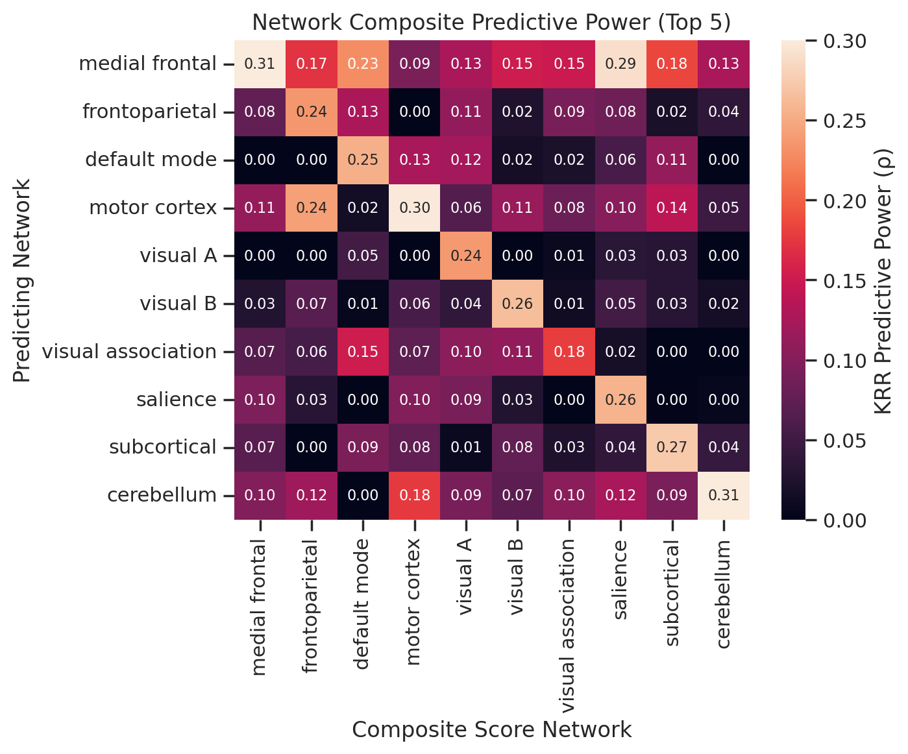
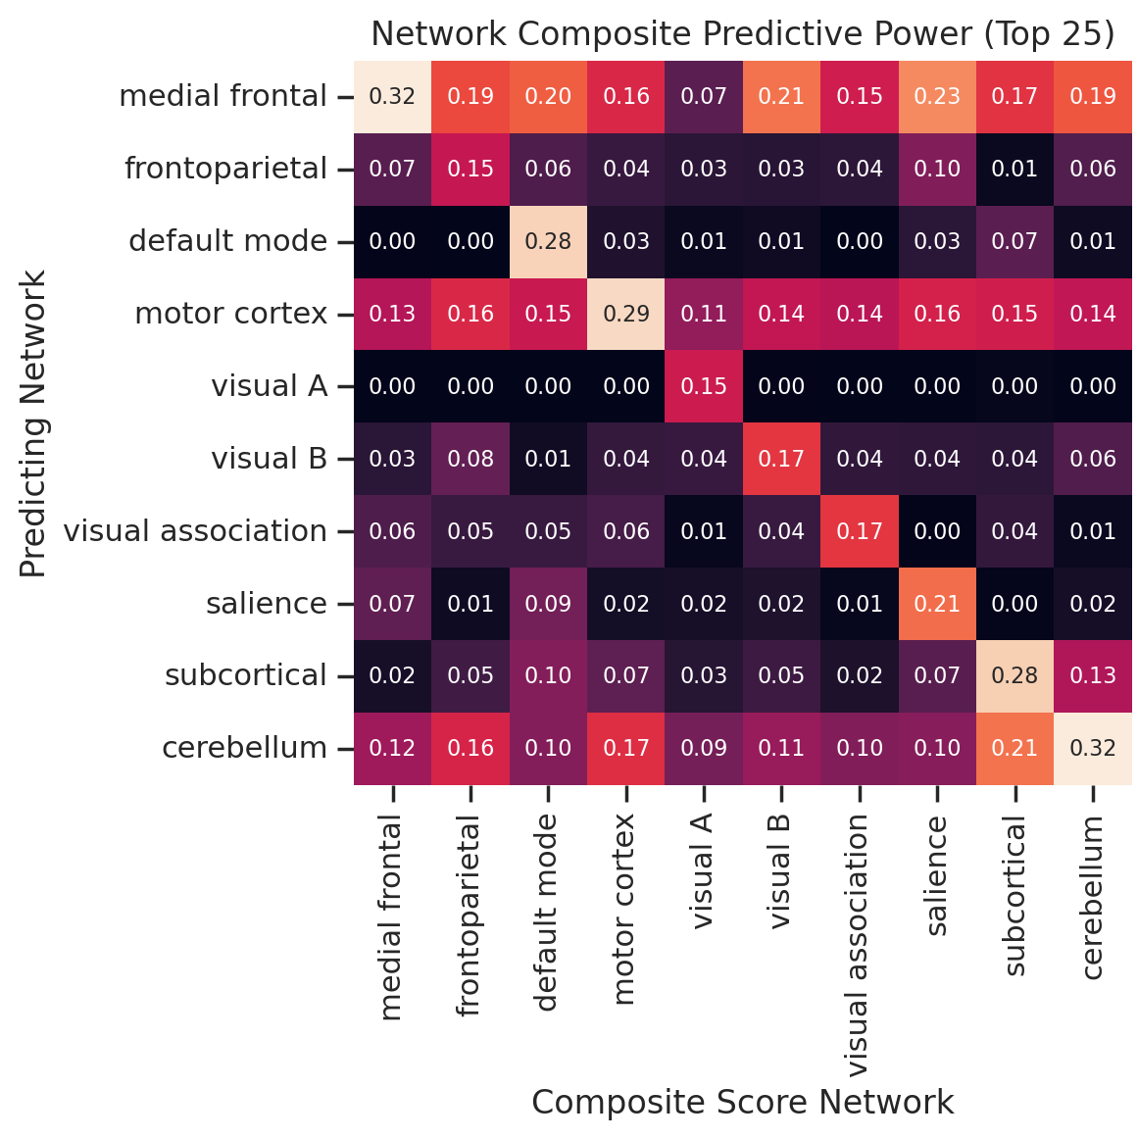
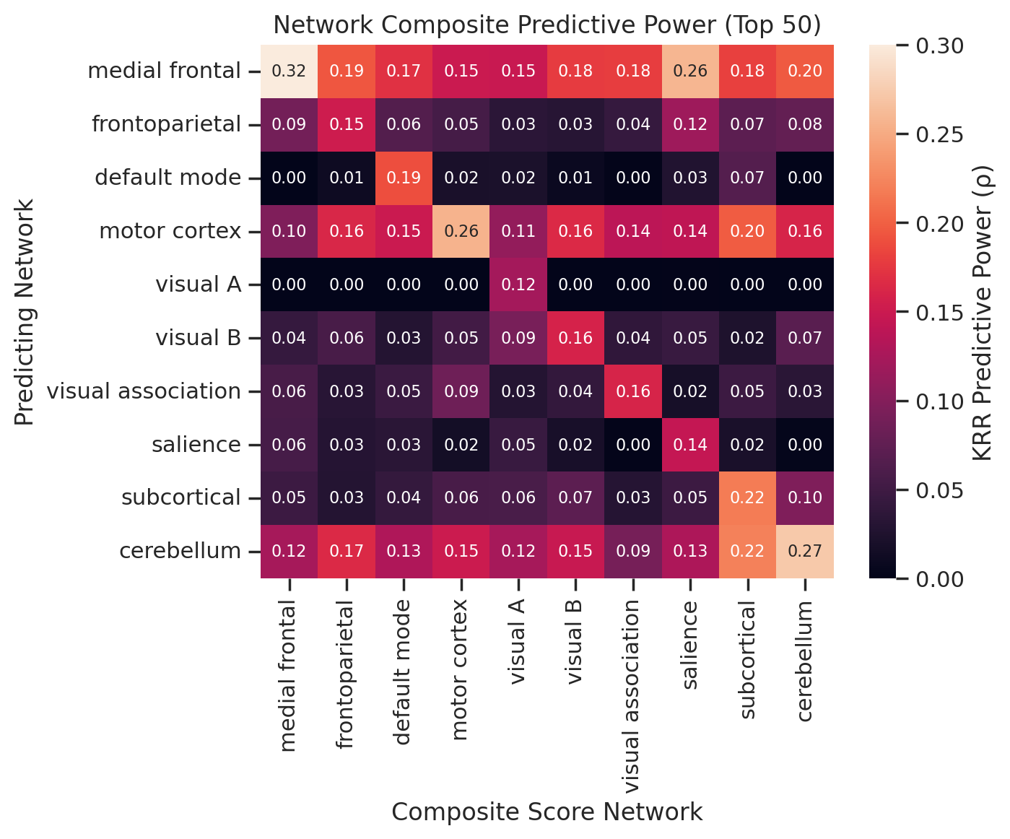
Supplementary Figure 8 – Pairwise comparison of functional networks predicting composite scores of top-ranked items

Supplementary Figure 8 — Pairwise comparison of kernel ridge regression (KRR) predictive power across functional networks. Networks predict composite scores of top-ranking items (top 3, 5, 25, and 50 items ranked by predictive power).

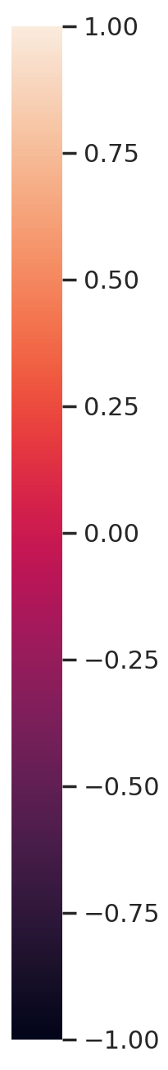
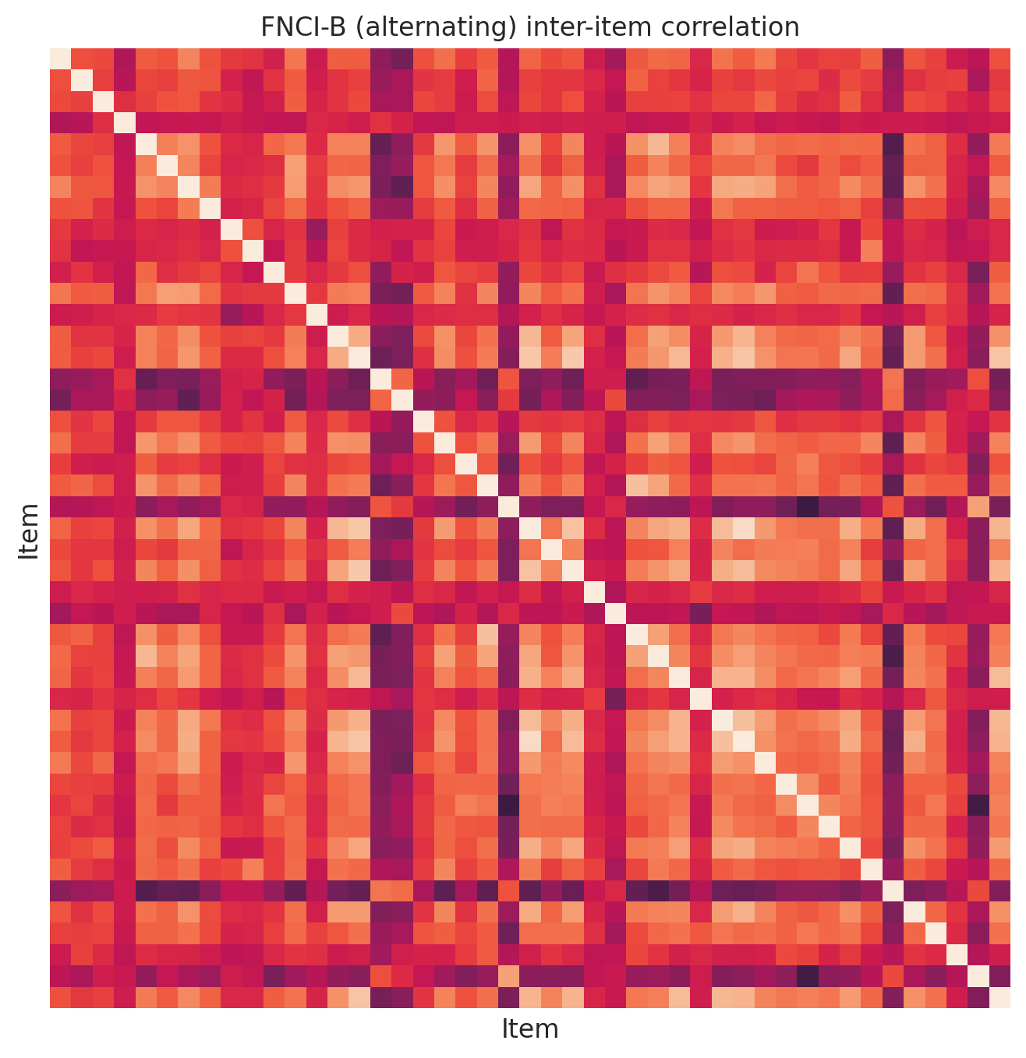
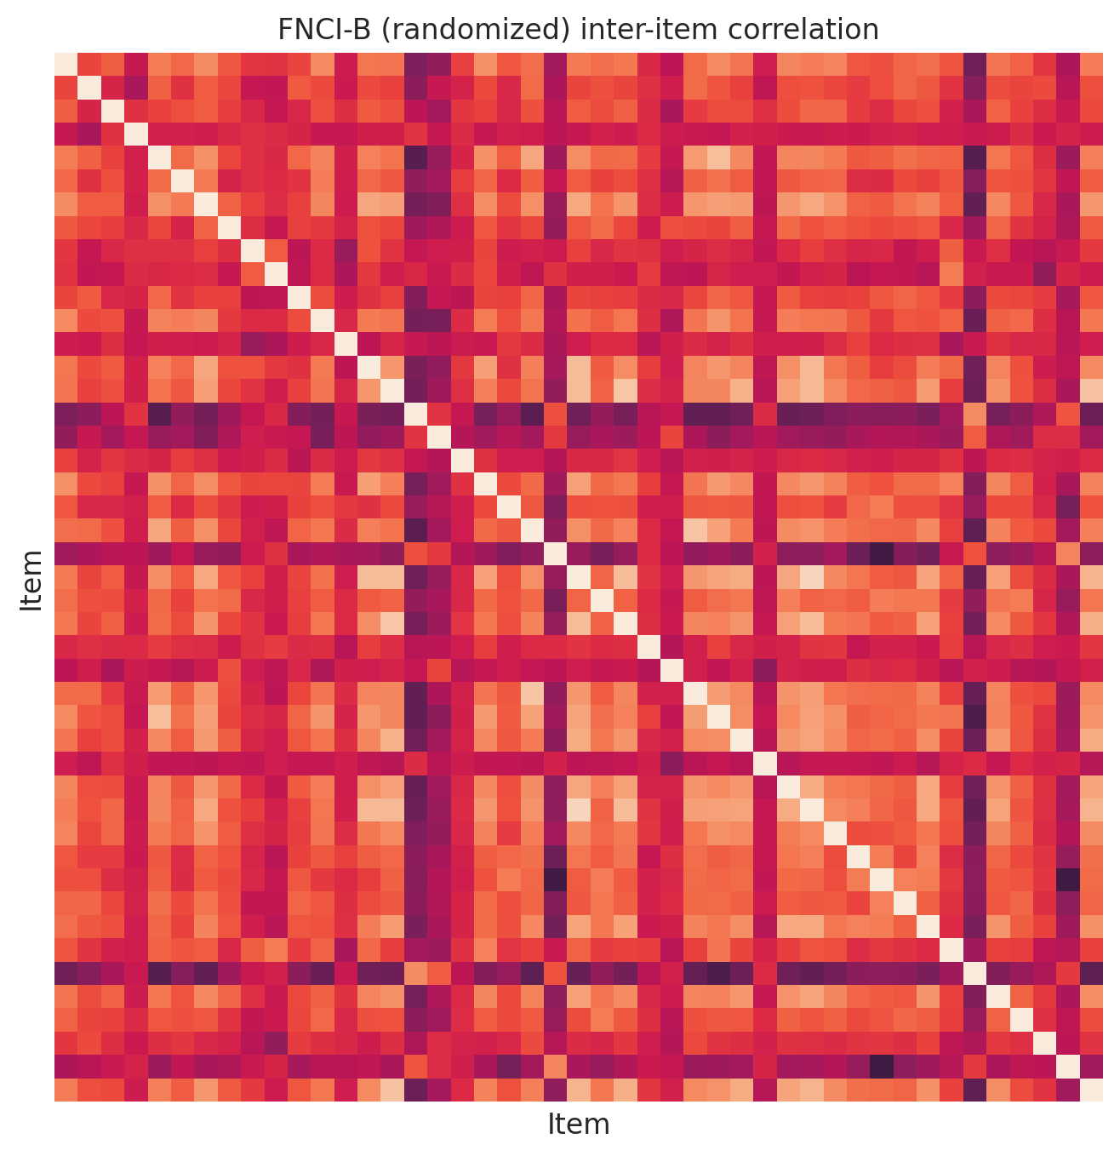
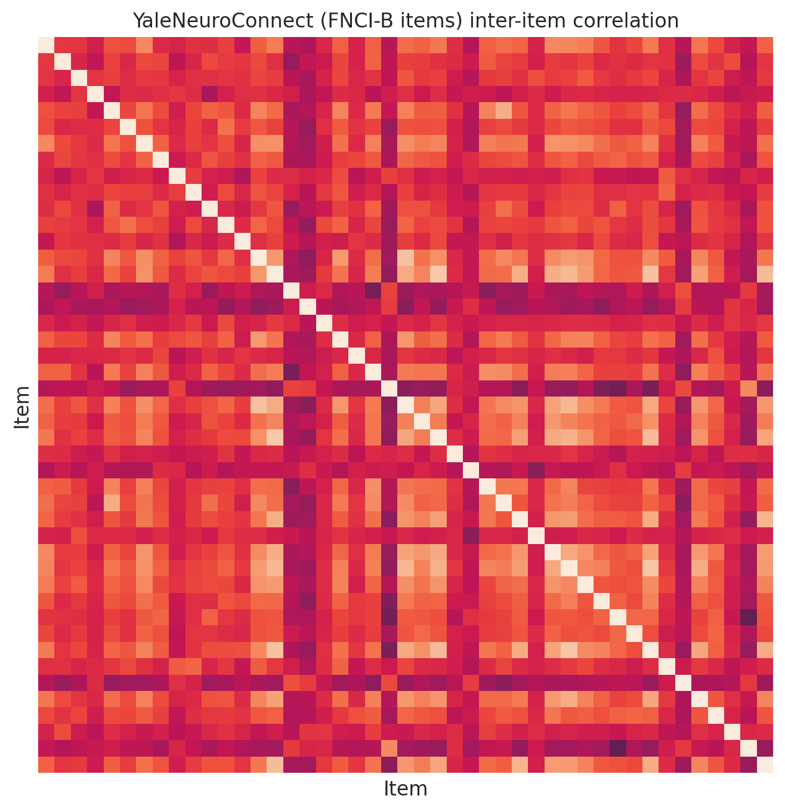
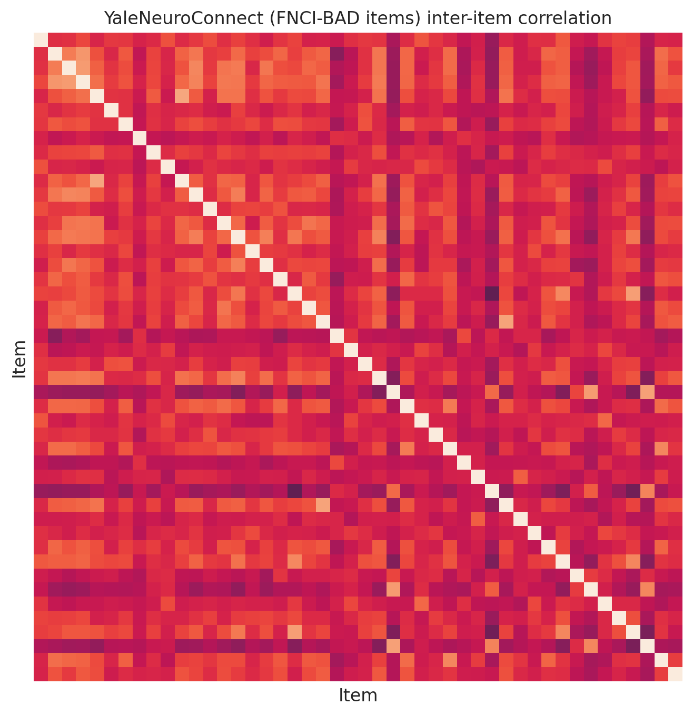
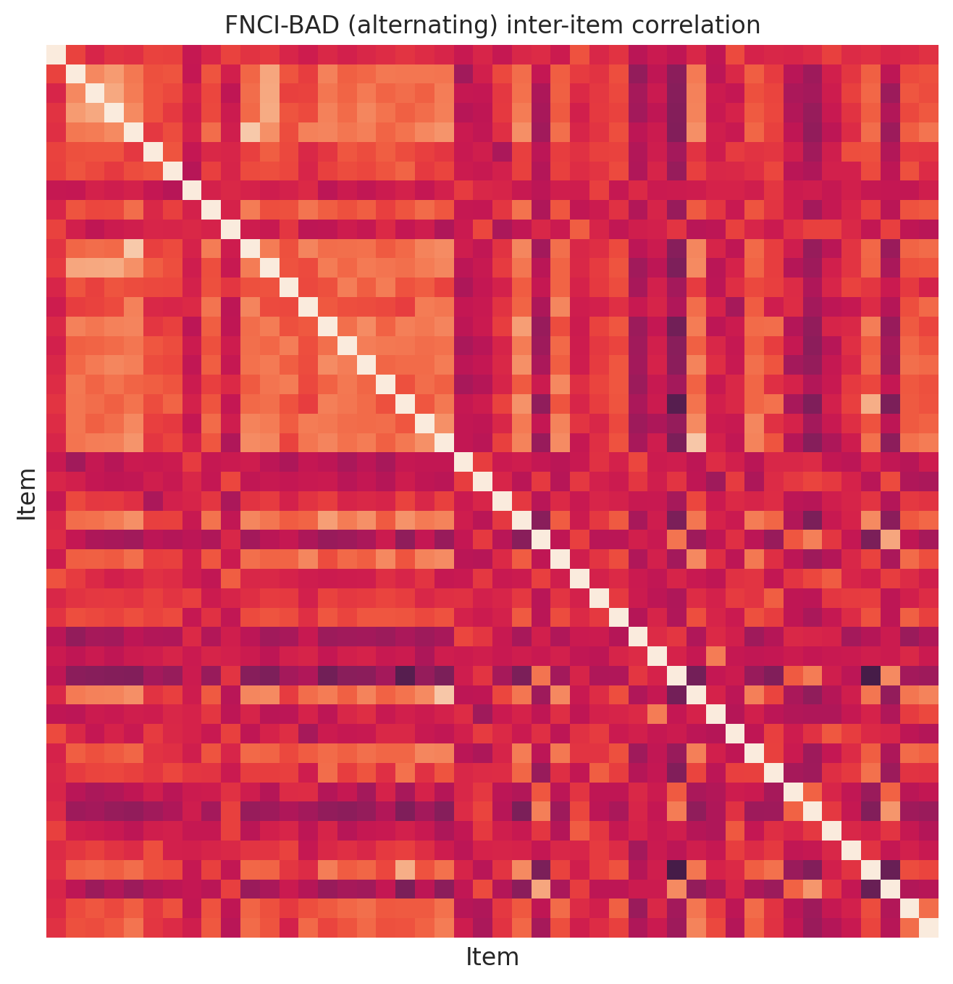
Supplementary Figure 9 – Functional Network Connectivity Index inter-item correlation structure across groups
Pearson Correlation
a)
b)
c)
d)
e)

Supplementary Figure 9 — Correlation structure of item responses within the Functional Network Connectivity Index – Brief (FNCI-B) and control test (FNCI-BAD) across administration groups. a) FNCI-B inter-item correlations in the YaleNeuroConnect (YNC) dataset. b) FNCI-B inter-item correlations for online administration with alternating item order. c) FNCI-B inter-item correlations for online administration with randomized item order. d) FNCI-BAD inter-item correlations in the YNC dataset. e) FNCI-BAD inter-item correlations for online administration with alternating item order.

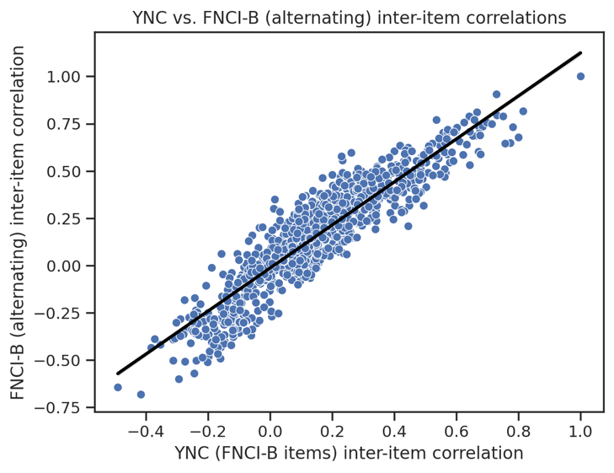
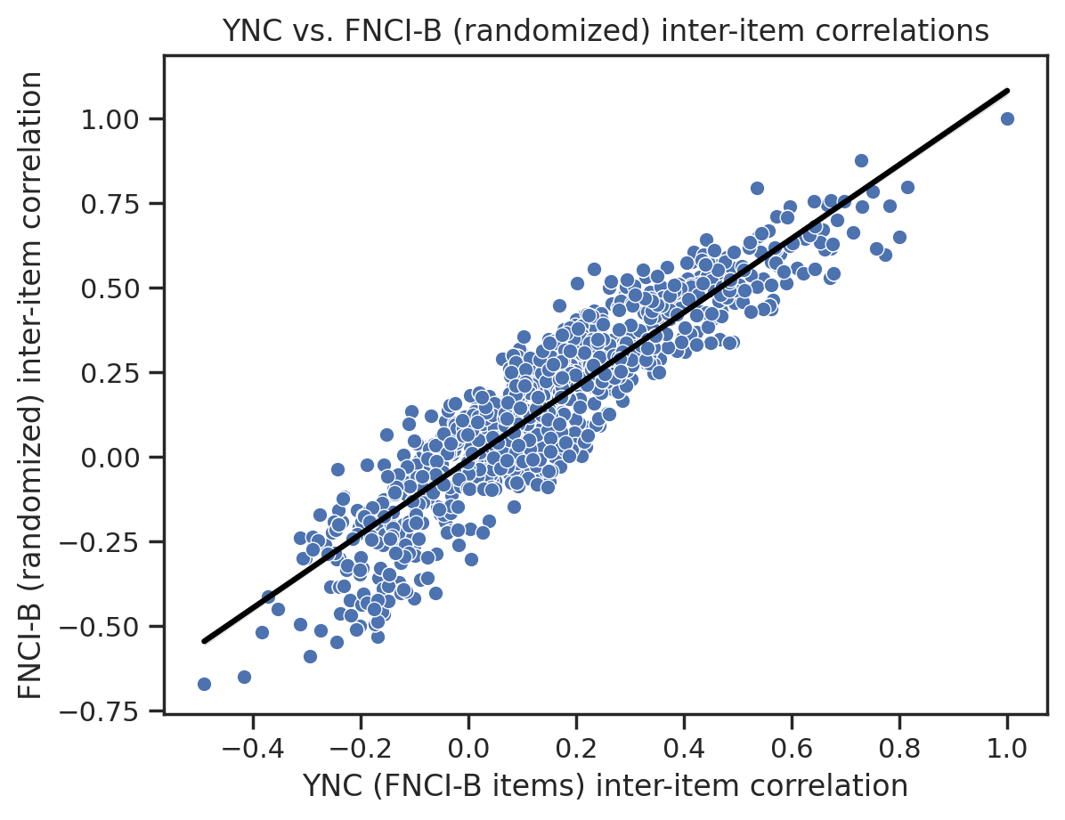
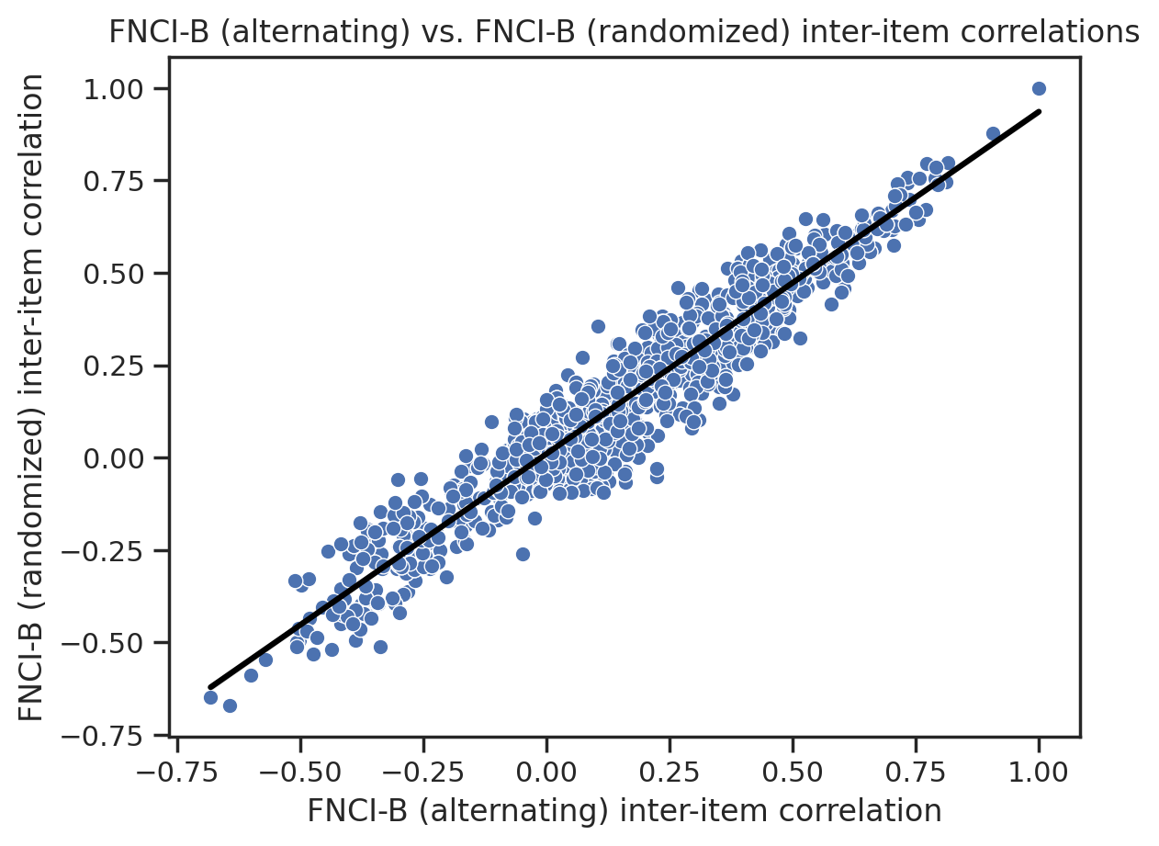
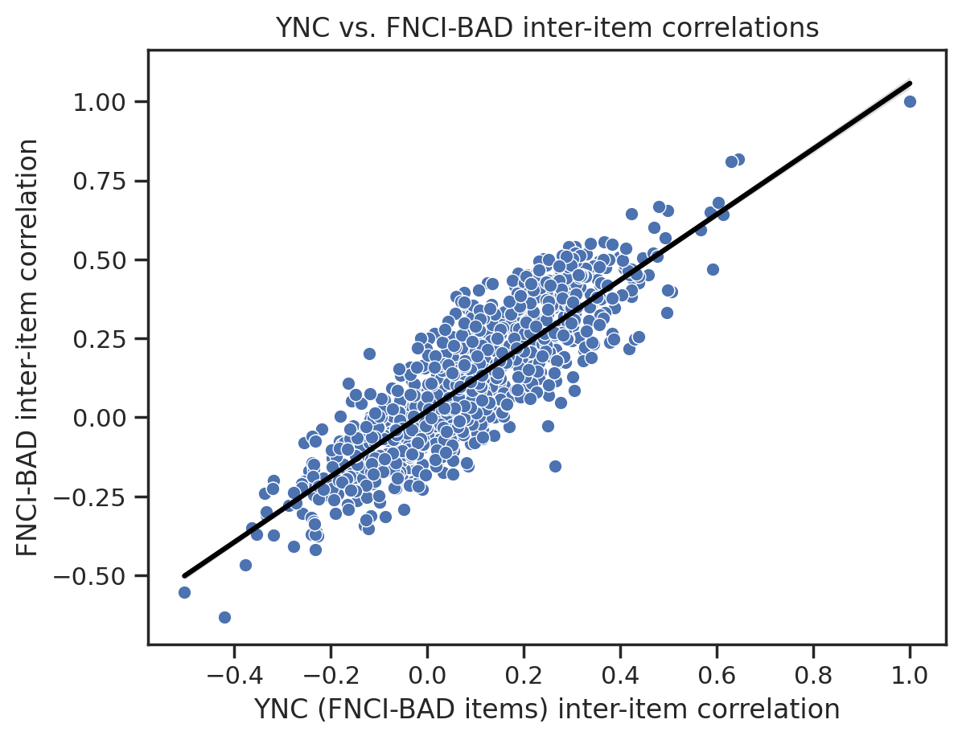
Supplementary Figure 10 – Functional Network Connectivity Index inter-item correlation is highly correlated across groups
r² = 0.87
r² = 0.86
r² = 0.93
r² = 0.81
a)
b)
c)
d)

Supplementary Figure 10 — Comparison of item response correlation structures across administration groups. a) Inter-item correlation of FNCI-B items in the YaleNeuroConnect (YNC) dataset versus in the online group (alternating item order). b) Inter-item correlation of FNCI-B items in the YNC dataset versus in the online group (randomized item order). c) Inter-item correlation of FNCI-B items in the online group with alternating order versus randomized order. d) Inter-item correlations of FNCI-BAD items in the YNC dataset vs online group (alternating item order). Correlation strength reported as the coefficient of determination (r²).

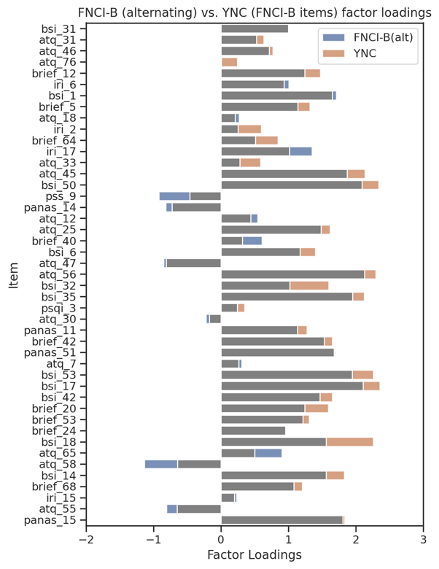
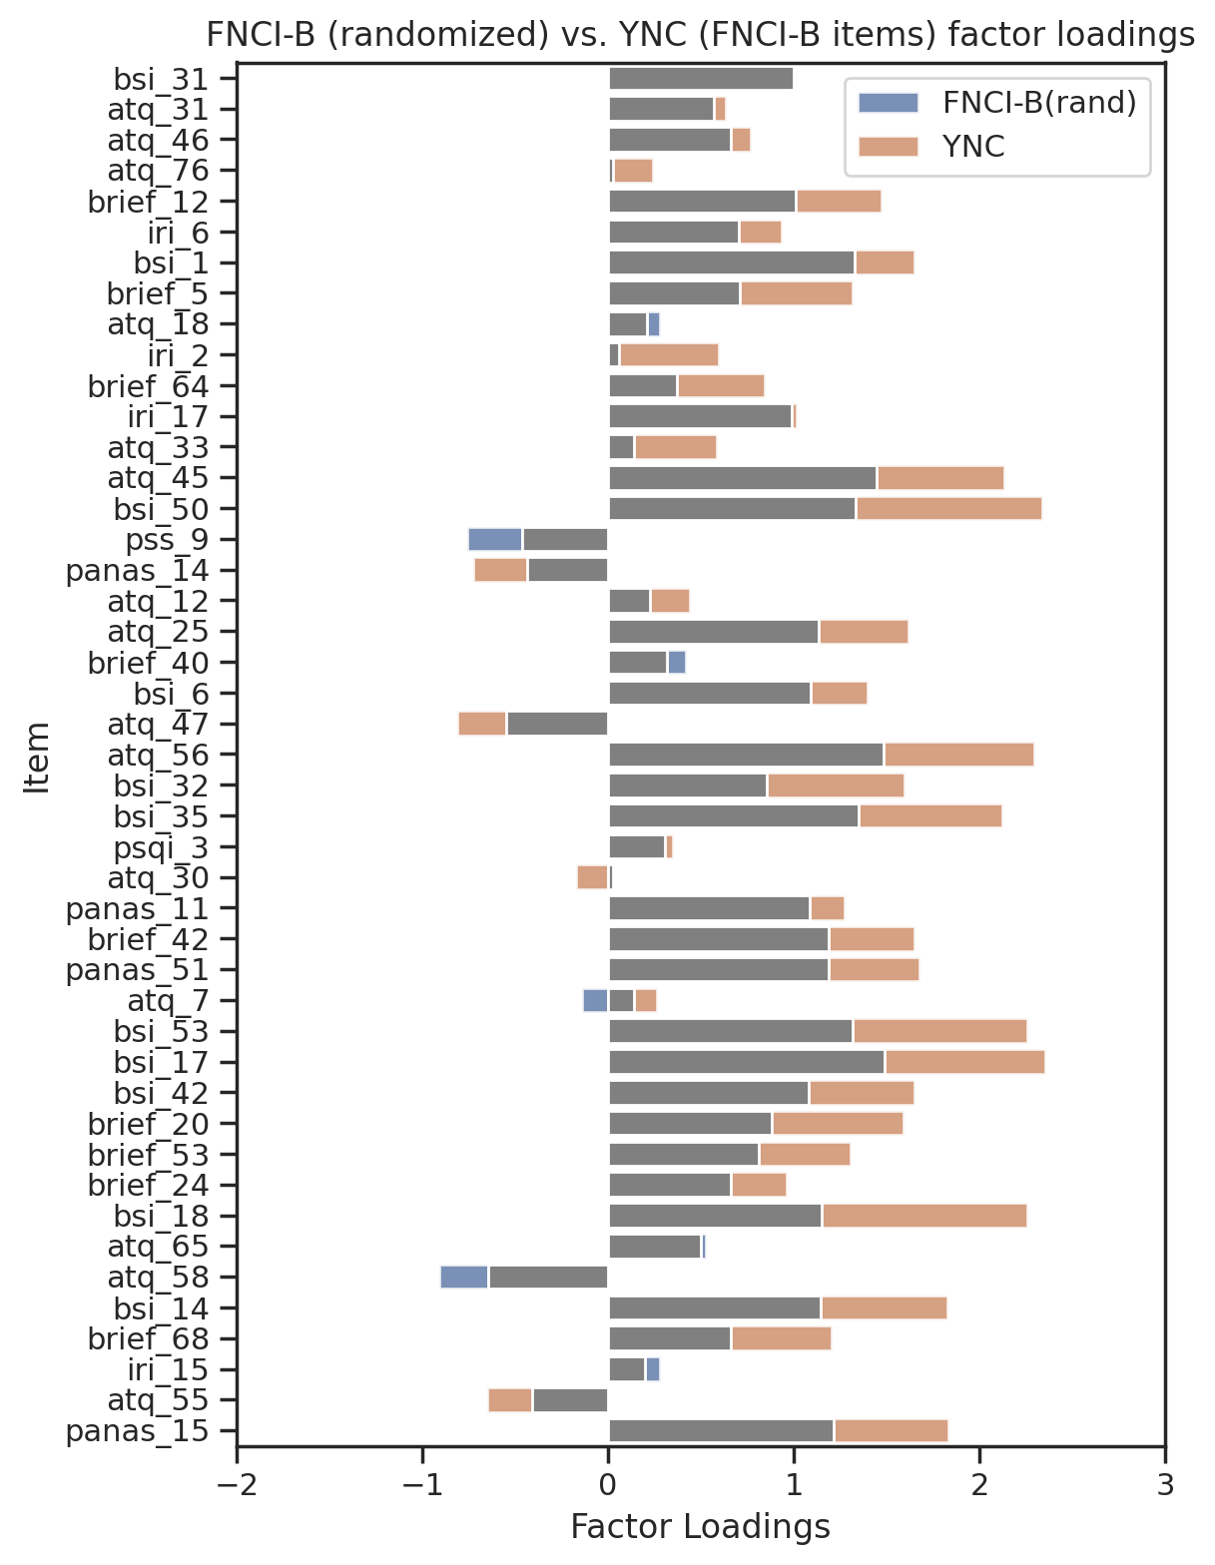
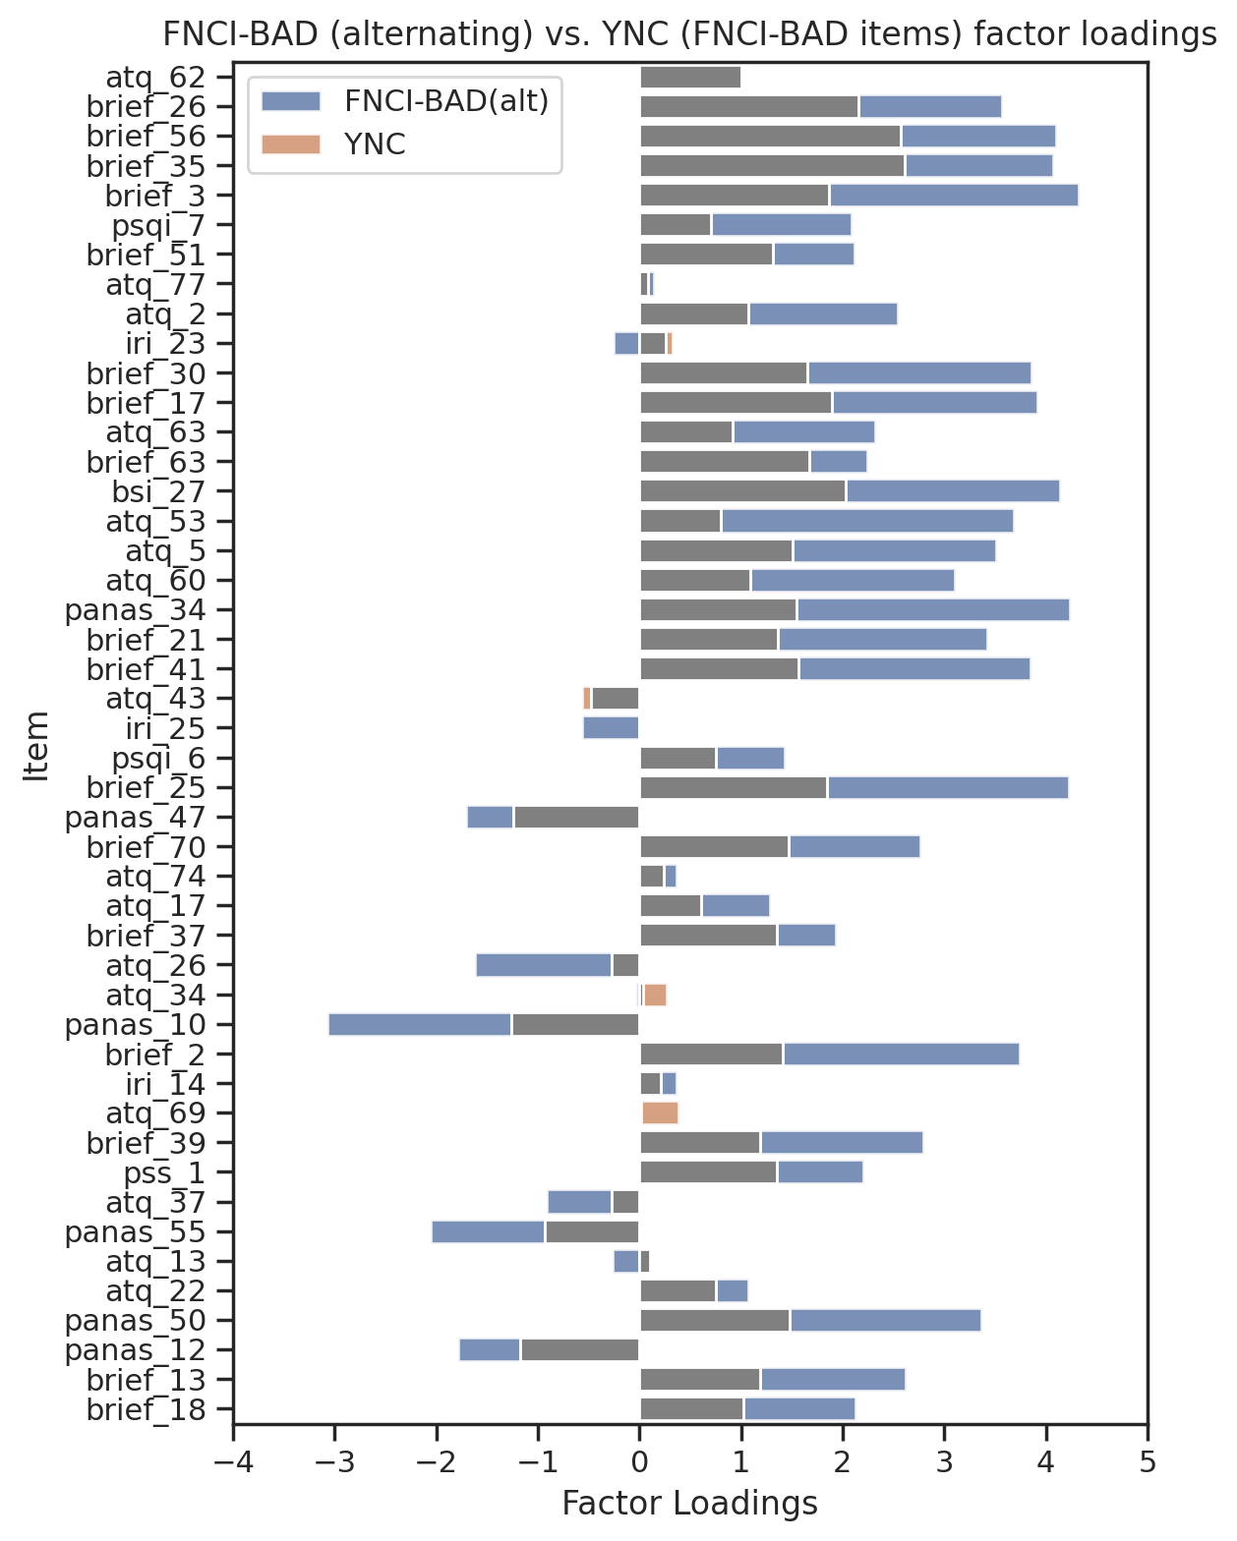
Supplementary Figure 11 – Functional Network Connectivity Index factor structure does not meaningfully differ across groups
a)
b)
ΔGFI =
-0.03
ΔGFI = -0.04
c)
ΔGFI = -0.04
Supplementary Figure 11 — Comparison of the single-factor structure of items across administration groups. a) Factor loadings for each item within the FNCI-B for YaleNeuroConnect (YNC) data (orange) and online administration with alternating item order (blue). b) Factor loadings for each item within the FNCI-B for YNC data (orange) and online administration with randomized item order (blue). c) Factor loadings for each item within the FNCI-BAD for YNC data (orange) and online administration with alternating order (blue).Change in goodness-of-fit from YNC to online administration is reported (ΔGFI) for each comparison.

