Supplement A

A.1 Excel tool instructions

A.1.1 Crop System
The crop module calculates an on-farm emissions baseline simply by selecting a crop from the dropdown list. The main emissions sources are from applied nitrogen and farm machinery. This data is pulled from national average values, however a user could override this if farm-specific data is available.

A.1.2 Afforestation Calculation
The calculation of the net effect of afforestation begins with inputs about the productivity of the herd of cattle which would be replaced by forest. In this example, we model a beef finishing operation. Users could use the methodology to model a dairy system as well. The default data in this Appendix come from LCA Jebari et al (2025) (Jebari et al. 2025).

Livestock Gains
Number of animals purchased* | 30
Starting weight (kg, carcass weight)* | 166
Finished weight (kg, carcass weight)* | 294
Number of animals sold* | 30
Total gains (kg) | 3,834
Total gains sold (kg) | 3,834
COC per kg gained (kg CO2 per kg gained)¹ | 50
COC of gains (kg) | 191,700
Feed and Forage
Feed A* | Wheat
Feed A Quantity (tonnes)* | 38.73
Feed A COC per tonne | 2.51
Total Feed A COC (tonnes) | 97.2123
Feed B* | Rapeseed
Feed B Quantity (tonnes) * | 1.92
Feed B COC per tonne | 4.62
Total Feed B COC (tonnes) | 8.8704
Grazed Area (hectares)* | 21
Table A.1: User inputs for the afforestation calculation
* denotes user input
¹ Regional COC value for Europe from (Wirsenius et al. In Review)

Years | High C (CO₂/ha) | Low C (CO₂/ha) | Baseline (CO₂/ha)
0 to 5 | 2.25 | 0.06 | 0.95
6 to 10 | 6.87 | 0.19 | 2.89
11 to 15 | 20.69 | 0.58 | 8.81
16 to 20 | 28.82 | 1.78 | 24.04
21 to 25 | 14.98 | 5.42 | 6.84
26 to 30 | 14.53 | 16.55 | 2.75
Total CO2/ha | 440.7 | 122.9 | 231.4
Species | Lodgepole Pine | Beech | Corsican Pine
Yield Class | 14 | 4 | 12
Management | NO_thin | Thinned | Thinned
Table A.2: Annual carbon sequestration rates from the Woodland Carbon Code database used in the baseline, high carbon, and low carbon scenarios for Table 1 in the main text. The baseline tree species and yield class were selected based on the ESC4 online tool’s suggestion of compatible tree species for the farm site in the LCA Jebari et al (2025).

To run the calculations for the afforestation simulation users must input farm-specific parameters regarding the herd size, grazed area, and feed use as shown in Table A.1. The farm used in this example uses supplemental wheat and rapeseed feedstuffs. The tool is currently programmed to handle up to two supplementary feeds, which users choose from a dropdown list.

We then estimate 30 years of carbon sequestration due to afforestation. Using the ESC4 tool online, users must select where the farm is located. ESC4 will then provide insights on the most optimal tree species to plant, and the yield class. Users must then input the species, yield class, and whether the forest is thinned or not in the dropdowns as shown in Table A.3, which then pulls the carbon sequestration rates from the Woodland Carbon Code database. The example shown is based on the location of the farm used for the demonstrative calculation in the main text of this article.

INPUTS
Tree species planted | Corsican Pine (determined with ESC4)
Yield Class | 12
Management | Thinned
Table A.3: Sample user inputs for tree species, yield class selection, and thinning.

A.1.3 Crop Interventions
This calculation runs by selecting an intervention from the dropdown list for the crop selected in the ‘Crop System’ module. This will generate a figure for the range of net-impacts associated with that crop and intervention.

Users must also input the assumed percent reduction in production emissions following an intervention. This can either be a known value using real farm data, from a published LCA, or a reasonable estimate.

A.2 Default data

Domestic Feed | COC Factor (kg CO2e per kg DM)¹ | UK Yield (tonnes per ha)² | Applied Synthetic N (kg/ha)³ | Applied Organic N (kg/ha)³
Wheat | 2.51 | 8 | 121 | 77
Barley | 2.34 | 6 | 81 | 51
Oats | 2.1425 | 5 | 67 | 43
Rapeseed | 4.62 | 3 | 115 | 73
Sugar Beet | 0.175 | 68 | 139 | 88
Peas | 4.62 | 3 | - | -
Beans | 12.375 | 3 | 0.49 | 0
Grass | 0.73 | 22 | 65 | 41
Table A.4: Default data on the production of domestic feed crops.
¹ Searchinger et al (2018) (Searchinger et al. 2018)
² DEFRA (DEFRA 2021)
³ National Inventory Report 2021 Annex Table A.3.3.9 (Brown et al. 2021)

A.3 Literature review on yield

Meta Study | Source(s) | Intervention | Crop
Cui 2022 | Cannell et al 1986  Christian and Bacon 1990 | No Till | Wheat
Su 2021 | Ball et al 1985  Campbell et al 1986  Newton et al 2012 | No Till | Wheat
Su 2021 | Giannitsopoulos 2019 | No Till | Barley
Pittelkow 2014 | Ball et al 1985  Campbell et al 1986  Christian and Bacon 1990  Newton et al 2012  Sharma 1985  Soane and Ball 1998 | No Till | Barley
Pittelkow 2014 | Soane and Ball 1998  Christian and Bacon 1990 | No Till | Rapeseed
Pittelkow 2014 | Cannell et al 1986  Christian and Bacon 1990 | No Till | Oat
 | Abdalla 2019 | Cover Crops | Oat
Badgley 2007 | Trewavas 2004 | Organic | Oat
Badgley 2007 | Trewavas 2004  Jenkinson 1994 | Organic | Wheat
Badgley 2007 | Trewavas 2004 | Organic | Beans
Badgley 2007 | Trewavas 2004 | Organic | Peas
Thapa 2018 | Catt 1998 | Cover Crops | Cereals
Poore 2018 | Lillywhite et al 2007  Williams et al 2006, 2010  Wiltshire et al 2009 | Organic | Wheat
Poore 2018 | Williams et al 2006 | Organic | Maize
Poore 2018 | Williams et al 2006 | Organic | Barley
Poore 2018 | Lillywhite et al 2007  Tzilivakis et al 2005 | Organic | Sugar beet
Poore 2018 | Williams et al 2006  Wiltshire et al 2009 | Organic | Field beans
Poore 2018 | Williams et al 2006, 2010 | Organic | Rapeseed
Conservation Evidence | McGrath 1990 | Manage Insecticides | Barley
Conservation Evidence | Rahn 2009 | Crop Residues | Barley
Conservation Evidence | Quinton 2004 | No Till | Grains
Conservation Evidence | Linzel 1986 | Reduced Fertilizers | Wheat
Smith 2019 | Gabriel 2013 | Organic | Cereals
Smith 2019 | Bilsborrow 2013 | Organic | Wheat
Table A.5: Sources in the literature containing data about the effect of crop farming practices on yield used in this study, including the publications providing raw data, and the meta-analyses used to find the raw data, when relevant.

Source | Intervention | Crop | Lower | Upper | Mean | n (tests)
Cui 2022 | No Till | Wheat | -4.95% | 13.64% | 3.58% | 22
Su 2021 | No Till | Wheat | -3.33% | 0.09% | -1.42% | 3
Su 2021 | No Till | Barley | -30.56% | 11.88% | -9.16% | 12
Pittelkow 2014 | No till | Barley | -31% | 64% | -2% | 59
Pittelkow 2014 | No till | Canola | -18% | 47% | 6% | 4
Pittelkow 2014 | No till | Oat | -45% | 7% | -14% | 3
Abdalla 2019 | Cover Crops | Oat | -15% | 2% | -6% | 8
Badgley 2007 | Organic | Oat |  |  | -15% | 1
Badgley 2007 | Organic | Wheat | -32% | 15% | -9% | 2
Badgley 2007 | Organic | Beans |  |  | -28% | 1
Badgley 2007 | Organic | Peas |  |  | -39% | 1
Reiss 2017 | Intercropping | Wheat |  |  | 10% | 1
Thapa 2018 | Cover Crops | Cereals | -19% | 16% | -0.08% | 9
Gooding 2007 | Intercropping | Wheat | -64% | -25% | -44% | 6
Pappa 2011 | Intercropping | Barley | 47% | 50% | 48% | 2
Bulson 1997 | Intercropping | Wheat | -24% | 29% |  | 16
Poore 2018 | Organic | Wheat | -70% | -13% | -38% | 3
Poore 2018 | Organic | Maize |  |  | -67% | 1
Poore 2018 | Organic | Barley |  |  | -61% | 1
Poore 2018 | Organic | Sugar beet | -56% | -34% | -45% | 2
Poore 2018 | Organic | Field beans | -39% | -10% | -24% | 2
Poore 2018 | Organic | Rapeseed |  |  | -65% | 1
Conservation Evidence | Alter insecticide use | Barley | -1% | 3% | 2% | 27
Conservation Evidence | Add crop residues | Barley | -0.63 | 0.23 | -0.194 | 5
Conservation Evidence | Reduced tillage | Grains | 0% | 0% | 16% | 1
Conservation Evidence | Reduce chemical inputs | Wheat | 5% | 8% | 7% | 2
Smith 2019 | Organic | Cereals |  |  | -52% | 96 (C), 69 (O)
Smith 2019 | Organic | Wheat | -26% | -19% | -23% | 8
Table A.6: Results of the literature review showing the lower, upper, and average yield effects for a given intervention and crop. Inclusion criteria, and excluded papers and criteria can be found in the Supplemental Excel File.

A.4 Practice definitions

Practice | Definition
No/Low Till | A method of sowing seeds which seeks to minimize disturbance of the soil to minimize erosion
Organic | Crops: Avoiding or minimizing the use of synthetic fertilizers and pesticides  Animal Products: Avoiding or minimizing antibiotics and hormones, generally higher standard of animal welfare
Cover Crops | Crops planted over the winter to prevent soil erosion and nitrogen leakage
Intercropping | Growing two or more crops simultaneously on a piece of land. For example, planting clover with a cash crop can reduce the need for nitrogen fertilizers
Alter Insecticide Use | Reducing or eliminating synthetic pest control chemicals
Crop Residues | Leaving harvest residues post-harvest (or applying residues from an external source) to build or maintain soil carbon (though the extent of these effects is disputed)
Reduce Chemical Inputs | Minimize application of synthetic fertilizers and pesticides (though not necessarily eliminate)
Table A.7: Definitions of practices included in the literature review

A.5 A note on no-till outliers

UK data on no-till as a farming practice shows a wide range of possible yield effects from a loss of 45% to a gain of 60%. Out of the 104 data points included (the practice with the next greatest amount of data points has 24), 7 are outliers. These abnormalities prompted additional digging so as to understand the reasons for this wide range.

Over half of these data points (and all 7 outliers) come from a 2014 meta-analysis by Pittelkow et al. Most of the studies conducted in the UK which we extracted from this meta-analysis were conducted in the 1980’s and 90’s. Thus, there is a question of whether these studies are relevant 40 years later, or whether they should be repeated using more modern technologies.

Age of the studies alone, however, is not sufficient to explain the anomalies. Upon closer inspection of each study which contained outliers, the other factors at play become clear. We include a discussion of these no-till studies from Pittelkow et al. (2014) to urge caution in the interpretation of the possible benefits (or drawbacks) of shifting to no-till.

The two outliers showing significant barley yield gains due to no till from Campbell et al. (1986) possibly occur because tillage is not the only independent variable in the study. The three-year study also assessed the effects of the number of times a tractor passes over the fields. While most no-till fields in years 0, 1, and 2 saw slight yield losses, the final no-till year saw significant yield gains relative to conventional tillage, but only in the instances where a tractor passes over the field 5 or 6 times. The author offers the explanation that higher numbers of tractor wheel passes reduces the integrity of soil structure for conventionally tilled fields. Thus, it is difficult to determine whether the yield effects are due to the number of wheel passes, or the choice of tillage.

Christian and Bacon (1990) conducted three long-term studies on no-till production of rapeseed in the 1970’s and 80’s. Two of the three studies found moderate declines in yield from no-till, while the third found a significant (47%) yield gain relative to conventional tillage. However, the authors explain that, at that site, the conventional tillage plots experienced a slug infestation which resulted in lower yields. Based on this study alone, it is not possible to determine whether the tillage type had any effect on susceptibility to pests. Therefore, this outlier may mislead interpretations of the results if taken outside of the context of the study.

The largest yield gain (64%) comes from a 25 year-long study, the longest by far included in the meta-analysis (Soane and Ball, 1998). The authors do not offer an explanation for this anomaly, but they do note that most years in the study saw yield losses for no-till relative to conventional tillage. They also include a discussion of how long-term success for no-till depends on the burning of crop residues. Most other studies included in Pittelkow et al. burned the residue, with the exception of this one. It is therefore important to note that residue burning as a management practice is not done in the UK today, bringing into question the potential for long-term benefits of no-till for crop yields.

Two outliers showed yield losses from no-till compared to conventional tillage. Newton et al. (2012)’s five-year study on barley investigated the combined effects of tillage, cultivar mixtures, and nitrogen application levels. Across the five years for all treatment types, conventional tillage yields steadily increased (with the exception of a drastic dip in year 3), while the yields for no-till steadily decreased. The authors explain that cultivar and nitrogen treatments significantly impacted yields.

The second yield-loss outlier comes from a 1986 study by Cannell et al. on oat production. This paper consists of two three-year experiments, both of which resulted in a yield loss for no-till compared with conventional tillage. However, the authors offer that the outlier (45% yield loss) can be explained by the additional controlled variable of drainage. In one of the two experiments, drainage was reduced, which affected the yield of the no-till plots but had little effect on the conventionally tilled plots.

The deep-dive on the outliers of no-till studies shows that, not only is there very little data from the 21st century on the yield effects of farming practices (specifically no-till) in the UK, but there are also few studies which look exclusively at the effects of tillage without some additional experimental variables such as nitrogen application or drainage level. Furthermore, for long-term studies containing outliers showing yield gains (such as Soane and Ball, 1998), the extreme values in one direction may dilute the overall trend in the opposite direction.

To conclude, due to the lack of availability of data which focus exclusively on no-till, and which is relevant to today’s farming practices, we recommend caution in interpreting the results of our calculator for no-till scenarios. The number of outliers suggests uncertainty for possible outcomes for farms shifting to no-till today.

A.6 Other crop practice examples

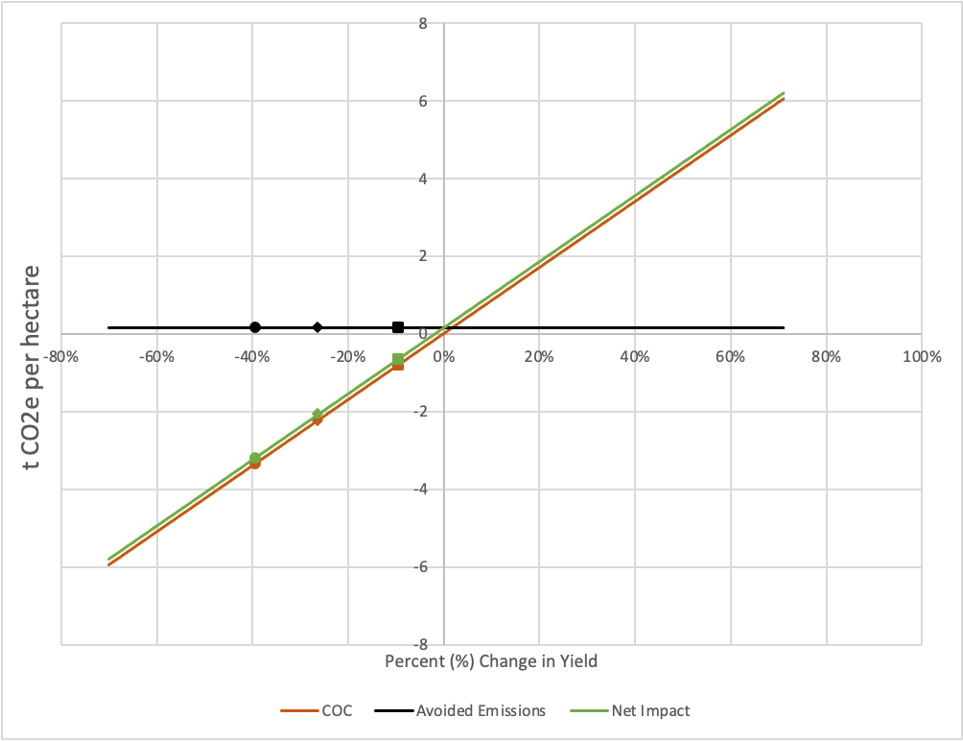
Figure A.1: Shift from conventional to organic production of beans and peas, assuming a 50% decrease in on-farm emissions

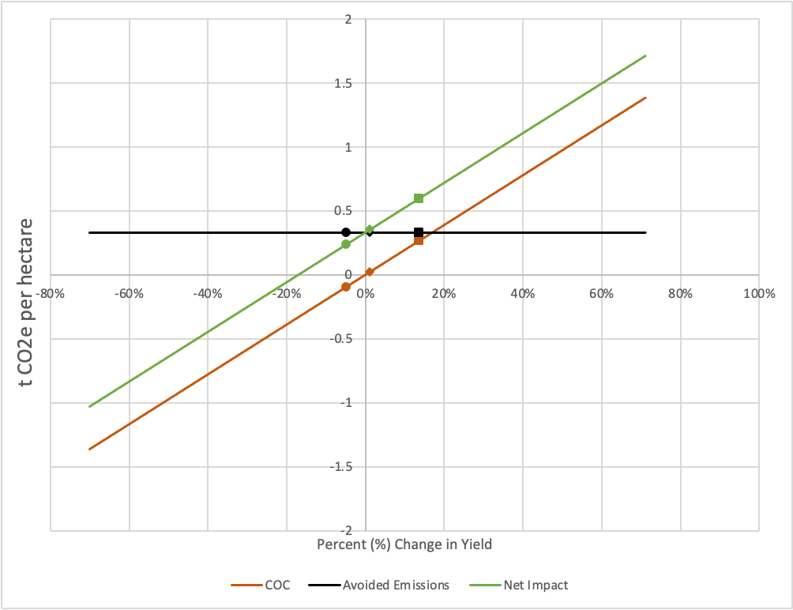
Figure A.2: Shift to no-till wheat production, assuming a 20% decrease in on-farm emissions

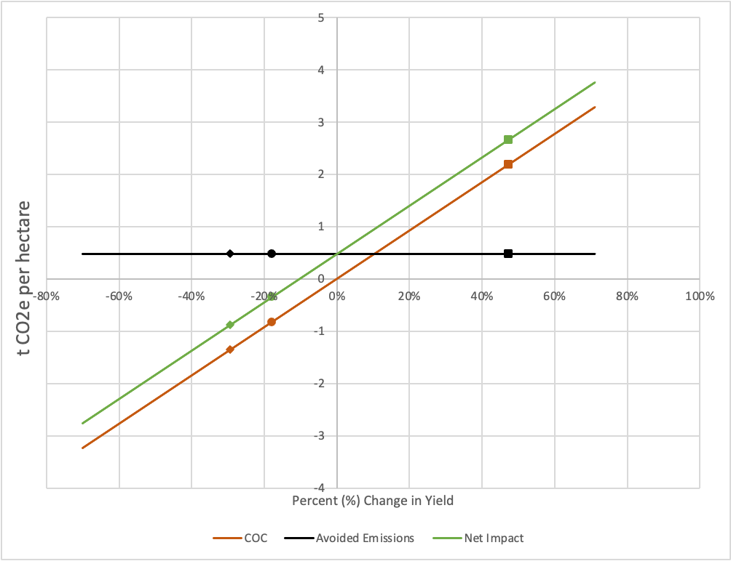
Figure A.3: Shift from conventional to organic rapeseed, assuming a 30% decrease in on-farm emissions.

A.7 Sensitivity of the discount rate for crop interventions

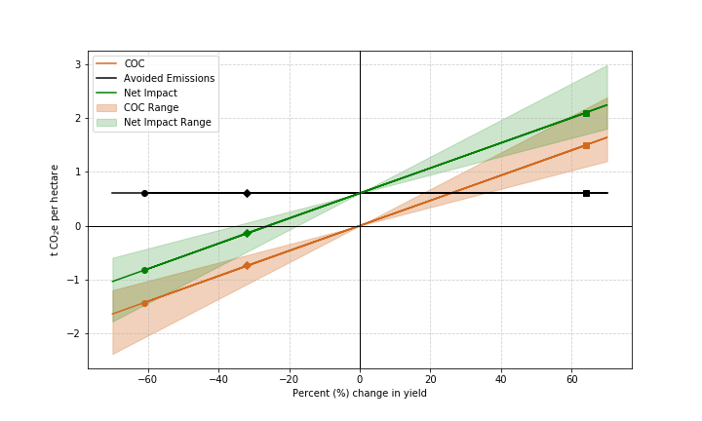
Figure A.4: Effect of applying a discount rate range from 2-6% where the solid red line represents a 4% discount rate for the example in Figure 4 of the main text (organic barley). Organic production shifts from being a net positive to net negative beyond a yield loss of about 25% (approximately the average value). The range of discount rates gives a range of inflection from a yield loss of 18-35%.

References

Brown, P, L. M. Cardenas, S Choudrie, et al. 2021. “UK Greenhouse Gas Inventory, 1990 to 2019: Annual Report for Submission under the Framework Convention on Climate Change.” Department for Business, Energy & Industrial Strategy.
DEFRA. 2021. “Chapter 7: Crops.” GOV.UK. https://www.gov.uk/government/statistics/agriculture-in-the-united-kingdom-2021/chapter-7-crops.
Jebari, Asma, Taro Takahashi, Michael R. F. Lee, et al. 2025. “Carbon Footprints of Greenhouse Gas Mitigation Measures for a Grass-Based Beef Cattle Finishing System in the UK.” The International Journal of Life Cycle Assessment 30 (4): 654–67. https://doi.org/10.1007/s11367-025-02428-9.
Searchinger, Timothy, Stefan Wirsenius, Tim Beringer, and Patrice Dumas. 2018. “Assessing the Efficiency of Changes in Land Use for Mitigating Climate Change.” Nature 564 (7735): 7735. https://doi.org/10.1038/s41586-018-0757-z.
Wirsenius, Stefan, Oliver James, Tim Beringer, and Timothy D. Searchinger. In Review. The Full Climate Costs of Agriculture Including Foregone Land Carbon Storage.

