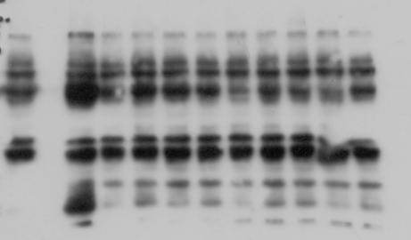
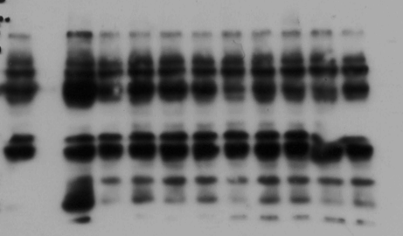
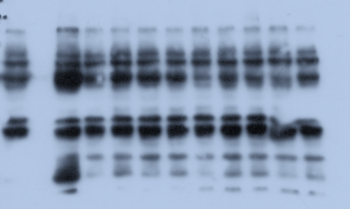
LMM3
MCC
NSC
pSTAT3
Actin
STAT3
LMM3
MCC
NSC
pSTAT3
Actin
LMM3
MCC
NSC
STAT3

Figure 2: Expression of activated STAT3 (pSTAT3) and PD-L1 in MC-C and LMM3 tumors. pSTAT3 was determined by Western Blotting in MC-C, LMM3 tumor cells, and normal splenocytes (NSC). Controls with actin and total STAT3 were added. Results are representative of three similar experiments.

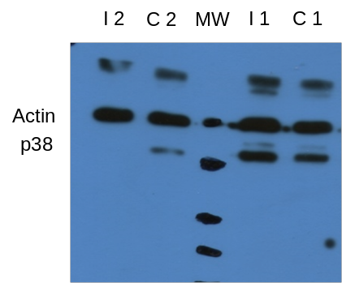
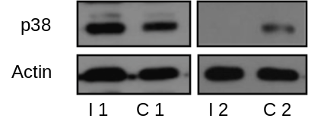

Figure 4: Expression of phosphorylated (p)-38 (p38) by Western blotting. Macrophages (3×10⁶ cells) were collected surrounding the s.c. primary and secondary MC-C tumors 7 days post-secondary implant. Mice were treated with anti-CTLA-4 + anti-PD-L1 (immunized group), and non-treated mice served as control. A representative experiment is shown.

