Supporting Information Material
Supplemental Figure S1 Flow chart illustrating the study population.
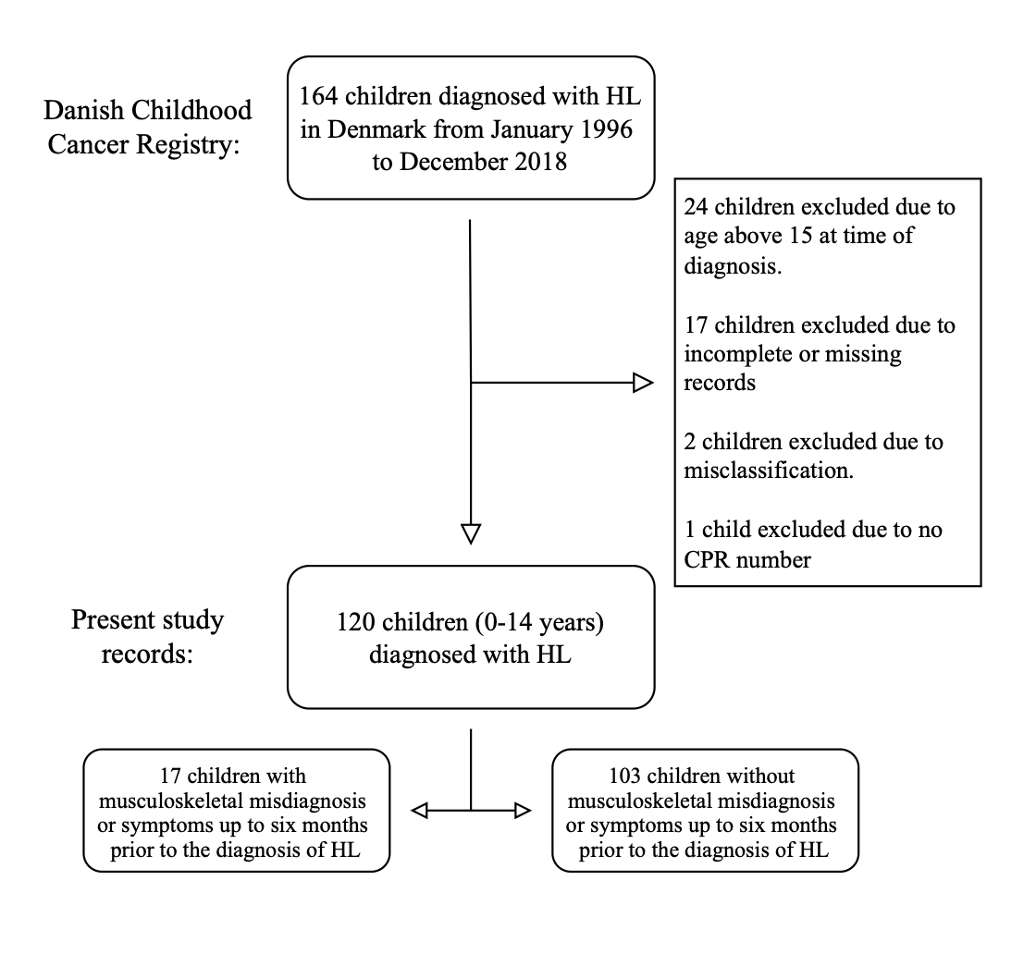
HL: Hodgkin lymphoma. CPR: Civil Personal Register number.

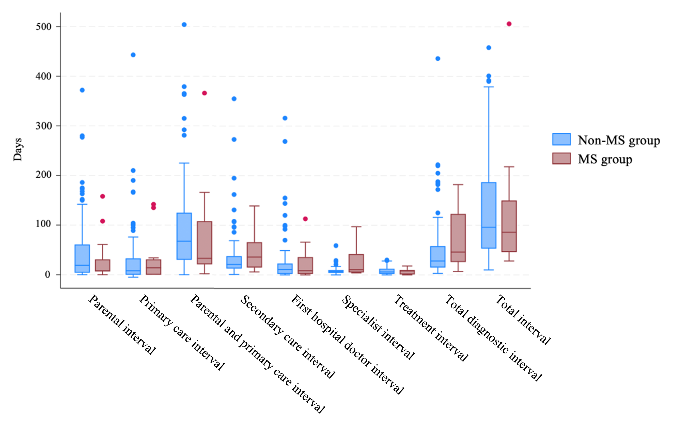
Supplemental Figure S2 Boxplot comparing diagnostic time intervals as median (horizontal line), interquartile range (the box), and total range (vertical line with spots showing outliners) for pediatric patients with Hodgkin lymphoma with and without MS symptoms/misdiagnoses. The figure does not top 3% of time interval values. The blue color represents the non-MS group, while red represents the MS group.
MS: Musculoskeletal.

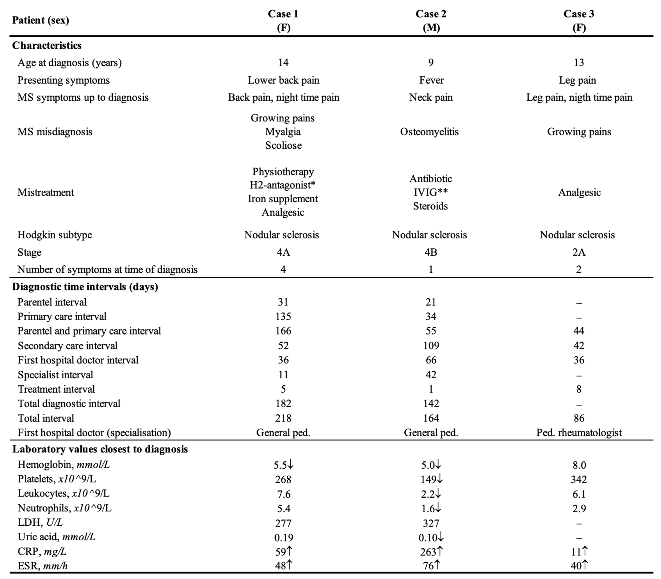
Supplemental Table S3 Clinical presentation of pediatric patients diagnosed with Hodgkins’s lymphoma with a musculoskeletal misdiagnosis prior to the cancer diagnosis.
F: Female. M: Male. MS: Musculoskeletal. HL: Hodgkin’s lymphoma. Ped: Pediatrician. ↑: Elevated values, adjusted for age. ↓: Decreased values, adjusted for age. LDH: Lactate dehydrogenase. CRP: C-reactive protein. ESR: Erythrocyte sedimentation rate. ”-”: Missing. *: Histamine H2-receptor antagonist. **: Intravenous immunoglobulin.

