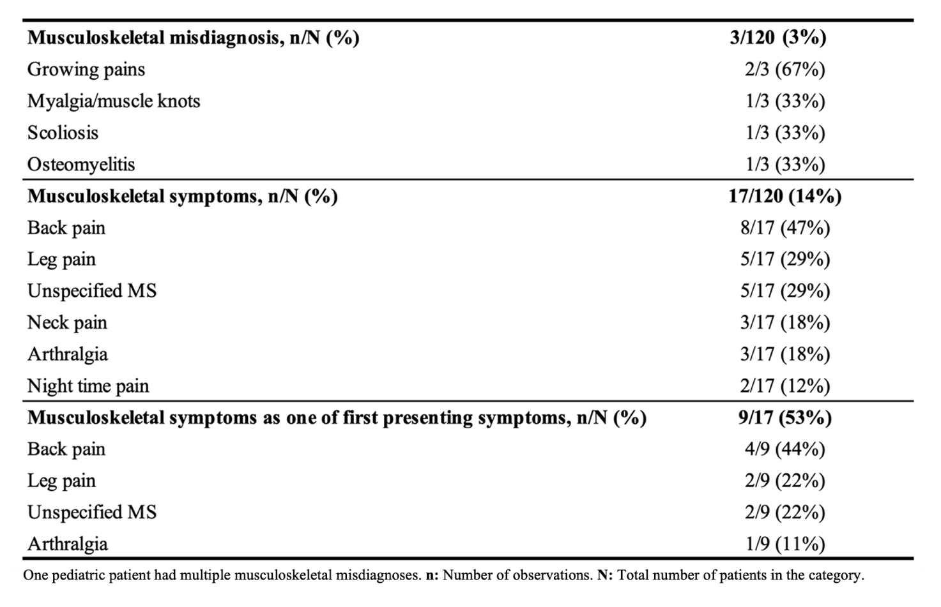
Table 1. The prevalence of musculoskeletal misdiagnoses and musculoskeletal symptoms in pediatric patients with musculoskeletal symptoms prior to the diagnosis of Hodgkin lymphoma.

Table 2. Age, sex, and cancer characteristics of pediatric patients with and without musculoskeletal symptoms/misdiagnoses prior to the diagnosis of Hodgkin lymphoma.
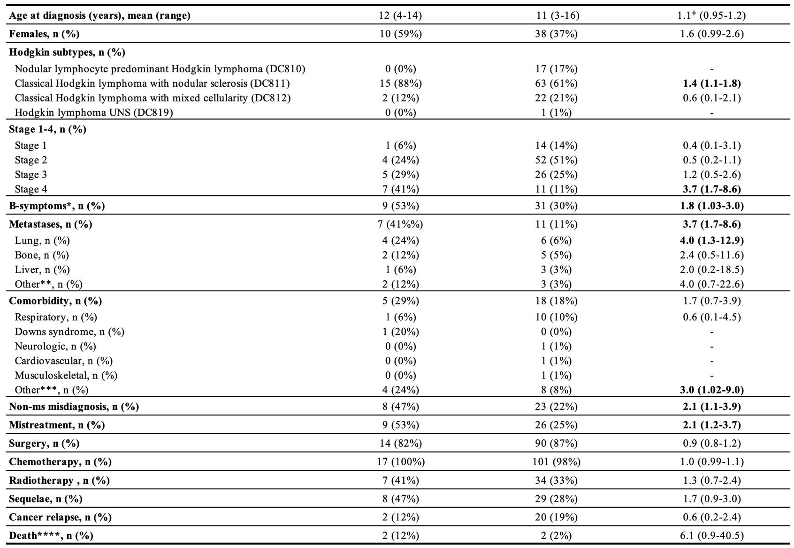
n: Number of observations. CI: Confidential interval. SD: Standard deviation. IQR: Interquartile range. UNS: Unspecified. MS: Musculoskeletal. “- “: Too few data to determine prevalence ratio. ⁺: Mean value ratio. *: Fever, weight loss, or night sweats. **: Includes bone marrow and pericardium. ***: Includes endocrinological, dermatological, genetic, connective tissue, otologic, and psychiatric diseases. ****: Death related to cancer or side effects of treatment.

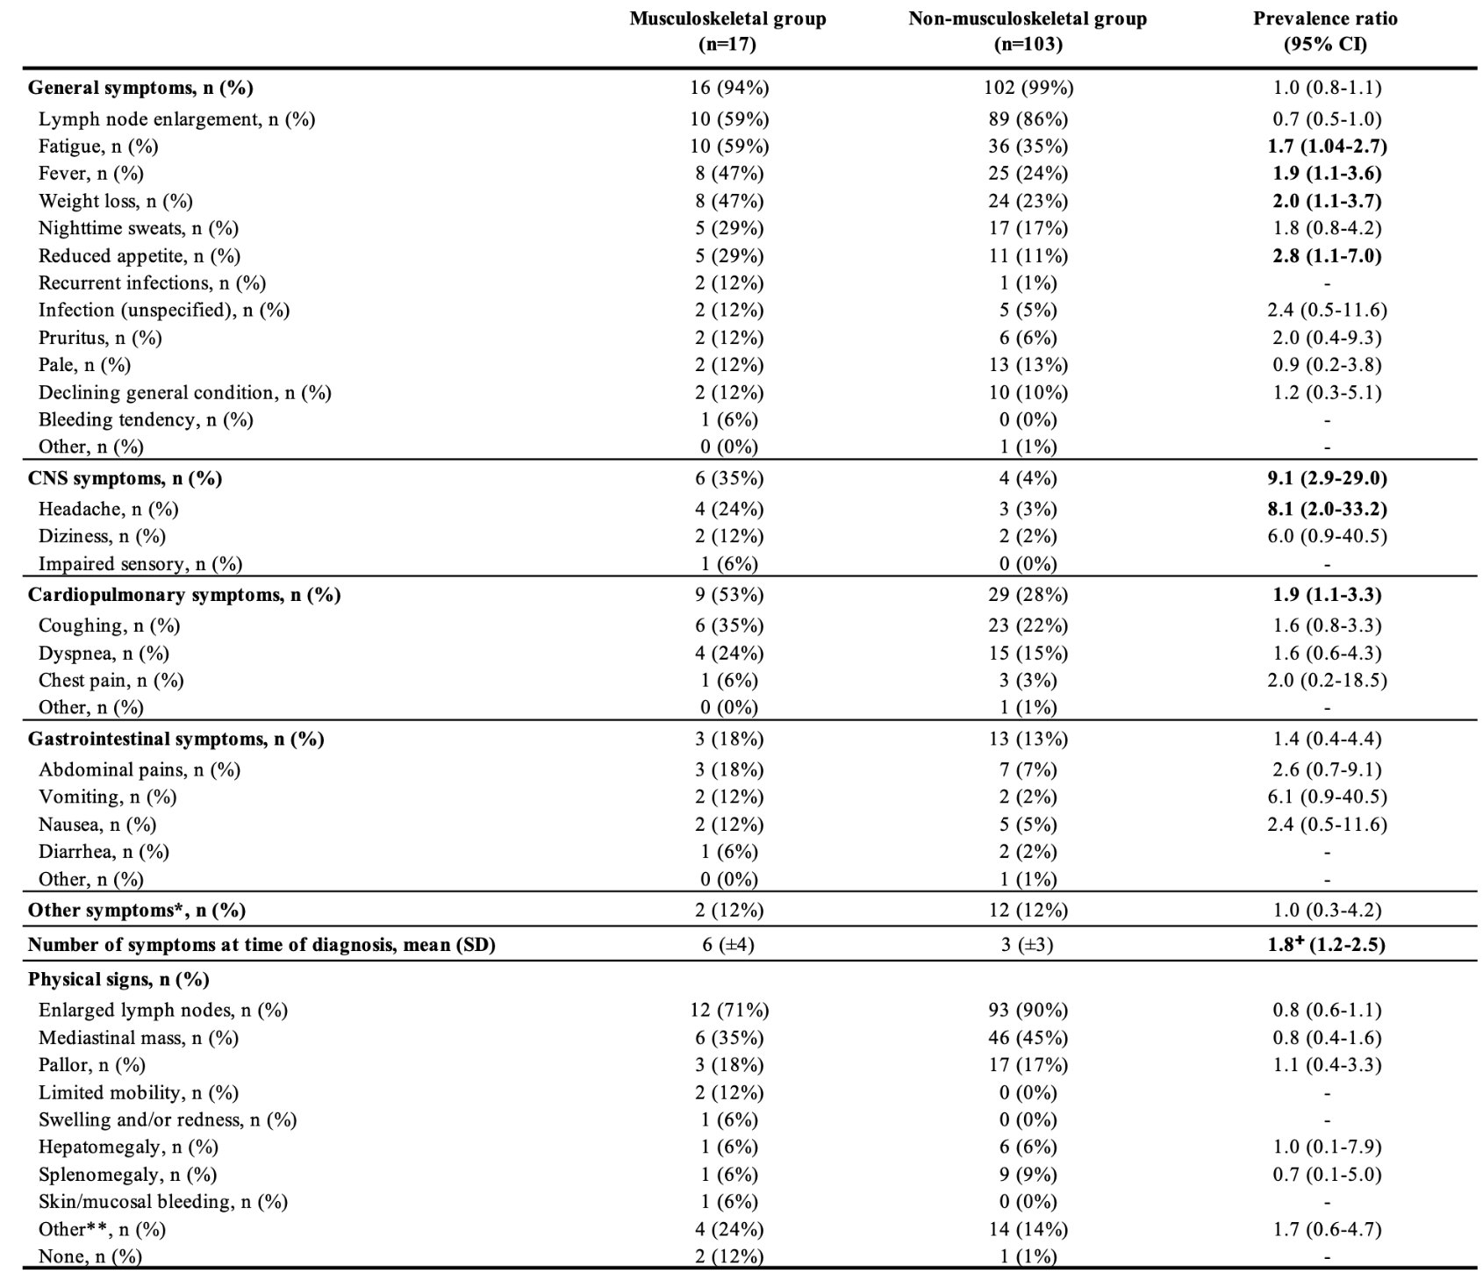
Table 3. Clinical presentation of pediatric patients with and without musculoskeletal symptoms/ misdiagnoses prior to the diagnosis of Hodgkin lymphoma.

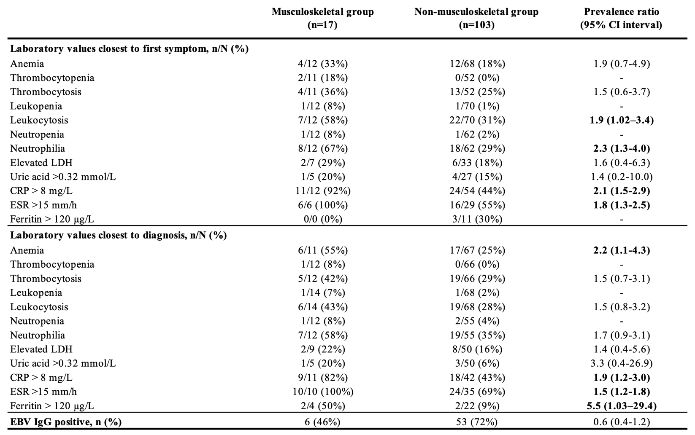
Table 4. Laboratory values closest to first symptom and closest to the diagnosis of pediatric patients with and without musculoskeletal symptoms/misdiagnoses prior to the diagnosis of Hodgkin lymphoma.

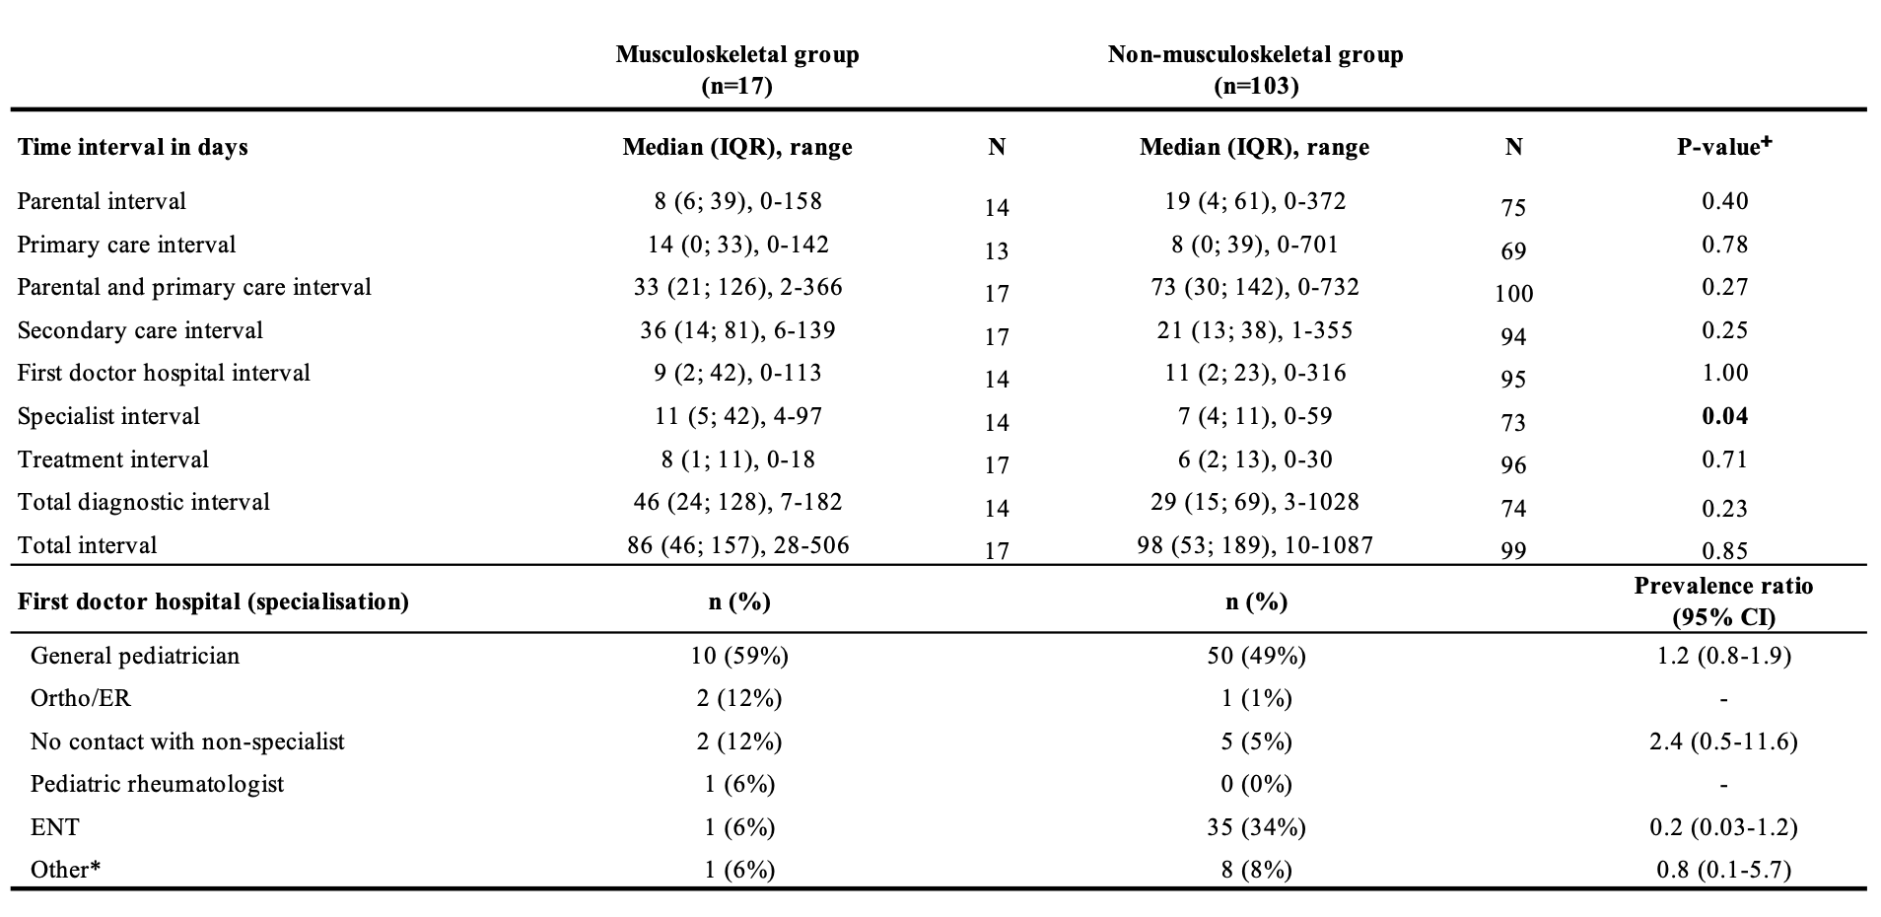
Table 5. The diagnostic time intervals for pediatric patients with and without musculoskeletal symptoms/misdiagnoses prior to the diagnosis of Hodgkin lymphoma.
n: Number of observations. N: Number of patients this variable was known for. IQR: Interquartile range. ENT: Ear-nose-throat doctor. Ortho: Orthopedic surgeon. ER: Emergency room “-“: Too few data to calculate prevalence ratio. ⁺: Calculated from Mann-Whitney U test. *: Subspecialized pediatrician, a non-pediatric specialist doctor, surgical specialist.

Neurologist, pediatric endocrinologist, hematologist, oncologist, general surgeon, abdominal surgeon.

