Supplement Materials
Content
Table S1. STROBE Statement—checklist of items that should be included in reports of observational studies. 2
Table S2. The detailed content of the eight core items and the selection parameters, related to Figure 1. 6
Table S3. Comprehensive comparison of performance metrics across ten machine learning algorithms, related to Figure 1a. 8
Table S4. Guidelines for the use of an efficient suicide screening tool and access to the online platform. 9
Table S5. External validation dataset demographic variables table. 11
Table S6. Descriptive statistics for the 8 core items were computed across the datasets, related to Figure 2 and Figure 3. 12
Fig. S1. Suicide risk network analysis research flow, related to Figure 4. 13
Fig. S2. Centrality property of the GLASSO network of the training cohort, related to Figure 2a. 14
Fig. S3. External validation plots for GLASSO and Bayesian network analyses, related to Figure 2. 15
Fig. S4. Sample selection process for the external validation dataset, related to Figure 4. 16
Fig. S5. Visualization of the core item screening process, related to Figure 1. 17
Fig. S6. Bootstrapped confidence intervals of estimated edge weights for the GLASSO network, related to Figure 2a. 18
Fig. S7. Bootstrapped difference test between edge weights that were non-zero in the estimated network, related to Figure 2a. 19
Fig. S8. Bootstrapped difference test between node strength of the network, related to Figure 2a. 20
Fig. S9. Stability of strength centrality index, related to Figure 2a. 21
Fig. S10. Centrality property of the GLASSO network of the high suicide risk cohort, related to Figure 2c. 22
Fig. S11. Centrality property of the GLASSO network of the low suicide risk cohort, related to Figure 2d. 23

Table S1. STROBE Statement—checklist of items that should be included in reports of observational studies.
 | Item No | Recommendation | Page  No
Title and abstract | 1 | (a) Indicate the study’s design with a commonly used term in the title or the abstract | 1
Title and abstract | 1 | (b) Provide in the abstract an informative and balanced summary of what was done and what was found | 1-2
Introduction
Background/rationale | 2 | Explain the scientific background and rationale for the investigation being reported | 3-5
Objectives | 3 | State specific objectives, including any prespecified hypotheses | 5
Methods
Study design | 4 | Present key elements of study design early in the paper | 5-8
Setting | 5 | Describe the setting, locations, and relevant dates, including periods of recruitment, exposure, follow-up, and data collection | 6-8
Participants | 6 | (a) Cohort study—Give the eligibility criteria, and the sources and methods of selection of participants. Describe methods of follow-up  Case-control study—Give the eligibility criteria, and the sources and methods of case ascertainment and control selection. Give the rationale for the choice of cases and controls  Cross-sectional study—Give the eligibility criteria, and the sources and methods of selection of participants | 6-8
Participants | 6 | (b) Cohort study—For matched studies, give matching criteria and number of exposed and unexposed  Case-control study—For matched studies, give matching criteria and the number of controls per case | 6-8
Variables | 7 | Clearly define all outcomes, exposures, predictors, potential confounders, and effect modifiers. Give diagnostic criteria, if applicable | 6-9
Data sources/ measurement | 8* | For each variable of interest, give sources of data and details of methods of assessment (measurement). Describe comparability of assessment methods if there is more than one group | 6-9
Bias | 9 | Describe any efforts to address potential sources of bias | 6-11
Study size | 10 | Explain how the study size was arrived at | 6-8
Quantitative variables | 11 | Explain how quantitative variables were handled in the analyses. If applicable, describe which groupings were chosen and why | 6-11
Statistical methods | 12 | (a) Describe all statistical methods, including those used to control for confounding | 7-11
Statistical methods | 12 | (b) Describe any methods used to examine subgroups and interactions | 9-11
Statistical methods | 12 | (c) Explain how missing data were addressed | 6-8
Statistical methods | 12 | (d) Cohort study—If applicable, explain how loss to follow-up was addressed  Case-control study—If applicable, explain how matching of cases and controls was addressed  Cross-sectional study—If applicable, describe analytical methods taking account of sampling strategy | 6-8
Statistical methods | 12 | (e) Describe any sensitivity analyses | 7-11
Continued on next page
Results
Participants | 13* | (a) Report numbers of individuals at each stage of study—eg numbers potentially eligible, examined for eligibility, confirmed eligible, included in the study, completing follow-up, and analysed | 6-8
Participants | 13* | (b) Give reasons for non-participation at each stage | 6-8
Participants | 13* | (c) Consider use of a flow diagram | 6
Descriptive data | 14* | (a) Give characteristics of study participants (eg demographic, clinical, social) and information on exposures and potential confounders | 6-8
Descriptive data | 14* | (b) Indicate number of participants with missing data for each variable of interest | 6-8
Descriptive data | 14* | (c) Cohort study—Summarise follow-up time (eg, average and total amount) | 6-8
Outcome data | 15* | Cohort study—Report numbers of outcome events or summary measures over time | 15-16
Outcome data | 15* | Case-control study—Report numbers in each exposure category, or summary measures of exposure | 14-16
Outcome data | 15* | Cross-sectional study—Report numbers of outcome events or summary measures | 12-15
Main results | 16 | (a) Give unadjusted estimates and, if applicable, confounder-adjusted estimates and their precision (eg, 95% confidence interval). Make clear which confounders were adjusted for and why they were included | 12-16
Main results | 16 | (b) Report category boundaries when continuous variables were categorized | 7-10
Main results | 16 | (c) If relevant, consider translating estimates of relative risk into absolute risk for a meaningful time period | Not Applied
Other analyses | 17 | Report other analyses done—eg analyses of subgroups and interactions, and sensitivity analyses | 12-16
Discussion
Key results | 18 | Summarise key results with reference to study objectives | 16,19
Limitations | 19 | Discuss limitations of the study, taking into account sources of potential bias or imprecision. Discuss both direction and magnitude of any potential bias | 19-20
Interpretation | 20 | Give a cautious overall interpretation of results considering objectives, limitations, multiplicity of analyses, results from similar studies, and other relevant evidence | 16-20
Generalisability | 21 | Discuss the generalisability (external validity) of the study results | 16,19-20
Other information
Funding | 22 | Give the source of funding and the role of the funders for the present study and, if applicable, for the original study on which the present article is based | 25

*Give information separately for cases and controls in case-control studies and, if applicable, for exposed and unexposed groups in cohort and cross-sectional studies.

Note: An Explanation and Elaboration article discusses each checklist item and gives methodological background and published examples of transparent reporting. The STROBE checklist is best used in conjunction with this article (freely available on the Web sites of PLoS Medicine at http://www.plosmedicine.org/, Annals of Internal Medicine at http://www.annals.org/, and Epidemiology at http://www.epidem.com/). Information on the STROBE Initiative is available at www.strobe-statement.org.

Table S2. The detailed content of the eight core items and the selection parameters, related to Figure 1.
No | Abbreviation | Item Content | Response Options
1 | GE12 | Have you ever been diagnosed with a mental disorder (e.g., anxiety disorders, phobias, hypochondriasis, depression, obsessive-compulsive disorder, or schizophrenia)? | Yes/No
2 | GE14 | Have you ever engaged in suicidal behavior? | Yes/No
3 | EPQN2 | Have you frequently experienced persistent low mood without obvious reason over the past two weeks? | Yes/No
4 | ASLEC6 | Do you often feel reluctant or unhappy about going to school? | 1. Never happened  2. No impact  3. Mild impact  4. Moderate impact  5. Severe impact  6. Extreme impact
5 | SSRS8 | When facing difficulties, which of the following support sources do you typically seek help from? | 1.Prefer self-reliance and never seek help from others  2.Rarely seek assistance from others  3.Occasionally seek help from others  4.Frequently ask others for help when facing difficulties
6 | BDI2 | The following statements describe various feelings and experiences. Please indicate to what extent each one has applied to you over the past week (including today). | 1. I am not disappointed about the future.  2. I feel discouraged about the future.  3. I feel the future is bleak.  4. I feel the future is hopeless and cannot improve.
7 | BDI7 | The following statements describe various feelings and experiences. Please indicate to what extent each one has applied to you over the past week (including today). | 1. I am not disappointed in myself.  2. I am disappointed in myself.  3. I am disgusted with myself.  4. I hate myself.
8 | BDI9 | The following statements describe various feelings and experiences. Please indicate to what extent each one has applied to you over the past week (including today). | 1. I do not have any thoughts of killing myself.  2. I have thoughts of suicide, but I would not act on them.  3. I want to commit suicide.  4. I would kill myself if I had the chance.
Elastic net regression was identified as the optimal machine learning algorithm. Core items were screened under four α settings (α = 0, 0.25, 0.75, and 1) by jointly considering item stability, importance, and relevance.

Table S3. Comprehensive comparison of performance metrics across ten machine learning algorithms, related to Figure 1a.
Model | Predictive Indicators |  |  | Main R Package
Model | RMSE | MAE | R² | Main R Package
Elastic Net Regression | 0.631825 | 0.452821 | 0.458623 | glmnet
Lasso | 0.631801 | 0.452655 | 0.458388 | glmnet
Gradient Boosting Machine | 0.6313 | 0.453102 | 0.456207 | gbm
Random Forest | 0.638797 | 0.466536 | 0.454451 | ranger
Ridge | 0.637481 | 0.457042 | 0.44833 | glmnet
Bagged trees | 0.638123 | 0.460872 | 0.444342 | randomForest
Mars | 0.645513 | 0.460532 | 0.430314 | earth
XGBoost | 0.646024 | 0.459862 | 0.429659 | xgboost
Support Vector Machine | 0.66841 | 0.45272 | 0.404161 | kernlab
Decision Tree | 0.670253 | 0.498517 | 0.388051 | rpart
A higher R² indicates better predictive performance of the model. The "Main R package" column lists the primary R packages used for training the model.

Table S4. Guidelines for the use of an efficient suicide screening tool and access to the online platform.
Category | Online Link | Predictive formula
Binary scoring | https://ykcnormgram.shinyapps.io/22334/  Risk probability estimation was conducted based on the Training Cohort, with a relatively balanced sample distribution. | Suicide Level = -1.5323 + 0.6847*GE12 + 0.7289*GE14 + 0.726*EPQN2 + 0.3124*ASLEC6 - 0.3381*SSRS8 + 0.4518*BDI2 + 0.6036*BDI7 + 1.1523*BDI9
Multi-level scoring | https://ykcnormgram.shinyapps.io/10282/  The probability estimation for four levels of suicide risk was conducted based on the Training Cohort. As the suicide risk level increased, the sample size progressively decreased, resulting in a relatively imbalanced distribution across risk categories. | In a multiclass classification setting, the elastic net regression model generates separate equations corresponding to each category. The following are the predictive formulas for the five classes (0 indicates no risk; 1–4 represent suicide risk levels 1 through 4, with higher levels indicating greater suicide severity).  Suicide Level(P(Y=0)) = 3.4869 + -0.9598 * GE12 + -1.0456 * GE14 + -0.7307 * EPQN2 + -0.3939 * ASLEC6 + 0.4851 * SSRS8 + -0.5456 * BDI2 + -0.6189 * BDI7 + -1.6814 * BDI9  Suicide Level (P(Y=1)) = 1.6846 + -0.4023 * GE12 + -0.4564 * GE14 + -0.1071 * ASLEC6 + 0.1984 * SSRS8 + -0.1542 * BDI2 + -0.0316 * BDI7 + -0.7971 * BDI9  Suicide Level (P(Y=2)) = 0.2688 + 0.0662 * EPQN2 + 0.075 * BDI2  Suicide Level (P(Y=3)) = -1.8983 + 0.0837 * GE12 + 0.0989 * GE14 + 0.0235 * EPQN2 + 0.0893 * ASLEC6 + -0.1362 * SSRS8 + 0.0175 * BDI2 + 0.366 * BDI7 + 0.462 * BDI9  Suicide Level (P(Y=4)) = -3.5419 + 0.8499 * GE12 + 0.1023 * GE14 + -0.3113 * SSRS8 + 0.4209 * BDI7 + 0.7319 * BDI9
For real-time estimation of the probability of suicide risk, the online link may be utilized. The predictive formula was derived from the Training Cohort using the glmnet package in R with α = 0.5. Minor fluctuations in the weights of individual items may occur; however, these variations do not affect its practical application.

Table S5. External validation dataset demographic variables table.
Characteristics | External validation
Sample | 394
Age
Mean (SD) | 15.6(2.4)
Median [Max, Min] | 15.1 [11.8,22.0]
Gender
Female | 276 (70.2%)
Male | 117 (29.8%)
BMI
Mean (SD) | 20.4 (4.3)
Median [Max, Min] | 19.2 [15.0,38.6]
Suicide level in peak period of life
Mean (SD) | 18.0 (19.4)
Median [Max, Min] | 17 [0,89]
Suicide level in the last year
Mean (SD) | 10.1 (11.8)
Median [Max, Min] | 7.5 [0,52]
Suicide level in recent 30 days
Mean (SD) | 8.8 (10.5)
Median [Max, Min] | 1.5 [0,62]

Characteristics | Cross-sectional design |  |  | Longitudinal design
Characteristics | Training Cohort | High-risk | Low-risk | Longitudinal Cohort
Sample | 4568 | 1816 | 1816 | 119
Age
Mean (SD) | 19.6 (1.1) | 19.7 (1.3) | 19.3 (0.9) | 20.3 (1.2)
Median [Max, Min] | 19.2 [16.3,29.4] | 19.4 [16.6,29.4] | 19.1 [16.3,26.8] | 20.3 [17.5,24.6]
Gender
Female | 3196 (70.0%) | 1273 (68.6%) | 1279 (68.9%) | 80 (67.2%)
Male | 1372 (30.0%) | 584 (31.4%) | 578 (31.1%) | 39 (32.8%)
Suicide level
Mean (SD) | 0.6 (0.84) | 1.5 (0.7) | 0 (0) |  | 0.9 (0.8)
Median [Max, Min] | 0 [0,4] | 1 [1,4] | 0 [0,0] |  | 1 [0,3]
GE12
Mean (SD) | 0.1(0.2) | 0.1(0.3) | 0.0(0.2) |  | 0.0(0.2)
Median [Max, Min] | 0[0,1] | 0[0,1] | 0[0,1] |  | 0[0,1]
GE14
Mean (SD) | 0.1(0.3) | 0.2(0.4) | 0.0(0.2) |  | 0.1(0.3)
Median [Max, Min] | 0[0,1] | 0[0,1] | 0[0,1] |  | 0[0,1]
EPQN2
Mean (SD) | 0.5(0.5) | 0.8(0.4) | 0.4(0.5) |  | 0.7(0.5)
Median [Max, Min] | 1[0,1] | 1[0,1] | 0[0,1] |  | 1[0,1]
ASLEC6
Mean (SD) | 1.8(0.9) | 2.2(0.9) | 1.6(0.8) |  | 2.0(0.9)
Median [Max, Min] | 2[1,5] | 2[1,5] | 1[1,5] |  | 2[1,5]
SSRS8
Mean (SD) | 2.7(0.7) | 2.5(0.8) | 2.8(0.7) |  | 2.6(0.8)
Median [Max, Min] | 3[1,4] | 3[1,4] | 3[1,4] |  | 3[1,4]
BDI2
Mean (SD) | 0.5(0.9) | 1.0(1.0) | 0.3(0.7) |  | 0.7(1.0)
Median [Max, Min] | 0[0,3] | 1[0,3] | 0[0,3] |  | 0[0,3]
BDI7
Mean (SD) | 0.5(0.7) | 0.9(0.7) | 0.3(0.5) |  | 0.7(0.7)
Median [Max, Min] | 0[0,3] | 1[0,3] | 0[0,3] |  | 1[0,3]
BDI9
Mean (SD) | 0.3(0.5) | 0.6(0.6) | 0.1(0.4) |  | 0.4(0.5)
Median [Max, Min] | 0[0,3] | 1[0,3] | 0[0,3] |  | 0[0,2]

Table S6. Descriptive statistics for the 8 core items were computed across the datasets, related to Figure 2 and Figure 3.

Fig. S1. Suicide risk network analysis research flow, related to Figure 4.
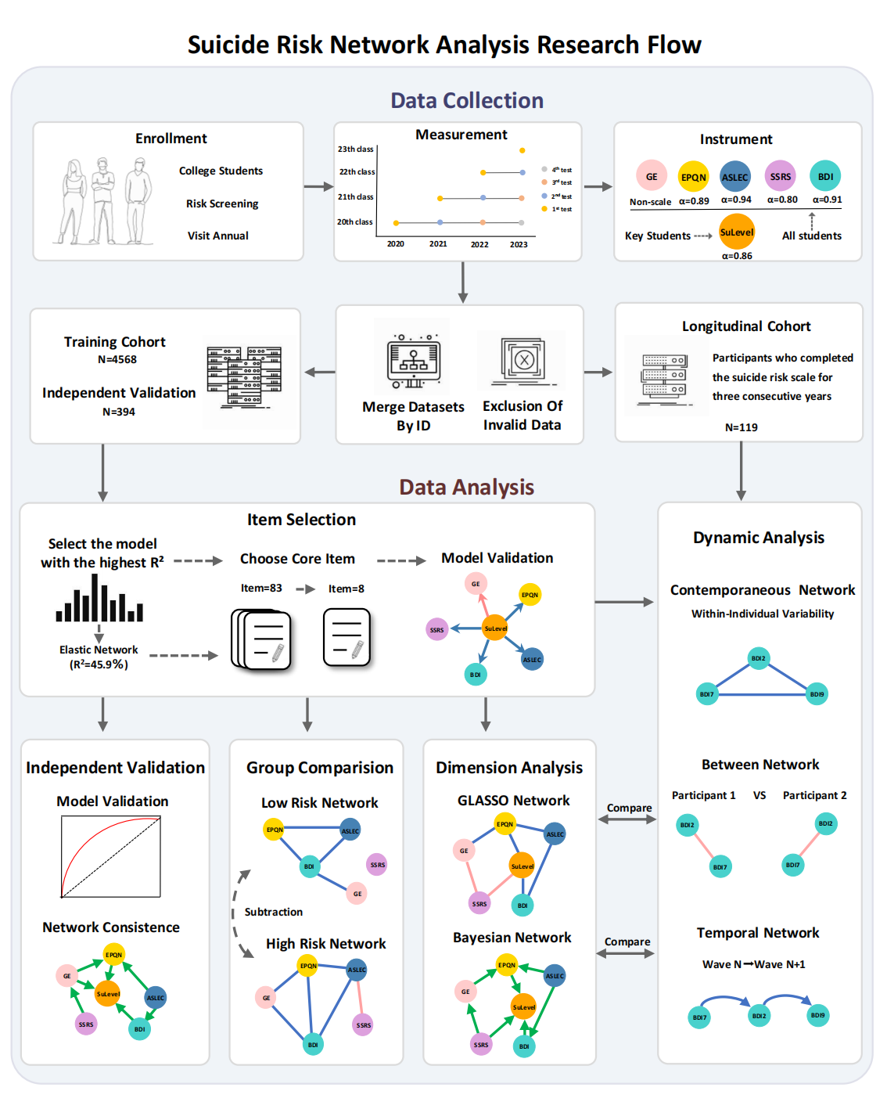
Note: Some illustrations in this flowchart are sourced from Freepik.

Fig. S2. Centrality property of the GLASSO network of the training cohort, related to Figure 2a.

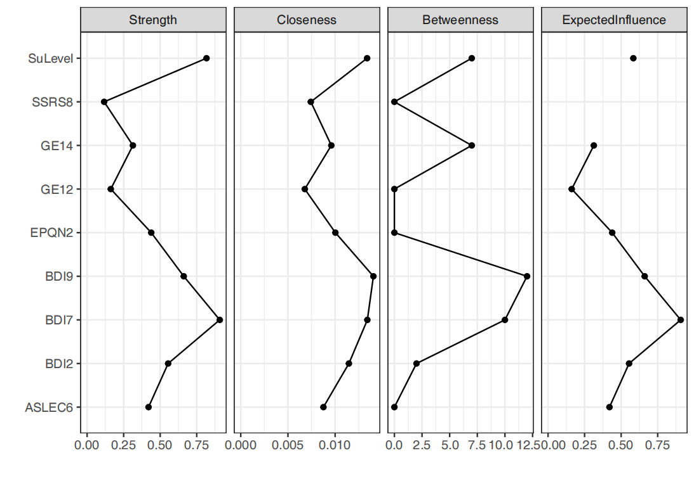
Fig. S3. External validation plots for GLASSO and Bayesian network analyses, related to Figure 2.

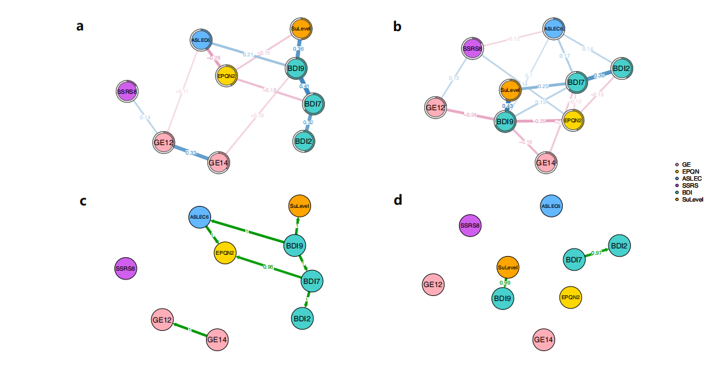
a). Validation plot of the GLASSO network based on an external training set. b). Validation plot of the GLASSO network based on an external validation set. c). Validation plot of the Bayesian network based on an external training set. d). Validation plot of the Bayesian network based on an external validation set.
The nodes in the graph are the filtered core items. The blue lines denote positive relationships, whereas the red lines indicate negative relationships, and line thickness and boldness reflect the strength of the associations. The values on the paths in the network represent the strength of the association or dependencies between the connected variables, and the directional arrows reflect the direction of the variable's influence. The green lines in the figure represent the conditional dependencies between the core items in the Bayesian network, GE, Growth Experience Subscale; GE12, mental illness; GE14, suicide history; EPQN, Eysenck Personality Questionnaire Neuroticism Subscale; EPQN2, unexplained misery; ASLEC, Adolescent Self-rating Life Events Checklist; ASLEC6, school aversion; SSRS, Social Support Rating Scale; SSRS8, help-seeking; BDI, Beck Depression Inventory; BDI2, hopelessness; BDI7, negative self-appraisal; BDI9, suicidal intent; SuLevel, suicide risk level.

Fig. S4. Sample selection process for the external validation dataset, related to Figure 4.
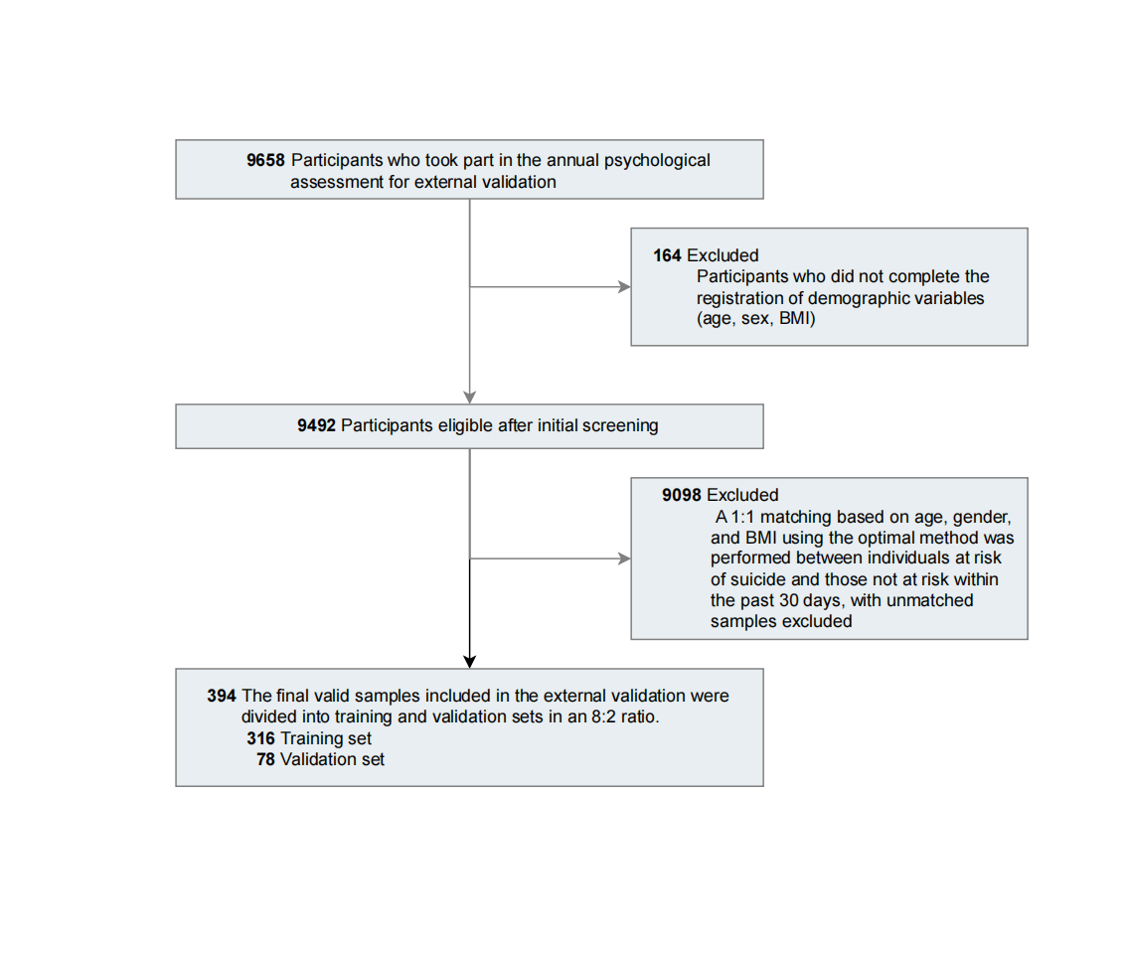

Fig. S5. Visualization of the core item screening process, related to Figure 1.

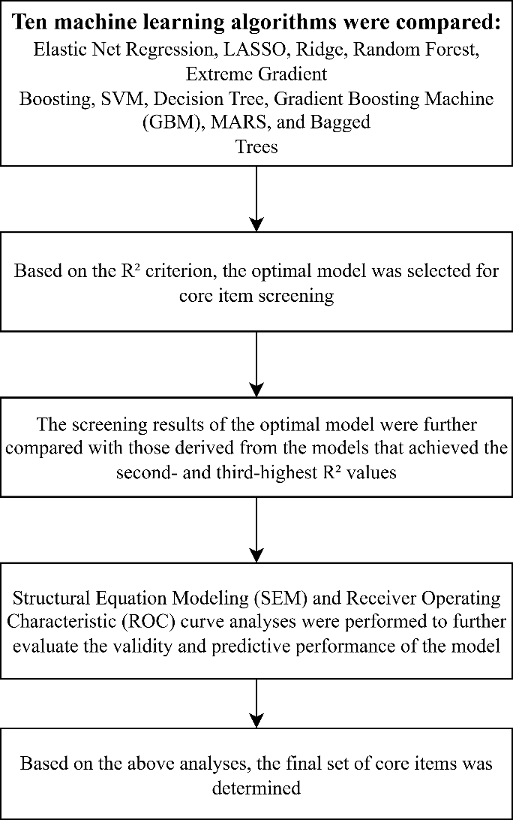

Fig. S6. Bootstrapped confidence intervals of estimated edge weights for the GLASSO network, related to Figure 2a.

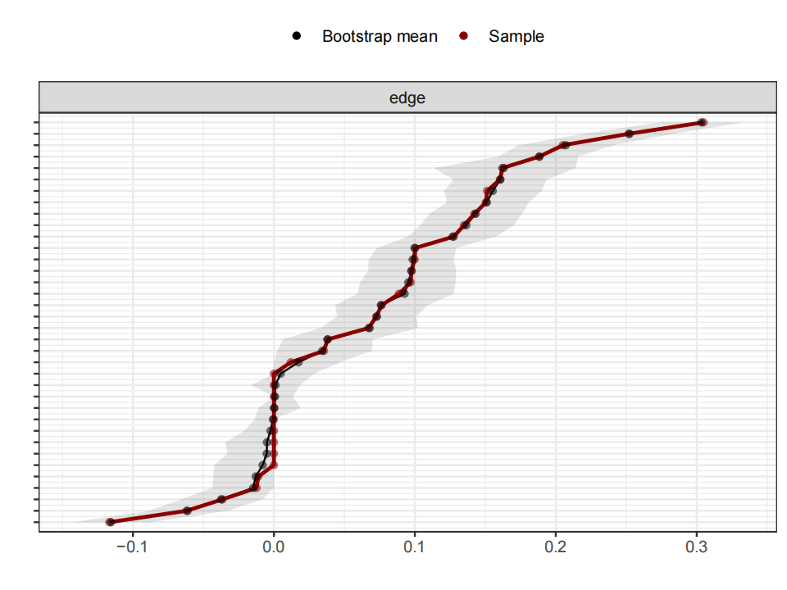
The red line indicates the sample values and the grey area the bootstrapped CIs.

Fig. S7. Bootstrapped difference test between edge weights that were non-zero in the estimated network, related to Figure 2a.
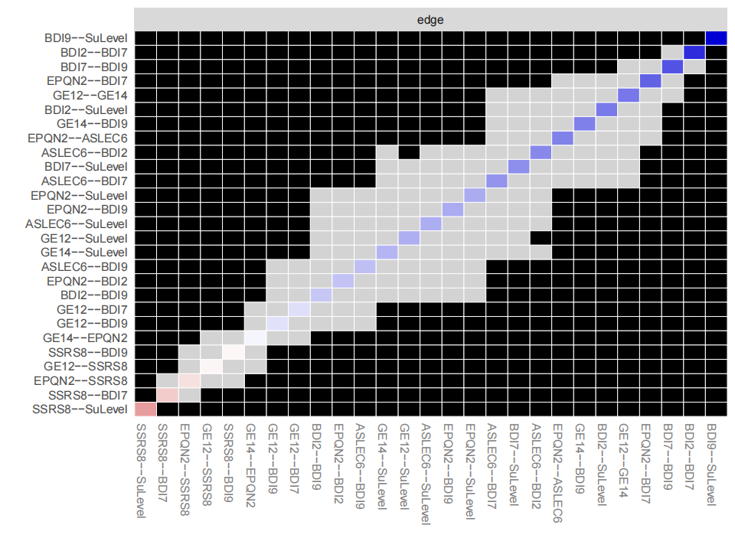Grey boxes indicate edges that do not differ significantly from one another and black boxes represent edges that differ significantly from one another.

Fig. S8. Bootstrapped difference test between node strength of the network, related to Figure 2a.

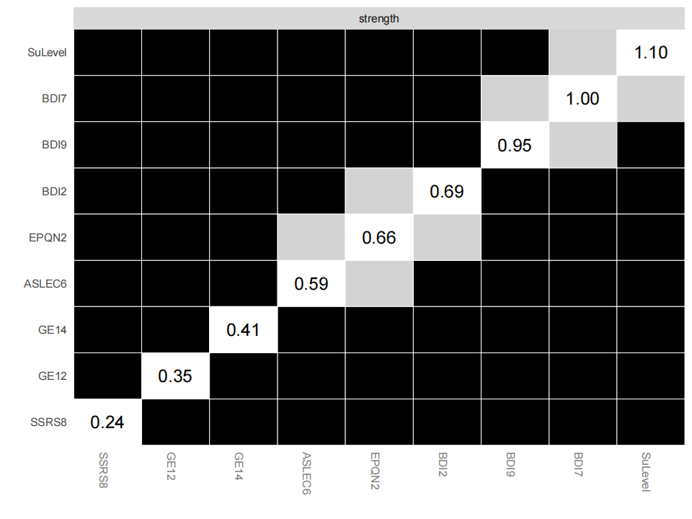
Grey boxes indicate nodes that do not differ significantly from one another and black boxes represent nodes that differ significantly from one another. The number in the white boxes (i.e., diagonal line) represent the value of node expected influences.

Fig. S9. Stability of strength centrality index, related to Figure 2a.

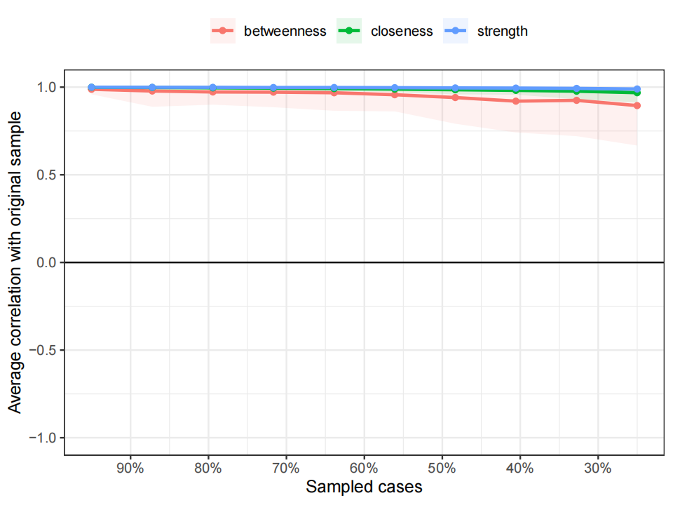
The red, green and blue lines represents the average correlation between betweenness, closeness and strength in the full sample and subsample.

Fig. S10. Centrality property of the GLASSO network of the high suicide risk cohort, related to Figure 2c.

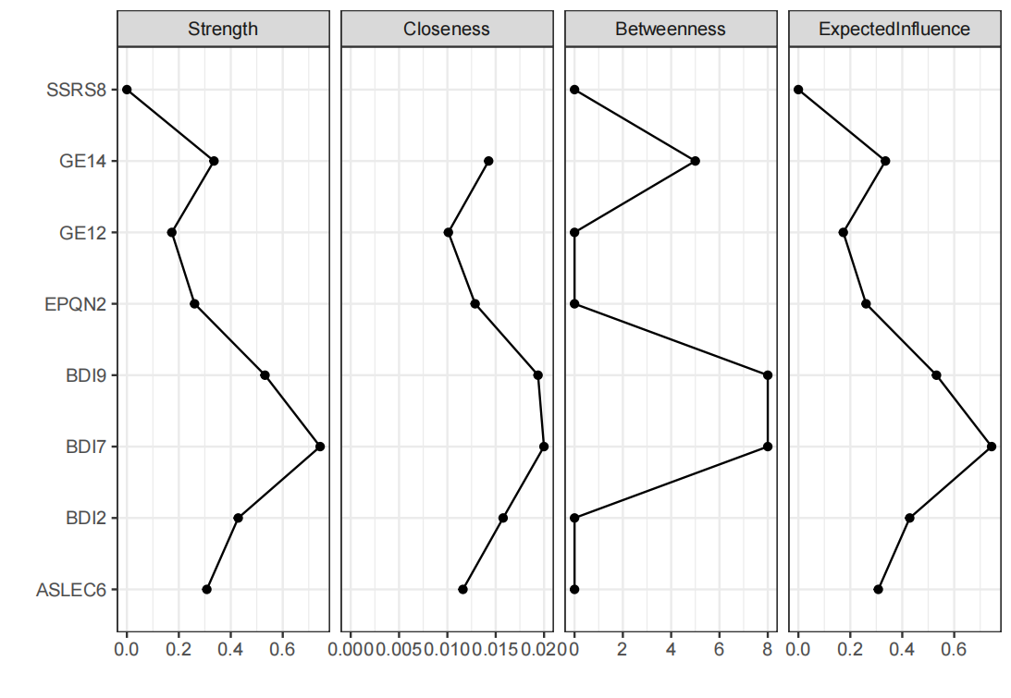

Fig. S11. Centrality property of the GLASSO network of the low suicide risk cohort, related to Figure 2d.

