Supplementary Information SI 1-5 (Altitudinal distribution and flight directions of migrating birds in the trade wind system of the western Sahara)

SI 1
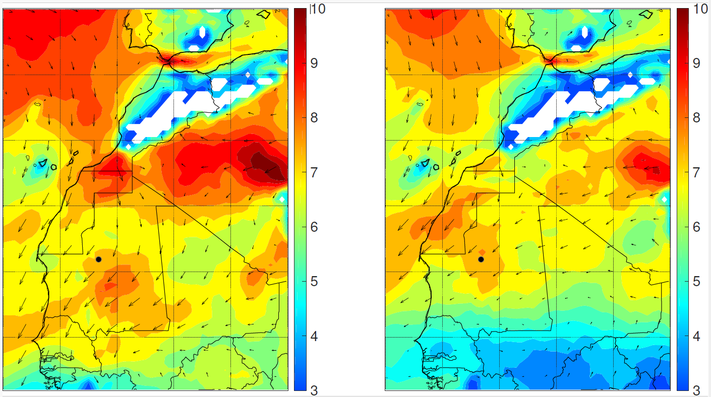
- b)
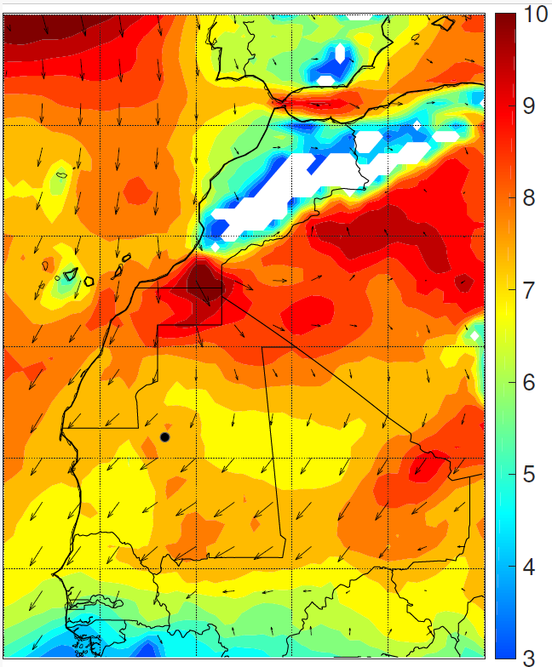
SI 1 Wind conditions over NW Africa data for the three observation periods at the 900 hPa level calculated from ERA5-reanalysis. Colours indicate average wind speeds, arrows average vectors; long vectors indicate persistent winds, short vectors indicate changing directions. The black point in central Mauritania is Ouadâne. a) spring 2003 (March-May), b) autumn 2003 (August-October), c) spring 2004 (March-May)

c)

SI 2
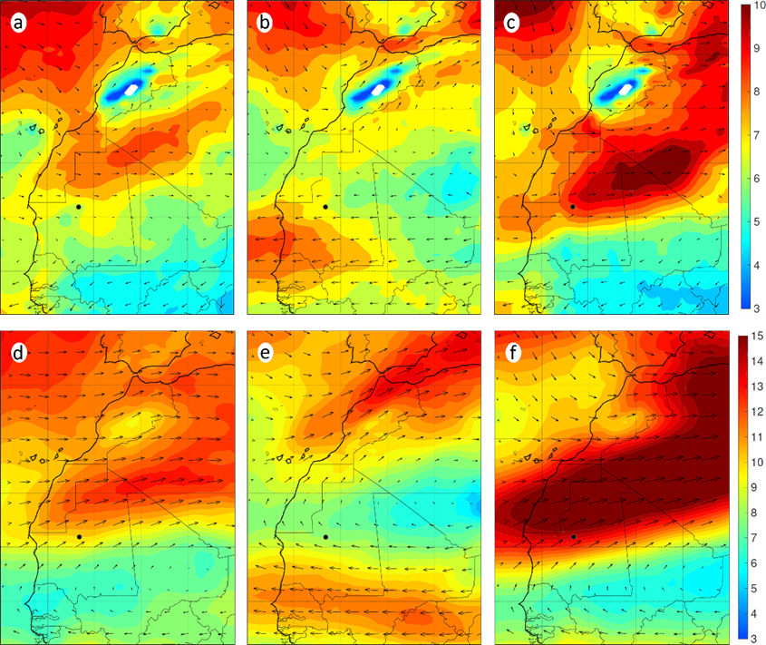
SI 2 Average wind speeds and average wind vectors over NW Africa during the three observation periods at the 800 hPa level (a-c) and at the 600 hPa level (d-f): a,d) spring 2003, b,e) autumn 2003, c,f) spring 2004. Details of the presentation as in SI 1

SI 3 and 4
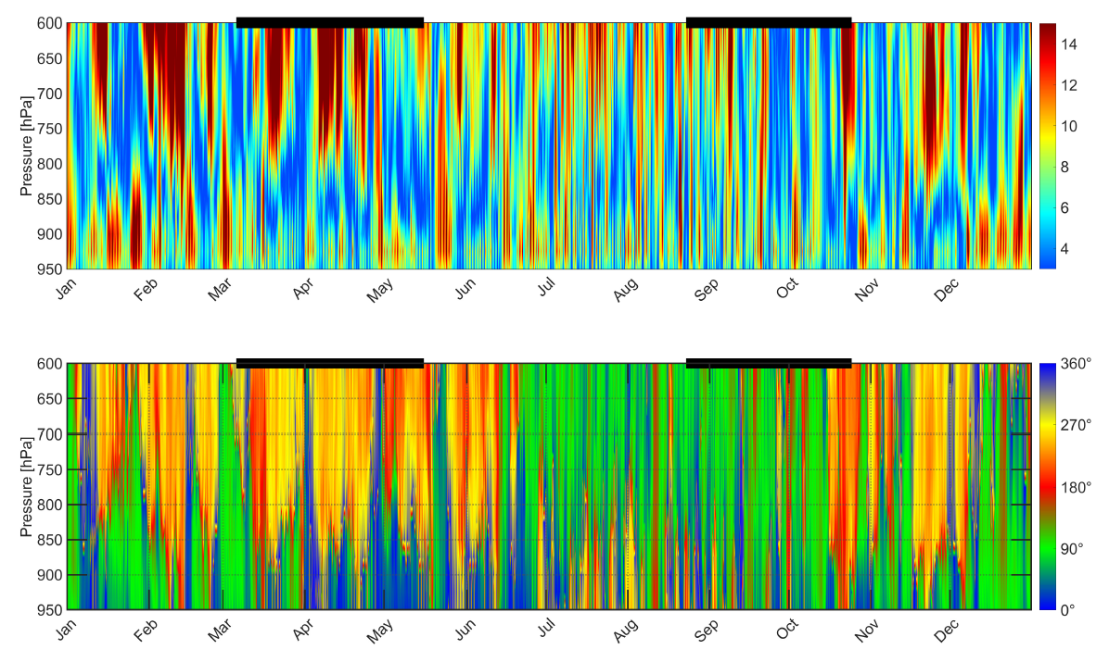
SI 3 Speed and directions of winds 2003 over Ouadâne: a) Variation of wind speed (m/s, scale to the right) with altitude and season. b) Direction of wind origin (180° = S = red, 270° = W = yellow, 0° = N = blue, 90° = E = green), derived from ERA5-reanalysis data for the region of Ouadâne. Spring and autumn migratory seasons are indicated by bold black bars at the top of the figures
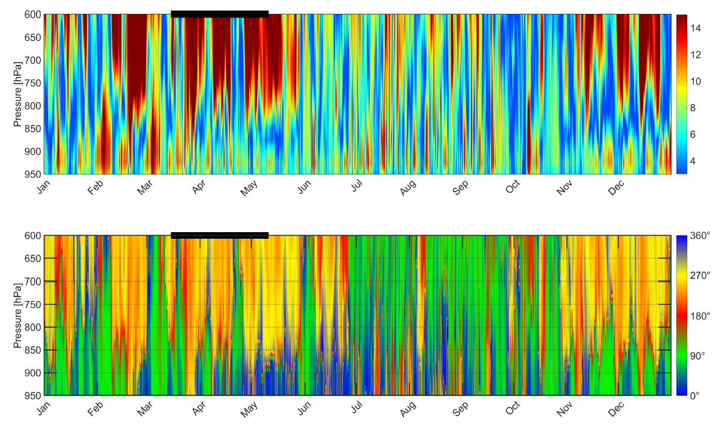
SI 4 Speed and directions of winds 2004 over Ouadâne: a) Variation of wind speed (m/s, scale to the right) with altitude and season. b) Direction of wind origin (180° = S = red, 270° = W = yellow, 0° = N = blue, 90° = E = green), derived from ERA5-reanalysis data for the region of Ouadâne. Spring migratory season is indicated by a bold black bar at the top of the figures
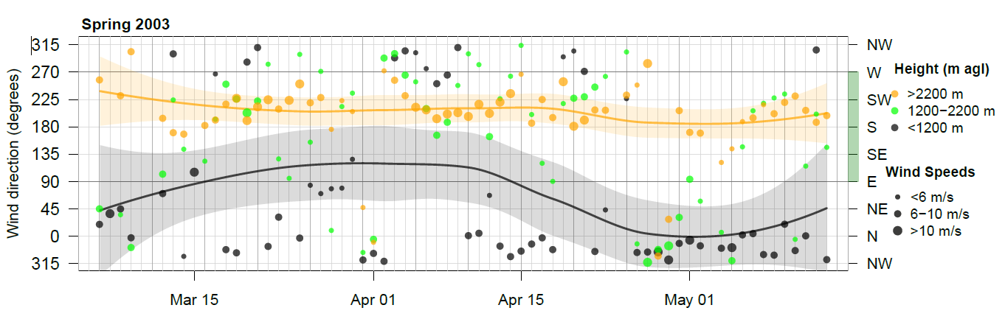
SI 5 Directions of available midnight winds above Ouadâne during spring 2003. Wind speeds indicated by the size of three points per night all along the season for three height bins. Trend lines for lowest and highest height bin indicate the variation throughout the year. Trend lines and 95% confidence intervals were obtained by fitting a local polynomial surface using the least squares methods (default loess() function in R). Range of supporting winds indicated by green shading on the right Y-Axis

