Supplementary Materials

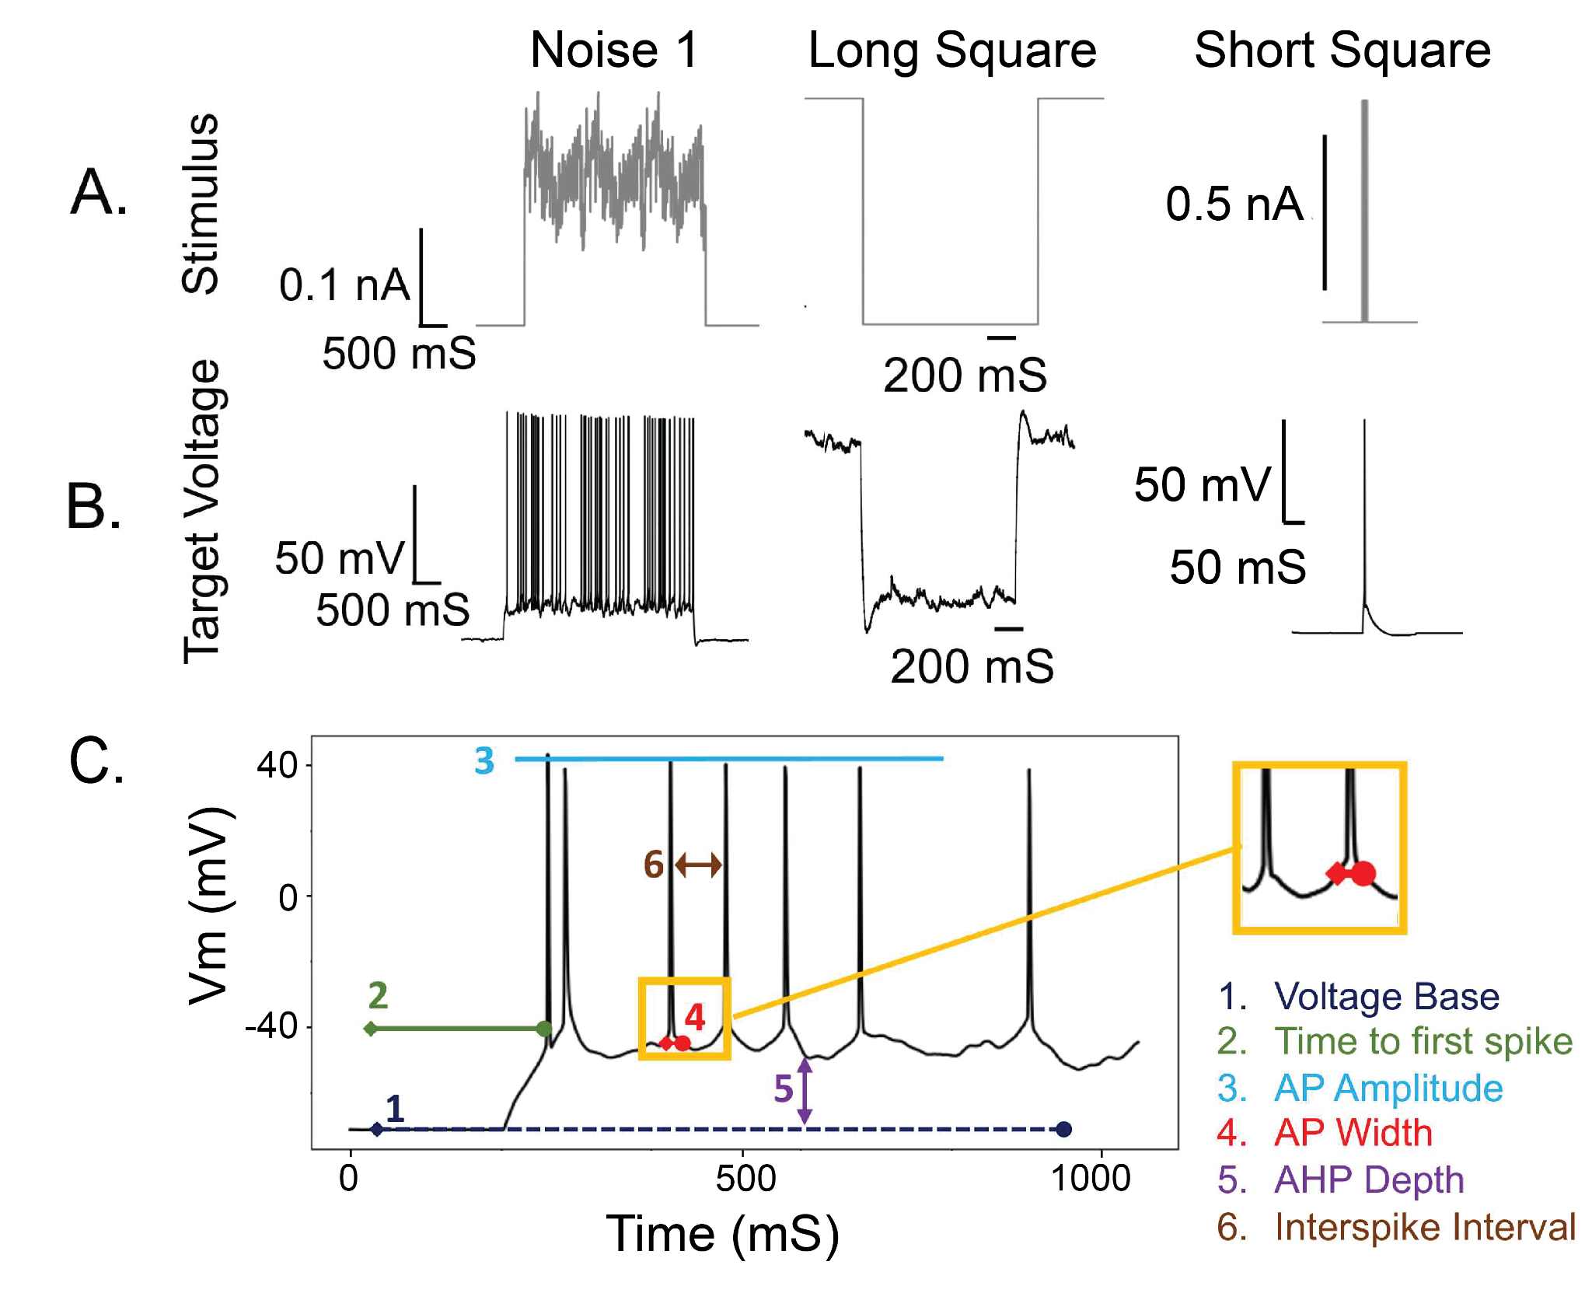
Figure S1. Stimuli and feature extraction for evolutionary algorithm fitting. (adapted from Ladd et al., 2022) A: Example stimuli protocols, noise was not used in CoMParE objectives but long square sub/subpra threshold (subthreshold shown) and short square were. B: Corresponding target voltage responses recorded from patch clamp experiments resulting from the stimuli in (A). These experimental traces represent the ground truth membrane potential dynamics that the evolutionary algorithm aims to reproduce through parameter optimization. C: Demonstration of how electrophysiological score functions are computed on a single voltage trace. eFEL+ features, including spike timing, action potential characteristics, and afterhyperpolarization properties, are extracted from both target and simulated traces. These error functions quantify the difference between experimental and model responses, forming the elementary errors that are weighted and combined in the CoMParE objective function.

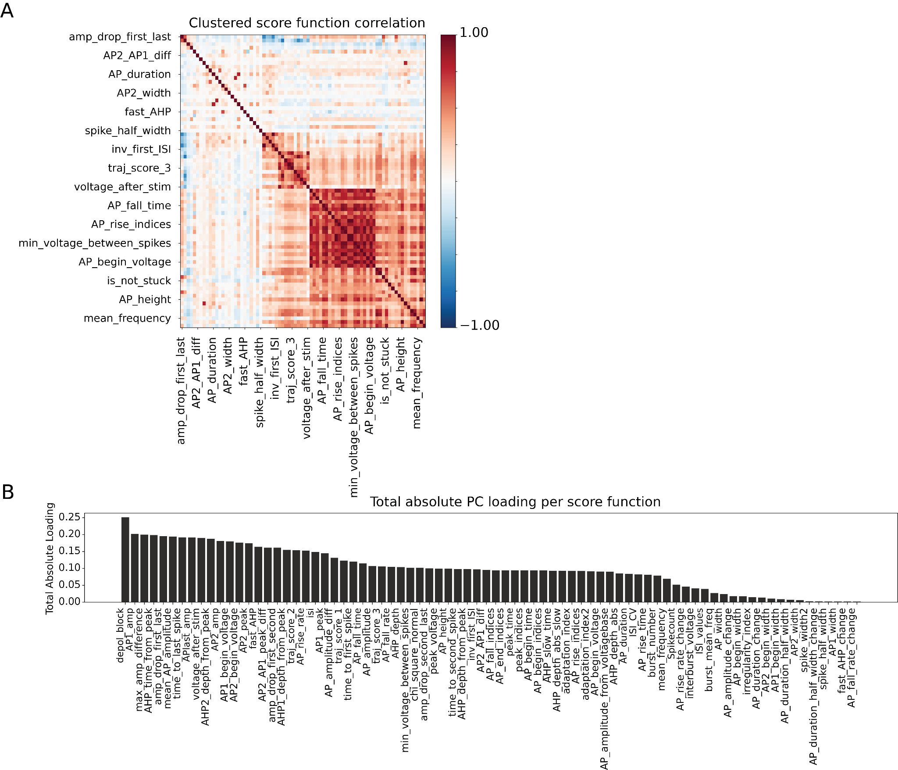
Figure S2. Multiple stimuli probe different dimensions of the electrophysiological feature space for the BBP model.
A: Covariance matrix of eFEL+ error functions computed across 5000 parameter samples for 4 stimuli. Features reordered by hierarchical clustering, revealing block structure of correlated feature groups. B: Total absolute PCA loading weight for each eFEL+ feature (summed across principal components), sorted by magnitude. Features with higher loading weights contribute more to the overall variance in the objective function space.

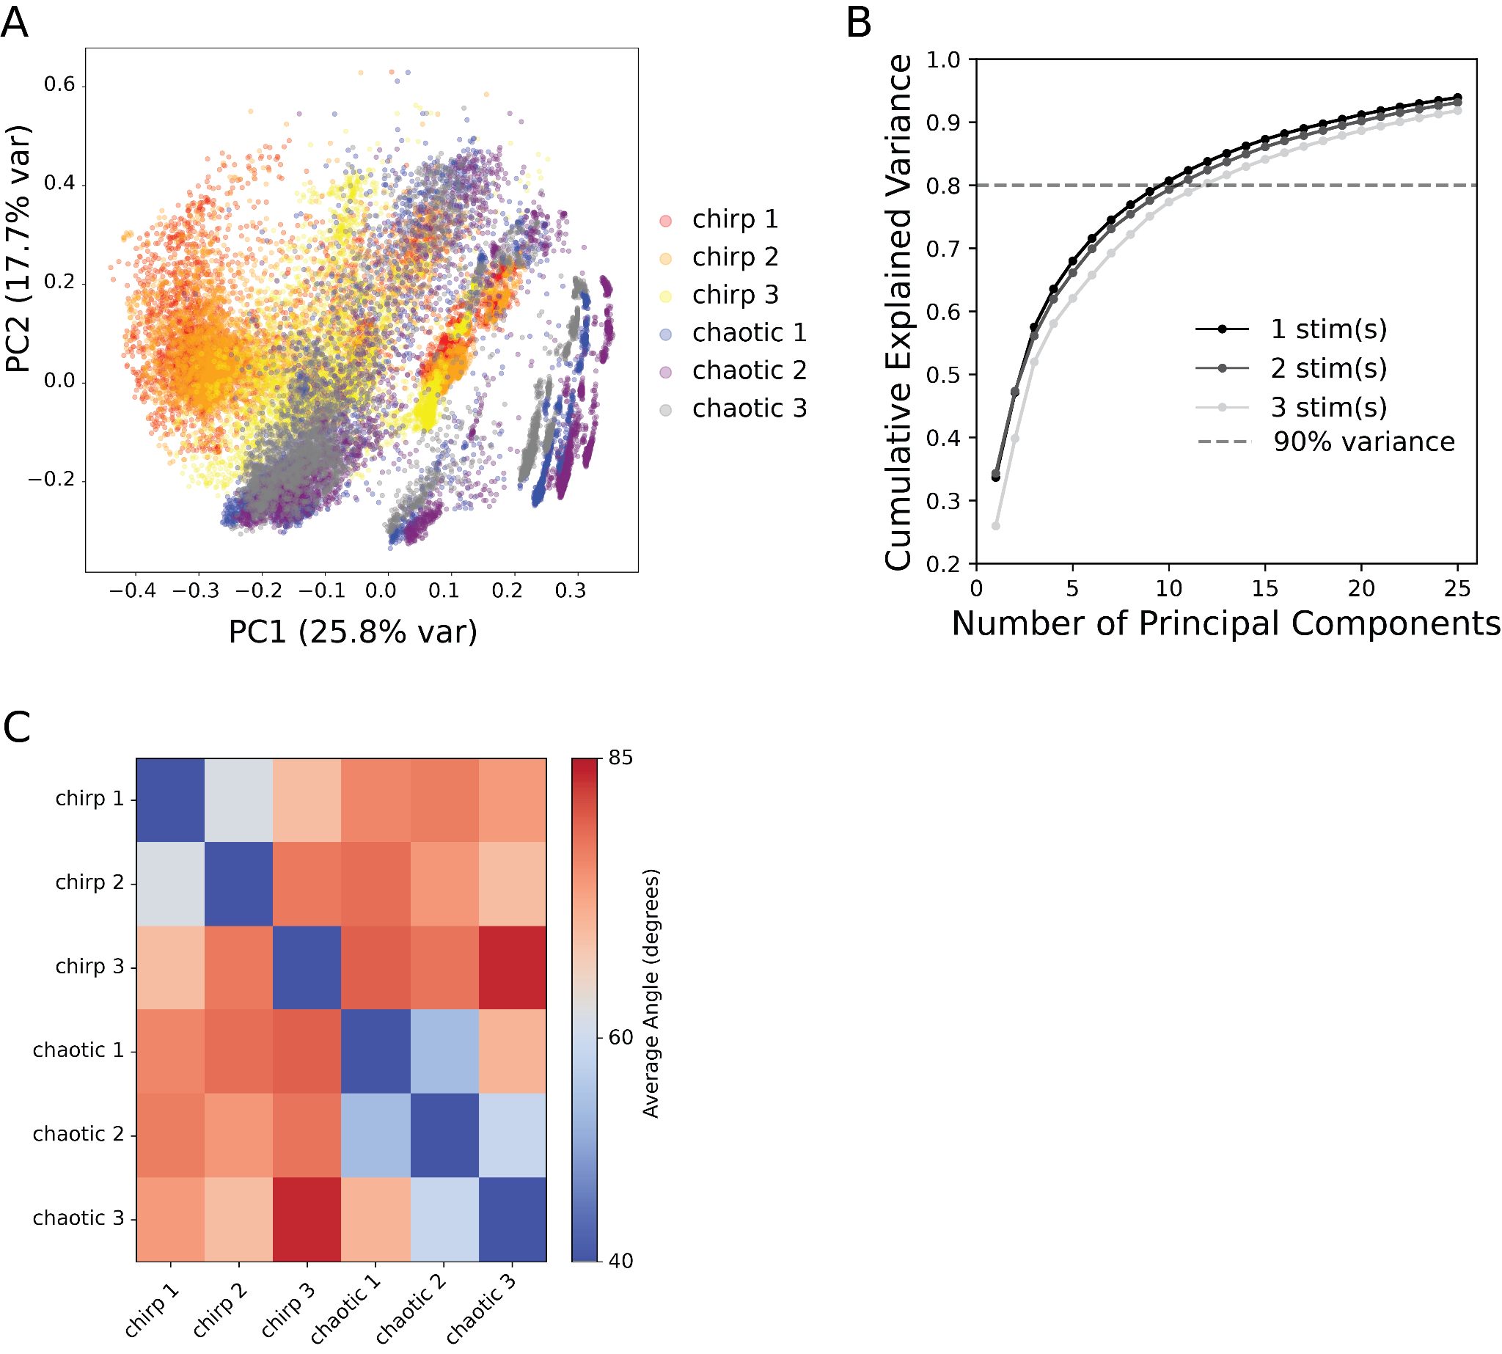

Figure S3. Principal component analysis shows additional stimuli increase the span of objective function space.
A: PCA projection of score functions onto the first two principal components for 6 stimuli (5000 parameter samples each). Each stimulus occupies a distinct region in PC space, with PC1 and PC2 explaining 26% and 18% of total variance, respectively. B: Cumulative explained variance as a function of principal component number for 1-5 stimuli. Increasing stimulus number requires more components to capture 80% of variance (dashed line), indicating that multiple stimuli explore complementary dimensions of the feature space. C: Angular similarity matrix showing average angle (in degrees) between stimuli in 10-dimensional PC space. For each stimulus pair, the angle θ between their representations is calculated as θ = arccos(v₁·v₂ / |v₁||v₂|), where v₁ and v₂ are the unit vectors of the PCA-transformed score function distributions in each principal component dimension. The displayed values represent the mean angle averaged across all 10 PC dimensions. Blue regions (≈40°) indicate high similarity with small angular separation between stimulus responses, suggesting similar electrophysiological profiles. Red regions (≈85°) indicate low similarity with near-orthogonal separation, suggesting distinct response patterns. Block structure reveals clusters of functionally related chirp and stimulus patterns.

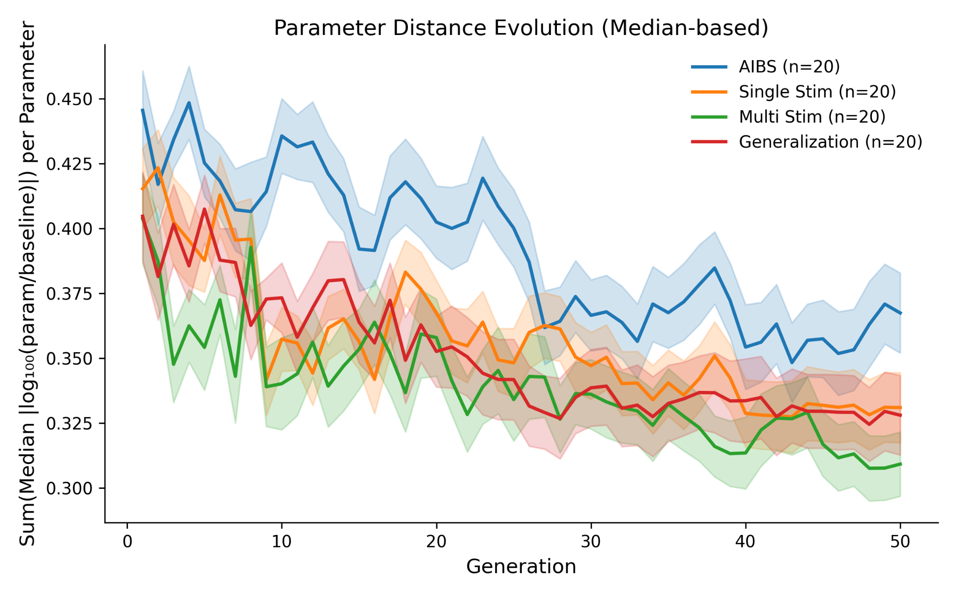
Figure S4. Distance from known target model parameters across EA (associated with Figure 3).
Each method uses an evolutionary algorithm (EA) to optimize a set of model parameters to produce electrophysiological waveforms identical to those of a BBP model with known ground-truth parameters. We measure distance from the best model to the ground truth using log₁₀₀(best_param/ground_truth) to calculate a distance for each parameter and seed pair. We take the median log distance over 20 seeds and then sum over 19 parameters to compute the distance metric on the y-axis. We plot SEM over the total error for each seed as shaded boundaries. All methods converge by generation 50. Lower distance is better. CoMParE multi-stim converges faster and to a lower overall median error. All CoMParE methods outperform the score function (employed by Gouwens et al., 2018).

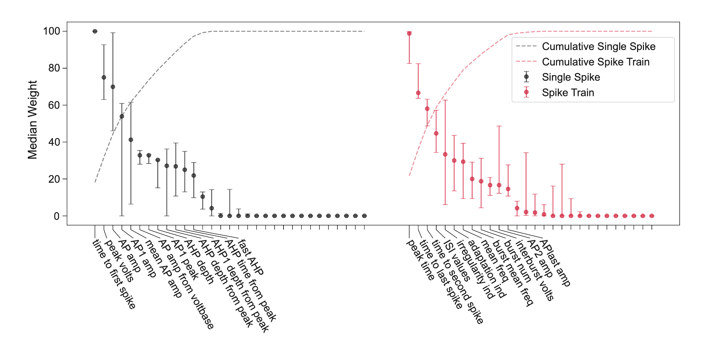
Figure S5. Weighting of individual eFEL+ features in meta-learned objective function.
Shows among which features did the CoMParE meta-learning algorithm selected as important features across all stimuli and cells. This weighting (median and interquartile range) provides interpretability which can bring electrophysiological insights relevant for accurate fitting of cells. For example, CoMParE heavily weighted spike timing features like time to first spike and peak time, both with weights of 100, which are likely sensitive to the interplay between sodium channel activation and potassium channel-mediated repolarization. This feature selection pattern suggests that CoMParE may have learned to prioritize different temporal aspects of the voltage waveform, which together provide complementary perspectives on the underlying ionic conductances. Out of widely available eFEL+ features, small subsets are chosen repeatedly across diverse stimuli and cells, yet their weight distribution varies. This behavior suggests that although a core subset of features is generally most informative for discriminating membrane potential responses, their weights must be carefully tuned to achieve the best fit for individual cells. CoMParE’s relative improvement in inferred parameter-set rank and the resulting optimized electrophysiological responses demonstrate how optimizing a linear combination of error function weights can create an empirically useful objective function.

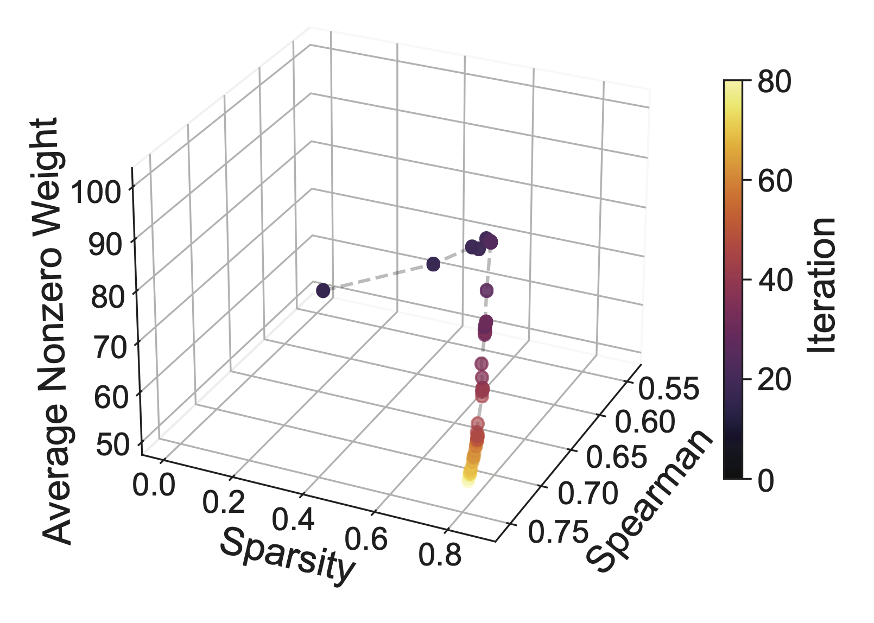
Figure S6 meta-learning trajectory from CoMParE with the BBP model.
Early iterations (dark colors) show low Spearman correlation (ρ < 0.5), but as optimization progresses (lighter colors), correlation increases, reaching final values of ρ ≈ 0.8. In addition, the weight sparsity and the average of nonzero weights show similar behavior, sharply increasing to maximum values in the early iterations but slowly converging in the later iterations. These behaviors suggest that the algorithm first explores broadly, then focuses on the most important features.

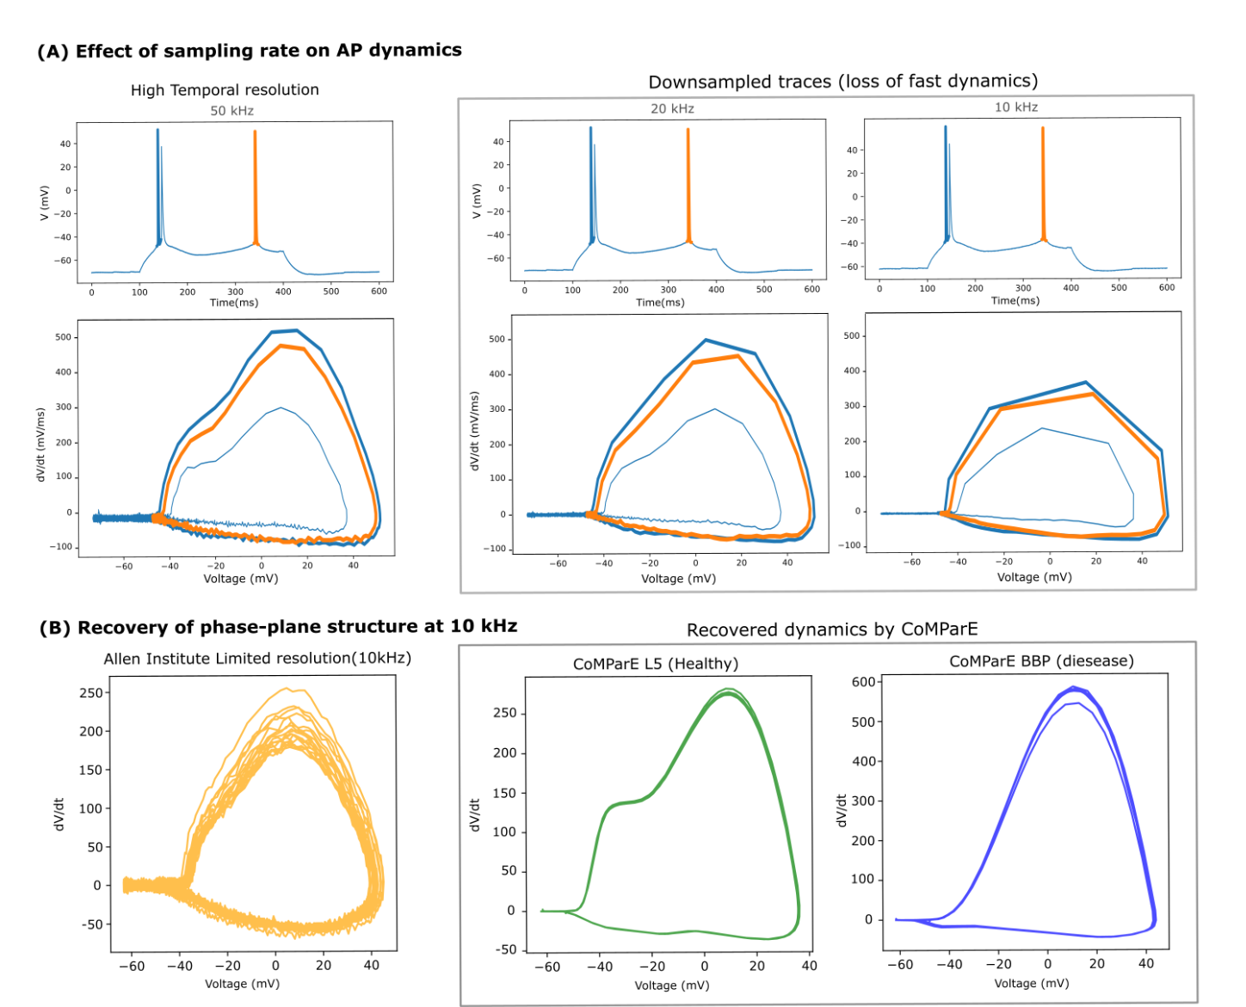

Figure S7: Effect of sampling rate on action potential dynamics and recovery of phase-plane structure using CoMParE.
(A): Voltage traces (top) and corresponding phase-plane representations (dV/dt vs. V; bottom) of the same action potential recorded at high temporal resolution (50 kHz) and after downsampling to 20 kHz and 10 kHz (adapted from Spratt et al., 2019). Reduced sampling progressively distorts spike upstroke dynamics, resulting in attenuation of peak dV/dt and deformation of phase-plane geometry. (B): Recovery of phase-plane structure at 10 kHz. Ground-truth experimental recordings from the Allen Institute are compared with dynamics recovered by CoMParE for a healthy L5 neuron and a disease-model BBP neuron. Despite limited temporal resolution, CoMParE recovers distinct and biologically interpretable action potential dynamics

Feature name | Single spike characterization | Spike train statistics | Passive | General | Feature type
peak_time |  | true |  |  | eFEL
time_to_first_spike | true | true |  |  | eFEL
time_to_last_spike |  | true |  |  | eFEL
time_to_second_spike |  | true |  |  | eFEL
inv_time_to_first_spike | true | true |  |  | eFEL
ISI_values |  | true |  |  | eFEL
all_ISI_values |  | true |  |  | eFEL
inv_ISI_values |  | true |  |  | eFEL
inv_first_ISI | true | true |  |  | eFEL
inv_second_ISI |  | true |  |  | eFEL
inv_third_ISI |  | true |  |  | eFEL
inv_fourth_ISI |  | true |  |  | eFEL
inv_fifth_ISI |  | true |  |  | eFEL
inv_last_ISI |  | true |  |  | eFEL
doublet_ISI |  | true |  |  | eFEL
ISI_semilog_slope |  | true |  |  | eFEL
ISI_log_slope |  | true |  |  | eFEL
ISI_log_slope_skip |  | true |  |  | eFEL
ISI_CV |  | true |  |  | eFEL
irregularity_index |  | true |  |  | eFEL
adaptation_index |  | true |  |  | eFEL
adaptation_index2 |  | true |  |  | eFEL
Spikecount |  | true |  |  | eFEL
Spikecount_stimint |  | true |  |  | eFEL
number_initial_spikes |  | true |  |  | eFEL
mean_frequency |  | true |  |  | eFEL
strict_burst_mean_freq |  | true |  |  | eFEL
burst_mean_freq |  | true |  |  | eFEL
strict_burst_number |  | true |  |  | eFEL
burst_number |  | true |  |  | eFEL
single_burst_ratio |  | true |  |  | eFEL
spikes_per_burst |  | true |  |  | eFEL
spikes_per_burst_diff |  | true |  |  | eFEL
spikes_in_burst1_burst2_diff |  | true |  |  | eFEL
spikes_in_burst1_burstlast_diff |  | true |  |  | eFEL
strict_interburst_voltage |  | true |  |  | eFEL
interburst_voltage |  | true |  |  | eFEL
interburst_min_values |  | true |  |  | eFEL
interburst_duration |  | true |  |  | eFEL
interburst_15percent_values |  | true |  |  | eFEL
interburst_20percent_values |  | true |  |  | eFEL
interburst_25percent_values |  | true |  |  | eFEL
interburst_30percent_values |  | true |  |  | eFEL
interburst_40percent_values |  | true |  |  | eFEL
interburst_60percent_values |  | true |  |  | eFEL
time_to_interburst_min |  | true |  |  | eFEL
time_to_postburst_slow_ahp |  | true |  |  | eFEL
postburst_min_values |  | true |  |  | eFEL
postburst_slow_ahp_values |  | true |  |  | eFEL
postburst_fast_ahp_values |  | true |  |  | eFEL
postburst_adp_peak_values |  | true |  |  | eFEL
time_to_postburst_fast_ahp |  | true |  |  | eFEL
time_to_postburst_adp_peak |  | true |  |  | eFEL
peak_voltage | true | true |  |  | eFEL
AP_amplitude | true | true |  |  | eFEL
AP1_amp | true | true |  |  | eFEL
AP2_amp |  | true |  |  | eFEL
APlast_amp |  | true |  |  | eFEL
mean_AP_amplitude | true | true |  |  | eFEL
AP_amplitude_change |  | true |  |  | eFEL
AP_amplitude_from_voltagebase | true | true |  |  | eFEL
AP1_peak | true | true |  |  | eFEL
AP2_peak |  | true |  |  | eFEL
AP2_AP1_diff |  | true |  |  | eFEL
AP2_AP1_peak_diff |  | true |  |  | eFEL
amp_drop_first_second |  | true |  |  | eFEL
amp_drop_first_last |  | true |  |  | eFEL
amp_drop_second_last |  | true |  |  | eFEL
max_amp_difference |  | true |  |  | eFEL
AP_amplitude_diff |  | true |  |  | eFEL
min_AHP_values |  | true |  |  | eFEL
AHP_depth | true | true |  |  | eFEL
AHP_depth_diff | true | true |  |  | eFEL
AHP_depth_from_peak | true | true |  |  | eFEL
AHP1_depth_from_peak | true | true |  |  | eFEL
AHP2_depth_from_peak |  | true |  |  | eFEL
AHP_time_from_peak | true | true |  |  | eFEL
fast_AHP | true | true |  |  | eFEL
fast_AHP_change | true | true |  |  | eFEL
AHP_depth_abs_slow | true | true |  |  | eFEL
AHP_depth_slow | true | true |  |  | eFEL
AHP_slow_time | true | true |  |  | eFEL
ADP_peak_values | true | true |  |  | eFEL
ADP_peak_amplitude | true | true |  |  | eFEL
depolarized_base | true | true |  |  | eFEL
min_voltage_between_spikes |  | true |  |  | eFEL
min_between_peaks_values |  | true |  |  | eFEL
AP_duration_half_width | true | true |  |  | eFEL
AP_duration_half_width_change | true | true |  |  | eFEL
AP_width | true | true |  |  | eFEL
AP_duration | true | true |  |  | eFEL
AP_duration_change | true | true |  |  | eFEL
AP_width_between_threshold | true | true |  |  | eFEL
spike_half_width | true | true |  |  | eFEL
AP1_width | true | true |  |  | eFEL
AP2_width |  | true |  |  | eFEL
APlast_width |  | true |  |  | eFEL
spike_width2 |  | true |  |  | eFEL
AP_begin_width | true | true |  |  | eFEL
AP1_begin_width |  | true |  |  | eFEL
AP2_begin_width |  | true |  |  | eFEL
AP2_AP1_begin_width_diff |  | true |  |  | eFEL
AP_begin_voltage | true | true |  |  | eFEL
AP1_begin_voltage |  | true |  |  | eFEL
AP2_begin_voltage |  | true |  |  | eFEL
AP_begin_time | true | true |  |  | eFEL
AP_peak_upstroke | true | true |  |  | eFEL
AP_peak_downstroke | true | true |  |  | eFEL
AP_rise_time | true | true |  |  | eFEL
AP_fall_time | true | true |  |  | eFEL
AP_rise_rate | true | true |  |  | eFEL
AP_fall_rate | true | true |  |  | eFEL
AP_rise_rate_change | true | true |  |  | eFEL
AP_fall_rate_change | true | true |  |  | eFEL
AP_phaseslope | true | true |  |  | eFEL
phaseslope_max | true | true |  |  | eFEL
initburst_sahp |  | true |  |  | eFEL
initburst_sahp_ssse |  | true |  |  | eFEL
initburst_sahp_vb |  |  |  |  | eFEL
steady_state_voltage_stimend |  |  |  | true | eFEL
steady_state_hyper |  |  | true |  | eFEL
steady_state_voltage |  |  |  | true | eFEL
voltage_base |  |  |  | true | eFEL
current_base |  |  |  | true | eFEL
time_constant |  |  | true |  | eFEL
decay_time_constant_after_stim |  |  |  | true | eFEL
multiple_decay_time_constant_after_stim |  |  |  | true | eFEL
sag_time_constant |  |  | true |  | eFEL
sag_amplitude |  |  | true |  | eFEL
sag_ratio1 |  |  | true |  | eFEL
sag_ratio2 |  |  | true |  | eFEL
ohmic_input_resistance |  |  |  | true | eFEL
ohmic_input_resistance_vb_ssse |  |  |  | true | eFEL
voltage_deflection_vb_ssse |  |  |  | true | eFEL
voltage_deflection |  |  |  | true | eFEL
voltage_deflection_begin |  |  |  | true | eFEL
voltage_after_stim |  |  |  | true | eFEL
minimum_voltage |  |  |  | true | eFEL
maximum_voltage |  |  |  | true | eFEL
maximum_voltage_from_voltagebase |  |  |  | true | eFEL
depol_block_bool |  |  |  | true | eFEL
impedance |  |  |  | true | eFEL
ADP_peak_indices |  |  |  |  | eFEL
AHP_depth_abs |  |  |  |  | eFEL
AP_begin_indices |  |  |  |  | eFEL
AP_end_indices |  |  |  |  | eFEL
AP_fall_indices |  |  |  |  | eFEL
AP_height |  |  |  |  | eFEL
AP_rise_indices |  |  |  |  | eFEL
burst_begin_indices |  |  |  |  | eFEL
burst_end_indices |  |  |  |  | eFEL
interburst_15percent_indices |  |  |  |  | eFEL
interburst_20percent_indices |  |  |  |  | eFEL
interburst_25percent_indices |  |  |  |  | eFEL
interburst_30percent_indices |  |  |  |  | eFEL
interburst_40percent_indices |  |  |  |  | eFEL
interburst_60percent_indices |  |  |  |  | eFEL
interburst_min_indices |  |  |  |  | eFEL
is_not_stuck |  |  |  |  | eFEL
min_AHP_indices |  |  |  |  | eFEL
min_between_peaks_indices |  |  |  |  | eFEL
peak_indices |  |  |  |  | eFEL
postburst_adp_peak_indices |  |  |  |  | eFEL
postburst_fast_ahp_indices |  |  |  |  | eFEL
postburst_min_indices |  |  |  |  | eFEL
postburst_slow_ahp_indices |  |  |  |  | eFEL
steady_state_current_stimend |  |  |  |  | eFEL
ISIs |  |  |  |  | eFEL
burst_ISI_indices |  |  |  |  | eFEL
depol_block |  |  |  |  | eFEL
trace_check |  |  |  |  | eFEL
activation_time_constant |  |  |  |  | eFEL
deactivation_time_constant |  |  |  |  | eFEL
inactivation_time_constant |  |  |  |  | eFEL
chi_square_normal |  |  |  |  | custom
traj_score |  |  |  |  | custom
rev_dot_product |  |  |  |  | custom
KL_divergence |  |  |  |  | custom
DTWDistance |  |  |  |  | custom

Table S1. List of all considered eFEL and custom features and the categorization.
The 4 categories of single spike characterization, spike train statistics, passive and general are chosen to best represent the features in described categories indicated with true marker, but not in a mutually exclusive manner. For a stimulus that produced less than 4 action potentials, only single spike characterization features were computed. If 4 or more action potentials are produced, single spike characterization, spike train statistics features were computed. For a stimulus that did not produce any action potentials, passive and general features were computed for analysis. The detailed implementation of the custom features are presented in our GitHub repository.

Param_name | Base_value | Lower_bound | Upper_bound | Fixed
gnabar_hh | 1.20E-01 | 1.20E-03 | 1.01E+01 | No
gkbar_hh | 3.60E-02 | 3.60E-04 | 3.60E+00 | No
gl_hh | 3.00E-04 | 3.00E-06 | 3.00E-02 | No

Table S2. HH model parameters and bounds.
Parameters used in the model-fitting procedure for Figure 2.

Param name | Base value | Lower bound | Upper bound | Fixed
gIhbar_Ih_basal | 8.00E-05 | 8.00E-05 | 8.00E-05 | Yes
gNaTs2_tbar_NaTs2_t_apical | 2.61E-02 | 2.61E-03 | 2.61E-01 | No
gSKv3_1bar_SKv3_1_apical | 4.23E-03 | 4.23E-04 | 4.23E-02 | No
gIhbar_Ih_apical | 8.00E-05 | 8.00E-06 | 8.00E-04 | No
gImbar_Im_apical | 1.43E-04 | 1.43E-05 | 1.43E-03 | No
gNaTa_tbar_NaTa_t_axonal | 3.14E+00 | 3.14E-01 | 3.14E+01 | No
gK_Tstbar_K_Tst_axonal | 8.93E-02 | 8.93E-03 | 8.93E-01 | No
gamma_CaDynamics_E2_axonal | 2.91E-03 | 2.91E-03 | 2.91E-03 | Yes
gNap_Et2bar_Nap_Et2_axonal | 6.83E-03 | 6.83E-04 | 6.83E-02 | No
gSK_E2bar_SK_E2_axonal | 7.10E-03 | 7.10E-04 | 7.10E-02 | No
gCa_HVAbar_Ca_HVA_axonal | 9.90E-04 | 9.90E-05 | 9.90E-03 | No
gK_Pstbar_K_Pst_axonal | 9.74E-01 | 9.74E-02 | 9.74E+00 | No
gSKv3_1bar_SKv3_1_axonal | 1.02E+00 | 1.02E-01 | 1.02E+01 | No
decay_CaDynamics_E2_axonal | 2.87E+02 | 2.87E+02 | 2.87E+02 | Yes
gCa_LVAstbar_Ca_LVAst_axonal | 8.75E-03 | 8.75E-04 | 8.75E-02 | No
gamma_CaDynamics_E2_somatic | 6.09E-04 | 6.09E-04 | 6.09E-04 | Yes
gSKv3_1bar_SKv3_1_somatic | 3.03E-01 | 3.03E-02 | 3.03E+00 | No
gSK_E2bar_SK_E2_somatic | 8.41E-03 | 8.41E-04 | 8.41E-02 | No
gCa_HVAbar_Ca_HVA_somatic | 9.94E-04 | 9.94E-05 | 9.94E-03 | No
gNaTs2_tbar_NaTs2_t_somatic | 9.84E-01 | 9.84E-02 | 9.84E+00 | No
gIhbar_Ih_somatic | 8.00E-05 | 8.00E-06 | 8.00E-04 | No
decay_CaDynamics_E2_somatic | 2.10E+02 | 2.10E+02 | 2.10E+02 | Yes
gCa_LVAstbar_Ca_LVAst_somatic | 3.33E-04 | 3.33E-05 | 3.33E-03 | No
g_pas | 3.00E-05 | 3.00E-06 | 3.00E-04 | No
Table S3. BBP model.
Parameters used in the model-fitting procedure for Figure 3.

Param name | Base value | Lower bound | Upper bound | Fixed
g_pas_all | 4.46E-06 | 4.46E-08 | 4.46E-05 | No
e_pas_all | 9.26E+01 | 6.00E+01 | 1.00E+02 | No
gNaTa_tbar_NaTa_t_axonal | 1.27E+00 | 1.27E-02 | 1.00E+01 | No
gK_Tstbar_K_Tst_axonal | 7.62E+00 | 7.62E-02 | 1.00E+01 | No
gNap_Et2bar_Nap_Et2_axonal | 2.70E-04 | 2.70E-06 | 5.70E-03 | No
gK_Pstbar_K_Pst_axonal | 1.85E+00 | 1.85E-02 | 1.00E+01 | No
gSKv3_1bar_SKv3_1_axonal | 8.34E-01 | 8.34E-03 | 8.34E+00 | No
gCa_LVAstbar_Ca_LVAst_axonal | 3.45E+00 | 3.45E-02 | 1.00E+01 | No
gCa_HVAbar_Ca_HVA_axonal | 8.43E-02 | 4.43E-04 | 8.43E-01 | No
gSKv3_1bar_SKv3_1_somatic | 3.37E-01 | 3.37E-03 | 3.37E+00 | No
gCa_HVAbar_Ca_HVA_somatic | 2.31E-04 | 2.31E-06 | 2.31E-03 | No
gNaTs2_tbar_NaTs2_t_somatic | 1.87E+00 | 1.87E-02 | 1.00E+01 | No
gCa_LVAstbar_Ca_LVAst_somatic | 6.21E-02 | 6.21E-04 | 6.21E-01 | No
gIh_dend | 3.76E-04 | 3.76E-06 | 3.76E-03 | No
cm_all | 1.90E+00 | 5.00E-01 | 3.00E+00 | No
cm_apical_basal | 5.35E-01 | 5.00E-01 | 3.00E+00 | No
Table S4. CoMParE BBP model.
Parameters used in the model-fitting procedure for Figure 4 and 5.

Param name | Base value | Lower bound | Upper bound | Fixed
dend_na12 | 1.77E-02 | 1.77E-03 | 1.77E-01 | No
soma_na12 | 4.53E-04 | 4.53E-05 | 4.53E-03 | No
ais_na12 | 3.20E-01 | 3.20E-02 | 3.20E+00 | No
dend_na16 | 3.67E-07 | 3.67E-08 | 3.67E-06 | No
soma_na16 | 5.87E-01 | 5.87E-02 | 5.87E+00 | No
ais_na16 | 3.80E-02 | 3.80E-03 | 3.80E-01 | No
ais_ca | 6.59E-07 | 6.59E-08 | 6.59E-06 | No
ais_KCa | 4.24E-05 | 4.24E-06 | 4.24E-04 | No
axon_KP | 1.08E-01 | 1.08E-03 | 1.16E+00 | No
axon_KT | 1.20E-02 | 1.20E-04 | 1.13E+00 | No
axon_K | 2.69E-01 | 2.69E-03 | 2.76E+00 | No
axon_KCa | 1.17E-01 | 1.17E-02 | 1.12E+00 | No
axon_HVA | 2.58E-08 | 2.58E-09 | 2.58E-07 | No
axon_LVA | 1.49E-06 | 1.26E-07 | 1.26E-04 | No
node_na | 5.38E+00 | 2.00E-02 | 1.00E+01 | No
soma_K | 2.18E-01 | 2.22E-04 | 2.22E+00 | No
dend_K | 2.37E-02 | 2.37E-03 | 4.23E-01 | No
gpas_soma | 6.81E-07 | 9.20E-10 | 3.00E-06 | No
gpas_apical | 3.41E-08 | 9.20E-10 | 3.00E-06 | No
gpas_basal | 1.24E-08 | 9.20E-10 | 3.00E-06 | No
gpas_axon | 2.15E-04 | 2.15E-07 | 2.15E-03 | No
cm_all | 1.93E+00 | 5.00E-01 | 3.00E+00 | No
cm_axon | 1.70E+00 | 5.00E-01 | 3.00E+00 | No
e_pas_all | 8.42E+01 | 6.00E+01 | 1.10E+02 | No
e_pas_axon | 8.01E+01 | 6.00E+01 | 1.10E+02 | No
ih_dend | 3.76E-04 | 3.76E-06 | 3.76E-03 | No
Table S5. CoMParE L5 AIS model.
Parameters used in the model-fitting procedure for Figure 5.

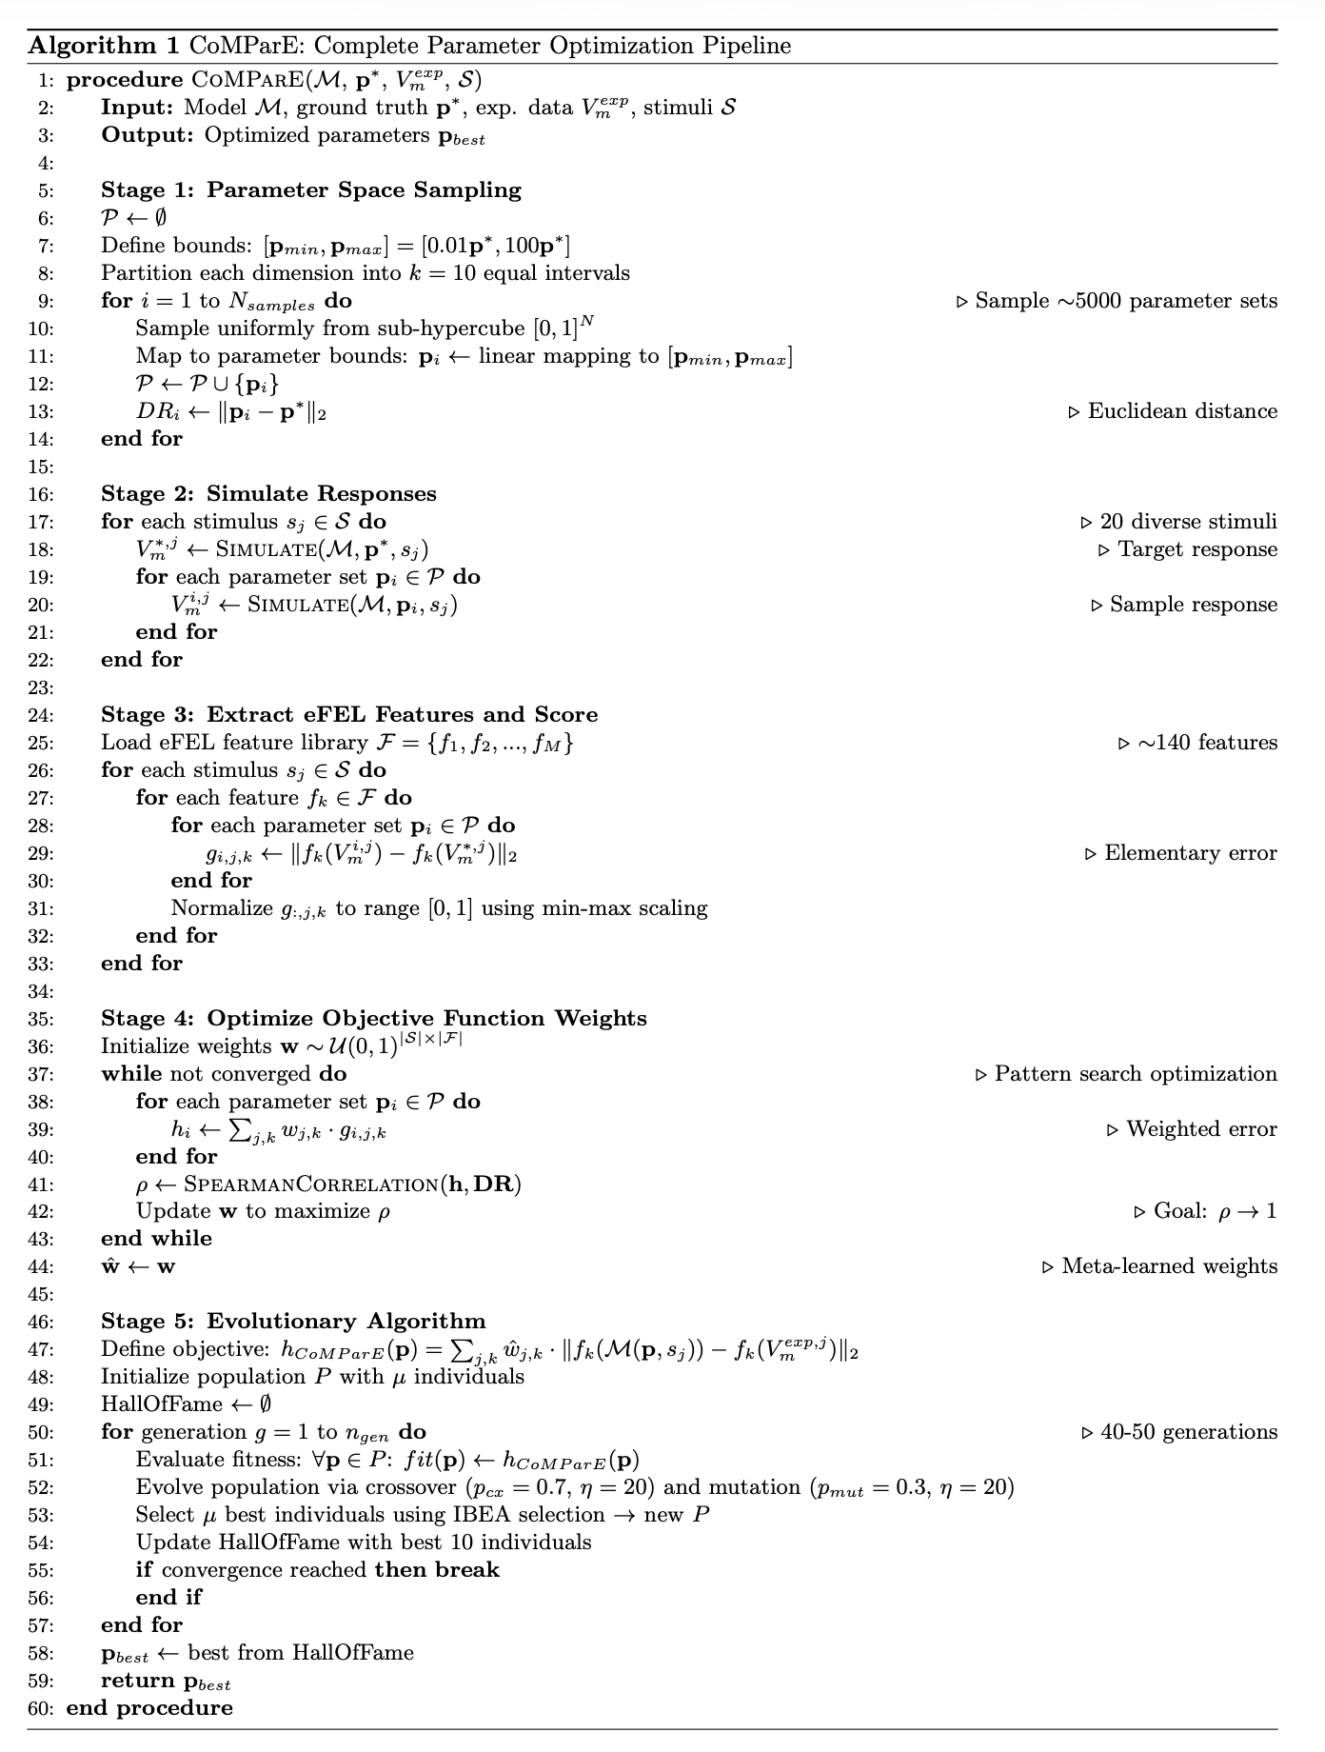
Supplementary Pseudocode.

