Supplementary Materials
Supplementary Table S1. Summary comparison of discontinuous-fiber composite manufacturing methods.
Method | Strength  (MPa) | Length  (mm) | Alignment class | End/topology class | Processability  avg. (/5) | Rationale
Gantry-based method | 550 | 50 | Highly aligned | Uniform end planes | 4.97 | Direct-to-part deposition using compact, low-cost, simple alignment hardware.
GMT | 38 | 25 | Short random whiskers | Distributed/staggered ends | 4.40 | Prepreg-like route with high processability but low alignment control.
Vacuum drum (1980) | 1200 | NR | Highly aligned | Distributed/staggered ends | 4.28 | Simple alignment route but requires vacuum collection and compression molding.
Glycerine | 290 | NR | Unaligned short fibres | Distributed/staggered ends | 3.05 | Indirect processing with relatively complex tooling.
Centrifuge | 1211 | 3 | Highly aligned | Distributed/staggered ends | 2.92 | Large tooling and indirect feedstock preparation.
DCFP | 293 | 100 | Unaligned short fibres | Distributed/staggered ends | 2.90 | Indirect processing with moderate scores across criteria.
Laser drilled | 1500 | NR | Highly aligned | Patterned discontinuity | 2.70 | Requires prepreg and laser patterning.
Disco | 1100 | 3 | Unaligned short fibres | Distributed/staggered ends | 2.55 | Moderate processability but limited by directness and cost.
Acoustic | 110 | 4.5 | Unaligned short fibres | Distributed/staggered ends | 2.42 | Acoustic alignment adds complexity and uses short fibers.
Ultrasonic | 45 | 0.05 | Short random whiskers | Distributed/staggered ends | 2.23 | Complex alignment route and very short reinforcement length.
DiscoTex | 535 | 32 | Unaligned short fibres | Patterned discontinuity | 1.77 | Limited published process detail; appears manually intensive.
HiPerDiF | 1509 | 3 | Highly aligned | Distributed/staggered ends | 1.15 | High alignment quality but complex and indirect feedstock preparation.
Scoring definitions: Directness, alignment simplicity, reproducibility, and cost were rated on a 0-5 scale, where higher values indicate more favorable processability. The processability average is the mean of the four criteria. NR indicates that the fiber/tow length was not reported in the dataset.

Supplementary Table S2. Processability scoring values used to calculate the average score.
Method | Directness | Alignment  simplicity | Reproducibility | Cost score | Processability  avg. (/5)
Gantry-based method | 5.0 | 5.0 | 5.0 | 4.9 | 4.97
GMT | 3.0 | 4.0 | 4.0 | 4.9 | 4.40
Vacuum drum (1980) | 3.6 | 4.4 | 4.0 | 4.0 | 4.28
Glycerine | 3.2 | 2.9 | 2.8 | 3.3 | 3.05
Centrifuge | 3.4 | 2.1 | 3.2 | 3.0 | 2.92
DCFP | 3.2 | 2.7 | 2.9 | 2.8 | 2.90
Laser drilled | 2.1 | 4.0 | 3.1 | 1.6 | 2.70
Disco | 3.2 | 2.1 | 2.0 | 2.9 | 2.55
Acoustic | 3.0 | 2.0 | 2.6 | 2.1 | 2.42
Ultrasonic | 2.8 | 1.6 | 2.5 | 2.0 | 2.23
DiscoTex | 1.5 | 3.0 | 1.1 | 1.5 | 1.77
HiPerDiF | 1.1 | 1.4 | 0.8 | 1.3 | 1.15
Note: The cost score is defined so that higher scores correspond to lower cost, lower equipment burden, or lower practical barrier to adoption.

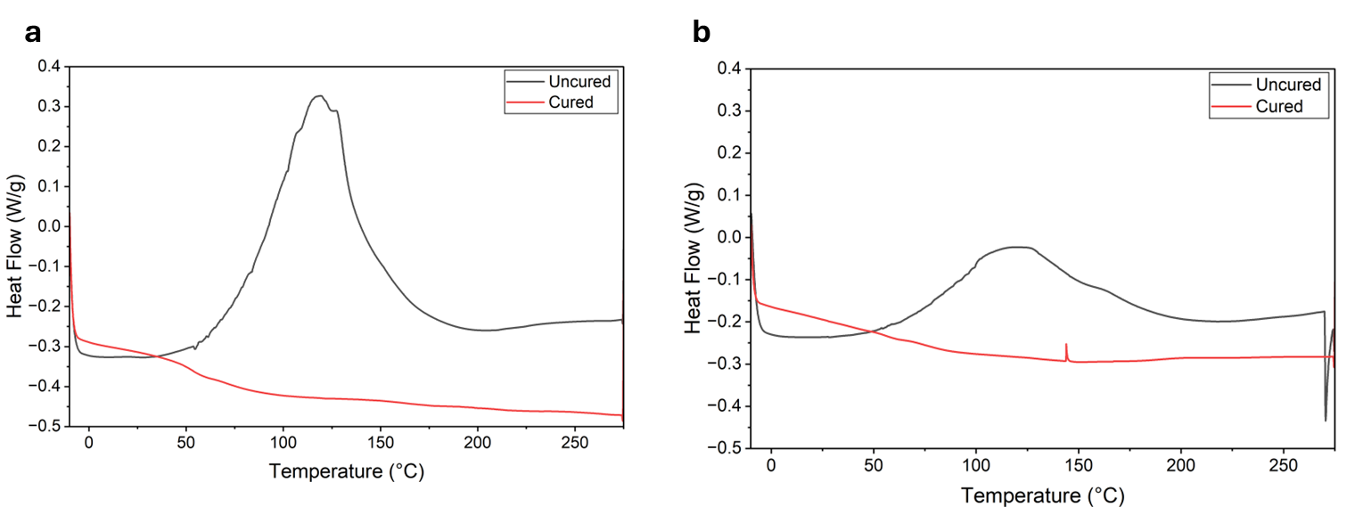
Supplementary Figure 1. DSC results for the hybrid UV resin combinations a) 0. wt% TI and b) .25 .wt% TI.

Data shows that all portions of the standard epoxy infusion resin are fully cured, and the TI has been fully reacted, resulting in no heat release.

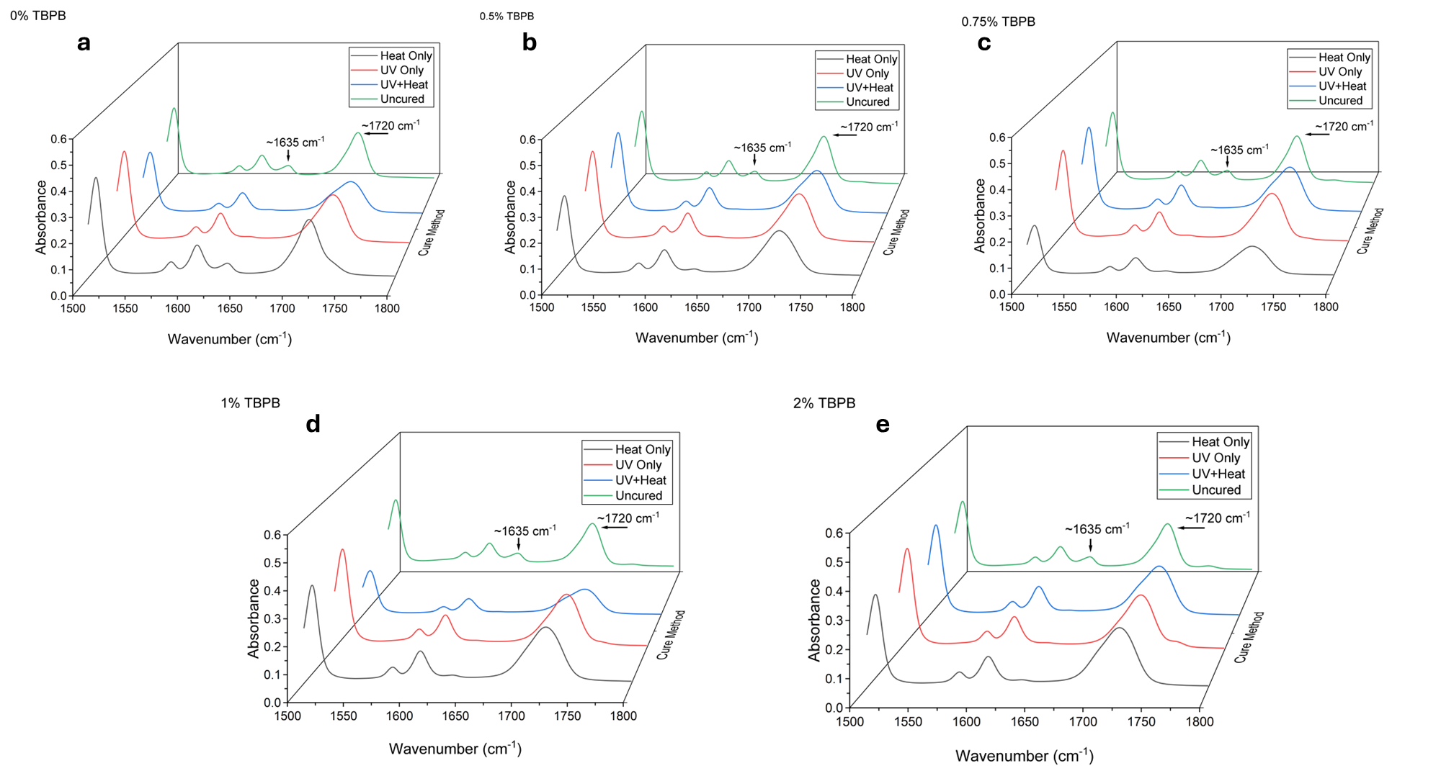
Supplementary Figure 2. FTIR spectra of resin formulations containing different TBPB concentrations under different curing conditions. Representative absorbance spectra in the 1500–1800 cm⁻¹ region for formulations containing (a) 0%, (b) 0.5%, (c) 0.75%, (d) 1%, and (e) 2% TBPB.

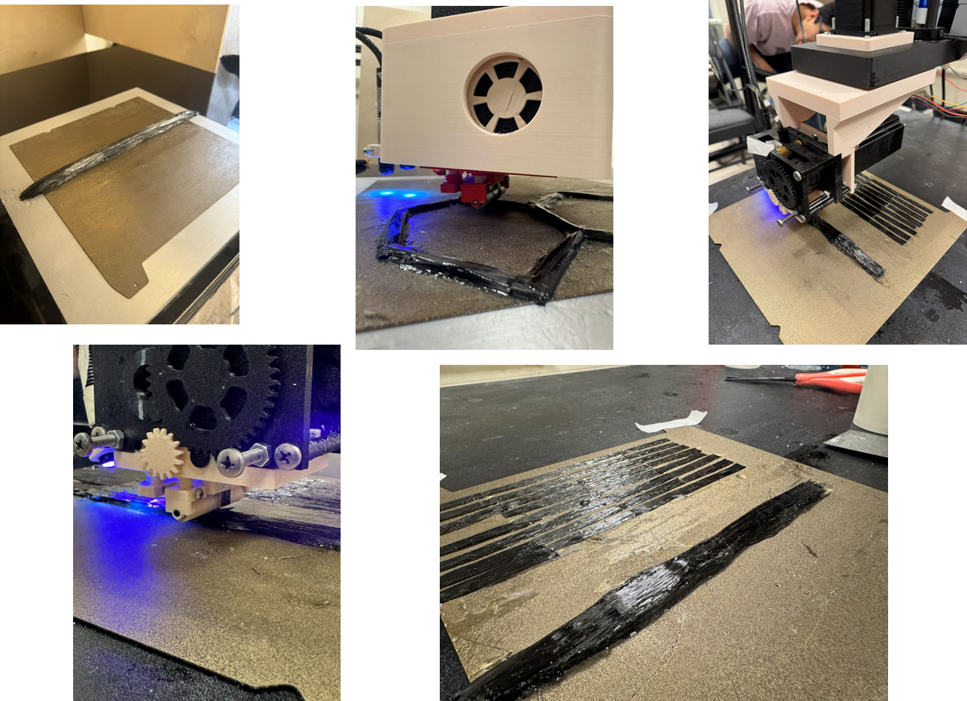
Supplementary Figure 3. Examples of additive manufacturing structures presented in this work.

