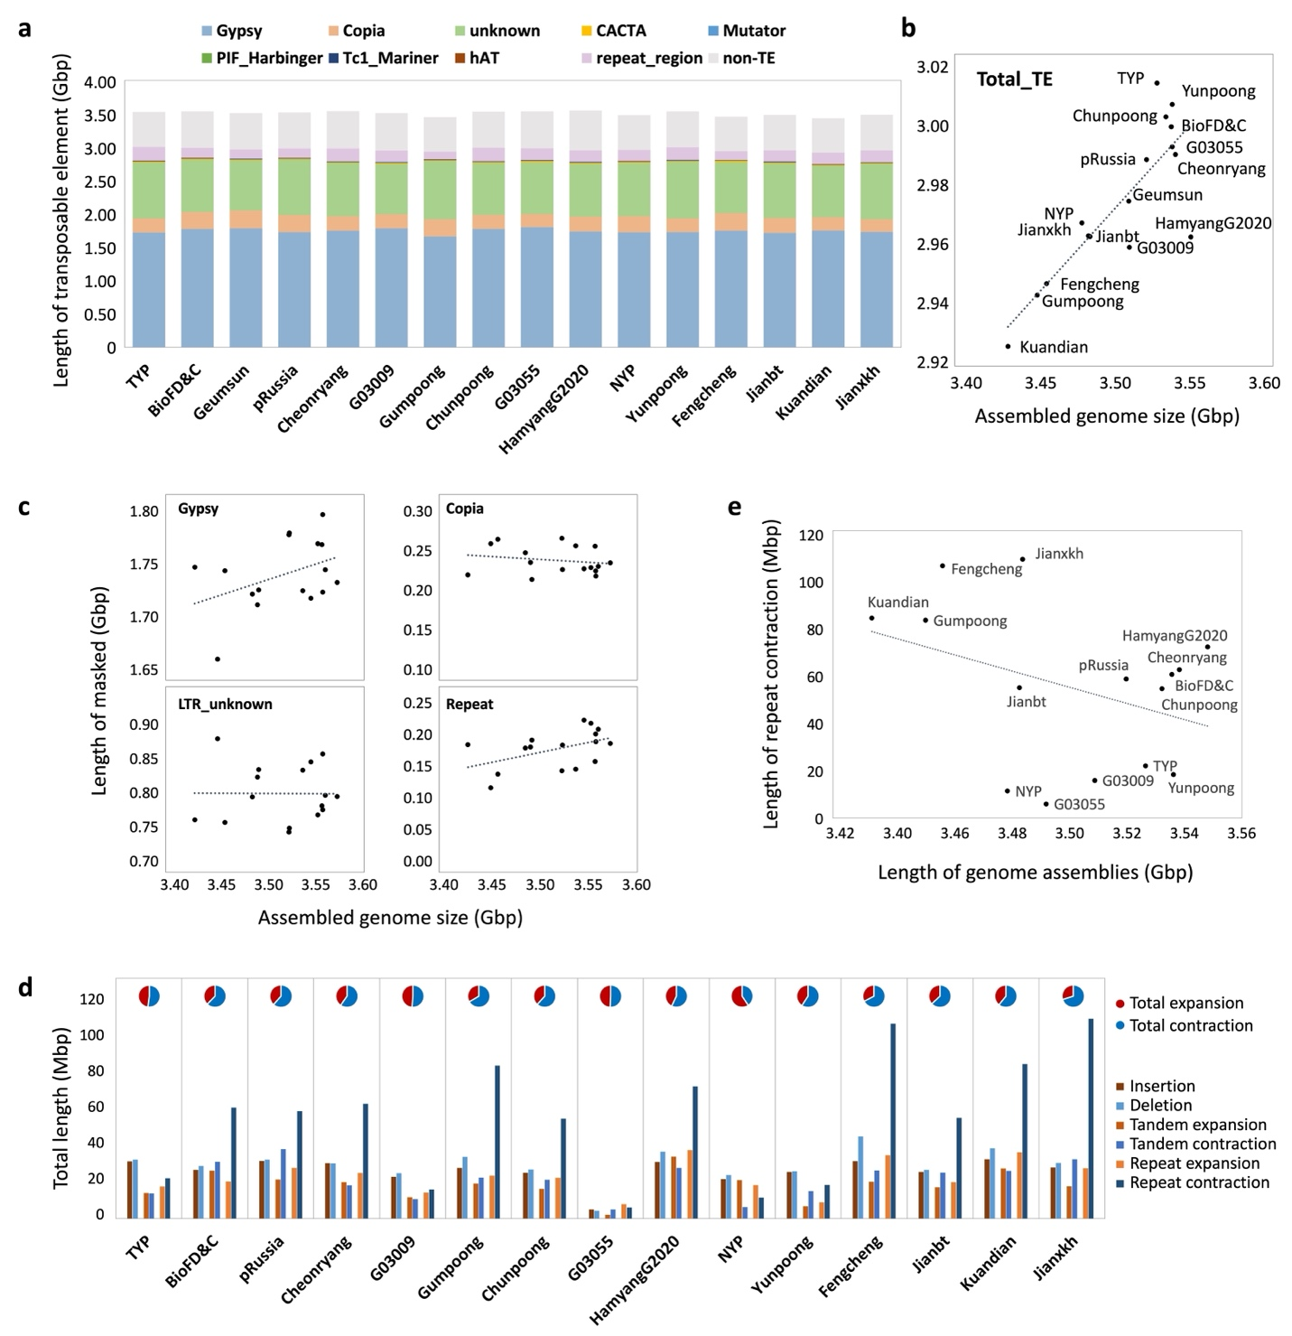
Fig. S1. Transposable element composition and structural variation across the ginseng pangenome. a, Composition of major transposable element (TE) classes across the 16 ginseng genome assemblies. Stacked bars show the proportion of each TE category. b, Relationship between total TE content and assembled genome size across the 16 ginseng assemblies. Each point represents an individual accession, highlighting the strong correlation between genome size variation and repeat content. c, Relationship between assembled genome size and the length of major transposable element (TE) categories across pangenome assemblies. d, Correlation between total repeat contraction and assembled genome size. The cumulative length of repeat contraction (Mbp) is plotted against final assembly size (Gbp), revealing a strong negative correlation in which accessions with larger repeat contractions exhibit smaller genome assemblies. e, Summary of structural variation detected in 15 pangenome assemblies relative to the Geumsun reference. Bars indicate the total genomic span of different classes of structural variants, including insertions, deletions, tandem expansions and contractions, and repeat-associated changes.
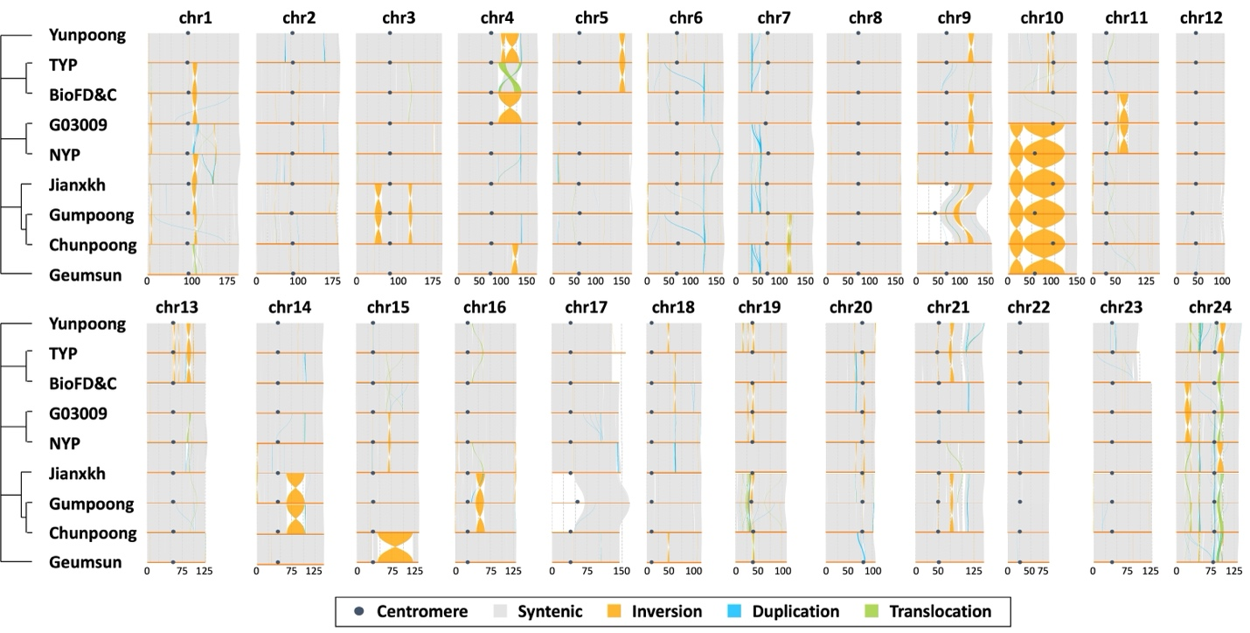
Fig. S2. Genome-wide synteny analysis across nine chromosome-scale ginseng assemblies. Syntenic blocks are shown in grey, with structural rearrangements highlighted, including large inversions on chromosome 10 and interchromosomal translocations involving chromosomes 9, 17 and 23.
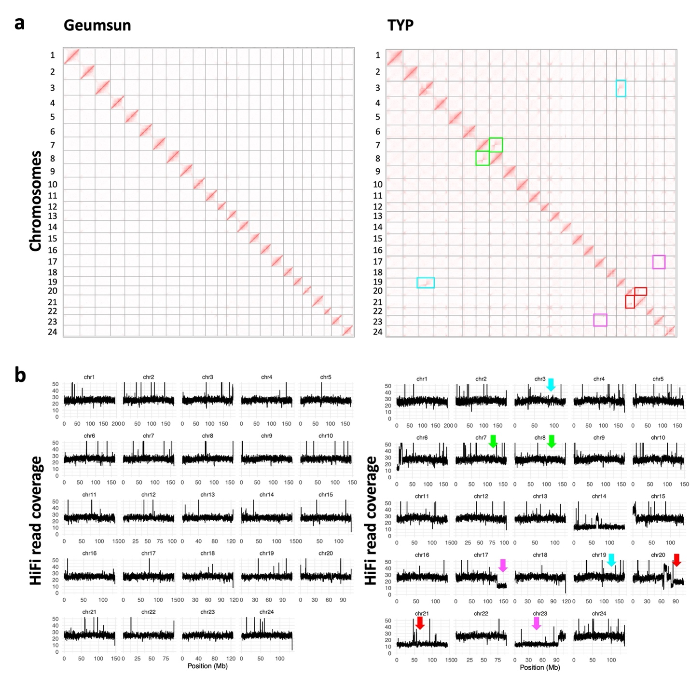
Fig. S3. Hi-C interaction abnormalities and matching read-depth signatures of Geumsun and TYP. a, Inter-chromosomal Hi-C contact maps for representative ginseng assemblies. Geumsun shows predominantly intrachromosomal interaction patterns, consistent with a structurally stable genome. In contrast, TYP shows multiple non-regular inter-chromosomal interaction signals, highlighted by colored blocks, indicative of chromosomal rearrangements. b, Corresponding HiFi read-depth profiles for Geumsun and TYP. Arrows mark the chromosomes that correspond to the colored blocks in panel a, showing the same loci with abnormal copy-number signatures, including localized trisomic (~1.5×) and monosomic (~0.5×) coverage shifts relative to the diploid baseline. The monosomic coverage observed for chromosomes 14, 21, and 23 indicates a total chromosome count of 2n = 45 in TYP.
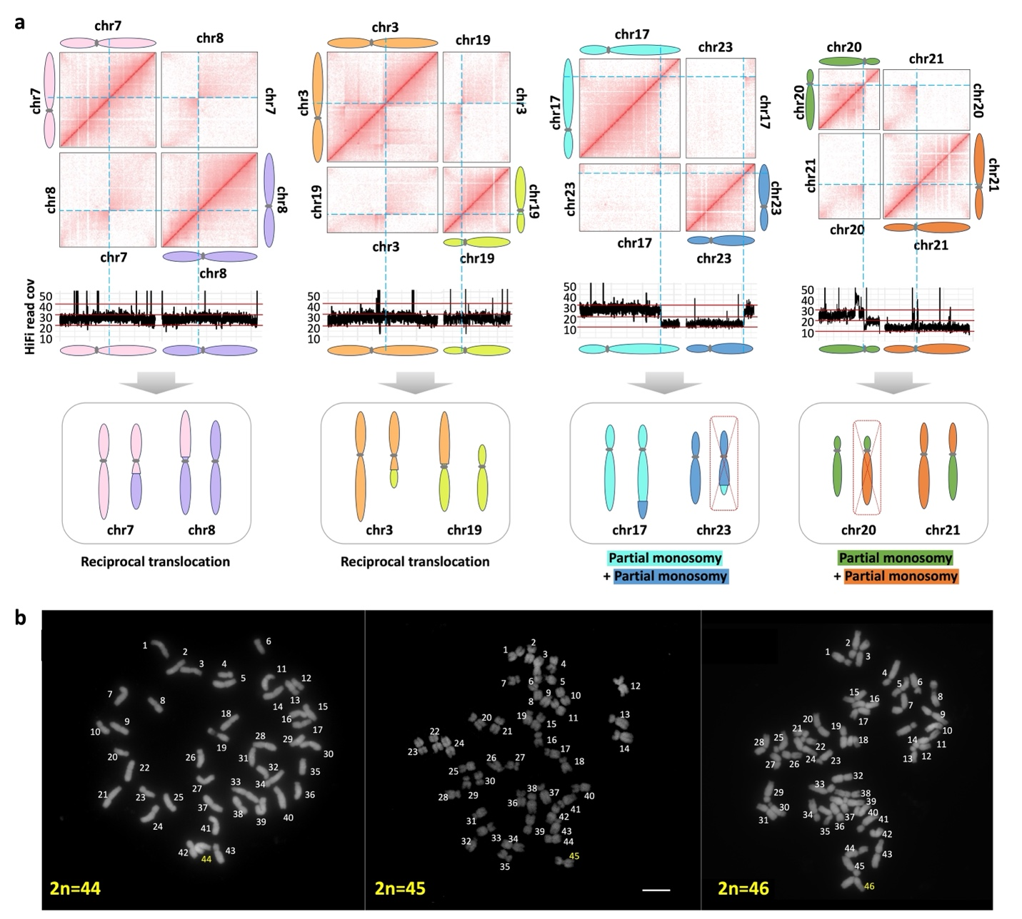
Fig. S4. Chromosomal rearrangements in the TYP accession. a, Inferred chromosomal structure of the TYP genome based on integrated Hi-C interaction data and HiFi read-depth profiles. Abnormal inter-chromosomal Hi-C contact patterns and corresponding coverage changes were used to infer complex structural rearrangements, including partial monosomy and reciprocal translocations. The schematic illustrates the proposed chromosomal configurations underlying these signals. b, Chromosome number variation in long-term tissue-cultured TYP adventitious roots. Cytological analysis of adventitious-root subcultures revealed multiple aneuploid karyotypes. Representative metaphase spreads show cells with chromosome counts of 2n = 44, 2n = 45, and 2n = 46, each derived from independent subcultures originating from the same parental line.
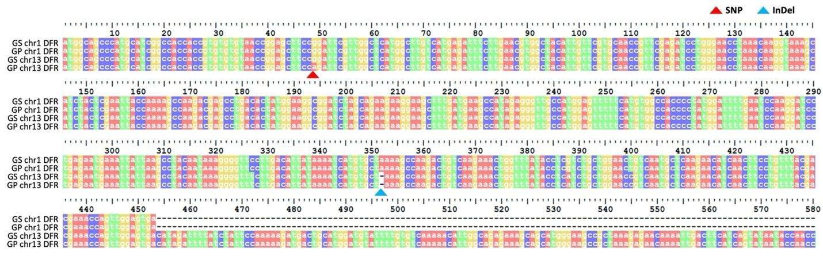
Fig. S5. Sequence variation in DFR paralogs. Multiple sequence alignment of DFR paralogs from red- (GS) and yellow-berry (GP) ginseng accessions. A SNP in chromosome 13 DFR introduces a missense mutation (Gly17Arg) specific to the yellow-berry genotype (GP). Additionally, a one–base pair insertion (InDel) in the chromosome 1 DFR paralog, shared by both red and yellow accessions, results in a frameshift that renders this copy nonfunctional.
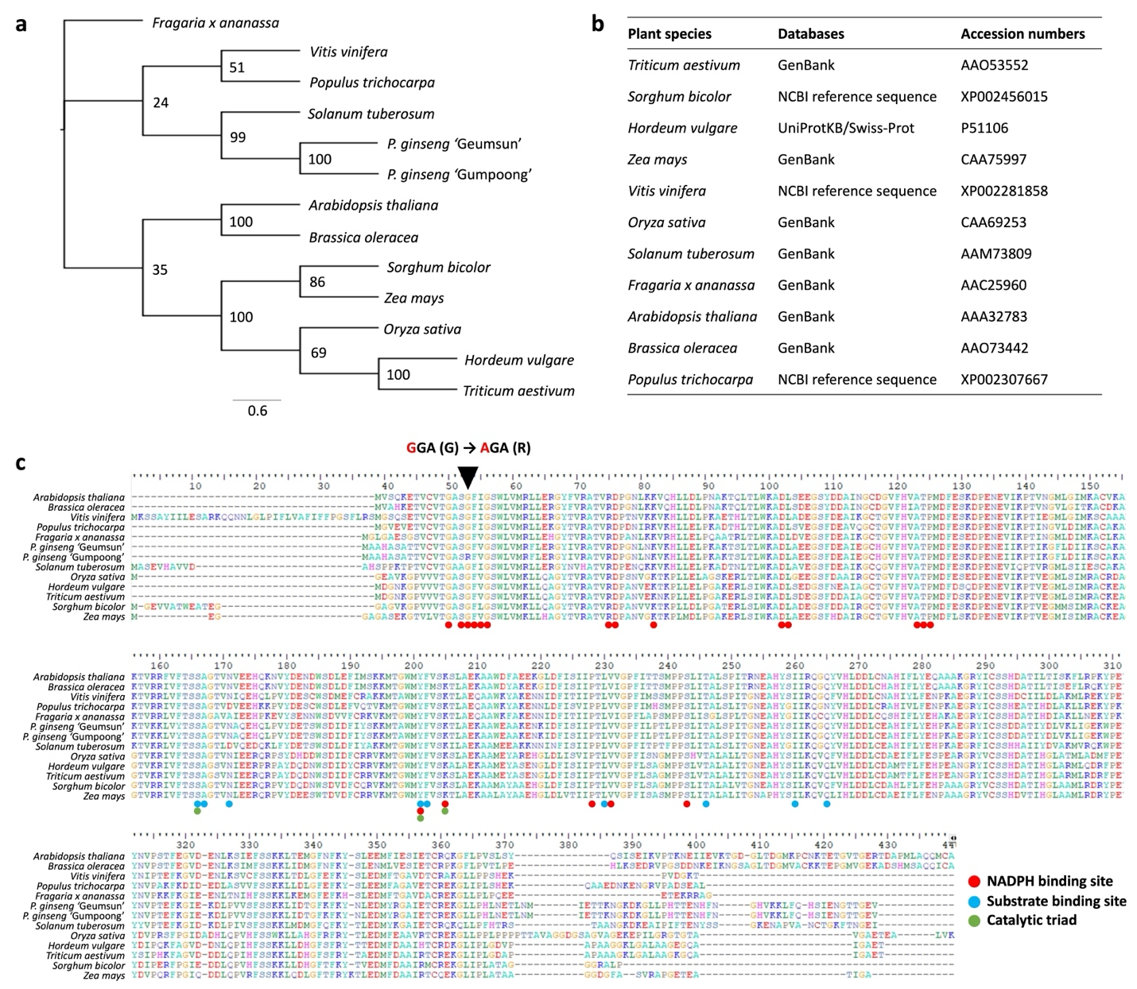
Fig. S6. Evolutionary conservation and sequence variation of DFR in ginseng. a, Neighbour-joining phylogenetic tree of DFR proteins from ginseng and representative plant species. The tree was constructed using protein sequences retrieved from public databases (listed in b), with bootstrap support values (1,000 replicates) shown at each node. b, List of plant species and database accession numbers for DFR orthologues. c, Multiple sequence alignment of DFR proteins from ginseng (Geumsun and Gumpoong) and representative plant species. The SNP unique to the yellow-berry accession Gumpoong results in a Gly17Arg substitution within the conserved NADPH-binding domain (indicated by a black triangle). Conserved catalytic and substrate-binding motifs are annotated below the alignment, highlighting the functional context of the substitution.
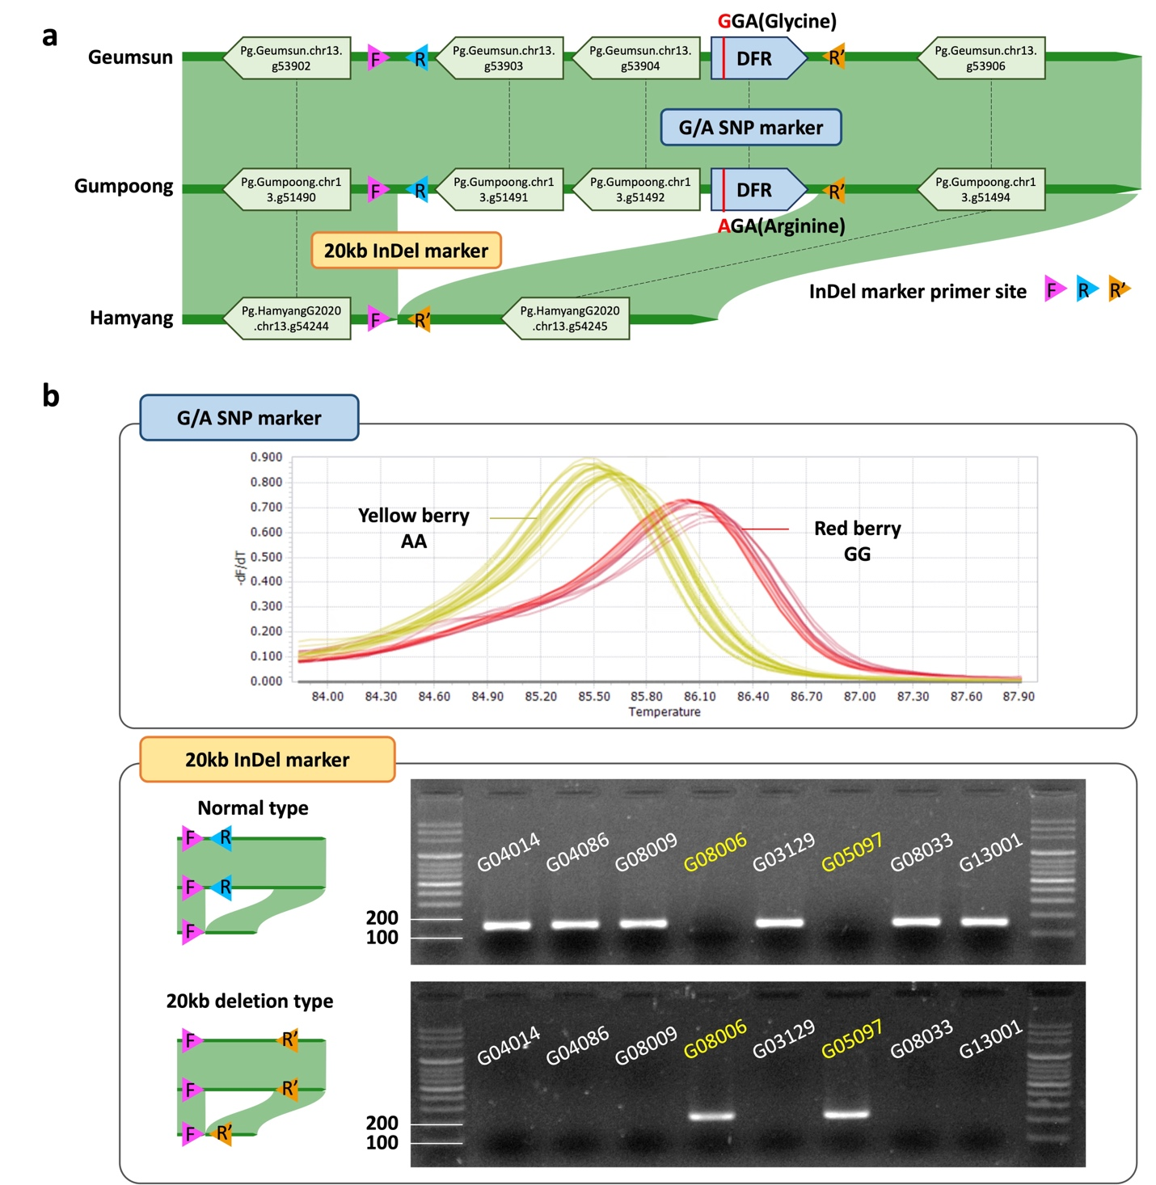
Fig. S7. Development and validation of diagnostic markers for DFR variants associated with berry colour in ginseng. a, Design of SNP and InDel markers targeting the DFR locus on chromosome 13. Primer positions are indicated schematically. b, Validation of DFR SNP and InDel markers across yellow-berry ginseng accessions. Genotyping of 20 yellow-berry accessions revealed that most carried the SNP-type allele with an intact DFR structure, whereas a smaller subset showed deletion-type profiles.
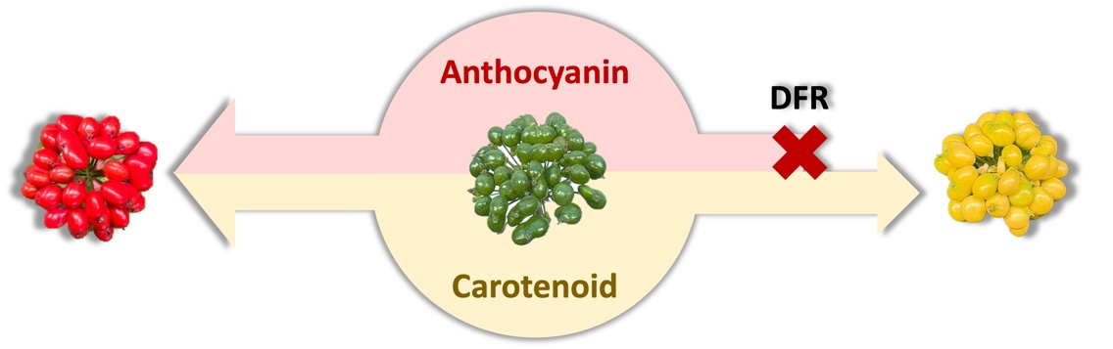
Fig. S8. Conceptual model of DFR-dependent berry colour determination in P. ginseng.

