Supporting Information for
Mechanical constraint enables room temperature near infrared emission and triplet reactivity in nickel(II) chromophores

Ruijing Zhang¹, Zi-Yi Tang¹, Guangliu Ran², Zi-Cheng Wang¹, Nan She³, Wenkai Zhang*², Jing Zhang*³ & Jun-Long Zhang*^{1,4}

- Beijing National Laboratory for Molecular Sciences, College of Chemistry and Molecular Engineering, Peking University, Beijing 100871, P. R. China
- Center for Advanced Quantum Studies, Department of Physics and Applied Optics Beijing Area, Major Laboratory, Beijing Normal University, Beijing, 100875, P. R. China;
- Center of Materials Science and Optoelectronics Engineering, College of Materials Science and Opto-Electronic Technology, University of Chinese Academy of Sciences, Beijing 100049, P. R. China
- School of Chemical Engineering of Guizhou Minzu University, Guiyang, Guizhou 550025, P. R. China

*Corresponding emails: wkzhang@bnu.edu.cn (W. Zhang); Zhangj271@ucas.ac.cn (J. Zhang); Zhangjunlong@pku.edu.cn (J.-L. Zhang)

The supplementary information includes:
1. Materials and instruments
2. Supplementary methods
3. Supplementary Figures (1-50) and Tables (1-9)
4. Supplementary References

- Materials and instruments
All reagents were purchased from commercial suppliers and used as received unless otherwise indicated. Column chromatography was performed on silica gel (200-300 mesh, Qingdao Ocean Chemicals) using the specified eluents. All other chemicals used in this work were of analytical grade and used without further purification. Deionized water was prepared using a Milli-QSP reagent water system (Millipore) and had a resistivity of 18.2 MΩ cm⁻¹. Dulbecco’s modified Eagle’s medium (DMEM), penicillin-streptomycin solution, phosphate buffered saline (PBS), and fetal bovine serum (FBS) were purchased from Gibco Life Technologies (Gaithersburg, MD, USA). Cell Counting Kit-8 (CCK8), 2’,7’-dichlorodihydrofluorescein diacetate (DCFH-DA, 97%), the Calcein AM/propidium iodide (PI) Apoptosis Detection Kit, and the Mitochondrial Membrane Potential Assay Kit with JC-1 were provided by Beyotime Biotechnology.
UV-vis spectra were recorded on an Agilent 8453 UV-vis spectrometer equipped with an Agilent 89090A thermostat (± 0.1 °C). ESI-MS spectra were recorded on Bruker APEX IV Fourier Transform Ion Cyclotron Resonance Mass Spectrometer using electrospray ionization. Mass spectrometric simulations were carried out using the IsoPro v3.0 package. ¹H and ¹³C NMR spectra were recorded on a Bruker-400 MHz instrument, ¹⁹F NMR spectra were recorded on a Bruker-500 MHz instrument. Fluorescence spectra was recorded using FLS-980 spectrometers. IR spectra were recorded on a Tensor 27 FTIR or a Spectrum Spotlight 200 FT-IR microscopic. All electrochemical experiments were carried out using a CH Instruments (model CHI660E Electrochemical Analyzer) at 20 °C, and the solution was bubbled with N₂ for at least 30 min before analysis. The Spectroelectrochemical spectra were recorded on a Shimadzu UV3600Plus UV-VIS-NIR spectrophotometer during electrolysis on a CHI 660E instrument. The size distribution of nanoparticles in aqueous solution was measured using a Brookhaven Zeta potential and particle size analyzer (90Plus Zeta). Confocal fluorescence microscopy was performed using an ISS Alba5 FLIM/FFS confocal system and Q2 multi-dimensional confocal microfluorescence imaging system equipped with a Nikon TE2000 inverted microscope. Photothermal effects were determined using a UNI-T UT325 thermometer. Infrared (IR) thermal imaging was performed using a FLIR E53 thermal imaging camera. Photoacoustic imaging (PAI) was carried out using the Visual Sonic Photoacoustic/Ultrasound multimodal small animal imaging system (Vevo 3100 LAZR, FUJIFILM VisualSonics, Canada).
Human cervical carcinoma (HeLa), human skin immortalized keratinocytes (HaCaT) cells were obtained from the American Type Culture Collection (ATCC, USA) and cultured in DMEM medium with penicillinstreptomycin (1%), puromycin (1 μg/mL), and FBS (10%). All animal procedures were approved by the Institutional Animal Care and Use Committee of Sinoresearch (Beijing) Biotechnology Co., Ltd. (Protocol number: ZYZC2024110013S) and carried out in accordance with the requirements of the National Act on the Use of Experimental Animals (People’s Republic of China). The BALB/c female nude mice (4~5 weeks old, ≈20 g) were purchased and maintained in a sterile environment and allowed free access to food and water.
2. Supplementary methods
2.1 Theoretical and computational details
Geometry optimizations of the ground and excited states with harmonic vibrational frequencies calculations were performed using the hybrid density functional, B3LYP^{[1]} functional with “D3BJ” dispersion corrections in density functional theory (DFT) calculations as contained in the program package Gaussian 16 (Revision A.03)^{[2]}. The 6-311G(d) basis set^{[3]} was used for was used for all atoms except Ni atom, which was described by the LanL2DZ^{[4]} pseudopotential and its accompanying basis set, respectively. The solvent effects were considered using the solvation model based on density (SMD) for solvation in acetonitrile^{[5]}. The excited optimized structures were calculated using time-dependent density functional theory (TD-DFT) calculations with the same functional and basis set along with the Tamm-Dancoff approximation^{[6]}. Frequency calculations were performed on the optimized structures to ensure that they were minimum energy structures by the absence of imaginary frequencies. The vertical excitations were calculated using TD-DFT at the optimized ground state structures with the same functional and basis set and then subject to hole-electron analysis using Multiwfn 3.8^{[7-9]}. The planarity of the ground and excited states structure were evidenced by the molecular planarity parameter (MPP) and span of deviation from plane (SDP) using Multiwfn 3.8^{[10]}. Molecular orbitals and hole-electron distribution isosurfaces were represented using the VMD program (version 1.9.3) ^{[11]}.
The spin-orbit coupling (SOC) integrals between the spin state S₁ and T_{n}, SOCME_{S-to-T}, were estimated using effective atomic charge (Zeff) method by PySOC^{[12]}. The radiative decay rate constant, intersystem crossing rate constant and non-radiative decay rate constant were calculated by MOMAP program package using a thermal vibration correlation function formalism for the transition between two adiabatic electronic states considering displacements, distortions, and Duschinsky rotation of potential energy surfaces within the framework of multidimensional harmonic oscillator model and Franck-Condon principle.^{[13]}

2.2 Synthesis and characterization
2,5-Bis((Z)-(5-bromo-2H-pyrrol-2-ylidene)(perfluorophenyl)methyl)-1H-pyrrole
A solution of 132 mg (0.724 mmol, 2 equivalents) N-bromosuccinimide (NBS) in anhydrous dichloromethane (10 mL) was slowly added to a solution of 200 mg (0.362 mmol, 1 equivalent) of the starting bis-pentafluorophenyltripyrrole in anhydrous dichloromethane (10 mL) in a two-necked flask at -78 ℃ with nitrogen protection. The reaction was stirred for 50 min.
After stirring for 50 min, the reaction was allowed to warm to room temperature. Then, 245 mg (1.086 mmol, 3 equivalents) 2,3-dichloro-5,6-dicyanobenzoquinone (DDQ) was added directly to the two-necked flask. The solution was stirred for 10 to 15 minutes, then concentrated under reduced pressure and purified by a flash silica-gel column chromatography (eluent: petroleum ether/CH₂Cl₂, 1:1) to give the product.

(1¹E,1²Z,5¹E,5²Z)-6,8-dimethyl-2,4-bis(perfluorophenyl)-1²H,3¹H,5²H-6,8-diaza-1,3,5(2,5)-tripyrrola-7(1,3)-benzenacyclooctaphane (TNBD)
The previous product (200 mg, 0.28 mmol, 1.0 equivalent) were added to a solution of 38 mg (0.28 mmol, 1 equivalent) N, N’-dimethylpyridine-2,6-diamine and 116 mg (0.84 mmol, 3 equivalents) anhydrous potassium carbonate in anhydrous acetonitrile (40 mL). The reaction was stirred at reflux for 24 h under a nitrogen atmosphere. Then, the solution was concentrated under reduced pressure and purified by a silica gel column chromatography (eluent: petroleum ether/ethyl acetate, 4:1) to give compound TNBD as a blue solid (110 mg, 56.9%).
TNBD: ¹H NMR (400 MHz, chloroform-d) δ 12.22 (s, 1H), 9.19 – 8.46 (m, 1H), 7.34 (t, J = 8.1 Hz, 1H), 7.02 (dd, J = 8.1, 2.1 Hz, 2H), 6.66 (d, J = 3.1 Hz, 4H), 5.85 (s, 2H), 3.62 (s, 6H). ¹³C NMR (101 MHz, Chloroform-d) δ 168.62, 150.40, 145.21, 140.99, 136.57, 136.35, 127.70, 120.48, 117.48. ¹⁹F NMR (471 MHz, Chloroform-d) δ -131.36 – -142.51 (m), -153.95, -158.70 – -164.38 (m). ESI-HRMS m/z: Calcd. For C₃₄H₁₈F₁₀N₅ [M]⁺ 686.13970, found [M+H]⁺ 686.13800.

Ni-TNBD
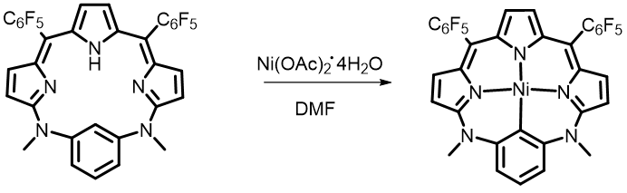
A 50 mL Schlenk flask was charged with 50 mg of TNBD (0.073 mmol, 1.0 equivalent), 181.7 mg nickel(II) acetate tetrahydrate (Ni(OAc)₂⋅4H₂O, 0.73 mmol, 10 equivalents) and 20 mL dry N,N-dimethylformamide under a stream of nitrogen. The solution was stirred at reflux until the solution becomes green. The resulting solution was concentrated under reduced pressure to afford a crude product. This crude product was purified by silica gel chromatography eluting with petroleum ether/ dichloromethane (1:1). This gave Ni-TNBD (25 mg, 46.2%) as yellow-green solid.
Ni-TNBD: ¹H NMR (400 MHz, CD₃CN) δ 7.34 (t, J = 8.0 Hz, 1H), 6.98 (d, J = 5.2 Hz, 2H), 6.76 (d, J = 5.2 Hz, 2H), 6.60 (d, J = 8.0 Hz, 2H), 6.27 (s, 2H), 3.58 (s, 6H). ¹³C NMR (101 MHz, Chloroform-d) δ 159.38, 145.34, 142.60, 138.59, 135.31, 132.78, 126.71, 121.79, 121.08, 117.16, 115.32, 102.00. ¹⁹F NMR (471 MHz, Chloroform-d) δ -138.29 (dd, J = 23.5, 8.1 Hz), -153.26 (t, J = 20.9 Hz), -161.40 (m). ESI-HRMS m/z: Calcd. For C₃₄H₁₆F₁₀NiN₅ [M+H]⁺ 742.05940, found [M+H]⁺ 742.05702.

Co-TNBD
A 50 mL Schlenk flask was charged with 50 mg of TNBD (0.073 mmol, 1.0 equivalent), 181.7 mg Cobalt (II) acetate tetrahydrate (Co(OAc)₂⋅4H₂O, 0.73 mmol, 10 equivalents) and 20 mL dry N,N-dimethylformamide under a stream of nitrogen. The solution was stirred at reflux until the solution becomes green. The resulting solution was concentrated under reduced pressure to afford a crude product. This crude product was purified by silica gel chromatography eluting with petroleum ether/ dichloromethane (1:1). This gave Co-TNBD (20 mg, 69.1%) as yellow-green solid.
Co-TNBD: ESI-HRMS: m/z: Calcd. For C₃₄H₁₆CoF₁₀N₅ [M]⁺ 743.05725, found [M]⁺ 743.05517.

Cu-TNBD
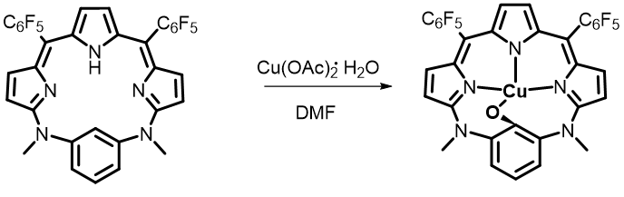
A 50 mL Schlenk flask was charged with 50 mg of TNBD (0.073 mmol, 1.0 equivalent), 145.7 mg Cupric (II) acetate monohydrate (Cu(OAc)₂⋅H₂O, 0.73 mmol, 10 equivalents) and 20 mL dry N,N-dimethylformamide under a stream of nitrogen. The solution was stirred at reflux until the solution becomes green. The resulting solution was concentrated under reduced pressure to afford a crude product. This crude product was purified by silica gel chromatography eluting with petroleum ether/ dichloromethane (1:1). This gave Cu-TNBD (45 mg, 85.0%) as deep green solid.
Cu-TNBD: ESI-MS: m/z: Calcd. For C₃₄H₁₅CuF₁₀N₅O [M]⁺ 762.04130, found [M]⁺ 762.03711.

Mn-TNBD
A 50 mL Schlenk flask was charged with 50 mg of TNBD (0.073 mmol, 1.0 equivalent), 178.9 mg Manganese (II) acetate tetrahydrate (Mn(OAc)₂⋅4H₂O, 0.73 mmol, 10 equivalents), 90.6 mg Manganese chloride (MnCl₂, 0.72 mmol, 10 eq) and 20 mL dry N,N-dimethylformamide under a stream of nitrogen. The solution was stirred at reflux until the solution becomes green. The resulting solution was concentrated under reduced pressure to afford a crude product. This crude product was purified by silica gel chromatography eluting with petroleum ether/ dichloromethane (1:1). This gave Cu-TNBD (20 mg, 37.1%) as green solid.
Mn-TNBD: ESI-HRMS: m/z: Calcd. For C₃₄H₁₆MnF₁₀N₅ [M]⁺ 739.06210, found [M]⁺ 739.06437.

Fe-TNBD
A 50 mL Schlenk flask was charged with 50 mg of TNBD (0.073 mmol, 1.0 equivalent), 92.5 mg Ferrous chloride (FeCl₂, 0.73 mmol, 10 equivalents) and 20 mL dry N,N-dimethylformamide under a stream of nitrogen. The solution was stirred at reflux until the solution becomes green. The resulting solution was concentrated under reduced pressure to afford a crude product. This crude product was purified by silica gel chromatography eluting with petroleum ether/ dichloromethane (1:1). This gave Fe-TNBD (13 mg, 27.6%) as green solid.
Fe-TNBD: ESI-HRMS: m/z: Calcd. For C₃₄H₁₆FeF₁₀N₅ [M]⁺ 740.05899, found [M]⁺ 740.05842.

Zn-TNBD
A 50 mL Schlenk flask was charged with 50 mg of TNBD (0.073 mmol, 1.0 equivalent), 99.5 mg Zinc chloride (ZnCl₂, 0.73 mmol, 10 equivalents) and 20 mL dry N,N-dimethylformamide under a stream of nitrogen. The solution was stirred at reflux until the solution becomes green. The resulting solution was concentrated under reduced pressure to afford a crude product. This crude product was purified by silica gel chromatography eluting with petroleum ether/ dichloromethane (1:1). This gave Zn-TNBD (22.0 mg, 40.3%) as green solid.
Zn-TNBD: ¹H NMR (400 MHz, Chloroform-d) δ 8.73 (s, 1H), 7.81 – 7.77 (m, 1H), 6.70 (d, J = 25.9 Hz, 2H), 5.44 – 5.24 (m, 1H), 3.59 (s, 3H). ESI-HRMS: m/z: Calcd. For C₃₄H₁₆F₁₀N₅Zn [M]⁺ 748.05320, found [M]⁺ 740.05141.

TCBD
A 100 mL flask was charged with 200 mg tripyrrole (0.36 mmol, 1 eq), 70 mg 1,3-Benzenedimethanol, a,a,a’,a’-tetramethyl (0.36 mmol, 1 eq) and 20 mL dry DCM. After 15 minutes of stirring, added 4.5 uL (0.036 mmol, 0.1 eq) of boron trifluoride ether solution. The solution was stirred for 2h at room temperature and then added 244.6 mg DDQ (1.08 mmol, 3 equivalents) until the solution becomes purple. The resulting solution was concentrated under reduced pressure to afford a crud product. This crude product was purified by silica gel chromatography eluting with petroleum ether/ dichloromethane (1:1) to remove DDQ. The purple product was concentrated under reduced pressure and purified by a neutral alumina column chromatography eluting with petroleum ether/ dichloromethane (3:1). This gave TCBD (70 mg, 27.4%) as red solid.
TCBD: ¹H NMR (400 MHz, CD₃CN) δ 12.05 (s, 1H), 7.86 (s, 1H), 7.28 (d, J = 1.2 Hz, 3H), 7.04 (d, J = 4.8 Hz, 2H), 6.87 (d, J = 4.8 Hz, 2H), 6.25 (d, J = 1.7 Hz, 2H), 1.74 (s, 12H). ¹⁹F NMR (471 MHz, CD₃CN) δ -141.97 (d, J = 15.3 Hz), -155.65 (d, J = 20.2 Hz), -155.71 (s), -155.75 (s), -163.40 (s), -163.45 (d, J = 14.6 Hz). ESI-HRMS: m/z: Calcd. For C₃₈H₂₄F₁₀N₃ [M+H]⁺ 712.18051, found [M+H]⁺ 712.17985.

Ni-TCBD
A 50 mL Schlenk flask was charged with 52 mg of TCBD (0.073 mmol, 1.0 equivalent), 181.7 mg Ni(OAc)₂⋅4H₂O (0.73 mmol, 10 equivalents) and 20 mL dry N,N-dimethylformamide under a stream of nitrogen. The solution was stirred at reflux until the solution becomes green. The resulting solution was concentrated under reduced pressure to afford a crude product. This crude product was purified by silica gel chromatography eluting with petroleum ether/ dichloromethane (3:1). This gave Ni-TCBD (36.4 mg, 62.5%) as green solid.
Ni-TCBD: ¹H NMR (400 MHz, CD₃CN) δ 7.14 (d, J = 7.6 Hz, 2H), 6.93 (t, J = 6.9 Hz, 3H), 6.65 (d, J = 5.0 Hz, 2H), 6.32 (s, 2H), 2.34 (s, 6H), 1.78 (s, 6H). ¹⁹F NMR (471 MHz, CD₃CN) δ -141.35 (s), -141.39 (d, J = 1.9 Hz), -141.78 (s), -155.35 (s), -162.94 (s), -162.97 (d, J = 22.7 Hz), -163.04 (s), -163.43 (s), -163.48 (s), -163.52 (s). ¹³C NMR (126 MHz, CD₃CN) δ 187.46, 154.45, 147.10, 137.38, 136.10, 128.85, 127.37, 124.36, 121.03, 117.49, 43.27, 28.36. ESI-HRMS: m/z: Calcd. For C₃₈H₂₂F₁₀N₃Ni [M+H]⁺ 768.10020, found [M+H]⁺ 768.09980.

2.3 X-ray diffraction studies
X-ray diffraction data were collected on a Rigaku XtaLAB Pro: Kappa single system instrument equipped with Mo Kα source. A suitable crystal was mounted on the diffractometer and cooled under a nitrogen stream as soon as practical after mounting to preclude desolvation. The CrysAlisPro program was employed for data processing. The structure was solved using the SHELXT 2014 program^{[14-15]} and refined against F² anisotropically for all non-hydrogen atoms per the full matrix least-squares protocol using the SHELXL 2016 program in Olex2 GUI^{[16]}. The Platon program package was employed for squeeze processing.

2.4 Photophysical measurements
Emission and excitation spectra were recorded on an Edinburgh Analytical Instruments FLS980 lifetime and steady state spectrometer equipped with a 450 W Xe lamp and a PMT R928 for visible and NIR emission spectral analyses.

2.5 Transient absorption spectroscopic studies
Nanosecond transient absorption spectra and triplet excited state decay dynamics were recorded on an Edinburgh LP980 spectrometer in conjunction with an optical parametric oscillator (OPO) laser excitation pulse (10 Hz, 2 mJ pulse⁻¹). Femtosecond transient spectra and singlet excited state decay dynamics were recorded using a HARPIA spectrometer equipped with a PHAROS femtosecond laser.

2.6 Preparation of Ni-TNBD@DSPE
Ni-TNBD (2 mg) and DSPE (6 mg) dissolved in THF (3 mL) were added dropwise into 10 mL of deionized water. After stirring for 2 h at room temperature, the mixture was dialyzed using a cellulose membrane (MWCO 3500 Da) for 72 h. The resulting constructs, Ni-TNBD@DSPE, were stored at 4 °C for further use.

2.7 Cell uptake and colocalization
The cellular uptake of Ni-TNBD@DSPE by HeLa cells was observed using confocal laser scanning microscopy (CLSM). Briefly, HeLa cells were seeded in confocal dishes at a density of 5×10⁴ cells per dish and cultured for 24 hours under standard conditions (37 °C, 5% CO₂). The cells were then incubated with Ni-TNBD@DSPE (20 µM) for varying durations (0, 1, 2, 4, 6, 8, 12, and 24 hours). After incubation, the cells were washed twice with PBS and imaged in fresh culture medium.
The subcellular distribution of Ni-TNBD@DSPE in cancer cells was analyzed using CLSM. Adherent cells in confocal dishes were incubated with Ni-TNBD@DSPE at final concentration of 20 µM for 8h. After incubation, the cells were washed three times with PBS and subsequently stained with Lysotracker Green, which was diluted in serum-free medium to the working concentration for 30 minutes. Following another two washes with PBS, the nuclei were counterstained with Hoechst 33258 for 3 min. Finally, the cells were washed three times with PBS to remove unbound dye and subjected to CLSM observation.

2.8 ROS assay
Intracellular ROS levels were measured to evaluate the ability of Ni-TNBD@DSPE (denoted as NPs in figures) to induce ROS generation. HeLa cells were divided into five groups: (1) Control (untreated), (2) Laser only, (3) NPs only, (4) NPs + Laser, and (5) NPs + Laser + SA (sodium ascorbate, a ROS scavenger). After 8 hours of incubation with the respective treatments, the cells were stained with either DCFH-DA or DHE (10 μM) in the dark for 30 min. Following three times washes with PBS (0.01 M, pH 7.4) to remove excess probe, fresh DMEM was added. Groups receiving laser treatment were irradiated with an 808 nm NIR laser (1.0 W cm⁻²) for 10 min. Cellular fluorescence was then immediately visualized using CLSM.

2.9 Cytotoxicity test
The cytotoxicity of Ni-TNBD@DSPE against HeLa cells and HaCaT cells were investigated by CCK-8 assay. For the dark cytotoxicity assay, cells were seeded in a 96-well plate at 1 × 10⁴ cells per well and incubated for 24 h. Cells were then treated with a medium containing different concentrations of Ni-TNBD@DSPE for 24 h. For the phototoxicity assay, HeLa cells were treated with Ni-TNBD@F127 at the doses of 0, 1.25, 2.50, 5.00, 10.00, and 20.00 μM for 8 h at different oxygen concentrations. Following 808 nm laser irradiation (1.0 W cm⁻², 10 min) at 4 °C, the cells were cultured in the dark for another 24 h. Cell viability was quantified using the CCK-8 assay.

2.10 Dead/live cell co-staining
HeLa cells were seeded in 35 mm confocal dishes at a density of 1×10⁴ cells per dish and cultured for 24 hours (37 °C, 5% CO₂). The cells were then divided into six treatment groups: (1) Control; (2) Laser only; (3) NPs only; (4) PTT; (5) PDT; (6) PTT + PDT. All groups containing NPs were incubated with the material at a final concentration of 20 µM for 8 h. After incubation and washing with PBS, the laser-treated groups were exposed to an 808 nm laser (0.5 W cm⁻²) for 10 minutes, followed by further culture for 12 h. Finally, the cells were stained with Calcein AM (2 µM) and PI (4 µM) in the dark for 30 min, washed, and imaged under a confocal microscope to visualize live (green) and dead (red) cells.

2.11 Mitochondrial membrane potential (ΔΨ_{m}) measurements
The ΔΨ_{m} of cells was determined using a JC-1 mitochondrial membrane potential probe. After incubating the different treatment groups for 12 h, the HeLa cells were further incubated with 5 μg mL⁻¹ of JC-1 at 37°C for 30 min. After washing twice with PBS, the cells were observed using CLSM.

2.12 Fluorescence imaging
Female Balb/c nude mice (5 weeks old) were used to establish a tumor model via subcutaneous injection of 100 μL of HeLa cell suspension (2×10⁶ cells/mL in PBS) into the back. When the tumor volume reached approximately 100 mm³, 100 μL of Ni-TNBD@DSPE (50 μM in PBS) was administered via tail vein injection. Under isoflurane anesthesia, the mice were placed in an in vivo imaging system, and fluorescence images of the tumor region were acquired at various time points (0, 2, 4, 6, 8, 12, 18, and 24 hours) using an 808 nm laser for excitation to monitor the accumulation of the nanoparticles at the tumor site.

2.13 In vivo phototherapy
Nude mice bearing subcutaneous HeLa tumors (~ 100 mm³) were divided into four groups randomly (5 mice per group) as follows: Control, Laser, NPs, NPs + Laser. NPs was injected intravenously using a dose volume of 100 μL at a concentration of 50 μM or PBS, and then subjected to laser irradiation 8 h after the i.v. injection. For the “Laser” and “NPS + Laser” groups, 808 nm laser irradiation was applied at a powder density of 1.0 W cm⁻² for 10 min. After treatment on the first day, tumor growth was measured by vernier caliper every two days for 2 weeks and the tumor volumes (V) were calculated as V = (tumor length) × (tumor width)²/2. The body weight of each mouse was monitored every other day using a digital balance during the treatment. Finally, the tumor issue and main organs (heart, liver, spleen, lung, and kidney) were extracted and fixed with 4% paraformaldehyde for hematoxylin and eosin (H&E) staining. TUNEL analyses of the tumors were also carried out.

- Supplementary Figures and Tables
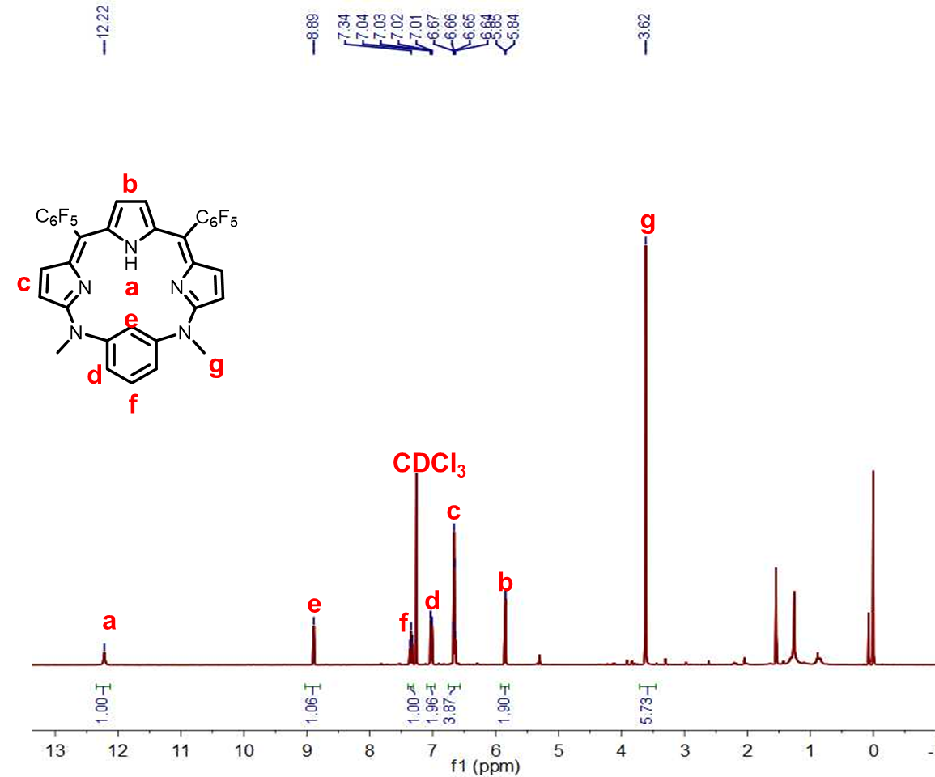
Figure S1. ¹H NMR spectrum of TNBD in CDCl₃.
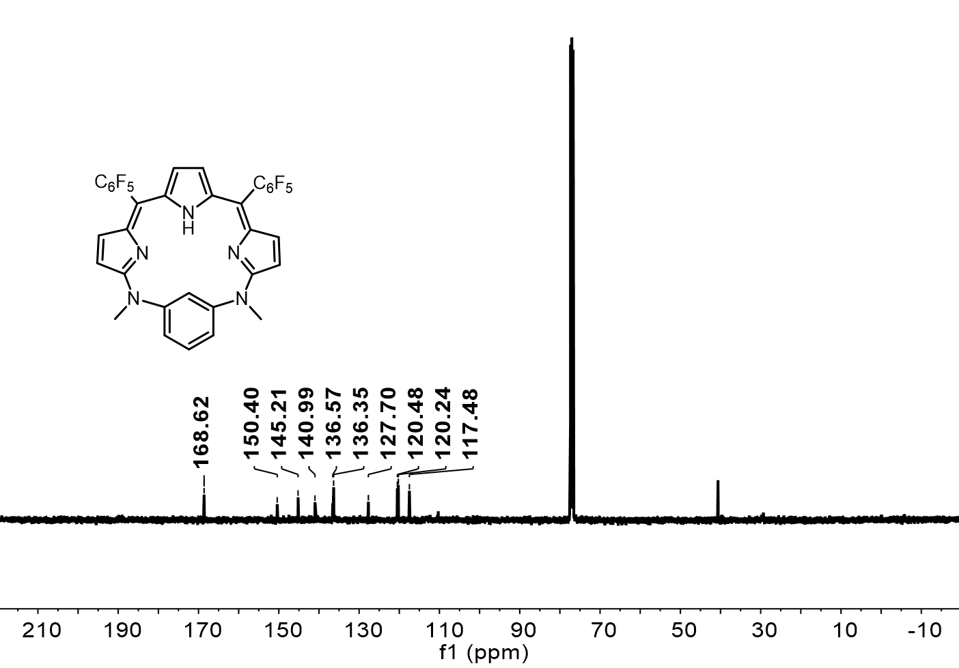
Figure S2. ¹³C NMR spectrum of TNBD in CDCl₃.
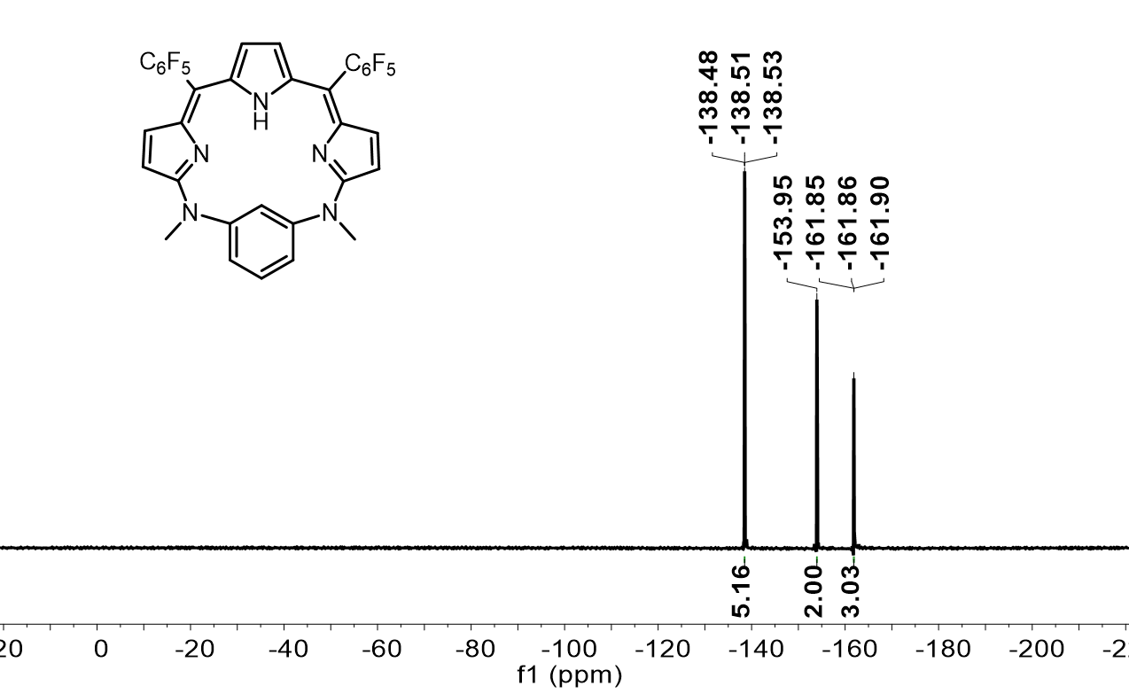
Figure S3. ¹⁹F NMR spectrum of TNBD in CDCl₃.

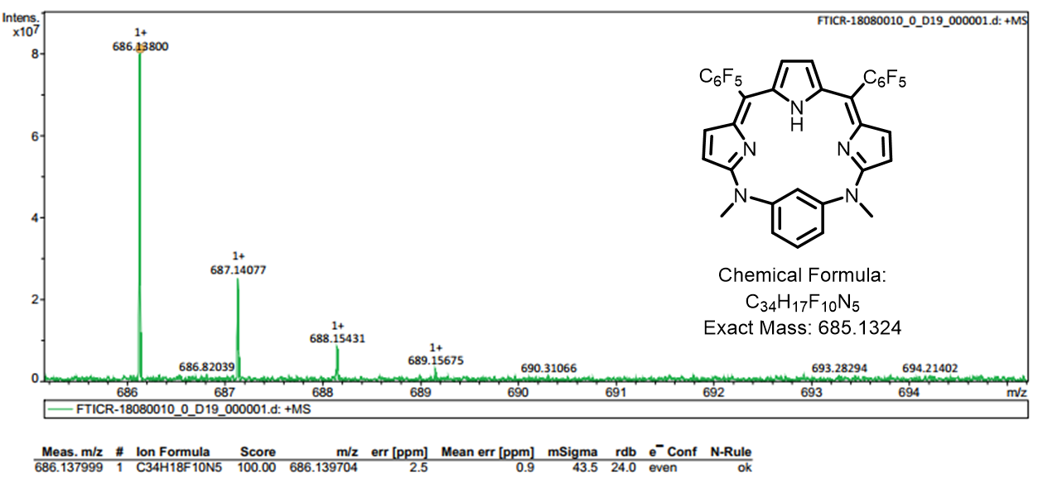
Figure S4. ESI-HRMS spectrum of TNBD.
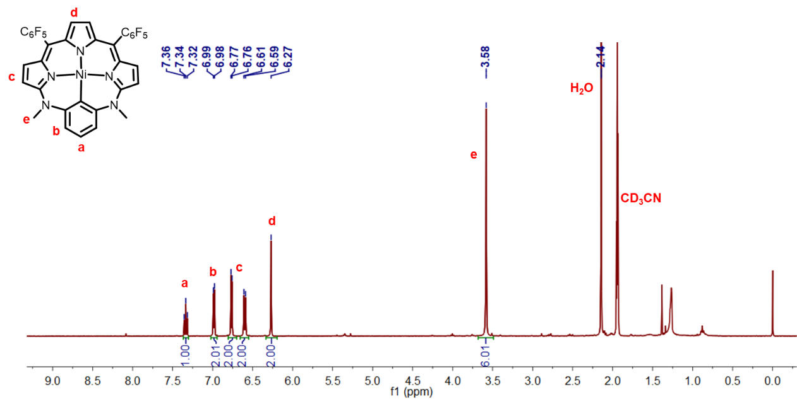
Figure S5. ¹H NMR spectrum of Ni-TNBD in CD₃CN.
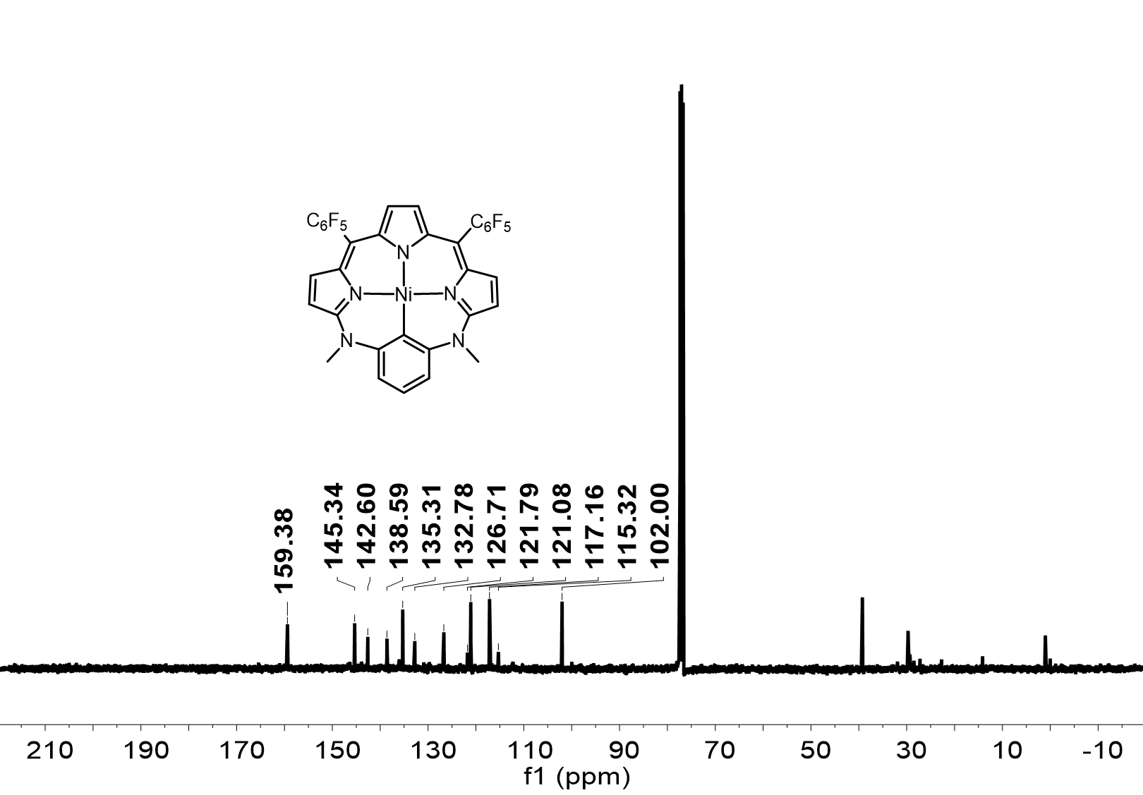
Figure S6. ¹³C NMR spectrum of Ni-TNBD in CDCl₃.
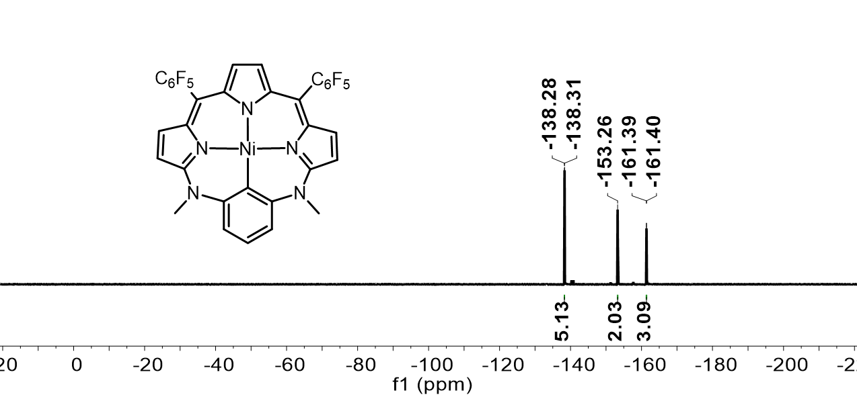
Figure S7. ¹⁹F NMR spectrum of Ni-TNBD in CDCl₃.

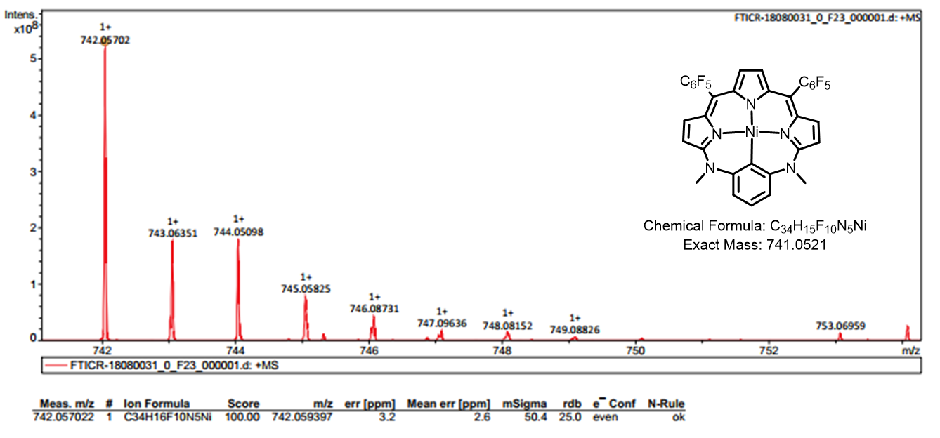
Figure S8. ESI-HRMS spectrum of Ni-TNBD.

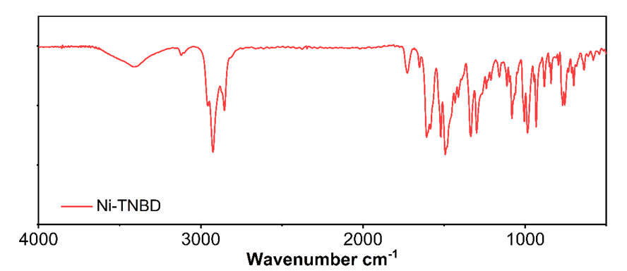
Figure S9. FT-IR spectrum of Ni-TNBD.
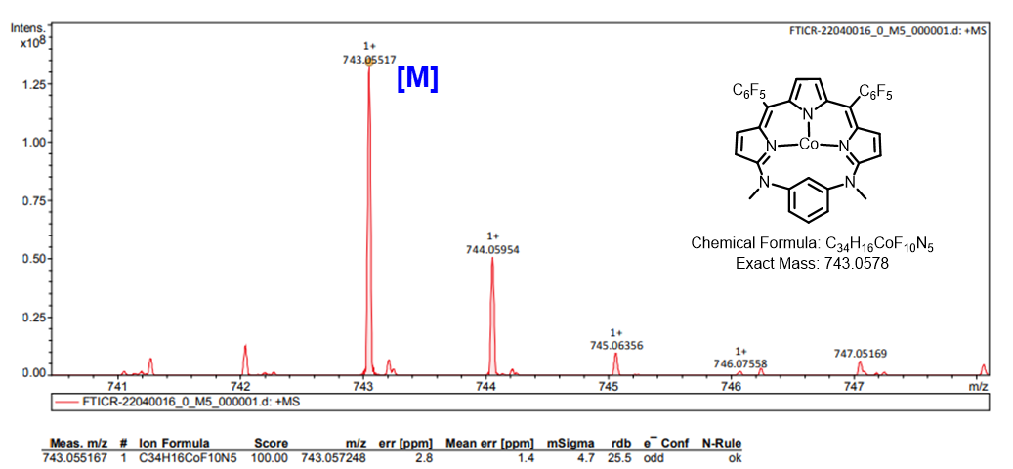
Figure S10. ESI-HRMS spectrum of Co-TNBD.
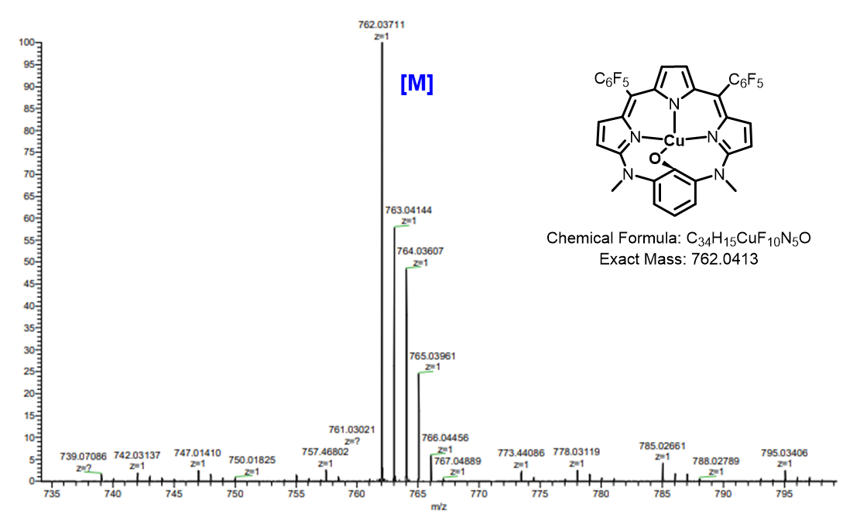
Figure S11. ESI-MS spectrum of Cu-TNBD.

Figure S12. FT-IR spectrum of Cu-TNBD.
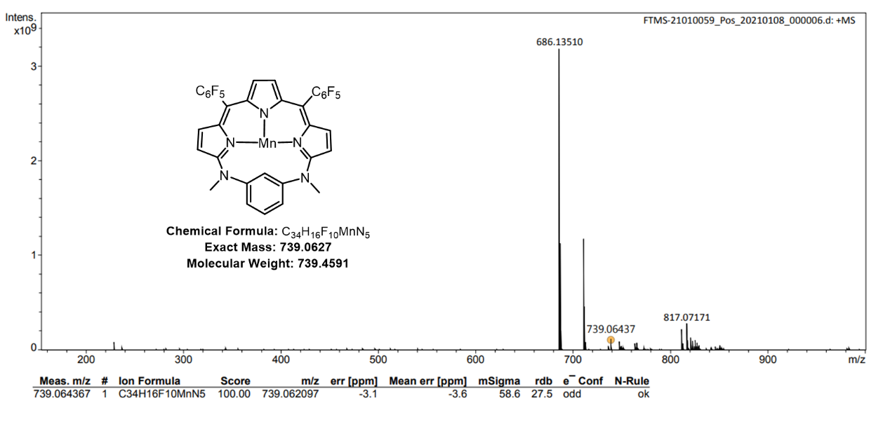
Figure S13. ESI-HRMS spectrum of Mn-TNBD.
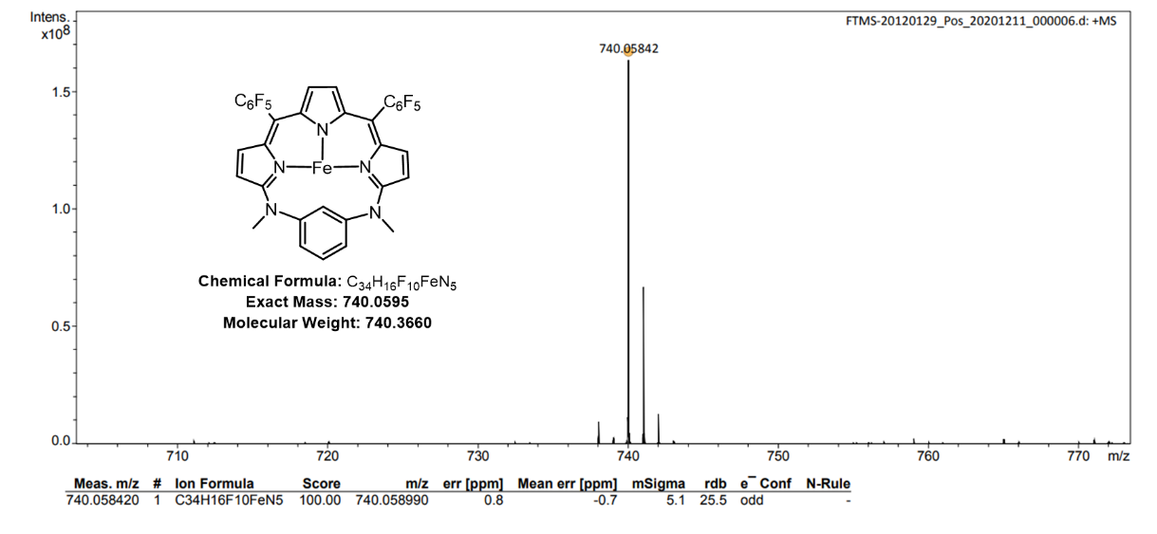
Figure S14. ESI-HRMS spectrum of Fe-TNBD.
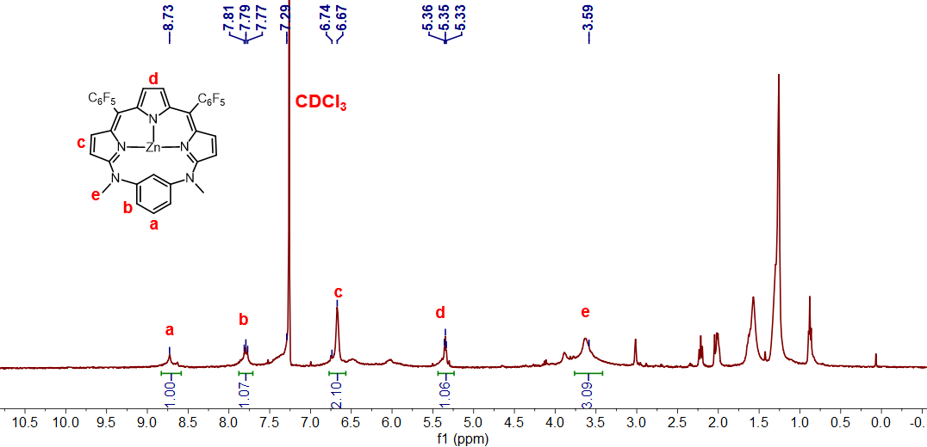
Figure S15. ¹H NMR spectrum of Zn-TNBD in CDCl₃.
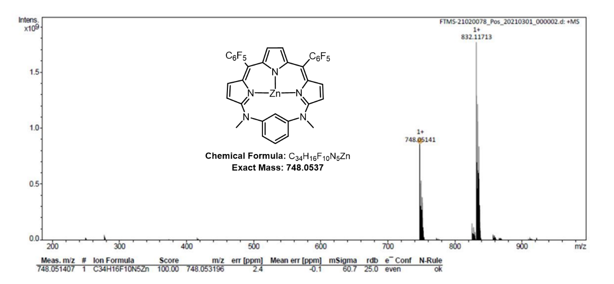
Figure S16. ESI-HRMS spectrum of Zn-TNBD.

Figure S17. FT-IR spectrum of Zn-TNBD.

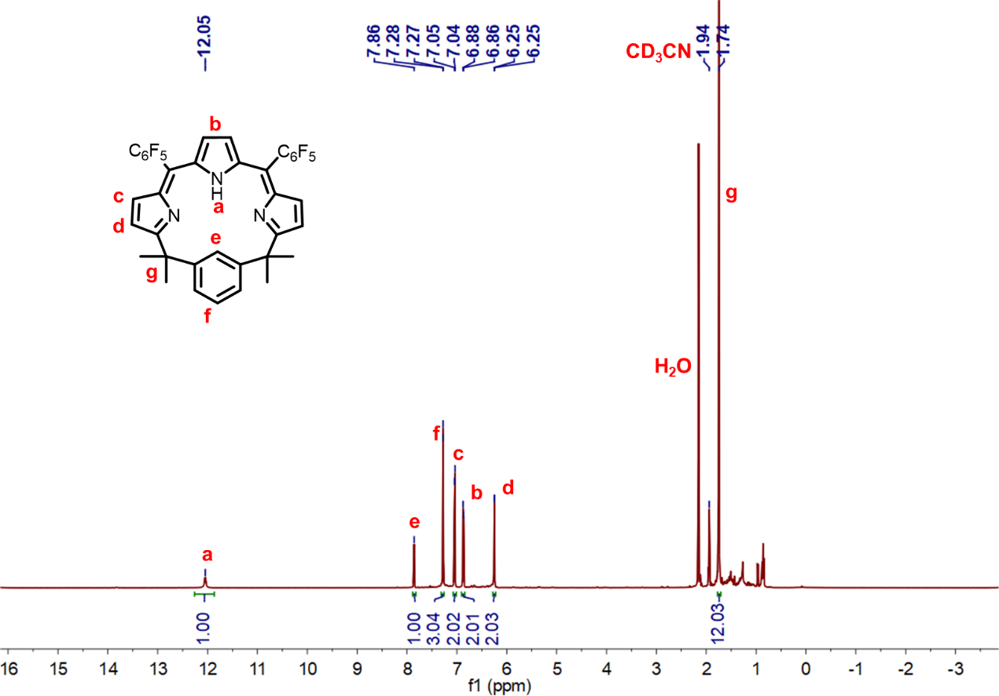
Figure S18. ¹H NMR spectrum of TCBD in CD₃CN.

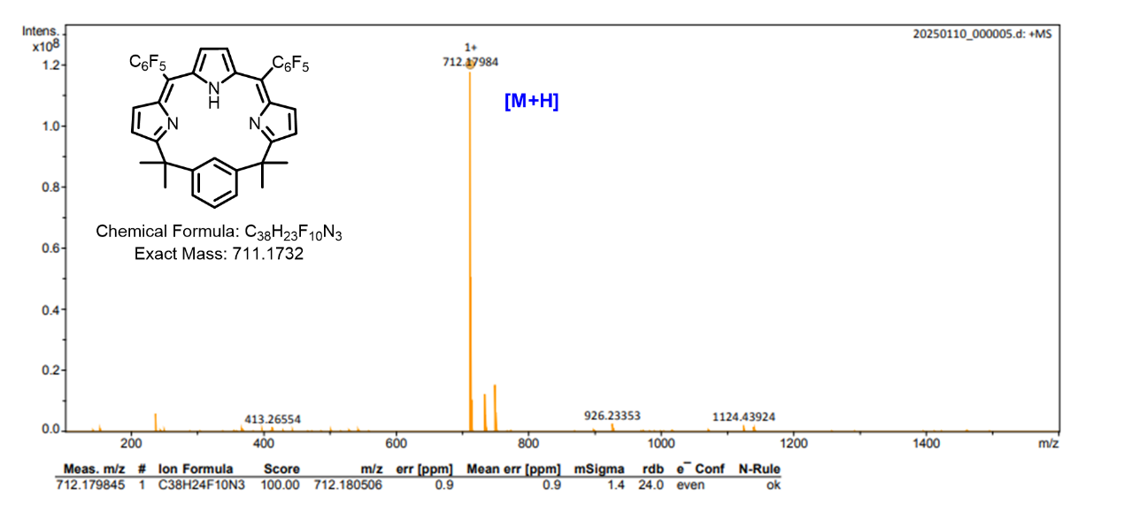
Figure S19. ESI-HRMS spectrum of TCBD.
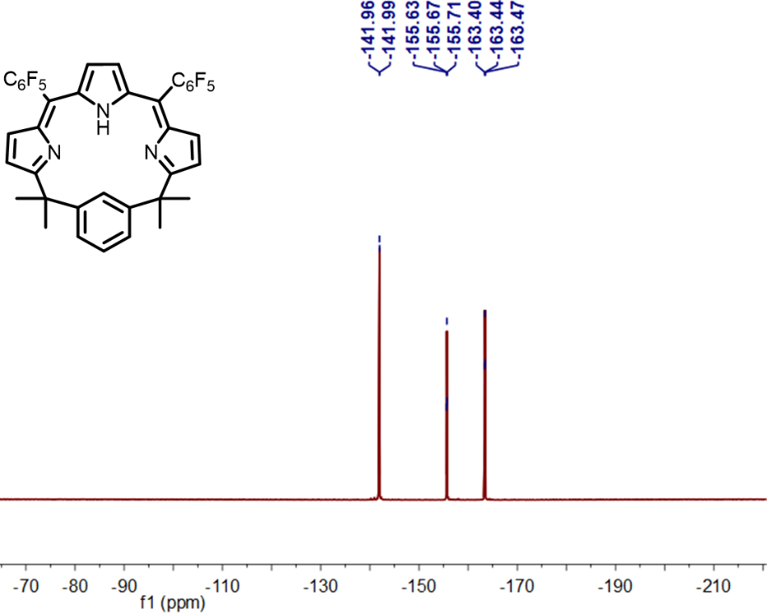
Figure S20. ¹⁹F NMR spectrum of TCBD in CD₃CN.

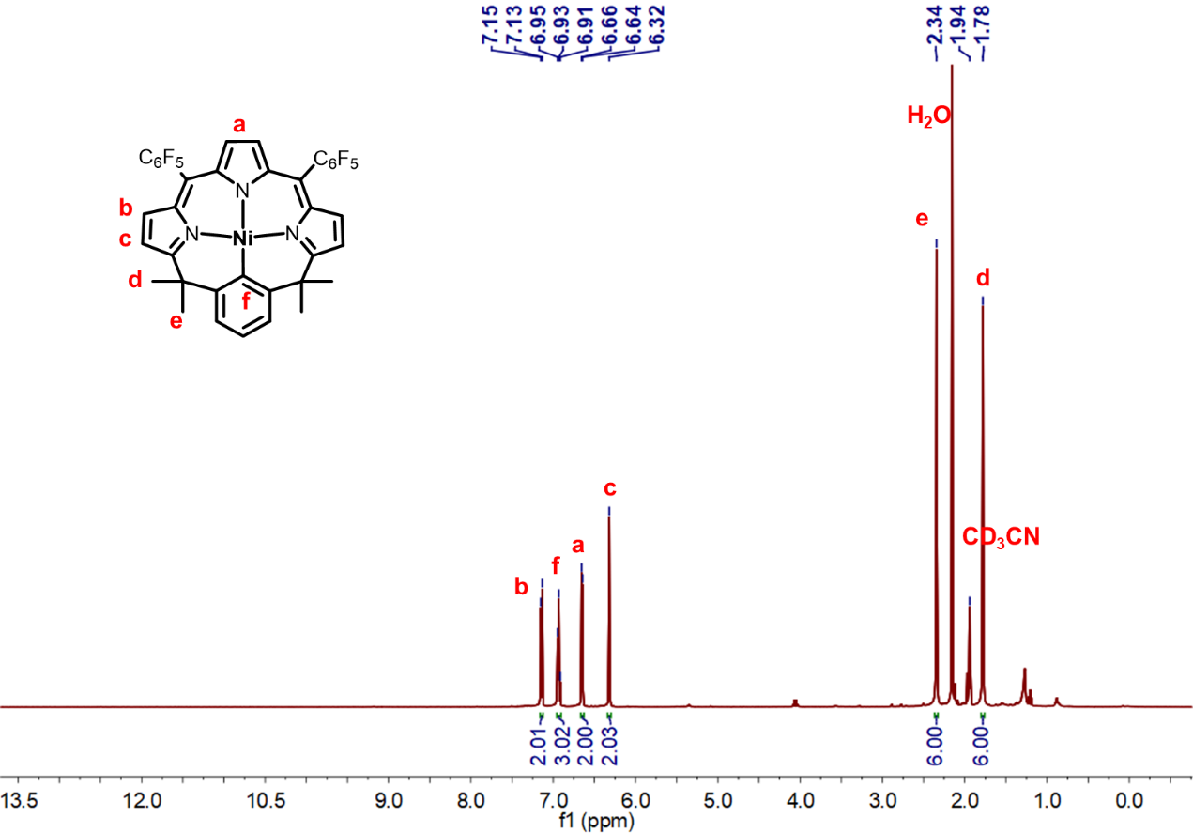
Figure S21. ¹H-NMR spectrum of Ni-TCBD in CD₃CN.
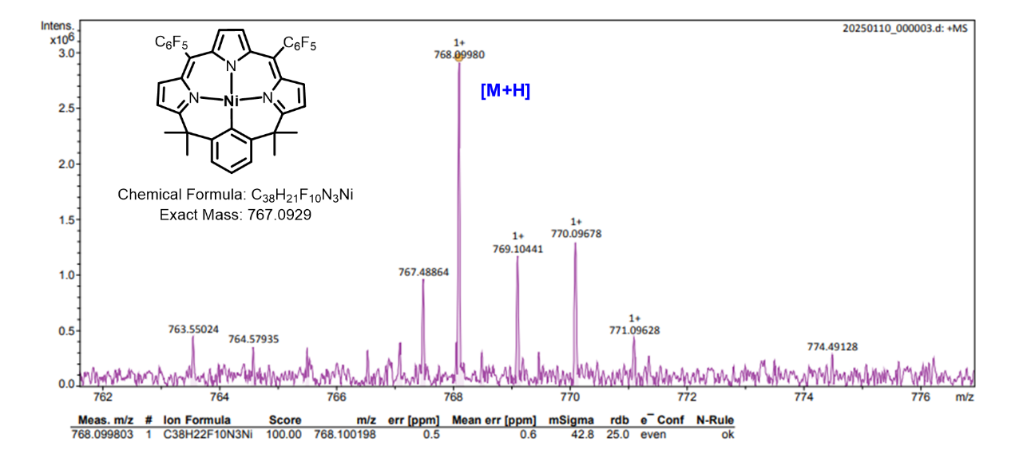
Figure S22. ESI-HRMS spectrum of Ni-TCBD.

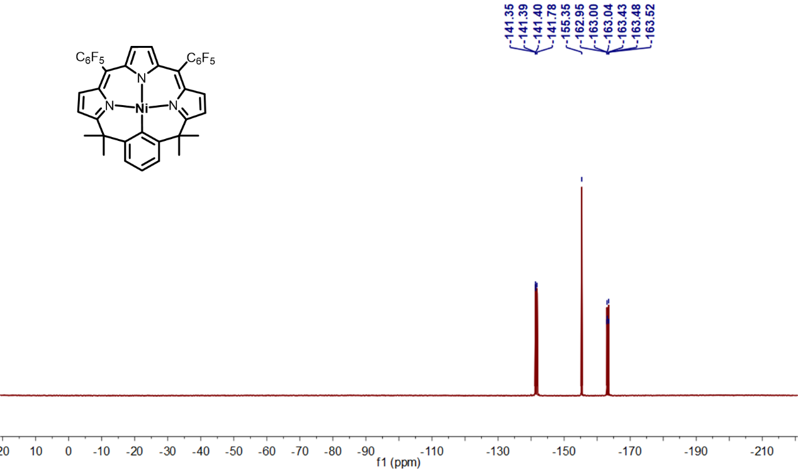
Figure S23. ¹⁹F NMR spectrum of Ni-TCBD in CD₃CN.

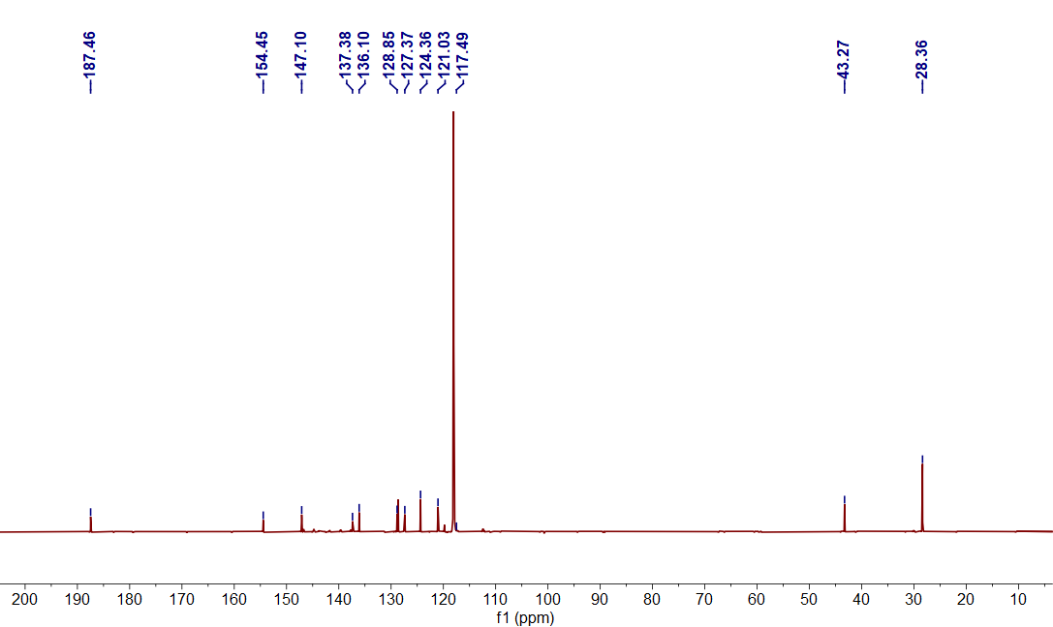
Figure S24. ¹³C NMR spectrum of Ni-TCBD in CD₃CN.

Figure S25. FT-IR spectrum of Ni-TCBD.

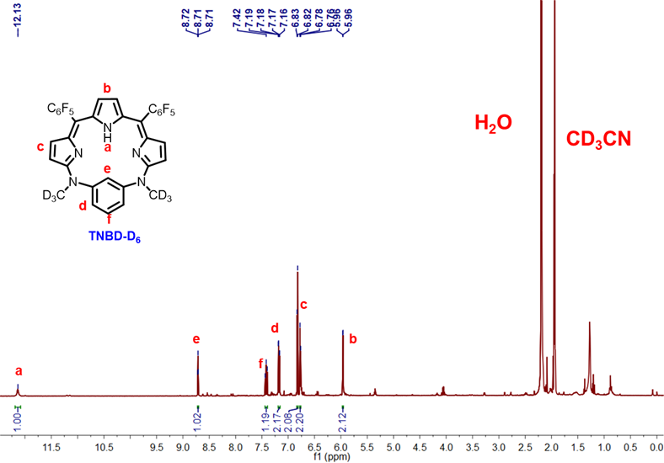
Figure S26. ¹H-NMR spectrum of TNBD-D₆ in CD₃CN.

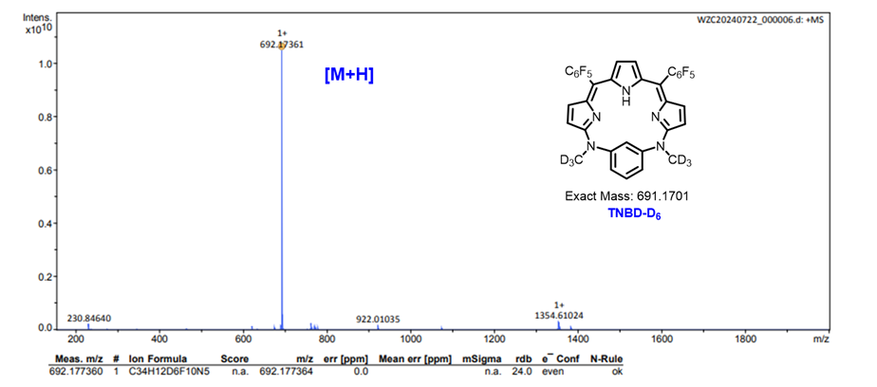
Figure S27. ESI-HRMS spectrum of TNBD-D₆.

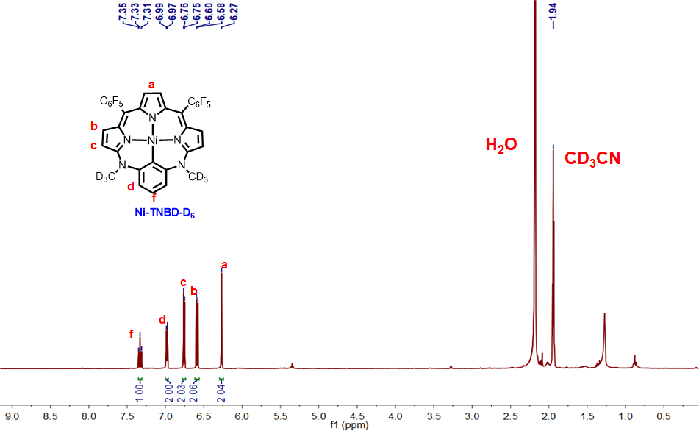
Figure S28. ¹H-NMR spectrum of Ni-TNBD-D₆ in CD₃CN.

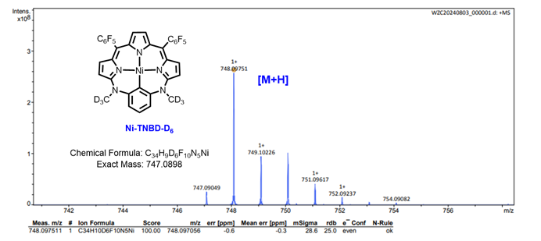
Figure S29. ESI-HRMS spectrum of Ni-TNBD-D₆.

Table S1. Crystal data and structure refinement for Ligand
Complex | Ligand
Molecular formula | C₃₂H₁₅F₁₀N₅
Formula wt. (g mol⁻¹) | 686.13
Temperature (K) | 180
Radiation (λ, Å) | 0.71073
Crystal system | monoclinic
Space group | P 2₁/n
a (Å) | 11.2788 (6)
b (Å) | 14.4918 (6)
c (Å) | 37.1218 (15)
α (º) | 90
β (º) | 94.881 (4)
γ (º) | 90
Volume (Å3) | 6045.6 (5)
Z | 4
ρ_{calcd} (g cm⁻³) | 1.593
μ (mm⁻¹) | 0.136
F (000) | 2840.0
Crystal size (mm³) | 0.1 × 0.05 × 0.02
Theta range | 1.785 to 25.026°
Reflections collected | 35868
Independent reflections | 1.0677 [R_{int} = 0.0773]
Completeness | 99.40%
Goodness-of-fit on F² | 1.042
Final R indices  [R > 2σ (I)] | R1ª = 0.0569  wR2^{b} = 0.1145
R indices (all data) | R1ª = 0.1759  wR2^{b} = 0.0944
Largest diff. peak and hole (e Å⁻³) | 0.652 and -0.191
Table S2. Crystal data and structure refinement for Ni-TNBD
Complex | Ni-TNBD
Molecular formula | C₃₄H₁₅F₁₀N₅Ni
Formula wt. (g mol⁻¹) | 742.05
Temperature (K) | 180
Radiation (λ, Å) | 0.71073
Crystal system | monoclinic
Space group | C 2/c
a (Å) | 35.5956 (6)
b (Å) | 13.7548 (2)
c (Å) | 12.5215 (2)
α (º) | 90
β (º) | 94.369 (2)
γ (º) | 90
Volume (Å3) | 6112.84 (17)
Z | 4
ρ_{calcd} (g cm⁻³) | 1.743
μ (mm⁻¹) | 0.865
F (000) | 3208.0
Crystal size (mm³) | 0.6 × 0.2 × 0.1
Theta range | 2.245 to 27.485°
Reflections collected | 43704
Independent reflections | 7014 [R_{int} = 0.0315]
Completeness | 99.40%
Goodness-of-fit on F² | 1.076
Final R indices  [R > 2σ (I)] | R1ª = 0.0338  wR2^{b} = 0.0932
R indices (all data) | R1ª = 0.0435  wR2^{b} = 0.0890
Largest diff. peak and hole (e Å⁻³) | 0.438 and -0.4

Table S3. Crystal data and structure refinement for Fe-TNBD
Complex | Fe-TNBD
Molecular formula | C₃₄H₁₆F₁₀N₅Fe
Formula wt. (g mol⁻¹) | 740.05
Temperature (K) | 100
Radiation (λ, Å) | 1.54184
Crystal system | tetragonal
Space group | P 4n
a (Å) | 25.5335 (7)
b (Å) | 25.5335 (7)
c (Å) | 11.0430 (5)
α (º) | 90
β (º) | 90
γ (º) | 90
Volume (Å3) | 7199.6 (5)
Z | 8
ρ_{calcd} (g cm⁻³) | 1.710
μ (mm⁻¹) | 7.435
F (000) | 3690.0
Crystal size (mm³) | 0.1 × 0.08 × 0.05
Theta range | 7.742 to 152.952°
Reflections collected | 24067
Independent reflections | 7225 [R_{int} = 0.0772]
Goodness-of-fit on F² | 1.033
Final R indices  [R > 2σ (I)] | R1ª = 0.0576  wR2^{b} = 0.1405
R indices (all data) | R1ª = 0.0672  wR2^{b} = 0.1471
Largest diff. peak and hole (e Å⁻³) | 0.76 and -0.60

Table S4. Crystal data and structure refinement for Cu-TNBD
Complex | Cu-TNBD
Molecular formula | C₃₄H₁₅CuF₁₀N₅O
Formula wt. (g mol⁻¹) | 763.06
Temperature (K) | 180
Radiation (λ, Å) | 0.71073
Crystal system | orthorhombic
Space group | P2₁2₁2₁
a (Å) | 11.70850(10)
b (Å) | 20.9333(2)
c (Å) | 42.0795(5)
α (º) | 90
β (º) | 90
γ (º) | 90
Volume (Å3) | 10313.58(18)
Z | 4
ρ_{calcd} (g cm⁻³) | 1.712
μ (mm⁻¹) | 0.908
F (000) | 5326.0
Crystal size (mm³) | 0.23 × 0.19 × 0.15
Theta range | 3.496 to 58.832°
Reflections collected | 124542
Independent reflections | 26309 [R_{int} = 0.0579]
Completeness | 99.90%
Goodness-of-fit on F² | 1.077
Final R indices  [R > 2σ (I)] | R1ª = 0.0695  wR2^{b} = 0.1615
R indices (all data) | R1ª = 0.0912  wR2^{b} = 0.1711
Largest diff. peak and hole (e Å⁻³) | 1.02 and -0.88

Figure S30. UV-vis absorption spectra of TXBD (X= NMe, O, C(Me)₂) in CH₂Cl₂.

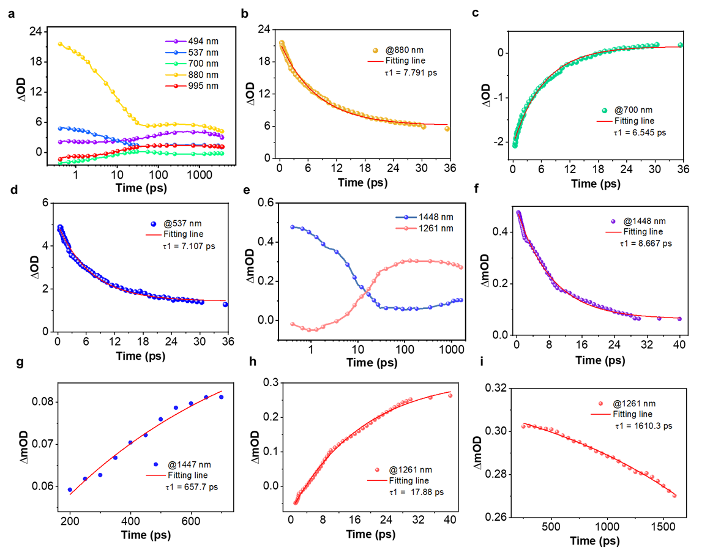
Figure S31. (a-i) TA kinetics traces at the selected wavelength of Ni-TNBD pumped at 785 nm in degassed toluene.

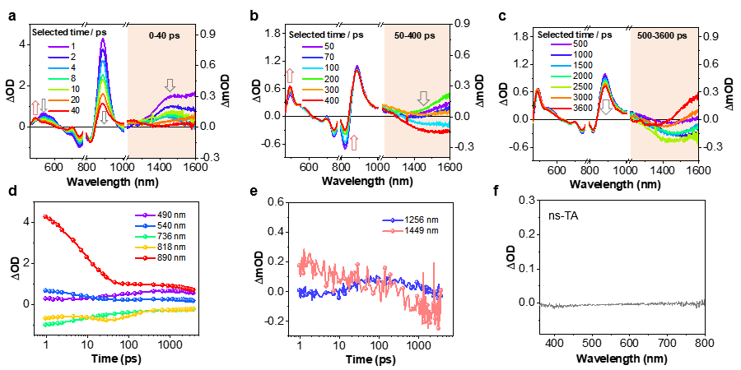
Figure S32. (a-c) Femtosecond spectrum for Ni-TNBD recorded at selected decay times in toluene obtained with λ_{ex}=785 nm at 298 K. The red portion of the spectrum was detected using a near-infrared detector. (d-e) TA kinetics traces at the selected wavelength of Ni-TNBD pumped at 785 nm. (f) Nanosecond transient absorption spectra of Ni-TNBD were recorded in toluene, pumped at 355 nm at 298 K, indicating the absence of a long-lived excited state in the presence of air, which may have been quenched by oxygen.

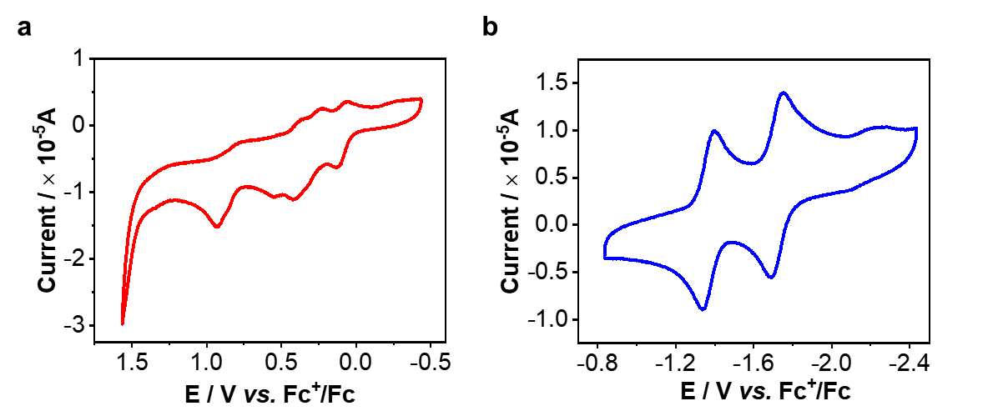
Figure S33. Cyclic voltammograms of 1.0 mM Ni-TNBD in dry CH₃CN containing 0.1 M ^{n} Bu₄NPF₆. (a) Oxidation and (b) reduction potentials of Ni-TNBD.

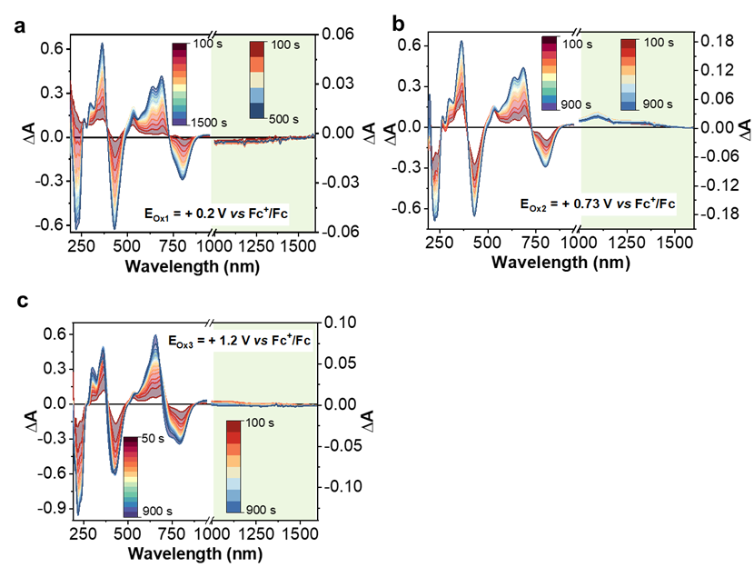
Figure S34. UV-vis absorption difference spectra obtained upon different electrochemical reduction at or oxidation potential vs Fc⁺/Fc of Ni-TNBD in CH₃CN.

Table S5. Calculated vertical excitations in S₀ state optimized structures of Ni-TNBD by TDDFT.
State | E/cm⁻¹ | λ/nm | f | Major MO contribution
T₅ | 15647 | 639.11 | 0.0000 | HOMO→LUMO+1(54.0%)  HOMO-1→LUMO(27.2%)  HOMO-4→LUMO(14.2%)
S₁ | 13652 | 732.50 | 0.1698 | HOMO→LUMO(98.3%)
T₄ | 9590.9 | 1042.66 | 0.0000 | HOMO-4→LUMO+2(33.2%)  HOMO-1→LUMO+2(31.6%)  HOMO-13→LUMO+2(16.5%)  HOMO-12→LUMO+2(16.2%)
T₃ | 9066.1 | 1103.01 | 0.0000 | HOMO-2→LUMO+2(37.8%)  HOMO-5→LUMO+2(32.7%)  HOMO-14→LUMO+2(17.3%)
T₂ | 7939.6 | 1259.51 | 0.0000 | HOMO→LUMO(99.5%)
T₁ | 6204.5 | 1611.74 | 0.0000 | HOMO-3→LUMO+2(106.1%)  HOMO-3←LUMO+2(-18.3%)

Table S6. Adiabatic energy difference, d-orbital splittings, and spin-orbit coupling matrix elements for Ni-TNBD obtained from DFT calculations.
Transition | S₁-T₁ | S₁-T₂ | S₁-T₃ | S₁-T₄
ΔE_{ST}ª/eV | 0.77 | 0.61 | 0.46 | 0.40
Δdd*^{b}/eV | 5.25
SOCME_{S to T} ^{c}/cm⁻¹ | 3.76 | 1.29 | 11.17 | 3.20
ªAdiabatic energy difference between S₁ and T_{n} state. ^{b}Splitting between the occupied and unoccupied d orbitals in the S₁ optimized structure. ^{c}Spin-orbit coupling matrix element between the S₁ and T_{n} state.

Table S7. Photophysical properties for Ni-TNBD obtained from DFT calculations.
Quantity | Value
λ_{em}(S₁→ S₀)ª/nm | 882.22
k_{R}(S₁→ S₀)^{b}/s⁻¹ | 9.75×10⁶
k_{NR}(S₁→ S₀)^{c}/s⁻¹ | 2.10×10¹²
k_{ISC}(S₁-T₁)^{d}/s⁻¹ | 1.32×10⁸
k_{ISC}(S₁-T₂)^{e}/s⁻¹ | 1.41×10⁶
k_{ISC}(S₁-T₃)^{f}/s⁻¹ | 2.25×10⁸
k_{ISC}(S₁-T₄)^{g}/s⁻¹ | 1.01×10⁷
ª Wavelength of the emission center from the S₁ state to the S₀ state. ^{b}Fluorescent rate constant corresponding to the depopulation of the S₁ state. ^{c}Non-radiative rate constant. ^{d-g} Intersystem crossing rate constant corresponding to the conversion from the S₁ state to the T_{n} state.

Table S8. Key structural parameters of optimized ground state (S₀) and metal-center dominated triplet (T₁) structures for Ni-TNBD.

Compound | Ni-TNBD
Compound | S₀ | T₁
Bond Lengths (Å)
Ni-C | 1.974 | 2.068
Ni-N1 | 1.924 | 2.025
Ni-N2 | 1.924 | 2.026
Ni-N3 | 1.996 | 2.078
Bond Angles (°)
C-Ni-N1 | 90.55 | 91.50
C-Ni-N3 | 179.78 | 179.76
N1-Ni-N2 | 178.86 | 177.07
N1-Ni-N3 | 89.41 | 88.53
Dihedral Angles (°)
N1-Ni-N3-N2 | 179.90 | 179.74

Table S9. Comparisons of changes in the key structural parameters of optimized metal-center dominated triplet (T₁) structures relative to ground state (S₀) for Ni-TNBD with previously reported systems.
Compound | ΔBond Lengths (Å) |  | ΔBond Angles (°) |  | ΔDihedral Angles (°) |  | Ref.
3 | 0.138 | -15.93 |  | -25.5 |  | [17]
2 | 0.244 | -6.9 |  | 0.06 |  | [18]
Ni-TNBD | 0.102 | -1.79 |  | -0.16 |  | This work

Figure S35. EPR spectra for Ni-TNBD and subject to photoirradiation in DMF at 298K. The presence of a well-resolved signal was taken as evidence of O₂^{-•}.

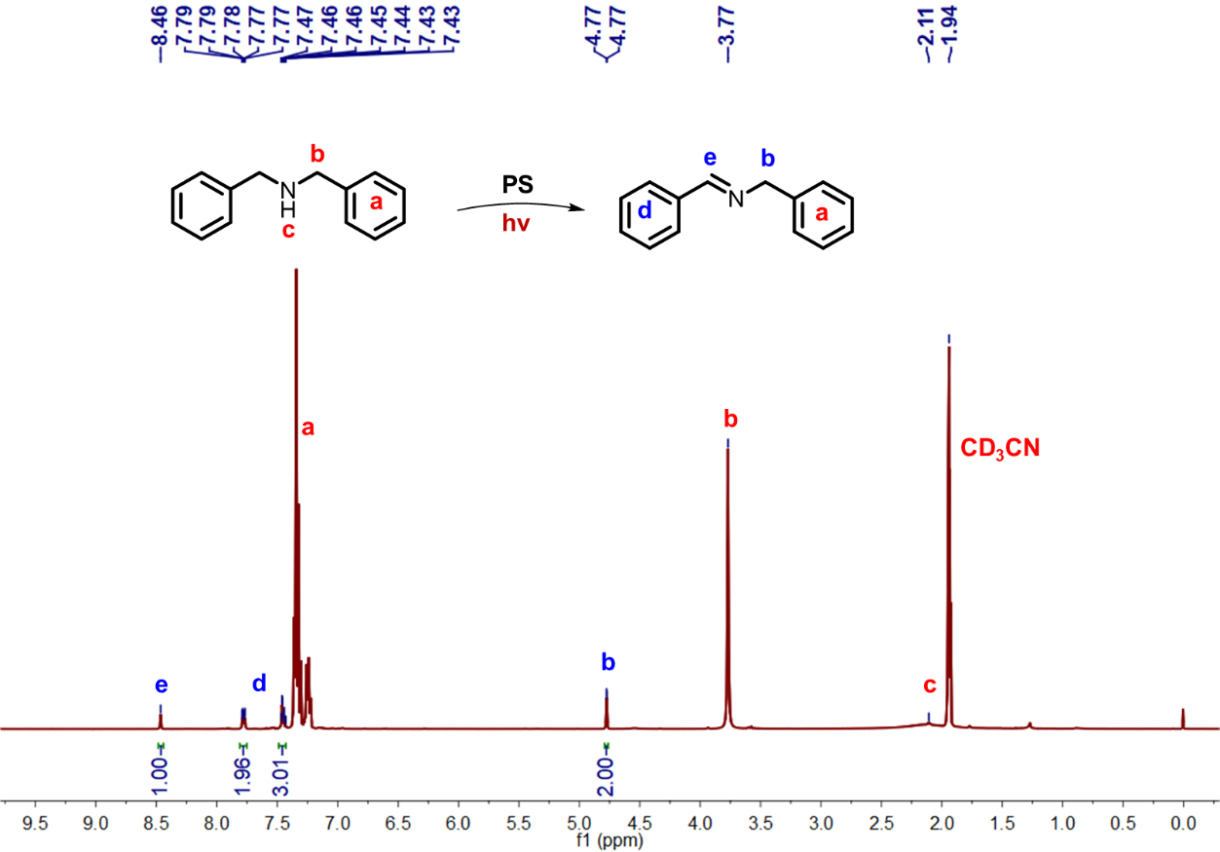
Figure S36. ¹H NMR spectrum of oxidation of dibenzylamine using Ni-TNBD as photocatalysts under 808 nm irradiation for 8h in CD₃CN.
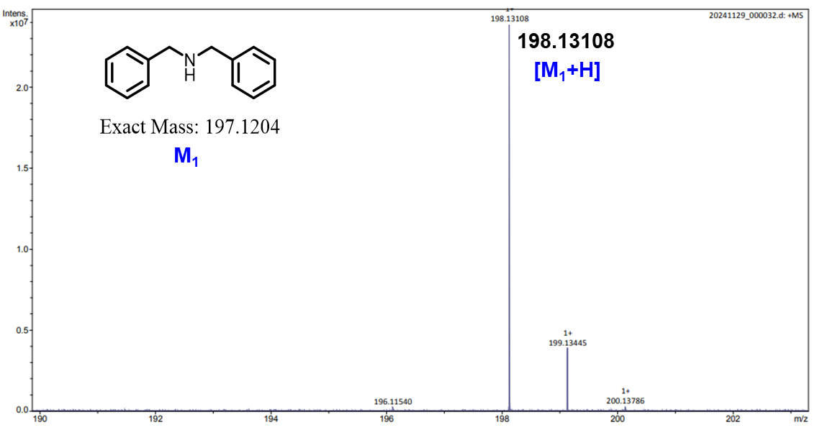
Figure S37. ESI-MS spectrum of dibenzylamine.

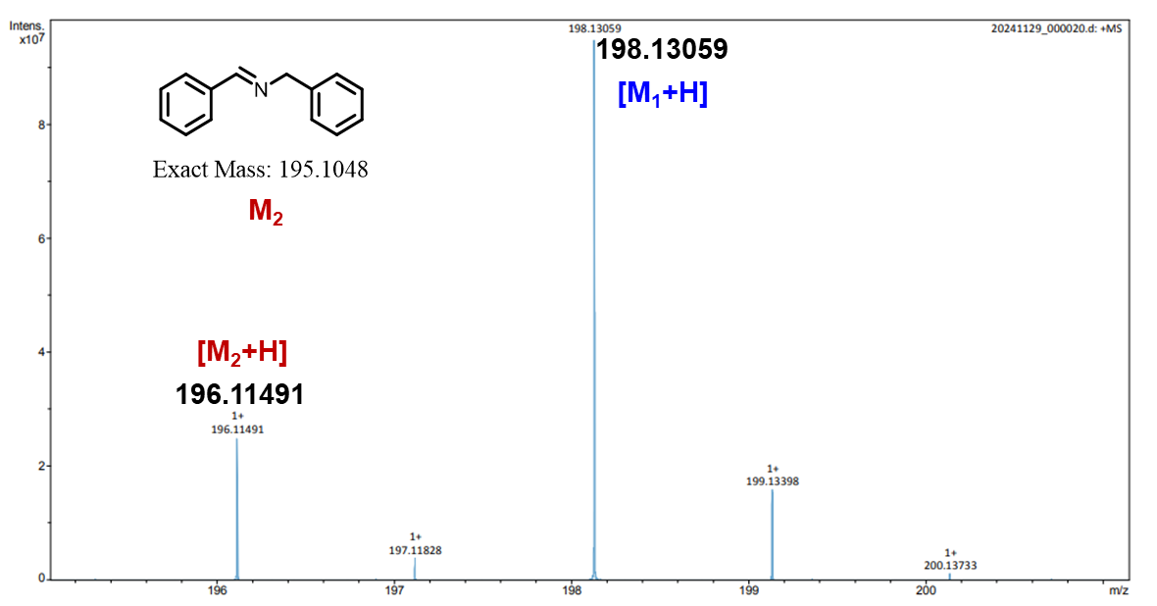
Figure S38. ESI-MS spectrum of compound after oxidation of dibenzylamine.

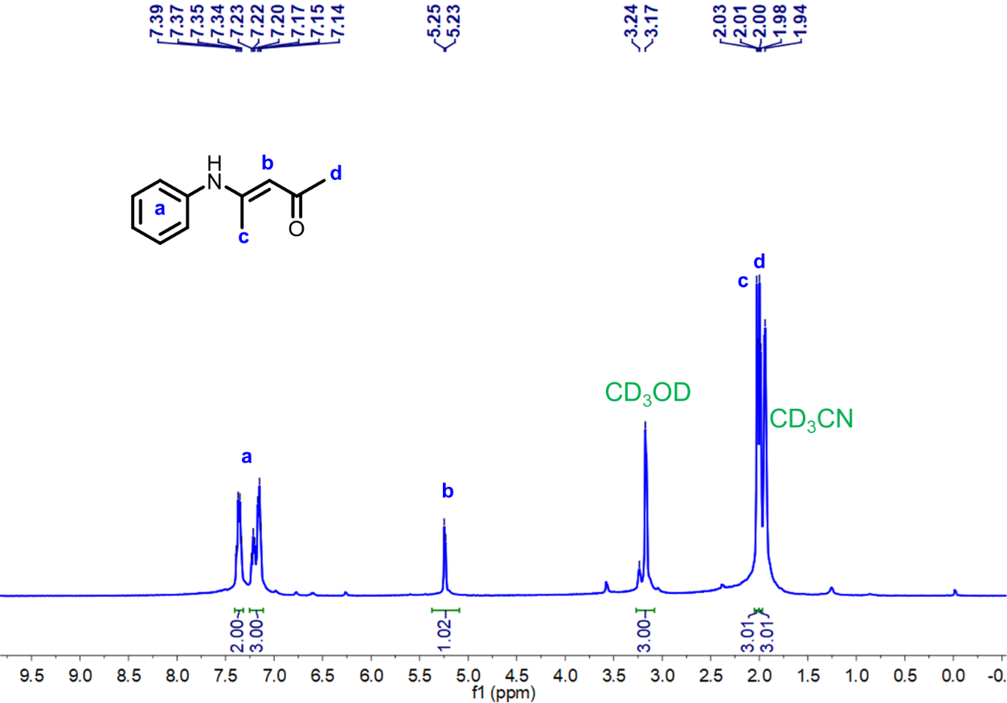
Figure S39. ¹H NMR spectrum of (E)-4-(phenylamino)pent-3-en-2-one compound in CD₃CN.

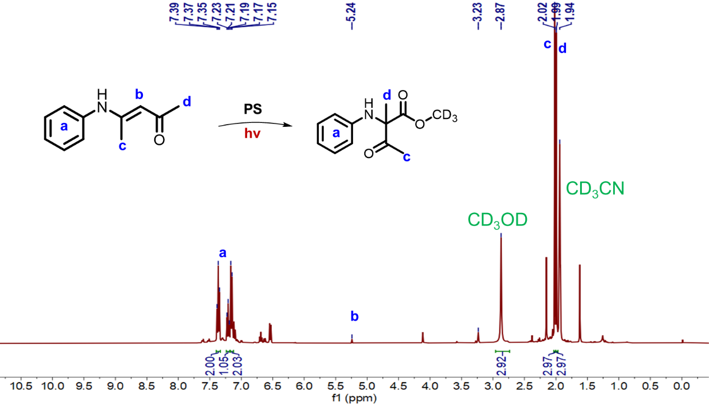
Figure S40. ¹H NMR spectrum of α-amino carbonyl compound via the 1,2-acyl migration reactions under 808 nm irradiation for 10h in CD₃CN.
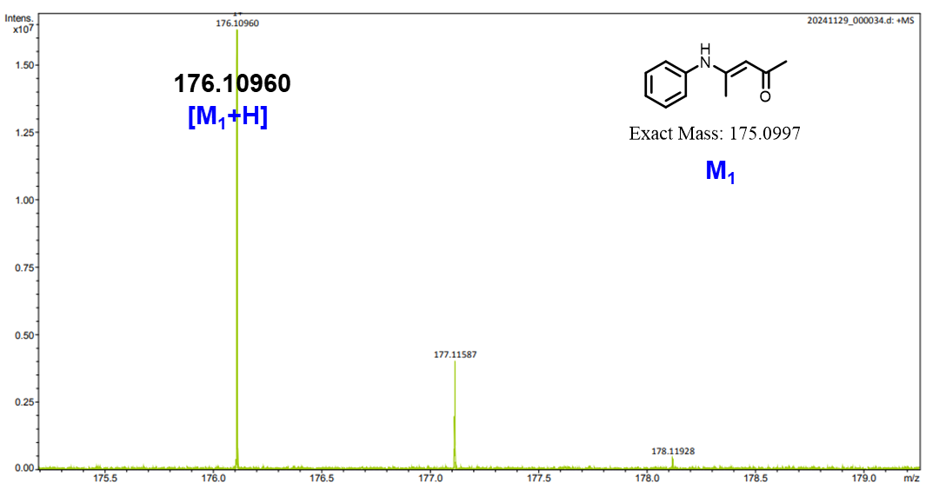
Figure S41. ESI-MS spectrum of (E)-4-(phenylamino)pent-3-en-2-one.

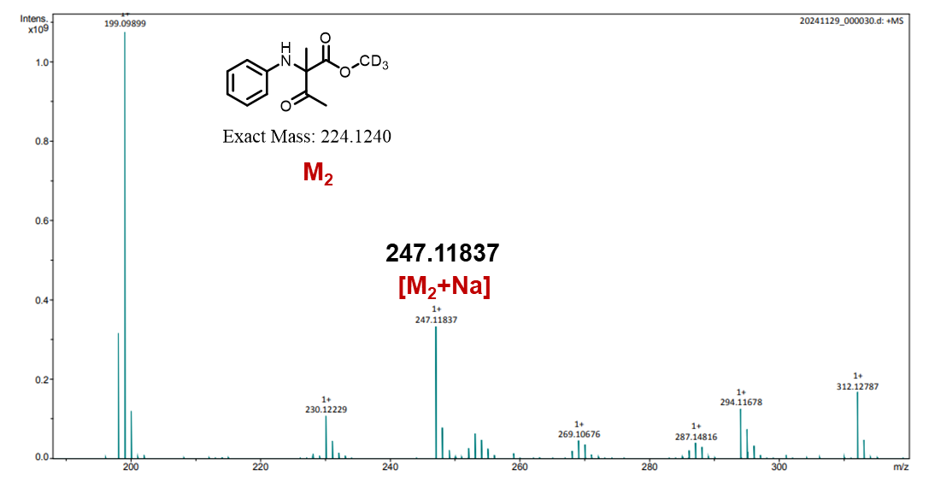
Figure S42. ESI-MS spectrum of α-amino carbonyl compound obtained by the 1,2-acyl migration reactions.

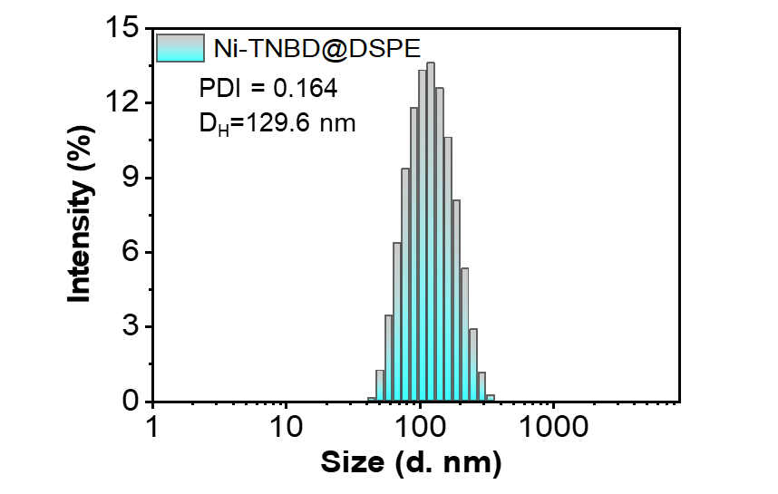
Figure S43. Hydrodynamic diameter distribution of Ni-TNBD@DSPE (aqueous solution).

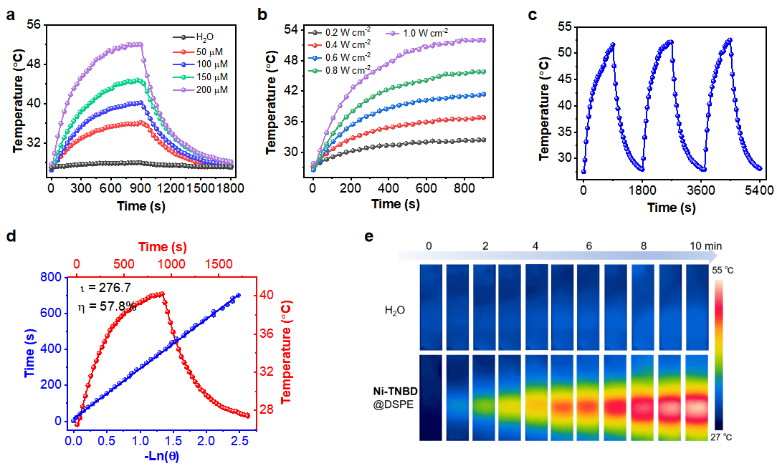
Figure S44. (a) Concentration-dependent photothermal heating curves (808 nm, 1.0 W cm⁻²). (b) Power density-dependent heating curves of 200 µM Ni-TNBD@DSPE (808 nm). (c) Photothermal cycling stability test. (d) Single heating-cooling cycle and linear plot of -ln(θ) vs. time for efficiency calculation. (e) IR thermal imaging of 200 µM solution under irradiation (808 nm, 1.0 W cm⁻²).

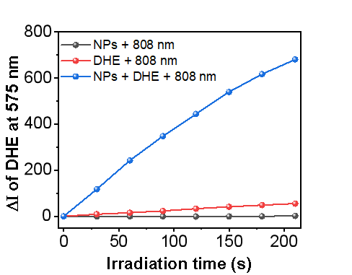
Figure S45. The Ni-TNBD@DSPE was able to produce O₂^{•-} in water under light.

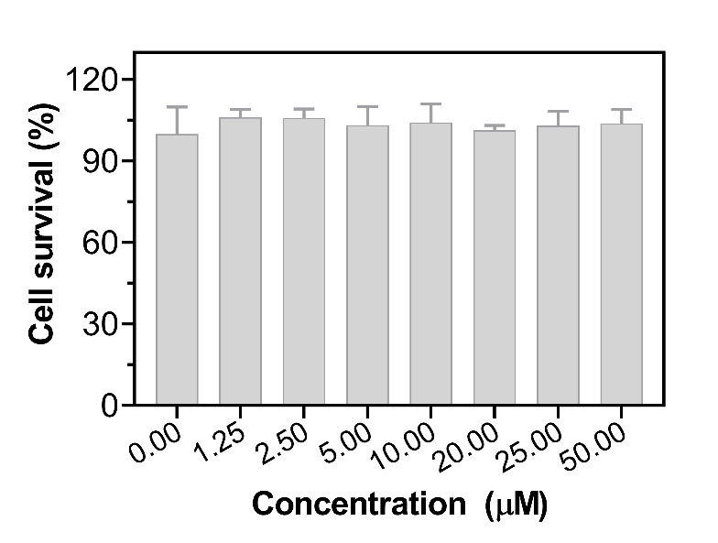
Figure S46. Biosafety assay: Relative viabilities of HaCaT cells incubated with Ni-TNBD@DSPE for 24 h.

Figure S47. Representative fluorescence intensity analysis of corresponding organs.

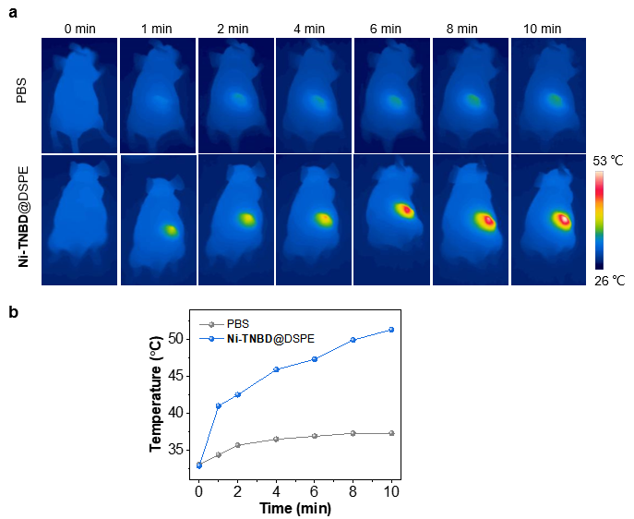
Figure S48. (a) Photothermal images of the tumor region in tumor-bearing mice exposed to 808 nm laser irradiation at 8 hours post intravenous (i.v.) injection of Ni-TNBD@DSPE, and (b) the corresponding temperature change curves.
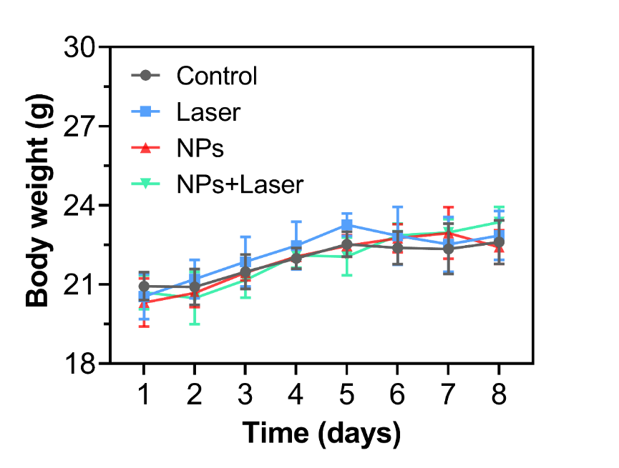
Figure S49. Body weight changes for mice subject to different treatment regimens.

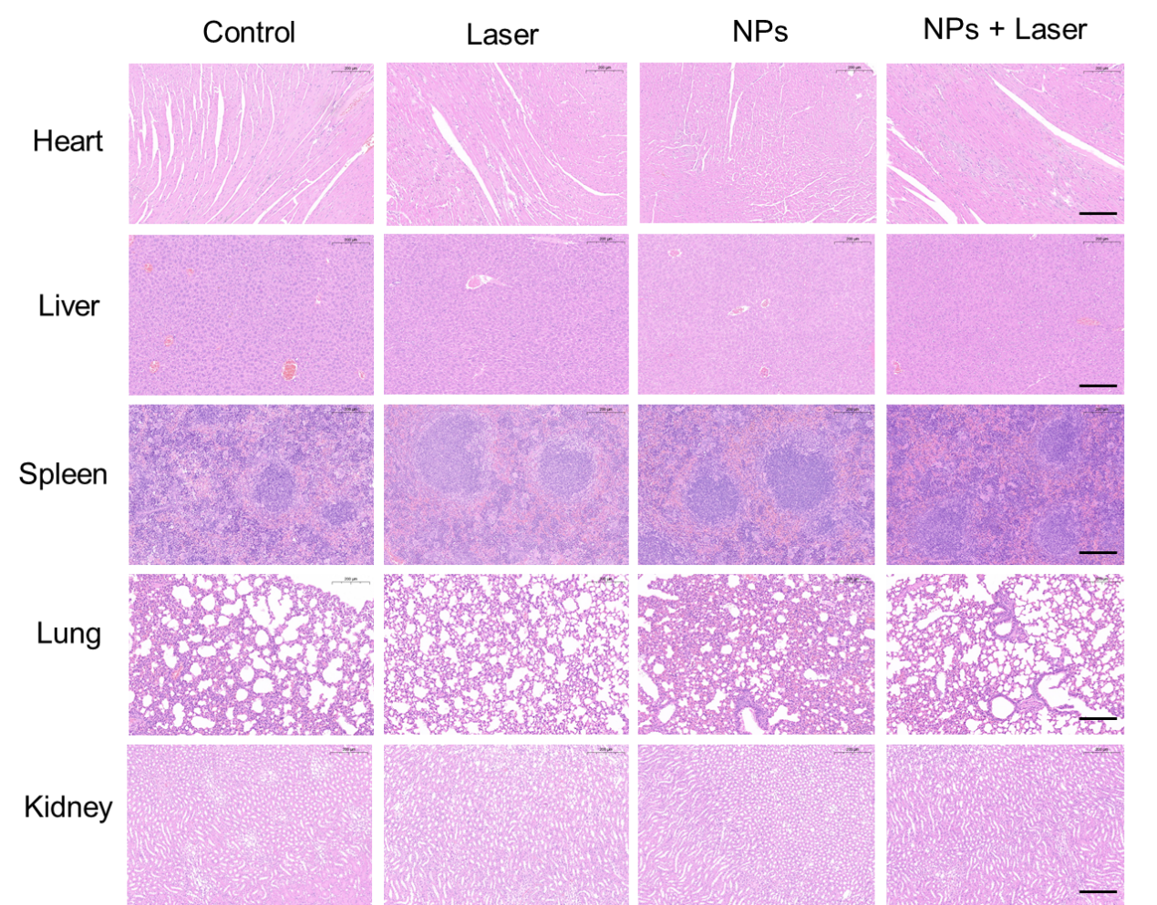
Figure S50. Histopathological analysis of different treatment regimens.

4. Supplementary References
- Stephens, P. J.; Devlin, F. J.; Chabalowski, C. F.; Frisch, M. J., Ab-initio calculation of vibrational absorption and circular-dichroism spectra using density-functional force-fields. J. Phys. Chem. 1994, 98(45), 11623–11627.
- Frisch, M. J.; Trucks, G. W.; Schlegel, H. B.; Scuseria, G. E.; Robb, M. A.; Cheeseman, J. R.; Scalmani, G.; Barone, V.; Petersson, G. A.; Nakatsuji, H.; Li, X.; Caricato, M.; Marenich, A. V.; Bloino, J.; Janesko, B. G.; Gomperts, R.; Mennucci, B.; Hratchian, H. P.; Ortiz, J. V.; Izmaylov, A. F.; Sonnenberg, J. L.; Williams; Ding, F.; Lipparini, F.; Egidi, F.; Goings, J.; Peng, B.; Petrone, A.; Henderson, T.; Ranasinghe, D.; Zakrzewski, V. G.; Gao, J.; Rega, N.; Zheng, G.; Liang, W.; Hada, M.; Ehara, M.; Toyota, K.; Fukuda, R.; Hasegawa, J.; Ishida, M.; Nakajima, T.; Honda, Y.; Kitao, O.; Nakai, H.; Vreven, T.; Throssell, K.; Montgomery Jr., J. A.; Peralta, J. E.; Ogliaro, F.; Bearpark, M. J.; Heyd, J. J.; Brothers, E. N.; Kudin, K. N.; Staroverov, V. N.; Keith, T. A.; Kobayashi, R.; Normand, J.; Raghavachari, K.; Rendell, A. P.; Burant, J. C.; Iyengar, S. S.; Tomasi, J.; Cossi, M.; Millam, J. M.; Klene, M.; Adamo, C.; Cammi, R.; Ochterski, J. W.; Martin, R. L.; Morokuma, K.; Farkas, O.; Foresman, J. B.; Fox, D. J. Gaussian 16 Rev. A.03, Wallingford, CT, 2016.
- Krishnan, R.; Binkley, J. S.; Seeger, R.; Pople, J. A. Self-consistent molecular orbital methods. XX. A basis set for correlated wave functions. J. Chem. Phys. 1980, 72, 650–654.
- Hay, P. J.; Wadt, W. R. Ab initio effective core potentials for molecular calculations - Potentials for the transition metal atoms Sc to Hg. J. Chem. Phys. 1985, 82, 270–283.
- Marenich, A. V.; Cramer, C. J.; Truhlar, D. G. Universal solvation model based on solute electron density and on a continuum model of the solvent defined by the bulk dielectric constant and atomic surface tensions. J. Phys. Chem. B 2009, 113(18), 6378–6396.
- Hirata, S.; Head-Gordon, M. Time-dependent density functional theory within the Tamm–Dancoff approximation. Chem. Phys. Lett. 1999, 314, 291–299.
- Lu, T.; Chen, F. Multiwfn: A multifunctional wavefunction analyzer. J. Comput. Chem. 2012, 33(5), 580–592.
- Lu, T. A comprehensive electron wavefunction analysis toolbox for chemists, Multiwfn. J. Chem. Phys. 2024, 161, 082503.
- Liu, Z.; Lu, T.; Chen, Q. An sp-hybridized all-carboatomic ring, cyclo[18]carbon: Electronic structure, electronic spectrum, and optical nonlinearity. Carbon, 2020, 165, 461–467.
- Lu, T. Simple, reliable, and universal metrics of molecular planarity. J. Mol. Model. 2021, 27, 263.
- Humphrey, W.; Dalke, A.; Schulten, K. VMD: Visual molecular dynamics. J. Mol. Graphics 1996, 14(1), 33–38.
- Gao, X.; Bai, S.; Fazzi, D.; Niehaus, T.; Barbatti, M.; Thiel, W. Evaluation of spin-orbit couplings with linear-response time-dependent density functional methods. J. Chem. Theory Comput., 2017, 13(2), 515–524.
- Shuai, Z. Thermal Vibration Correlation Function Formalism for Molecular Excited State Decay Rates. Chin. J. Chem., 2020, 38, 1223–1232.
- Sheldrick, G. M., A short history of SHELX. Acta. Crystallogr. A 2008, 64, 112-22.
- Sheldrick, G. M., Crystal structure refinement with SHELXL. Acta Crystallogr. C 2015, 71, 3-8.
- Dolomanov, O. V.; Bourhis, L. J.; Gildea, R. J.; Howard, J. A. K.; Puschmann, H., OLEX2: a complete structure solution, refinement and analysis program. J. Appl. Crystallogr. 2009, 42, 339-341.
- Ogawa, T.; Sinha, N.; Pfund Björn; Prescimone, A.; Wenger, O. S. Molecular Design Principles to Elongate the Metal-to-Ligand Charge Transfer Excited-State Lifetimes of Square-Planar Nickel(II) Complexes. J. Am. Chem. Soc. 2022, 144, 21948-21960.
- Ogawa, T.; Wenger, O. S. Nickel(II) Analogues of Phosphorescent Platinum(II) Complexes with Picosecond Excited State Decay. Angew. Chem. Int. Ed. 2023, 62, 46, e202312851.

