A
Snake CEACAM1N exon amino acid alignment

10 20 30 40 50 60 70 80 90 100 110 120 130
| | | | | | | | | | | | |
Bja_Ceacam1N_ITIM SIFSSSFL--LAQGQ--LASTTNYNISISKNPPETLEGQNVNLTLQHEAANFVTCNWYRGIEMKENLIVTFYLPPISANTTGNSYTGREVSGFGCSLLIKNLNLNDTGTYTVTMNGPSVHGTGHVNIQVL
Bmo_Ceacam1N_ITIM SIFSSSFL--LAQGQ--LASTTNYNISISKNPPETLEGQNVNLTLQHEAASFVTCNWYRGIEMKENLIVTFYLPPINANTTGNSYTGREVSGFGCSLLIKNLNLNDTGTYTVIMNGPSVHGTGLVNIQVL
Cad_Ceacam1N_ITIM SIFSSSFL--LAQGQ--LASTTDYNISISKNPQETLEGQNVNLTLQHEAANFIVCNWYRGIEMKENLIVTYYLPPITGTTNGNSYTGREVVGFGCSLLIKNLNLNDTGTYMVIMNGPSVHGKGLVNIQVL
Cpy_Ceacam1N_ITIM SIFSSSFL--LAQGQ--LASTTDYNISISKNPQETLEGQNVNLTLQHEAANFIVCNWYRGIEMKENLIVTYYLPPITGTTNGNSYTGREVVGFGCSLLIKNLNLNDTGTYMVIMNGPSVHGKGLVNIQVL
Cti_Ceacam1N_ITIM SIFSSSFL--LAQGQ--LASTTDYNISISKNPQETLEGQNVNLTLQHEAANFIVCNWYRGIEMKENLIVTYYLPPITGTTNGNSYTGREVVGFGCSLLIKNLNLNDTGTYMVIMNGPSVHGKGLVNIQVL
Coe_Ceacam1N_ITIM SIFSSSFL--LAQGQ--LASTTDYNISISKNPQETLEGQNVNLTLQHEAANFIVCNWYRGIEMKENLIVTYYLPPITGTTNGNSYTGREAVGFGCSLLIKNLNLNDTGTYMVIMNGPSVHGKGLVNIQVL
Cvi_Ceacam1N_ITIM SIFSSSFL--LAQGQ--LASTTNYNISISKNPQETLEGQNVNLTLQHEAANFIVCNWYRGIEMKENLIVTYYLPPITGTTNGNSYTGREVVGFGCSLLIKNLNLNDTGTYMVIMNGPSVHGKGLVNIQVL
Cho_Ceacam1N SIFSSSFL--LAQGQ--LATTTDYNISISKNPQETLEGQNVNLTLQYEAANFIVCNWYRGSEMKENLIVTFYLPPIIGTTNGKSYTGRETVGFGCSLLIKNLNLNDTGTYVVIMNGPSVHGNGHVNIQVL
Gin_Ceacam1N_ITIM SIFSSSFL--LAQG---LDSTTDYDISISKNPPETLEGQNVNLTLQHEAAKFITCSWYRGTEMKENVIVTYYLPPINGITNGNSYTGREAVGFGCSLLIKNLNLNDTGTYVVIMNGPAVHGEGLVNIQVL
Pfl_Ceacam1N_ITIM SIFSSSFL--LAQGQ--LASTTDYDISISMNPPETLEGQNVNLTLKHTGTNFALCNWYRGTEVKENLIVTFYLPPIIGNTTGNSYTGREAVGFGCSLLIKNLNLNDTGTYMVIMNGPSVHGKGLVNIQVL
Pmr_Ceacam1N_ITIM FVFSSSFL--LAQGQ--LASTTDYDISISMNPPETLEGQNVNLTLKHNGTNFALCNWYRGTELKENLIVTFYLPPIIGFTTGNSYTGREAVGFGCSLLIKNLNLNDTGTYMVIMNGPSVHGKGLVNIQVL
Afe_Ceacam1N_ITIM SIFSSSFL--LAQGQ--QATTTNYEILIILNPPETLEGQNVNLTLKHAAANFALCNWYRGTEIKENLIVTLYLPPIIGNTTGDSYTGREVVGFGCSLLIKNLNLNDTGTYVVIMNGPSVHGKGLVNIQVL
Vla_Ceacam1N_ITIM SIFSSSFL--LAQGQ--LSPTTDHKIIISTNPPETLEGRNINLTLKHDAANFAMCNWYRGIEMKENLIVTLYLPPINGNTTGNSYTGRETVGFGCSLLIKNLNLNDTGTYLVVMNGPSVHGSGQVNIEVL
Vur_Ceacam1N_ITIM SIFSSSFL--LAQGQ--LSPTTDHKISISTNPPETFEGRNINLTLKHDAANFAMCNWYRGIEMKENLIVTLYLPPINGNTTGNSYTGRETVGLGCSLLIKNLNLNDTGTYLVVMNGPSVHGSGQANIEVL
Vbe_Ceacam1N_ITIM SIFSSSFL--LTRGQ--LSPTTDHEISISRNPPQTFEGRNINLTLKHDAANFAMCNWYRGSEMKENLIVTLYLPPINGNTTGNSYTGRETVGFGCSLLIKNLNLNDSRTYLVVMNGPSVHGSGQVKIEVL
Dsi_Ceacam1N_ITIM SIFSSSFL--LAQGQ--LSPTTDYKISIYTNPPETLEGRNINLTLKHAAANFAMCNWYRGIEIKENLIVTLYLPPINGNTTGNSYTGRETVGIGCSLLIKNLNLNDTGTYLVVMNGPSVHGSGQVNIEVL
Mth_Ceacam1N_ITIM SILSSSFLPSLAQGK--LSTTTSYDIEISVNPPETLEGQMVNLTLKYSAANFVLCKWYRGTDTKEKMIATFYLT-VTGNTSGPSNTGRETIGFGCSLLIQNLHLNDSGTYVVNMEGPSVVGKGLVNITVL
Ael_Ceacam1N_ITIM FVLSFSFL--LAQGQPSLSKTTIYNITIFTDPPVALEGQTVNLTLKYNATNFAFCNWYRGTDVKENLIVTFYLPPINGNTTGPSYTGREVAGFGCSLFIDNLHLNDSGTYVVTMNGPSVHGKGDVKIQVL
Pob_Ceacam1N_ITIM FVLSFSFL--LAQGQPSLSKTTIYNITIFTDPPVALEGQTVNLTLKYNAANFAFCNWYRGTDVKENLIVTFYLPPINGNTTGPSYTGREVAGFGCSLFINNLHLNDSGTYVVTMNGPSVHGKGDVKIQVL
Pgu_Ceacam1N_ITIM FVLSFSFL--LAQGQPSLSKTAMYNITIFTEPPVALEGQTVNLTLKYNAANFAFCNWYRGTDVKENLIVTFYLPPINGNTTGPSYTGREVAGFGCSLFINNLHLNDSGTYVVTMNGPSVHGKGDVKIQVL
Eca_Ceacam1N_ITIM FVLNFSFL--LAQDQPLLSKTAVYNITIFTDPPVALEGQTVNLTLKYNAAKFVVCNWYRETDVKENLIVTFYLPPISGNTTGSSYTGREVAGFGCSLLINNLRLNDSGTYVVTMNGPSVHGKGDVKIQVL
Apr_Ceacam1N_ITIM FILSSSFL--LAQGPPLAAKTAFYNITISADPPAALEGRAVNLTLKHNATNFAFCSWFRGIDVKENLIVTLYLPPLVGNTTGPSHTGREVAGFGCSLFIHNLHLNDSGTYVVTMNGPSVHGKGDVRIQVL
Bfu_Ceacam1N_ITIM SIFSSSFL--LAQGQ--LSTTTLYNITIFSNPPEALEGQAVNLTLQHNGSNFALCSWFREIDTNENLIVTLYLPPLVGITMGPSYTGREVAGFGCSLLLKNLHLNDSGKYVVTMNGPSVHGRGDVGIQVL
Hcy_Ceacam1N_ITIM SILSSSFL--LAQGQ--LSTTTFYNISISMDPPETLEGQTVNLTLKHDATNFVLCNWYREINTKEHLIVTTYLPPLAGNTLGLSYSGREVVGFGCSLLIKNLLLDDTGTYVVTMNGPSVDGKGDIKIQVL
Hme_Ceacam1N_ITIM SILSSSFL--LAQGQ--LSTTTFYNISISMDPPETLEGQTVNLTLKHDATNFVLCNWYREINTKEHLIVTTYLPPLAGNTLGPSYSRREVVGFGCSLLIKNLRLDDTGTYVVTMNGPSVDGKGDIKIQVL
Hcu_Ceacam1N_ITIM SILSSSFL--LAQGQ--LSTTTFYNISISMDPPETLEGQTVNLTLKHNATNFFLCDWYREINTKEHLIVTTFLPPLAGNTLGPSYSGREVVGFGCSLLIKNLRLDDTGTYVVTVKGPSVDGKGDIKIQVL
Eij_Ceacam1N_ITIM SILSSSFL--LAQGQ--LSTTTFYNISISTDPPETLEGQTVNLTLKHTATNFALCNWYREIDMKEHLIVTLYLPPLVGNTTGPSYSKREVVGFGCSLLIKNLRLDDTGTYVVTMNGPSVDGKGDIKIQVL
Lco_Ceacam1N_ITIM SILSSSFL--LAQGQ--LSTTTFYNISISRNPPETLEGQTVNLTLEHTTANFALCSWYREIDTKEHLIVTLYLPPIVGNTTGPSYTGREAAGFGCSLLIKNLHLDDTGTYVVTMNGPSVDGKGDIKIQVL
Lla_Ceacam1N_ITIM SILSSSFL--LAQGQ--LSTTTFYNISISRNPPETLEGQTVNLTLEHTTANFALCSWYREIDTKEHLIVTLYLPPIVGNTTGPSHTGREVAGFGCSLLIKNLHLDDTGTYVVTMNGPSVDGKGDIKIQVL
Nsc_Ceacam1N_ITIM SILSSSFL--LAQGQ--LSTTTFYNISISRNPPETLEGQTVNLTLEYPTTNFALCNWYREIDTKEHLIVTLYLPPLAGNTTGPFYTGREVGGFGCSLLIKKLRLDDTGTYVVTMNGPSVDGKGDIKIQVL
Mco_Ceacam1N SILSSSFL--LAQGQ--LGTTTFYNISISVNPPETLEGQTVNLTLQHKATNFALCSWYREIDTKEHLIVTLYLPPLVGNTSGPFYTGREVAGFGCSLLIKNLHLNDSGTYVVTMSGPSVDGKGNVKMEVL
Msp_Ceacam1N SILSSSFL--LAQGQ--LGTTTFYNISIAVSPPETLEGQTVNLTLNHAATTFALCSWYREIDTKEHLIVTLYLPPLVGNTSGPSYTGREVAGFGCSLLIKNLHLSDSGTYVVTMSGPSVDGKGQVKMQVL
Nna_Ceacam1N_ITIM SILSSFFL--LAQGQ--LSTTTSYNISVSVNPPETLEGQTVNLTLKYSATNFAVCSWYREMDTKEHLIVTLYLPPIGGTTTGPSYTGREVAGFGCSLLIKNLHLNDTGTYVVTMSGPSVDGRGDVKLQVL
Oha_Ceacam1N_ITIM SILSSFFL--LAQGQ--LSTTTFYNISISVNPPETLEGQTVNLTLKHSATNFALCNWYREIDTKEHLIVTLYLPPIVGNTTGPSYTGREVAGFGCSLLIKNLHLNDTGTYVVTMNGPSVDGKGEVKMQVL
Dpu_Ceacam1N_ITIM FILCSSCL--FAQGN--LSKTALYEISISMSPAETLEGQTVNLTLKHNGANFAFCNWYREIETKEHLIVTFYLPPLSGNTTGPSHTGREFAGFGCSLLIQNLHLNDSGTYVVTMEGPSVEGKGLVNIQVL
Tba_Ceacam1N_ITIM FILCSSFL--LAQGQ--LITTTFYNISISMRPPETLEGQTVNLTLKHNGANFALCSWYRGIDTKENLIVTFYLPPIIGNTTGPSHTGREIAGFGCSLLIQNLHLNDSGTYVVTMNGPSVHGKGLVNIQVL
Ice_Ceacam1N_ITIM FILCSSFL--LAQGQ--LNKPVFYNISIFMSPSETLEGQTVNLTLQHDGDKFVVCNWYREIDTKENLIVTLYLP-IVGNTTGPFYTGRQVVGFGCSLLIQNLHLNDSGTYVVTMKGPSVDGKGLVKLQVL
Tva_Ceacam1N_ITIM FILCSSFL--LAQGQ--LNKAVFYNISIFMSPSETLEGQTVNLTLKHDGDKFVVCNWYRGIETKENLIVTLYLP-LIGDTPGPSYSGREVVGFGCSLLIQNLHLNDSGTYVVTMKGPSLDGKGVVNLQVL
Mru_Ceacam1N_ITIM FIFSSSFL--LAQGQ--VPSITFYNILIFMNPPETLEGRTVNLTLQHNMAKFALCSWYRELDTKENLIVTLYQPPFGGNTTGPSHTGREFAGFGCSLRIQNLTLNDSGTYVVTIDGPSVTGKGLVKIQVL
Tdo_Ceacam1N_ITIM FIFNSFFL--LAQGQ--LSSTVSYNISILMNPPETLEGRTVNLTLQHNVAKFALCSWYRKLDTKENLIVTVYQPPFEGNTLGPSNTGREFAGFGCSLRIQNLTLNDSGVYVVTIDGPSVTGKGLIRIQVL
Tel_Ceacam1N_ITIM FVLGSSFL--LAQGQ--T--TIFYDISILTNPPETLEGRTVNLSLKHKPANFAFCNWYRALDTKEHVIVTHYLPPLAGNTTGPSYTGREVAGFGCSLLIQNLTLNDSGDYVVTMNGPSVQGKGNVKIQVL
Tsi_Ceacam1N_ITIM FILGSSFL--LAQGQ--T--TIFYDISILTNPPETLEGRTVNLSLKHKPANFAFCNWYRALDTKEHVIVTHYLPPLAGNTTGPSYTGREVAGFGCSLLIQKLTLNDSGDYVVTMNGPSVQGKGNVKIQVL
Mvi_Ceacam1N_ITIM SILSSAFL--LTQAQ--SP-TTDYNISIFMNPPEASEGQEINLTLKRAPVTFFVCNWHGGTDRKENLIVTAYLPPLNGNTFGPTYTKRETPGFGCSLLIVNLHPNDSGNYIVTKSGPSVSGRGLVNIQVL
Sbo_Ceacam1N_ITIM SILSSAFL--LTQAQ--SP-TTNYNISIFMNPPEALEGQEINLTLKHAPVTFFVCNWYRETENKENLIVTAYLPPLNGNTFGPTYTKRETPGFGCSLLIVNLHPNDSGNYIVTKSGPSVSGRGLVNIQVL
Pbi_Ceacam1N_ITIM SILSSAFL--LTQAQ--SP-TTDYNISIFMNPPEALEGQEINLTLKHASVTFFVCNWYRETENKENLIVTVYLPPLDGNTLGPAYTKRETPGFGCSLLIANLHPNDSGNYIVTKSGPSVSGRGLINIQVL
Cbo_Ceacam1N_ITIM SVLSSSFL--LTQAQ--ES-TTLYNISVSMDPAEALEGQRINLTLAHDPATFFLCNWFRGSEGKDNLIVTAYLPPIEGNTFGPAYTKREIPGFGCSLLITDLHPNDSGSYIVTKDGAGVHGRGIANIQVL
:: * ::: :.* : * : **: :**:* .* *.*. : ::::*.* : . . . * * : *: *:**** : .* .*: * * .*..: * * : **

Snake CEACAM1L1N exon amino acid alignment

10 20 30 40 50 60 70 80 90 100 110 120 130
| | | | | | | | | | | | |
Coe_Ceacam1L1bN -FFLSSNFLL--THAQV----TQYSLPVFMSPSNAIEGQGVNLTTGSSPTAFFICNWYRG-TEIKKNLIVTVYLPPLNGNVFGPAYTGRETADKNCSLFVGN-LKQDDSGTYTVTKDGPSVHGRGDLNVEVL
Cti_Ceacam1L1N -FFLSSNFLL--THAQV----TQYSLPVFMSPSNAIEGQGVNLTTGSSPTAFFICNWYRG-TEIKKNLIVTVYLPPLNGNVFGPAYTGRETADKNCSLFVDN-LKQDDSGTYTVTKDGPSVHGRGDLNVEVL
Cho_Ceacam1L1N -FFLSSNFLL--THAQV----TQYNLPVFMSPSNAIEGQGVNLTTGSSPTAFFICNWYRG-TEIKKNLIVTVYLPPFNGNVFGPAYTGRETADKNCSLFVGN-LKQDDSGTYTVTKDGPSVHGRGDLNVEVL
Cvi_Ceacam1L1N -FFLSSNFLL--THAQV----TQYNLPVFMSPSNAIEGQGVNLTTGSSPTAFFICNWYRG-TEIKNNLIVTVYLPPLNGNVFGPAYTGRETADKNCSLFVGN-LKQDDSGTYTVTKDGPSVHGRGDLNVEVL
Coe_Ceacam1L1aN -FFLSSNFLL--THAQV----TQYNLPVFMSPSNAIEGQGVNLTTGSSPTAFFICNWYRG-AEIKKNLIVTVYLPPLNGNVFGPAYTGRETADKNCSLFVDN-LKQDDSGTYTVTKDGPSVHGRGDLNVEVL
Cpy_Ceacam1L1N -FFLSSNFLL--THAQV----TQYNLPVFMSPSNAIEGQGVNLTTGSSPTAFFICNWYRG-AEIKKNLIVTVYLPPLNGNVFGPAYTGRETADKNCSLFVGN-LKQDDSGTYTVTKDGPSVHGRGDLNVEVL
Cad_Ceacam1L1N -FFLSSNFLL--THAQV----TQYNLPVFMSPSNAIEGQGVNLTTGSSPTAFFICNWYRG-TEIKKNLIVTVYLPPLNGNVFGPAYTGRETADKNCSLFVDN-LKQDDSGTYTVTKDGPSVHGRGDLNVEVL
Bja_Ceacam1L1N -FILSSNLLL--THAQV----TQYNLPVLMSPSNAIEGQGVNLTTGSSPTAFFICNWYRG-TEMKKNLIITVYLPPLNGNVLGPAYTGRETADKNCSLFVDN-LKQDDSGTYTVTKDGPSVHGRGDLNVEVL
Pfl_Ceacam1L1N -FILSSNFLL--THAQV----TQYNLPVFMSPSNAIEGQGVNLTTGSAPTAFFICNWYRG-TEIKENLIVTVYLAPLSGNVFGPAYTGRETADKNCSLLVDN-LKQDDSGIYTVTKDGPSVHGRGDLTVEVL
Pmr_Ceacam1L1N -FILSSNFLL--THAQV----TQYNLPVFMSPSNAIEGQGVNLTTGSAPTAFFICNWYRG-TEIKENLIVTVYLAPLSGNVFGPAYTGRETADKNCSLLVDN-LKQDDSGTYTVTKDGPSVHGRGDLNIEVL
Dsi_Ceacam1L1N -FILSSNFLL--THAQV----AKYNLPVFMNPSNAIEGQGVNLTIGSSPTSFFICNWYRG-TEIKENLIVTVYLPPLSGNVFGPAYTGRETADNNCSLLMEN-LKQDDSGTYTVTKDGPSVHGRGDLNVEVL
Vur_Ceacam1L1N -FILSSNFLL--THAQV----SKYNLPVFMNPSNAIEGQGVNLTIGSSPTSFFICNWYRG-TEIKENLIVTVYLPPLSGNVFGPAYTGREAADKNCSLLMEN-LKQDDSGTYTVTKDGPSVHGRGDLNVEVL
Vla_Ceacam1L1N -FILSSNFLL--THAQV----TKYNLPVFMNPSNAIEGQGVNLTTSSSPTSFFICNWYRG-TEIKENLIVTVYLPPLSGNVFGPAYTGRETADNNCSLLMEN-LKQDDSGTYTVTKDGPSVHGRGDLNVEVL
Afe_Ceacam1L1N -FILSSNFLL--THAQV----TKYNLPVSMSPSNAIEGQRVNLTVGSVPTAFFICNWYRG-TEMKENLIVTVYLPPLSGNVFGPAYTGRETPDKNCSLLVDS-LKQDDSGTYTVTKDGPSVHGRGDLNLEVL
Mth_Ceacam1L1N -FLFSCNFLS--AQVQYRGSSTQYNLPVFMNPSNATEGQSINLTVGASPTAFVICSWYRG-RDIKANLIVTIYLPPITGYVFGPAYTGRETPGPNCSLLIDNLIKKEDSRTYTVTKDGPSVHGRGDLSVQVL
Ael_Ceacam1L1N -FILSSNFLS--TQAQV----TKYNLPVFMNPSNAIEGQRINLTIGSASTAFIICNWYRG-ADSQKNLIVTVYLPPLSGYVFGSAYTGRETAGPNCSLHIEN-LNQDDSGTYTVTKDGPSVHGKGELSVEVL
Pct_Ceacam1L1N -FILSSNFLS--TQAQV----TKYNLPVFMNPSNAIEGDRINLTIGSASTAFIICNWYRG-ADSQKNLIVTVYLPPLSGNVFGSAYTGRETVGPNCSLHIEN-LNQDDSGTYTVTKDGPSVHGKGELSVEVL
Pgu_Ceacam1L1N -FILSSNFLS--TQAQV----TKYNLPVFMNPSNAIEGQGINLTIGSASTAFIICNWYRG-ADSQKNLIVTVYLPPLSGNVFGSAYTGRETAGPNCSLHIEN-LNQDDSGTYTVTKDGPSVHGKGELSVEVL
Pob_Ceacam1L1aN -FILSSNFLS--TQAQV----TKYNLPVFMNPSNAIEGQRINLTIGAASTAFIICNWYRG-ADSQKNLIVTVYLPPLSGYVFGPAYTGRETAGPNCSLHIEN-LNQDDSGTYTVTKDGPSVHGKGELSVEVL
Pob_Ceacam1L1bN -FILSSNFLS--TQAQV----TKYNLPVFMNPSNAIEGERINLTIGSASTAFIICNWYRG-ADSQKNLIVTVYLPPLSGYVFGPAYTGRETAGLNCSLHIEN-LNQDDSGTYTVTKDGPSVHGKGELSVEVL
Pmc_Ceacam1L1N -FILSSNFLS--TQAQV----NKYNLPVFMNPSNAIEGQRINLTIGSAPTAFIICNWYRG-EDSQKNLIVTVYLSPLSGYVFGPAYTGREAAGPNCSLHIEN-LNQDDSGTYTVTKDGPSVHGKGELSVEVL
Apr_Ceacam1L1N -FILSSNFLS--TQAQV----TKYNLAVFMNPSNAIEGQGINLTVGSAPTAFFICNWYRG-GDSQKNLIVTIYLLPLSGYVFGPAYTGRETPGPNCSLHLEN-LNQDDSGIYTVTEDGPSVHGKGELSVEVL
Cor_Ceacam1L1N -FILGSNFLS--TQAQV----TKYNLPVFMSPSNAVEGQGVNLTVGSAPTAFIICNWYRG-GDSQKNLIVTVYLPPLSGYVFGPAYTGRETPGANCSLHLEN-LNQEDSGTYTVTEDGPSVHGRGELSVEVL
Tel_Ceacam1L1N -FILGSNLLS--AQAQA----TKYNLPVFMNPSNAIEGQGINLTVRSAPAAFFICNWYRGGSDSKRNLIVTLYLPPLSGYDFGPAYTGRETPGPNCSLHIEN-LSQDDSGTYTVTQDGSSVHGRGDISMEVI
Tsi_Ceacam1L1N -FILGSNLLS--AQAQA----TKYNLPVFMNPSNAIEGQGINLTVRSAPAAFFICNWYRGGSDSKRNLIVTLYLPPLSGYDFGPAYTGRETPGPNCSLHIEN-LSQDDSGTYTVTQDGSSVHGRGDISMEVI
Tdo_Ceacam1L1N -FILGCNFLSTEAQIKT----NKYNLPIYMNPSNAIEGQGINLTIGPAPTAFFICNWYRG-SDSKQNLIVTVYLSPLSGYVFGPASTGRETPGSNCSLRIEN-LNQDDSGTYTVTKDGPSVHGRGHIGVEVL
Dpu_Ceacam1L1N -FILSSNFLS--TQAQV----TKYNLPVFMNPSNAIEGRRINLTVGSAPTSFFICNWYRG-RDSKENLIVTVYLPPLSGNVFGPAHTGRETPGPNCSLLIGN-LTQDDSGTYTVTEDGPSVHGRGNLSVEVL
Ice_Ceacam1L1N -FILSSNFLS--TQAQV----KKYNLPVFMNPSNAIEGKRINLTVGSAPTSFAICNWYRG-SESKENLIVTVYLPPLSGLDFGPANTGRETPGLNCSLHIRN-LNEDDSGTYTVTKDGPSVHGRGELSVEVL
Tba_Ceacam1L1N -FILSSNFLS--TQAQV----TKYNLPVFMNPSNAIEGQRINLTVGSAPTAFFICNWYRG-RDSKENLIVTVYLPPLSGYVFGPSYTGRETPGPNCSLHIEN-LNQDDSGTYTVTKDGPSVHGRGDLSVEVL
Nna_Ceacam1L1N -FILSSNFLL--TKAQV----VKYHLPIFMDRSNAIEGQRINLTVGAAPTSFFICNWYRG-SDSQEKLIVTVYLPPLSGYVFGPAYTGRETPGPNCSLRIEN-LNQDDSGTYTVTKDGPSVHGTGNHSVEVL
Oha_Ceacam1L1N -FILSSNFLL--TQAQV----VKYHLPIFMDHSNAIEGQRINLTVGAAPTSFFICNWYRG-SDSQEKLIVTVYLPPLSGYVFGPAYTGRETPGLNCSLRIEN-LNQDDSGTYTVTKDGPSVHGRGNLSVEVL
Bmu_Ceacam1L1N -FILSSNFLS--TRAQV----VKYHLPVSMDRSNAIEGQTINLTVGAVPTSFFICNWYRG-YDSQEKLIVTVYLPPLSGYVFGPAYTGRETPGQNCSLRIEY-LNQDDSGTYTVTKDGPSVHGRGNLSIEVL
Hcy_Ceacam1L1N -FILSSHFPS--TQAQV----VKYHLPVFMDRSNAIEGQGINLTVGAAPTSFFICNWYRG-SDSQEKLIVTIYLPPLSGRVFGPAYTRRETPGPNCSLQIEN-LNQDDSGTYTVTKDGPSVHGRGNLSVEVL
Hme_Ceacam1L1N -FILSSHFPS--TQAQV----VKYHLPVFMDRSNAIEGQGINLTVGAAPTSFFICNWYRG-SDSQEKLIVTIYLPPLSGRVFGPAYTRRETPGPNCSLQIEN-LNQDDSGTYTVTKDGPSVHGRGNLSVEVL
Nsc_Ceacam1L1N -FILSSHFPS--TQAQV----VKYHLPVFMDRSNAIEGQGINLTVGAAPTSFFICNWYRG-SDSQEKLIVTVYLPPLSGYVFGPAYTRRETPGPNCSLQIEN-LNQDDSGTYTVTKDGPSVHGIGNLSVEVL
Eij_Ceacam1L1N -FILSSHFPS--TQAQV----VKYHLPVFMDRSNAIEGQGINLTVGAAPTSFFICNWYRG-SDSQEKLIVTVYLPPLSGYVFGPAYTRRETPGPNCSLQIEN-LNQDDSGTYTVTKDGPSVHGRGNLNVEVL
Hcu_Ceacam1L1N -FILSSHFPS--TQAQV----VKYHLPVFMDRSNAIEGQGINLTVGAAPTSFVICNWYRG-SDSQEKLIVTVYLPPLSGRIFGPAYTRRETPGPNCSLQIEN-LNQDDSGTYTVTKDWTLCPWKRKPQCGGS
Lco_Ceacam1L1N -FILSSNFLS--TQAQV----VKYHLPVFMDRSNAIEGQRINLTIGAAPTSFFICNWYRG-SDSQEKLIVTVYLPPLSGYVFGPAYTRRETPGPNCSLQIEN-LNQDDSGTYTVTKDGPSVHGRGNLNVEVL
Lla_Ceacam1L1N -FILSSNFLS--TQAQV----VKYHLPVFMDRSNAIEGQRINLTVGAAPTSFFICNWYRG-SDSQEKLIVTVYLPPLSGYVFGPAYTRRETPGPNCSLQIEN-LNQDDSGTYTVTKDGPSVHGRGNLNVEVL
Bfu_Ceacam1L1N SILLSSHVLS--SRAQV----TKYDLPVFMSPSNAVEGQGINLTVGASPTAFFICNWYRG-SDSQGNLIVTVYLPPLSGYVFGPAYTGREAPGPNCSLHIEN-LNQDDSGTYRVTKDGPSVHGRGDLNVDVL
Mvi_Ceacam1L1N -SILSSCFLL--TQAQV----TEYNIPVFMNPPKAIEGQRINLTLGHAPATFFVCSWYRE-IDNKENLIVTIYLPPLHGNVFGPAYTGREIPGSNCSLLITN-LNQDDSGIYIVTKDGASVYGRGDTSIKVL
Sbo_Ceacam1L1N -SILSSCFLL--TQAQV----TEYNIPVFMNPPKAIEGQRINLTLGHAPATFFVCSWYRE-IDNKENLIVTIYLPPLHGNVFGPAYTGREIPGSNCSLLITN-LNQDDSGIYIVTKDGASVYGRGDTSIKVL
Pbi_Ceacam1L1N -SILSSCLLL--TQAQV----TEYNIPVFMNPPKAIEGQRINLTLGHAPATFFVCSWYRE-IDNKENLIVTIYLPPLHGMVFGPAYTGREIPGPNCSLLITN-LNQDDSGIYIVTKDGASVYGRGDTSIEVL
Cbo_Ceacam1L1N -SILHSCVLL--TQAQV----TKYNVPVFMNPPNAIEGQRINLTLGYAPATFFLCSWYRG-AESKENLIVTVYLPPLSGTVFGPAYTGREIPDPNCSLLIGN-LNYDDSGTYIVTKDGASVYGRGDTSIEVL
:: . . :: : :* :.: *. .:* ** :*** .::* :*.*** : : :**:*:** *: * :*.: * ** . **** : :. :** * **:* . .

Snake CEACAM1L2N exon amino acid alignment

10 20 30 40 50 60 70 80 90 100 110 120
| | | | | | | | | | | |
Pfl_Ceacam1L2N ----TIFHLAVTEETIRIVIEPRNPMEGSDVLLSPPTPLNHIVYCSWFRQSTPPGTMREIGTRYRLPTEGTSQGPDYSGREDIHPNCSLSICKLSRLDSVNYQLTEGAPGVLYIGNARLTVS-
Pmr_Ceacam1L2N ----TIFHLAGTEETIRIVIEPRNPMEGSDVLLSPPTPLNHIVYCSWFRQSTPPGTMREIGTRYRLPIEGTSQGPDYSGREDIHPNCSLSIHKLSRLDSVNYQLTEGAPGVLYVGNARLTVS-
Bja_Ceacam1L2N ----TIFHLAGTEETIRIVIEPRNPTEGSDVLLSPPTPLNHIVFCSWFRQSSPPGTMKEIGTRYRLPNEGTSQGPDYSGREDIHPNCSLSIHKLTLLDSVNYQLREGAPGVLYVGNARLTVS-
Cad_Ceacam1L2N ----TIFHLAGTEETIRVVIEPQNPTVGSDVWFNPPTVPNHIVFCSWYRQSSPPERMREIGTRYRLPTEGTSRGASYSGREDIHPNCSLSIHKVTRFYSVKYQLREGAPGVLYVGDARLTVS-
Cho_Ceacam1L2N ----TIFHLAGTEETIRVVIEPQNPTVGSDVWFNPPTVPNHIVFCSWYRQSSPPERMREIGTRYRLPTEGTSRGASYSGREDIHPNCSLSIHKVTRFDSVKYQLREGAPGVLYVGDARLTVS-
Cpy_Ceacam1L2N ----TIFHLAGTEETIRVVIEPQNPTVGSDVWFNPPTVLNHIVFCSWYRQSSPPERMREIGTRYRLPTEGTSRGASYSGREDIHPNCSLSIHKVTRFDSVKYQLREGAPGVLYVGNARLTVS-
Cti_Ceacam1L2N ----TIFHLARTEETIRIVIEPQNPTAGSDVWFNPPTVPNHIVFCSWYRQSSPPERMREIGTRYRLPTEGTSRGASYSGREDIHPNCSLSIHKVTRFDSVKYQLREGAPGVLYVGDARLTVS-
Coe_Ceacam1L2N ----TIFHLAGTEETIHVVIEPQNPTVGSDVWFNPPTVPNHIVFCSWYRQSSPPERMREIGTRYLLPTEGTSRGASYSGREDIYPNCSLSIHKVTRFDSVKYQLREGAPGVLYVGNTRLTVS-
Cvi_Ceacam1L2N ----TIFHLAGTEETIHVVIEPQNPTVGSDVWFNPPTVPNHIVFCSWYRQSSPPERMREIGTRYLLPTEGTSRGASYSGREDIYPNCSLSIHKVTRFDSVKYQLREGAPGVLYVGNTRLTVS-
Dsi_Ceacam1L2N ----TIFHLAKTEDTIPVLIQPQNPMEGSDVLLSPPTPLAHIVYCSWYRAISPSGVMTEIGTRYRLAKERTSQGPQYTGREDIYYNCSLSIQKLRRADSVNYQLIEGAPGVVYVGNARLTVS-
Hcu_Ceacam1L2N ----AIFHLVGAEDSINIMAAPQEPMITTQGLLVPPLPRDEIVFCKWSRGISP-STMQEIGTRYRRPIYGTSQGPQYTGREFIYQNCFLCIKQLRREDSKLYELIEGAPGIYSIGYVWLSVTS
Hcy_Ceacam1L2N ----AIFHLVGAEDSINIMAAPQEPMITTQGLLVPPLPRDEIVFCKWSRGISP-STMQEIGTRYRRPIYGTSQGPQYTGREFIYQNCTLRIKQLRREDSKLYELIEGAPGIYSIGYVWLSVTS
Eij_Ceacam1L2N ----AIFHLAGAEDSINIMAAPQEPMITTQGLLVPPLPRDEIVFCKWSRGISP-STMQEIGTRYRRPIYGTSQGPQYTGREFIYQNCTLRIKQLRREDSKLYELIEGAPGIYSIGYVWLSVTS
Lco_Ceacam1L2N ----AIFHLAGAGDSINIMAAPQEPMITTQGLLVPPLPRDEIVYCKWSRGISS-STMQEIGTRYRRPTYGTSQGPQYTGREFIYQNCTLRIKQLRREDSKLYELVEGAPGIYSVGYVWLSVTS
Lla_Ceacam1L2N ----AIFHLAGAGDFINIMAAPQKPMITTQGLLVPPLPRDEIVYCKWFRGISS-SRMQEIGTRYRRPTYGTSQGPQYTGREFIYQNCTLRIKQLRREDSKLYKLVEGAPGIYSIGYVWLSVTS
Nsc_Ceacam1L2N ----AIFHLAGAGDSINIMAAPQEPMITTQGLLVPPLPRDEIVYCKWSRGISP-STMQEIGTRYRRPIYGTSQGPQYTGREFIYQNCTLRIKQLRREDSKLYELIEGAPGIYSVGYVWLSVTS
Oha_Ceacam1L2N ----AIFHLTGAEDSIXIMAAPQEPMITTQRVLVPPLPRDEIVYCKWSRGISS-STMQEIGTRYRRPIYGTSEGPQYMGREFIYQNCTLCIKQLRREDSKLYELIEGAPGIYSIGYVWLSVTS
Msp_Ceacam1L2N ----AIFHPTGAEDSINIMAVPQEPMMTTQGFLVPPLPRDEIVYCKWSRGISS-STMQEIGTRYRRPKYGTSRGPQYTGREFIYRNCTLRIEQLRREDSKLYELIEGAPGIYSVGYVWLSVTS
Nna_Ceacam1L2N ----AIFHLTGAEDSINIMAVPQEPMITTQGLLVPPLPRDEIVYCKWSRGISS-STMQEIGTRYRRPTDGTSRGPQYTGRESIYPNCTLCIKQLRREDSKLYELIEGGPGIFSVGYVWLSVTS
Bmu_Ceacam1L2N ----AIFHFAEAGDSINIMAVPQEPMITTQGLLVPPLPRNEIVYCKWSRGVSL-NTMQEIGIRFRRPTYGTSQGPQYTGREFIYPNCTLRIKQLRREDSKLYELIEGAPGIYSVGYIWLSVTS
Dpu_Ceacam1L2N ----AIFHLAGAAVSINVVVIPPDPKESSSVILMPPVPMAGIVYCKWSRGSSP-DTMQQIGIRYLRPNEGTSRGPQYTGREDIYRNCTLFIRRLTSQDATMYELIEGAPSLNLVGYATVTVSA
Tba_Ceacam1L2aN ----AIFHLARAEVSINVVVIPPNPTESSGVILMPPLPMAGIVYCKWSWGSSP-ETMQEIGIRYLRPKEGTSRGPQYTGREDVFQNCTLSIQRLTRQDATMYELIEGAPGLNLVGYATVTFA-
Tel_Ceacam1L2N ----AIFHLAGAEESINVAVVPPISRVSSSVLLIPPLPMDGIVFCKWSRGSSP-RTMREIGIRYLRPTKGTSEGPSHTGRETIFLNCTLLIQQLTQEDATMYELIEGAPGIMNAGYATVKFA-
Mvi_Ceacam1L2N TNLLARFWLVEADGEIAITLDPPKPMEGQEIVLQPPEPPADIVYCSWSRGETP-DTMKIIGRLFRSPYEGSNRGPGYTGRETIYKNCTLHIQDLKLQDSSTYMLLEGAPGVSLEGLIKLVIS-
Sbo_Ceacam1L2N TNLLARFWLVEADGEIAITLDPSKPMEGQEIVLQPPEPPADIVYCSWSRGETP-DTMKIIGRLFWSPYEGSNRGPGYTGRETIYKNCTLHIQDLKLQDSSTYMLLEGAPGVSLEGLIKLVIS-
Pbi_Ceacam1L2N TNLLAHFWLVKADGEIAITLDPSKPMEGQEIVLQPPEPPADIVYCSWSRGETP-DTMKIIGRLFRSPCEGSSRGPGYTGRETIYENCTLHTQDLKLQDSSTYMLLEGAPGVSLESHIKLVIS-
: * . : * : * . : ** **:*.* : * ** : . :..*. : *** :. ** * : : * * **.*.: . : .:

Snake CEACAM1L3N exon amino acid alignment

10 20 30 40 50 60 70 80 90 100 110 120
| | | | | | | | | | | |
Coe_Ceacam1L3N --PFFH----LAG------AEVMVQIVSDPPNPMEKLDVRLDPPKPLDEIVYCSWSRGLSPETMGEIGIRFRPPINGSTQGPQYTKREDIYTNCSLVIRGLRFQDSVNYMLTEGGPGLFYVGYATITV
Cpy_Ceacam1L3N --PFFH----LAG------AEVMVQIVSDPPNPMEKLDVRLDPPKPLDEIVYCSWSRGLSPETMGEIGIRFRPPINGSTQGPQYTKREDIYTNCSLVIRGLRFQDSVNYMLTEGGPGLFYVGYATITV
Cho_Ceacam1L3N --PFFH----LAG------AEVMVQIVSDPPNPMETLDVRLDPPKPLDEIVYCSWSRGLSPETMGEIGIRFRPPINGSTQGPQYTKREDIYTNCSLVIRGLRFQDSVNYMLIEGGPGLFYVGYATITV
Cvi_Ceacam1L3N --PFFH----LAG------AEVTVQIVSDPPNPMEKLDVRLDPPKPLDEIVYCSWSRGLSPETMGEIGIRFRPPINGSTQGPQYTKREDIYPNCSLVIRGLRFQDSVNYMLIEGGPGLFYVGYATITV
Cad_Ceacam1L3N --PFFH----LAG------AEVTVQIVSDPPNPMEKLDVRLDPPKPLDEIVYCSWSRGLSPETMEEIGIRFRPPIIGSTQGPQYTKREDIYPNCSLVIRGLRFQDSVNYMLIEGGPGLFYVGYATITV
Cti_Ceacam1L3N --TLFH----LAG------AEETVQIKSDPPNPMEKLDVRLDPPKPLDEIVYCSWSRGLSPETMGEIGIRFRPPINGSTQGPQYTKREDIYTNCSLVIRGLRFQDSVNYMLIEGGPGLFYVGYATITV
Bja_Ceacam1L3N --TLFH----LAG------AEETVQIESNPPHPMEKLDVRLDPPKPLDEIVYCSWSRGLSPETMQEIGIRFRPPISGSTQGPQYTQREDIYTNCSLIIRGLTFNDSVNYMLIEGGPGRFYVGYATVTV
Pfl_Ceacam1L3N --ALFH----LAG------AEETVQIMSHPPDPMEKLDVRLDPPEPLPEIVYCSWSRGSSPETMQEIGIRFRPPINGSTQGPQYTRREDIYPNCSLVIRGLTFQDSVNYLLIEGGPGLFYVGYANITV
Pmr_Ceacam1L3N --ALFH----LAG------AEETVQIMSHPPDPMEKLDVRLDPPEPVPEIVYCSWSRGSSPETMQEIGIRFRPPINGSTQGPQYTRREDIYPNCSLVIRGLKFQDSVNYLLIEGGPGLFYVGYANITV
Dsi_Ceacam1L3N --ALFP----LAG------AEETVDIASDPPHPMEKLDVRLDPPQPLDEIVYCSWSKGFSPDTMQEIGIRFRPPINGSTQGPKYTGREDIFPNCSLIIRDLTFQDSVNYQLIEGGPGLFYVGSANIAV
Vla_Ceacam1L3N --AIFP----LAG------AEETVDIASDPPHPMEKLDVRLDPPQPLDEIVYCSWSKGFSPDTMQEIGIRFRPPINGSTQGPKYTGREDIFPNCSLIIRDLTFQDSVNYLLIEGGPGLFYVGYANIAV
Vbe_Ceacam1L3N --ALFP----LAG------AEETVNITSDPPHPMEKLDVRLDPPQPLDEIVYCSWSRGFSPDTMQEIGIRFRPPINGSTQGPKYTGREDIFPNCSLIIRDLTFQDSVNYLLIEGGPGLFYVGYANIAV
Afe_Ceacam1L3N --AIFH----LAG------AEETVQIVSDPPNPMEKLDVRLDPPKPLDGIVYCSWSRGLSPETMQEIGIRFRPPINGSTQGPQYTGRENIYPNCSLFIHDLTFQDSVNYLLIEGGPGLFYVGYANIAV
Ael_Ceacam1L3N --AIFH----PTR------AEETVPIALNPPVPMEKLHVMFDPPKPVHGIVYCSWSKGHSPETMEEIGIRFLPPINGSNQGPKYTGREDIYPNCSLSISNLTFQDSVNYLLIEGGPGHFIVGYANIKV
Pct_Ceacam1L3N --AIFH----PTG------AEETVPIELNPPVPMEKLHVMFDPPEPVHGIVYCSWSKGHSPETMEEIGIRFLPPINGSNQGPKYTGREDIYPNCSLSISNLTFQDSVNYLLIEGGPGHFIVGYANIKV
Pmc_Ceacam1L3N --AIFH----LTG------AEETVPIKLNPPVPMEKLPVMFDPPKPGHGIVYCSWSKGQSPETMEEIGIRFLAPINGSNQGPQYTGREDIYPNCSLSISNLTFQGSVNYLLIEGGPGLLIVGYANATV
Apr_Ceacam1L3N --AIFH----LAG------AEVTVPIVLNPPVPMERLGVMFDPPKPRDGLVYCSWSKGLSPETMKEIGIRFLPPINGSNQGPKYTGREEIYPNCSLSISNLTFQDSVNYLLIEGGPGLIIVGYANITV
Cor_Ceacam1L3N --AIFH----LAG------AEDTVPIALNPSFPMEKLSIMFDPPKLRDGLVYCSWSKGLSPETMEEIGIRFLPPIHGSNQGPKYTGREEIYPNCSLSISNLTFQDSVNYLLIEGGPGLIIVGYANITV
Ice_Ceacam1L3N --AIVH----LAG------AEETVRIVVNPPFPMETFDVRFDPPKPRDGIVYCSWSKGRSPETMQEIGIRFLPPIYGSLQGPAYTKREDIDPNCSLSISNLTFQDSVNYLLIEGGPNLMIVGYANLTV
Dpu_Ceacam1L3N --AIFH----LAG------AEQTVPIVLNPPIPMEKLDVMFNPPKPQDGIVYCSWSRGLSPETMQEIGIRFLAPIYGSSQGAQYTEREDIYPNCSLSISNLTFKDSVNYLLIEGGPGLLIVGYATLTV
Tba_Ceacam1L3N --AIFH----LAG------AEVTVPIKLNPPVPMEKLDVMFDPPKPLDGIVYCSWSRGLSPETMQEIGIRFRPPIYGSTQGPQYTGREDIYPNCSLSISNLTFKDSVNYLLIEGGPGLSIVGYANITV
Bfu_Ceacam1L3N --AIFH----LAG------AEETVPIVLNPPVSMEKLEVMLEPPNPRNGIVYCSWSRGLSPETMQEIGMRFRSQINGSTQGPQYTGREDIYPNCSLSISNLTFQDSVNYLLTEGGPGLLIVGYANLTV
Eij_Ceacam1L3N --TVFH----LAG------AEETVPIVLNPPNPMEKLDVMLHPPKLRDGIVYCSWSRGLSPETMQEIGIRFHPPISGSMQGPQYTGREDIFQNCSLSISNLTFQDSVNYMLIEGGPGLFIVGYANITV
Nsc_Ceacam1L3N --TVFH----LAG------AEDTVPIVSNLPNPMEKLDVMLHPPKLRDGIVYCSWSRGLSPETMQEIGIRFHPPISGSMQGPQYTGREDIFQNCSLSISNLTFQDSVNYLLIEGGPGLFIVGYANITV
Hcu_Ceacam1L3N --TVFH----LAR------AEETVPIVLNPPNPMEKLDVMLHPPKLRDGIVYCSWSRGLSPETMQEIGIRFHPPISGSMQGPQYTGREVIFQNCSLSISNLTFQDSVNYLLIEGGPGLFIVGYANITV
Hcy_Ceacam1L3N --TVFH----LAR------AEETVPIVLNPPNPMEKLDVMLHPPKLRDGIVYCSWSRGLSPETMQEIGIRFHPPISGSMQGPQYTGREVIFQNCSLSISNLTFQDSVNYLLIEGGPGLFIVGYANITV
Hme_Ceacam1L3N --TVFH----LAR------AEETVPIVLNPPNPMEKLDVMLHPPKLRDGIVYCSWSRGLSPETMQEIGIRFHPPISGSMQGPQYTGREVIFQNCSLSISNLTFQDSVNYLLIEGGPGLFIVGYANITV
Lco_Ceacam1L3N --TVFH----LAG------AEETVPIVLNPPNPMEKLDVMLHPPKLKAGIVYCSWSRGLSPETMQEIGIRFHPPINGSMQGPQYTGREDIFQNCSLSISNLTFQDSVNYLLIEGGPGLLIVGYANITV
Lla_Ceacam1L3N --TVFH----LAG------AEETVPIVLNPPNPMEKLDVMLHPPKLKAGIVYCSWSRGLSPETMQEIGIRFHPPINGSLQGPQYTGREDIFQNCSLSISNLTFQDSVNYLLIEGGPGLLIVGYANITV
Mle_Ceacam1L3N --TVFH----MAG------AEETVHIVLNPRNPMEKLNVMLDPPKLRDGIVYCSWSRGPSPEKMQEIGKRFQPPINGSMQGPQYTGREDIFQNCSLSISNLTFQDSVNYLLIEGGPGLFIVGYANITV
Nna_Ceacam1L3N --TVFH----LAG------AEETVPIVLNPPNPMEKLSVMLDPPKPRDGIVYCSWSRGLSPETMQEIGMRFHPPINGSKQGPQYTGREDIFQNCSLSISNLTFQDSVNYLLIEGGPGLFIVGYATITV
Oha_Ceacam1L3N --TVFH----LAG------AEETVHIELNPPHPMEKLDVMLNPENLANEIVYCSWSRGRSPETMQEIGMRFHPPINGSMQGPQYTGREDILQNCSLSISNLTFQDSVNYLLIGGGPGLFIVGYANITL
Bmu_Ceacam1L3PN QPLSSI----WPE------AEETVTIELNPPNPMEKFDVMLHPSKLKEGIVYCSWSRGLSPETMQEIGIRFHPPIYGSMQGPQYTGREDISQNCSLFISNLTFQDSVNYLFIEGGPGLFVVGYANITV
Mth_Ceacam1L3N --TIFQ----LCSMPSSAVAEVTVPIVLNPPAPMEKLDVILHPPKPLDEIVYCSWSRGRSPETMQKIGMRFQPPIYGSNQGPQYTGRENIFPNCSLFISNLTFQDSVNYLLIEGAPGLSIVGYATITV
Tsi_Ceacam1L3N --TVFH----LAG------AEITVPIELKPRNPMEKLDVIFEPPKPIDGLVYCSWSRGTSPETMQEIGIRFLPPIYGSTQGPQYTGREDIYPNCSLSISNLTFQDAVNYLLIEGGPGLFIVGYASPTV
Pbi_Ceacam1L3N --SIFHSSFRLAQ------AKDTIPITLDSPKPMEMLEVMLSPPEPIDKIVLCSWSRGLSPETMQEIGIQFRFPFYGSTQGPQYTGREIIYSNCSLSIHHLTLQDSATYMLMEGGPGLSYVGYANITV
Sbo_Ceacam1L3N --SIFHSSFRLAQ------AEDTIPIMLDSPKPMEKLEVMLSPPEPIDEIVLCSWSRGLSPETMQEIGIRFRSPLYGSTQGPQYTGREIIYPNCSLSIHHLTLQDSATYMLIEGGPGLSYVGYANITV
Cbo_Ceacam1L3N --SIFHSSFSLAQ------AEDTVPVKLDPPNPMEKLGVMMSPPEPIDRIVFCSWSRGLSPETMQEIGIKFRAPLYGSTQGPQYTGREIIHPNCSLSIHNLRLQDSATYMLIEGAPGLSYVGYEKITV
*: : : . .** : : : * : :* ****:* **:.* :** :* : ** **. ** ** * **** * * ::.:..* : *.*. ** . :

Human PSG (mature N) Zimmermann and Kammerer, BMC Genomics 22, 128 (2021)

10 20 30 40 50 60 70 80 90 100
| | | | | | | | | |
Hsa_PSG1N QVTIEAQPPKVSEGKDVLLLVHNLPQNLTGYIWYKGQMRDLYHYITSYVVDGEIIIYGPAYSGRETAYSNASLLIQNVTREDAGSYTLHIIKGDDGTRGVTGRFTFTLH
Hsa_PSG8N QVTIEAQPTKVSEGKDVLLLVHNLPQNLTGYIWYKGQIRDLYHYITSYVVDGQIIIYGPAYSGRETIYSNASLLIQNVTQEDAGSYTLHIIMGGDENRGVTGHFTFTLY
Hsa_PSG7N QVTIEAQPPKVSEGKDVLLLVHNLPQNLTGYIWYKGQIRDLYHYVTSYVVDGQIIKYGPAYSGRETVYSNASLLIQNVTQEDTGSYTLHIIKRGDGTGGVTGRFTFTLY
Hsa_PSG10N QVTTEAQPPKVSEGKDVLLLVHNLPQNLTGYMWYKGQIRDLYHYITSYVVDGQIITYGPAYSGRETVYPNASLLIQNVTREDGVSYTLHIIQRGDGTRGVTGNFTFTLY
Hsa_PSG2N QVTIEAQPPKVSEGKDVLLLVHNLPQNLTGYIWYKGQIRDLYHYITSYVVDGQIIIYGPAYSGRETAYSNASLLIQNVTREDAGSYTLHIIKRGDGTRGVTGYFTFTLY
Hsa_PSG11N QVMIEAQPPKVSEGKDVLLLVHNLPQNLTGYIWYKGQIRDLYHYITSYVVDGQIIIYGPAYSGRETVYSNASLLIQNVTREDAGSYTLHIIKRGDGTRGVTGYFTFTLY
Hsa_PSG4N QVTIEAQPPKVSEGKDVLLLVHNLPQNLAGYIWYKGQMTYVYHYITSYVVDGQRIIYGPAYSGRERVYSNASLLIQNVTQEDAGSYTLHIIKRRDGTGGVTGHFTFTLH
Hsa_PSG6N QVIIEAKPPKVSEGKDVLLLVHNLPQNLTGYIWYKGQMTDLYHYITSYVVHGQ-IIYGPAYSGRETVYSNASLLIQNVTQEDAGSYTLHIIKRGDGTGGVTGYFTVTLY
Hsa_PSG5N QVTIEALPPKVSEGKDVLLLVHNLPQNLAGYIWYKGQLMDLYHYITSYVVDGQINIYGPAYTGRETVYSNASLLIQNVTREDAGSYTLHIIKRGDRTRGVTGYFTFNLY
Hsa_PSG3N QVTIEAEPTKVSKGKDVLLLVHNLPQNLAGYIWYKGQMKDLYHYITSYVVDGQIIIYGPAYSGRETVYSNASLLIQNVTREDAGSYTLHIVKRGDGTRGETGHFTFTLY
Hsa_PSG9N EVTIEAQPPKVSEGKDVLLLVHNLPQNLPGYFWYKGEMTDLYHYIISYIVDGKIIIYGPAYSGRETVYSNASLLIQNVTRKDAGTYTLHIIKRGDETREEIRHFTFTLY

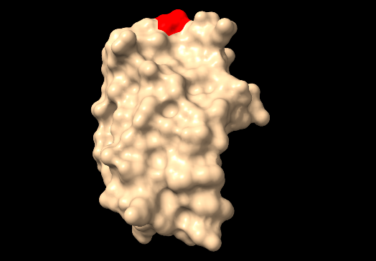
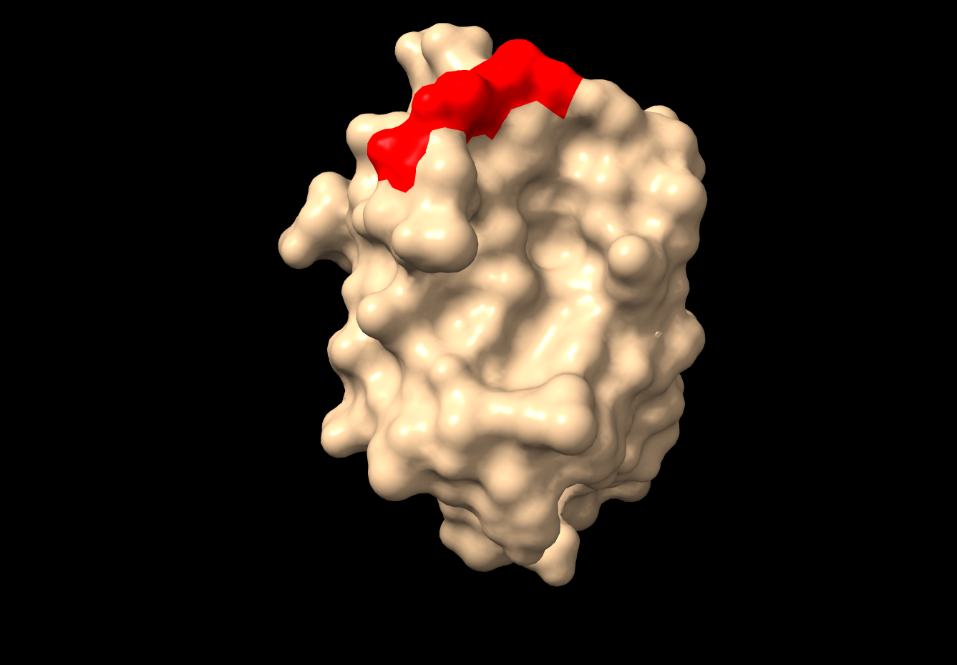
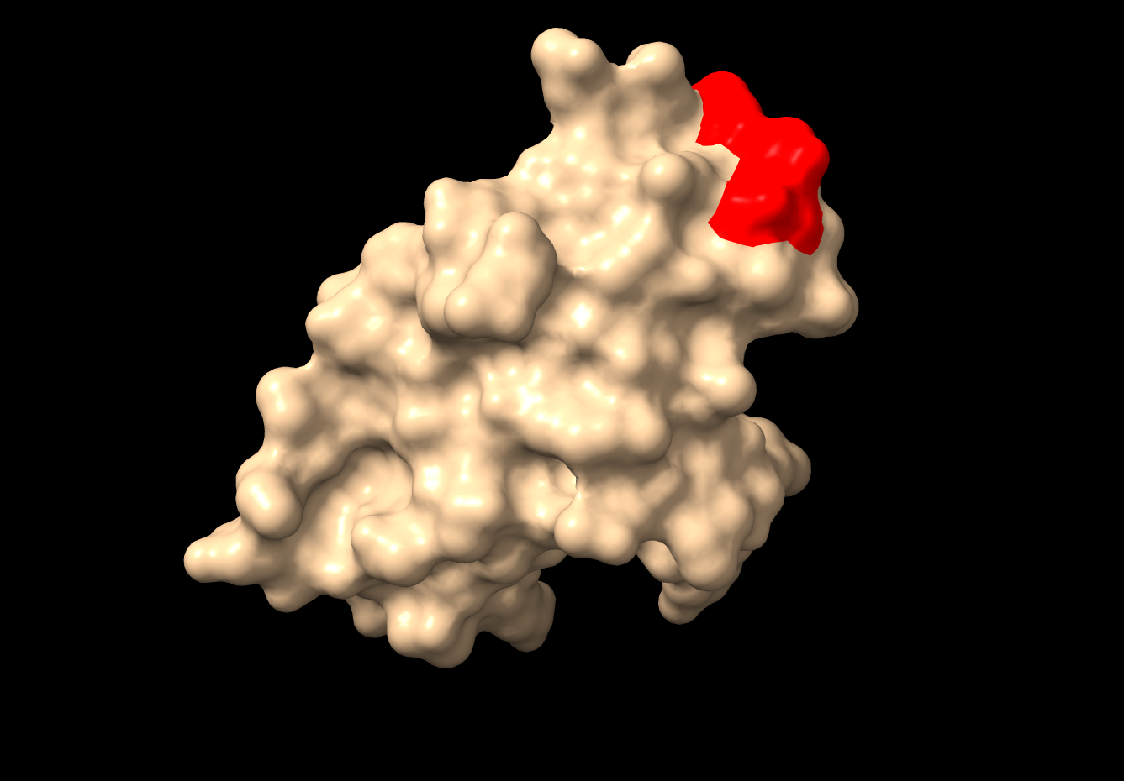
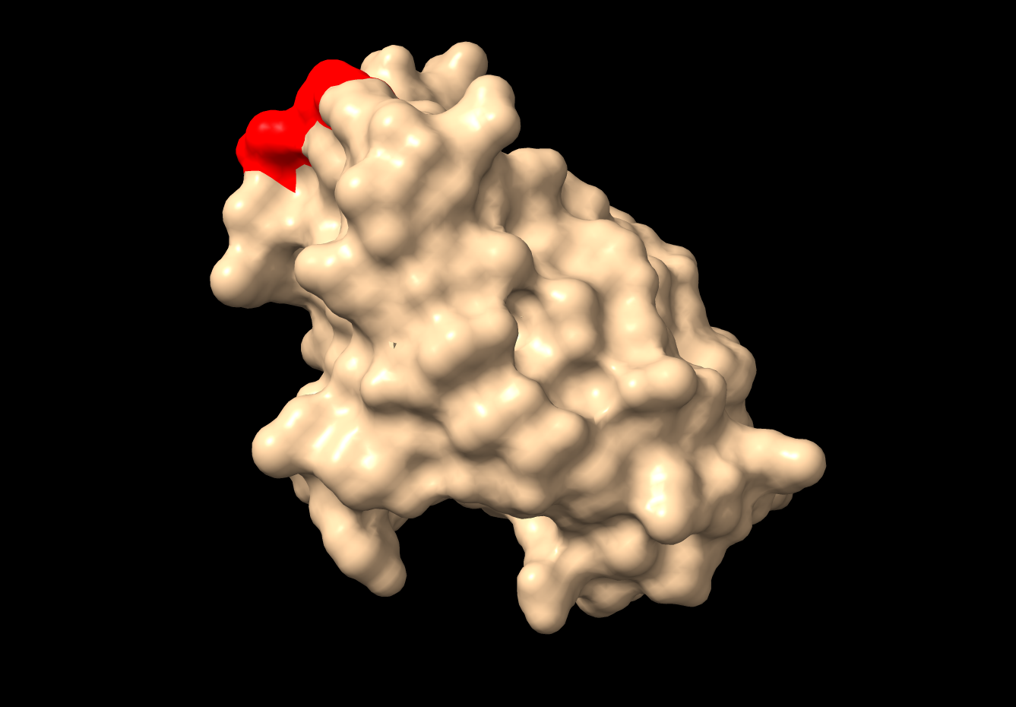
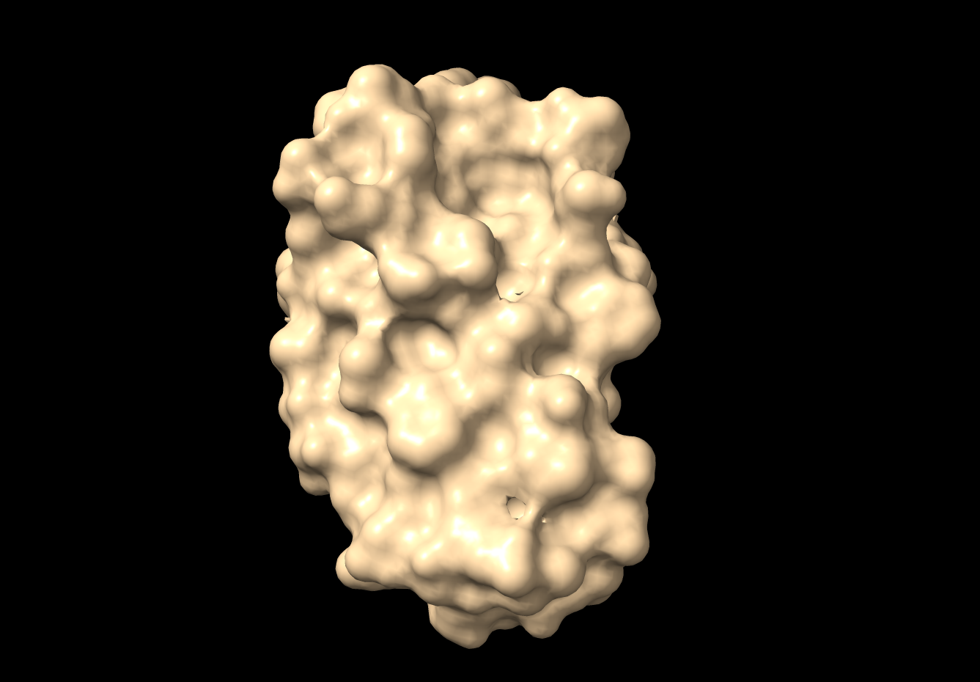
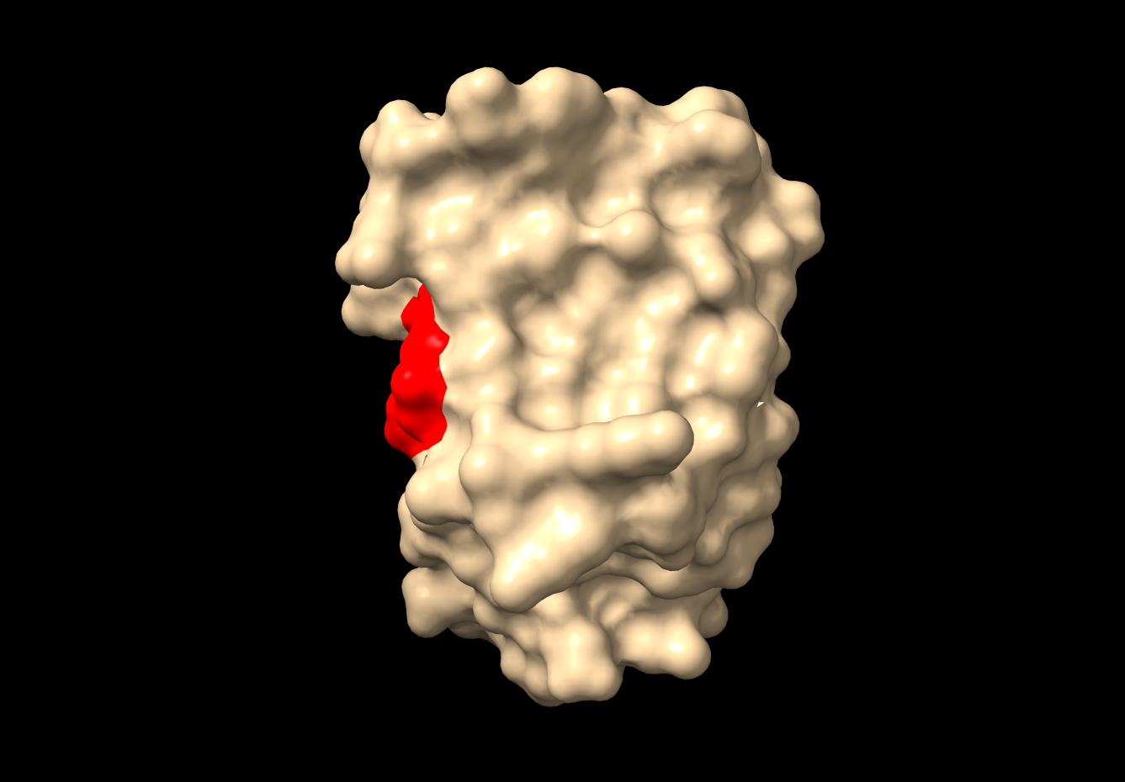
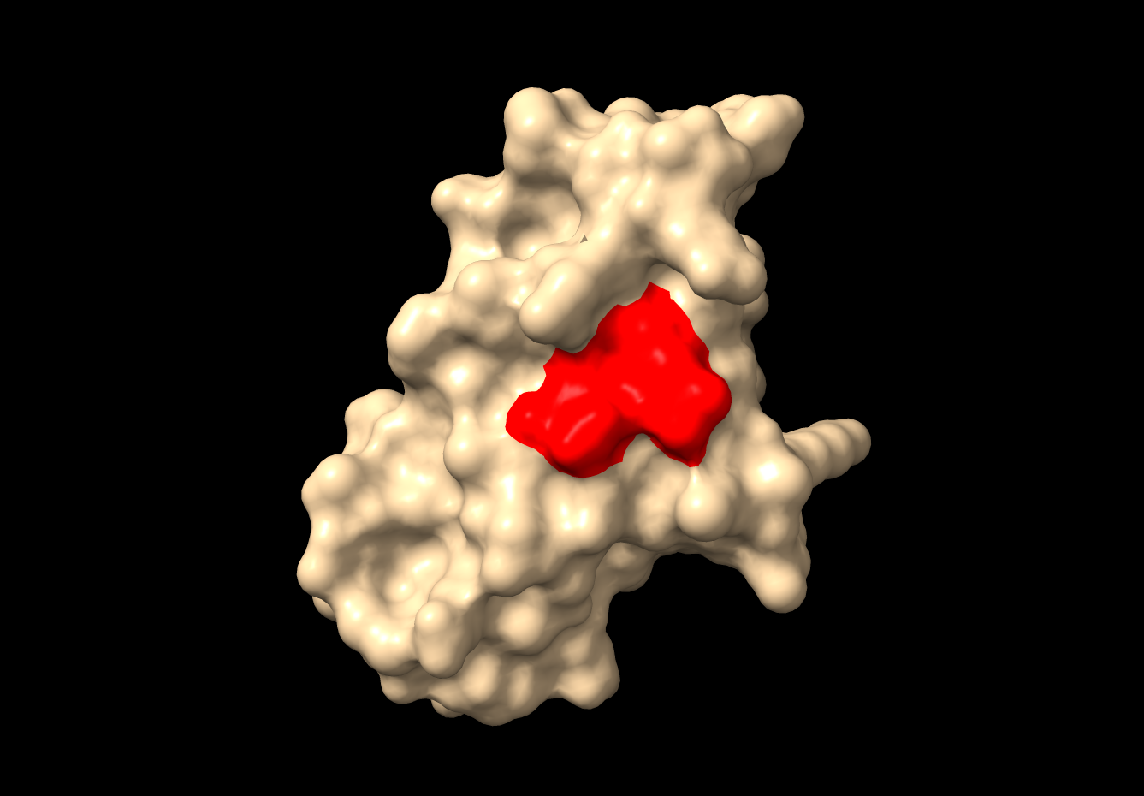
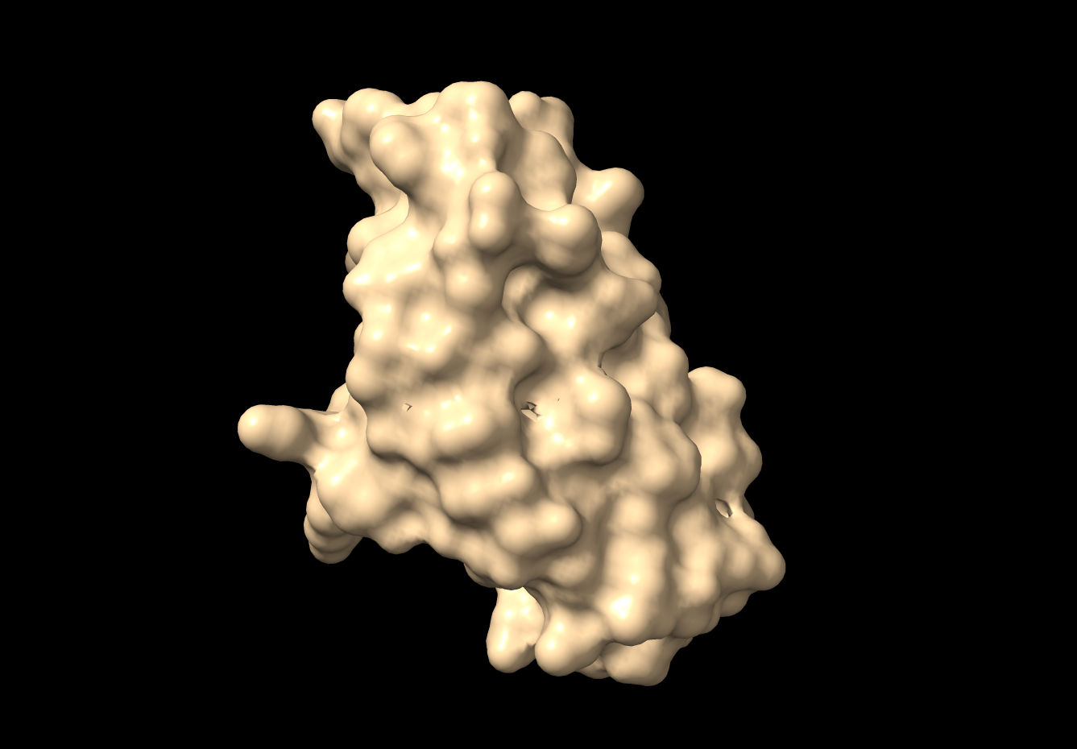

B
C
GFC face
GFC face
90°
90°
90°
90°
90°
90°

Supplementary Figure 4 – Disintegrin-like motifs in snake CEACAM N and human PSG N domains. (A) To identify putative disintegrin-like motives amino acid sequences of IgV-like N domain exons of predicted soluble snake CEACAM1L1, CEACAM1L2 and CEACAML3 and for comparison of membrane anchored CEACAM1 were aligned using the KALIGN multiple protein sequence alignment program. Amino acids identical in all sequences are shown in red (*), conserved amino acids in green (:), less conserved amino acids in blue (.). Consensus disintegrin motifs (RGD) are marked with dark gray underlay, less similar motifs (KGD, KGE, RGE) are labeled with a lighter gray color. For comparison, mature human (Hsa) PSG N domain alignments are shown. For decoding of the species 3-letter abbreviation please refer to Supplementary Table 1.Location of the RGD motif in 3D models of the N domains of human PSG7 (B) and timber rattlesnake (Crotalus horridus, Cho) CEACAM1L1 (C). Note the shift of RGD motif to the side of the GFC face in snakes in comparison to human PSGs. 3D model prediction was performed on the AlphaFold 3 server and visualized with ChimeraX. The predicted surface area of the RGD motif is shown in red. The GFC β-sheet consisting of β-strands G, F, C, C’ and C’’ faces the viewer at the leftmost orientation.

