Biodiversity Co-benefits of Land Sparing and Land Sharing Strategies for Tiger Conservation in Central India
Kamana Pokhariya, Ajay Singh, Supratim Dutta, Zainab Khan, Ramesh Krishnamurthy*

Wildlife Institute of India, Post Box #18, Chandrabani, Dehradun 248001, Uttarakhand, India
*Corresponding author: Ramesh Krishnamurthy, Address: Wildlife Institute of India, Chandrabani, Dehradun 248001, Uttarakhand, India. E-mail address: ramesh@wii.gov.in

Online Resource 1 Land use land cover class description
Class | Description
Dense forest | Tree canopy density over 50%
Open forest | Tree canopy density between 10-50%
Scrub land | Area with sparse tree and shrub distribution with understory grass cover
Water | Rivers, lakes, and other drainages
Cropland/Agriculture | All kinds of cultivated lands
Bare land | Area covered by bare rock, soil and sand

Online Resource 2 Description of change classes created using LULC in 1989 and 2019
Class | Description
Forest remains same | Unchanged forested areas during the study duration
Non-forest remains same | Unchanged non-forested areas during the study duration
Forest gain | Conversion of open to dense forest and other classes to open forest
Forest degradation | Conversion of dense to open forest/scrubland and open forest to scrubland
Cropland to scrubland | Conversion of cropland to scrubland or grassland
Other changes | All other changes in non-forested classes

Online Resource 3 Occurrence data points for bird, mammal, and tree species
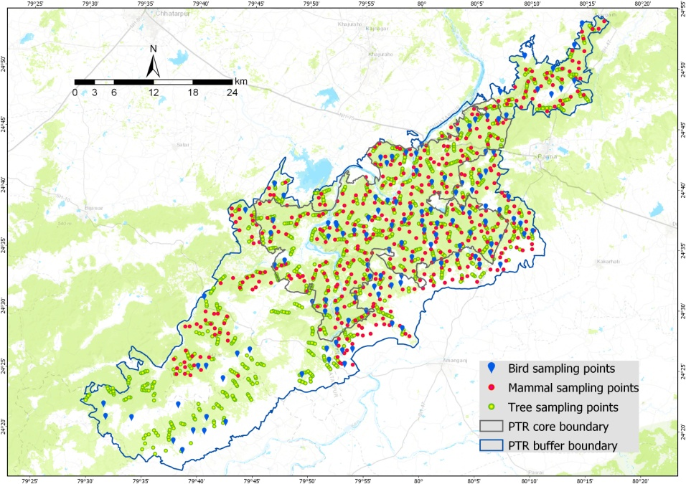
Online Resource 4 Decadal LULC patterns in Panna tiger reserve from year 1989 to 2019

Online Resource 5 Class-wise area changed from the year 1989 to 2019
Area changed (km²)
LULC class | PTR | Core | Buffer
Dense forest | 365.68 | 182.09 | 183.59
Open forest | -162.1 | -104.64 | -57.46
Scrub land | -235.16 | -69.84 | -165.32
Water body | 8.89 | 5.14 | 2.75
Cropland/Agriculture | -29.65 | -12.49 | -17.16
Bare land | 52.3 | -0.07 | 52.37

Online Resource 6 Evaluation statistics (means, n = 3) for each ensemble model generated using Biomod 2 package in R environment
Taxa: Bird
Sr. No. | Species | TSS | ROC | Sr. No. | Species | TSS | ROC
1 | Acridotheres tristis | 0.533 | 0.83 | 20 | Megalaima zeylanica | 0.549 | 0.841
2 | Centropus parroti | 0.516 | 0.825 | 21 | Merops orientalis | 0.552 | 0.841
3 | Copsychus saularis | 0.542 | 0.836 | 22 | Orthotomus sutorius | 0.542 | 0.839
4 | Coracias benghalensis | 0.537 | 0.835 | 23 | Parus cinereus | 0.51 | 0.819
5 | Corvus macrorhynchos | 0.511 | 0.823 | 24 | Pavo cristatus | 0.554 | 0.844
6 | Dendrocitta vagabunda | 0.534 | 0.832 | 25 | Phoenicurus ochruros | 0.532 | 0.828
7 | Dicrurus caerulescens | 0.521 | 0.814 | 26 | Prinia inornata | 0.536 | 0.835
8 | Dicrurus macrocercus | 0.513 | 0.823 | 27 | Psittacula cyanocephala | 0.561 | 0.849
9 | Dinopium benghalense | 0.537 | 0.834 | 28 | Psittacula krameri | 0.522 | 0.815
10 | Elanus caeruleus | 0.51 | 0.811 | 29 | Pycnonotus cafer | 0.55 | 0.843
11 | Eremopterix griseus | 0.524 | 0.812 | 30 | Rhipidura aureola | 0.518 | 0.827
12 | Ficedula parva | 0.552 | 0.842 | 31 | Saxicoloides fulicatus | 0.537 | 0.833
13 | Francolinus pondicerianus | 0.546 | 0.84 | 32 | Spilopelia chinensis | 0.543 | 0.839
14 | Gymnoris xanthocollis | 0.531 | 0.825 | 33 | Spilopelia senegalensis | 0.517 | 0.824
15 | Gyps indicus | 0.538 | 0.837 | 34 | Streptopelia decaocto | 0.535 | 0.836
16 | Halcyon smyrnensis | 0.512 | 0.822 | 35 | Sturnia pagodarum | 0.529 | 0.824
17 | Iduna caligata | 0.519 | 0.825 | 36 | Treron phoenicoptera | 0.513 | 0.812
18 | Lanius schach | 0.521 | 0.817 | 37 | Turdoides striata | 0.521 | 0.816
19 | Lanius vittatus | 0.532 | 0.827 | 38 | Vanellus indicus | 0.511 | 0.812
Taxa: Mammal
39 | Axis axis | 0.681 | 0.875 | 52 | Macaca mulatta | 0.546 | 0.864
40 | Boselaphus tragocamelus | 0.621 | 0.865 | 53 | Mellivora capensis | 0.513 | 0.812
41 | Canis aureus | 0.594 | 0.874 | 54 | Melursus ursinus | 0.576 | 0.868
42 | Canis lupus pallipes | 0.548 | 0.818 | 55 | Panthera pardus | 0.67 | 0.874
43 | Cuon alpinus | 0.527 | 0.812 | 56 | Panthera tigris | 0.65 | 0.891
44 | Felis chaus | 0.519 | 0.829 | 57 | Paradoxurus hermaphroditus | 0.547 | 0.865
45 | Felis silvestris ornata | 0.517 | 0.825 | 58 | Rusa unicolor | 0.581 | 0.874
46 | Gazella bennettii | 0.574 | 0.868 | 59 | Semnopithecus | 0.564 | 0.862
47 | Herpestes edwardsii | 0.531 | 0.842 | 60 | Sus scrofa | 0.571 | 0.867
48 | Herpestes smithii | 0.539 | 0.851 | 61 | Tatera indica | 0.514 | 0.837
49 | Hyaena hyaena | 0.576 | 0.869 | 62 | Tetracerus quadricornis | 0.512 | 0.813
50 | Hystrix indica | 0.587 | 0.873 | 63 | Viverricula indica | 0.545 | 0.852
51 | Lepus nigricollis | 0.579 | 0.872 | 64 | Vulpes bengalensis | 0.583 | 0.869
Taxa: Tree
65 | Acacia catechu | 0.589 | 0.838 | 85 | Lagerstroemia parviflora | 0.641 | 0.844
66 | Acacia leucophloea | 0.538 | 0.823 | 86 | Lannea coromandelica | 0.67 | 0.89
67 | Aegle marmelos | 0.681 | 0.901 | 87 | Madhuca longifolia | 0.571 | 0.835
68 | Albizia procera | 0.561 | 0.829 | 88 | Miliusa tomentosa | 0.542 | 0.816
69 | Anogeissus latifolia | 0.642 | 0.845 | 89 | Mitragyna parvifolia | 0.591 | 0.839
70 | Anogeissus pendula | 0.648 | 0.861 | 90 | Naringi crenulata | 0.551 | 0.825
71 | Bauhinia racemosa | 0.635 | 0.847 | 91 | Nyctanthes arbor-tristis | 0.514 | 0.804
72 | Bombax ceiba | 0.522 | 0.809 | 92 | Phyllanthus emblica | 0.542 | 0.815
73 | Boswellia serrata | 0.658 | 0.88 | 93 | Pterocarpus marsupium | 0.581 | 0.836
74 | Bridelia retusa | 0.524 | 0.809 | 94 | Schleichera oleosa | 0.521 | 0.807
75 | Buchanania cochinchinensis | 0.656 | 0.878 | 95 | Soymida febrifuga | 0.548 | 0.821
76 | Butea monosperma | 0.546 | 0.818 | 96 | Sterculia urens | 0.532 | 0.81
77 | Ceriscoides turgida | 0.513 | 0.804 | 97 | Tectona grandis | 0.614 | 0.842
78 | Diospyros melanoxylon | 0.55 | 0.824 | 98 | Terminalia arjuna | 0.548 | 0.813
79 | Flacourtia indica | 0.533 | 0.81 | 99 | Terminalia bellirica | 0.547 | 0.818
80 | Gardenia latifolia | 0.519 | 0.802 | 100 | Terminalia elliptica | 0.609 | 0.84
81 | Grewia orbiculata | 0.584 | 0.837 | 101 | Wrightia arborea | 0.635 | 0.845
82 | Haldina cordifolia | 0.521 | 0.807 | 102 | Ziziphus mauritiana | 0.59 | 0.839
83 | Holoptelea integrifolia | 0.562 | 0.831 | 103 | Ziziphus xylopyrus | 0.643 | 0.843
84 | Kydia calycina | 0.51 | 0.801

Online Resource 7 Alpha diversity values for Trees, Birds and Mammals in PTR

