Supplementary Figure S2. SHAP bar plots across four landmark windows
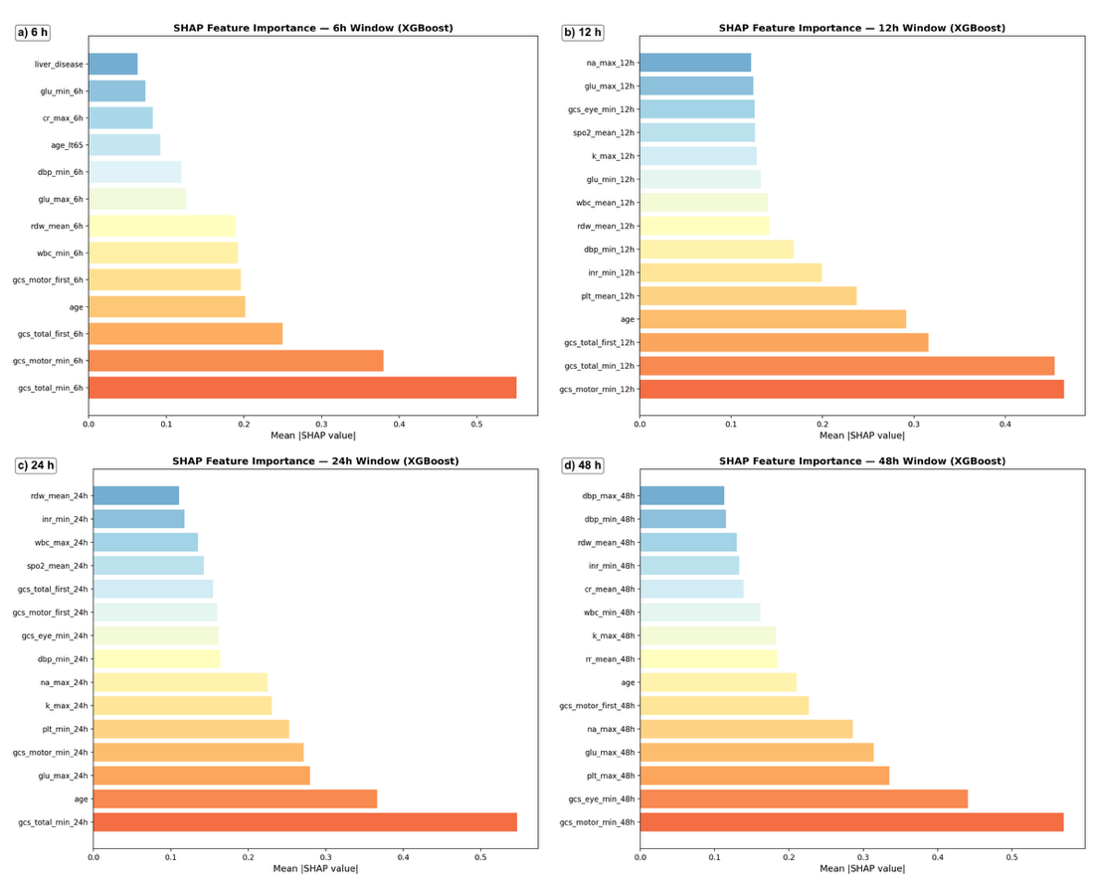
Per-window mean |SHAP| bar plots for all LASSO-selected features. Four panels: a) 6h, b) 12h, c) 24h, d) 48h. Complements the heatmap display in Figure 3 by showing the complete feature importance ranking within each window.

