Supplementary Figure S1. Participant flow diagram
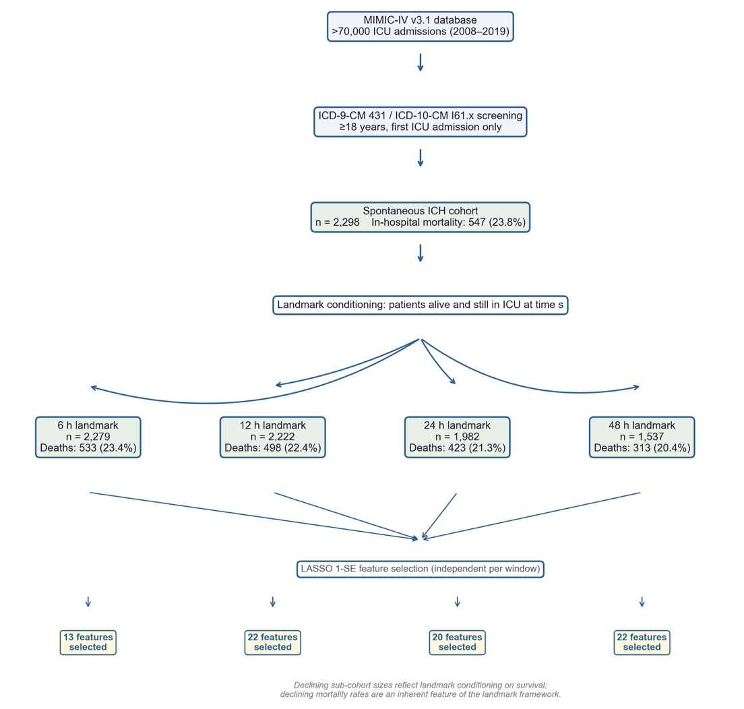
Flowchart illustrating cohort derivation and landmark sub-cohort allocation. Adult patients (≥18 years) with a first ICU admission and a primary diagnosis of spontaneous intracerebral hemorrhage (ICD-9-CM 431; ICD-10-CM I61.0–I61.9) were identified from the MIMIC-IV v3.1 database, yielding a total cohort of 2,298 patients with 547 in-hospital deaths (23.8%). At each landmark time point, only patients who were still alive and remained in the ICU were included, producing four conditioning sub-cohorts: 6 h (n = 2,279; deaths = 533, 23.4%), 12 h (n = 2,222; deaths = 498, 22.4%), 24 h (n = 1,982; deaths = 423, 21.3%), and 48 h (n = 1,537; deaths = 313, 20.4%). The progressively declining sub-cohort sizes reflect landmark conditioning on survival; the declining mortality rates are an inherent feature of the landmark framework, as each model addresses the distinct clinical question of risk assessment for patients who have survived to that specific time point. Feature selection via LASSO with the one-standard-error rule was performed independently within each sub-cohort, yielding 13, 22, 20, and 22 features for the 6 h, 12 h, 24 h, and 48 h windows, respectively.

