Supplementary Figure S4. Decision curve analysis
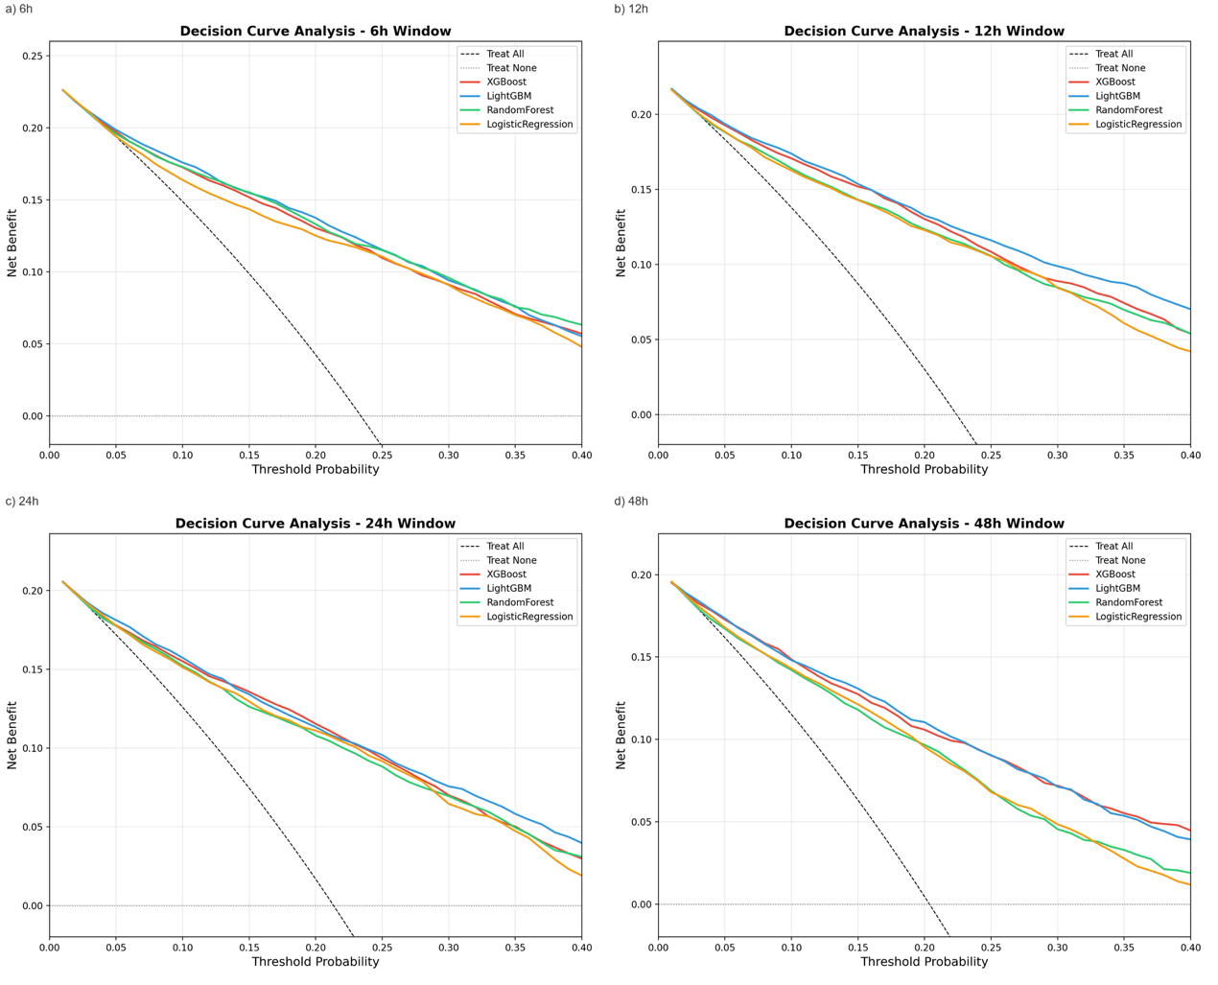
Net benefit plotted against threshold probability (0–0.40). The threshold range reflects the clinically plausible range for acute ICH management decisions. Thresholds beyond 0.40 correspond to scenarios where the predicted risk would be too extreme to alter clinical decision-making and where net benefit estimates become unreliable. The "treat all" and "treat none" strategies serve as reference lines. Within the clinically relevant range, XGBoost demonstrates consistent positive net benefit across all windows.

