Supplementary Figure S3. SHAP beeswarm plots
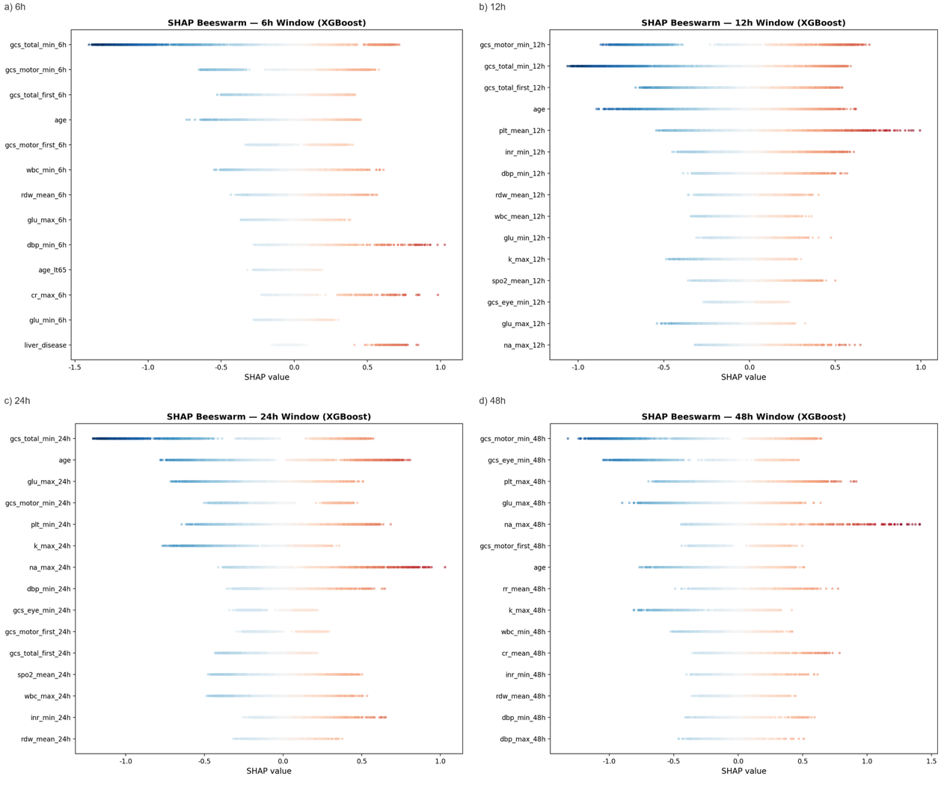
Per-window SHAP value distributions for the top 15 features. Each point = one patient; red = high feature value, blue = low. Horizontal position = SHAP contribution. Complements Figure 3 by showing effect directionality.

